Managing Project in the Organization

Student Name : Olinda Raposo
Student No – 1605749
Modul name - BA Leadership and Management skills for the workplace
Module Tutor – Dr Rexon Nting

Table of Content
Title | Page Number
“Introduction” | 03
“Provide a critical assessment of the usefulness of project management tools and techniques” | 04
“Prepare a plan for the implementation of the project and specify the relevant steps that must be followed and how the plan is going to be implemented. Communicate the project plans with appropriate colleagues and stakeholders” | 07
“Critically evaluate your ability to manage a project. Use feedback from others to evaluate your own ability to plan and implement a project, identifying strengths and weaknesses. Create a self-development plan to improve your own performance in managing projects” | 28
“Conclusion” | 29
“Reference” | 30
“Appendix” | 31

Introduction
Project management is an important business tools to make the company take business decision for minimizing organizational complex issues, develop new strategies, etc. There are various tools and technique that need to consider for ensuring smooth implementation of the determined project. Again it is also important for the project manager to develop own ability to ensure all activities performed appropriately. This report has developed a project implementation plan for Rahim Brothers Ltd to start its new store at Kensington. Rahim Brothers Ltd is an East London based grocery stores which is doing better in recent days and the company is able to increase its sale. The company does not have any store outside East London so it is developing plan to expand its business outside East London

Provide a critical assessment of the usefulness of project management tools and techniques
1.1 Project Initials
It is important to develop project initials as it makes the project manager to perform all strategies appropriately and ensure the complete of project within the determined time (Horine, 2012). The selection of SMART aim and objectives for the project makes the project manager to complete all activities within the determined time.
1.2 Work Breakdown Structure (WBS)
The work breakdown is very effective for the project to manage project activities in all small tasks to ensure the project activities performed as more manageable activities. The usefulness of WBS is it makes the manager easy to manage the total project work. The time duration could select appropriately (Horine, 2012). The management is also able to make resource planning about how it consumes to perform all strategies appropriately. It find easy to identify the project risks and perform all activities of the project appropriately.
1.3 Gantt Charts
According to Kodukula (2014), a Gantt chart is a horizontal bar chart developed for scheduling the project. Each activities of the task is developed in real time and planned for performing all activities appropriately. Gantt chart could be used for the planning of project time scale. It helps to plan co-ordinate and ensure to perform specific task of the project. Powell (2019) stated that the development of Gantt chart is very effective for performing small projects. Sopko (2015) stated that Gantt chart is not very effective for the lengthy and complex project.
1.4 Critical path analysis
Gilbert and Gamze (2018) stated that critical path analysis is very effective to calculate the estimated time of the project very effectively. It ensures the use of resources more effectively. Gantt chart many activities are interrelated so that one activity could not start until the previous activities has finished, so the use of critical path diagram clearly reveal the inter dependency of the project activities and makes the project completed within the determined time.

1.5 Project Evaluation and Review Technique (PERT)
According to Wilson (2014), the application of PERT diagram gives a proper description of the project time duration and defines the uncertainty of the project time. The project manager could define the best and worst of a project activity time and then able to set the right time for the project. The average time duration of the project could be derive by considering the elapse time duration of the project. The PERT diagram develop interrelationship between the project activities and the resources could be rightly allocated for performing business activities. () stated that the limitation of this process is uncertainty exist when estimating the project duration and predict poor timing of the project.
1.6 Resources
According to Gilbert and Gamze (2018), it is important to ensure the proper selection of resources to complete the project in determined time. The financial issues if very important for the project so it needs to determine to ensure that all finance of the project is being managed appropriately. It is important to ensure the proper maintenance of the quality of the project to ensure that all the project activities are performed appropriately. It is important to perform the proper communication of the project outcomes among all the stakeholders of the project. It is important to ensure that the project require less resources to perform
1.7 Milestone
According to Garrison (2013), milestone is a details explanation of the project from starting to closer. Gates are the stages of the project that been performed at the various stages of the project. The milestone of the project ensures the key completion of the project within the determined time. The limitation of the project milestone is it is unlikely to driving from one place to another.
1.8 Project Planning Document (PID)
It justified the business case for the project with details about the justification of the selection of the project. Project Planning Document (PID) is mainly developed the financial and other benefits of the project. The cost, time scale and other constraints of the project is being discussed in this process.
1.9 Risk Assessment
According to Richardson (2014), there is always risk associated with the project management that could cause the failure of the project these are: cost, time, quality, resources, etc. It is the responsibility of the project manager and the board of the project team to ensure the proper implementation of the project task, right use of the project deliverables and define the associated risk which might harm the potentiality of the project.

2) Prepare a plan for the implementation of the project and specify the relevant steps that must be followed and how the plan is going to be implemented. Communicate the project plans with appropriate colleagues and stakeholders.
Project Aim:
The aim of the research is to start new store for Rahim Brothers Ltd at Kensington as a strategy of business expansion.
Project Activities
- It needs to find out a new store near Kennington tube station within the May 31st 2019
- To improve the awareness of the customers about the product and service offered by the company within the 31st December of 2019
- To develop the product distribution of Rahim Brothers Ltd within 30th October 2019
- To ensure the development of good communication with the customer and develop their loyalty level within the April 2020.
Reason of the project
Rahim Brothers Ltd is an East London based grocery stores which is doing better in recent days and the company is able to increase its sale. The company does not have any store outside East London so it is developing plan to expand its business outside East London
Role and responsibilities of the project manager
The project manager needs to engage the marketing manager of the company. The department of the organization that needs to engage is: IT department, research and development department, finance department to allocate budget for the company, HRM department to allocate right numbers of people for the project. The IT manager will ensure all require technological use that is important for the successful completion of the project. The research and development department of the project identify all the innovative strategies for the project to ensure the successful implementation of the project and able to meet with the basic needs and demand of the customers.

Work Breakdown Structure (WBS)
The work breakdown structure of Rahim Brothers Ltd new business expansion project is given below:
Figure 01: WBS Structure of Rahim Brothers Ltd
Rahim Brothers Limited

5.0 Evaluation and Closure
4.0 Developing Distribution
3.0 Marketing
2.0 Developing Resources
1.0 Project Specification

5.1 Communicate with stakeholders
5.2 Data Collection and Analysis
5.3 Project Review
4.0 Manage Distribution Channel
3.1 Implement Marketing
2.1 Project resource evaluation
2.2 Project Cost Analysis
2.3 Managing risk
2.4 Communication with stakeholders
2.5 Recruitment
2.6 Training

1.1 Project Objectives
1.2 Find new store location

Gantt chart
The Gantt chart of Rahim Brothers Ltd new project is given below
Figure 03: Gantt Chat
Project Activities | 2018
Project Activities | May |  |  |  | June |  |  |  | July |  |  |  | August |  |  |  | September |  |  |  | October
Project Objectives
Find new store location
Project resource evaluation
Project Cost Analysis
Managing risk
Communication with stakeholders
Recruitment
Training
Implement Marketing
Manage Distribution Channel
Communicate with stakeholders
Data Collection and Analysis
Project Review

Network Diagram
 | Task | Weeks | Proceeding
A | Project Objectives | 1
B | Find new store location | 3 | A
C | Project resource evaluation | 1 | B
D | Project Cost Analysis | 1 | C
E | Managing risk | 1 | D
F | Communication with stakeholders | 1 | E
G | Recruitment | 2 | F
H | Training | 2 | G
I | Implement Marketing | 8 | H
J | Manage Distribution Channel | 4 | H
K | Communicate with stakeholders | 8 | J
L | Data Collection and Analysis | 3 | I
M | Project Review | 1 | L

Critical Path
I
L

3
8
M
1
2
2
1
1
1
1
3
1
8
4
H
G
F
E
D
C
B
A
K
J

Longest Path
A+B+C+D+E+F+G+H+I+L+M = 1+3+1+1+1+1+2+2+8 +3+1 = 24 Weeks

Resources
Allocate Human Resources: The project manager needs to communicate with the HRM department of the organization and allocate right numbers of workforce in organization to preform organizational activities. Project manager needs to provide training to the employees of the organization to ensure that all work activities are being performed accurately in organization. Again all activities of the project need to perform maintaining ethical standards.
Additional Staff members: Project manager needs more staff members for the project so needs to recruit more staff for the new store. Again for conducting research work project manager needs to engage employees staff members for conducting survey and collect data for the research work.
Milestone
 | Project Activities | Responsible Person | Start Date | End Date | Duration | 2018-2019
 |  |  |  |  |  | May |  |  |  | June |  |  |  |  | July |  |  |  |  | August |  |  |  |  | Sept |  |  |  |  | Oct
A | Project Objectives | PM | 01/05/2019 | 06/05/2019 | 1
B | Find new store location | Estate Officer | 01/05/2018 | 31/05/2019 | 3
C | Project resource evaluation | PM | 01/06/2019 | 07/06/2019 | 1
D | Project Cost Analysis | Finance | 08/06/2019 | 14/06/2019 | 1
E | Managing risk | HRM | 15/06/2019 | 21/06/2019 | 1
F | Communication with stakeholders | HRM | 22/06/2019 | 28/06/2019 | 1
G | Recruitment | HRM | 02/07/2019 | 14/07/2019 | 2
H | Training | HRM | 15/07/2019 | 31/07/2019 | 2
I | Implement Marketing | Marketing | 01/08/2019 | 31/09/2019 | 8
J | Manage Distribution Channel | Marketing | 01/08/2019 | 30/08/2019 | 4
K | Communicate stakeholders | Marketing | 01/09/2018 | 30/10/2019 | 8
L | Data Collection and Analysis | Marketing | 01/06/2018 | 21/06/2018 | 3
M | Project Review | Marketing | 22/06/2018 | 30/06/2018 | 1

Project Planning Document (PID)
Project Initiation Document (PID) | Tick when complete
Section 1 – What is the project all about?
Project Title:
“New Store Opening in Kennington”
Background:
Rahim Brothers Ltd is an East London based grocery stores which is doing better in recent days and the company is able to increase its sale. The company does not have any store outside East London so it is developing plan to expand its business outside East London
Purpose
The aim of the research is to start new store for Rahim Brothers Ltd at Kensington as a strategy of business expansion.
Objectives
- It needs to find out a new store near Kennington tube station within the May 31st 2019
- To improve the awareness of the customers about the product and service offered by the company within the 31st December of 2019
- To develop the product distribution of Rahim Brothers Ltd within 30th October 2019
- To ensure the development of good communication with the customer and develop their loyalty level within the April 2020.

Project scope
The employees of Rahim Brothers Ltd participate for the business expansion procedure and Project manager will also engaged additional staff members.
Exclusions from scope
N / A

Deliverables
The update of the project needs to rightly present to the manager of the marketing department frequently in every week. The updated also needs to present to the organizational customer relationship development manager, sales department manager and product distribution manager.

Constraints
The knowledge gap to perform all activities of the project is a major constrain for the project to perform all activities appropriately.

Assumptions
N/ A

Section 2: Why should this project go ahead?

Business case: Project Benefits

The project will prove beneficial for the company as it will make the company to expand its operational activities. Increase the sale volume of the company and also will develop organizational brand image.

Options
- Rahim Brothers Ltd could acquire small businesses of that location
- Rahim Brothers Ltd could make direct investment and purchase property
Cost and Timescale
The total project cost

Cost/Benefit Analysis
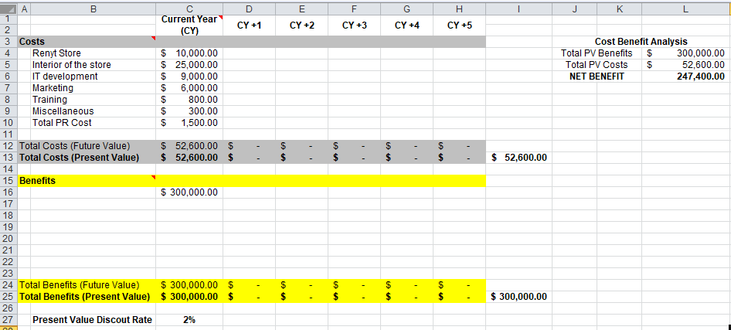
Risk Analysis: Risk Identification
The marketing department might find problem to implement the marketing strategies to the right segment of the customers. Unable to implement right strategy might cause the project failure, so it is important to rightly implement marketing strategies of the organization.

Risk prevention
Training needs to provide to the employees of the organization to get able to successfully implement marketing strategies and minimizes chances of error.

Risk Management
N/A

Risk Monitoring
It is important for the project manager to measure store sale frequently and evaluate the performance level of the employees so that it would be effective for the manager to identify the limitations.

Section 3: Who will work on the project?
Roles and Responsibilities
The project manager needs to engage the marketing manager of the company. The department of the organization that needs to engage is: IT department, research and development department, finance department to allocate budget for the company, HRM department to allocate right numbers of people for the project. The IT manager will ensure all require technological use that is important for the successful completion of the project. The research and development department of the project identify all the innovative strategies for the project to ensure the successful implementation of the project and able to meet with the basic needs and demand of the customers.

Project Organization Chart/Structure diagram
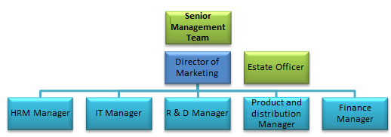
Names of: Project Sponsor
“Senior Management Team”

Project Manager (PM)
“Director of Marketing”

Section 4: How and when will the project are delivered?

Initial Project Plan
Start date of the project is 01/05/2019 and end date is 31/12/2019. The project will implement to achieve the goal of the company.
Schedule (Gantt Chart)
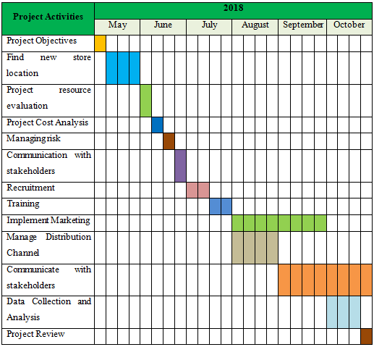
Human Resource Requirements
The project manager needs to communicate with the HRM department of the organization and allocate right numbers of workforce in organization to preform organizational activities. Project manager needs to provide training to the employees of the organization to ensure that all work activities are being performed accurately in organization. Again all activities of the project need to perform maintaining ethical standards.
Support Staff
Project manager needs more staff members for the project so needs to recruit more staff for the new store.

Additional Staff
Again for conducting research work project manager needs to engage employees staff members for conducting survey and collect data for the research work.

Project Control: Monitoring mechanisms
It is important for the project manager to measure store sale frequently and evaluate the performance level of the employees so that it would be effective for the manager to identify the limitations. Again the financial performance also needs to identify for every month.

Communication channels and schedules
The project implementation plan and the expected outcomes needs to communicate with the stakeholders of the company.

Quality Control
The project performance needs to evaluate in every week and a monthly statistical data needs to develop for analysis and based on the outcomes final plan needs to develop.

Risk Assessment:
The marketing department might find problem to implement the marketing strategies to the right segment of the customers. Unable to implement right strategy might cause the project failure, so it is important to rightly implement marketing strategies of the organization. The project manager needs to ensure the proper use of resources and ensure the quality of the project implementation.
Project Evaluation Technique
According to Richardson (2014), the posit implementation review (PIR) is the process that ensure the successful implementation of the project and company would able to achieve its ultimate goal. The project manager will able to achieve the ultimate goal. Project manager get able to find out the limitation of the project implementation process and develop strategies to minimize those problems. The identified issues need to consider for the further analysis of the project. The project manager needs to review the success of the implementation of the project after six month of the project implementation. It would make the stakeholders of the company gain benefit. The customers, employees, shareholders of the company and suppliers will greatly influence by the implementation of the project.
To evaluate the success of the company a survey questionnaires has designed at Appendix A to find out the success of the project by identifying customers success. Again questionnaires also developed for interview at Appendix B to conduct interview of the management.
At the time of evaluation the project manager need to investigate three issues these are: cost of the project, identify the gap, stakeholder’s satisfaction and the lesson that learnt.
Identify Financial Savings
There are some financial ratios that need to find out to derive out the success of the project. The financial decision is important for the company to minimize loss. There are some tools that need to consider for analyzing financial issues these are: NPV, discounted cash flow, internal rate of return, etc.
NPV: According to Richardson (2010), net present value is the different between the cash inflow and cash outflow.
NPV define as below:
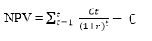
Internal rate of return: this rational identify the return of the company that gain from the investment and effective for the decision making process of the organization.
Internal Rate of return is defined as below:
Identify the financial savings
According to Crawford (2014), it is important to identify the issues that could be consider for minimize the cost of the project and make the company able to achieve the goal of the project. There are some key financial issues that need to consider minimizing costs and also achieving the sustainable advantage like,
- The store need to develop in a way that air and light get in so that store needs less energy during the day time
- The store size needs to keep smaller so that fewer resources require maintaining the store and customers find easy to shop.
- The brand awareness of the local people needs to improve.
There are some non-financial issues that also needs to consider like,
- The performance of the employees need to evaluate regularly and send training for their performance development
- It is important for the manager of the store to recognize the employees for their better performance to motivate them
- Manager needs to perform regular meeting with the suppliers to ensure that product reach to the store just in time, to use less resources.

Communicate the Project Plan with colleagues and Stakeholders
The project manager has developed presentation with the appropriate tools and technique of the project and present to the CEO of the organization and to the employees. The presentation is as below:
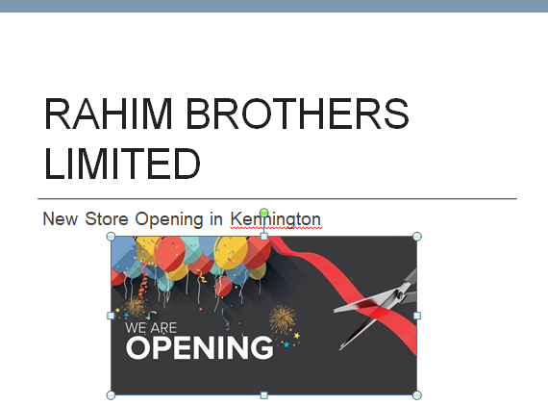
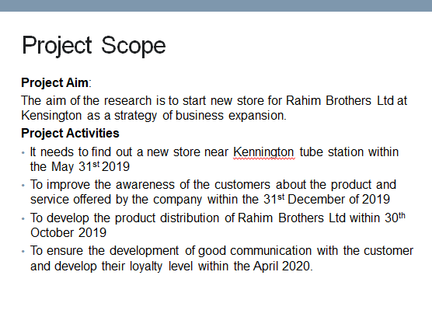
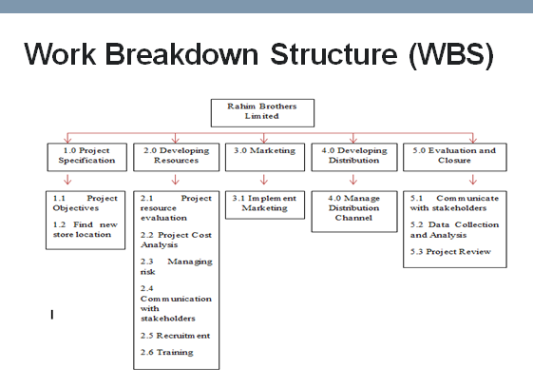
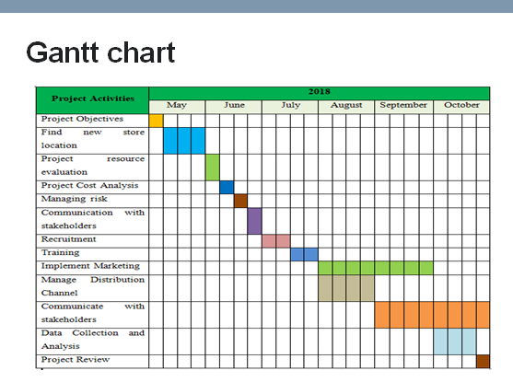
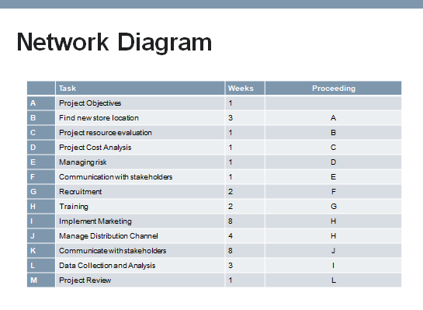
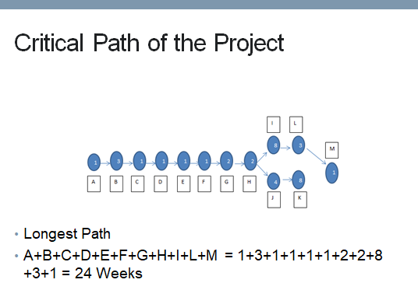
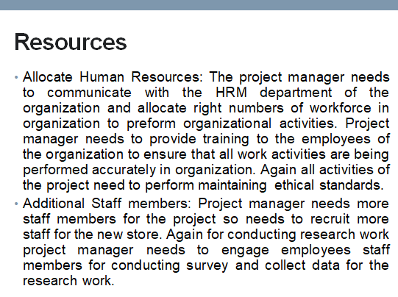

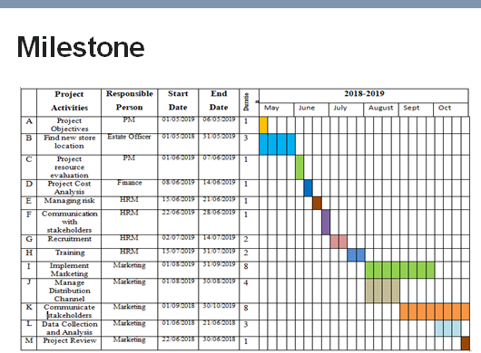
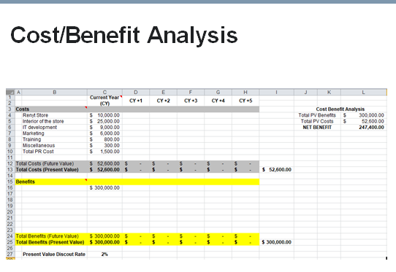

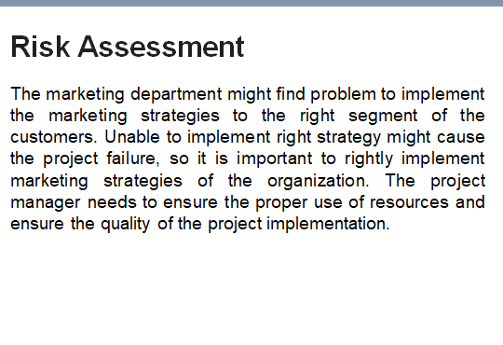
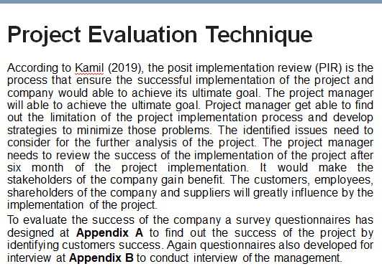

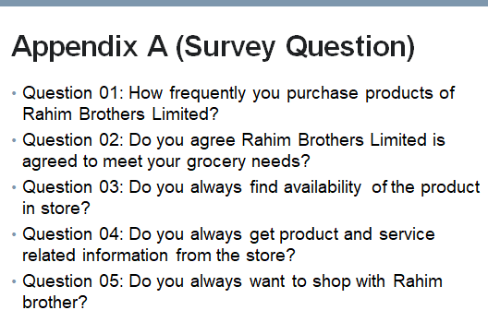
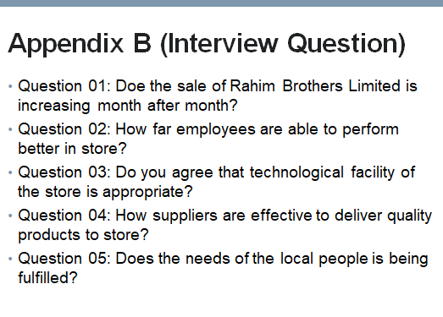

3. Critically evaluate your ability to manage a project. Use feedback from others to evaluate your own ability to plan and implement a project, identifying strengths and weaknesses. Create a self-development plan to improve your own performance in managing projects.
Own ability of managing a project
According to Crawford (2014), one of the important skills that a project manager require is to judge situation properly and take appropriate decision. I have good judgment ability and I believe I could judge the project more appropriately and design the required resources of the project. Powell (2019) stated that the communication skill is very important for the project managers to make the project success by communicating effectively with all parties. I realized that I have good communication ability and I have knowledge in both the verbal and non-verbal method of communication which makes me able to communicate effectively with the team members and the senior members of the manager. Sopko (2015) it is important for the manager to identify the risks and take appropriate measures to minimize those risks. I am good in performing this risk assessment as I used to perform risk assessment considering a pre-determined check list and evaluate all pliable areas of operation. However I have some limitation as I do not have proper knowledge in the ethical issues. It is important to gain appropriate knowledge in ethical issues to perform all activities properly. It is important for the manager to remain firm at the time of complex situation to minimize problem (Gilbert and Gamze,2018). I had limitation as I get nervous when I found complex situation so I have to enhance my problem solving ability to improve my confident level and perform all activities with confident.
Strength and weaknesses of the project implementation
According to Wilson (2014), it is important for the individuals to find out strength and weaknesses to ensure the successful implementation of the project and achieve success. I get feedback from my colleague about my ability to plan, implement and evaluate a project and the strength and weaknesses that I have received is presented below:
Strength
- I have good ability of judgment and prioritizing abilities to determine the small and large task of the project in right time.
- I am very good communication skills so that I would able to communicate with every one properly about the project implementation plan
- I will respect other and I would able to empower the team members and make them able to perform better at the time of project implementation process.
- I have the ability to show the bigger picture of the project
- I have good ability to analyze the resources appropriately which require for the organization
- I have good ability to perform risk assessment process
- A good business sense to monitor the project to ensure successful implementation of the project
Weaknesses
- I am less able to manage ‘Hard Skills’
- I need to enhance my knowledge on work ethics
- I need to gain knowledge on difference in culture to maintain all team members appropriately.
- I am less creative, so I might face problem at the time of complex project situation
- I get nervous when I found problem
- I have lack of ability of problem solving
At the time of planning the project the project manager does not able to know the people with whom PM has to work. This could result as in adequate input of the project and might cause the shortage of resources.
Develop a plan in a shorter period of time. It needs to communicate with different stakeholders before started planning of the project
There are too many responsible people that should communicate

Personal Development Plan
It is important to develop a personal development plan to ensure my skill and ability development and enhance my future career. My personal development plan has presented below to improve my performance to manage project appropriately
What are my development  objectives | Priority | What activities do I need to undertake to achieve my objectives? | What support/resources do I need to achieve my objectives | Target date for achieving my objectives | Actual date of achieving my objectives
IT skills | High | Need to receive short training | Need support from trainer | 01-05-2019 to 15-06-2019 | 01-05-2019 to 20-06-2019
Problem Solving Ability | High | Need to read different case studies | Need laptop to study | 01-05-2019 to 30-05-2019 | 01-05-2019 to 30-05-2019
Knowledge in work ethics | High | Need to find knowledge on ethics | Need to gain ability to find out right ethics | 01-05-2019 to 25-05-2019 | 01-05-2019 to 25-05-2019
Manage complex organizational situation | Moderate | Need to read different case studies | Need laptop to study | 01-05-2019 to 25-05-2019 | 01-05-2019 to 25-05-2019
Gain knowledge in different culture | Moderate | Need to receive short training | Need support from trainer | 01-05-2019 to 15-06-2019 | 01-05-2019 to 15-06-2019

References
Crawford, J. K., (2014). Project Management Maturity Model, Third Edition: CRC Press
Gilbert, S., Gamze, K., (2018). Developing Organizational Maturity for Effective Project Management: IGI Global
Garrison, R. W., (2013). Case Study in Developing Federal Organizational Project Management Capability: Project Management Institute
Horine, G., (2012). Project Management Absolute Beginner's Guide: Que Publishing
Kodukula, P., (2014). Organizational Project Portfolio Management: A Practitioner’s Guide: J. Ross Publishing
Powell, R., (2019). Exam Prep Flash Cards for Practical Organizational Project Management: Powell Publications
Richardson, G. L., (2014). Project Management Theory and Practice, 2nd Edition: CRC Press
Sopko, J. A., (2015). Organizational Project Management: Why Build and Improve: Que Publishing
Wilson, R., (2014). Mastering Project Management Strategy and Processes: Proven Methods to Meet Organizational Goals: FT Press

Appendix A (Survey Question)
Question 01: How frequently you purchase products of Rahim Brothers Limited?
Question 02: Do you agree Rahim Brothers Limited is agreed to meet your grocery needs?
Question 03: Do you always find availability of the product in store?
Question 04: Do you always get product and service related information from the store?
Question 05: Do you always want to shop with Rahim brother?

Appendix B (Interview Question)
Question 01: Doe the sale of Rahim Brothers Limited is increasing month after month?
Question 02: How far employees are able to perform better in store?
Question 03: Do you agree that technological facility of the store is appropriate?
Question 04: How suppliers are effective to deliver quality products to store?
Question 05: Does the needs of the local people is being fulfilled?

