BMSW-4005

Professional and Career development

Reflective portfolio
Task-3

Huma Shamas

2030024
Besty Jose

3/8/22

Contents

Appendix…………………………………………………………………………………………………..3
Introduction 3
Personal SWOT Analysis 3
The 16 Personalities 4
Employment opportunities……………………………………………………………………………….5
Strategies to Find Employment Opportunities 5
Short and Long Term Goals 6
Intuitive approach and Cognitive approach 6
Learning Styles 7
Social Learning Theory 8
Reflection 8
Gibbs Reflective Cycle 8
Evaluation 9
Analysis 10
Conclusion 10
Action Plan 11
References 12

Appendix
Learning styles - Activist learners are more likely to fully involve themselves in new experiences, problems, and opportunities. People with this learning style work with others in solving their problems and involves in role playing exercise (O'Hara, 2016).
People with reflector learning style are more likely to think about the experiences and observed from various perspectives. These people before coming to conclusion consider all the angles of experience (O'Hara, 2016).
Theorists are the learners who focuses on learning and understanding about the theory behind any action. These types of people like to follow model and processes and focus of facts to better understand the learning process (O'Hara, 2016).
Pragmatic people try new ideas, theories, models, and concept to ensure if these models and ideas work in practice. These kinds of people search for new ideas and experiment these ideas with application (O'Hara, 2016).

The Gibbs reflective cycle model is used to reflect on the experience, learning, and skills acquired during the module. It is a widely used concept with six stages (Gibbs, 1988).
Reflections are considered an essential part of academic as it helps individual in learning from their experience (The University of Edinburgh, 2020). In this reflection, I will reflect on the concepts and knowledge I acquired during the module.

Introduction
Finding a job is sometimes a daunting task for fresh graduates because of their lack of experience. Job seekers spend much of their time looking a suitable and appropriate position. A quality career provision demands a national effort (Wanberg et al., 2020). The United Kingdom government sets out strategies for quality career provision to students to make Britain fairer and offer everyone equal opportunity (Department for Education, 2017). Students’ time is split into different activities. These activities might increase the student’s chances of developing skills and knowledge.
Some common strategies individuals can use to find out different employment opportunities are discussed below.

Personal SWOT Analysis
STRENGTHS | WEAKNESSES
- Communicate effectively with patients, carers, and team members.  - Work effectively with individuals and agencies to meet the needs of the patients.  - Effectively manage workload, time, and resources.  - Deal with various visit requests and phone calls.  - Having sufficient knowledge of telephone systems.  - Register requests of patients and make changes in the patient’s detail if asked by patients. | - Lack of knowledge of business management.  - Gaps in the capability and service areas.  - Managing the staff seems to be a problem sometime.  - Lack of English proficiency skills.  - Weak data analysis skills.  - Lack of experience as a receptionist.  - Take on too much work and responsibilities for others.
OPPORTUNITIES | THREATS
- Excellent communication skills offer room to communicate with different members working in the health setting effectively.  - Adequate knowledge of the telephone makes it easy to address more client requests.  - Increased client trust because their needs are met.  - Effectively managing workload, time and resources can reduce the chances of developing distress or anxiety issues. | - Taking too much work from others might sometime increase the workload.  - Weak data analysis skills might affect the management of patient records and data.  - Difficulties might occur because of a lack of English proficiency.  - Lack of staff management might affect the operations in the GP’s setting.

The 16 Personalities
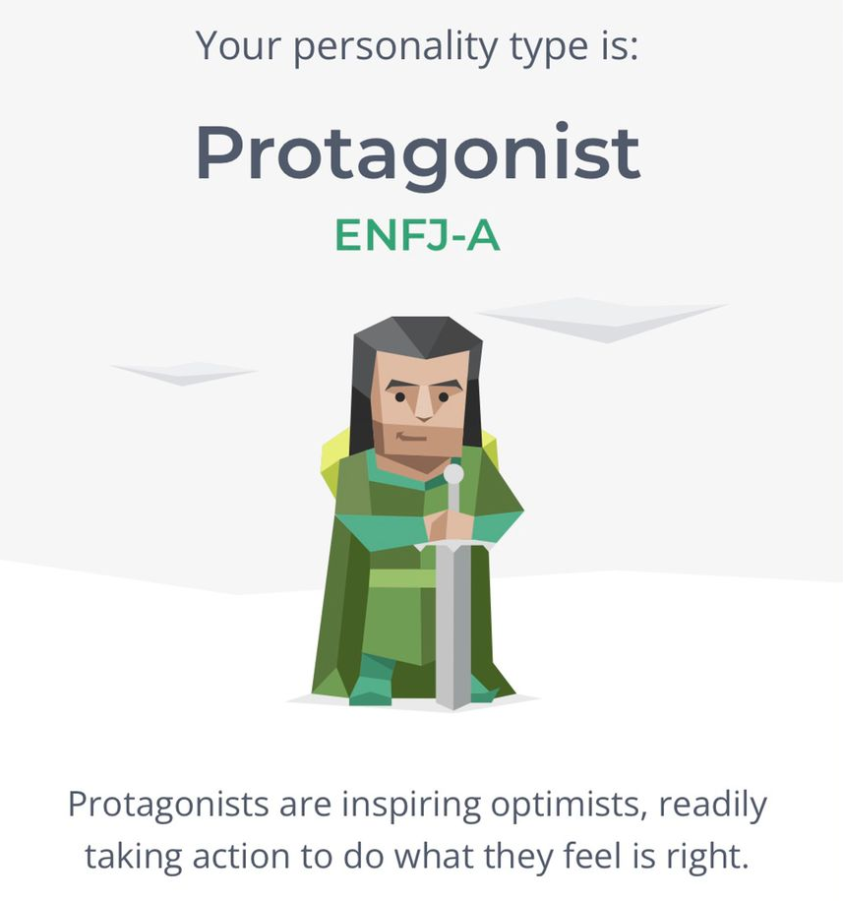
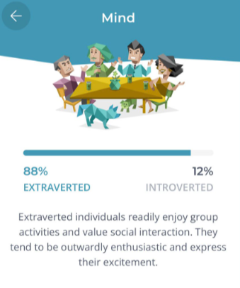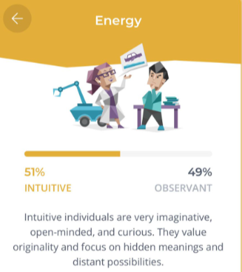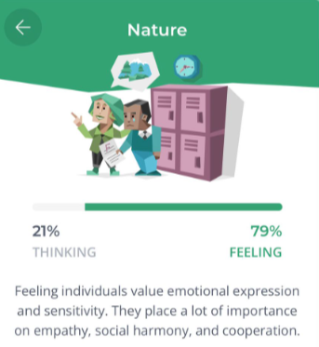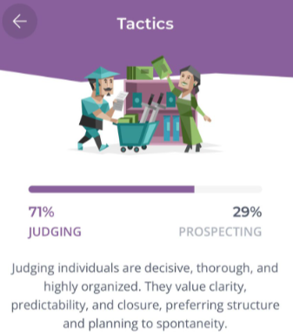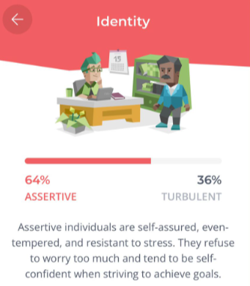
The receptionist job is more suitable for this Protagonist Personality type. Individuals with Protagonists (ENFJ-A) personality type are more likely to be organised, humble, encouraging, warm hearted and persuasive (Puri, 2022). These people share their life with others and support their friends and family when they needed them the most. There are some common traits and characteristic that are required by the receptionist. I chose GP receptionist, it’s important for me to have soft skills, empathy, patience to carry out my desired job role (Tetiana, 2021). People that belong to this personality type try to serve others and spends a significant amount of time in engaging with other. This personality type would help me in performing my job role as a general practitioner receptionist. Having this type of personality, I would feel a sense of responsibility and duty regarding those around me. People that belong to the protagonist personality type are more likely to involved themselves in the process of making things happens for others. These types of people enjoy working with the material and the things that they have learned and are more likely to make logical connection through grasping over the already available material. The only issue with this personality type is that they often indulge with others and to make world a better place while neglecting their own needs.

Employment Opportunities
It’s essential for individuals to first know themself. Individuals must focus on their strengths and weaknesses and what motivates them to perform any specific job (Oesterkloeft, 2020). When exploring employment opportunities, the job seeker should not limit themselves to a single option; instead, shortlisting several options is preferred. In my case I have considered three job options that include carer, care home receptionist and general practitioner receptionist. I have performed a SWOT analysis and a personality to test to better understand which job or career is most suitable for me. After analysis, I chose to work as a general practitioner receptionist.

Strategies to Find Employment Opportunities
Different strategies could be used to find employment opportunities include graduate schemes, internships, and reaching out to employers (UCLA, 2022). Some of the graduate schemes that could be accessed as employment opportunities. For instance, My Future, Prospect, Target Jobs, and Milk round. Apart from this, many internship facilities are available for fresh graduates to seek employment. For example, Graduate Talent Pool is based in England. It is an internship opportunity program for graduates. The UK government also offered a “Find a Job” online platform to search for full-time and part-time jobs in Scotland, Wales, and England. Different online platforms and job-seeking sites such as Indeed, Reed, LinkedIn, and Monster can also be used to search for receptionist jobs. For example, graduates can apply to King’s College Hospital NHS foundation trust for a GP receptionist position. In addition, graduates seeking receptionist job positions for GPs can apply in NHS services, social care homes, primary care centres, and healthcare settings to get better opportunities. To find this job, I searched websites, and I found this job on NHS website. I was scared as to whether I would get this job or not but because of my previous experience I got the opportunity to work as a GP receptionist.

Short- and Long-Term Goals
Considering my job role and associated weaknesses and strengths I have decided to make short- and long-term goals as this would help me decide how much I must travel to reach my desired destination. My short-term goals include,
- Improving my communication skills by 20 percent by the end of this month to effectively communicate with the customers.
- Improve active listening skills by 10 percent within two months to handle patient's requests.
- To improve my time management skills by 20 percent at the end of this month to better manage the tasks each day.
My long-term goals include:
- I will try to improve the customer service by 15% at the end of this year to satisfy more customers and clients.
- Try to nurture and strengthen the relationship by next summer with every customer who visit the GP.

Intuitive approach and Cognitive approach
Intuitive approach is a fast and efficient approach that is used to determine the meaning in the observed pattern. This approach is based on the mental and experimental capacity. This approach can help individuals in tackling the complex matters (Sieck, 2021).
Cognitive approach uses the experimental research methods to get to know about the internal mental processes for instance attention, perception and decision making (Prezenski, et al., 2020).

Learning Styles
My learning style is tactile. I conducted a learning style test, and the results were auditory 35%, visual 25% and tactile 40%. As my learning style is tactile, I learn things through physical movement. These individuals are active and take frequent breaks. This style is more suitable with my job, and it would help me in solving problems of customer by involving with them in any physical activity.
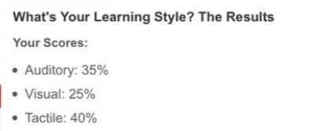

Social Learning Theory
Social learning theory states that human learn from observing the behaviours of others. This theory demonstrates the idea that behaviour can be learned through observation. Social learning theory is considered as a powerful theory that is used by educators for teaching, learning, and motivating the student’s behaviour (Bandura, 1971). Cognitive learning is the process in workplace when employees learn, work, and interact together. I learned communication skills, decision making, problem-solving skills from my seniors working in my workplace. This helped me a lot in performing similar behaviour as my seniors.

Gibbs Reflective Cycle
I learned about various professional and career development concepts. I learned about self-awareness and why it’s essential in professional development. I learned about the tools used to help improve awareness, such as SWOT Analysis, Johari Window, and personality tests such as the 16 personalities test. SWOT Analysis is a great way to assess yourself when deciding on your career. The Johari window is another vital tool used in understanding and training self-awareness (Self-Awareness UK, 2013). During my module I did an open book assignment in which I performed very well and got 8 out of 10. The open book assignment was about self-harm. The duration of the open book assignment was 2 hours.
I also learned about the different learning styles that refer to models and theories discussing differences in an individual's learning. The next session, I learned about the various employment opportunities. I learned about the multiple steps that could be used in finding employment opportunities. The same week, the module also taught about the different strategies for finding employment opportunities, including government graduate schemes, internships, online portals, and websites, and directly reaching out to employers.

I was unaware of career and professional development and its importance to individual students and graduates. After getting enrolled in this module, I learned about several skills and concepts that helped me in creating a CV and cover letter. By learning different concepts, I was also able to identify my personality type and my strengths and weaknesses. This helped me a lot in deciding on my career as a receptionist or general practitioner. I created a cover letter and CV that could help me apply for the job of GP receptionist. It was the best decision to enrol in this module as it helps us understand career and professional development. I felt great after a mock interview. I along with the team arrange a mock interview to improve myself in the future. Before the mock interviews I was worried and anxious but after that I felt great as it was great opportunity for me to learn.

Evaluation
The positive things about this experience are that the professionals provide students with details regarding legislation and legal issues in UK employment. There were different materials being provided to the students to learn about the different legislations and regulations used in the UK for employment. It was difficult for me to know too many concepts regarding my professional and career. Course material provided to me was quite extensive, it was difficult for me to learn about every individual concept discussed in the course material. I learned about different ideas, performed various class activities, created a CV and cover letter, learned about different CV styles, and learned personal development process, learning styles, different laws and legislation in UK employment. In one of the sessions, we learned about the Equality Act 2010. The Equality Act 2010 makes it illegal to discriminate against employees or job applicants. Another important act is the Employment Rights Act 1996. It talks about the protection of employees and discusses the legal rights of the employees (Lawman, 2022). I also learned about the Data Protection Act 2018 that is designed to safeguard the information of employees. During the module, I also learned about self-awareness methods. These include mediating, writing down key plans and priorities, taking psychometric tests, asking trusted friends, and getting regular feedback at work. These are important self-awareness method.

Analysis

Participating in different activities during this module taught me to perform personality tests. I took the personality test, and my personality result was Protagonists (ENFJ-A). I learned about other personality types as well during this module. This module helped me learn about my personality and my desired career role. I also took a career motivation test. My results are:

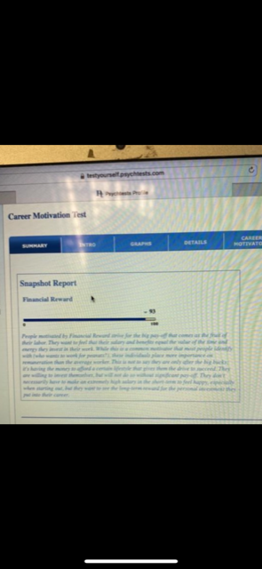

I am motivated by financial reward. Which gives me the desire to succeed and invest in myself. I wanted to become a receptionist as a general practitioner. This module also helped me in finding out about different job opportunities, such as websites, graduate schemes, and different internship programs. I learned about CV and the different components that should be included in the CV, such as personal data, objectives, employment history, education history, skills area, certificates, and references. By learning about the different types, formats, and styles, I made my CV based on my learning and skills considering my desired job role.
I also prepared myself for mock interview. After that, I took part in the career development process. During my module, I got through a short guide to understand the different legislation available in the UK for employment.

Conclusion
Things that I will aim to do differently if a similar situation arises in the future include taking help from my senior. I will also find sources on the internet and learn more about the legal issues and legislation regarding employment. I will also plan to cover all the concepts and topics. This will help me to align with the teacher’s learning pace. I will try to develop a creative and efficient CV and resume and will also help my friends in making innovative CV designs that would attract employers.

Action Plan
In the future, I aim to use the knowledge and skills acquired during this module. I will try to improve my skills by practicing what I have learnt. I will practice for the mock interviews so that I can perform well during the actual job interviews. I will also make a compelling CV that I aim to send to NHS and other healthcare and primary care setting to get my desired job role. I will explore more about my personality that I get to know from the 16 personalities test. I will also explore different job opportunities that are associated with my job role and will try my best to perform better soon.

References
Ajani, A., 2022. Why You Shouldn’t be Afraid to Reach Out to Employers. [Online]
Available at: https://theundercoverrecruiter.com/reach-out-employers/
[Accessed 21 July 2022].
Cherry, K., 2021. ESFJ: The Caregiver (Extroverted, Sensing, Feeling, Judging). [Online]
Available at: https://www.verywellmind.com/esfj-extraverted-sensing-feeling-judging-2795983#:~:text=People%20with%20an%20ESFJ%20personality,described%20as%20outgoing%20and%20gregarious.
[Accessed 21 July 2022].
Department for Education , 2017. Careers strategy: making the most of everyone’s skills and talents, London: Department for Education .
Gerencer, T., 2022. 30+ Best Job Search Engines & Boards for Finding a Job 2022. [Online]
Available at: https://zety.com/blog/best-job-search-sites
[Accessed 21 July 2022].
Gibbs, G., 1988. Learning by doing: A guide to teaching and learning methods.. London: Further Education Unit..
GOV.UK, 2022. Find a job, s.l.: GOV.UK.
KTP, 2022. Knowledge Transfer Partnerships. [Online]
Available at: http://ktp.innovateuk.org/
[Accessed 21 July 2022].
Lawman, 2022. Employment Rights Act 1996. [Online]
Available at: https://www.netlawman.co.uk/ia/era-1996
[Accessed 21 July 2022].
Oesterkloeft, H., 2020. Knowing your strengths and weaknesses boosts career progression. [Online]
Available at: https://www.icas.com/members/careers-support/career-development-change/news-in-career-development/knowing-your-strengths-and-weaknesses-boosts-career-progression#:~:text=Having%20this%20knowledge%20about%20yourself,manage%20potential%20employers'%20expect
[Accessed 21 July 2022].
Self-Awareness UK, 2013. Understanding the Johari Window model. [Online]
Available at: https://www.selfawareness.org.uk/news/understanding-the-johari-window-model#:~:text=A%20Johari%20window%20is%20a,improving%20communications
[Accessed 21 July 2022].
Southard, J., 2021. 5 Reasons Researching an Employer Before an Interview is a Good Idea. [Online]
Available at: https://www.terrastaffinggroup.com/resources/blog/5-reasons-researching-an-employer-before-an-interview-is-a-good-idea/#:~:text=Researching%20an%20employer%20beforehand%20allows,and%20confidence%20during%20the%20interview.
[Accessed 21 July 2022].
The University of Edinburgh, 2020. General tips for academic reflections. [Online]
Available at: https://www.ed.ac.uk/reflection/reflectors-toolkit/producing-reflections/academic-reflections/general-tips
[Accessed 15 December 2021].
UCLA , 2022. Job & Internship Search Strategies, s.l.: UCLA School of Education & Information Studies.
Wanberg, C. R., Ali, A. A. & Csillag, B., 2020. Job Seeking: The Process and Experience of Looking for a Job. Annual Review of Organizational Psychology and Organizational Behavior, 7(1), pp. 1-10.

