Anghel Adrian Brezeanu
1918103
Anghel Adrian Brezeanu
1918103
Assessment 2 market research & website
BMSW4003 Digital Skills & Research Methods

Website login details
Email address: aab1918103@gmail.com
Password: dob07.07.88

Introduction

The actual report will focus on market research and website developing for the Raw company, which is a juice bar that only sells natural juice. To check if this business idea would be profitable, a questionnaire has been created to spot if there will be interest from the public for the natural juices. The primary questionnaire data will be analyzed to identify the consumers’ trends and behaviors in regard to the healthy choice of drinking a glass of natural juice. This data will also prove if it is indicated to open such a business.
Moreover, based on the initial research, the knowledge about the trends will also help further on the website developing.

Questionnaire design & analysis

Market research is a way for businesses to learn more about their target market, and to use the data collected to shape the business to sell (Roque, 2020). The market research can be divided in primary market research and secondary market research (Farese, 2021). The primary research is the most important for the market research because it can give more accurate answers, a more complex feedback and a deeper idea about the current trends and behaviors (McCrocklin, 2018). By having accurate data it is easier to take business decision and to create sales opportunities which will increase the profit. Even though it is usually a pricy research, which also takes a lot of time, it is the most efficient way for a business to gather information that will be beneficial in the future (Driscoll, 2011). One of the most efficient tools used in primary research is the questionnaire, which is meant to investigate the target’s opinion in regard to a company’s goal (McLeod, 2018).
The main curiosity of the Raw company was to see what the target’s market behavior regarding the fresh juice is. A questionnaire was addressed to people that shop in big supermarkets in Cardiff, such as ASDA, Morrison’s, or Tesco, that being the proposed location of the business. The questionnaire was built with 10 questions, and it was made to take only a few minutes, so that the target market will keep its interest in responding (Brace, 2018). The most important 3 questions from the questionnaire are:
- How often do you visit stores such as ASDA, Morrison’s, or Tesco?
- In your opinion, what are the benefits of fresh juice?
- How likely are you buy fresh juice after you finished your grocery shopping?
These 3 questions are important to see how often people travel to the supermarkets, if they are aware of the benefits of fresh juice, and if they would buy a glass of juice after they finished their grocery shopping. The answers will identify if the target market has information regarding the fresh juice and if they would be keen to buy it, which will also clarify if the business has enough chances to become profitable in the future.
The answer at the first question is clearly showing that people visit supermarkets at least once per month, more frequently 2 times per week. By using this information, it can be established that the location was chosen perfectly, as it is a popular zone, and the chances of having sales is increased.
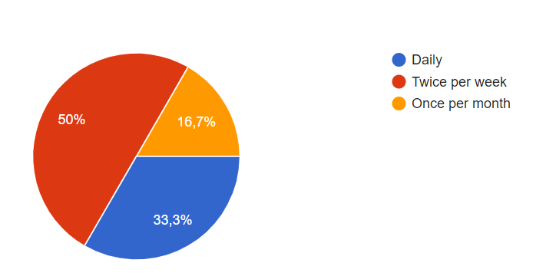

The answers for the second question were a bit different, because it was an open question, which let the respondents to share their knowledge (Fauvelle, 2019) about the benefits of fresh juice. Most of the responses were about health and vitamins, which means that the target market knows that such a product has multiple benefits, especially for health in general.
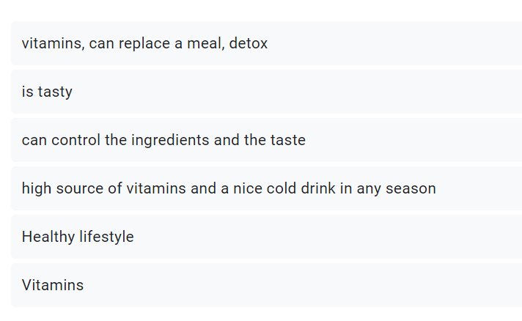

The answers for the final question showed excellent numbers, and it seems like the target market, after remembering the benefits of the fresh juice, is willing to purchase this product after they finish their groceries. For the business, that is a lot of sales potential, especially seeing that the target market is educated in regard to the benefits of fresh juice, and they are willing to spend their money on it.
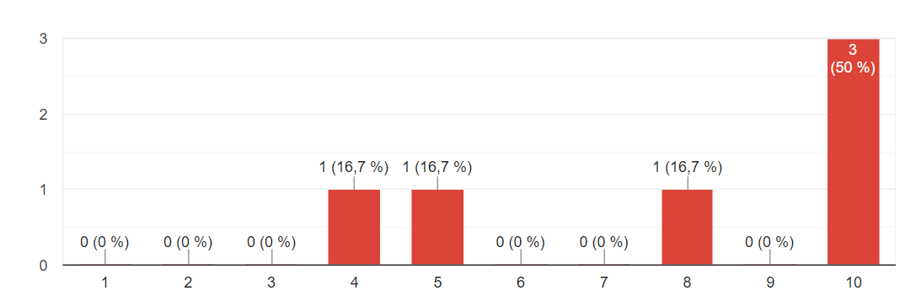
Based on the primary market research, the decision to open up a juice bar seems to be a good one, because the customers are educated, and they are willing to spend money to drink a glass of juice.

Website design

The data collected in the primary research show that people are well educated in regard to fresh juice, so the website should not be an educational one, but to be solely used for promotion. This means that the website must be attractive for the customers, to make them curious and to make them to want to spend money (Ciotti, 2021) at Raw.
The first step in website building is SEO, which represents Search Engine Optimization (Demers, 2021). This is important because the website must be used around key words, to bring organic traffic on the website (Hollingsworth, 2021). Based on that, the meta words used for the Raw website are fresh juice, fresh, health, natural juice, fruits, vegetables.
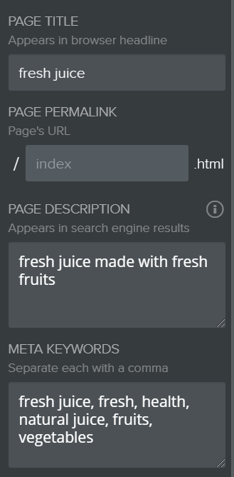
Another important part of the business to make it attractive is represented by the colors used. In this case, the main color used in green, which is representative for the brand because it translates as health, and people automatically will think about health while they will look at the website.

The font used is normal, because the target market must feel that it is normal to drink healthy drinks which have lots of vitamins and will increase the metabolism.
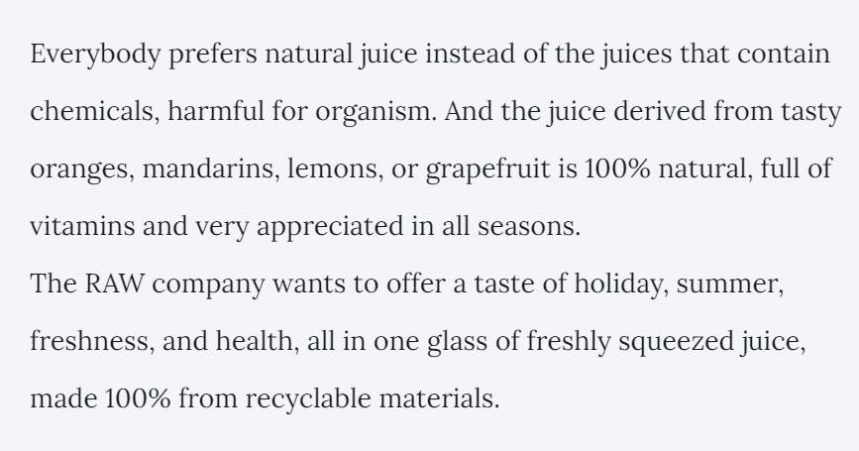

The images used are only with juices, in different formats, because the target market needs to see the products, and many times, the aspect of a product will sell it before its taste. If people do not know how the product look like, they will not be so keen to try it. In this situation, all the juices are colorful, made with fresh fruits, and they represent a great source of daily vitamins.
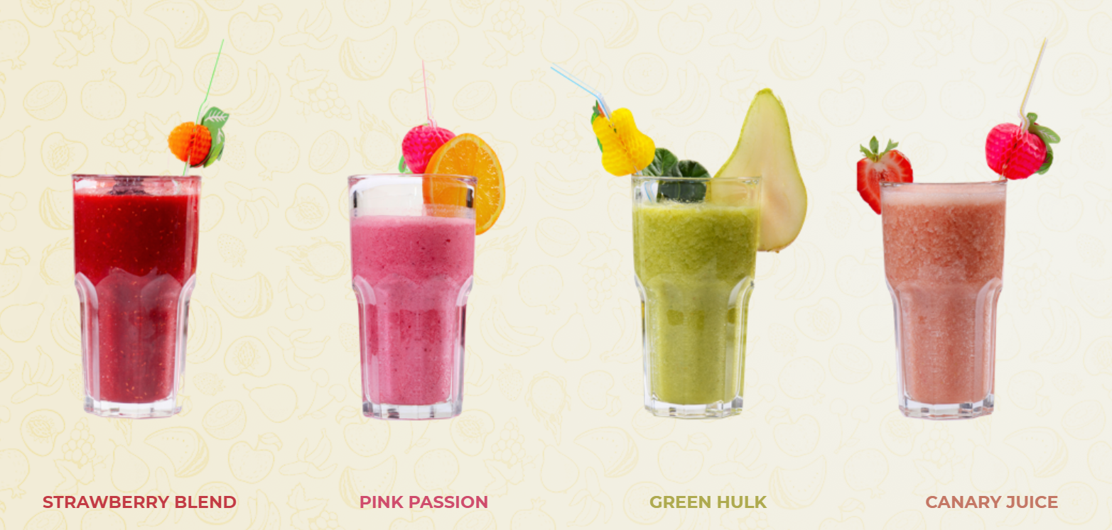

The logo of the company is right at the beginning of the page, and it is colorful, using primary colors that will make it stand out and easy to remember for everyone. 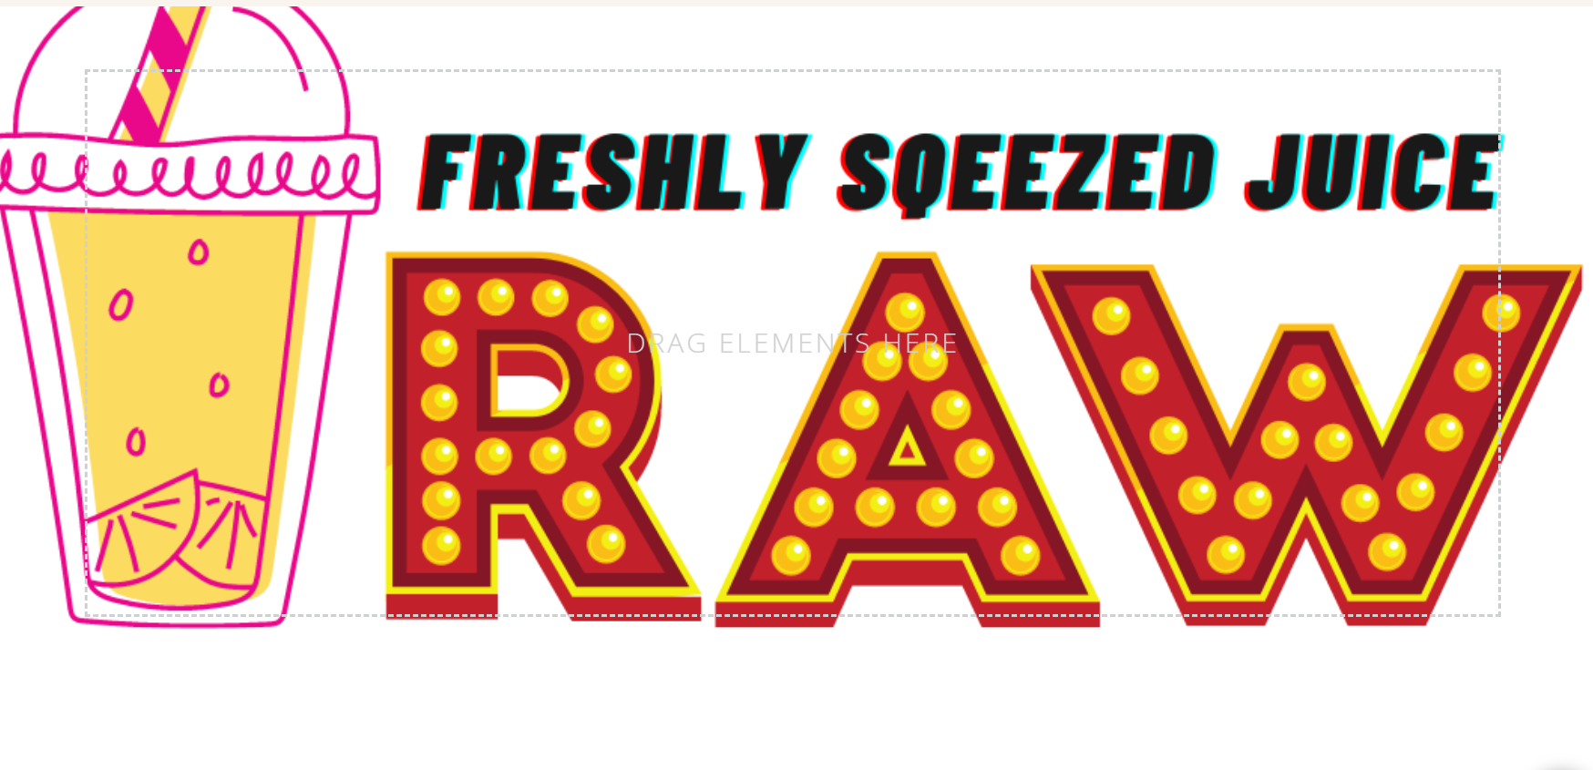
Based on the elements described above, the website was built to increase the awareness for the brand Raw, and to increase the customers’ interest. The elements above were carefully chosen, so that the customer can have the best experience online, before buying the delicious juice. The meta keywords used will help at the organic traffic, and once people will visit the website, they will have a deeper understanding about out brand and our juices, and this has a lot of potential to transform the organic traffic into sales, which will further help to achieve all the company’s goals and create new ones.

Conclusion

The market research is important in establishing if the company will have success or not, and it is an important tool used by small businesses. Based on the primary research of the company Raw, using a questionnaire, it was highlighted that the location of the business was a good business decision, because the target market is always visiting supermarkets. The other important highlight showed that the target market has great knowledge about the main product sold by the Raw company, fresh juice. The majority of the target market considered the fresh juice a source of health and vitamins, while the other part considered it a good tool for detox or a nice drink. Following that, the target market was keen to buy a fresh juice from the Raw company, which strengthen the idea of a good business decision to open this small business. Since the response of the target market was positive, the website building was the next natural step. Tools like SEO were used to make sure that the traffic will be solely organic, and the website was built to offer a deeper view of the products of the company, showing attractive pictures with the products and using fonts and colors that will strengthen the idea of health in the customer’s mind.
In conclusion, the market research is important in website building, because the data might determine how to approach the customers and how to make the products to feel more close to the customers.

References

Brace, I. (2018) Questionnaire Design: The Trick of Keeping it Short (But Making it Big). Available at: https://www.koganpage.com/article/questionnaire-design-tricks (Accessed: 21st of March 2021).
Ciotti, G. (2021) 10 Proven Ways to Build a Website that Customers Will Love. Available at: https://www.helpscout.com/blog/website-customers-love/ (Accessed: 21st of March 2021).
Demers, T. (2021) SEO Basics: Complete Beginner’s Guide to Search Engine Optimization. Available at: https://www.wordstream.com/blog/ws/2015/04/30/seo-basics (Accessed: 21st of March 2021).
Driscoll, D. L. (2011) Introduction to Primary Research: Observations, Surveys, and Interviews. Library of Congress Cataloging-in-Publication Data. Vol. 2, pp. 153-155.
Farese, D. (2021) How to Do Market Research: A Guide and Template. Available at: https://blog.hubspot.com/marketing/market-research-buyers-journey-guide (Accessed: 20th of March 2021).
Fauvelle, L. (2019) Qualitative research: open-ended and closed-ended questions. Available at: https://www.intotheminds.com/blog/en/qualitative-research-open-and-closed-ended-questions/ (Accessed: 21st of March 2021).
Hollingsworth, S. (2018) 12 Reasons Why Your Business Absolutely Needs SEO. Available at: https://www.searchenginejournal.com/why-seo-is-important-for-business/248101/#close (Accessed: 21st of March 2021).
McCrocklin, S. (2018) Primary Vs. Secondary Research. Available at: https://www.geopoll.com/blog/primary-vs-secondary-research/ (Accessed: 20th of March 2021).
McLeod, S. (2018) Questionnaire: Definitions, Examples, Design and Types. Available at: https://www.simplypsychology.org/questionnaires.html (Accessed: 20th of March 2021).
Roque, C. (2020) 7 Reasons Why Marketing Research Is Important to a Business. Available at: https://business.tutsplus.com/articles/why-is-marketing-research-important--cms-31593 (Accessed: 20th of March 2021).

