

Topic : Demonetisation

Name : Koteshwar Reddy Mudireddy
Student ID : 2216776

Table of Contents
Declaration Form 3
Abstract 6
CHAPTER 1: Introduction 6
1.1 Framework of the research topic 6
1.2 Research Problem 8
1.3 Aim & Objectives 9
1.4 Research Questions 9
1.5 The scope and limitations 10
CHAPTER 2: Literature Review 10
2.1 Introduction to the Chapter 10
2.2 Demonetization and its influence of Bharath economy considering its strengths & weakness. 11
2.3 Indian Fabric organisation- Summary 15
2.4 Effect of demonetization on Indian Fabric Organisation 18
2.4.1 Demonetization and insistance in the Fabric Organisation 18
2.4.2 Demonetization and cash flow in the Fabric Organisation 19
2.4.3 Demonetization and Capability in Fabric Organisation 21
2.4.4 Demonetization and digitisation in the fabric organisation 22
2.5 Output and performance of the fabric organisation both before and after the government decided to demonetize high-value banknotes. 23
CHAPTER 3: Research and Methodology 30
3.1 Research Method 30
3.2 Research Design 30
3.3 Research Strategy and approach. 31
3.4 Data collection 32
3.5 Secondary data Collection 32
3.6 Research Framework 33
3.7 Limitations of the research 33
CHAPTER 4: Discussion 35
4.1 Introduction 35
4.2 Summary 42
CHAPTER-5 42
5.1 Conclusion 42
References 45

Declaration Form
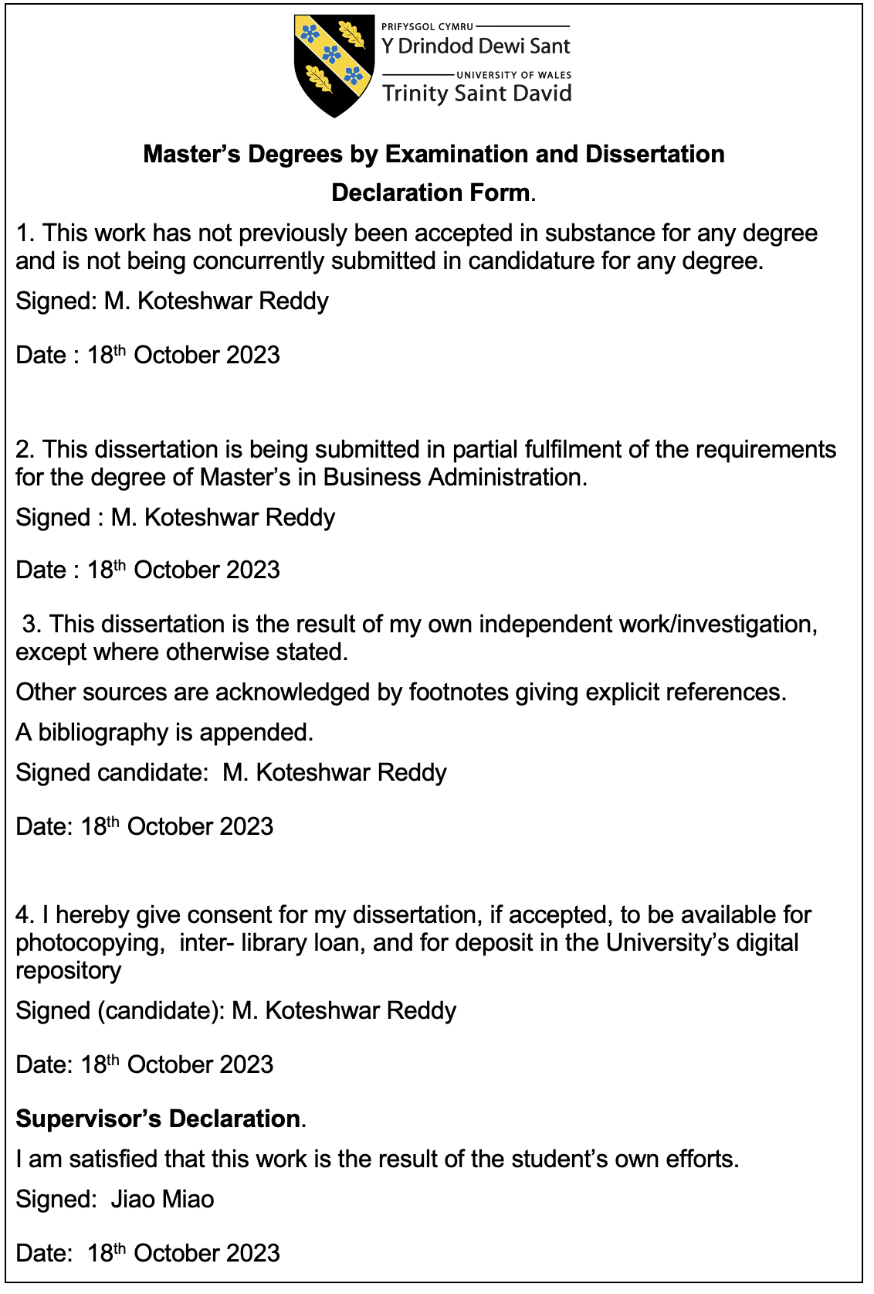

Acknowledgment

I want to express my gratitude to all those who helped me complete my thesis. Without their contributions, encouragement, and support, my work would not have been possible. My dissertation supervisor Jia Miao also deserves recognition for their continuous assistance throughout the entire process. The individuals who helped me with my thesis have been exceptional. Their patience, dedication, and expertise have helped me grow as a professional and academic. Their feedback has also contributed to my development. My research aims to contribute positively to society and I am hoping that it will help improve the quality of life for all. I want to thank the entire community for its support and encouragement during my academic journey. Without their help and support, I would not have been able to complete my thesis. I am very grateful to the individuals and institutions that helped me reach my goal.

Abstract
In India, the fabric sector is a vital part of the country's employment generation. Unfortunately, in recent times, the organisation has been struggling due to factors such as low Capability, rising costs of production, and falling exports. Demonetization has also affected the sector.The objective of this study is to find out the current trends and the impact of the demonetization on the Indian fabric organisation. Through a detailed questionnaire, the participants were able to provide their feedback on the various factors affecting the organisation.The results of the study were analyzed using the IBM SPSS software. The findings indicated that the demonetization has led to a decrease in the demand for various fabric products, which has resulted in a reduction in the overall Capability of the organisation.The cash flow constraints resulted in a distortion of the entire value chain, as it impacted the operations of farmers and manufacturers. Despite the significant digital advancements that have occurred in the organisation, the pace of digitization still remains slow.

CHAPTER 1: Introduction

1.1 Framework of the research topic

The terms monetization and demonetization are frequently used interchangeably. The former refers to the process in which money is converted into something that can be used as a circulating medium. On the other hand, the latter involves the withdrawal of old currency, which makes it useless for any transaction. On November 8, 2016 (Ahram and Karwowski, 2017), the value of old currency notes was shown to have been discontinued in India. This was the first time that the country's currency had been demonetized. One of the biggest issues that people and businesses had with the demonetization was its inability to use old currency for transactions. This was because the notes were no longer worth anything and could not be stored for future use. It has also been argued that the decision to demonetize was an extreme step that needed a strong purpose and effective planning.
A study conducted by the Indian academician, Sangeetha, in (2018), claimed that the government's decision to demonetizes old currency notes was aimed at curbing the flow of black money into the country. It also stated that this would invalidate the old notes' current owners. However, there was not enough evidence supporting this claim to support its claims. To address the issue of black money, the government also launched various other measures to fight corruption and improve the country's cash system. The decision to demonetize old currency notes was not the first time that an Indian government had done this. However, the implementation of the procedure has been significantly affected by the challenges that it faced.
The fabric sector in India is a vital part of the country's economy, providing employment to over 6 million people. However, in recent times, the organisation has been struggling due to the decline in exports and the rise in cost of production. This research aims to analyze the current trends and the influence of demonetization on the demand, Capability, digitization, and cashflow of the organisation.
In 2017, a study conducted by Bayan revealed that the Authorities decision to demonetize old currency notes was not the first time that an Indian government had done this. However, the difference between the previous steps and the present situation is that the intention of the government was to curb the flow of black money. The study also noted that the immediate effects of the demonetization were very different from those of the long-term measures.. The long lines at the banks and ATMs caused many people to die and collapse in the queue. The demonetization had a negative impact on the entire country, as it affected both the individuals and businesses. People also had a hard time understanding the details of the decision, as well as the government's failure to ensure that there was enough currency in the market to meet the withdrawal period and gap between the notes' value and the current value. Vendors ran out of ways to tender to their customers due to the government's decision to demonetize old currency notes. This aims to analyse the effects of the measure on the different aspects of the cash transaction organisation. In addition to cash-based businesses, this paper also explores how digital businesses were affected by the demonetization.

1.2 Research Problem
In (2017), Senthamizhselvi noted that although the demonetization of high-value currency notes helped the Indian government in recovering the unaccounted money, the impact of this measure on the country's businesses was unprecedented. Due to the lack of proper financial support and the increasing number of cash-based businesses, small enterprises have been e experiencing huge financial losses. In (2017), Neelam noted that the fabric organisation had mixed reactions to the demonetization. While the organized fabric sector had welcomed the move as it will help improve the efficiency of the organisation, the other sectors had expressed their concerns. It has been noted that the implementation of the demonetization measure had a negative impact on the cash flow of the organisation. It resulted in companies not being able to purchase the raw materials they needed to continue their operations. Despite the negative effects of the currency exchange ban, there is still a scope for the organisation to adopt electronic clearing systems to improve its operations.
The question is, if the demonetization only resulted in digitization, as it impacted the way businesses were conducted in the country. The manufacturing, retail, and wholesalers sectors were affected the most. During the winter season, the Authorities decision to demonetize high-value currency notes affected the business activities of small and medium-sized enterprises. It also caused the lack of affirmative reply of digital payments to escalate the issue. Large businesses, on the other hand, had a hard time making the payments due to the cash crunch. According to an article appearing on Economic Times, the demonetization has led to a reduction in the consumer spending on luxury goods and fabrics, which has affected the abundance and demand of the fabric organisation. However, it has been stated that since around a third of the organisation is export-oriented, the smack of the measure on the organisation might not be as severe as that of import-based firms.
It has been suggested that once the insistence returns to normal levels, the overall impact of the authorities decision to demonetize cherished currency notes can be neutralized. Although the impact of the measure on the country's exports and imports has been studied, other financial indicators such as Capability and cash flow have also been identified that have been adversely affected by the currency exchange ban. The goal of this work is to provide a comprehensive exploration of the several aspects of the Indian fabrics organisation, and this will contribute to the development of a deeper understanding of the country's demonetization. India is one of the sporty-growing major economies in the economy, and its manufacturing and other industries have been instrumental in its growth. It is therefore important that the study explores how the demonetisation measure affected the country's economy.

1.3 Aim & Objectives
The objective is to highlight the significance of the study. It seeks to analyse how the demonetization affected the Bharath fabric sector. The study's objectives are to analyze and study this subject.
- The study aims to look into the view of the Indian Fabric sector. It explores how the demonetization impacted it.
- The research will look into how the demonetization affected fabrics demand in the nation. It will also explore the effects of the measure on the country's fabric organisation's Capability.
- The cash flow of the country's fabrics organisation has been affected by the government's decision to demonetize old currency. This study aims to look into its impact on the sector's digitization.

1.4 Research Questions
For the assigned research questions, the researcher will seek solutions.
  - What effect does the demonetization measure have on the demand for fabrics in India?
  - What effect does the demonetization measure have on the Capability of the Indian fabrics organisation?
  - What is the cash flow of the fabric sector in India was impacted by the recent demonetization measure? How the implementation of the stop on high-value currency has simulated the digitization process in the fabric sector of India?

1.5 The scope and limitations
The objective of this study is to analyse the effects of the demonetisation on the Indian fabric sector. It focuses on the various factors that affect the organisation, such as the demand, Capability, and cash flow. Through this study, the researchers hope to gain a deeper understanding of the organisation's technological adoption and production. Although the study aims to analyse the factors that affected the fabric organisation during the demonetization period, it has not looked into the revenue aspect of the business. Instead, it focuses on the individuals who run the companies in the organisation. This means that the study doesn't cover the aspects of employee employability.

CHAPTER 2: Literature Review

2.1 Introduction to the Chapter
The research firm aims to analyse the effects of the demonetization on various aspects of the Indian fabric organisation, such as its demand, Capability, and cash flow. Through this study, the researcher was able to highlight the adoption of technology within the organisation. Unfortunately, it did not look into the organisation's revenue and supply chain. Although the researcher doesn't intend to look into the profitability of the fabric sector, he is interested in how the demonetization affected the organisation. This study was conducted from the viewpoint of the individuals who are involved in the organisation, not the employees. Also, the study didn't cover the employability aspect.

2.2 Demonetization and its influence of Bharath economy considering its strengths & weakness.
In (2018), Karwowski and Ahram stated that demonetization was an extreme step that was not carried out without a purpose. However, it is important to understand what currency is and how it is used. Although there is no standard definition of money, it is commonly referred to as a mode of payment and is the lubricant that enables exchange. The monetization process involves the use of money as a legal tender. On the other hand, demonetization refers to the Cancellation of currency from rotation, which makes it legally useless in transactions. This means that cryptocurrencies can no longer be used by businesses or customers in any manner. According to Tosh, demonetization aims to prevent the use of money or currency. It strips the legal tender status of the currency by removing it from the market. Demonetization also involves the change of the old currency into a new one. The concept of demonetization refers to the introduction of new currency units. It can be outlined as the introduction of new goods or the complete withdrawal of old currency. Another aspect of this process is the remonetisation, which is the process of bringing back the currency. (Uke, 2017).
In November (2016), India's Authorities distinct to demonetize high-value currency notes. The important intention of this move was to prevent the flow of black money. By doing so, the government hopes to prevent the use of illicit money in the country. In (2018), scholar and critic, Sangeetha, stated that demonetization was carried out due to various factors. These included India's rising inflation, increasing corruption, and the government's desire to discourage cash transactions.
Banned Currency Notes:
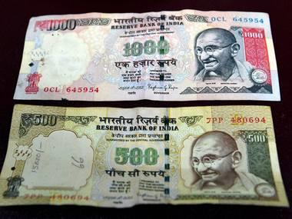
Reissue of brand new currency notes:
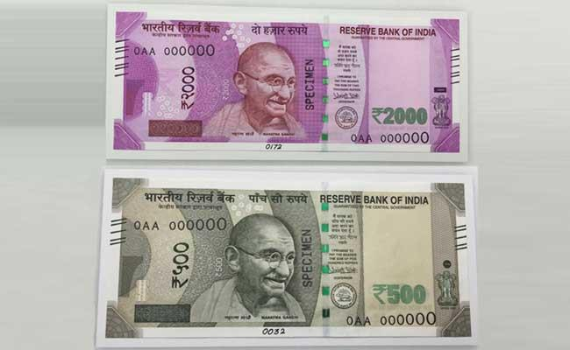
In (2018), Kalaimani and Muthulakshmi shared their thoughts on the rationale behind the demonetization of high-value currency notes. It was stated that the move was carried out to promote a more cashless economy and combat terrorism. It is also not a new phenomenon for either the world or India. Several countries have already banned the circulation of currency notes, which rendered a huge amount of money useless. India had also experienced demonetization twice before. In 1946, Rs 1000, Rs 5000, and Rs 10000 notes were withdrawn from the country's financial system. The country's central bank also demonetized high-value currency notes. In 1948, the government demonetized Rs 5000, Rs 10,000, and Rs 1000 notes. In 2016, the Authorities fixed to demonetize the notes of Rs 500 and Rs 1000. During the early stages of the demonetization, over 86% of the country's cash supply came from the notes. In (2016, Singh and Singh) noted that India has the highest number of circulating currencies in the world. These notes contribute over 12.1% of the country's GDP. According to a study conducted by Singh and Singh, a considerable portion of India's house cash is not reported to the authorities. This has led to the rise of corruption. The scrapping of high-value currency notes led to people hoarding the money at the right time and causing it to be devalued. In (2017), Uke examined the effects of India's demonetization on the country's economy. He focused on whether it was a threat or a boon. It was revealed that although the country's citizens faced various challenges, such as the inconvenience of carrying out transactions, the currency exchange ban was beneficial for the country's banks. The market's decline was attributed to the businesses that rely on cash transactions.

(Source: Singh, 2016)

The image above shows that the higher denomination notes have the biggest share of the country's currency. Table 1 shows the details about the banknotes' value and volume.
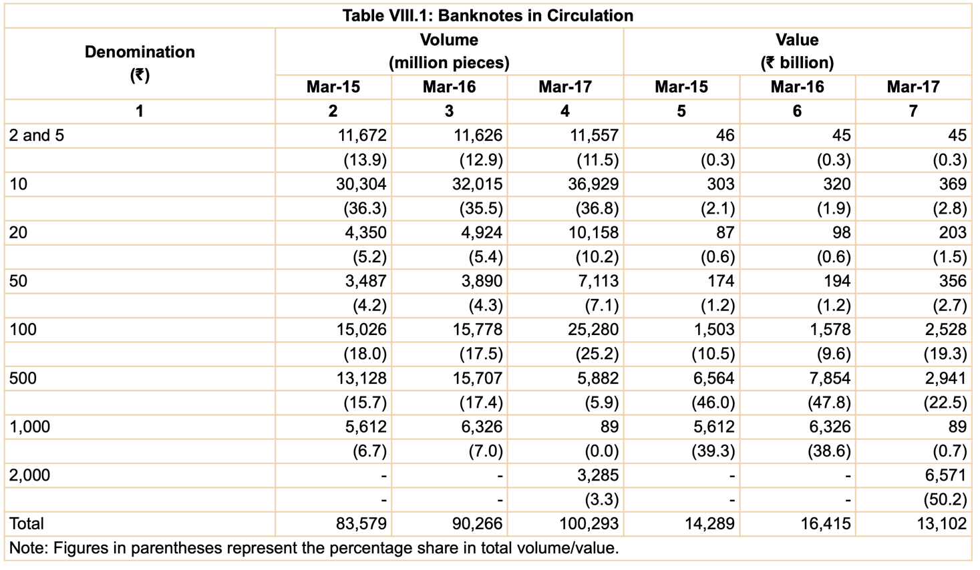

Note: The image above shows that the higher denomination notes have the biggest share of the country's currency. Table shows the details about the banknotes' value and volume
(Source: Rbi.org.in, 2018)
The table above shows the decline in the value of high-value currency notes since the government demonetized them. In 2015, almost half of the total currency notes were of Rs.500, while Rs.1000 contributed almost 38%. During March 2016, the circulation of these notes increased. By March 2017, the notes of Rs. 500 and Rs. 1000 were still in circulation. However, since the government was focused on combating the black money issue, the value of these notes had dropped to 22.5% and 0.7%, respectively. The demonetization, which was carried out in November 2016, impacted the Indian economy.
The demonetization of high-value currency notes has had various positive effects. It can help the government in tackling the issue of black money in the country. People were able to exchange old notes for new ones at the designated time. Since the period following the demonetization of high-value currency notes has ended, anyone holding these notes is considered illegal and invalid. The people have deposited the money to help the country's development. Another significant aspect of the demonetization was the country's decision to adopt the digital payment system. (Deepika et al., 2017). The demonetization drive and the push to replace cash with digital payments have resulted in the growth of the e-commerce organisation in India. Some of the prominent companies in the country that have been promoting the use of digital payments include Amazon and Flipkart. However, the citizens of the country were inconvenienced by the demonetization. One of the main drawbacks of the government's decision to demonetize high-value currency was the public inconvenience caused by the process. The people who were able to use digital transactions were the main beneficiaries of the move. However, the sudden emergence of new Rs 2000 notes and the lack of sufficient money in circulation led to a severe shortage of Rs 100. Instead of tackling corruption, some officials of public and private banks were reportedly involved in the illegal exchange of old currency notes. Although the demonetization drive affected the general public in a short term, it has also resulted in various long-term benefits for the country.

2.3 Indian Fabric organisation- Summary

In India, businesses and industries have been affected by the demonetization of high value notes. This study focuses on the domestic fabric sector. According to the reports, the country's fabric organisation is expected to grow at a rapid pace and reach an amount of about $250 billion by 2019.

Fabric and Apparel Organisation in India (US$ billion)

250
150
137

The Make in India crusade was started in 2016 to attract foreign straight forward investment. In the current financial year, the government has allocated Rs 7,148 crore to the fabric sector to develop it. The country's fabric organisation is an extensive contributor to the country's manufacturing sector. The fabric sector has an outstanding role in India's economy, as it employs over 45 million individuals and contributes 2% to the country's GDP. Apart from generating income, it is also helping in reducing the country's underemployment rate. The Indian fabric sector is characterized by its robust production base, which is mainly comprised of natural fibers such as silk, cotton, and jute. It is one of the world's leading producers of fabrics. Although the organisation was previously unorganized, the opening up of the country's economy has provided it with a much-needed boost to its growth.
There are many factors that a company needs to consider when it comes to growing and becoming profitable in India's fabric organisation. According to the Ministry of Fabrics, the sector contributed 14% to the country's total industrial output in 2017. It is also expected that the organisation will reach a value of over $200 billion by 2021. The organisation is also planning on increasing its workforce by about two-fold within the next three years. It has been estimated that for every 100,000 rupee saturated in the nation, there should be around seven jobs created.

Key points in the organisation | Details
Supply in the organisation | Despite the various factors that have contributed to the country's increasing foreign direct investment, the majority of the fabric sectors are still not able to meet the demand. (source : ministry of fabrics )
Demand in the organisation | The demand for premium and branded products has increased significantly in the country. This is due to the rising per capita income.
Barricade to entrance in the organisation | The use of advanced technology is required for the fabric sector to operate successfully. It also requires skilled and unskilled workers. The entry barriers to the organisation are high due to the lack of access to both the global and domestic markets.
Negotiating capacity of the suppliers in the organisation | Due to the oversupply of raw materials in the unorganized markets, the bargaining power of the suppliers has decreased. But, the organisation is expected to benefit from the rising demand.
Negotiating capacity of the customers | The bargaining strength of the consumers of the fabric organisation varies depending on the type of product they are looking for. For instance, domestic customers have low bargaining power when it comes to premium and branded products. On the other hand, foreign buyers have a higher bargaining strength due to the presence of inexpensive sourcing locations.
Competitiveness in the Organisation | Due to the high competition in the organisation, many companies are reluctant to invest in the country. Foreign Direct Investment allows low-cost producers to sell their goods in the nation.
(Source: Fabrics, 2018)

2.4 Effect of demonetization on Indian Fabric Organisation

2.4.1 Demonetization and insistance in the Fabric Organisation
In (2017), Singh and Yadav stated that the demonetization of high-value currency had affected the demand for various legacy in the Indian market. This was especially true in the fabric sector, where the customers' decreased demands resulted in a significant decline in the overall sales. In (2016), Mohapatra mentioned in an article that compared the demonetization to the organized segments, the unorganised fabric organisation in the country had been significantly affected. This is because the bulk transactions conducted by this segment rely on cash. During the demonetization period, the demand for various fabric products, such as clothes, decreased significantly. This was due to the lack of cash and the increasing number of people who did not have sufficient money to pay for their purchases. In addition, the lower number of customers who relied on digital payments also led to a decline in the consumer spending. The demonetization was implemented during the winter season's early stages, which affected the operations of the winter wear organisation. These manufacturers and retailers are mainly concentrated on the domestic market.
According to a study conducted by Neelam (2017), the lack of liquidity has affected the fabric organisation, as it has restricted the buyers' ability to purchase clothes. In 2016, Sagar also noted that the customers' demand had been affected by the existence of a type of currency offered by the traders. Many traders were inclined to continue operating in the old currency notes, even though these were not accepted by the companies. In 2018, a study by Gulati revealed that even though the new Rs.500 and Rs.2000 notes were introduced, India was still stagging due to the demonetization. Similar to the study conducted by Mohapatra in (2016), Gulati (2018) noted that the demonetization has affected the demand for fabrics in the unorganised sector. She also stated that the unorganized segment was under increasing pressure to comply with the new digital laws. The study also revealed that the demonetization had affected the other end products of the fabric organisation, which included the various components of the value chain. Due to the lower disposable income and the reduction in the demand, the companies started to accumulate their stocks. This resulted in the retailers and manufacturers delaying the purchase of goods.
In (2018), Waghmare reported that the demonetization of high-value currency had affected Mumbai's fabric market. Since November, the city's businesses have seen a decline of around 20%. This was mainly due to the lack of demand during the wedding season and winter. During the initial few note ban days, businesses were experiencing a complete lack of business. In terms of the demand for luxury goods, the drop in sales was much greater than that of low-end products. People started to prioritize plain and simple clothes over expensive ones. According to the merchants, the machines used for manufacturing clothes were not as affected by the demonetization. However, the manual work related to the production of the clothes, such as putting buttons and zipper closures on them, was severely affected due to the lack of funds for the wages. During the financial times, the sudden reduction in consumer spending was one of the factors that affected the fabric organisation. According to a study conducted by Kumar and Bumra in (2017), the demonetization had a positive impact on the fabric organisation by reducing the demand for goods. It also led to an increase in labor turnover. Most of the brands and retailers reported a drop-in sales of around 40% to 60% following the implementation of the measure. Although the demand for clothes increased during the first few weeks following the demonetization, it was not as robust as the drop. According to Raj in (2017), the impact of the measure was felt for about three to four months.

2.4.2 Demonetization and cash flow in the Fabric Organisation
As per the study conducted by Mohapatra in (2016), the reduction in the flow of foreign currency had a notable effect on the daily transactions in the fabric sector. It has been observed that since cash transactions are the main method of business in the country's fabric organisation, the currency circulation shift reduced the volume of transactions. The rise in the inventory and the subsequent decline in the apparel demand also resulted in stretched and delayed payments, which impacted the cash flow of the sector. (The Financial Express:2018). In the section, we had talked about how the demonetization affected the fabric organisation. Apart from affecting the demand, it also slowed down the people's disposable income, which in turn decreased their purchasing power. A study conducted by the economist Ghosal (2016), revealed that the increasing number of delayed and stretched payments had a negative effect on the overall demand chain of the fabric organisation. He noted that the decline in the apparel demand and the increase in the number of retailers and manufacturers postponing their purchases had affected the supply chain. The demonetization of high-value currency notes has had a significant effect on the daily transactions in the unorganized sectors. Most of these transactions are carried out through cash transactions. The reduction in the circulation of cash has caused the business transactions to temporarily stop. It was also observed that the players in the fabric organisation were looking into ways to address the cash crunch that they were experiencing. The lack of cash and demands caused the sales at shops to fall. In addition, due to the overstocks within the fabric sector's value chains, companies were unable to collect outstanding receivables. This caused the cash flow of the sector to be severely affected. (Fibre2fashion.com, 2018).
In his study entitled “Demonetization's Impact on the Flow of Cash,” Preuss (2018), noted that the measure led to a reduction of the cash flow, and it also caused potential customers not to go to the stores. According to the author, the lack of cash prevented people from making purchases, and they had to queue up in order to acquire the money needed to purchase various essential items. The demonetization of high-value currency led to a strange belief that buying non-essential items, such as clothes, is a waste of money. Although urban consumers were still able to use their debit or credit cards to make purchases online, the majority of transactions were still carried out using cash on demand. An article appeared in the Indian Express by ANI (2016) about the situation of the Mathura sari organisation, which noted that the factory owners had no other option but to close their operations due to the lack of cash. The factory owners also stated that they were still waiting for the government's "Ache Din," which was promised by Prime Minister Narendra Modi.
It was reported that around 70% to 75% of power loom units were unable to operate in various fabric sectors due to the cash transactions being carried out in them. Moreover, manufacturers and traders were hoarding stocks across different value chains. The lack of cash has caused companies to not be able to collect the orders they received. This was mainly due to the liquidity issues. According to a 2018 study by Fabric excellence, around 70% of the workforce received their weekly pay in the form of cash. Due to the demonetization, many companies were unable to pay their workers. Even those who made advance payments were required to allow their employees to use the bank's cash counters for transactions. The scrapping of high-value currency notes has affected the informal sector of the fabric organisation. It used to be that payments were made in cash or through bearer cheques. Due to the restrictions, the manufacturers could not purchase raw materials or pay workers. The cash shortages and the strain on the business caused by the lack of it resulted in various unusual patterns in the fabric sector. (Indianfabricjournal.com, 2018).

2.4.3 Demonetization and Capability in Fabric Organisation

Besides affecting the cash flow, the demonetization also led to the accumulation of stocks in the companies, which impacted the production and Capability of the fabric sector. According to Mohapatra, this stockpiling affected the output of the organisation. The demonetization resulted in a drop in the export sales, which further cut down the production costs of the fabric sector. Business-standard.com reported that there were only a few units in the country that could produce enough goods to meet the demands of the customers. Some of these units also temporarily stopped their operations. The sudden demonetization had a major impact on the entire value chain of the fabric organisation. It affected the people who are directly involved in the production process. (Bizvibe, 2018).
It was suggested that due to the impact of the government's move on the fabric sector, China and Bangladesh could become significant competitors of the country within the next few months. In 2016, Sagar said that the operations of the organisation had been severely affected by the demonetization. He attributed the decline in the fabric and cloth market to the lack of raw material supplies and the government's actions. According to various organisation players, they were unable to maintain their inventories at the current level. They warned that the production would stop if the situation did not improve. Demonetization also severely affected the operations of the unorganized and organized sectors. The withdrawal of cash from the fabric sector was severely affected by the government's decision to demonetize high-value currency notes. This resulted in constraints on the organisation's ability to meet its daily requirements, which negatively impacted the production and procurement procedures. (Ph.D. Research Bureau, 2014).
Manufacturers and fabric firms immediately felt the effects of the demonetization, and other intermediaries in the chain experienced a delay in their orders and sales. It is believed that both the unorganized and organized yarn and fabric sectors were adversely affected by the measure. Around 30% to 40% of the business transactions and stock accumulations in the supply chain were impacted. The manufacturing organisation has been severely affected due to the capital blockage and slower demand. (Indianfabricjournal.com, 2018).

2.4.4 Demonetization and digitisation in the fabric organisation
The goal of demonetization was to encourage people in India to adopt digital payment methods in order to establish a more cashless economy. Although the demonetization did not stimulate the country's economy, it has led to the current economic transition, according to a study conducted by a research firm in 2017. The study noted that the move benefited the fabric organisation as it increased industrialization and consumption of fabrics. On the other hand, the organized fabric organisation was more positive about the implementation of the new transaction system as it improved the transparency of the trade. Nevertheless, the heightened cash scarcity has exerted a notable influence on the procurement of fabrics and other essential raw materials, particularly fabric.
To deal with the effects of the demonetization, the fabric sector has launched a drive to digitize its operations. This process has been carried out in response to the cash crunch and the recession felt by the customers and the traders. To ensure that all employees have bank accounts, the sector has installed machines at various processing units. (Yarns and fibers.com, 2018). In 2017, Neelam noted that the demonetization move could have affected the fabric organisation in the country. But, it was also beneficial for the country's efforts to address the issue of black money. It paved the way for the establishment of a Digital India, which would allow people to make payments across the nation. In (2017), Khan and Ahmad stated that the decision to demonetize high-value currency was the right step toward establishing a cashless economy. Transactions involving digital and electronic mediums have been carried out since the cash flow has ceased.
It has been argued that the government's decision to demonetize has been beneficial for the country's development as it allows for the creation of a more cashless economy. However, some people are concerned about the potential impact of this move on the digitization of the financial sector. In 2016, the government's decision to demonetize high-value currency notes led to millions of people lining up at banks and ATMs. It also aligned with the government's digital push. Around 15% of the country's total consumer spending was attributed to digital payments. With the government's initiative, the number of people who are expected to spend money in the country through digital means is expected to increase significantly. According to Business Today, the government is expecting the cash-strapped consumers to start using digital payment methods. The decision to demonetize high-value currency notes has been beneficial for the country's development. It has been argued that it allowed for the creation of a more cashless economy.

2.5 Output and performance of the fabric organisation both before and after the government decided to demonetize high-value banknotes.

The researcher has looked into the fabric sector's performance before and after the country demonetization. This section analyzed the organisation's performance from 2015 to 2016. In the previous section, we had looked into the effects of the demonetization on different aspects of the organisation. This section also analyzed the organisation's performance from 2016-2017 and 2017-2018.
As indicated by the authors, the researcher has looked into the export trend of the sector. It has been suggested that the demand and production of fabrics are going down.

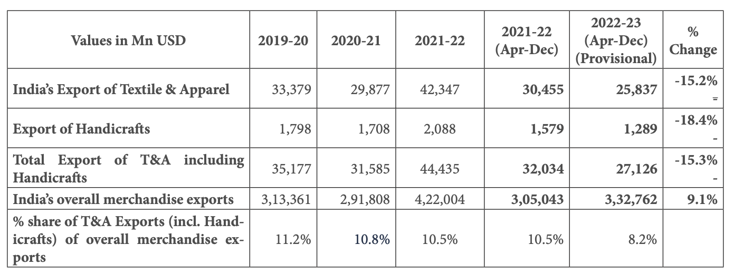
(Source : Ministry of fabrics, 2022)
The table above shows the country's fabric export percentage from the period of 2019-2023. It shows that the percentage went up to -18.4% during that period. However, during the next year, the export figure dropped to -15.3%. The government's announcement in November that it would no longer accept high-value notes has affected the fabric sector 2017 has affected the operations of the fabric businesses, the export of fabrics has dropped by almost 3.1%. Despite the overall improvement in the country's export performance, the drop in the fabric export rate has been attributed to the cash crunch.
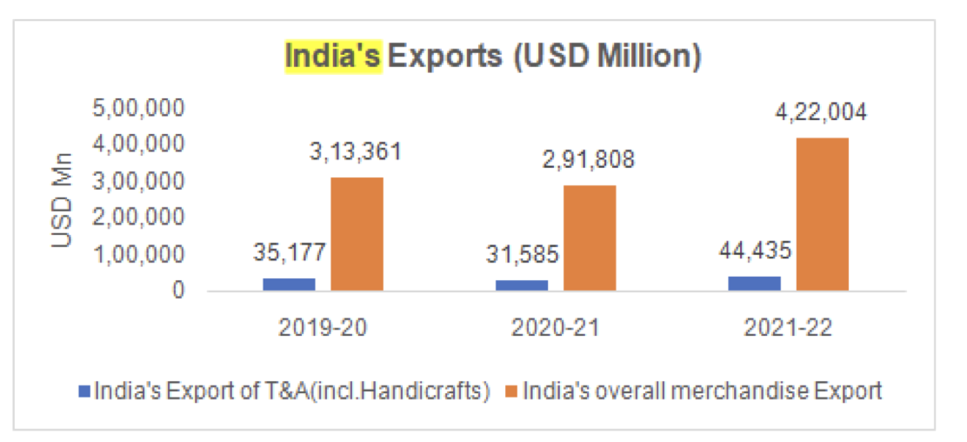
(Source: Ministry of fabrics, 2022)
The export figures for the years 2019 and 2022 can be viewed monthly through the chart above. We will focus on November 2017 since the demonetization started. In the previous month, the export was only 3.1% in 2019 but it increased to 4.2% in the succeeding year. The export capabilities of companies have significantly improved following the implementation of the demonetization. This can be attributed to the increasing focus on digitization in the organisation.
The data presented below includes information about the turnover, Capability, and capacity utilization of the Indian fabrics organisation.
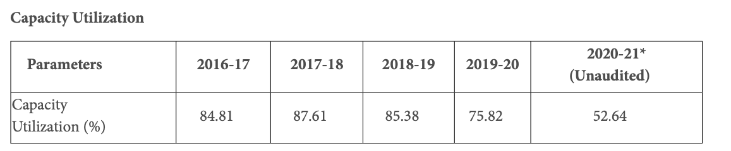
(Source: Ministry of fabrics, 2021)

The term capacity utilization refers to the utilization of the productive resources of a company for the generation of goods and services. It can be shown from the table above that during the period 2016-2017, the organisation's capacity utilisation was at 84.81%, while it was at 87.61% in the year 2017-2018. The capacity utilization of the organisation during the period 2018-2019 decreased to 85.38%. In addition, it was observed that during 2017, the organisation performed the highest level of utilization, which was almost four months after the government demonetization. It is believed that the lower figure was caused by the impact of the demonetization on the organisation during the first quarter of the year.
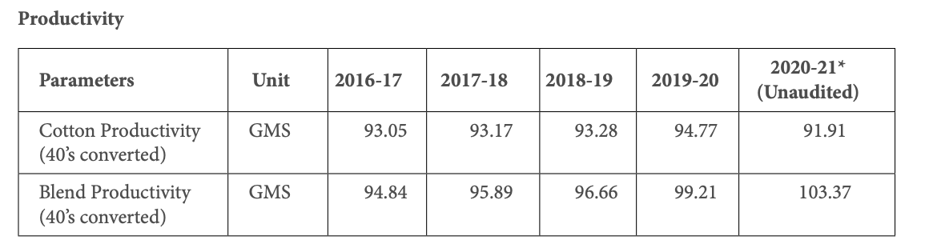
(Source: Ministry of fabrics, 2021)
The Capability of an organisation is evaluated by taking into account the inputs that are used to produce the output. The table below shows the cotton organisation's Capability from 2016-2017 to 2019-2020. It shows that in 2016-2017, it was 94.84, and in 2019-2020, it was 99.21. But, in 2020-2021, it went up to 103.37%.The graph shows that the blend organisation's Capability increased during the 2019-2020 following the demonetization. It's believed that the demonetization didn't significantly affect the organisation's Capability.

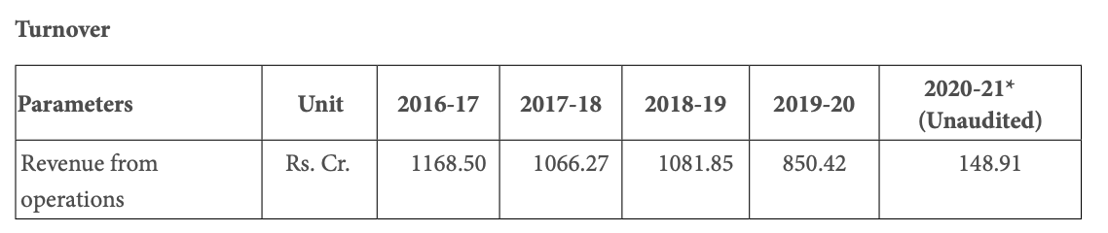
(Source: Ministry of fabrics, 2021)
The table below shows the turnover of the cotton organisation from 2016-2020. It shows that during that period, the organisation's turnover was at about Rs.1168.50 crore. However, in 2019-2020, it decreased to Rs.850.42 crore. It is believed that the organisation's turnover took a hit due to the government decided to invalidate old currency notes of Rs.1,000 and Rs.500 denominations. During the period between 2017, the turnover of the organisation was around Rs.1168.50 crore, which is significantly lower than the future year's figure.

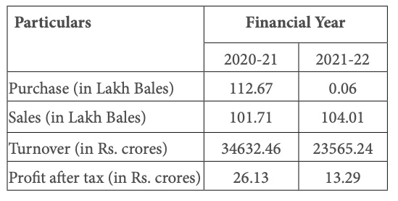
(Source: Ministry of fabrics, 2022)

The chart presented above is a comparison of the export and domestic sales of the organisation during the period 2020 to 2022. It takes into account the year before and after the demonetization. During this period, the domestic sales of the organisation were at Rs.104.01, which is lower than the previous year. The turnover of the Lakh Bales organisation decreased to Rs. 235665.24 crore in 2021-2022, considering the period when the government demonetization was carried out. In the previous year, the turnover had been reported at Rs.34632.46 crore. The profits earned by the organisation also went high.

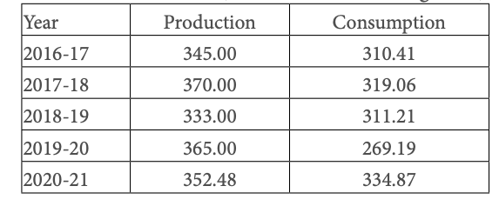
(Source: Ministry of fabrics, 2021)
The production of cotton has increased in 2017 to 2018. However, during this period, the consumption of raw materials has decreased. Since companies were not able to acquire raw materials due to the government's decision to demonetize old notes, the export of cotton also decreased. Other raw materials were being handled through cash transactions.
This study aims to analyze the impact of the government's decision on the country's fabric organisation. It has been conducted on the performance of a leading company known as Bombay Dyeing.

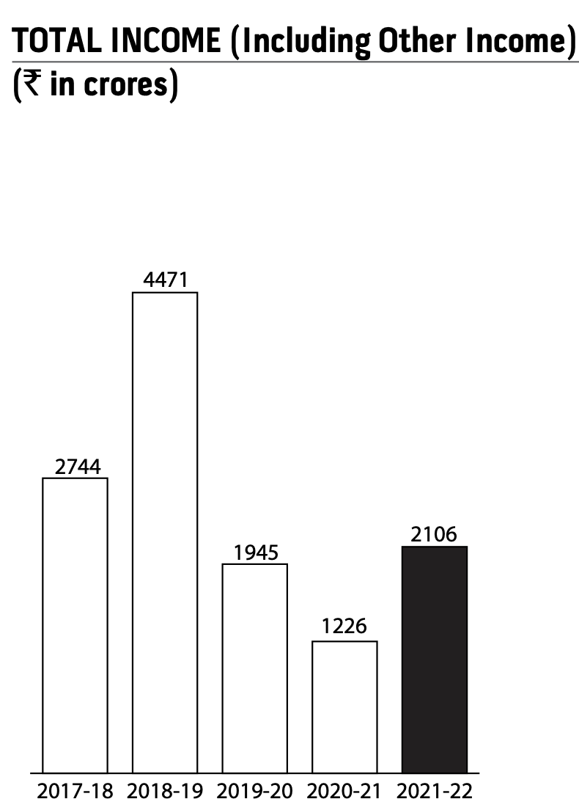
(Source: Bombay Dyeing, 2022)

The chart presented above shows that the company has balanced to maintain its revenue throughout all the year. Between 2018 and 2019, the company was able to perform well in the organisation, but its revenue started decreasing in 2020 and then in 2021. This has been a major problem for the organization, as it has consistently lost money from 2020 to 2021. And then after increased in 2021 -2022

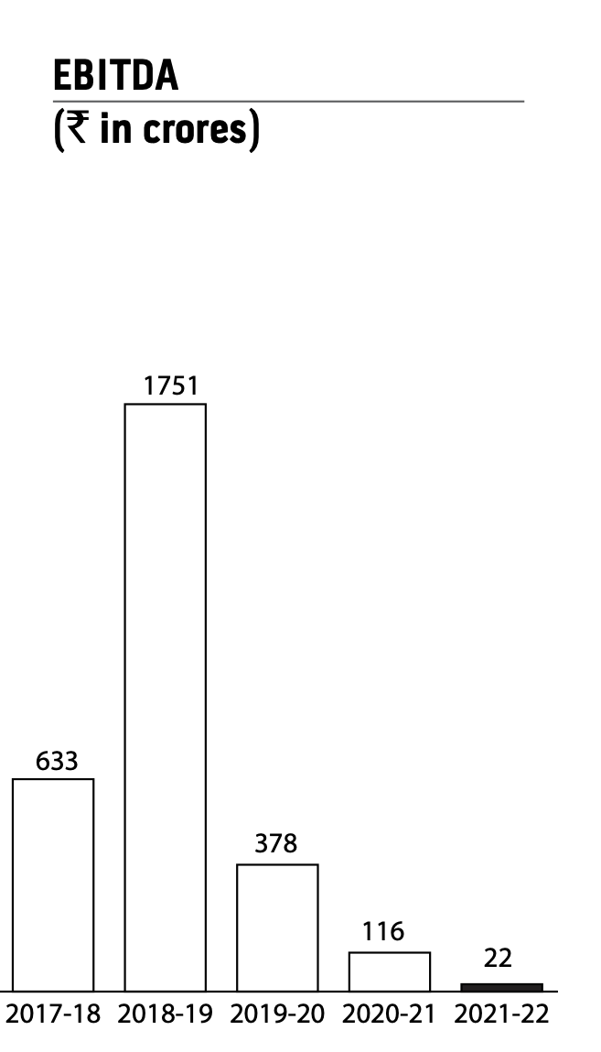
(Source: Bombay Dyeing, 2022)

The chart presented above indicates that the company has not maintained a steady level of profitability during the year. The continuous decline in the company's revenue has also affected its earnings. From 2021 to 2022, its earnings dropped to around 116Cr. In 2021-22, the company's revenue had dropped to around 22 Cr. However, during the next year, its earnings may increase or decrease. In 2021 and 2022, the company's revenue and EBITDA declined significantly. This has been a negative factor for the company's financial performance since it has continuously experienced a continuous decline in its revenue.

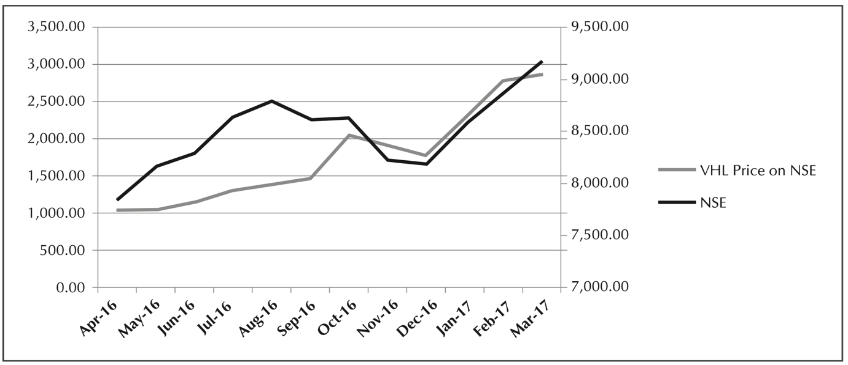
(Source: Vardhman, 2022)

The graph shows that the organization's performance significantly improved from November 16, 2016, to December 31, 2016. The decision by the Indian government to demonetize old currency notes had a major effect on the fabric sector. But, after a few months, the performance of the organization started to improve.

CHAPTER 3: Research and Methodology

3.1 Research Method
The objective of this study was to examine the impact of the Indian government's demonetization on its fabric organisation. Through a quantitative method, the researcher was able to collect data related to the organisation before and after the demonetization. A quantitative research study involves conducting an in-depth analysis of the various elements and properties of a phenomenon or a group through a systematic approach. The main goal of this type of research is to generate a hypothesis or a statistical model for the investigation. Adopting a quantitative method will allow the researcher to connect empirical observations with theoretical ones (Tripathy and Tripathy, 2017).
By utilizing the quantitative method, an individual can collect and evaluate the required information, allowing them to explore the link between independent and dependent factors. This approach can be beneficial or detrimental for certain research topics. One of the main advantages of quantitative research is its ability to provide an unbiased analysis of the data it collects. This allows the researcher to avoid misinterpretations and ensure that the information they gather is numerical. In addition, it allows them to examine the data's attributes using statistical techniques. The data collected through the quantitative method can be analysed and applied to the intended population in a quick and efficient manner. But, this method requires the data to be gathered from a large sample to arrive at statistically accurate results (HRFnd, 2018).

3.2 Research Design
In (2004), Sutton and David explained that a research design provides a framework for the researcher to follow through the various steps involved in the project. It also enables him or her to collect all the required evidences to come out with a definitive solution to the questions. The design of a research study is not related to the type of research that will be conducted or the data collection process that will be used. In principle, it can utilize any type of research technique (De Vaus, 2006). It has also been argued that a research design helps minimize the chances of data being mis-interpreted or incorrect.
The goal of this study is to adopt the exploratory approach. This type of research design aims to identify the most critical questions that need to be answered in order to improve the quality of our knowledge. In addition to being able to uncover the phenomenon itself, the exploratory approach also aims to provide a deeper understanding of its various aspects. Although previous studies on demonetization have been conducted, the scope of this research has not been fully examined from India's perspective (Sim and Wright, 2002). The advantages of an exploratory research approach are its ability to reduce the costs, generate quick results, and be implemented easily (Hedrick, Bickman and Rog, 1994). The strength of an exploratory approach lies in its ability to help the researcher improve their knowledge. Unfortunately, this type of research design also has a weakness, which is its ability to generate judgemental results. This is because the limited number of sample sizes can prevent the study's applicability. Therefore, in this study, a justified sample size has been used (Hedrick, Bickman and Rog, 1994).

3.3 Research Strategy and approach.
The research strategy is generally defined as a plan that describes the structure and ideal outcomes of a research problem. It also provides the necessary steps to carry out the study. This strategy is part of the overall development plan for the study (Singh, 2004) The researcher decided to use the mixed approach for this study, as it allowed them to collect various types data. This strategy was mainly adopted because the researcher planned to use more than one research method (Bergman, 2009). Through the use of mixed research approach, the researcher can offset the weaknesses that were presented by using different methods. This strategy has allowed them to gain a deeper understanding of the issue. The adoption of this approach has also aligned with the choice of quantitative methods for the study.
In (2017), Creswell and colleagues defined the research approach as the plan and procedures for carrying out the study, which reflects broad assumptions about the data collection, interpretation, and analysis methods. It is important for researchers to identify the appropriate approach to take in the study. The two main methods for conducting studies are the inductive and deductive approaches. For this study, the researcher chose the latter. Deductive means that the researcher employs a theory to formulate a hypothesis or proposition, and then creates a research framework that tests these propositions. According to Collins in (2010), deductive methods are strong because they can ensure that a researcher is not influenced by the issues that are being studied. This ensures that both the researcher and the study remain objective. The appropriate sample size is also important to ensure that the data collected is interpreted and applied to the population in a deductive manner.

3.4 Data collection
The gathering of data is a systematic process that involves gathering and analyzing the information related to a set of variables. This helps in developing effective solutions to scientific problems (Saha and Agarwal, 2018). According to Musenge (2014), the process of gathering data involves both field work and desk work. While the latter requires the researcher to use the internet for most of the work, the former requires interaction with the individuals who are involved in the study. According to Payne, in (2005), a successful research should consider utilizing the secondary data to emphasize the emphasis placed on the primary information that links the subject to its specific location. This is accomplished through the collection of secondary data and primary information.

3.5 Secondary data Collection
The secondary data collected is the information that was gathered for other purposes apart from the main research (Gillespie and Hennessey, 2016). The advantages of having secondary data are numerous, such as their economical value and usefulness in reducing the time and cost of conducting research. Unfortunately, they are often underutilized and can lead to errors due to how the data was gathered. Also, the relevance of the collected information is questionable. Although the cost of collecting secondary data is generally better than the cost of obtaining primary information, some of the sources or reports that are used for the study may require a lot of money to access. Also, the scope of the data collected is different depending on the reason for its inclusion. However, the main advantage of having secondary data is that it can be utilized for solving a research issue without the need for the main data BPP Learning Media, (2012). The secondary data collected for this study came from various sources such as books, journals, internet sources, and organisation reports.

3.6 Research Framework
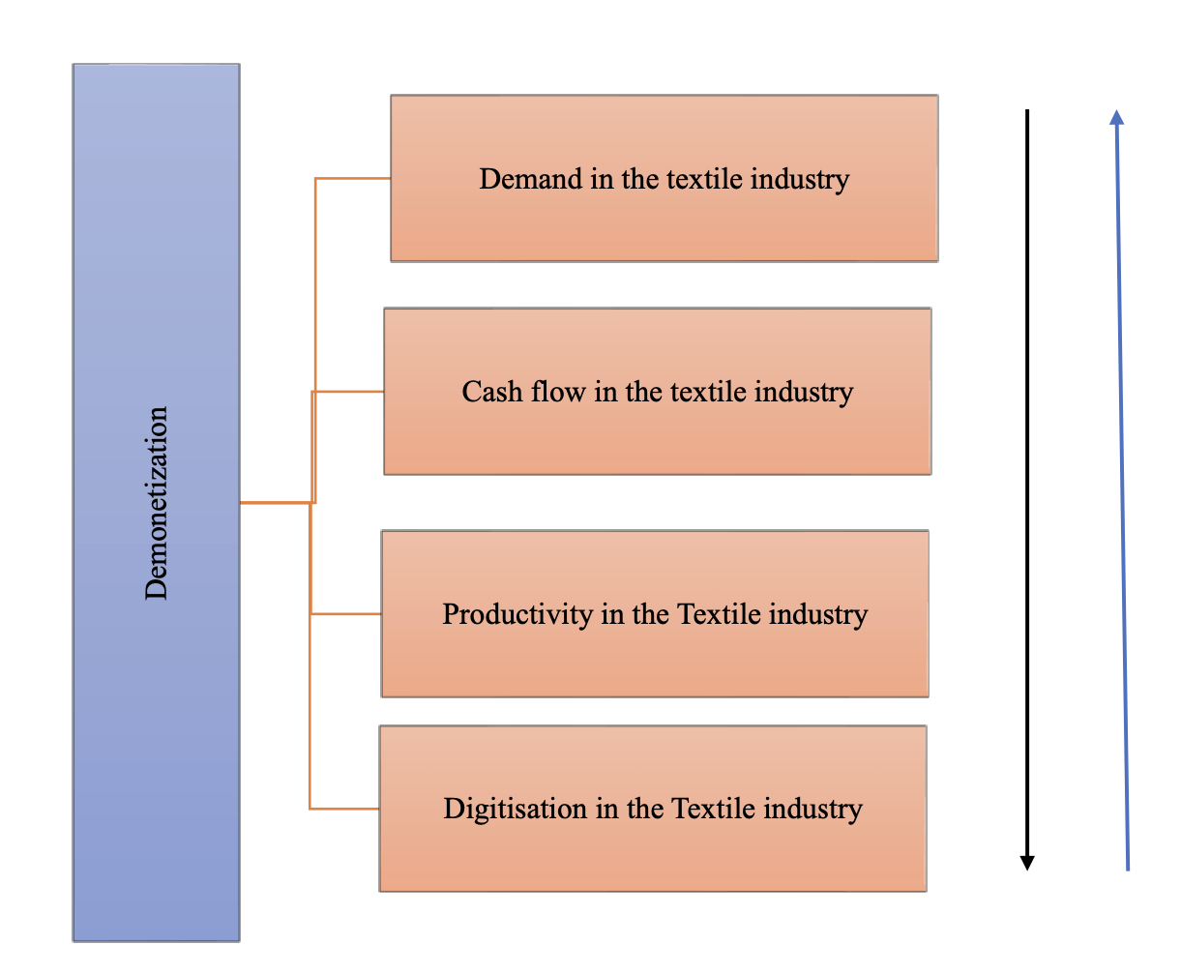

3.7 Limitations of the research
The data collected for this study came from a sample population, which means that any limitations may be attached to it. The researcher tried to collect secondary information from various sources, but there is a lack of academic research about how the demonetization affected the Indian fabric sector.
Although the theoretical data presented by the researcher helped in gaining a deeper understanding of the subject, the secondary information was linked to the sources, and there was scope for it to be vague or outdated.
The study looked into the Indian government's decision to demonetize the fabric sector, which they claimed would help build the organisation. But, instead of focusing solely on it, the research was also conducted on the people who work in the organisation. Through this perspective, the researcher was able to gain a deeper understanding of how the demonetization impacted the sector.

CHAPTER 4: Discussion

4.1 Introduction
The goal of this study was to analyze the impact of India's demonetization on its fabric organisation. It was conducted due to the country's recent economic downfall, which has been widely talked about but has also been criticized for its negative effects. As a result, I decided to focus on this issue. My academic journey has been full of life-changing experiences and learning opportunities. Through this study, I was able to gain a deeper understanding of the issue that has affected various economies around the world. In addition to learning about different economic concepts, I was also able to observe how governments can affect the growth of the country's economy. As I mentioned earlier, India has been experiencing remarkable growth rates, with the country becoming an international center of commerce and business. The rise of foreign direct investment (FDI) has also increased the country's growth potential. The country's rapid growth was stopped by the government's decision to demonetize high-value currency notes. Although experts believed that this measure was aimed at curbing the rising cases of corruption and money laundering, the government claimed that it was also beneficial for the country's economy by promoting a cash-less system.
On November 8, 2016, the Indian Government decided to demonetize high-value currency notes. These notes were withdrawn immediately, except for certain special circumstances. This term paper considers these notes completely withdrawn. By December 30, new notes were supposed to have been deposited in banks. But, restrictions were placed regarding how much money one could withdraw and deposit. In the financial language, cash deposits and money withdrawals were restricted. In essence, cash is a type of currency that has various features. Since the notes were no longer legal tender, they no longer function as a storage of value or a unit of exchange. Demonetization led to a cash-based crisis as 86% of the total currency in circulation was lost. This paper does not discuss the long-term benefits of the move. The objective of this paper is to analyze the impact of demonetisation on the business world. It also explores the various effects of this policy on the stakeholders and a large scale organisation. In a broad sense, the policy affected the liquidity of a company. The ultimate goal of a company is to maximize the wealth of its shareholders. Through concepts like managerial accounting and finance management, we try to understand how this policy affects the company. Before going into that analysis, we need to first establish a basic understanding of the cash structure of Indian economy. This will allow us to link the various aspects of the company's operations and the policy's impact.
Although the term money doesn't have a standard definition, it is commonly used as a form of payment. It can be used in various ways, such as to exchange and monetize. Demonetization, on the other hand, is the withdrawal of money from circulation, which invalidates it in transactions. Tosh explains that demonetization is a process that prevents people from using cryptocurrencies in any way. It aims to remove money from the market. This can be done by taking the legal tender's status away from it. Another aspect of this process is the conversion of old money into a new currency. Demonetization refers to introducing new currency units. In this process, old money is withdrawn completely and replaced with new goods. The demonetization is the procedure in which old currency is brought back.
The government's decision to demonetize high-value banknotes has been commended. It has helped the administration in its efforts to combat the issue of illicit financial transactions in the nation. People were permitted to exchange their old notes at designated times. However, since the period following this action has come to an end, those holding these notes are considered invalid and illegal. Depositing the money has helped the country's development. Another important aspect of the government's decision to demonetize was its implementation of a digital payment system. This has led to the emergence of e-commerce businesses in the country. Many companies in the country, such as Flipkart and Amazon, have been promoting the benefits of using digital payments. Unfortunately, the people of the nation were inconvenienced when the government demonetized high-value banknotes. Individuals who used digital money were the main beneficiaries. However, due to the sudden introduction of new banknotes, which were not sufficient to meet the needs of the people, a shortage of Rs 100 became a common issue. Instead of addressing the issue of corruption, some private and public bank officials reportedly participated in illegal transactions. Although it affected the general population in a short time, the demonetization drive has also resulted in numerous long-term benefits.
Demonetization was carried out in India to encourage people to adopt digital payments in order to establish a cashless economy. Though it didn't work immediately, it has been regarded as a turning point for the nation's economic development. In 2017, a study revealed that the fabric sector had mixed reactions to the move. The study noted that the rapid industrialization and the increasing use of engineered fabrics had affected the organisation. However, it was also beneficial for the organized fabric sector as it allowed for more transparent transactions. The sudden rise in the cash crunch caused by the government's decision affected the purchase of fabrics and raw materials. To address the situation, several factories closed, which prompted the fabric organisation to launch a digital campaign to maintain its operations. The campaign was initiated to help the traders and customers cope with the cash crunch and the recession. To address the issue, the various processing facilities of the organisation began implementing machines that allow their employees to swipe their bank cards. In 2017, Khan and Ahmed noted that Demonetization had been beneficial for the country's move toward becoming a more digital economy. Transactions have been conducted through electronic means or digital means following the cessation of cash flow.
In India, a significant portion of the fabric organisation, which is mostly unorganized and small businesses, relied on cash transactions for raw material procurement and labor payments. Demonetization led to a cash shortage, which severely disrupted daily operations. . The cash shortages affected the operations of various fabric companies. They were unable to pay their employees, causing temporary labor shortages. The implementation of the country's demonetization program accelerated the digital payment methods' adoption. This resulted in increased transparency in the transactions. In July 2017, the government introduced the Goods and Services tax (GST), which further reinforced this trend. The rise of the formalization of the financial services organisation has resulted in better compliance with the tax laws. It also decreased the scope for evasion and unreported earnings After the government demonetized high-value currency notes, there was an immediate dip in the demand for fabrics. This was mainly due to the uncertainty regarding the new notes' value and the restrictions on withdrawals. Demand for fabrics started to recover as consumer confidence and the cash situation improved. But at a slower pace
The Indian rupee's depreciation following the demonetization of the currency provided a competitive advantage to the country's fabrics exports. This trend could also boost the export-oriented sectors of the organisation. Nevertheless, the export of fabrics faced various challenges due to the global trade environment. These include the implementation of new trade policies and the uncertainty of the global economy Short-term job losses were reported in certain sectors of the fabric organisation due to cash constraints and production slowdowns. But, these losses were offset by the formalization and modernization of the organisation, which increased Capability
In response to the changes brought about by the post-demonetization era, various fabric companies started investing in automation and technology to improve their efficiency. The supply chain of the fabric organisation underwent considerable change, with emphasis placed on improving quality, streamlined processes, and increasing value addition Demonetization had a major effect on the Indian fabric sector, as it led to short-term disruptions and shifts in consumer demands. The organisation eventually adapted to these changes and managed to maintain its production and efficiency. These impacts highlight the intricate nature of Indian economic policies. Some segments of the organisation, such as those that have experienced temporary difficulties, have also benefited from supply chain and efficiency reforms.
The report looks into the effects of India's November 2016 demonetization on the country's fabric organisation, which is a vital part of the nation's economy. Demonetization, which was carried out as part of a bold economic reform, affected various sectors. Among these is the fabric sector, which witnessed a significant decline in Capability and cash flow. The report takes a look at the changes in detail, utilizing different sources to produce a comprehensive evaluation. One of the most important industries in the nation, the fabric sector employs millions of individuals and plays a vital role in the country's export organisation. In November 2016, India's government demonetized high-value currency notes in an effort to fight corruption and black money. But, the fabric organisation, which mainly comprises small and medium-sized enterprises (SMEs), faced various challenges as it tried to adapt to the new economic conditions.
The sudden withdrawal of high-value banknotes caused financial problems for the fabric sector. Due to the lack of liquidity, many small and medium-sized enterprises (SMEs) were unable to pay their workers and purchase raw materials To address the liquidity issues, many fabric firms shifted their operations to digital payment methods. These include mobile wallets, online banking and Unified Payment Interface (UPI). These methods provided transparency and helped reduce their reliance on physical currency (Sharma, R. 2018).In response to the financial problems faced by the fabric sector, the government of India launched various programs and incentives. Some of these included reducing the Goods and Services Tax (GST) rates and providing financial support. (Ministry of Fabrics, Government of India. 2019).

The demonetization of the country's fabric organisation led to a decline in its Capability. This was caused by various factors such as the disruption of the supply chain and the reduction in consumer spending (Das, S. (2017).In order to boost competitiveness and improve Capability, many fabric companies started investing in modern machinery. They then adopted automation in their production processes . The demonetization drive provided the fabric sector with export opportunities. It made it easier for companies to conduct international trade due to the digital transactions From 2016 to 2022, the Indian fabric sector experienced considerable changes in Capability and cash flow. Although demonetisation halted cash flows, it triggered the adoption of electronic payment methods. The short-term decline in Capability was compensated by companies' efforts to adopt new export opportunities and technology. The rapid emergence and evolution of the digital fabric ecosystem is expected to drive the organisation's growth and resilience. Besides government support, various export-oriented strategies and technological upgrades are also expected to help the sector.
Most of the fabric workers in clusters across the country are paid in cash. They do not have bank accounts, and most of them are migrant workers. Due to the cash-crunch situation in the organisation, many companies are unable to pay their employees. Those who were able to get their salaries earlier by extending their advance payments had to queue up in front of banks to exchange old notes. The cash-crunch situation has severely affected the Capability and production of the fabric organisation. It has also resulted in the laying off of many workers.
Due to the slump in the demand, many companies decided to hold their inventories for a longer time. It could take them up to three to six months to see a recovery. Due to the slow recovery of the cotton season and the lack of working capital, the fabric organisation has been severely affected by the cash-crunch situation. The International Fabric Federation (ITF) has requested banks to consider providing additional working capital support to the organisation. It has also requested that these facilities be granted for a period of six to nine months.
The liquidity crunch in the fabric sector has resulted in a shortage of workers and a significant number of companies having insufficient funds to pay their employees. Most of the time, the wages of the workers are paid in cash. Many migrant workers have started moving out of the country's biggest man-made fabric manufacturing sector due to the liquidity crisis. Due to the sudden reduction in production, many processing units have stopped operating.
The major demands of the fabric mills are the availability of funds to pay the workers and the establishment of bank accounts for the employees. The larger companies have started opening these accounts for the benefit of the workers, but the weavers and yarn agents in the northern states are not ready to support the mills' operations. The situation in the weaving centres has affected the operations of the mills. Due to the lack of funds, the ginners are not able to pay the farmers in cash. This has resulted in the farmers not bringing cotton into the market. The sales and raw material front are under pressure. A spokesperson for the Confederation of Indian Organisation said that the government should consider ways to help businesses affected by the cash-crunch situation. In some clusters, the movement of goods and services has been affected due to the demonetisation. Most of the mills are only buying cotton to meet their immediate needs.
It is believed that the large companies with strong financial backing were not adversely affected by the demonetization, while the smaller firms had witnessed a decrease in their demands. The demonetization measure has been widely reported in the unorganised segment of the fabric organisation. In 2016, a study conducted by Mohapatra examined the effects of the demonetization measure on the organized and unorganized sectors. The study revealed that the demonetization had a significant impact on the demand for fabrics. The findings support the argument made by Singh and Yadav in 2017, where they stated that the demonetization had affected the fabric sector at various levels. Another factor that has been identified as a contributing factor to the reduction in demand is the cash crunch that the market is experiencing. The study also linked the demonetization measure to the reduction in the demand for fabrics in the unorganized sector. It noted that the decrease in the demand for fabrics was most apparent in the domestic market. The arguments presented by these researchers are in line with those made by other researchers such as Sagar, Mohapatra, and Gulati. One of the main findings of the study revealed that the lack of supply in the market affected the operations of cash-based businesses in the Indian fabrics sector. Despite the various steps that the companies have taken to comply with the regulations, it is still believed that the lack of money in the market has a significant impact on the demand for fabrics. The objective of this study is to analyze the effects of the demonetization measure on the demand for fabrics in the country.

According to the findings, the lack of demand for the product led to a reduction in the market's currency circulation. This issue was also highlighted by Mohapatra in 2016. As a result, there was an accumulation of inventory in the market. The cash crunch has led to the closure of several small businesses and the inability of companies to dispose of their inventories, which has hindered their production capacity. According to a study conducted by Bizvibe in 2018, the decline in the demand for the products has affected the Capability of the fabric organisation .The study found that the decline in the demand for the products and the reduction in the market's currency circulation led to an accumulation of inventory, which has affected the fabric firms' production capacities. This finding is supported by the argument of Mohapatra in 2016, who claimed that a connection exists between Capability and cash flow in the fabric sector. Besides the companies, it was also highlighted that the demonetization affected the Capability and cash flow of the various sectors of the organisation. The cash flow of the manufacturing companies and the farmers directly related to the organisation was severely impacted by the measure. The reduction in the flow of cash has led to companies not compensating their employees, which has affected their Capability. This issue was raised by Ghosal in 2016. His analysis supports the notion that the demonetization affected the value chain of businesses. The demonetization also affected the people involved in the manufacturing process, as well as the entire value chain.
This focused on the positive effects of the demonetization process on the Indian fabrics organisation. While the large companies were already using the digital payment gateways, the unorganised segments were also forced to adopt them. This has led to a decrease in the potential corruption, as all the transactions are now recorded and there is a low margin for fraud. The findings support the arguments made by researchers such as Khan and Ahmad, who claim that although demonetization paralyzed the Indian fabric and economic sectors, it also encouraged people to adopt digital solutions to create a more secure and accountable economy. The study noted that although the demonetization process may have caused people to face issues with cash, it has also led to more digital transactions.
This reinforced the positive effects of the demonetization of high-value notes on the fabric sector. While the unorganized segment had to adopt digital payment methods, this had reduced the likelihood of corruption since all the transactions were documented and there was a minimal chance of fraud. The research supports the claims made by researchers such as Neelam (2017) and Ahmad and Khan (2017), who claim that although the demonetization deeply affected the Indian fabric and economy, it also encouraged individuals to become more digital and contribute towards the creation of a more secure and accountable financial framework. According to the study, the demonetization of old notes may have caused people to face hardships in terms of obtaining cash, resulting in a rise in digital payments.
It is important for them to understand the government's intention behind demonetization. Digitization is beneficial for the organisation as it allows companies to conduct transactions online and through payment gateways. The government's decision to demonetize high-value currency notes won't have a major impact on the operations of the fabric companies and their customers. Since digital payment gateways are becoming more prevalent in the country, the use of such platforms will continue to be beneficial.
This aims to promote transparency and accountability in the way that companies and consumers conduct transactions. Companies should encourage their customers to use digital payment methods instead of cash transactions. Doing so helps in the development of a digital economy. Since there are both unorganised and organized segments in the Indian fabric organisation, it is important that these entities make changes in their business strategies to focus on the organized segment. In addition, the companies should also participate in the export and import activities. If the government's decision to demonetize the currency has an impact on the cash flow and imports, the affected companies can benefit from their production capacities. While foreign direct investment (FDI) has been pouring into the luxury goods organisation in India, the country's fabric organisation can also benefit from the partnership of international companies.

4.2 Summary
This chapter summarizes the findings of the research, which is in line with the literature review's findings. Although there were various issues raised in the proceedings, the researchers were able to distinguish between the positive and negative impacts of the demonetizing of Rs 500 and Rs 1,000 notes on different sections of the fabric sector, customers, stakeholders, and Indian economy.

CHAPTER-5

5.1 Conclusion
The objective of this study was to analyze the impact of India's demonetization on various aspects of the fabric organisation, such as Capability, digitization, and demand. Demonetization refers to the withdrawal of the country's existing currency, which makes it legally useless for any transaction. The government of India had decided to withdraw the old Rs 500 and Rs 1,000 notes on November 8th, 2016. This caused a massive outcry in the nation, considering that businesses and citizens are affected by this move. The government stated its objective was to combat the increasing cases of corruption and encourage the country to transition to a digital economy. The study also analyzed the impact of the government's decision on the Indian fabric organisation, which is composed of both unorganized and organized groups. The organized segment was in favor of the move due to its intention to promote digitization, while the unorganised one was not so happy with it as their businesses were heavily dependent on cash transactions, and the higher value notes were devalued. The demonetization affected the way businesses were conducted in the fabric sector, as it made it difficult for wholesalers, retailers, manufacturers, and consumers to conduct transactions. Although organized groups were able to minimize the effects of the demonetization, certain unorganised entities had to close their operations.
The study also noted that the demonetization had a significant impact on individuals' disposable income. This reduced the demand for apparels, which mainly affected domestic companies operating in the market. These organizations rely on exporting to manage their business, and they have shifted their focus to the local market. The demonetization resulted in a reduction in the demand for low-end apparels, which is a major contributor to the overall decline in the fabric organisation's revenue. The immediate impact of the measure on the consumer spending habits led to a slower growth in the organisation's overall demand. It was also observed that the cash flow from the fabric sector had a significant impact due to the currency circulation changes. The decline in the demand for goods led to a reduction in the cash flow of the fabric sector. Due to the demonetization, the factories could not purchase raw materials, pay workers, or build up stocks for the upcoming sales, which affected their Capability and production. The increase in the accumulation of stocks due to the reduction in cash flow and the decrease in demand has affected the production capacities of companies. The demonetizing also impacted the entire value chain, as it affected the individuals involved in the manufacturing process. Despite the negative effects of the measure, the Indian fabric organisation is expected to see a positive impact on the adoption of digital payment procedures and digitization. According to the new laws, employees are required to have bank accounts to receive their salaries. The study noted that the government's decision to demonetize old currency is the right step toward establishing a cashless economy. It can help improve the country's corruption levels and prevent businesses from experiencing issues related to cash shortages. The study determined that the government's decision to demonetize old currency has a negative effect on the demand for fabrics. It also leads to a reduction in the flow of cash, which in turn has a negative impact on Capability and the demand for goods. In spite of this, cash flow is expected to be positive in the future as the organisation begins adopting digitization.

References
- Ahmad, I. and Khan, N. (2017). Demonetization and Indian Economy. Asian Research Consortium, 7(8), pp.60-75.
- Ahmed, V. (2016). Research Methodology in the Built Environment: A Selection of Case Studies. Routledge.
- Ahram, T. and Karwowski, W. (2017). Advances in Human Factors, Software, and Systems Engineering: Proceedings o. Springer.
- Ahram, T. and Karwowski, W. (2018). Advances in Human Factors, Software, and Systems Engineering. Cham: Springer.
- Allen, M. (2007). Understanding Regression Analysis. Springer Science & Business Media.
- ANI (2016). Mathura sari organisation hit by demonetisation. [online] The Indian Express. Available at: http://indianexpress.com/article/cities/lucknow/mathura-sari- organisation-hit-by-demonetisation-4444054/ [Accessed 12 Apr. 2018].
- Aranca.com. (2017). Effect of Demonetization and GST on India’s Fabric Sector. [online] Available at: https://www.aranca.com/knowledge-library/blogs-and- opinions/investment-research/effect-of-demonetization-and-gst-on-indian-fabric- sector [Accessed 2 May 2018].
- Awe, S. (2012). The entrepreneur's information sourcebook. Santa Barbara, Calif.: Libraries Unlimited.
- Bayan, T. (2017). DEMONETISATION- ITS PROS AND CONS. South -Asian Journal of Multidisciplinary Studies, 4(3).
- Bergman, M. (2009). Advances in mixed methods research. Los Angeles, Calif.: Sage.
- Bizvibe (2018). Demonetization and its Effect on the Indian Fabric Organisation - Bizvibe Blog. [online] Bizvibe Blog. Available at:
- Bombay Dyeing (2017). Annual Report. [ebook] Available at: http://www.bombaydyeing.com/media/bd/financial_updates/Annual%20Report%202 016-2017.pdf [Accessed 11 Apr. 2018].
- Boone. (2014). Contemporary Marketing Update 2015. Cengage Learning.
- BPP Learning Media (2012). CIM 3 Marketing Information and Reseach 2012. BPP Learning Media.
- Business-standard.com (2018). Demonetisation: How India's fabric organisation is tottering after note ban. [online] Business-standard.com. Available at: http://www.business-standard.com/article/economy-policy/demonetisation-how-india- s-fabric-organisation-is-tottering-after-note-ban-117012300160_1.html [Accessed 12 Apr. 2018].
- Businesstoday.in. (2018). How demonetisation has pushed India towards a digital economy. [online] Available at: https://www.businesstoday.in/current/economy- politics/how-demonetisation-has-pushed-india-towards-a-digital- economy/story/241958.html [Accessed 11 Apr. 2018].
- Businesstoday.in. (2018). PM Modi's demonetisation brings GDP down to 6.1 per cent: Top economists stand vindicated. [online] Available at: https://www.businesstoday.in/current/economy-politics/pm-modis-demonetisation- brings-gdp-down-to-61-per-cent-top-economists-stand-vindicated/story/253436.html [Accessed 10 Apr. 2018].
- Collins, H. (2010). Creative Research: The Theory and Practice of Research for the Creative. AVA Publishing.
  - Constable/ Stenographer. Disha Publications.
- Creswell, J. and Creswell, J. (2017). Research Design: Qualitative, Quantitative, and Mixed Methods Approaches. SAGE Publications.
- Dattalo, P. (2008). Sample-Size Determination in Quantitative Social Work Research. Oxford University Press.
- David, M. and Sutton, C. (2004). Social Research: The Basics. SAGE.
- De Vaus, D. (2006). Research design. London: SAGE Publications.
- Deepika, Nisha, Kumar, R. and Raj, L. (2017). Demonetization in India-A cleanliness
- Disha Experts (2017). General Awareness for SSC Exams - CGL/ CHSL/ MTS/ GD
  - drive against the black money. International Journal of Applied Research, 3(1),
  - Economics and Management Studies, 4(2), pp.18-23.
  - Economy. IOSR Journal of Business and Management.
- Explorable.com. (2018). Advantages and Disadvantages of Surveys. [online] Available at: https://explorable.com/advantages-and-disadvantages-of-surveys [Accessed 30 Apr. 2018].
- Fabricexcellence.com (2018). How Is Demonitisation Impacting The Fabric Organisation. [online] Fabricexcellence.com. Available at: http://www.fabricexcellence.com/news/details/1623/how-is-demonitisation- impacting-the-fabric-organisation [Accessed 12 Apr. 2018].
- Fabricexcellence.com. (2018). How Is Demonitisation Impacting The Fabric Organisation. [online] Available at: http://www.fabricexcellence.com/news/details/1623/how-is-demonitisation- impacting-the-fabric-organisation [Accessed 11 Apr. 2018].
- Fabrics (2018). Indian Fabrics Organisation Report - Fabrics Sector Research & Analysis in India - Equitymaster. [online] Equitymaster.com. Available at: https://www.equitymaster.com/research-it/sector-info/fabrics/Fabrics-Sector- Analysis-Report.asp [Accessed 10 Apr. 2018].
- Fibre2fashion.com (2018). SIMA suggests measures to overcome demonetisation impact. [online] Fibre2fashion.com. Available at: http://www.fibre2fashion.com/news/fabric-news/sima-suggests-measures-to- overcome-demonetisation-impact-202707-newsdetails.htm [Accessed 12 Apr. 2018].
- Foster, J. (2001). Data Analysis Using SPSS for Windows Versions 8-10. London: Sage Publications.
- Ghosal, S. (2016). Demonetisation hits disposable incomes and sales of fabric goods. The Economic Times. [online] economictimes.indiatimes.com. Available at: https://economictimes.indiatimes.com/organisation/cons-products/garments-/- fabrics/demonetisation-hits-disposable-incomes-and-sales-of-fabric- goods/articleshow/55727890.cms [Accessed 12 Apr. 2018].
- Ghosal, S. (2016). Demonetisation hits disposable incomes and sales of fabric goods. [online] The Economic Times. Available at: https://economictimes.indiatimes.com/organisation/cons-products/garments-/- fabrics/demonetisation-hits-disposable-incomes-and-sales-of-fabric- goods/articleshow/55727890.cms [Accessed 2 May 2018].
- Gillespie, K. and Hennessey, H. (2016). Global marketing. New York: Routledge.
- Gulati, G. (2018). Demonetisation and its impact on Indian Garment Organisation. [online] Magzter.com. Available at: https://www.magzter.com/article/Fashion/Business-Of-Fashion/Demonetisation-and- its-impact-on-Indian-Garment-Organisation [Accessed 12 Apr. 2018].
  - Hamburg: Diplomica Verlag.
- Hedrick, T., Bickman, L. and Rog, D. (1994). Applied research design. Thjousand Oaks [u.a.]: Sage.
- HRFnd. (2018). Pros and Cons of Quantitative Research - HRFnd. [online] Available at: https://healthresearchfunding.org/pros-cons-quantitative-research/ [Accessed 30 Apr. 2018].
- https://esource.dbs.ie/bitstream/handle/10788/3506/mba_saqlain_m_n_2018.pdf?sequence=1&isAllowed=y
- https://www.bizvibe.com/blog/demonetization-and-its-effect-on-the-indian-fabric- organisation/ [Accessed 12 Apr. 2018].
  - https://www.vardhman.com/user_files/investor/VHL%20Annual%20report%202016-
  - Humanities And Social Science, 2(7), pp.29-30.
- Indian Fabrics and Apparel Organisation Analysis (2018). Fabric Companies in India: List of Top Indian Fabric Manufacturers... IBEF. [online] Ibef.org. Available at: https://www.ibef.org/organisation/indian-fabrics-and-apparel-organisation-analysis- presentation [Accessed 10 Apr. 2018].
- Indianfabricjournal.com (2018). Indian Fabrics Journal - The Indian Fabric Journal - Technology & Trade info for tomorrow's Fabric Organisation.. [online] Indianfabricjournal.com. Available at: http://www.indianfabricjournal.com/News.aspx?nId=Y7FAVlG62MtLPHj1AnMCug ==&NewsType=DEMONETISATION---Shaken,-but-not-out!-India-Sector [Accessed 12 Apr. 2018].
- Indianfabricjournal.com. (2017). Indian Fabrics Journal - The Indian Fabric Journal - Technology & Trade info for tomorrow's Fabric Organisation.. [online] Available at: http://www.indianfabricjournal.com/News.aspx?nId=Y7FAVlG62MtLPHj1AnMCug ==&NewsType=DEMONETISATION---Shaken-but-not-out- [Accessed 11 Apr. 2018].
- Kumar, S. and Bumra, S. (2017). DEMONETIZATION IN INDIA: PRE AND POST EFFECT ON INDIAN ORGANISATION. International Journal of Scientific & Engineering Research, 8(7).
- Li, Y. (2016). Expatriate Manager's Adaption and Knowledge Acquisition. Singapore: Springer Singapore.
  - London: Sage Publications.
- MacKenzie, I. (2012). Human-computer interaction. Burlington: Elsevier Science.
- Mikkelsen, B. (2005). Methods for development work and research. New Delhi;
- Ministry of fabrics (2018). Annual Report 2017-2018. [ebook] Available at: http://texmin.nic.in/sites/default/files/AnnualReport2017-18%28English%29.pdf [Accessed 11 Apr. 2018].
- Mohapatra, D. (2016). Fabric organisation faces tough time as demand dips: ICRA. [online] International Business Times, India Edition. Available at: http://www.ibtimes.co.in/fabric-organisation-faces-tough-time-demand-dips-icra-706737 [Accessed 12 Apr. 2018].
- MUSENGE, K. (2014). ENTREPRENEURSHIP-BUSINESS MANUAL TO BE A SUCCESSFUL ENTREPRENEUR. [S.l.]: LULU COM.
- Muthulakshmi, E. and Kalaimani, G. (2018). Impact of Demonetization on Indian Economy E.Kamatchi Muthulakshmi1, Dr. G. Kalaimani2. Journal Of Humanities And Social Science, 1(14), pp.50-54.
- Naidu, C. (2003). Statistics as Easy as 1, 2, 3 with Microsoft Excel for Windows. Chi Publishers Inc.
- Neelam (2017). Impact of demonitisation on Indian fabric organisation. International Journal Of Advanced Research And Development, [online] 2(5), pp.224-225. Available at: http://www.advancedjournal.com/download/518/2-5-79-567.pdf.
  - note ban. [online] Business-standard.com. Available at: http://www.business- standard.com/article/economy-policy/demonetisation-how-india-s-fabric-organisation-is- tottering-after-note-ban-117012300160_1.html [Accessed 11 Apr. 2018].
- Payne, D. (2005). Coursework skills companion for geography GCSE. Oxford: Heinemann.
- PHD Research Bureau (2014). IMPACT OF DEMONETIZATION ON ECONOMY, BUSINESSES AND PEOPLE. [ebook] New Delhi: PHD Research Bureau. Available at: http://phdcci.in/image/data/Research%20Bureau- 2014/Economic%20Developments/paper/Study%20on%20Impact.pdf [Accessed 12 Apr. 2018].
  - pp.780-782.
- Preuss, S. (2018). Demonetisation hits Indian fabric and apparel sector hard. [online] Fashionunited.in. Available at: https://fashionunited.in/news/retail/demonetisation- hits-indian-fabric-and-apparel-sector-hard/2016111414416 [Accessed 12 Apr. 2018].
  - Publishers.
- Raj, B. (2017). Demonetisation and Its Impact on the Indian Economy. IOSR Journal of Business and Management, 5(3), pp.12-19.
- Rbi.org.in. (2018). Reserve Bank of India - Annual Report. [online] Available at: https://rbi.org.in/scripts/AnnualReportPublications.aspx?Id=1208 [Accessed 10 Apr. 2018].
- Sagar, A. (2016). IMPACT OF DEMONETISATION ON FABRIC ORGANISATION OF MAHARASHTRA. International Journal Of Management And Applied Science, 2(11).
- Saha, A. and Agarwal, N. (2018). Assessing Social Support and Stress in Autism- Focused Virtual Communities. Hershey: IGI Global.
- Sangeetha, S. (2018). Benefits of Demonetization: Rich and Poor. Journal Of
- Senthamizhselvi, A. (2017). Demonetization and Its Impact on Business and
- Sim, J. and Wright, C. (2002). Research in health care. Cheltenham: N. Thornes.
- Singh, P. and Singh, V. (2016). IMPACT OF DEMONETIZATION ON INDIAN ECONOMY. New Delhi: Indian Federation of United Nations Associations.
- Singh, Y. (2004). Research Methodology:techniques & Trends. APH Publishing.
- Sivakumar, S. (2018). Indian Fabric Organisation, Fabric Manufacturing &amp;amp; Export, Indian Economy Economic Liberalization, Textiie Exports, Fibre2fashion. [online] Fibre2fashion.com. Available at: http://www.fibre2fashion.com/organisation- article/4780/indian-fabric-organisation-and-its-share-in-gdp [Accessed 10 Apr. 2018].
- Smith, S. (2010). Practical tourism research.
- Stommel, M. and Wills, C. (2004). Clinical research. Philadelphia: Lippincott Williams & Wilkins.
- Sullivan, L. (2008). Essentials of biostatistics. Sudbury, Mass.: Jones and Bartlett
- Suresh, S. (2014). Nursing Research and Statistics. Elsevier Health Sciences.
- The Financial Express (2018). Demonetisation impact: Fabric sector to be impacted in near-term, says ICRA. [online] The Financial Express. Available at: http://www.financialexpress.com/market/commodities/demonetisation-impact-fabric- sector-to-be-impacted-in-near-term-says-icra/461853/ [Accessed 12 Apr. 2018].
- Tosh, T. (2015). The Life and Times of Benjamin Helm Bristow. Page Publishing Inc.
- Tripathy, P. and Tripathy, P. (2017). Fundamentals of Research. A Dissective View.
- Uke, L. (2017). Demonetization and its effects in India. International Journal of
- Vardhman (2017). Annual Report. [ebook] Available at:
- Waghmare, A. (2018). Demonetisation: How India's fabric organisation is tottering after
  - Yadav, R. and Yadav, V. (2017). A Study on Impact of Demonetisation in India. International Journal Of Business And Management Invention, [online] 6(7), pp.79- 81. Available at: http://dx.doi.org/10.2139/ssrn.2968940.
- Yarnsandfibers.com (2018). Demonetization digitizes Surat fabric organisation. [online] Yarnsandfibers.com. Available at: http://www.yarnsandfibers.com/news/fabric- news/demonetization-digitizes-surat-fabric-organisation#.Whk3AUxuLIU [Accessed 12 Apr. 2018].

