Student Name: Libby Turner
Student Number: 2401135
Programme of Study: Photography In The Arts
Module: ADAD5003
Word Count: 2647
Tutor’s Name: Paul Duerinckx

Question 5: From the Lens-Based Image Making research strand lectures, choose a theme, movement, or selection of artists that relate to your practice or interests, and construct a 2,500-word essay. Critically assess primary themes, key writers, and relevant practitioners.

This essay will examine how both theorists and locations can change the meaning and viewing of an artwork. It will explore the changes that they make to how the audience views and interacts with them as well as the impact on the artwork as well. Using past knowledge and research, the essay will explore a range of different theorists with different goals of their theory, some being behaviour and others being about mental struggles. By exploring the impact of theorists and locations separately it will give a greater understanding of the impact they make. After the discussion of them separately, they will be brought together and be discussed on how they work together to impact the audience and the artwork to help understand the greater outcome of it.

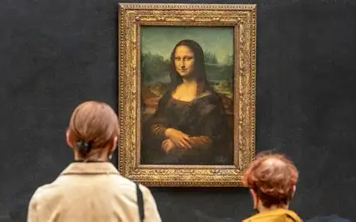
To start this section off, the first theorist that can affect an artwork is Gustave Le Bon. Le Bon’s theory on Crowd Psychology states that ‘individuals lose their sense of self in a crowd…When people gather, they enter a collective state where personal judgment fades, replaced by shared impulses.’ (Lapadat, 2025) When looking at artworks that have been affected by this theory, one stood out to me which is very well known. This being the Mona Lisa. Although the artwork hasn’t been affected physically by the crowded room, the atmosphere within the room is different.
Figure 1 Mona Lisa (Inspiredpencil.com, 2021)

Due to the number of crowds, it can be a very overwhelming experience yet one to remember. The theory shows how people’s characteristics change due to the crowd which can be seen in the Louve while waiting for the Mona Lisa. People around the world come to see this piece however they all act the same. For example, they wait in long lines and wait their turn while also being respectful to those around. This links to the theory as although everyone has different cultures and standards, they all follow the same path and thoughts in this room to view the Mona Lisa. Of January 2025, the Louvre’s director Laurence des Cars responded to warnings that ‘the museum was suffering from grave problems of overcrowding and failing infrastructure.’ (Schofield, 2025) Ms Des Cars stated in a letter to the government that the pyramid ‘was “structurally unable to cope” with visitor numbers that now reach more than nine million a year.’ (Schofield, 2025) Due to this statement, it is revealed in the news article by the BBC that the Mona Lisa will be moved to a different space in the Louvre. This is due to a renovation plan to help accommodate to the overcrowding and help adapt better to the conditions in the building.


Another theorist who links to how crowds affect people’s behaviours in Kurt Lewin’s theory of Change. The theory suggests that ‘behaviour is the result, not just of the individual’s mental health, but also in how they interact with their environment.’ (Thudium, 2023) In order to show how mental health can affect an artwork, I have chosen Janelia Mould’s photography. Mould creates self-portraits of herself however she removes one of her limbs in post-production to create a ‘glimpse on how a person with depression might experience life.’ (Stewart, 2017) By doing this she creates a character that is never fully complete which links to how a person with depression may feel as there is something missing.
Figure 2 ‘Dangling' “Why can’t I try on different lives, like dresses, to see which one fits best?” – Sylvia Plath (Stewart, 2017)

As a person who has suffered from depression for 5/6 years, I can relate and back the images up to the accuracy of how I feel. However, someone who hasn’t experienced mental health before will see and react to the image differently as it won’t have the same meaning. By having an image relate to your life creates a bigger impact when studying it and although Mould never put these pieces in an exhibit, she has posted them online. Having them online will create a bigger impact on people due to the fact that the internet has grown a lot and that people are more likely to see it there then anywhere else. It also allows people to share the work more and share their own opinions about it helping others understand the work if they don’t.


As well as the images, Mould has put quotes for their captions. Mould has also experienced and struggled with depression and so uses her work as a therapeutic outlet to share her story and get how she is feeling out without having to speak. The image to the right shows the image Barren with the caption ‘Some days, I feel everything at once. Other days, I feel nothing at all. I don’t know what’s worse―drowning beneath the waves, or dying from the thirst.’

Linking back to Lewin’s theory of change and how mental health effects the way the image views and the environment within the image, Barren shows that well as within the image. Rain is associated with sadness and depression and so by only making the area under the umbrella helps involve the environment of the image more making viewers look at the full picture. Within having depression, mental health effects the head the most and so by removing the head it shows the main target of what is going on. Other people will view the owl in this image differently, however in my perspective it is the idea of others adding weight to the struggle and not being alone yet struggling with no help.
Figure 3 ‘Barren' “Some days, I feel everything at once. Other days, I feel nothing at all. I don’t know what’s worse―drowning beneath the waves, or dying from the thirst.” (Stewart, 2017)

Using knowledge that I gained from a different project in the semester, I have learnt that locations have a big impact within an artwork. Whether that be within an exhibit or somewhere in the landscape. These are called site specific art which is ‘artwork made to exist in a specific location. This involves the artwork interacting with the environment/ architecture of the space. It is used to enhance or respond to the location through its unique characteristics. These include the site’s history, relation to its environment, inhabitants and social/ cultural standing which helps bring meaning to the artwork.’ (admin, 2024) This could also affect how the artwork is produced and displayed.

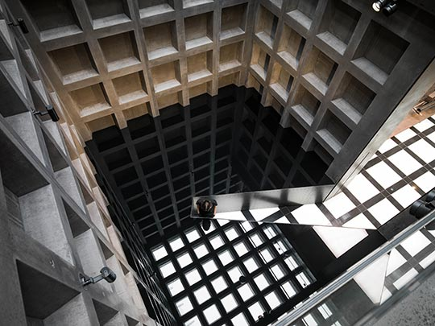
An example of a site-specific work which shows this is Richard Wilson’s work of 20:50. The name 20:50 comes from the name of the engine oil that he used within the exhibition creating an illusion within rooms. He states, ‘The impenetrable, reflective surface of the oil mirrors the architecture of the room exactly, placing the viewer at the mid-point of a symmetrical visual plane.’ (Wilson, 2017) This work was placed specifically due to the architecture within the rooms helping create the illusion of symmetry seamlessly. This work was shown permanently between the years of ‘1991 to 2015’ (Gallery, n.d.) As stated by the gallery that hosted 20:50 the oil was used to ‘alter perspective’ which meant that ’20:50’s phantasmical aura is enhanced, amplifying the disorientating and mesmerising experience of the space, and further confounding physical logic.’ (Gallery, n.d.)
Figure 4 20:50 (Wilson, 2017)

After reading the book ‘Thomas Reid’s theory of perception’ (Nichols, 2007b) Nichols writes ‘Ried holds that we do not see distance from the eye…, but we perceive distance through touch.’ With this, it gives the audience of the exhibit the effect of not knowing the true size of the room as they are not able to walk to each wall of the space and instead are confined to a small walkway which reaches as far as the centre of the room. As well as this the audience in the exhibit were warned not to touch the oil due to the characteristics of 20:50 oil but were instead told that it can be seen by blowing very gently on the surface to break the illusion. Only then can the true size of the room be told as the illusion is no longer there as the still oil is broken. By blowing gently on the oil, it gives the audience the sense of what it would look like if they could touch it as they are both methods of disturbing the oil and the illusion. Ried’s theory of perception and the exhibit by Wilson both show how we can’t rely on just one sense and that it is better to use multiple at once to understand the truth of a room. Using these rooms, Wilson has fit Ried’s theory well by creating this illusion and allowing the audience to decide whether to break the illusion or not or allow their site to be deceived by the architecture symmetry.
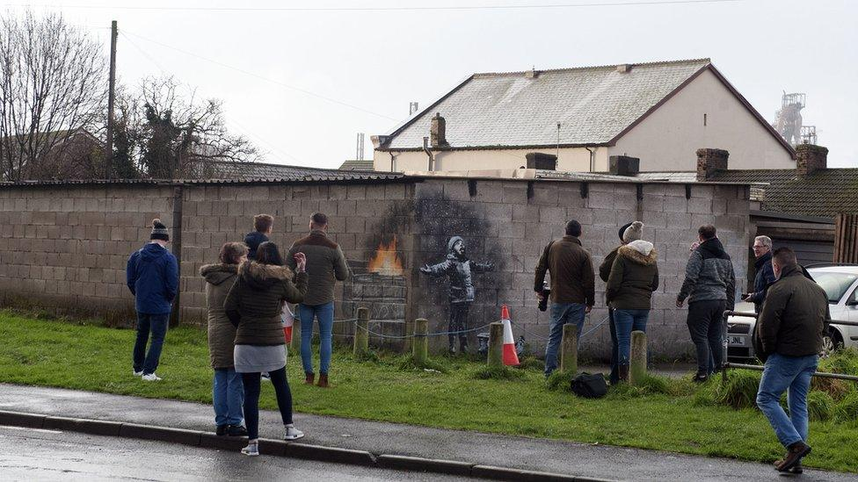
An artwork that speaks more then words is more impactful on the audience, this opinion is due to the how much the audience can relate to the artwork without needing an explanation to it. An example of this is Banksy’s work called Season’s Greetings in Port Talbot, 2018. The artwork is on 2 sides of a wall, one shows a boy playing in snow however when looking at the 2 side of the wall it reveals that the snow is ash from a dumpster fire. The meaning behind this work was to echo ‘the larger plumes of smoke emitted day and night at the steelworks.’ (Grice, 2025) Banksy placed this work here as Port Talbot is known for its steel works and wanted to warn the city about the effects of the pollution and how easy it is to misunderstand it.
Figure 5 (Banksy confirms Port Talbot ‘Season’s greetings’ piece is his, 2018)

Unfortunately, an English art collector brought the piece and removed it to an undisclosed location removing it from the site. From it being removed, 2 years later the works’ blast furnace got switched off, which made Paul Jenkins (a playwriter) to make a story on it. At first, he was going to write the story on Banksy and his first appearance in Wales and the public’s views on it however this changed after the steel works were shut down. With this Paul stated in a BBC news article ‘it became much more about the theme of the Banksy, drawing attention to the pollution from the steelworks, and then of course when the threat to the steelworks [happened] it’s become much more a gritty portrait of that community and their resilience.’ (Grice, 2025) He then goes to state an explanation ‘They were gifted the Banksy at Christmas- that was taken away from them. And now the blast furnaces, the industry that they’ve had for 100 years.’ (Grice, 2025)

With these statements it becomes clear how the community has been impacted by the artwork being removed as well as the work that influenced the art. By removing the artwork from the location, the community felt like a part of the town was removed along with a connection that brought them together. However, with this being said after the piece was removed, it influenced more artists to share work, meaning that streets were filled with colourful images and graffiti from the community. From what was a town filled with pollution it turned into a community all brought together from one artwork. This shows the importance of a location to the art as it can change how the audience reacts and views the town as a whole.

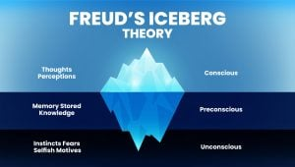
An artwork study that showed both how theorist and locations affect meaning is Uli Aigner with her piece in the Freud Museum in London. Feud’s theory is well known for the iceberg where his theory is shown through how the visible part of the iceberg is small whereas beneath the surface there is much more that is to be seen. This links to the mind and how people think. The iceberg is split into three sections, the Conscious (Thought/ Perceptions), Preconscious (Memory Stored/ Knowledge), and the Unconscious (Instincts Fears/ Selfish Motives). (Mcleod, 2024) From doing research and previous knowledge obtained from Criminology, Freud also proposed a tripartite model of the mind, made up of the Id, Ego and Superego. These three represent different parts for example ‘the id represents primal desires, the ego balances the id and reality, and the superego represents societal norms and morals.’ (Mcleod, 2024) This will be important for later.
Figure 6 An illustration of Freud’s Iceberg Theory, where the conscious mind is the visible tip above the water, while the larger unconscious mind lies submerged, out of immediate sight yet immensely influential.

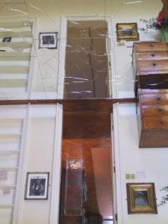
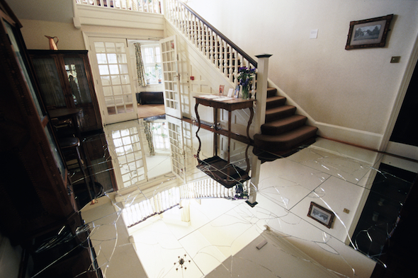
Aigner’s work in the exhibit showed 4 pieces of work however her most memorable was her idea of placing mirrors through the hallway of the museum. She wanted the museum to not only represent a museum but also a house. Australian Newsletter observed that ‘Aigner’s work explores ‘being at home’ and ‘being displaced’ becoming oneself and becoming something else through masking and unmasking.’ (London, 2018) I could not find the original newsletter however found an insert on the official Freud Museum Website.
Figure 7 Uli Aigner- A visit to Freud's (Vargas Organisation, London, 2025)

Although instead of placing mirrors on the walls, she had placed them on the floor. This forced people to walk on them to view the exhibit while the mirrors shattered below them. Aigner wanted to make the work engaging for the audience which will introduce conversations between groups and whether or not they will walk. Unfortunately, ‘the London Borough of Camden Health and Safety officers posed the mirrors as a health and safety risk and required that the mirrors be removed.’ (London, 2018) Luckily, she was able to relocate the work else where however due to it not being in the Freud Museum it did not have the same view and idea behind it.
Figure 8 Uli Aigner- A visit to Freud's (London, 2018)
This exhibit links to Freud’s theory due to everyone being different in the way they think. The mirrors on the floor is almost a test for the audience to see who would take the risk and walk on them and who wouldn’t and it is all down to how big their unconscious mind is compared to the conscious mind. As well as this if the person has conflict between the Id, Ego and Superego they are more likely to walk as they are going against the societal norms and morals as well as the reality of what could happen when they walk on the mirrors. (Mcleod, 2024) The fear of the mirrors shattering beneath someone is enough to put people off however others would thrive for the thrill and attention they would have from walking on them therefore doing it. By placing the exhibit in Freud’s Museum, it allows the theory to link more as Freud is the creator of the decision behind placing the mirrors on the floor and so by having to relocate the exhibit piece somewhere else, the exhibit loses the connection to the location and part of its meaning.

To conclude, the essay shows how use of theorists and locations in different ways to change the meaning of an artwork and how they are viewed. By dividing the theorists and locations and describing how each of them change an image individually it helps break down the themes and why the images were made. Using Aigner’s exhibit piece of A visit to Freud’s House, it allows the viewer of this essay to understand how the artwork is powerful once a theory and location is used to construct the meaning behind the artwork. The findings within this essay help to show the importance of finding connections and engaging the audience within the piece. It also shows how it’s not just about the artwork itself it is also about how the audience perceives the work and how they act toward it.

Bibliography:
Books
Nichols, R. (2007b). Thomas Reid’s Theory of Perception. Clarendon Press.

News Articles
Grice, N. (2025). Banksy legacy amid loss of Port Talbot steelworks fuels new play. BBC News. [online] 5 May. Available at: https://www.bbc.co.uk/news/articles/cy9vw540zngo.

Schofield, H. (2025). Mona Lisa to be moved as part of major Louvre overhaul. BBC News. [online] 28 Jan. Available at: https://www.bbc.co.uk/news/articles/cde9r0xgk67o.

Websites
admin (2024). Site-Specific Art - Definition, Examples, History & More - Art Theory Glossary - jerwoodvisualarts.org. [online] jerwoodvisualarts.org. Available at: https://jerwoodvisualarts.org/art-theory-glossary/site-specific-art/.

Gallery, S. (n.d.). Richard Wilson - Artist - Saatchi Gallery. [online] www.saatchigallery.com. Available at: https://www.saatchigallery.com/artist/richard_wilson.

Lapadat, D. (2025). Gustave Le Bon’s Essential Theories on Crowd Psychology Explained. [online] davidlapadat. Available at: https://www.davidlapadat.com/post/gustave-le-bon-s-essential-theories-on-crowd-psychology-explained.

Mcleod, S. (2024). Sigmund Freud’s Theories. [online] Simply Psychology. Available at: https://www.simplypsychology.org/Sigmund-Freud.html.

Stewart, J. (2017). Interview: Photographer Explores Own Depression with Surreal Self-Portraits. [online] My Modern Met. Available at: https://mymodernmet.com/janelia-mould-conceptual-photography-depression/.

Thudium, T. (2023). Lewin’s change theory. [online] Practical Psychology. Available at: https://practicalpie.com/lewins-change-theory/.

Wilson, R. (2017). 20:50 | Sculptures | Richard Wilson. [online] Richardwilsonsculptor.com. Available at: https://richardwilsonsculptor.com/sculpture/2050.html
Images:
Figure 1: Inspiredpencil.com. (2021). Inside The Louvre Mona Lisa. [online] Available at: https://ar.inspiredpencil.com/pictures-2023/inside-the-louvre-mona-lisa

Figure 2: Stewart, J. (2017). Interview: Photographer Explores Own Depression with Surreal Self-Portraits. [online] My Modern Met. Available at: https://mymodernmet.com/janelia-mould-conceptual-photography-depression/.

Figure 3: Stewart, J. (2017). Interview: Photographer Explores Own Depression with Surreal Self-Portraits. [online] My Modern Met. Available at: https://mymodernmet.com/janelia-mould-conceptual-photography-depression/.

Figure 4: Wilson, R. (2017). 20:50 | Sculptures | Richard Wilson. [online] Richardwilsonsculptor.com. Available at: https://richardwilsonsculptor.com/sculpture/2050.html

Figure 5: Banksy confirms Port Talbot ‘Season’s greetings’ piece is his. (2018). BBC News. [online] 19 Dec. Available at: https://www.bbc.co.uk/news/uk-wales-46617742

Figure 6: Mcleod, S. (2024). Sigmund Freud’s Theories. [online] Simply Psychology. Available at: https://www.simplypsychology.org/Sigmund-Freud.html.

Figure 7: Vargas Organisation, London. (2025). Available at: http://vargas.org.uk/artists/anthony_auerbach/planet/enemy_contact_surface.html.

Figure 8: London, F.M. (2018). Uli Aigner - A Visit to Freud’s - Freud Museum London. [online] Freud Museum London. Available at: https://www.freud.org.uk/exhibitions/uri-aigner-a-visit-to-freuds/.

