

LEVEL 4

SEMESTER 2

MODULE CODE: SHSS4086
INTRODUCTION TO SPORT AND EXERCISE PSYCHOLOGY
aSSESSMENT TYPE: REPORT
Assessment/Component: 2

COMPONENT WEIGHTING: 50%

WORD COUNT: 1500 WORDS

MODULE TUTOR: ALISON CONNAUGHTON

SUBMISSION DETAILS:
Assignments should be submitted via Turnitin (Moodle) by 3pm on Friday 27th of April, 2018.

TASK:
Write a report on the following topic:
As a group, you will gather data using the CSAI-2 (Martens et al., 1982) for at least 20 team sport participants and 20 individual sport participants from the student population at UWTSD.

Competitive State Anxiety in Team vs. Individual Sports

Aim: To undertake a comparison of the intensity of competitive state anxiety for two groups of sports participants (team and individual) from the School of Sport, Health and Outdoor Education.
Introduction – Review of relevant literature relating to competitive state anxiety and performance (approx. 500 words).
This should include research relating to differences found in anxiety intensity between team and individual sports participants.

Method – Briefly outline the participants, procedures and design of the study (approx. 200 words).

Results – Using the data provided, present the results in an appropriate format. This should include descriptive statistics, table, figure and associated narrative (approx. 250 words).

Discussion – Discussion of your findings in relation to previous anxiety research (approx. 550 words).
In this section you need to relate your findings to the research discussed in the introduction and either support or reject previous research findings. Briefly explain the practical implications of research your findings.

The format required for the different section of the report will be discussed during lectures, with further guidance placed on Moodle.

Word count – 1500 Words

Submission Date: Friday 27th of April, 2018.

School of Sport, Health & Outdoor Education

Assessment Feedback Sheet

Student No./Name:
Module: Introduction to Sport and Exercise Psychology

Module Code: SHSS4086

Personal Evaluation – to support your academic progress please complete the section below BEFORE submitting your work.
What do you consider to be the best aspects of this work?
Which aspects do you consider could have been improved in this piece of work?
What have you found most satisfying whilst undertaking this submission?
ASSESSMENT CRITERIA | Learning  Outcomes |  | GRADE
ASSESSMENT CRITERIA |  |  | Poor  < 20% | Weak  20-29% | Unsatisfactory  30-39% |  | Satisfactory  40 – 49% | Good  50 – 59% | Very Good  60 – 69% | Excellent  70 – 84% |  | Exceptional  85– 100% | %
1. Introduction:  Review of relevant literature relating to competitive state anxiety and performance  (approx. 500 words) | 1,2 |  |  |  |  |  |  |  |  |  |  |  | 30%
2. Method:  Outline the participants, procedures and design of the study (approx. 200 words) | 1,2 |  |  |  |  |  |  |  |  |  |  |  | 15%
2. Results:  Descriptive statistics, use of tables, figures and associated narrative (approx. 250 words) | 1,2 |  |  |  |  |  |  |  |  |  |  |  | 25%
3. Discussion:  Discussion of your findings in light of previous research & Practical implications.  Use of appropriate resources (approx. 550 words) | 1,2 |  |  |  |  |  |  |  |  |  |  |  | 30%
It is expected that students will present work that is proof read, correctly referenced and adheres to the Assessment Checklist. Therefore a range of 0 – 10 marks will be deducted for non-completion of any of the points on the checklist below.
TUTOR COMMENTS:

Submission date: 27/4/18  via Turnitin |  | Return date:  (at least within 4 weeks) |  |  |  | Tutor: Alison Connaughton |  |  |  |  | Mark:

Assignment Checklist

- Please complete the Personal Evaluation section of the Assessment Feedback sheet, add your name and details, and paste the whole of this assignment document into the front of your assignment

- Submission is a single word file, clearly labelled with your name and module code
- Font style - Times New Roman, size -12 for text and 14 for headings
- Ink colour – black only
- Line spacing – 1.5 line spacing and 2cm- 2.5cm page margins
- Quotations more than three lines to be indented 1 line spacing
- One line space between paragraphs, paragraphs must be left aligned
- Pagination (your assignment should have page numbers)
- All tables and figures are internally referenced and have a title
- Word count checked and written at end of text (before references and any appendix)
- Assignment is within 10% of the word limit (excluding references and any appendices)
- All references in the text are included in the reference list
- Correct referencing following the Harvard style, as described in the Palgrave study skills book ‘Cite them Right’.
- Correct spelling using UK English
- Correct use of punctuation
- Grammar and syntax correct- double check anything that has a green line under it
- I have read my assignment out loud to myself and it makes sense and is easy to read
- Somebody else has read my work and it makes sense to him or her!
- I have checked and I have not plagiarised
Failure to follow these guidelines will cost you marks!

Write a report on the following topic:

As a group, you will gather data using the CSAI-2 (Martens et al., 1982) for at least 20 team sport participants and 20 individual sport participants from the student population at UWTSD.

Introduction
In this report, I am going to discuss results obtained from extensive research into CSAI-2 and compare results attained in conjunction with team players and those that compete individually. To be an ‘Athlete’ means far more than having a high level of ability. All levels of sport require a strong mental capacity to cope with both positive and negative phycological demands. Failure occurs in everyday life and is an aspect that all athletes need to be able to control and overcome. However, for some, failure can cause competitive state anxiety which will impact negatively on their performance levels. Competitive state anxiety has two major components, physical and mental. The mental component has been defined as “Cognitive state anxiety”. Martins, et al (1990) describes its occurrence as being ‘Caused by a fear of negative social evaluation, fear of failure, and loss of self-esteem.’. “Somatic state anxiety” can be described as the physical symptoms that occur in Competitive state anxiety. ‘Somatic state anxiety was defined as the physical component of anxiety and reflected the perception of physiological responses as increased heart rate, respiration, and muscular tension’ (Martens, et al., 1990). These two statements clarify what Competitive state anxiety is and the cause of it. A way to prevent competitive state anxiety from developing is to build one’s self efficacy. In doing so, athletes will build both self and sporting confidence which in turn will avoid athletes seeing potentially threatening situations due to the environment they are performing in. The aim of the research carried out (CSAI-2) is to determine the difference in anxiety levels between individual performing athletes and those that perform as part of a team.

Before commencing my research, I held the opinion that those whom perform individually would have higher levels of state anxiety than those that were part of a team. However, Martens (et al., 1990.) stated that there would be “no significant” difference between individual and team athletes. 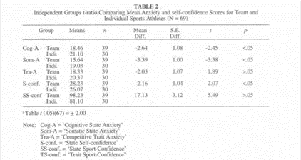Z, Heng (International Sports Journal/Winter, 2003).
The above results are as I expected, although after further research I discovered a contrast to this. Parnabas (et al, 2014) portrays a different outcome as “The result showed that the cognitive anxiety was higher on team compared to individual sports athletes, before and during competitions. Besides that, the results also revealed the tendency of cognitive anxiety increases during competition on team compared to individual sports athletes.” It is fair to say that two contrasting results are evident here. Nevertheless, one concept that cannot be argued against, is that there is a negative correlation between high levels of cognitive anxiety and performance levels. Therefore, as a result of this, I had to conduct my own research in relation to the topic, in order to gain a conclusive answer once and for all.

Method
The way in which I gathered my research was by issuing 20 team performers and 20 individual performers with a CSAI-2 (Martens et al., 1982) to complete. I asked both sets of performers to complete the CSAI-2 (Martens et al., 1982) one hour prior to competing, in applying this, I was assuring that the test would be viable as all athletes would have the same time frame prior to performing. If the performers were able to complete the form at any time of the day, then the results would be inconclusive as they would not be an accurate representation of the performers anxiety levels prior to competition. CSAI-2 (Martens, et al., 1982) has three measuring components, CAI (Cognitive anxiety intensity), SAI (Somatic anxiety intensity) and SCI (Self confidence intensity). By using 20 scores for each trait, I will then work out the mean score for Competitive state anxiety between individual and team performers. The data will then be finalised and presented in the form of a table, enabling data collected to be visible and easily interpreted. This format will facilitate me to compare CSA levels between the two sets of performers and present the necessary information for a decision to be made on whether or not there is a difference between CSA levels in individual and performers.

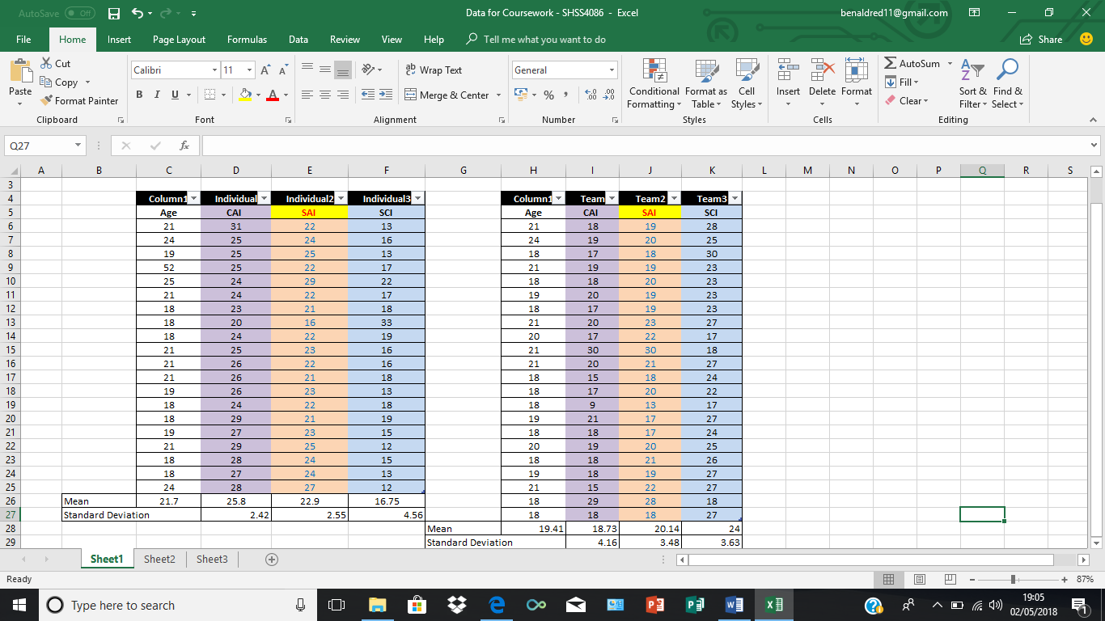
Results
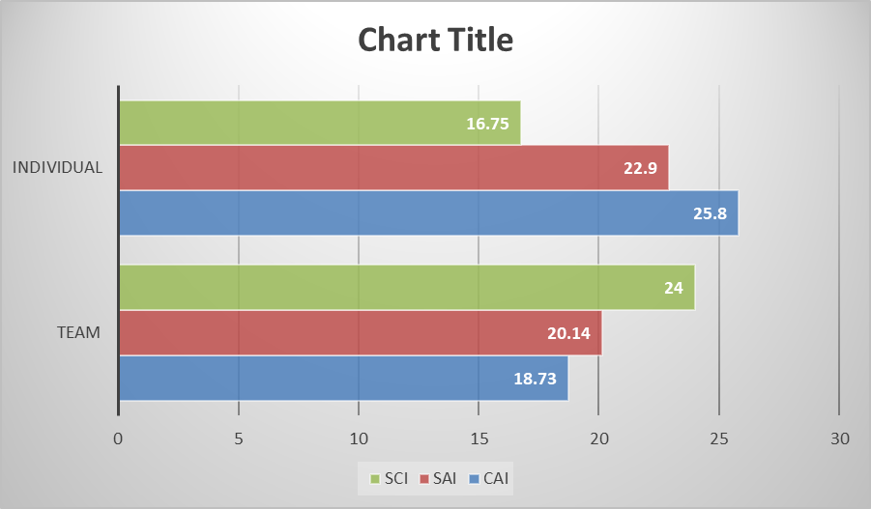

Above are the results accumulated from the CSAI-2 (Martens, et al., 1982). The set of results from team performers are on the right and the results of those that perform individually on the left. It is indicated in the data collected that firstly, the levels of CAI are lower in team performers compared to individuals. Secondly, the SAI levels are also lower and thirdly, team performers have higher levels of SCI. An explanation as to why this is the case, is due to the fact, that team performers are aware that if they are not performing at the required level then it may not directly be a negative effect as they have other members of the team to bridge the gap. The standard deviation for all 3 components for both sets of performers is fairly low, however, individual performers have a lower standard deviation in their results which may suggest that there are some team performers who have higher levels of CSA than those competing individually.

The one statistic that is evident in the data presented, is the results for self confidence levels between the two sets of performers. As exhibited, there is a range of 7.25 with team performers attaining an average of 24 and individuals attaining an average of just 16.75. The collaboration of such results proposes the question as to why are individual performers so negative about themselves when they have the ability to perform solo which many athletes struggle to do? It is fair to say that this was not in line with my expections and as a result I was inquisitive as to find answers as to why this occurred.

Discussion
The findings of the research conducted, conforms with any expectations that I had, prior to data collected. Personally, I had the assumption that team performers would not suffer from Competitive state anxiety as much as individual performers due to a variety of reasons. If a team performer is under performing then they have encouragement and help from team mates throughout competitions which will help prevent the performer to let their bad performance get the better of them, which could result in anxiety being formed or choking next time. Z, Heng (2003) published a report on CSAI-2 and Competitive state anxiety levels between the two sets of performers and advocated the same conclusion as myself. It was projected that individual athletes build up higher levels of CSA before competing. This is contrasting to Parnabas (et al., 2014), as he advocated that it was team performers who had the higher level of CSA. It is fair to say this led me to question the reliability and accountability of my research and results. Researching further into the matter at hand, I found much of the same contrast. Thus, different researchers were finding various outcomes meaning that there is no definite scientific answer to who suffers more from Competitive state anxiety. This could be due to a number of factors such as ability levels, experience, age or the enormity of the match/event that the athlete will be competing in. Although each performer is given the same CSAI-2 (Martens, et al., 1982) to complete, they may all be competing in different games/events. For example, one performer could be competing in their first ever match in their chosen sport and as a result they will have high levels of anxiety as they will not know what to expect. This is misleading as the results do not take this type of situation into consideration and just give a generic answer.

Another question that was in the back of my mind throughout the research was, would high levels of anxiety affect the performer? And if so how? The answer to this is yes it does affect the performer, and, this can be physically as well as mentally. Performers that suffer from anxiety may experience excessive sweat, a raised heart rate, muscle tension, vomiting which are all physical symptoms. But, the performer can also have their performance level hindered by high levels of anxiety. It is crucial for athletes to come up with coping mechanisms to limit the level of anxiety they build up pre-competition, this can be done through visionary and goal setting which will enable the athlete to have a visual picture of themselves achieving to help relief any nerves or stress. Breathing techniques can also be effective as a way of keeping the performers mind clear and also not allowing themselves to get aroused too much that it will affect their performance negatively. The best way to eliminate high Competitive state anxiety levels is to talk to sports phycologists. This enables performers to air what is troubling them and receive positive feedback or coaching on the matter which in turn will allow them to concentrate on what they are good at rather than constantly worrying about what the weaknesses are. Anxiety is normal before competing and is a healthy part of preparation, but it must be identified if levels become too high. Different athletes have different ways to overcome the problem and some find it simply too much for them and as a result it reflects with a poor performance.

After completing this task, it has brought to light some symptoms that I, myself as a team performer has suffered from. Before a few big games I have played in I have had somatic anxiety symptoms such as vomiting, racing heart rate and even muscle tension but once I had vomited, I was able to relax and perform as I normally would. I have come to the conclusion that I agree with Martens (et, al.,1990) in advocating that there is no significant difference between the two sets of performers and Competitive state anxiety is common for many athletes.

REFERENCES
Heng, Z. (2003). The Differences between Anxiety and Self-Confidence between Team and Individual Sports College Varsity Athletes. International Sports Journal/Winter. 33.

Howard, Z. Zeng, Raymond, W. Leung Wenhao, LIU.. (2003). An Examination of Anxiety and Self Confidence among College Varsity Students. Journal of Physical Education & Recreation . 14 (2), 1-3.

Lynette L. Craft, T. Michelle Magyar, Betsy J. Becker, and Deborah L. Feltz . (2003). The Relationship Between the Competitive State Anxiety Inventory-2 and Sport Performance: A Meta-Analysis. JOURNAL OF SPORT & EXERCISE PSYCHOLOGY. 25 (.), 44-65.

Martens, R. et al. (1990) The Development of the Competitive State Anxiety Inventory-2 (CSAI-2)

Parnabas, V, et al. (2014). Cognitive Anxiety and Performance on Team and Individual Sports Athletes. Proceedings of the International Colloquium on Sports Science, Exercise, Engineering and Technology 2014 (ICoSSEET 2014). p301-308

Lynette L. Craft, T. Michelle Magyar, Betsy J. Becker, and Deborah L. Feltz . (2003). The Relationship Between the Competitive State Anxiety Inventory-2 and Sport Performance: A Meta-Analysis. JOURNAL OF SPORT & EXERCISE PSYCHOLOOY. 25 (.), 44-65.

Heng, Z. (2003). The Differences between Anxiety and Self-Confidence between Team and Individual Sports College Varsity Athletes. International Sports Journal/Winter. 33.

Parnabas, V, et al. (2014). Cognitive Anxiety and Performance on Team and Individual Sports Athletes. Proceedings of the International Colloquium on Sports Science, Exercise, Engineering and Technology 2014 (ICoSSEET 2014). p301-308

Howard, Z. Zeng, Raymond, W. Leung Wenhao, LIU.. (2003). An Examination of Anxiety and Self Confidence among College Varsity Students. Journal of Physical Education & Recreation . 14 (2), 1-3.

