Nicole Norton 2007743

Rachel Rivers BMHP5003_BIRM

Individual Academic Poster Presentation

INTRODUCTION
How well do we really know and understand the gastrointestinal tract (G I) otherwise known as the digestive system?. This poster should give you a brief but descriptive overview of the system in question, the part it plays within the human body , also the organs involved along with a few health related problems in relation to the digestive system, followed by a small quantity of recommendations to help decrease such issues. Have you ever wondered what happens to the breakfast in the morning or that cheeseburger you allow yourself to have on a cheat day If yes you’re in the right place . So what is the digestive system, It is a group of organs that breaks down the food we intake to absorb nutrients such as protein , carbohydrates ,vitamins & minerals then when the lengthy process has finished it allows our body to rid waste for short it can be known as (I.M.A.R) which is intake , mechanical , absorption , removal (Tresca,2020). The nutrients our bodies absorb enables the body to gain energy , grow and even help with cell repair (NIH,2023). Did you know it takes anywhere from 24-72 hours, for the body to rid waste (Liew,2018)

image source innerbody.com 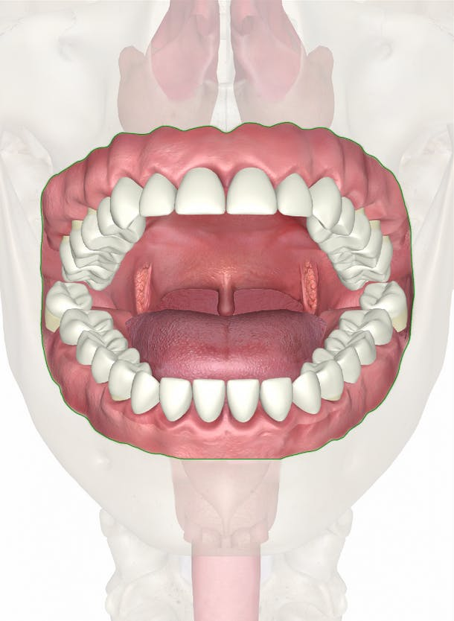

So now we understand what the system is required for, and a small quantity of its advantages, what is the process , where does it even begin?. The digestive system has 2 process known as mechanical, which is starts with the oral cavity (mouth). This is the first stage of the overall process ,from the chewing through our teeth and turning of the tongue, the second process is known as chemical (Nall,,2018).Which also begins within the mouth once you start to chew the food it then releases saliva. Once the food has been chewed enough it forms into ball of food, otherwise known as Bolas Which gets the food ready to be able to be pushed to the Pharynx ( back of the throat) Which consciously opens up Upper esophageal sphincter (UES) (Britanica,2023). Did you know we have three salivary glands located in the throat known as sublingual submandibular and parotid or for short S.S.P ((Sieroslawska, 2022). Enzymes’ are secreted through these glands called amylase ,lingual lipase lysozyme.
The ball of food is now ready to leave the mouth through the oesophagus (windpipe), and enter into our stomach from the lower oesophageal sphincter, once inside the stomach an enzyme called pepsin, is now secreted via the stomach walls enzyme’s purpose in the digestive system is to help speed up the absorption process(Nall,2018). Pepsin mixed with gastric juices within the stomach such as hydraulic acid, turns the food into chyme through wave like movements otherwise know as peristalsis. Other organs such as your Liver which produces bile to help break down fats, and the gallbladder is also working alongside to help the stomach to digest the food further (BBC,2023). The digested food which is now in a liquid format is ready to enter the small intestines, through the pyloric sphincter into the duodenum which is the first out of three parts of the small intestines and where the larger digested molecules get broken down second part is called the jejunum and third part is called the ileum where absorption of minerals and water takes place. Did you know The pancreas, when you eat squeezes bile through the ducts into your small intestines (BBC,2023).
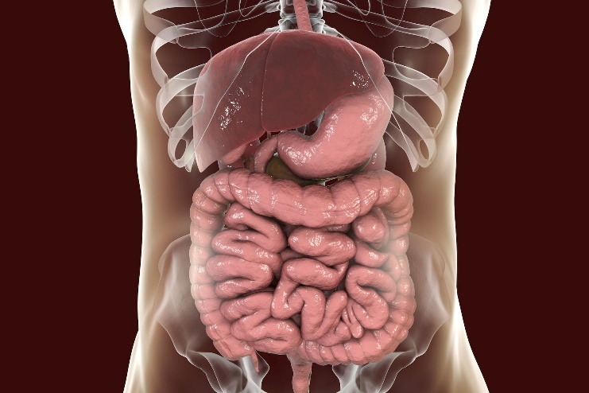 image source about health.com

Did you know we have a piece of flap like tissue that sits under our tongue called epiglottis which covers the trachea that stops us from chocking and having food enter our lungs (Knott,2018).
Once the food has entered down into the duodenum where the higher amount of food and water absorption takes place, (Jones,2020). It then pushes through in the form of peristalsis (wave like movements) to the jejunum, and then the illum which is the final place of the small intestines, where food is able to pass into blood vessels through absorption of its walls (Libretexts,2023).The next destination is to enter into the large intestine (colon) through the cecum which is like a small pouch that connects the small to the large intestine. The colon starts its journey in the direction of transcending up on the right side, then across (transverse ) finally descending on the left where the digested food, is ready to leave the sigmoid colon and continue is journey in the final parts the rectum and anus.

Once the digested food has left the sigmoid colon it is the rectums job to collect the stool, and store it until it leaves the body. The rectum is like a store house for the waste, once the brain has sent a signal to the body we then go to the bathroom, the anal muscle become then becomes relaxe,d and the waste now in the form of stool, leaves from the rectum via the anal canal then exits our bodies (Robinsion,2022). Did you know It is important to keep an eye on your bowel movements, or even the colour of your stools as this sometimes could be an early indication of a health problem (Aimes,2021). We have now completed our journey of the digestive system.

Common Digestive system health problems
- IBS (irritable bowel syndrome )
- Lactose intolerance
- Gallstone
- Crohn’s disease (Aimes,2021).
so what could we do here is some tips to help.
Healthy diet include fibre as it helps regulate bowl movement (Cleveland Clinic,2021).
Maintain a healthy Body weight being overweight can cause fat to put pressure on your stomach which can lead to heartburn.
Stop smoking , smoking causes the muscle to weaken allowing bile to come back up through the oesophagus causing a person to vomit (NHS,2022).
Reduce stress although it’s very hard to not stress especially within 2023, with the current economic climate , or just having survived a pandemic, cost of living rising however reducing stress can have a positive impact on your mind and body (Cherpack, 2019).
Finally as we close to the end of the digestive we should be able to have a better understanding in the way it works, but also what issues may arise if we don’t do all we can as individuals to keep a healthy digestive system. Even a small start today will make a huge change in the latter run Don’t let the fear of the time it will take to accomplish something stand in the way of your doing it. The time will pass anyway; we might just as well put that passing time to the best possible use ( Nightingale,2020). Remember it is not just what’s on the outside we need to keep conscious of but the inside too.

Reference Page
Aimes, H. (2021) Common digestive disorders: Symptoms and treatments, Medical News Today. MediLexicon International. Available at: https://www.medicalnewstoday.com/articles/list-of-digestive-disorders#ibs (Accessed: February 22, 2023).
Digestive diseases (no date) National Institute of Diabetes and Digestive and Kidney Diseases. U.S. Department of Health and Human Services. Available at: https://www.niddk.nih.gov/health-information/digestive-diseases#:~: [Accessed: February 23, 2023}.
Digestive system: Function, Organs & Anatomy (2021) Cleveland Clinic. Available at: https://my.clevelandclinic.org/health/body/7041-digestive-system (Accessed: February 23, 2023).
Esophageal Cancer (2023) Enciclopedia Britannica. Enciclopedia Britannica, inc. Available at: https://www.britannica.com/science/esophageal-cancer (Accessed: February 24, 2023).
Image 1Human Mouth (2022 [image] .Mouth. Available at Mouth - Human Mouth Anatomy (innerbody.com) Accessed on: [16th of February 2023].
Image 2: Human digestive system , (2020 ),organs that make the digestive system. [Image] Available at: Organs That Make up the Digestive System (verywellhealth.com)Accessed on: [16th February 2023].
Jones , O. (2020) The small intestine, TeachMeAnatomy. Available at: https://teachmeanatomy.info/abdomen/gi-tract/small-intestine/ (Accessed: February 24, 2023).
Knott, D.L. (2018) Epiglottitis (swelling & inflammation), Patient.info. Available at: https://patient.info/ears-nose-throat-mouth/epiglottitis-leaflet (Accessed: February 21, 2023).
Libretexts (2023) 22.13a: Absorption in the small intestine, Medicine LibreTexts. Libretexts. Available at: https://med.libretexts.org/Bookshelves/Anatomy_and_Physiology/Book%3A_Anatomy_and_Physiology_(Boundless) (Accessed: February 24, 2023).
Liew, M. (2018) How long does it take to digest food? 6 stages of digestion, Life Advancer. Available at: https://www.lifeadvancer.com/how-long-does-it-take-to-digest-food/ (Accessed: February 21, 2023).
Nall, R. (2018) Chemical digestion: Definition, purpose, starting point, and more, Healthline. Healthline Media. Available at: https://www.healthline.com/health/chemical-digestion#chemical-vs.-mechanical (Accessed: February 21, 2023).
National Health Service.(2022) NHS choices. NHS. Available at: https://www.nhs.uk/live-well/eat-well/digestive-health/five-lifestyle-tips-for-a-healthy-tummy/ (Accessed: February 23, 2023).
Nitingale, e., (2020). Earl Nightingale Quotes. [online] Brainy Quote. Available at: <https://www.brainyquote.com/quotes/earl_nightingale_107070> [Accessed 22 February 2023].
Robinson, J. (2022) Digestive system (anatomy): How it works, WebMD. WebMD. Available at: https://www.webmd.com/heartburn-gerd/your-digestive-system (Accessed: February 24, 2023).
Sieroslawska, A. (2022) Salivary glands, Kenhub. Kenhub. Available at: https://www.kenhub.com/en/library/anatomy/the-salivary-glands (Accessed: February 24, 2023).
The digestive system - the digestive system in humans – WJEC - GCSE biology (single science) revision - WJEC - BBC bitesize (no date) BBC News. BBC. Available at: https://www.bbc.co.uk/bitesize/guides/z92dj6f/revision/2 (Accessed: February 24, 2023).
Tresca, A.J. (2020) What organs are part of the digestive system?, Verywell Health. Verywell Health. Available at: https://www.verywellhealth.com/what-is-the-digestive-system-1943098 (Accessed: February 22, 2023).

