Evaluate the significance of the destruction of the second temple and its significance for the development of Jewish belief.
In the history of Judaism, the religion has faced many conflicts and over centuries of its existence. Judaism has always managed to survive, evolve and mould into new concepts in responses to horrific events that have been caused by outbursts of anti-Semitism/anti-Jewish behaviour by tribes and sects over the last 2000 years. In this essay, I will be exploring arguably the most significant event in the history of Judaism. The destruction of their second temple in Jerusalem, 70CE. Plus, the impact this event had on the whole religion and its beliefs, and how this destruction is still remembered in modern Judaism today. I will also give my own personal views on the matter of this events’ significance and compare it to many other manipulative and propagandistic conflicts that still occur today.
‘The destruction of Jerusalem left the Jews not only without their cherished center of worship, the holy Temple, but also resulted in immense loss of life and property, political repression, economic deprivation and social dislocation.’
Josephus Flavius is a main influence of the post-2nd temple era in his writing of ‘The Jewish War’. His writing gives detail of the conflicts and wars faced by the Jewish religion. Including the fall of Jerusalem and its temple.
‘with a great noise, and without any consideration had of the rest of the seventh day, although the Sabbath was the day to which they had the greatest regard; but that rage which made them forget the religious observation [of the sabbath] made them too hard for their enemies in the fight: with such violence therefore did they fall upon the Romans’.
Josephus Flavius wanted to spread his teachings into what Judaism is. He was a major influential advocate of widespread Jewish knowledge and right of freedom for the Jewish religion. Evolution and survival are hugely significant for the Jewish religion, post-second temple destruction as seen in the previous quote. Examples of this were the revolts of 66CE – 73CE such as the siege of Masada with Josephus’s account of the Jewish will to die rather than be killed. Stories like these are only some of the reasons why Judaism always managed to prevail even in the hardest of times.

‘Josephus had enough of all [the Roman’s] ignorance of gloating. About 20 years after writing the Jewish war, he took up his pen again’ – ‘with a patient dignity and a note of firm defiance he wrote an over-considerable length on [what] Judaism was and what it did. It’s the first serious attempt by a Jew to make a sceptical, none- Jewish world understand that Judaism is not like [a superstition, but an authentic religion]’.
Post-destruction of the second temple by General Titus and his army in 70CE, Judaism was in complete dis-array and many theological questions needed answers by the Jewish people on why God would punish them by having their focal centre of faith destroyed. For example, Jews, especially those of apocalyptic beliefs, claim that this destruction stemmed from divine intervention of sin committed by the Jews.
‘For the word of God is alive and active. Sharper than any double-edged sword, it penetrates even to dividing the soul and spirit, joints and marrow; it judges the thoughts and attitudes of the heart’. – (Hebrews 4:12-13)
However, shifting from this, Judaism managed to survive and continue to shape and evolve into a new form of religion with new ways of enacting worship, laws and study. Led and taught by the Pharisees and still through remaining scripture such as the Torah.
‘The Pharisees are those who are esteemed most skillful in the exact explication of their laws’. War (5:14)
‘[The Pharisees] ascribe all to fate [or providence], and to God, and yet allow, that to act what is right, or the contrary, is principally in the power of men’ War (5:14)
This is still seen today wth scriptures such as the Torah, Mishnah and Talmud are still studied both orally and in writing within synagogues all over the world. Another example of this shift from the second temple is the use and wear of the Tefillin which includes stories Kadesh, Shema, Vehayah. (Exodus and Deuteronomy) daily, wrapped around the arm and hand. Practices like these are only some of the effects that caused Judaism to change throughout their discussions in founded academies such as in Yavneh just after the second temple’s destruction. Reminding followers of their Jewish faith behind the scripture and laws in the Torah.
As well as these changes to Judaism into a more Rabbinic lead religion; Christianity, otherwise known as the ‘Jesus Movement’ was on the rise after the destruction of the second temple. Mainly, started through Saul (Paul) of Tarsus and his journeys of conversion throughout Israel and Rome. Jews were beginning to be an outcast religion as the Jewish faith was blamed for causing the death of the real Messiah. An example of writing during this era is the Gospel of Saint John. His writings focus mainly on Jesus’ teachings rather than his life, and to emphasise to all that Jesus is the true Messiah.
‘Jesus answered, "I am the way and the truth and the life. No one comes to the Father except through me.’ (John 14:16)
This resulted in Judaism being more of a negative and rebuked religion for quite some time. Especially, under Roman rule and later during the Constantinople era (early 4th century), the middle ages and time towards the enlightenment. Many apathetic Jews even became Christians during this time, due to sudden strong beliefs that Jesus was indeed the Messiah and redeemer of the world. These groups were known as ‘Ebionites’ up until the 4th century. Additionally, for many Jews, the destruction of the second temple would be a sign of divine punishment by God. As mentioned previously the quote by the Gospel of John is about the Christian desire of spreading Jesus, the founder of Christianity’s parables and messages in spreading the word of God and the coming of God’s kingdom for those deemed righteous. In this case, the righteous being Christian and not Hellenistic, Pagan, Jewish or any other religion at the time.
Because of these harsh times faced by the Jews post second temple destruction, Judaism would be re-invented through the efforts of the Rabbinic Movement in scholarly centers, such as Yavneh, Usha and Galilee, in which the unwritten laws of the oral Torah (Mishnah) would be created and recorded. Other issues would be raised through Tannaim and Amoraim where these new teachings would be taught to all Jewish followers, and this would be led mainly by Rabban Yohannan Ben Zakkai. Influenced by Nasi Hillel, who was an extremely influential figure in helping Judaism to change and adapt to survive to the new way of life post-destruction of the temple in what is still taught and practiced in modern Judaism today.
Yohannan Ben Zakkai, along with other Pharisaic teachers would implement ideas on the reconstruction of Judaism and to maintain Jewish texts both Aggadah (Lore) and Halakha (Law) such as the Torah and some literature in the Mishnah, which also has commentaries on it known as the Gemara and resulting in the Talmud. Especially, the Babylonian Talmud which was compiled around 500CE. New writings and types of worship were key factors in the survival and perseverance of the Jewish religion for the centuries to come post-destruction.
Additionally, as mentioned previously, due to the destruction of the second temple it led to the founding of synagogues which became very important for Jewish worship even to today. Biblical interpretations were also studied during this era. Especially from the martyr Rabban Akiva ben Joseph, and rabbinic ordination was put in place to keep authoritative scriptures existing and being studied. Mainly the scripture known as the ‘Tanakh’. Subsequently, due to the Bar Kokhba revolt in 135CE, Jewish communities were forced to re-locate themselves in Galilee which became known as the Usha era. Yohannan Ben Zakkai embodied Jewish faith, perseverance and will to survive during this harsh era.
‘Rabban Yohannan ben Zakkai set the course followed by subsequent generations for many centuries. While the faith of Israel undoubtedly has been enriched by many other figures from biblical times to our own day, none apart from Moses and Jeremiah held such extraordinary responsibility.’
This era is also significant for the development of Judaism post-destruction because this was the time where the ‘Oral Torah’, known as the Mishnah was written down and compiled by Rabban Judah Ha-Nasi and his fellow Rabbis between 200CE – 220CE and was later commentated on during the Ammoraic era by Rabbinic scholars. The Mishnah is especially important since within its writing the temple is still seen as a necessity for Jewish people. Hence, this scripture is still used in modern Judaism where it is spoken out by Rabbis and Jews (Mikra) that can concisely read the passages.
The destruction of the temple also had significant effect in the middle ages. As Judaism saw high significance in innovative beliefs and freedom of movement during this time. Mainly, through the diaspora of Jews from Israel, emigrating to countries such as Spain, Egypt and parts of North Africa. The Jewish religion flourished during this era through Hebrew poetry and Jewish philosophy. Especially, in Egypt and parts of Spain where new Jewish academies, poets and scholars arose such as the Yeshivah academy in Cairo, Egypt and scholars such as Isaac Alfasi, and many innovative poets such as Moses Ibn Ezra and Judah Halevi. Where their poems bring a sense of belonging for the Jewish people to be back in Jerusalem. ‘My Heart is in the East’ by Judah Halevi for example. This became known as the ‘Golden Age’ for the Jewish religion and Hebrew poetry. It’s also significant for the Jewish religion and beliefs because individual scholarly opinions and ideas were held in much higher regard during this time than the collective discussions and ideas from the authoritative Rabbis from the Yavneh and Usha eras. The Hebrew poetry written by famous poets during this time can be linked to the destruction of the second temple due to their need to be back in Jerusalem where the second temple was and is why its’ significance still influenced the Jewish communities. As many Jews still appealed for God’s mercy and a repentance of sin, which was expressed through poetry of Israel’s conflicts during and post the temples destruction.
‘Thy former glories, thy temple now broken stones. I wish I could fly to thee on the wings of an eagle and mingle my tears with thy dust.’
Even through the Muslim-Conversion of many Jews by the Almohades, Rabbi Moses ben Maimon, one of the most influential figures in the history of Judaism and chief authoritarian on halakha, kept the Jewish religion evolving through his up to date commentaries on the Mishnah, including the ‘13 principles of the Jewish Faith’ which are principles showing devotion to the one monotheistic God and to also have complete faith and trust in the Hebrew bible, as well as the coming of the Messiah. He is also remembered today for his writings of the Sefer Ha-Mitzvot which is the book of commandments explained within the Torah; and additionally, for his work on his Guide for the Perplexed to help Jewish communities better understand revelation and scriptural beliefs. The goal for Maimonides and other scholars during this time was to improve Jewish intellect on both religious and spiritual matters. The main example being the works of Aristotle and Plato which was translated into Arabic. Despite being criticised, Maimonides’ work helped to strengthen the Jewish religion during this era and make it have its own community and agenda away from Christianity or Islam. Despite, the libel murders and hatred expressed onto them in western Europe up until the second world war.
This era is extremely significant for the development of Judaism from the destruction of the second temple to today, because it shows the huge development Judaism went through from the temple’s destruction to the 13th century. Emigrating all over the world and opening new academies. Additionally, the writings of Rabbi Maimonides are still used to this day in a hymn within synagogues all over the world known as the Yigdal hymn. Making this era hugely significant in the development of Judaism. Both remembering the past and making new writings and scripture that benefits future generations to come.
Another significance in Jewish belief was through the Haskalah during the enlightenment. Science and reason were becoming main thought processes and equal civil rights for all was being introduced. Even to the Jewish communities. Moses Mendelssohn was a key figure during this time who made a German-Translated commentary on the Torah (Bi’ur) and opening German Jewish schools in Germany. Creating new reforms for Judaism and spreading secular thoughts as well as religious ones.
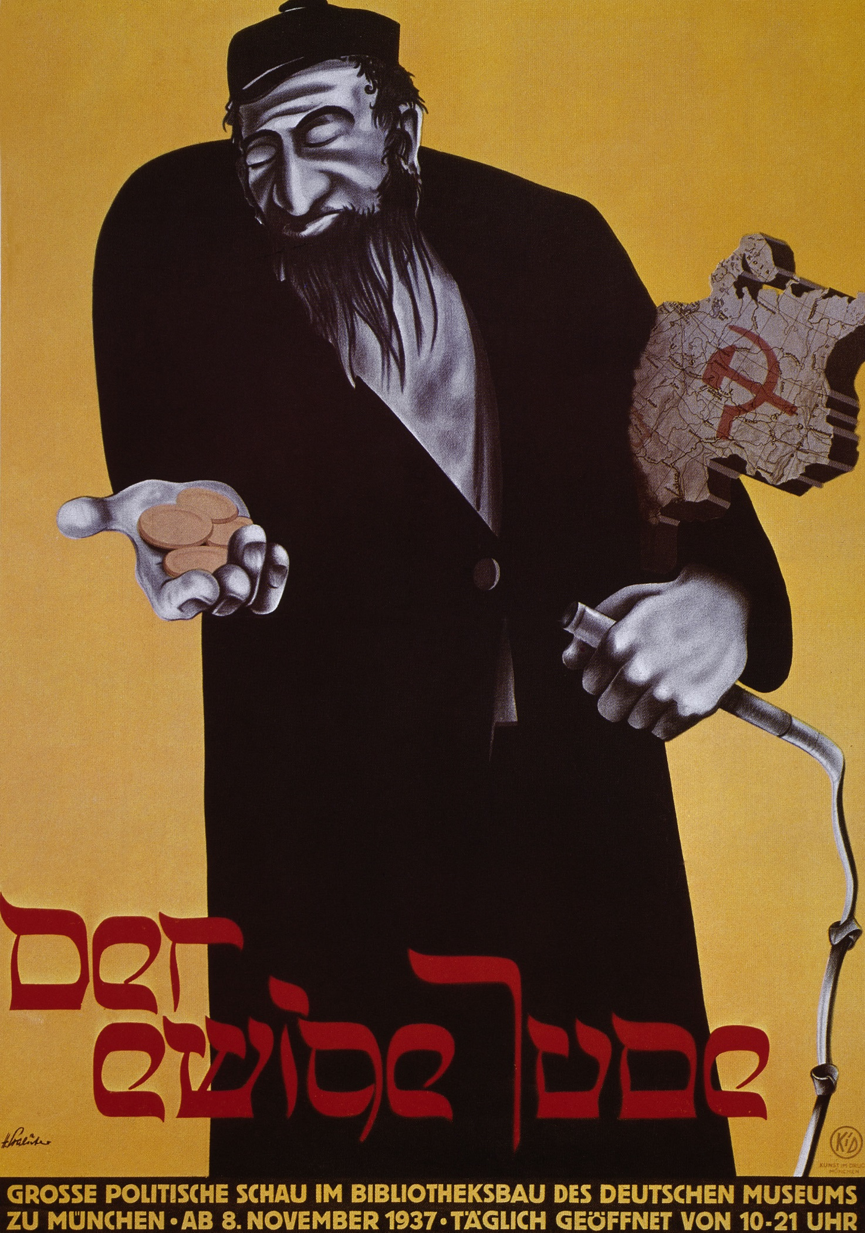
‘The Ethereal Jew’ (1937, Munich) Fig. 1
Conflict, controlled hatred and the survival of the Jewish religion are the key significant components of Judaism ever since the destruction of the second temple. Another example from post-second temple’s destruction is the ‘Arch of Titus’ which can still be viewed today on the Via Sacra in Rome. The Romans are seen in the arch carrying out Jewish scripture and the Menorah along with other Jewish artefacts. This was to show that the state in which the Jewish people lived and worshipped in, was no more, and was now under Roman rule. Partly, resulting in the Jewish diaspora (Yavneh and Usha era).
The Jewish religion and communities still fought for survival even in arguably, the biggest event of conflict in their history. Events like these are still remembered today within the Jewish religion worldwide. An event known as Tisha B’av which is a day of mourning and remembering the destruction of the second temple and other horrific events within the history of the Jewish religion until the believed coming Messiah is to be born on Tisha B’av. Additionally, the second temple will be restored on this day too.
‘We've survived. Many of you have come up to me and thanked me. Thank yourselves. Thank your fearless Stern, and others among you who worried about you and faced death at every moment.’
In conclusion, the destruction of the second temple is arguably the most significant event in Jewish history. Which has been significant due to innovations by influential figures such as Yohannan Ben Zakkai, Rabbi Maimonides and Moses Mendelssohn as only some examples. The horrific events such as the temple’s destruction, the Kokhba Revolt and the Holocaust have shown the world that Judaism has and always hopefully will prevail, innovate and somehow survive to become a bigger and more accepted religion in the years to come.

Bibliography
Christian Kim, Heerak, The Jerusalem Tradition in the Late Second Temple Period, 1st edn (Estover Road, Plymouth PL6 7PY, UK: University Press of America, inc, 2007)
De Lange, Nicholas, An Introduction To Judaism, 2nd edn, (The Edinburgh Building, Cambridge CB2 8RU. Cambridge University Press. 2010)
J. Hunt, Stephen, Religion in Western Society, 1st edn (Houndmills, Basingstoke, Hampshire RG21 6XS: PALGRAVE, 2002)
Neusner, Jacob, Judaism: The Evidence of the Mishnah, 1st edn, (United States of America, University of Chicago Press. 1981)
Segal, Eliezer, Introducing Judaism, 1st edn, (711 Third Ave, New York, NY 10017. Routledge. 2009)
‘The Ethereal Jew’ (1937, Munich) Fig. 1
‘THE WARS OF THE JEWS OR HISTORY OF THE DESTRUCTION OF JERUSALEM (<documentacatholicaomnia.eu/03d/…Josephus, _De_Bello_Judaico, _EN.pdf>) [accessed 17-28 September 2018]

Segal, Eliezer, Introducing Judaism, 1st edn p. 40
War (19:2)
‘The Story of the Jews’, dir. By Simon Schama (BBC Two, 2013)
(Hebrews 4:12-13): New Revised Standard Version
Neusner, Jacob, A Life of Rabban Yohannan Ben Zakkai: Ca I-80CE, 2nd edn p.11
Yehudah Halevi: ‘Jerusalem’ Poem
Another modern example of anti-Jewish propaganda. However, with new innovations coming into the Jewish religion through the middle ages and Haskalah. They still faced harsh conflict by other religions and groups who were filled with hatred and despise of the Jews. Just like the hate attack by the Romans which caused the fall of the second temple. My example for this will be the ‘Second World War’ and ‘Nazi Germany’. From Hitler’s rise to power in 1933 straight through to the end of the second world war in 1945, Jews were stereotyped and hated upon within Germany. Blamed for Germany’s loss of the first world war, many hate attacks were laid upon them such as ‘Kristallnacht’ This attack resulted in many Jewish synagogues, schools, hospitals businesses and family homes being destroyed by Nazi rioters. Which further led towards the ‘Final Solution’ and ‘Holocaust’ resulting in the deaths of over six million Jewish people across the world. This hatred was spread mainly by propaganda. The Jewish religion has a history of being discriminately stereotyped. Making many people begin to hate Jews. Hence, what they read about them in the media and newspapers making them think in certain ways. (lead by Josef Goebbels) Arguably, helping in Hitler’s rise to power of dictator and the resulted actions of the second world war and Holocaust.
‘Schindler’s List, dir. By Steven Spielberg (Universal Pictures, 1993) [DVD]

