Assignment Title: Cultural Awareness (BMIH5003)
Student Name: Suhel Miah
Student ID: 2017367
Lecturers Name: Mike Davies
Executive Summary
Hotel staff has to deal with different kinds of people who come from different cultural backgrounds. Working in an international hotel is always challenging for any employees as they have to deal with people from different countries’ cultural backgrounds. Dealing with international guests requires the knowledge of cultural nuances to make the guest feel that they are getting services in their home country in their preferred way. Every hotel management should focus on increasing cultural awareness among their hotel staff.
The report with an aim to find out the insights into cultural differences and likeliness between France and China have demonstrated the well-known Hofstede’s model. The report also tried to show some service failures due to the lack of awareness of Chinese culture. The report has used the example of one of the most luxurious hotels Hilton Paris Opera. The six dimensions described in Hofstede’s model are analysed in this report for a better understanding of the cultural differences.
The report finds out that there are differences and similarities to some extent between the cultures of France and China. Differences in the dimension such as individualism, masculinity, and uncertainty avoidance are observed significantly in this report. So, the hoteliers should focus more on these areas in serving guests from China. Finally, the report has provided some guidelines for hotel staff of both countries.

Contents
Introduction 1
Country A 2
Country B 3
Country Analysis 5
Hotel Handbook (Do’s and Don’ts) 6
Conclusion 7
References 8

Introduction
Cultural awareness helps an individual in understanding the nuances between his/her own culture and the culture of others (Kristina Urbonienė, 2015). Serving international guests requires a deep understanding of the guests’ culture to avoid meeting the expectations of the guests. The report will analyse the culture of France as a host country and China as a guest country by using the Hofstede model. The report will also try to provide some guidelines for the hotel staff of both countries.

Country A
Hilton Paris Opera is situated at 108 Rue Saint-Saint-Lazare, 75008 Paris, France is a luxury hotel of France (HiltonParisOpera, n.d.). Hofstede’s model is illustrated below to analyse France’s culture.

Figure 1: Hofstede's cultural dimension model. Source: (Minkov and Hofstede, 2010)
France scores on the six dimensions of Hofstede’s model are illustrated in the following figure.
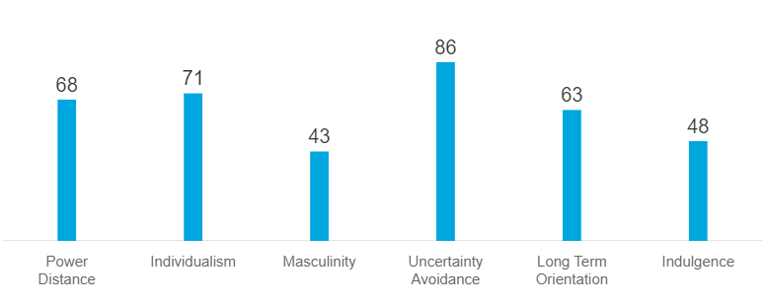
Figure 2: France's score on Hofstede's model. Source: (Hofstede Insights, 2017).
Power Distance
France’s score in the power distance dimension is high indicating justification on the acceptance of a minimal level of inequalities. Hierarchical levels are maintained to a certain extent in France. The hotel staff may likely differ guests based on their status.
Individualism vs Collectivism
People of France belong to an individualistic society accounting for a score of 71 in the individualism dimension (Potot, 2013). The hotel staff of France belonging to the individualistic society will tend to be performance-oriented and try to serve the guest in the best way.
Masculinity vs Feminine
France holds below average in the masculinity dimension. Belonging to the feminine society, the hotel staff of France tend to be caring.
Uncertainty Avoidance
With a score of 86, the people of France are likely to take adequate preparation to avoid any uncertainties in the future. The hotel staff of France will take necessary preparation and will design their services in a structured way.
Long-term vs Short-term Orientation
In the long-term orientation, the score of France is high which means that France belongs to a pragmatic society. The hotel staff of France will be perseverant to achieve results in serving international guests.
Indulgence
France’s score in indulgence is 48 which refers France may tend to give less importance to leisure and they love their works (Kang and Um, 2018). The people working in the hospitality industry tend to be more concentrated on their work and try to satisfy their guests as part of their job.

Country B
China is one of the growing economies of the world. China’s scores on the cultural dimension given referred to in Hofstede’s model are illustrated below.
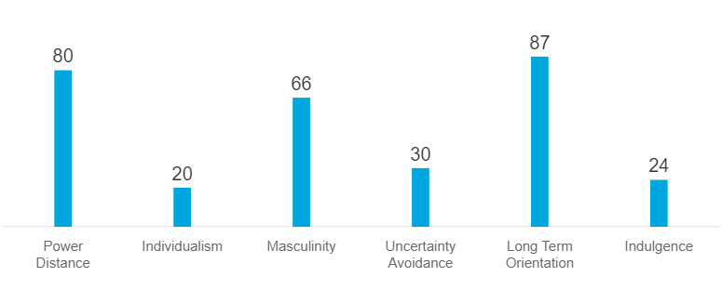
Figure 3: China's scores on cultural dimensions. Source: (Hofstede Insights, 2018)
Power Distance
China cuts a high figure in the power distance, where its score is 80. The high score on power distance entails that China maintains a certain level of hierarchical status. The guest of China in taking international hotel services may likely be more demanding in terms of service and respect.
Individualism vs Collectivism
China belongs to a collectivist society as its score is 20 in the individualism dimension (Pingfang, 2001). So, Chinese guests may love to build a personal relationship with the hotel staff. They may expect they will be treated with the utmost care and attention.
Masculinity vs Feminine
China’s score in masculinity is 66 which means that China fosters a masculine society. Chinese guests may like the service-oriented hotel staff. They are likely to hope that the hoteliers will be self-assertive in solving any guest’s complaints.
Uncertainty Avoidance
The uncertainty avoidance score of China is 30 which means Chinese people may take any unexpected situation happening in the time of taking international hotel services easily and normal way. In any service failure situation, guests from China may not be rude to the hotel staff.
Long-term vs Short Orientation
China holds a very high score in long-term orientation, and the guest of China belong to a pragmatic society. The guest may try to adjust to other international cultures.
Indulgence
The low score in indulgence indicates that China’s society is retrained. The people of a restrained society don’t give much time to leisure time spending (Aleqedat, 2021).

Country Analysis
There are some likeliness and differences between the culture of France and China. China and France have similarities in power distance, long-term orientation, and indulgence whereas there are remain differences in the rest of the three dimensions of Hofstede’s model.
The comparison of the culture between China and France.
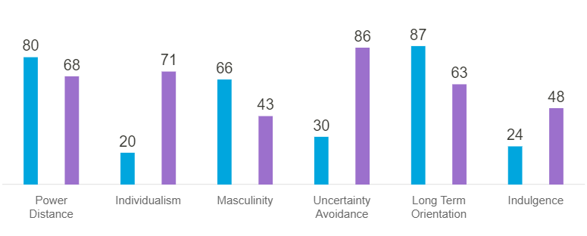
Figure 4: Cultural comparison between France and China. Source: (Hofstede Insights, 2021).
Both Chinese and French people belong to a society of high power distance. But in serving the Chinese guests, the hotel staff of Hilton Paris Opera should understand the cultural nuances of China with France. China belongs to a collectivistic society whereas France belongs to an individualistic society. So, hotel staff should try to build rapport with Chinese guests while providing the utmost care and respect to them.
The elderly people of China expect that they will be addressed by using the honorific word. Addressing Chinese guest without using honorific word make guests dissatisfied. Praising the external beauty of Chinese guests is not usual and they may take it as an offending act (Yingxin, 2020). So, the hotel staff shouldn’t give compliments of external beauties of Chinese guests.

Hotel Handbook (Do’s and Don’ts)
In the following table, certain guidelines for the hotel staff for avoiding cultural misunderstanding are provided.
Etiquettes | Do’s and don’ts
Greetings | France | - Use hello in greetings.  - Don’t be in a sad mood.
Greetings | China | - Do use seniority words in addressing guests.  - First address senior people.
Handshakes | France | - Maintain eye contact.  - Don’t make the handshake too long.
Handshakes | China | - Do use nod instead of a handshake.  - Don’t make the handshake too firm.
Presenting gifts | France | - Do give flowers, perfumes, candies, etc.
Presenting gifts | China | - Give gifts with both hands.  - Do gift miniature items like books, recoding, etc.  - Don’t force for unwrapping gifts.
Praising | France | - Do use the word beautiful and handsome in praising French guests.
Praising | China | - Provide praise politely.  - Don’t praise external beauty.
Punctuality | France | - Don’t late more than 5 minutes.
Punctuality | China | - Be more punctual in serving Chinese guests.
Food | France | - Offer both forks and knives.
Food | China | - Do offer Chinese dishes.
Others | France | - Use name in addressing guests.
Others | China | - Avoid asking sensitive questions.  - Don’t use black in gift wrapping.

Conclusion
The report has analysed both the cultures of France and China by using the Hofstede model. The report should how Chinese guests should be treated in France to avoid service failure. The report also provided some guidelines for the hotel staff of both countries.

References
Aleqedat, H.Q. (2021). Does Cultural Hofstede dimension “Indulgence versus Restraint” impact the Corporate Performance. Journal of Sustainable Community Development (JSCD), 3(2), pp.111–118.
HiltonParisOpera (n.d.). Hilton Paris Opera | Luxury hotel in Paris. [online] Hilton Paris Opera. Available at: https://www.hiltonparisoperahotel.com/ [Accessed 16 Feb. 2022].
Hofstede Insights (2017). France - Hofstede Insights. [online] Hofstede Insights. Available at: https://www.hofstede-insights.com/country/france/.
Hofstede Insights (2018). China - Hofstede Insights. [online] Hofstede Insights. Available at: https://www.hofstede-insights.com/country/china/.
Hofstede Insights (2021). Country Comparison - Hofstede Insights. [online] Hofstede Insights. Available at: https://www.hofstede-insights.com/country-comparison/china.
Kang, K.-H. and Um, H.-S. (2018). An Analysis of “Asterix”, the Cultural Soft Power of France. Academic Association of Global Cultural Contents, 32, pp.1–21.
Kristina Urbonienė (2015). Educating for Cultural Awareness. US-China Foreign Language, 13(10).
Minkov, M. and Hofstede, G. (2010). Hofstede’s Fifth Dimension. Journal of Cross-Cultural Psychology, 43(1), pp.3–14.
Pingfang, X. (2001). Perspectives on the Regionalization of Chinese Archaeological Cultures in Historic Times. Chinese Archaeology, 1(1).
Potot, F. (2013). A Case Study of Women’s Participation in DIY in France: Towards an Increasingly Androgynous and Individualistic French Society? Nottingham French Studies, 52(1), pp.59–80.
Yingxin, Z. (2020). A Study of Some Cultural Differences Between China and English-Speaking Countries. Journal of Educational Theory and Management, 4(2), p.12.

