
Skills for the Workplace
Module Assignment Submission
Student Name: | ABDUR RAHIM ROAP
Student Number: | 1911044
Module No: | BMSK4002
Module Title: | Effective Team Working and Communication Part 2

Statement of Confirmation of Authenticity
By the act of making this submission, the student declares that this is the work of the student named above. The work has not, in whole or in part, been knowingly presented elsewhere for assessment, or where assessment has been built on a previous assessment, this has been identified. Where materials have been used from other sources it has been properly acknowledged. If this statement is untrue, the student acknowledges that an assessment offence has been committed.
Attention is drawn to the plagiarism and unfair practice policies of both the University and of ILM.

Table of Contents
What is Communication? 3
Why do we communicate? 3
Forms of Communication 4
The Communication Cycle 4
The Sender 4
The Message 5
The Channel 5
The Receiver 6
The Feedback 6
The Environment 6
The Context 7
The Interference 7
Communication Models 7
Shannon and Weaver’s Model of the Communication Process 8
Critique 8
Types of Communication Models 9
In short 10
Barriers to Communication 10
Noise and Misunderstanding 10
Barriers to effective communication and the way forward 11
The practicalities of effective communication in the workplace 12
Assessing own communication skills 13
Conclusion 13
References 14
Bibliography 17
Appendix A -S.W.O.T Analysis 21
Appendix B - Gap Analysis 21
Appendix C - Personal Development Plan 22
Appendix D - Questionnaires 23
Skills You Need Communication Quiz results 23
Mind Tools Communication Quiz 24
Communication Effectiveness Questionnaire 25
Communication Style Questionnaire 26

What is Communication?

If you were to look up the definition of communication, you will find a diverse array of answers for example, according to Pearson, J., & Nelson, P. (2000) it’s “the process of understanding and sharing meaning”. The Oxford Dictionary on the other hand express’s communication as the “imparting or exchanging of information by speaking, writing, or using some other medium” (Leigh-Hunt, N. 2016).

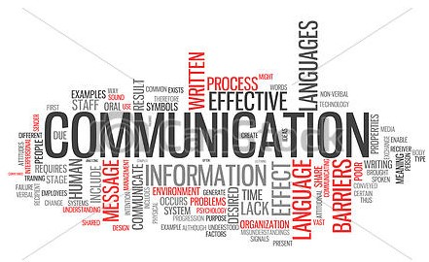

The etymology of "communication" is derived from the Latin word "communis," which means "common" Weekley, E. (1967) and it includes all human communications. interaction. Academics who study communication investigate the human element and its effectiveness. As such it is a characteristic of human nature to interact with one and another as individuals or as groups on a social basis” (Velentzas et al. 2010)

Why do we communicate?

The Irish playwright, George Bernard Shaw, said: “The single biggest problem in communication is the illusion that it has taken place.”

So, what are reasons to communicate; Here are some examples;

- guides your way of thinking
- helps how you learn
- epitomises you and your employer
- enables people to receive different business information
- is a core management skill
- skills are a desirable trait for business and industry;

Forms of Communication
According to Bremmer (2006), “the words we choose when we speak are said to be based on three factors: the social distance between the speaker and listener, the relative power of the speaker, and the degree of imposition he/she is making”. How we do this comes in many forms and, basically, there are;
Verbal communication: manifests itself when two people converse and tune in as to what the other has to say.
Non-verbal communication: referred to as body language. Because it involves using the body and appearance to communicate. For example, paralinguistic (the study of vocal signals beyond the verbal message) a non-verbal communication conduit that is always constant. Research shows that nearly half of all meaning in a message is nonverbal; but nonverbal communication can convey the entire message (DuBrin, 2000)
Other forms of communication include visual, extra personal, intrapersonal, organisational, and mass communication.

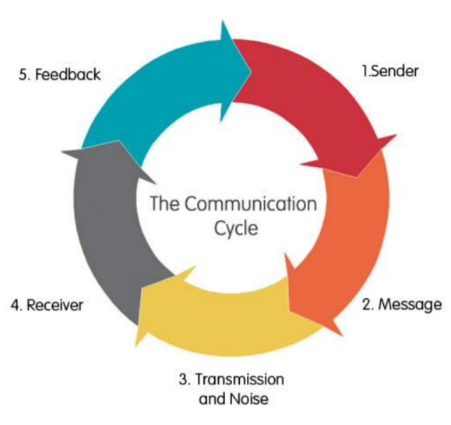
The Communication Cycle
Now that communication has been defined, then what is the communication cycle?
The Communication cycle is a way in which you can measure the effectiveness of intercommunication. Choosing the right methodology of delivery will expedite its effectiveness. Different interpretations of the cycle may include different stages and terminology, but most agree on the basic elements.
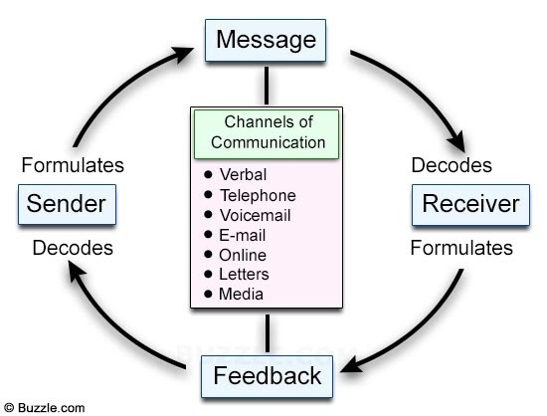
The Sender
The source creates and sends the message. The first stage is determining the message. The second stage concerns encoding the message by choosing just the correct delivery to convey the intended meaning. The third step is to present or send the information to the receiver. Finally, the response or feedback from the recipient.

The Message
“The message is the stimulus or meaning produced by the source for the receiver or audience.” (McLean, 2005) This consists of the words chosen, the way they are constructed, the way it’s conveyed, and context.

The Channel
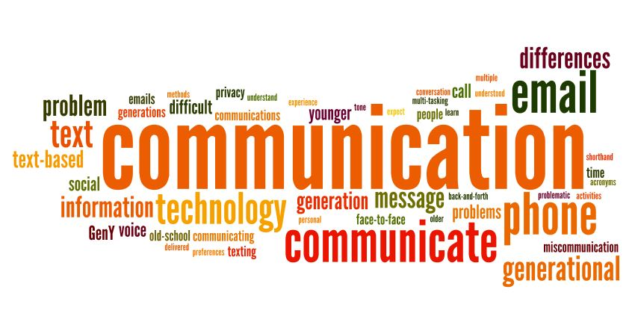
“The channel is the way in which a message or messages travel between source and receiver.” (McLean, 2005). The sender transmits the encoded message through a media channel such as telephone e-mail etc. to the receiver.

The channel directly affects the quality of communication. Research by Richard Daft and Robert Lengel (1996) found that channels differ in their capacity to convey information and some are more effective than others. This is bi-directional.
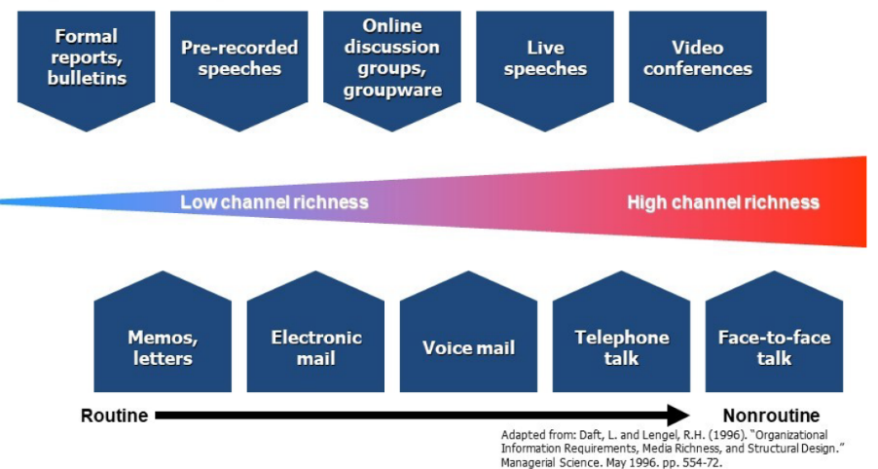

The Receiver
“The receiver receives the message from the source, analysing and interpreting the message in ways both intended and unintended by the source.” (McLean, 2005). The receiver tries to interpret the message by decoding its content and take into account previous experience when doing so.

The Feedback
A response to a message constitutes giving feedback. According to Mehrabian & Weiner (1967), “feedback is composed of messages the receiver sends back to the sender. Therefore, feedback is the manner and degree to which a receiver responds to a message”.
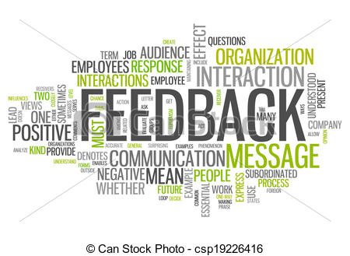
As the amount of feedback increases, the accuracy of communication also increases (Leavitt & Mueller, 1951).
From a systems theory perspective, Bertalanffy (Bertalanffy, 1972) considered feedback is crucial for individual and group growth and performance. Applied to enhance effectiveness to garner constructive feedback.
Therefore, soliciting and correctly interpreting feedback is key to enhancing the effectiveness of communication. Without feedback, you cannot improve the way that you communicate your message

The Environment
“The environment is the atmosphere, physical and psychological, where you send and receive messages.” (McLean, 2005). Simply put; your surroundings. This may include people, animals, and technology.

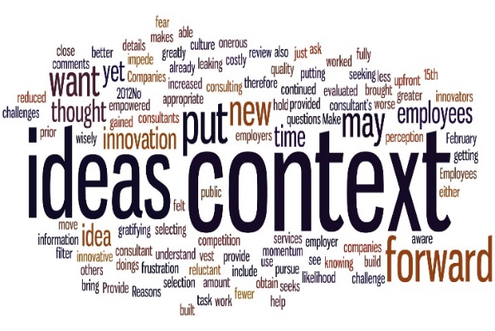
The Context
“The context of the communication interaction involves the setting, scene, and expectations of the individuals involved.” (McLean, 2005).

The Interference
Interference, also called noise, can come from any source. “Interference is anything that blocks or changes the source’s intended meaning of the message.” (McLean, 2005) 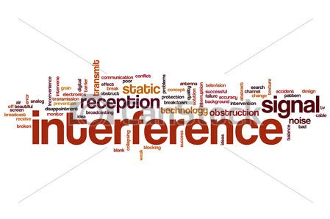Key takeaway
Sending an email is not communication; it’s simply sending a message. For communication to ensue, the sender must solicit and receive a response. This completes cycle. By effectively managing the cycle, you are able to develop conversations that successfully maintain the cyclical nature of communication.
However, some behavioural scientists argue that communication conflict has a beneficial outcome for communication to perform effectively (Robbins, 2003).

Communication Models

According to 2Communication models are representations of the process which helps in understanding how communication works”.
Over time, the field of communication has morphed but one abiding factor that binds them all is Shannon’s classic Model of Communication (1948). Chapter after chapter has been written as an introduction in published literature, such as Adler, (1991) and Wood, (2002). Figure 1 provides, a breakdown of the flow of a message from source to destination and in doing so, provided, a general model of the communication.
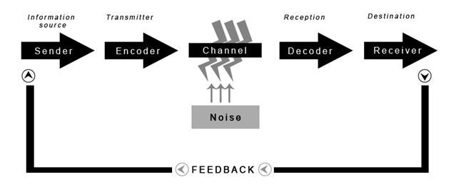
Fig. 1 – Shannon and Weaver’s Model of Communication (1949)

Shannon and Weaver’s Model of the Communication Process
Shannon-Weaver model (1949) is typical of what is often referred to as a transmission type of communication. Ellis and McClintock (1990) describe this as “a linear, one-way process in which a sender intentionally transmits a message to a receiver” the elements of which can be found in Figure 1.

Critique
Shannon and Weaver’s model of communication is considered by some in the field as incomplete because it serves to show the flow of information that is better suited through a channel. An example of this would be the telephone.
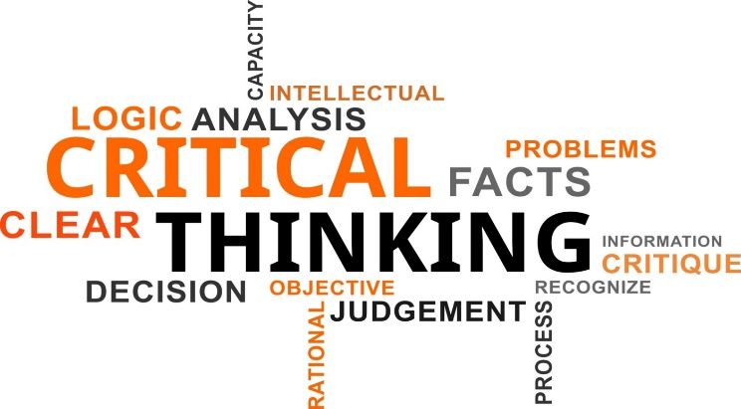
In the real world, messages can be stored in the cloud and accessed from any location and by anyone and therefore communication is often unidirectional and indirect.
This was addressed in Katz's intermediary model of communication (Katz, E. 1957). It’s focal point, mass communication, and the role of intermediaries in the communication process. There are, however, many intermediary roles (Foulger, 2002a) associated with the communication.

Types of Communication Models
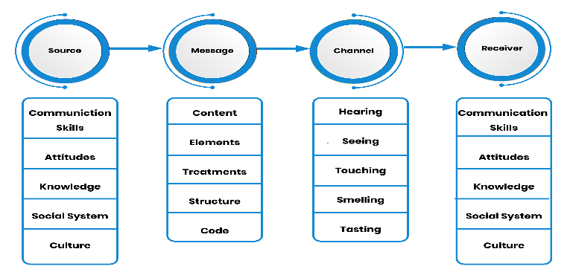
There are three types of communication models in which all other communication models mainly fall under.
The first Linear model, examples of which are Shannon and Weaver and Berlo’s S-M-R-C Models (Fig. 1). These are simple one-way communication model with no concept of feedback.
Fig 2 - Berlo’s SMCR model of communication
With the Transactional Model of Communication, senders and receivers both are known as communicators and both play an equally important role in communication. They are current, have context, and adopt non-verbal feedback.
Models that adhere to this model type are:
- Barnlund’s Transactional Model (1970)
- Frank Dance Helical Model (1967)
- Becker’s Mosaic Model (1968)
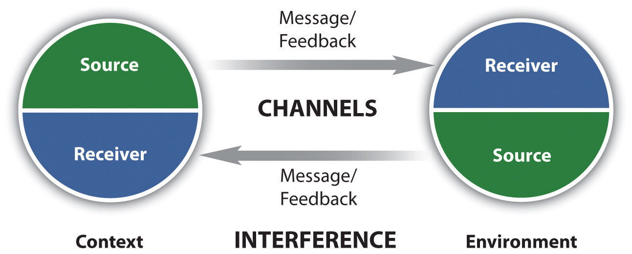

Fig 3. Transactional Model of Communication

Furthermore, transaction models differ from others in the application, the role of the sender and receiver, and context (Barnlund, 1970).
Interactive Model of Communication is similar to a transactional model. However, it’s best suited for modern mass media. A proponent of this type is Schramm’s Interactive Model (1954). Both sender and receiver alternate positions and garner a greater understanding through b-directional feedback,
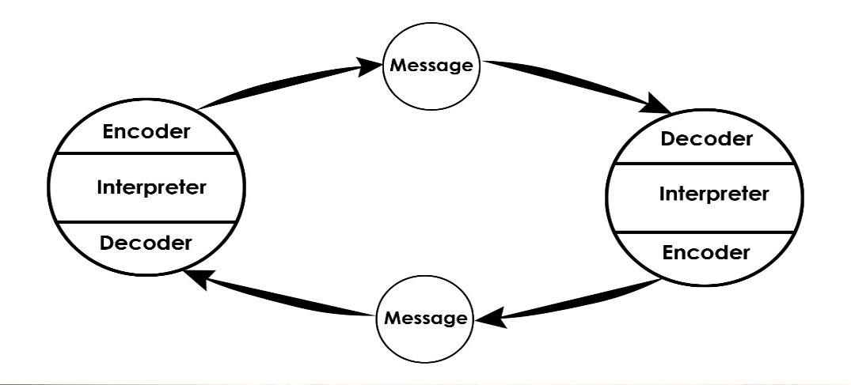
Fig 4. Schramm’s Interactive Model

However, this model is not perfect as it does not give credit to the receiver A transactional model developed to balance this shortcoming is Watzlawick, Beavin, and Jackson’s (1967) model.

In short
Communication models are not accommodating enough to grasp all that takes place in communication. But they can help examine the steps in the process to better understand communication and in doing so we can use them for enhancing effective communication.

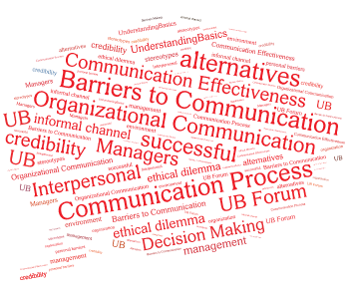
Barriers to Communication
Personal Barriers relate to the factors that are personal to the sender and receiver and act as a hindrance in the communication process.
Whereas, organisational barriers refer to the impediment in the flow of information among the employees.

Noise and Misunderstanding
Noise sometimes known as interference refers to anything that interferes with the communication process between a sender and receiver. It can be both external or internal and it can disrupt communication at any point or anything that affects successful communication. Noise is a barrier to effective communication (Shannon, C. E 1998)
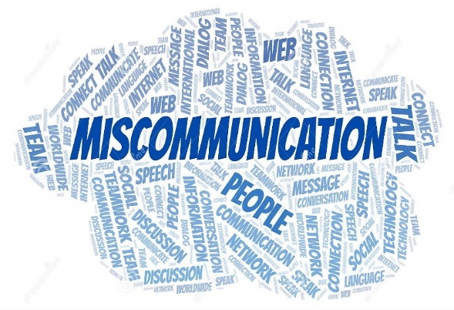
Types of noise include, physiological, physical, psychological, and sematic (interpretation).
Understanding how misunderstanding arises arms us with the knowledge to counter it.
Causes for misunderstanding are explicit or implicit communication, written or verbal, competitive conversations, negative bias, poor listening, and speaking skills, misaligned jargon and mental models – a different interpretation of what is said
Identifying the culprit can help avoid errors in any organisation.
According to Susan Washburn (2008), miscommunication can lead to conflict, loss of productivity, inefficiency, missed opportunities, and unmet objectives.

Barriers to effective communication and the way forward
So, what is effective communication? “Effective communication occurs when the desired effect is the result of intentional or unintentional information sharing, which is interpreted between multiple entities and acted on in the desired way”. Velentzas, John. (2014). By understanding the steps in the communication process, it propagates effective communication.
Factors that hinder effective communication include language, physical barriers, noise, information overload, using technical language, emotional bond between sender and receiver, too many intermediaries, the inconsistency of message and generational conflict (Zemke et al., 2000).
Ways of improving effective communication include active listening, study and understand non-verbal communication, be aware of cultural differences, learn the 7 C’s of Communication (Mulder, P 2013), and finally question skills. Here, “managers and employees should identify possible reasons why someone might be asking questions rather than jumping to the wrong conclusions” (Deal, 2007).
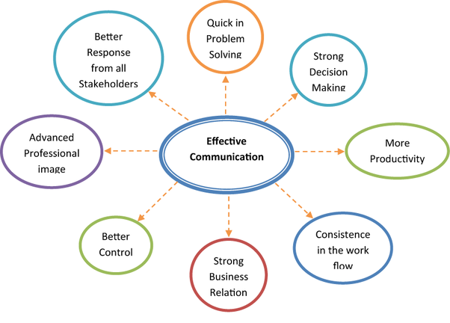
Being effective involves knowing how to avoid miscommunication by taking responsibility in the communication process to ensure proper understanding.

The practicalities of effective communication in the workplace
What Is workplace communication?
“Exchanging information and ideas, both verbal and non-verbal between one person/group and another person/group within an organization is called workplace communication. It includes e-mails, text messages, notes, calls, etc. Effective communication is critical in getting the job done, as well as building a sense of trust and increasing the productivity of employees”. (Faizal, F. 2019)
Today, business success depends on effective communication. (Kristina L. Guo and Yesenia Sanchez. 2005). It is critical for productivity, positive workplace relationships, and the expansion and success of the business.
At LS Wholesale Ltd, my employers, there are many barriers to effective communication. Primarily, they consist of language and cultural indifferences. The workforce consists of a diaspora of people from different ethnic backgrounds that use different languages and cultural norms. For many English is not their first language both spoken or written. Though Bengali is the primary language for many, differences in regional dialect make comprehension difficult.
In this scenario “the intent of the sender can be different from the understanding of the receiver” (Schermerhorn, Hunt, & Osborn, 2007).
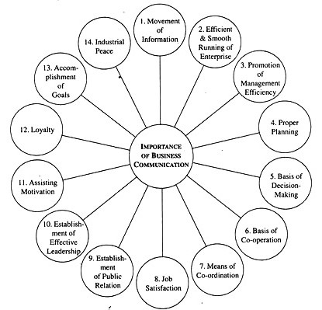
In this maelstrom giving and following instructions do not follow the linear model of communication. It is an amalgamation of transactional and transmission model types as communication is omnidirectional and, non-verbal methods as paralinguistic communication utilised frequently. This has its flaws though. Statistics show that 257% of employees report not being given clear directions and 69% of managers’ report feeling uncomfortable communicating with the employees in general” Solomon, L. (2016). The company has invested in English lessons to alleviate this barrier and improve the level of communication.

Assessing own communication skills
According to the Business Dictionary, communication skills are “the ability to convey information to another effectively and efficiently. Business managers with good verbal, non-verbal, and written communication skills help facilitate the sharing of information between people within a company for its commercial benefit”. To this end, I have outlined my skills through the assessment of a S.W.O.T analysis, a Gaps analysis and a personal development plan. The methodology; the completion of several questionnaires (see Appendix A) to ascertain my communication skill level. I have attached the S.W.O.T analysis, the GAP analysis, and the Personal development plan in Appendices B, C, and D to demonstrate this.

Conclusion
The communication process involves understanding, sharing, and meaning, and it consists of essential elements. This, in turn, has led to communication models that are the fundamental building block and instructive tools for this process.
Furthermore, communication is a key aspect in the success of any organisation. As such, managers should be highly effective communicators using the correct channel and negate any barriers to effective communication.

References

Adler, R. B. and Rodman, G. (1991). Understanding Human Communication. Chicago; Holt, Rinehart, and Winston.
Barnlund, D. C. (1970). “A Transactional Model of Communication,” in Foundations of Communication Theory, eds. Kenneth K. Sereno and C. David Mortensen (New York, NY: Harper and Row, p. 83–92.
Bertalanffy, L. V. (1972). The history and status of general system theory. Academy of Management Journal, 15, p. 407-425.
Blenkinsop, P. (2010). The Communication Cycle. [online] available at http://manyana-education.blogspot.com/2010/10/communication-cycle.html accessed 18 May 2020
Bremner, Stephen. (2006). Politeness, Power, and Activity Systems: Written Requests and Multiple Audiences in an Institutional Setting. Written Communication - WRIT COMMUN. 23. p .397-423.
BusinessDictionary (2020) ‘Communication Skill’ [online] available at http://www.businessdictionary.com/definition/communication-skills.html accessed 18 May 2020
C. E. Shannon, C.E. (1998) "Communication in the Presence of Noise," in proceedings of the IEEE, vol. 86, no. 2, p. 447-457, [online] available at http://www.ee.oulu.fi/~kk/dtsp/tutoriaalit/shannonpaper.pdf accessed 18 May 2020
Daft, R. L., & Lengel, R. H. (1996). Organizational information requirements, media richness, and structural design. Managerial science, p. 554-572.
Deal, J. J. (2007). Retiring the generation gap: How employees young and old can find common ground. San Francisco: Jossey-Bass.
DuBrin, A. J. (2000). Applying psychology: Individual and organizational effectiveness. New Jersey: Prentice Hall, Inc.
Ellis, R. and McClintock, A. (1990) You take my meaning: Theory into practice in Human Communication, London: Edward Arnold, p. 71.
Faizal, F. 2019 What Is Workplace Communication & shy does it matter? [online] available at https://www.feedough.com/what-is-workplace-communication-why-does-it-matter/ accessed 18 May 2020
Foulger, D. (2002a). Roles in Media. Presented at National Communication
Association Summer Conference [online] available at http://davis.foulger.info/papers/ecologicalModelOfCommunication.htm accessed 18 May 2020
George Bernard Shaw (1856 -1890) [online] available at https://philosiblog.com/2012/01/06/the-single-biggest-problem-in-communication-is-the-illusion-that-it-has-taken-place/ accessed 18 May 2020

Katz, E. (1957). The two-step flow of communication: an up-to-date report on an hypothesis. Public Opinion Quarterly, 21, p. 67-78.
Kristina, G. L and Sanchez, Y. (2005) Chapter 4: Workplace Communication [online] available http://healthadmin.jbpub.com/Borkowski/chapter4.pdf accessed 18 May 2020
Leigh-Hunt, N. (2016) Principles, theories and methods of effective communication (written and oral) in general, and in a management context [online] available at https://www.healthknowledge.org.uk/public-health-textbook/organisation-management/5a-understanding-itd/effective-communication accessed 18 May 2020
Leavitt, H., & Mueller, R. (1951). Some effects of feedback on communication. Human Relations, 4, p. 401–410.
McLean, S. (2005). The basics of interpersonal communication. Boston, MA: Allyn & Bacon, p. 10.
Mehrabian, A., & Weiner, M. (1967). Decoding of inconsistent communications. (A. a.-1. Mehrabian, Ed.) Journey of personality and social psychology (6), p. 109-114.
MindTools (2019) How good are your communication skills? [online] available at https://www.mindtools.com/pages/article/newCS_99.htm accessed 18 May 2020
Mulder, P (2013). 7 C’s of Communication [online] available at https://www.toolshero.com/communication-skills/7cs-of-communication/ accessed 18 May 2020
Pearson, J. and Nelson, P. (2000). An introduction to human communication: Understanding and sharing. Boston, MA: McGraw-Hill. p. 6.
Robbins, S. P. (2003). Organizational behaviour. New York, NY: Prentice Hall.
Shannon, C. and Weaver, W. (1949). The Mathematical Theory of Communication. Urbana: University of Illinois Press.
Schermerhorn, J. R., Hunt, J. G., and Osborn, R. N. (2007). Organizational Behaviour (9th ed.). New York: John Wiley & Sons, Inc.

Schramm, W. (1997), The Beginnings of Communication Study in America (Thousand Oaks, CA: Sage.
Skills You Need (2019) Interpersonal Skills Self-Assessment. [online] available at https://www.skillsyouneed.com/ls/index.php/343479 accessed 18 May 2020
Solomon, L. (2016). Two-Thirds of Managers Are Uncomfortable Communicating with Employees [online] https://hbr.org/2016/03/two-thirds-of-managers-are-uncomfortable-communicating-with-employees accessed 18 May 2020
Velentzas, J. (2014) “Communication cycle: Definition, process, models and examples.” [online] available at https://www.semanticscholar.org/paper/Communication-cycle-%3A-Definition-%2C-process-%2C-models-Velentzas/da4e69265653057d6f03fdc4ce3692b4e6923a0f p122 accessed 18 May 2020
Velentzas, Mamalis and Broni. (2010) Communication, Public Relations & Advertisement, 2010, p. 26.
Washburn, S. (2008). The miscommunication gap. ESI Horizons, 9(2). https://www.modernanalyst.com/Resources/Articles/tabid/115/ID/244/The-Miscommunication-Gap.aspx accessed 18 May 2020
Watzlawick, P., & Beavin, J. H,. B., & Jackson, D. D. (1967). Pragmatics of Human communication: A study of interactional patterns, pathologies, and paradoxes. New York: Norton
Weekley, E. (1967). An etymological dictionary of modern English (Vol. 1). New York, NY: Dover Publications. p. 338.

Wood, J. T. (2002). Interpersonal Communication: Everyday Encounters. Wadsworth/Thomson Learning.
Zemke, R., Raines, C., & Filipczak, B. (1999). Generations at work: Managing the clash of veterans, boomers, Xers, and nexters in your workplace. New York: AMACOM

Bibliography

Adler, R. B. and Rodman, G. (1991). Understanding Human Communication. Chicago; Holt, Rinehart, and Winston.
Association of Colleges (2014) Module 4: Working Relationships [online] available at https://www.aoc.co.uk/files/module-4-working-relationshipspdf accessed 18 May 2020
Associated Press. (2017). Lack of comma, sense, ignites debate after $10m US court ruling. CBC News | Business. [online] available at http://www.cbc.ca/news/business/comma-lawsuit-dairy-truckers-1.4034234 accessed 18 May 2020
Austen, I. (2006). The comma that costs 1 million dollars (Canadian). The New York Times. [online] available at http://www.nytimes.com/2006/10/25/business/worldbusiness/25comma.html accessed 18 May 2020
Bajracharaya, S. (2018) Helical Model of Communication [online] available at https://www.businesstopia.net/communication/helical-model-communication accessed 18 May 2020
Barnlund, D. C. (1970). “A Transactional Model of Communication,” in Foundations of Communication Theory, eds. Kenneth K. Sereno and C. David Mortensen (New York, NY: Harper and Row, 1970), p. 83–92.
Bertalanffy, L. V. (1972). The history and status of general system theory. Academy of Management Journal, 15, p. 407-425.
Blenkinsop, P. (2010). The Communication Cycle. [online] available at http://manyana-education.blogspot.com/2010/10/communication-cycle.html accessed 18 May 2020
Bremner, S. (2006). Politeness, Power, and Activity Systems: Written Requests and Multiple Audiences in an Institutional Setting. Written Communication - WRIT COMMUN. 23. p .397-423.
BusinessDictionary (2020) ‘Communication Skill’ [online] available at http://www.businessdictionary.com/definition/communication-skills.html accessed 18 May 2020
Businesstopia in communication (2018). Becker’s Mosaic Model of Communication [online] available at https://www.businesstopia.net/communication/becker-mosaic-model-communication accessed 18 May 2020
Businesstopia in communication (2018) Barnlund’s Transactional Model of Communication [online] available at https://www.businesstopia.net/communication/barnlund-transactional-model-communication accessed 18 May 2020
C. E. Shannon, C.E. (1998). "Communication in the Presence of Noise," in proceedings of the IEEE, vol. 86, no. 2, p. 447-457, [online] available at http://www.ee.oulu.fi/~kk/dtsp/tutoriaalit/shannonpaper.pdf accessed 18 May 2020
Daft, R. L., & Lengel, R. H. (1996). Organizational information requirements, media richness, and structural design. Managerial science, p. 554-572.
Deal, J. J. (2007). Retiring the generation gap: How employees young and old can find common ground. San Francisco: Jossey-Bass.
DuBrin, A. J. (2000). Applying psychology: Individual and organizational effectiveness. New Jersey: Prentice Hall, Inc.
Ellis, R. and McClintock, A. (1990). You take my meaning: Theory into practice in Human Communication, London: Edward Arnold, p. 71.
Faizal, F. (2019). What Is Workplace Communication & why does it matter? [online] available at https://www.feedough.com/what-is-workplace-communication-why-does-it-matter/ accessed 18 May 2020
Foulger, D. (2002a). Roles in Media. Presented at National Communication Association Summer Conference [online] available at http://davis.foulger.info/papers/ecologicalModelOfCommunication.htm accessed 18 May 2020
George Bernard Shaw (1856 -1890). [online] available at https://philosiblog.com/2012/01/06/the-single-biggest-problem-in-communication-is-the-illusion-that-it-has-taken-place/ accessed 18 May 2020

Goffman, E. (1967). Interaction ritual; essays on face-to-face behavior. Garden City, N.Y., Doubleday. [online] available at
https://books.google.co.uk/books?hl=en&lr=&id=qDhd138pPBAC&oi=fnd&pg=PR7&dq=erving+goffman+1967+interaction+ritual+pdf&ots=9j27KYhGDt&sig=jC1eskEftr-8CBEWi3MQBhav9jM#v=onepage&q&f=false accessed 18 May 2020
John, A. (1962). How to do things with words [online] available at https://www.academia.edu/36270217/Austin_1962_how_to_do_things_with_words accessed 18 May 2020
Katz, E. (1957). The two-step flow of communication: an up-to-date report on an hypothesis. Public Opinion Quarterly, 21, p. 67-78.
Kristina, G. L and Sanchez, Y. (2005). Chapter 4: Workplace Communication [online] available http://healthadmin.jbpub.com/Borkowski/chapter4.pdf accessed 18 May 2020
Leigh-Hunt, N. (2016). Principles, theories and methods of effective communication (written and oral) in general, and in a management context available at https://www.healthknowledge.org.uk/public-health-textbook/organisation-management/5a-understanding-itd/effective-communication accessed 18 May 2020
Leavitt, H., & Mueller, R. (1951). Some effects of feedback on communication. Human Relations, 4, p. 401–410.
McLean, S. (2005). The basics of interpersonal communication. Boston, MA: Allyn & Bacon p. 10.
Mehrabian, A., & Weiner, M. (1967). Decoding of inconsistent communications. (A. a.-1. Mehrabian, Ed.) Journey of personality and social psychology (6), p. 109-114.
MindTools (2019) How good are your communication skills? [online] available at https://www.mindtools.com/pages/article/newCS_99.htm accessed 18 May 2020
Morgan, P. (2017). Business Student's Guide to Study and Employability. Los Angeles: SAGE.
Mulder, P (2013). 7 C’s of Communication [online] available at https://www.toolshero.com/communication-skills/7cs-of-communication/ accessed 18 May 2020
Ndawula ,S. (2018). Effective Communication [online] available at https://www.slideshare.net/StephenNdawula/effective-communication-87312432 accessed 18 May 2020
O’Bannon, G. (2001). Managing our future: The generation X factor. Public Personnel Management, 30, p. 95–109.
Pearson, J. and Nelson, P. (2000). An introduction to human communication: Understanding and sharing. Boston, MA: McGraw-Hill. p. 6.
Robbins, S. P. (2003). Organizational behaviour. New York, NY: Prentice Hall.
Shannon, C. and Weaver, W. (1949). The Mathematical Theory of Communication. Urbana: University of Illinois Press.
Schermerhorn, J. R., Hunt, J. G., and Osborn, R. N. (2007). Organizational Behaviour (9th ed.). New York: John Wiley & Sons, Inc.

Schramm, W. (1997). The Beginnings of Communication Study in America (Thousand Oaks, CA: Sage.
Skills You Need (2019). Interpersonal Skills Self-Assessment. [online] available at https://www.skillsyouneed.com/ls/index.php/343479 accessed 18 May 2020
Solomon, L. (2016). Two-Thirds of Managers Are Uncomfortable Communicating with Employees [online] available at https://hbr.org/2016/03/two-thirds-of-managers-are-uncomfortable-communicating-with-employees accessed 18 May 2020
Veglis, A. & Maniou, T. (2018). The Mediated Data Model of Communication Flow: Big Data and Data Journalism. 6. p. 32-43. [online] available at https://www.researchgate.net/publication/330187604_The_Mediated_Data_Model_of_Communication_Flow_Big_Data_and_Data_Journalism accessed 18 May 2020
Velentzas, J. (2014). “Communication cycle: Definition, process, models and examples.” [online] available at https://www.semanticscholar.org/paper/Communication-cycle-%3A-Definition-%2C-process-%2C-models-Velentzas/da4e69265653057d6f03fdc4ce3692b4e6923a0f p122 accessed 18 May 2020
Velentzas, Mamalis and Broni. (2010) Communication, Public Relations & Advertisement, 2010, p. 26.
Washburn, S. (2008). The miscommunication gap. ESI Horizons, 9(2). https://www.modernanalyst.com/Resources/Articles/tabid/115/ID/244/The-Miscommunication-Gap.aspx accessed 18 May 2020
Watzlawick, P., & Beavin, J. H. B., & Jackson, D. D. (1967). Pragmatics of Human communication: A study of interactional patterns, pathologies, and paradoxes. New York: Norton.
Weekley, E. (1967). An etymological dictionary of modern English (Vol. 1). New York, NY: Dover Publications, p. 338.
Wood, J. T. (2002). Interpersonal Communication: Everyday Encounters. Wadsworth/Thomson Learning.
Zemke, R., Raines, C., & Filipczak, B. (1999). Generations at work: Managing the clash of veterans, boomers, Xers, and nexters in your workplace. New York AMACOM.

Appendix A -S.W.O.T Analysis
STRENGTHS  - Written communication  - Willing to educate | WEAKNESSES  - Self-critical  - Presentational skills
OPPORTUNITIES  - Further learning development techniques such as conversation classes or workshops through Microsoft Teams and WhatsApp groups  - Education and research | THREATS  - Boredom  - Distance learning

Appendix B - Gap Analysis

Objective | Current Position | Deficiency | Action
What do I want to do? | What can I already do? | What am I lacking? | How do I fix this?
Be better at PowerPoint presentations | Have some understand of using PowerPoint to create slides | Full knowledge and the workings of PowerPoint software | Read user guides and access online tutorials and videos
Learn to be better at critical thinking | Have a reasonable level of research skills | Lack an analytical mindset to understand all that I research | Work alongside peers with capabilities and gain experience from them
Improve speaking skills | Have a limited level of speaking skills | Lack of practice opportunities and confidence building chances | Practice, practice and practice. Ask for feedback.
Objectives | Tasks | Success Criteria | Time Frame | Resources
List your Goals | What do you need to do to achieve these goals? | How will you identify your success? | When do they need to be done by? | Who or what do you need to help you?
Learn to use PowerPoint software like an expert | Obtain PowerPoint software and sign up to an online course that teaches PowerPoint use | When I complete the course and gain qualification | 30th Sept 2020 | Software and online course
Need to master critical thinking | Continually do course modules and practice research and analysis | Improvements in module grades and positive feedback | 30th June 2020 | Access to Level 4, 5 and 6 education
To be fluent in speaking skills | Practice, practice and practice. Ask for feedback. | When peer feedback shows that my speaking skills are on the same level of a professional speaker. | 30th June 2020 | Access to Level 4, 5 and 6 education and opportunities to practice e.g. workshops. Lectures and public speaking events

Appendix C - Personal Development Plan

Appendix D - Questionnaires

Skills You Need Communication Quiz results

Mind Tools Communication Quiz

Communication Effectiveness Questionnaire

Communication Style Questionnaire

