
BA Leadership and Management Skills for the Workplace
BMSK 5001 Developing Workplace Critical Thinking

Farzana Hussen (1709301)
Critical Analysis of Management Theories relevant to workplace

Executive Summary
The concept of management is when an individual is responsible for controlling a company. The impact is substantial as it contributes to organisational revenue. The researcher believes by exploring, probing and examining writers and management theories will benefit and influence organisation behaviours and attitudes towards practice. The purpose of this report is to demonstrate critical thinking. Critical Thinking is a skill that human resource seeks in organisations. In this report the researcher will identify a management theory that is relevant to the individual’s workplace. The research attempts to predict the behaviour of the organisation. Evaluate assumptions, criticism and arguments by leading writers analysis of the theory and the impact it has on organisations and its workers. Critically analyse values, beliefs and attitudes and the importance and the relevance in the workplace. How can organisations influence its worker? The researcher will evaluate in accordance to evidence, literature whether the organisation is valued-led. The researcher reviews the findings and suggests from the agenda, recommendations to improve and better understanding of critical thinking, management theories and values, that is important to organisations in this current universal form.

Table of Contents
0
II. 3.0 Introduction 3
III. 3.1.0 Critical Thinking 3
IV. 3.1.1 Critical Thinking Model 3
4.0 Findings 4
4.1.0 Recognise Assumptions 4
4.1.1. Evaluate Argument 4
4.1.2 Management Theory 4
4.1.3Max Weber Bureaucracy Management Theory 5
4.1.4 TSB and Bureaucracy Management Theory in Practice 7
4.1.5 Aligning TSB values with its Employee 8
V. 5.0 Conclusion 10
6.0 Recommendation 11
(1) 7.0 Appendices 12
(2) 7.0 Appendices 13
(3) 7.0 Appendices 14
(4) 7.0 Appendices 15
(5) 8.0 Reference list 16
(a) 9.0 Bibliography 20

3.0 Introduction

3.1.0 Critical Thinking
Critical thinking is a cognitive attitude, cognitive represents an individual’s mind, thoughts, beliefs and opinion of something. To be analytical and evaluative is about using the mental process of being attentive, selective, judgemental and categorisation. (Cottrell 2011) There is great benefit to critical thinking such as; focus reading, ability to identify key points in texts and written communication, improving individual’s ancillary skills. According to Judge et al (2013) organisations have identified that critical thinking, analysis and problem solving are key requirement that HR seeks for person specification in graduates, however the expertise is fairly scarce. Chartrand et al (2009) conducted primary research; the survey evaluated that critical thinking skills ranked the highest position exceeding information technology desired by HR. Judge et al (2013) agrees that having the ability to be critical guarantees job enrichment and job enlargement into leadership and management. Facione (2015) expresses that it is not always essential to be competitive, the potential to effectively prove a point, problem-solve, analysing what something means is far greater than being biased and the ability to block out emotions and opinions. An individual that can question from different perspectives, looking for hidden false assumptions will gain knowledge in the long term. The researcher acknowledges that the advantages of the skill provides effective job performance, the knowledge will influence possibility to move up the hierarchy in the organisation. Facione (2015) argues that practicing critical thinking does not always guarantee success, happiness or virtue, however it gives a better opportunity to be those things. It is better to be skilled and trained than to endure the consequences of making bad decisions. Chartrand et al (2009) indicates that once organisations understand the importance of the role of critical thinking in every day decisions, it will encourage organisations to take action to develop the skills in their managers and staff.

3.1.1 Critical Thinking Model
To Critically assess the researcher has identified; Pearson RED critical thinking model.
RED critical thinking model is a framework with clear instruction supporting the step by step guide to questioning everything in a piece of report or statement. Talent lens from Pearson (2009) has developed this model, it is a way to view and apply critical thinking principles when faced with decision, this model is suitable in training programs.
RED description:
R - Recognise assumptions – it is the ability to separate facts from opinions
E - Evaluate argument – establishing what is it about? Analysing the information objectively and accurately, questioning the quality of the evidence using the CRAAP test. Avoiding being influenced by emotions. Learning to put personal assumptions aside and working with the facts
D - Drawing conclusion – by being critical will give the true picture, using the evaluation to solve problem.
University of Plymouth (2010) developed critical questions – A Linear model. This model provides individuals with simple questions to ask during evaluation. (see appendix 1 – A & B)

4.0 Findings
The researcher will now demonstrate RED Model to evaluate evidence, critical analysis by leading academic writers, academic professionals of management, senior lecturers, external examiners and consultants. These writers have specialities in teaching and consulting leadership, organisational change, behaviour, theory and strategic management. The researcher will highlight any limitations, contradiction, using sources; textbooks, articles and websites, primary and secondary research to ensure the evidence is acceptable and favourable.

The researcher will merge and combine RED model conclusion and overall report conclusion of the introduction and findings.

4.1.0 Recognise Assumptions
- Management theories are essential to organisations.
- Weber Bureaucratic management theory is effective.
- TSB values influence their employee to perform well with aligning Weber management theory.
- TSB is value led organisation.
- Employee values is aligned with TSB values.

4.1.1. Evaluate Argument

4.1.2 Management Theory
According to researcher; management is the concept of achieving goals through people. Olum (2004) explains management has the authority, potential and ability to plan, organise, lead, control, direct staff of its interest to productivity through the commitments of its people. According to Enock and Beynon (2017) management is applied in a structured organisation setting with direct, authorised roles. It is governing towards the success and achievement of objectives through influencing, coaching and mentoring the efforts and commitments of others. The researcher agrees with Mullins (2005) that managers who analyse and evaluate work of international leading writers on management theories, can interpret the knowledge of the writers and use ideas to implement how they should behave. The researcher will now evaluate Weber’s Bureaucratic Theory in the next section.

4.1.3Max Weber Bureaucracy Management Theory
Max Weber (1864-1923), A German Sociologist developed Bureaucratic Management Theory. Classical theories emphasise on structure and prescriptive of what is good for the organisation. Weber developed interest in authority of structure, Weber was intrigued to understand why people obey those in authority over them, Weber’s research lead to invention. The theory is influenced by Henri Foyal (1841 – 1925). (see appendix 2) Foyal’s theory characteristics include authority structure, order and more. (Clegg et al 2008)

Weber’s Theory features
- Authority Hierarchy – A well-defined formal hierarchy of commands. A sharp distinction between managers and workers. Managers who are at the higher tier will direct and monitor over employees of lower. (Mullins 2005)
- Division of work – division of labour and work specialisation, this is to organise workers into specific teams. This will increase efficiency by dividing jobs.
- Impersonality – bureaucracy should be seen as impersonal this is when managers maintain an impersonal relationship with its workers. This ensures that there is no favouritism and gives equal treatment to all its workers.
- Formal selection – job appointments or promotion should be mainly on technical competence, qualifications and merits, not on personality. (Cole 2004)
- Formal rules and regulations – to preserve consistency and accountability, organisations and its members should follow rules, regulations, procedures, this will be measured by record-keeping

Bureaucratic theory is used globally, majority businesses and public sectors adapts to Weber’s characteristics. (Cole 2004) The researcher is influenced by Weber’s quote; “The decisive reason for the advance of bureaucratic organization has always been its purely technical superiority over any other form of organization.” (Hickson & Pugh 2007 p1) According to Andrews & Mead (2009) Weber’s model expresses conviction that bureaucracy is ideal for organisations, it is logical in the recognition of sensible rules. The employee is employed to merely serve only the company’s interests and values. Bureaucratic rules are created to make staff behaviours predictable and to reduce inefficiencies. Button et al (2012) stated that Weber illustrated bureaucrat as a calculating, intelligent operative, following regulations, rules of conduct, managing through written communications, working in a hierarchy of responsibilities and authority, providing ritualistic flow of business. It is believed that control will make organisation effective. Grey (2013 p.102) claimed that Bureaucratic theory is always used; “as a weapon to pursue particular agenda”. Beynon (2017) also emphasised Weber’s analysis that bureaucracy as the most efficient way of working.

The theory has been criticised by Mullins (2005) for its red-tape approach, due to adherence of rules and formalities. Clegg et al (2008) also argues that there are literatures that cite criticisms of leading writers. Although the theory is practiced, many have expressed bureaucracy rules develop uncertainty, unpredictable outcomes. It should be perceived that workers must share the same vision as managers of its organisational cultures and values to be prepared to go beyond individuals’ abilities to achieve its goals, not just following rules. The researcher acknowledges that control and rules delay results, however it is better to be efficient, competence to avoid litigation by customers and regulators.

Grey (2013) argued that bureaucracy is a hostile attraction. Grey commented that any literature on management and organisation will argue of its limitations that it is deemed unsuitable in the current universal and organisational form. Grey suggests that organisations should discontinue practicing bureaucracy and look at post-bureaucratic theory. Grey reviewed case studies of post-bureaucracy practice in organisations, Grey could not bring forward evidence from the company to support its claims. This made Grey question if critics assumptions of removing bureaucracy was a sensible idea.

According to Daft et al (2010) Weber’s theory has advantages; an effective way to control large quantity of people and prevent abuse of power. Daft believes, organisations that do not use control can potentially lead to corruption. Daft notes eBay accused of corruption due to seller abuse the system. Barr (2017) revealed eBay list tools to remove security tags of stolen goods. The researcher evaluates that critics acknowledge that bureaucracy implies ethics and fairness, with impersonality structure, equal treatment towards workers, leads to protection and reduced corruption.

Hamel (2014) stated in Harvard Business Review that Weber’s theory was incompatible and incompetent of present-day demands. Hamel argued there are few executives that are champions of bureaucracy. The researcher established that it has been perceived by Hamel; “formal hierarchy overweight’s experience and underweight new thinking…” Command and control is not sufficient for success in this environment and should be eliminated. Hamel & Zanini (2016) later argued that Bureaucracy had been growing, with evidence presented to show management occupation has increased. (see Appendix 3) Research shared that more individuals are working in large bureaucratic organisations. The articles evidence (see appendix 4) demonstrated that after the economic crisis in 2008 bureaucracy made appearance and maintained a consistent level. HBR research evidence reflects Hamels statement that control is important as an alignment, discipline and accountability, although freedom is equally important. Hamel argues precision, consistency and predictability favours bureaucracy, however, is it not valid for future. The researcher defines; writers are against the theory, however, praise its effectiveness.

The researcher will now discuss TSB practicing the theory and the effectiveness in the next section of the findings.

4.1.4 TSB and Bureaucracy Management Theory in Practice
TSB is a financial institution licensed to market lending. TSB is a commercial/retail bank providing financial products and services in the UK. The organisation is subsidiary of Spanish Bank; Sabadell Group. Authorised by Prudential Regulation Authority. BOE instructs regulations and rules to ensure firms hold sufficient capital and have appropriate risk controls in action. PRA supervise closely to ensure that institutions are operating adequately. (Bank of England 2019) TSB is regulated by FCA, covered by FCSC, scribing to the lending code (TSB 2019).

TSB practice many characteristics of Weber’s Bureaucracy Theory; confirmed by Doherty (2019) Hierarchy of authority, commands and orders are being delivered by senior managers to subordinates. CEO communicates via written or visual communication. Agile engagement for workplace improvement. Continuous fraud, sanction, money laundering training.

Hussen (2019) confirms practice of formal rules and regulations; TSB employees at lower hierarchy level have the ability to problem solve, decision make through critical thinking within guideline, such as consumer complaints. Managers monitor, coach and supervise frequently to ensure its partners are compliant and competent.

Primary research evaluated; TSB have departments that is divided throughout the UK. In 2015 Swansea centre developed two Mortgage team, the learning and development team have supported employees to receive training, finance covered by the organisation for the CeMAP qualification. (Hussen 2019) The qualification meets the FCA examination standards for providing advice. CeMAP qualification leads to authorised mortgage adviser. (LIBF 2019)

TSB have been ranked in the top 10 of Best Companies to work for. Two consecutive years they have been recognised and accredited. (Best Companies 2018) This indicates the effectiveness of Weber’s theory in practice. TSB has been recognised by CEO Tom O’Byrne of Great Place to work he said; “…The hallmark of a great workplace like TSB is that their policies and practices are designed around the employee…” (TSB 2017) The researcher agrees that despite criticism Bureaucracy is effective and successful for TSB and this evidence proves it. Weber’s theory influences worker; this supports reduction in litigation and disciplinary action, by sharing the organisations values and culture.

Mullins (2005) cited in his publication that Argyris (1964) insisted that bureaucracies restricted the psychological growth of workers resulting to feelings of defeat, frustration and conflict, the researcher at some extent visualises Argyris point of view and criticism, reflecting on Weber’s features. Church & Conger (2018) argue that it can be difficult to stand out as an individual, due to formal structure. Individuals highly ambitious, may not achieve their career aspiration within timeframe. The researcher argues that organisations do practice the psychological growth in the workplace, if it was restricted; successful organisation such as TSB would not receive recognition for its commitment towards employees.

4.1.5 Aligning TSB values with its Employee
The researcher defines Values as what is important to the individual or organisation, Values have important lasting beliefs about what is favourable and unfavourable. Values has a continuous influence on individuals’ attitude and behaviour. Individual and organisational beliefs are assumptions and conviction that is perceived to be true. (Furnham 2008) Attitude is about responding negatively or positively towards a perception. Behaviours influence choice of action.

Clegg et al (2008) explains that values are something individual’s feel strongly about. Values have strong motivational aspects to them. Values are guidance of individual behaviours throughout individual’s life. Values will change frequently, due to internal and external business environment rapidly changing. The author persuades the researcher; that organisations require to take interest in workers values to sustain, improve relationship or motivate them.

Barrett (2010) a British writer who studied Human values interprets that values are important due to the verity it supports individual and organisations to grow and develop, values help organisations to build and create the future they want to experience.

TSB values are; straightforward, collaborative, transparent, responsible and pioneering. TSB values will develop relationship values such as; honesty, trust and internal cohesion culture. Barrett (2014) explains for an organisation; values is a shorthand method of describing what is important to an individual or collectively at any given moment in time. It is implemented as ‘shorthand’ as the concept of values can be captured in one word. The researcher has found evidence in Barrett’s most recent publication, Barrett said that values have much more depth than just ‘what is important’. Barrett adds that values are energetic drivers of individuals aspiration and intentions, which is a source of all human motivation of decisions.

The researcher assessed the employee’s Personal Value Assessment (see appendix 5). Barrett Value centre assessment is used by leaders and organisations internationally. A PVA defines that human beings grow and develop with seven level of consciousness. (see appendix 6) Each level focuses on particular needs. The development of an individual will vary depending on the ability to satisfy the needs. The researcher has established from Barrett’s research that individuals need to foremost be satisfied by the lower levels of Maslow’s Hierarchy of needs, (see appendix 7) individual values change throughout lives however survival, safety and security remains priority indefinitely.

According to employee’s PVA results; employee is an individual for whom meaning is relevant. They have strong set of morale standards, which reflects that they want to be treated fairly. Overcoming barriers of fears and anxiety. The employee’s value shows that they strive for success and set high aspirations, passionate and taking the lead, being proactive, dedication, motivation, creativity, initiating ideas and concepts. Employees decision making is influenced by close relationships i.e. family. Employee always seeking opportunities to develop and grow. Barrett (2018) claims that many people are not aware of their values. This may potentially be because, they have not required or never reflected on what is important to them.

TSB believe in developing talented resources, and employee has aspiration to develop, take lead and demonstrate ideas and suggestions. Committed, self-disciplined to be responsible, pioneering to initiate being creative. Independence; supporting the diverse culture. CIPD (2018) states that an inclusive workplace enables diverse range of staff to work together, everyone feels valued, their contribution matters, and they are able to use their abilities to the fullest whatever their ethnics.

The researcher has evidence that TSB partners are inspired by its values. The new forthcoming CEO Crosbie said: “I’ve known and admired TSB for many years and I have huge respect for the values on which TSB has been built. A lot of banks talk about creating the right culture, but TSB has it. The passion and commitment of TSB partners to deliver for customer is second to none.” (TSB 2018) The researcher explains as a new appointee, it is important to understand the organisations culture within a limited timeframe. By understanding the values and culture are the earliest will contribute to the success. (Church & Conger 2018) Values can be underlined through training programs demonstrating the importance for organisation. (People Management 2017) Barrett (2018) Illustrated that organisations must support its workers to be successful. When workers feel employers care about them and their values, the worker will feel sense of commitment and devotion to be energetic in the workplace.

5.0 Conclusion
The researcher evaluated that the evidence by writers are credible, relevant, reliable and resourceful. The work of leading writers requires to be assessed prior publication; this ensures affirmative of information and qualitative analysis. The publication of leading authors literature has variety of endorsement by management professionals.

The researcher concludes that it is important to develop critical thinking skills. By Having the ability to be think objectively and critically about a problem and presenting it with a well-constructed argument contributes to career advancement in the workplace and academically.

Weber’s Bureaucratic theory is effective and influential despite criticism, it is an invention by a Sociologist that has no management practice. Weber’s theory is very powerful and difficult to defeat. The advantage of the theory are the rules and regulations; stimulates increased awareness of the workers which leads to consistency. TSB have been successful with formal structure in the workplace. TSB motivates its partners to learn and develop within a planned structure. Although writers want freedom in organisations, it is attractive, however the negative impact is far more superior, providing too much freedom leads to consequences due to negligence and litigation. Weber’s theory will continue to be criticised, throughout this report many writers described it as military operated, to later contradict that the theory is effective due to strong presence of its characteristics.

The researcher studied Barrett’s evolution and agrees that when individual values are aligned with organisation values, they feel liberated. Only then can individual be committed, motivated to bring energy, creativity and enthusiasm to the workplace. For an organisation to be successful they must meet their worker’s needs. The researcher has evaluated that the individual values is aligned with TSB values, this influences the individual to perform well and work successfully. The researcher concludes TSB is a value-led organisation, TSB focuses on its partners, TSB belief and attitude resemble the “employer of choice” market, through financial incentives, performance culture, positive workplace environment that attracts, retains talented employees.

6.0 Recommendation

The researcher recommends; supporting individuals and managers in learning and development through:

- Developing Critical Thinking skill; training, register for online courses and local colleges.

- Study: Pearson RED & Toulmin’s Critical thinking model

- Management should study Henri Fayol (1841 – 1925); Weber had been influenced by this theory.

- Professor of organisational studies, Grey’s literature persuaded the researcher to recommend trialling post-bureaucratic theories, to establish whether post-bureaucratic theory is successful as Weber’s Bureaucracy theory. Researcher recommends Elton Mayo: Hawthorne studies (1933). Human relations theory focuses on motivation, concern of the human factor.

- Researcher recommends reading Richard Barrett publication on Values, Barrett publications has been endorsed by international leaders, appraisals of invaluable literature to understanding human values through decades of research.

- Study Neo-human relation theory; Maslow’s Hierarchy of needs 1943, Lower levels of the hierarchy represents the priorities of Human values

- Individuals should complete personal value assessment; this allows individuals to discover themselves and what motivates them. Available on: https://www.valuescentre.com/our-products/products-individuals/personal-values-assessment-pva

- Frequent agile engagement in the workplace, use feedback data to review management practice and innovate, to support employee needs and satisfaction.

7.0 Appendices
- A) A linear Model
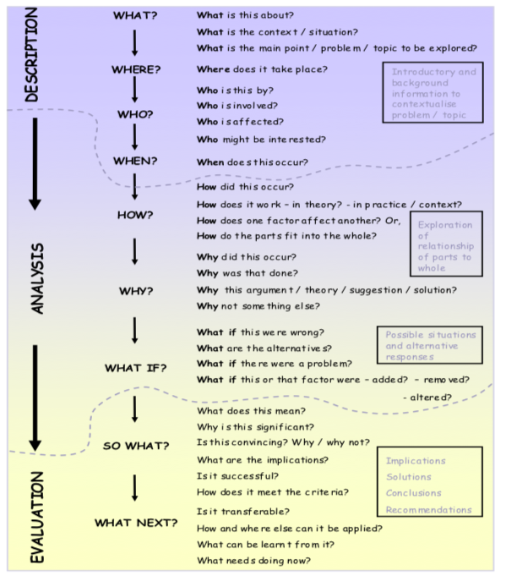
B)
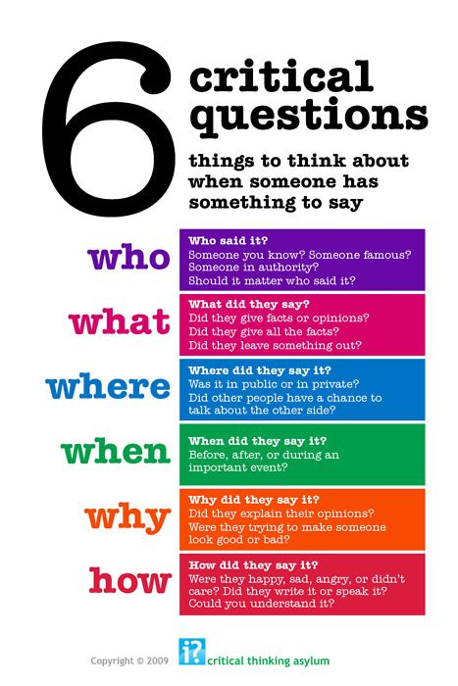

- Henri Fayol Theory
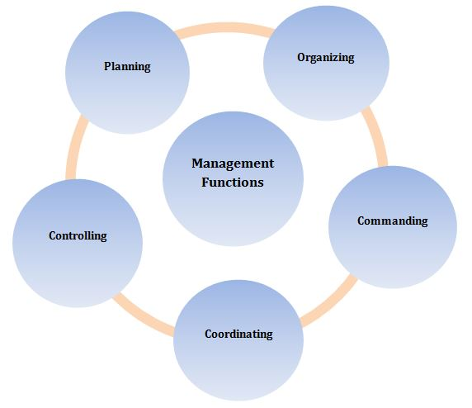

7.0 Appendices
- HBR (2016)
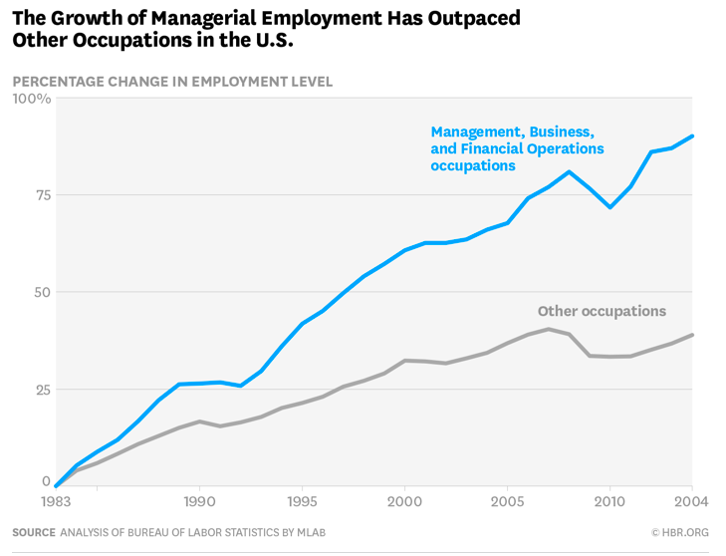

- Harvard Business Review (2016)

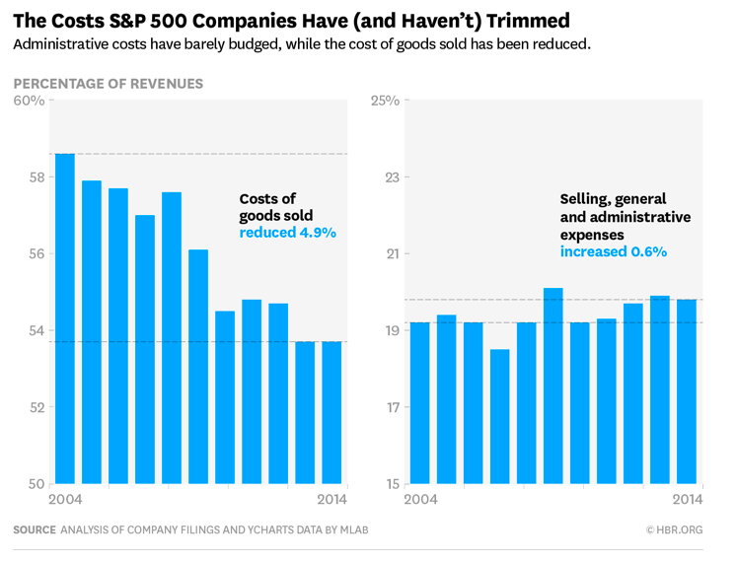

7.0 Appendices

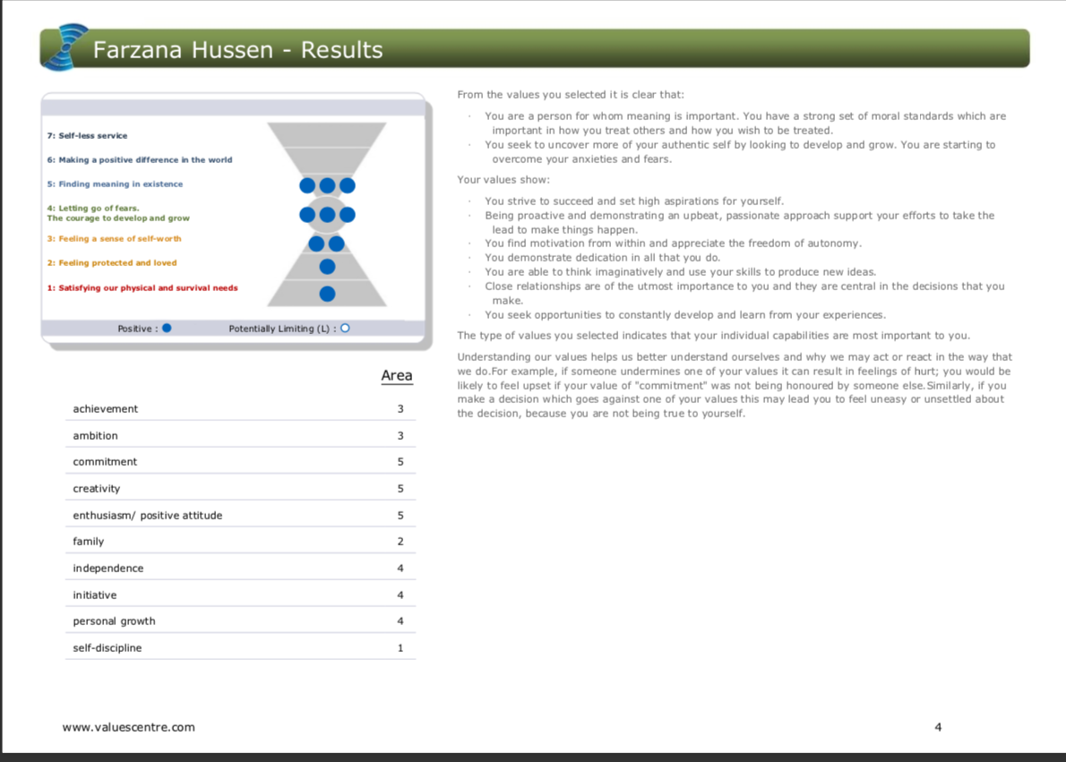

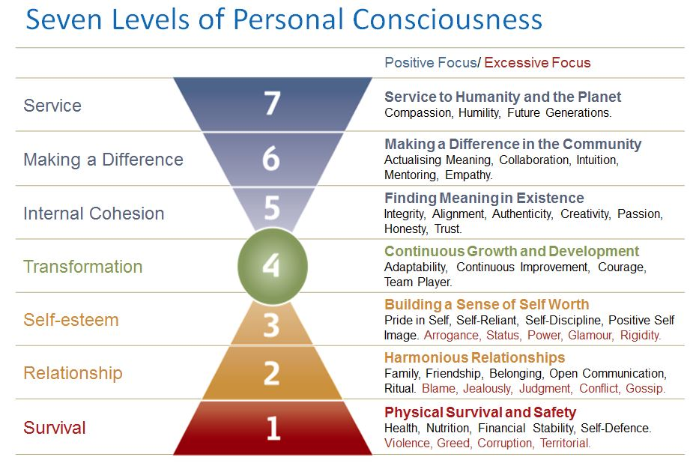

7.0 Appendices

- Maslow’s Hierarchy of Needs 1943

8.0 Reference list

Bank of England (2019) Prudential Regulations
Available at: https://www.bankofengland.co.uk/prudential-regulation
(accessed: 10th April 2019)

Barr, S. (2018) Independent: Tools that can be used by shoplifters to remove security tags available on eBay.
Available at: https://www.independent.co.uk/life-style/ebay-security-tag-tools-available-buy-shoplifters-magnetic-devices-a8332286.html
(Accessed:29th April 2019)

Barrett, R. (2010) Barrett Value Centre: The Importance of Values in Building a high Performance Culture
Avaliable at: https://www.valuescentre.com/sites/default/files/uploads/2010-07-06/The%20Importance%20of%20Values.pdf
(accessed: 7th April 2019)

Barrett, R. (2014) The Value-driven Organization. Unleashing human potential for performance and profit. Oxon: Routledge

Barrett, R. (2018) Everything I Have l Learned about Values. LULU publishing service

Best Company (2017) Best 30 Big Companies
Available at: https://www.b.co.uk/the-lists/big-companies/?year-2017-p-241-676/
(accessed: 7th April 2019)

Best Company (2018) Best 25 Big Companies
Available at: https://www.b.co.uk/the-lists/big-companies/?year-2018-p-266-751/
(accessed: 7th April 2019)

Button, G. and et al (2012) ‘Lifting the mantle of protection from Weber’s Presuppositions in his Theory of Bureaucracy ‘
Available at:
https://link-springer-com.ezproxy.uwtsd.ac.uk/content/pdf/10.1007%2Fs10746-012-9229-x.pdf
(accessed: 10th April 2019)

Chartrand, J. Flander, S. and Ishikawa, H. (2009) Pearsons Talentlens Critical thinking means Business
Available at: https://www.pearsonclinical.com.au/files/Critical%20Thinking%20Means%20Business.pdf
(accessed: 9th April 2019)

Church, A.H and Conger, J.A. (2018) Harvard Business Review. Professional Transitions: When you start a new job, pay attention to these 5 aspects of company culture.
Available at: https://hbr.org/2018/03/when-you-start-a-new-job-pay-attention-to-these-5-aspects-of-company-culture?utm_medium=social&utm_source=linkedin&utm_campaign=hbr
(accessed: 10th April 2019)

CIPD (2018) Diversity and Inclusion in the Workplace
Available at:https://www.cipd.co.uk/knowledge/fundamentals/relations/diversity/factsheet
(Accessed: 8th April 2019)

Clegg, S. Kornberger, M. and Pitsis, T. (2008) Management and Organizations an Introduction to Theory and Practice. 2nd ED. London: Sage Publication LTD

Cole, G.A (2004) Management Theory and Practice. 6th ED. London: Thomson

Cottrell, S. (2011) Critical Thinking skills. Developing effective analysis and argument. 2nd ED. Hampshire: Palgrave Macmillan

Daft, R.L. Murphy, J. and Willmott, H. (2010) Organization Theory and Design. Hampshire: Cengage Learning EMEA

Doherty, S. (2019) Text to Farzana Hussen, 9th April

Enock, K. and Beynon, C. (2017) Health Knowledge: Education, CPD and Revalidation from Phast. Management Models and Theories Associated with motivation, leadership and change management, and their application to practical situations and problems.
Available at: https://www.healthknowledge.org.uk/public-health-textbook/organisation-management/5c-management-change/basic-management-models#Max_Weber_(1864_-_1924),_Germany
(accessed: 9th April 2019)

Facione, P.A. (2015) Critical Thinking: What is it and why it counts. Hermosa Beach, CA: Measured Reasons LLC

Furnham, A. (2008) Personality and intelligence at work, exploring and explaining individuals at differences at work. East Sussex: Routledge

Grey, C. (2013) A Very, short, Fairly Interesting and Reasonably Cheap Book about Studying Organizations. 3rd ED. London: Sage Publication LTD

Hamel, G. (2014) Harvard Business Review. Bureaucracy Must Die
Available at: https://hbr.org/2014/11/bureaucracy-must-die
(Accessed: 16th April 2019)

Hamel. G and Zanini, M. (2016) Harvard Business Review. More of us are working in a big bureaucracy organisation than even before
Available at: https://hbr.org/2016/07/more-of-us-are-working-in-big-bureaucratic-organizations-than-ever-before
(accessed: 16th April 2019)

Hickson, J. and Pugh, D.S (2007) Writers on Organization. 6th ED. USA: Sage Publication

Hussen, F. (2019) Conversation to Farzana Hussen, 1st April

Judge, B. and et al (2013) Critical Thinking Skills for Education Students. 2nd ED. London: sage publication

Mead, R. and Andrews, T.G. (2009) International Management Culture and Beyond. 4th ED. West Sussex: john Wiley & sons

Mullins, J. (2005) Management and Organisational Behaviour. 7TH ED. Essex: Pearson Education Limited

Olum, Y. (2004) Modern Management Theories and Practices. Department of political science and public administration. Makerere University

People Management (2017) Fixer: How can we inspire staff to live our values?
Available at: https://www.peoplemanagement.co.uk/experts/advice/fixer-inspire-staff-live-values
(accessed: 11th April 2019)

Plymouth University (2010) Critical Thinking
Available at: https://www.plymouth.ac.uk/uploads/production/document/path/1/1710/Critical_Thinking.pdf
(accessed: 11th April 2019)

The London Institute of Banking & Finance (2019) Professional Qualifications CeMAP
Available at: https://www.libf.ac.uk/study/professional-qualifications/mortgage-advice/certificate-in-mortgage-advice-and-practice-(cemap)
(accessed: 13th April 2019)

TSB (2017) TSB recognised as great place to work
Available at: https://www.tsb.co.uk/news-releases/tsb-recognised-as-a-great-place-to-work/
Accessed: 14th April 2019

TSB (2018) TSB announces Debbie Crosbie as new CEO
Available at: https://www.tsb.co.uk/news-releases/tsb-announces-new-ceo/
(accessed: 5th March 2019)

TSB (2019) Information about us
Available at: https://www.tsb.co.uk/legal/information/information-about-us/
(Accessed: 10th April 2019)

TSB (2019) Truth and banking
Available at: https://www.tsb.co.uk/investors/truth-and-banking/#Modern_Slavery_Act-1490876234829
(Accessed: 10th April 2019)

9.0 Bibliography

Argyris, C. (2017) Integrating the individual and the Organization. OXON: Routledge

Cambridge dictionary (2019) the meaning of bureaucratic in English
Available at: https://dictionary.cambridge.org/dictionary/english/bureaucratic
(Accessed: 10th April 2019)

Christie, S. (2014) The Telegraph: ‘I’ve had a horrendous experience with eBay’
Available at: https://www.telegraph.co.uk/finance/personalfinance/money-saving-tips/11161041/Ive-had-a-horrendous-experience-with-eBays-Money-Back-Guarantee.html
(Accessed: 29th April 2019)

Cottrell, S (2014) The Study Skills Handbook. 4th ED. London: Palgrave Macmillan

Daft, R.L. (2001) Organization Theory and Design. USA: South Western, Thomson Learning

Fortin, J. (2017) The New York Times: 12 Are accused of selling stolen electronics on eBay
Available at: https://www.nytimes.com/2017/03/15/nyregion/organized-crime-ring.html
(Accessed: 29th April 2019)

Hughes, O.E. (2003) Public Management & Administration. An Introduction. 3rd ED. Hampshire: Palgrave

