MANAGING PROJECTS IN THE ORGANISATION
BMSW-5104 T2G1
Shamima Akther Supa-1916787
Lecturer- Rexon Nting

Table of Content
Task 1
Executive summary……………………………………………………….3
Introduction………………………………………………………………..3
Scope and basic outline of the project……………………………….4
Stakeholder analysis……………………………………………………4
Work breakdown structure……………………………………………5
Required project management tools and techniques and
their usefulness in the light of Covid 19…………………………6
Agile model………………………………………………………..6
Iterative model…………………………………………………….6
Draft for required resources, and required cost………………7
Communication strategies……………………………………….8
Communications requirement assessment………………….9
Risk assessment……………………………………………….11
Conclusion…………………………………………………..…14
Task 2…………………………………………………….……15
References………………………………………………….24

Task 1
Executive summary
Due to the emergence of the global epidemic, the government of the United Kingdom has had to thrust incarceration on their economies which have led the majority of the establishments to opt for remote working. Several analysts have forecasted that the remote working phenomena are here for the betterment and will persist for the predicted future. As part of this, several communication technologies have been consolidated into the new work mechanism, and virtual platforms like Zoom, Google Meets have been rapidly consolidated into the new work culture. Currently, the global trade and commerce community and the companies worldwide have begun to return to the new normal after the current wave of vaccinations. Organizations like CoreBlue, which is one of the reputed software development firms, provide services like software development, mobile app development as well as the up-gradation of the end-users desktop computer application. Through this study, software development tools and applications will be implemented, which will be beneficial for the development and implementation of this project as the company is currently working on a software development project (utility software).

Introduction
CoreBlue is one of the reputed software development firms in the United Kingdom which provides software development solutions across a vast range of technologies. They offer extensive solutions from upgrading the subsisting desktop application to building brand new mobile applications for their consumers. Last year due to the emergence of the global epidemic, it has created a profound impact on the cognitive well being of the employees of the United Kingdom. There was an apprehension of unemployment which was palpable among the people of this nation. It is significant for the project managers to develop a viewpoint about projects which will be sustainable or profitable. Based on this organisation, this study will integrate a software development project (utility software development) related to tools or applications, which will be beneficial in light of the global epidemic. Along with it, a work breakdown structure will be provided with an illumination of the scope and basic outline of this software development project.

Scope and basic outline of the project
CoreBlue is currently working on a utility software development project in order to provide an end-user enriching experience. The attributes of this software will be innovative, especially its navigation part. After the development of this software, it will empower the employees of Coreblue to accumulate the regular data while combining it with the right software. This software will also be utilized by the management of this organization in order to retain data of the recent trends among their clients. After the development and implementation of this software, COreBlue will be able to have a better consumer outreach, as software development is the rapid way to increase the organization's brand cognizance, as software development is solely the one thing which can assist the companies to have regular virtual interactions with the consumers. Through utility software development CoreBlue will be able to promote its products and utilities at any pace without any additional expenditure.

Stakeholder analysis
Stakeholders are those who possess the inclination for the execution of a project. They are conventionally the members of this implemented software development team, the managers of this project, executives, and the facilitators of utility software development projects. The terminology called stakeholders refers to the individuals or groups who are impacted by a software development project. Stakeholders will subsist within Coreblue and also outside of this company who will be the consumers, or they might simply be impacted by the project implementation procedure. Suggestions from the stakeholders will be provided to this company in terms of what types of software will be required as well as suggesting their ideologies for attributes of the software or the issues which may arise during the implementation and development of the software which will be required to resolve. They will build use case diagrams and map working flows which will provide guidelines to the development and implementation of the new software’s user interface design. As a team, the internal stakeholders will assess the benefits of one another’s perception, allotting an initial prioritization to the potential attributes inventory. Stakeholders will be in the best position to provide specified suggestions on the requirement of their level. They will comprehend what will work and what will not function in their working mechanism. Ignoring the stakeholders will be a hazardous approach. First and foremost, without their suggestions, the software developers will be functioning from an incomplete inventory of the requirements. Even when the allotting deadlines and allocations will be satiated, missing endowments will have an intense consequence. Deficiencies of adaptation are an intense hazard. Sometimes the operating systems turn out as exact as the management was striving for; however, they may not be utilized by the workers. They might already have more productive applications; however, Coreblue may not find the new software already have the attributes they wanted. Thus it is significant to work unanimously, and seeking the inputs of the stakeholders has to be the topmost priority during the development and implementation of the new software.

Work breakdown structure
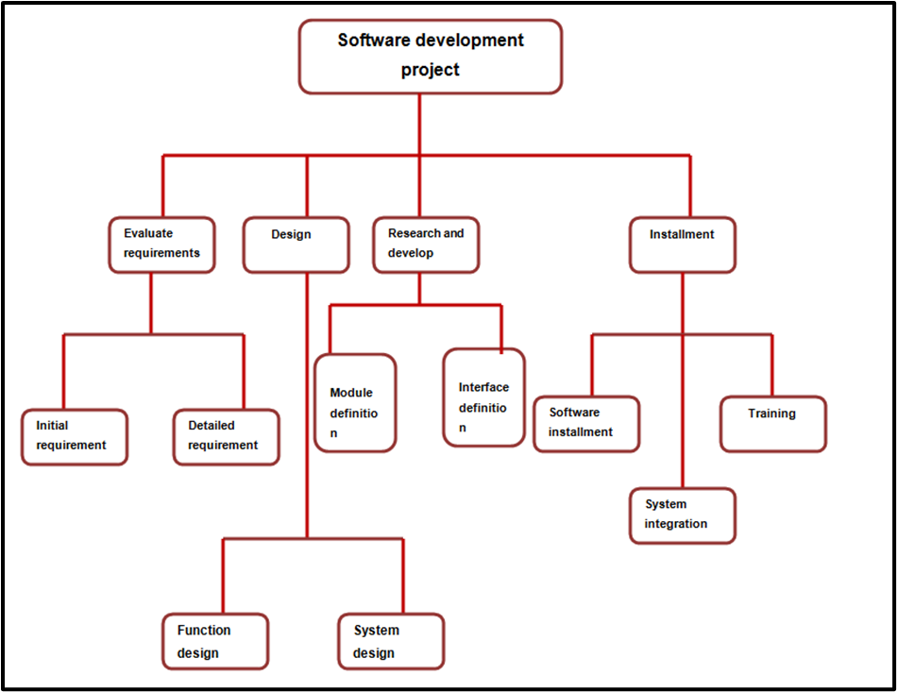
Figure: work breakdown structure
(source: self-made)

In software development projects, a work breakdown structure plays a significant part. The project is generally segregated into small factors in a hierarchical configuration into varied modules of the project. Work breakdown structure is the one that interprets the tasks which are relied on one another and tasks that are interdependent. This is also vital in the phase of resources allotment and timing allotment as well to grant the measure and control of the project.
Required project management tools and techniques and their usefulness in the light of Covid 19
The global epidemic has had colossal repercussions on the trade and commerce of the United Kingdom. During the global epidemic, just under three million individuals were recruited in the United Kingdom's digitized tech economy, an elevation of 11% within two years. The fear of unemployment was conspicuous among the people As the government of the United Kingdom were seeking to save lives through slowing down the spread of the global epidemic followed by the incarcerations, which created a colossal impact on all the economic pursuits of this nation. Nearly 50% of all the jobs were at stake. Irrespective of the challenges, the IT sectors have shown their perseverance through continued growth, with competent workers are required to accelerate the momentum. There are several software development tools and models that the development teams can comply with, such as;
Agile model
In this conjecture, the software development teams function in sprints to construct, establish and evaluate the parts of the ciphers, and then they can proceed with the immediate phase of the next sprint and construct upon what is already established. This grants for liquidity and adaptability in accordance with the demands and the end-user expectations amend throughout the project.
Iterative model
In this conjecture, the fundamental software is improved and released with the fundamental demands and liquidity. Then a new version of the software, which develops and enlarges on the subsisting program, is upgraded with each of the immediate releases.
Slack
This trade and commerce communication platform grants the users to interact one on one, as well as create varied conversations which are based on projects or subject matter. Built-in files partaking grant the files to be passed back and forth within the conversation as well.

Github
This tool is an assortment between an amalgamation platform and an improved platform. On the one hand, the project managers can allot tasks and allure the competitiveness between the employees. On the other hand, developers can partake and amalgamate on the ciphers in a protected atmosphere. Cipher libraries can even be consolidated through this tool.

Embold
This tool assesses over 10 varied linguistics of the ciphers to find out bugs and mistakes, which klets the users unleash the associated issues which impact stabilization, security or put attributes at stake before the code is final.
Draft for required resources, and required cost
Project details: CoreBlue, which is one of the reputed software development firms, is currently developing a utility software development project which will be beneficial not only for the employees of this organization but also for the end-users. The required sources for the development and the implementation of this project will be provided below, as well as the rationale behind incorporating this project as well as the required timeline for the execution of this project as well as the stakeholders who will be involved in the execution of this project will also be mentioned in this context. While the execution of this project, some significant planning or strategies have to be implemented for successful execution of a project which includes planning of the project, assessment, system construction, incorporation, testing of the software and also prior management of the software.
Objectives of the project: Through the development of this software, CoreBlue will be able to promote its products and utilities at any place without any additional or further expenditure. Each and every trade and commerce are inclined towards increasing their devoted consumers. This organization, through the execution of their software, will be able to incorporate their virtual marketing policy, through which the company will be able to boost their engagement with their consumers. They can even develop a website with the help of this software to increase their brand cognizance. The organization will also be able to perceive the perceptions of the consumers regarding their products and the services and also about the brand as well. If the organization would like to know the viewpoint of the consumers, then they will also be able to launch a virtual platform with the help of this software to let the consumers reach out to them conveniently.
Involved stakeholders: Stakeholders in this utility software development project are those who will be impacted by the implementation or consequences of this project. It won't matter if they will be impacted in an optimistic or in a pessimistic way; if they are impacted, they will be defined as stakeholders. Key project stakeholders are those who possess the governance and the authority to reveal whether this project will be a success or not. It is significant to comprehend the key stakeholders inside and outside of the organization. Stakeholders are usually segregated into internal and external stakeholders. Internal stakeholders in this project will be the project manager, the project team representatives, colleagues, asset manager. External stakeholders are those people who may be not part of the development of this software or this organization; however, it is those for whom the software development project will be implemented who can be termed as the end-users.
Required resources: human resources, reusable factors and hardware and software tools. These resources are pivotal for the successful development and execution of this utility software development project. Without these resources, it is impossible to culminate this project. In the project planning phase, proper identification of the assets which will be required for the culmination of the project and how they will be allotted is the key factor and a very significant task to do. These assets are considered as very essential for the completion of this project and implementation of this project on time and on budget.
Required resources | Required budget | Timeline | Responsible person
Recruitment of the developers | £50 | One month | HR department
Reusable components | £65 | Two months | Software development division
Hardware and software tools | £75 | Two months | Hardware and software division

Communication strategies
Communication strategy is the process that concerns interpreting the categories of the information Coreblue would like to obtain, the responsible person to receive it, configure it for interacting through it and the timeframe of its release and disbursement. It is estimated that 90% of the project manager's job is utilized on communication. Thus, it is significant to corroborate if the employee obtains the right message at the correct time.

Communications requirement assessment
The initial step of implementing a communication strategy is to figure out the types of communication the stakeholders will be required from the Utilitysoftware development project in order to make good decisions which can be defined as Communications requirement assessment. The utility software development project may produce a lot of information; however, as it is important for the project managers not to be exhilarated, they will perceive that the inputs of the stakeholders regarding this context are valuable. Interacting the valuable information may consist of either good or bad news as well. The point is that it is important not to overburden the stakeholders with too much information. At the same time, it is also important to provide the information in a concise way so that they make proper decisions.
Synchronous communication
A telephonic or skype convocation call is precedence of synchronous communication. The methods are mentioned below;
Live meeting
Congregation of the team members at the same time.

Conference call
A telephonic call in which several employees can be involved.
Computer-assisted conference
An audio conference with a relation between computers can exhibit a document or datasheet which can be rectified by both of the parties.
Video conference
It consists of the live streaming of all the employees while there are some desktop computers that have built-in cameras to promote video conferencing.
Modern communication technology has made it possible to construct and congregate project teams from anywhere worldwide. As the majority of the employees operate in the daytime, it can make synchronous communication hard if the employees of this organization come from varied time zones.

Gantt chart
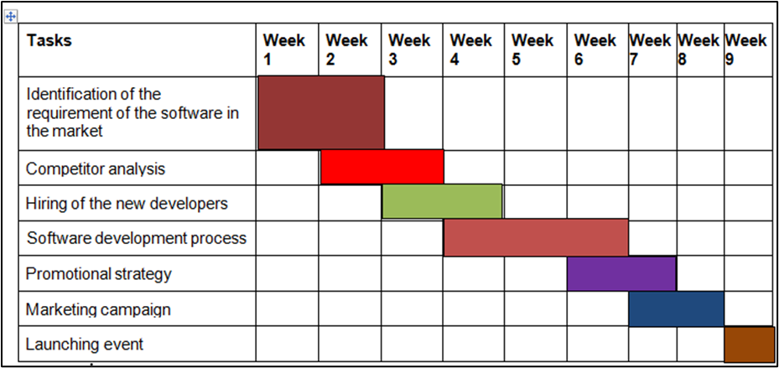

Figure: Gantt chart
(source: self-made)
From the above mentioned Gantt chart, the total utility software development and implementation phase and its associated activities are segregated into six divisions, Identification of the requirement of the software in the market, Competitor analysis, Hiring of the new developers, Software development process, Promotional strategy, Marketing campaign, Launching event. For the culmination of these strategies, the timeline will be nine consecutive weeks. The activities, which are the Identification of the requirement of the software in the market, will be started from 2nd December 2021 and will be ended on 16th December 2021. The competitor analysis will be started on 16 th of December, and it will end on 7th of January 2022. The hiring of the new developers will start 21st of January 2022, and it will end on 12 th of February 2022. The promotional strategy will be started on the 12th of February 2022, and it will end on the 26th of February 2022. The marketing campaign will be started on the 26th of February, 2022, and it will culminate on the 10th of March, 2022. And the successful promotional campaign will be held on the 11th of March 2022.

Risk assessment
The report has been developed based on software development (utility software) which is considered as one of the most significant in recent time, which allow a consumer to get access to required data, information, and facilities easily. In this section, the identified associated risk is further assessed to help out the management of the organization to find out the right way to confront the possible risks that can be occurred.

Description of rik | Level of threat | Possibility to occur
Not able to meet the deadline | High | 4
Not able to perform the task within the allocated budget | High | 4
Fulfill the demands of the market appropriately | Moderate | 3
Compatibility of the utility software in all system software | Moderate | 3
Consumer expectancy in terms of price offering | Low | 1
Competitors can launch the same type of product before | Low | 1

After evaluating the risk, further mitigation or contingency plan has been prepared; therefore, the management stays ready to confront the risk effectively.

Scenario | Trigger | Response | Responsible person | Timeline
Not able to meet the deadline | Trying to conduct the task and complete the task within the deadline | Meeting the deadline | Time management officer | 20-12-21
Not able to perform the task within the allocated budget | Trying to find out where the overflow of the budget may occur | Trying to do the job within the allocated budget | Finance manager | 1-1-22
Fulfill the demands of the market appropriately | Identification of the market demand effectively | Development of the utility software according to the demand of the market | Marketing manager | 15-1-21
Compatibility of the utility software in all system software | Identification of the compatibility measure of system software | Listening down the compatibility of every popular system software, such Windows 10, oreo android | Technical executives | 30-1-22
Consumer expectancy in terms of price offering | Identification of the price which would be perfect for offering the product at affordable and at a competitive price range | Meeting the demand of the clients | Marketing manager | 5-2-22
Competitors can launch the same type of product before | Monitoring the progress of the competitors | Trying to launch the product as soon as possible in the market | Human resource management and marketing manager | 25-2-22

Conclusion
Since we are moving into the new era of automation, mobile applications or tools, and post epidemic life, people’s credibility on utility software persists to elevate, which is not a bad thing at all; an application possess immense advantages to make the lives of the people productive. In order to succeed in this era of technological advancement, trade and commerce establishments are required to invest in utility software development. Utility Software development is not merely an application or a virtual site, but it is more than this. The users and the organizations obtain numerous benefits that they get post the development, execution as well as up-gradation of software.

Task 2
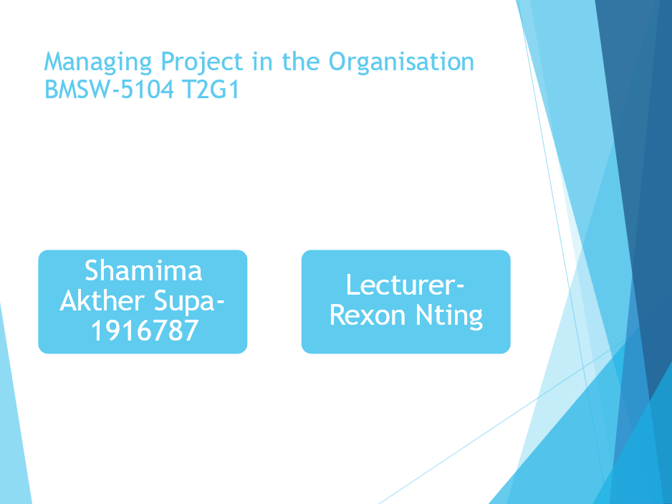

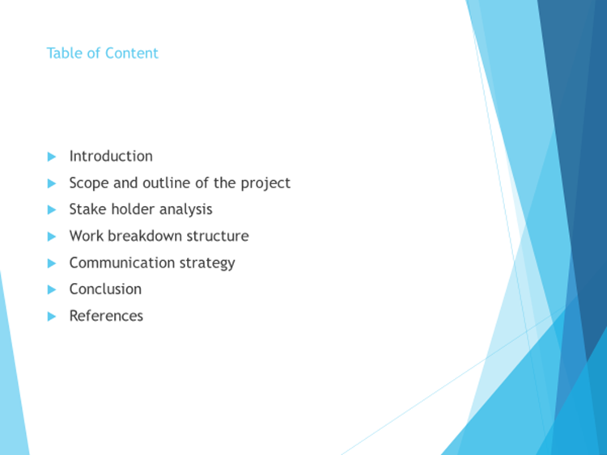
Table of Content
Introduction
Scope and outline of the project
Stakeholder analysis
Work breakdown structure
Communication strategy
Conclusion
References

Introduction
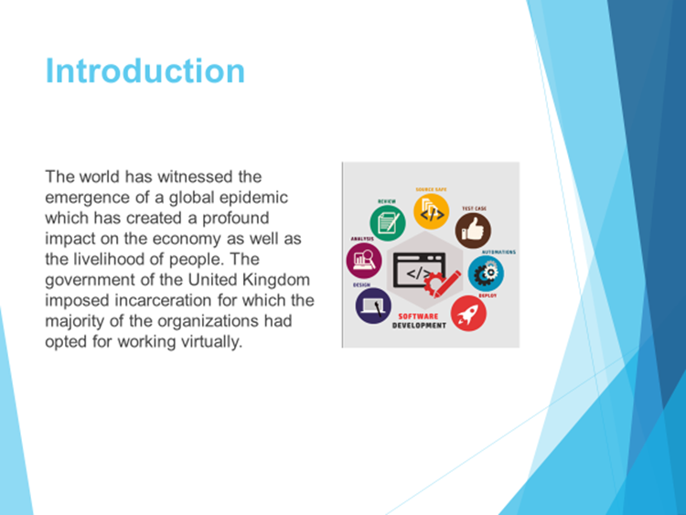
Speaker notes
The government of the United Kingdom is conducting vaccinations, and there is an expectation that the employees may return to their workplaces in the near future, and some of these curbs may be relaxed. The project managers are required to implement profitable projects in order to cope up with the scenario.

Scope and outline of the project
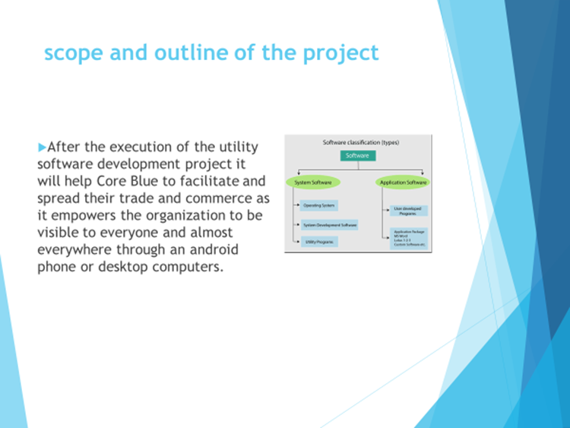
Speaker notes
Through the development and execution of this software, CoreBlue will be able to promote its products and services to the consumers through its virtual sites, as digital marketing would be one of the potential ways to tell the magnification and success of the trade and commerce of the establishment.

Stakeholder Analysis
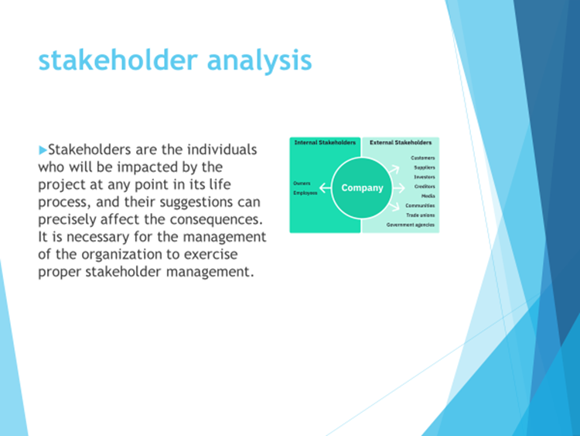
Speaker notes
Stakeholders of an organization are segmented into two parts, inward and outward stakeholders. Some of the conventional and necessary stakeholders of an organization may include the end-users, project leaders, project facilitators, governing council, assets manager and executives.

Work breakdown Structure
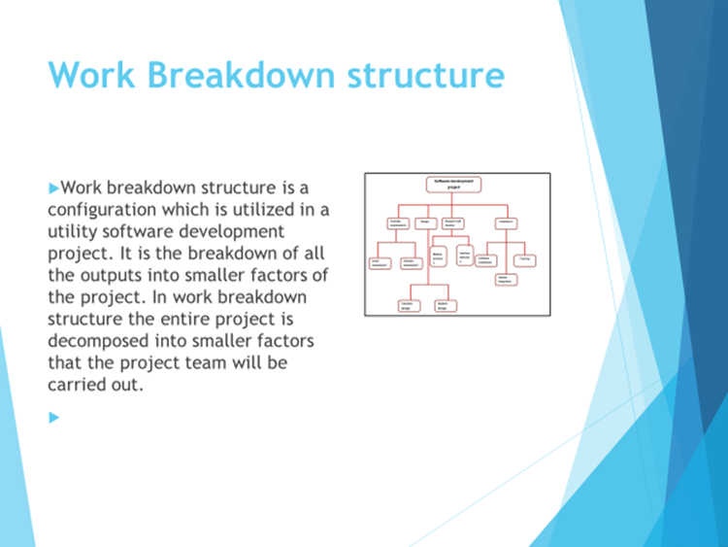
Speaker notes
In software development project work breakdown structure carries utmost significance. The structure is basically segregated into miniscule factors in a gradational structure into varied modules of the project. It is the one that interprets the tasks which are relied on one another.

Required project management tools and techniques and their usefulness in the light of covid 19

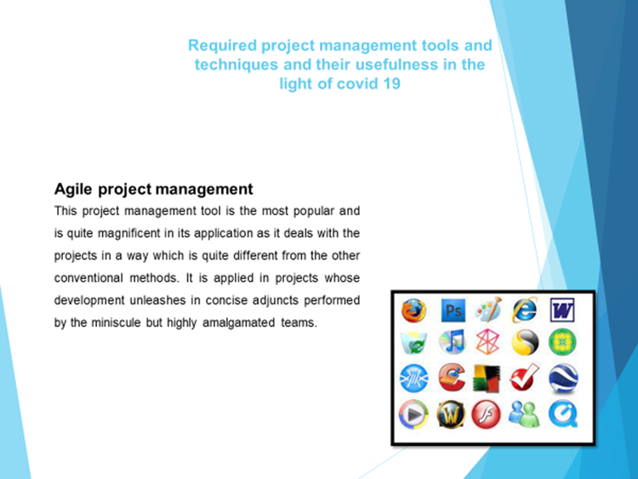
Speaker notes
The Agile proposition is fundamentally crushing the enormous project phases into miniscule sprints, which assist in an extensive assessment of the whole methods during the development phase. This extensive evaluation helps in a productive scheming in accordance with the amendments required in the project.

Communication strategy
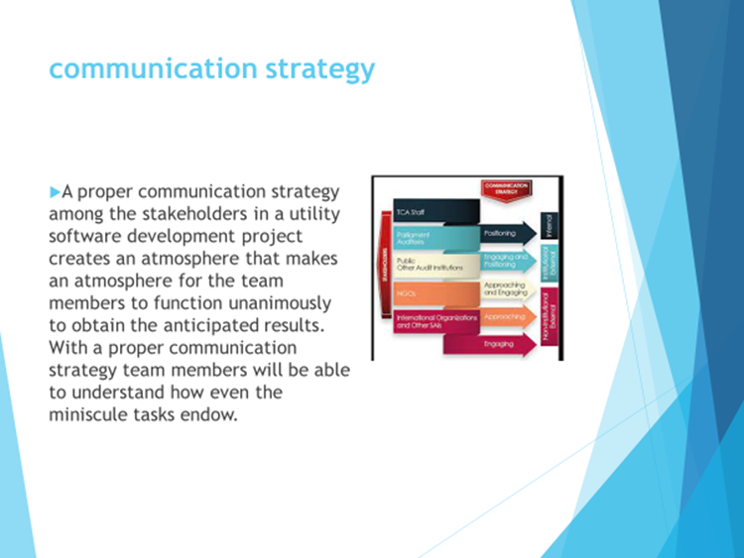
Speaker notes
Communication strategy provides the specifications for the categories of the messages and the responsible persons to deliver those messages. A conspicuous identification of the audience and its requirements makes the communication strategy way more convenient.

Conclusion
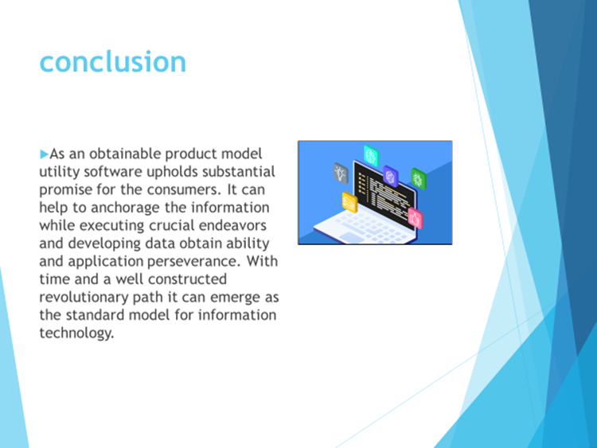
Speaker notes
Utility software upholds the competency for wide-reaching trade and commerce advantages. Through the usage of this software, it becomes convenient to maintain applications and mechanisms. Through the usage of this software, the establishments become way more flexible and nimbler in their management.

References
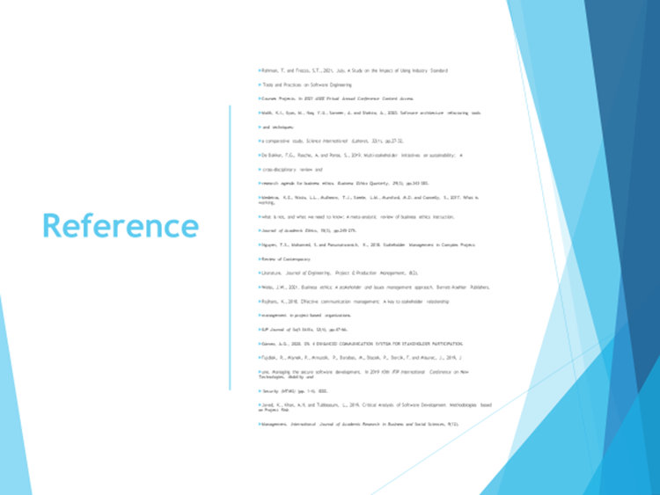

References
Rahman, T. and Frezza, S.T., 2021, July. A Study on the Impact of Using Industry Standard Tools and Practices on Software Engineering Courses Projects. In 2021 ASEE Virtual Annual Conference Content Access.
Malik, K.I., Ilyas, M., Haq, Y.U., Sameer, A. and Shakira, A., 2020. Software architecture refactoring tools and techniques: a comparative study. Science International (Lahore), 32(1), pp.27-32.
De Bakker, F.G., Rasche, A. and Ponte, S., 2019. Multi-stakeholder initiatives on sustainability: A cross-disciplinary review and research agenda for business ethics. Business Ethics Quarterly, 29(3), pp.343-383.
Medeiros, K.E., Watts, L.L., Mulhearn, T.J., Steele, L.M., Mumford, M.D. and Connelly, S., 2017. What is working, what is not, and what we need to know: A meta-analytic review of business ethics instruction. Journal of Academic Ethics, 15(3), pp.245-275.
Nguyen, T.S., Mohamed, S. and Panuwatwanich, K., 2018. Stakeholder Management in Complex Project: Review of Contemporary Literature. Journal of Engineering, Project & Production Management, 8(2).
Weiss, J.W., 2021. Business ethics: A stakeholder and issues management approach. Berrett-Koehler Publishers.
Rajhans, K., 2018. Effective communication management: A key to stakeholder relationship management in project-based organizations. IUP Journal of Soft Skills, 12(4), pp.47-66.
Gómez, A.G., 2020. D5. 4 ENHANCED COMMUNICATION SYSTEM FOR STAKEHOLDER PARTICIPATION.
Fujdiak, R., Mlynek, P., Mrnustik, P., Barabas, M., Blazek, P., Borcik, F. and Misurec, J., 2019, June. Managing the secure software development. In 2019 10th IFIP International Conference on New Technologies, Mobility and Security (NTMS) (pp. 1-4). IEEE.
Javed, K., Khan, A.H. and Tubbassum, L., 2019. Critical Analysis of Software Development Methodologies based on Project Risk Management. International Journal of Academic Research in Business and Social Sciences, 9(12).

