

An Exploration into Ex-Offender Stigma and Public Opinion on Ex-Offender Issues.

Name:
Student ID:
School: UWTSD Swansea
Degree: BSc Criminology and Law
Due Date: 7th May 2021
Word Count: 8711
Impact of COVID-19
In light of the continuing impact of the global pandemic, it is important to include a statement at the start of this dissertation which outlines the effects that COVID-19 has had on the research that has been undertaken towards an undergraduate degree.
The University of Wales Trinity Saint David recognises that the COVID-19 pandemic, and consequent closures of our campus (18th March 2020) and national and international lockdowns, has directly or indirectly impacted the work of many of our undergraduate researchers. Although the campus had periods of re-opening in 2020 and 2021, some research will have been disrupted and some personal circumstances difficult to manage. Teaching was arranged via suitable meeting software and documents shared electronically. All research data collection was designed to utilise digital data collection.
The inclusion of this statement is to facilitate the reader’s awareness, both now and in the future, that the pandemic may have influenced the scope, direction, and presentation of the research.
The academic standards and quality threshold for the award remains unchanged. I wish to reassure readers that this statement is not evidencing a lack of original research or quality.

Declaration
This work has not previously been accepted in substance for any degree and is not being concurrently submitted in candidature for any degree.
Signed: Date: 3/05/2021

STATEMENT 1
This dissertation is being submitted in partial fulfilment of the requirements for the degree of BSc.
Signed: Date: 3/05/2021

STATEMENT 2
This dissertation is the result of my own independent work/investigation, except where otherwise stated.
Other sources are acknowledged in the Reference Section.
Signed: Date: 3/05/2021

STATEMENT 3
I hereby give consent for my dissertation, if accepted, to be available for photocopying and for interlibrary loan, and for the title and summary to be made available to outside organisations.
Signed: Date: 3/05/2021

STATEMENT 4
I hereby give consent for my dissertation, if accepted, to be available on the university’s IT system to those who have consent to use the system.
Signed: Date: 3/05/2021

Acknowledgements

I would like to thank my supervisor, Mike Durke, not just for his continued support and availability throughout the process of my dissertation, but also for his presence throughout my first three years of university where he remained a figure of constant positivity.
I would also like to thank my friends and family for the support they provided during my dissertation. Though this work is my own, I never felt alone completing it. You were all there for me constantly, and for that I am extremely grateful.

Abstract
Prison is the punishment for those that have broken the law. However, it could be seen that the prison system is creating victims by detaining people for a certain amount of time then leaving them back out into the world where problems they had before entering prison, such as substance abuse, mental health, and unemployment, are awaiting them when they leave. Without rehabilitating these issues, these ex-offenders can easily fall back into the cycle of committing crime. Even with rehabilitation, reintegrating back into society is hampered by public stigma which harms an ex-offender’s ability to find work and build relationships. Which is why this study looked to confirm whether this stigma against ex-offenders did exist by testing public opinion on ex-offenders. Through an online questionnaire, the public could present their opinions, and that data could be collected and analysed. The results showed that generally people’s opinions of ex-offenders tended to be more sympathetic than once thought. Though not necessarily positive, the answers given indicated the public’s agreement that rehabilitation was important that people tended to judge the crime rather than the purpose and that factors like age, gender and community did not influence opinions. This suggested that a stigma did not exist against ex-offenders. It was also found that it is the media which has an overwhelming monopoly on people’s opinions regarding ex-offenders. After concluding, recommendations were given which suggested that researched continued to sample a larger pool of responses to confirm or rebuff any findings here. It was also suggested that people take heed of the medias influence on their opinions.

Table of Contents
1.Chapter One: Introduction 1
1.1 Introduction 1
1.2 Background/Context and Rationale 1
1.3 Aim and Objectives. 2
1.3.1 Aim: 2
1.3.2 Objectives: 2
1.4 Research Structure 3
1.5 Conclusion 4
2. Chapter Two: Literature Review 5
2.1 Introduction 5
2.2 Prisons and Prisoners 5
2.3 Education & In-Prison Programmes 6
2.4 Mental Health 7
2.5 Employment 7
2.6 Employer Attitudes 8
2.7 Public Attitudes 9
2.8 Stigma 10
2.9 Conclusion 11
3. Chapter Three: Research Methods 12
3.1 Introduction 12
3.2 Research Onion 12
3.2.1 Philosophy 13
3.2.2 Approach 13
3.2.3 Strategy 14
3.2.4 Choice 14
3.2.5 Time Horizon 15
3.3 Ethical Considerations 15
3.4 Limitations 16
3.5 Conclusion 16
4. Chapter Four: Data Analysis 17
4.1 Introduction 17
4.2 Data Presentation 17
4.3 Conclusion 32
5. Chapter Five: Conclusions and Recommendations 33
5.1 Introduction 33
5.2 Main Findings 33
5.3 Recommendations 34
5.4 Conclusions 35
Bibliography 36

List of Figures

Figure 3.1: The Research Onion (Saunders et al., 2016)
Figure 4.1: Graph Presenting Data Findings from Question
Figure 4.2: Graph Presenting Data Findings from Question 2
Figure 4.3: Graph Presenting Data Findings from Question 3
Figure 4.4: Graph Presenting Data Findings from Question 4
Figure 4.5: Graph Presenting Data Findings from Question 7
Figure 4.6: Graph Presenting Data Findings of Age vs Yes, with Results Collected from Question 7
Figure 4.7: Word Cloud Combing the most Frequent Words and Phrases to Appear in “why?” following Question 7
Figure 4.8: Graph Presenting Data Findings from Question 8
Figure 4.9: Graph Presenting Data Findings from Question 9
Figure 4.10: Graph Presenting Only Female Data Findings from Question 10
Figure 4.11: Graph Presenting Only Male Data Findings from Question 10
Figure 4.12: Graph Presenting Data Findings from Question 11
Figure 4.13: Graph Comparing Community Specific Data Findings from Question 11
Figure 4.14: Graph Presenting Data Findings from Question 12
Figure 4.15: Graph Presenting Data Findings from Question 13
Figure 4.16: Graph Presenting Data Findings from Question 14
Figure 4.17: World Cloud Presenting Most Frequent Words and Phrases from “Why?” Question that Followed Question 14
Figure 4.18: Graph Presenting Data Findings from Question 15
Figure 4.19: Graph Presenting Data Findings from Question 16
Figure 4.20: Graph Presenting Data Findings from Question 17
Figure 4.21: Word Cloud Compiling the Most Frequent Words and Phrases from “why?” Following Question 17

List of Abbreviations
Covid 19: Coronavirus
UWTSD: University of Wales Trinity Saint David
HM: Her Majesty’s

Appendices
Appendix. 1 – Copy of Questionnaire
Appendix. 2 – Ethics Form

1.Chapter One: Introduction

1.1 Introduction

This introductory chapter aims to provide both context and background, as well as rationale for this study. The aims and objectives will also be explored, along with a run-down of the research project description and structure.
The research aims to examine the opinions of the public regarding ex-offenders and explore whether a stigma exists against ex-offenders that is influencing the publics opinions. It has been decided through extensive research that the term “ex-offender” will be used to refer to anyone that has spent time inside prison and has now left, as that is the term most used by professionals and charities (e.g., HM Prison Service, Future society, Timpson, St Giles).

1.2 Background/Context and Rationale

Currently, there are around 500 men living inside HM Prison Swansea (Gov. UK, 2020), a category B/C institution. Inside, as the Gov.UK article professes (2020), residents have access to a wide range of learning opportunities from basic level English, Welsh and Maths to higher learning and qualifications. We are also told, by Gov.UK (2020), that employment is available in prison workshops, kitchens, and recycling units. Although giving prisoners an opportunity to work within the prison is good for keeping both their mind and body active, The Prison Reform Trust (2019) found that in 2018 it was recorded that 59,000 people had been sent to prison in England and Wales, almost half were sentenced to serve six months or less; meaning that this work experience could only last for six months before prisoners come to the end of their sentence and leave prison, potentially without the means to find employment afterwards. This can leave ex-offenders entering back into a world without the skills necessary to succeed, build relationships with people or begin to move on from their past.
Charlotte Whelan (2020) explains that ex-offenders leaving prison find themselves in a world very different from the one they left, and without a job, money, or connections there can be very little chance for success. Therefore, the idea of rehabilitating prisoners seems of utmost importance. However, in a Guardian article by Diane Taylor (2019) we read that the former director general of the prison service, Sir Martin Narey, made the claim that rehabilitation does not work and should be scrapped. It was also in 2019 that Boris Johnson, the Prime Minister, announced a £100m programme to deal with crime inside prison and “make prisons properly equipped to reform and rehabilitate” (Gov.UK, 2019).
In addition to personal problems, ex-offenders also face negative attitudes from the public which can further hinder reintegration into society (Whitehead, 2016). If an ex-offender should find work, there still exists the problem of being surrounded by individuals who have not spent time in prison and therefore regard ex-offenders differently, treating them differently, not allowing them to integrate and feel normal or accepted. Glasser (1999) expresses the importance of positive relationships and how feeling accepted and wanted can improve mental wellbeing. It stresses the point that when ex-offenders leave prison the last thing they need is to be rejected by society. Therefore, if there truly is a negative stigma related to ex-offenders it should be highlighted so that societal systems (e.g., The Government, charities) can begin to understand it and eradicate its harmful effects.
This research will work to gauge with public opinion of ex-offenders and display whether attitudes truly are negative or if there exists more acceptance than once thought. It is from knowing how people feel that confidence can be given to ex-offenders to not expect negative attitudes upon release and to feel safer in the workplace knowing they have the support of co-workers who can judge them more as a person than as an ex-offender.

1.3 Aim and Objectives.

1.3.1 Aim:

To explore the general public’s views on ex-offenders, the prison system and rehabilitation, whilst discerning whether a pattern of pre-existing prejudice exists against ex-offenders.

1.3.2 Objectives:

- To critically analyse academic literature on the rehabilitation of ex-offenders and the potential existing prejudice against ex-offenders which may exist in the public.

- To discern and select a suitable research approach to begin exploring public views and attitudes concerning ex-offenders, rehabilitation, and influential factors on opinions.

- To analyse the data collected, exploring public views and attitudes concerning ex-offenders, rehabilitation, and influential factors on opinions.

- To understand the implications of the research, making recommendations for both future research and social practise

1.4 Research Structure

To achieve all four objectives, this research project will consist of five chapters. Chapter one being the introduction; chapter two presenting a literature review; chapter three being that of the method and methodology for research; chapter four following with the data analysis; and finally, chapter five which will be the conclusion and recommendations.
Chapter one has introduced the research project, providing both the background and context for which it exists, as well as the reasoning for conducting the research, along with the aims and objectives of the project. Secondary and primary data will be collected in the form of a literature review, followed by a participant survey.
Chapter two will consist of the literature review which will provide a more in depth look at the topic of the research project. The literature helps further understanding of the topic, as well as highlight areas in which similar studies have taken place and the results they acquired. Reviewing secondary research before conducting primary research can be beneficial to understand what areas the research should take – whether to expand on current research or fill in gaps where little research has been conducted.
Chapter three will be composed of the research methods and methodology that will identify the best possible research techniques and procedure for the primary research. Following through with the research, the data will then be analysed.
Chapter four will analyse and present the primary data collected using methods mentioned in chapter three. analysed and presented, the data will then be reviewed and discussed further.
The final chapter will be chapter five, in which the research project will be concluded by providing a discussion of the data found and the implications it implies. The final chapter will also provide recommendations for the future, both in context of research and society.

1.5 Conclusion

Chapter one has provided an introduction of the research project, presenting the aims and objectives, whilst also outlining why this research is both practical and beneficial to bring awareness to potential stigma against ex-offenders.
The next chapter will be the literature review, which will discuss issues brought up during chapter one in even more depth.

2. Chapter Two: Literature Review

2.1 Introduction

The aim of this chapter is to gain further understanding on the themes and subjects relevant throughout this dissertation by exploring preceding literature on the topic of which this research project revolves.
This chapter will aim to achieve the first objective:
“To critically analyses academic literature on the rehabilitation of ex-offenders and the potential existing prejudice against ex-offenders which may exist in the public.”
Sources used below were acquired using the UWTSD online library and from Google Scholar. The sources include a mixture of academic journals, articles, and government reports. Search terms used included: ‘Prisoner’, ‘ex-offender’, ‘employment’, ‘rehabilitation’ ‘stigma’ and ‘reintegration’.

2.2 Prisons and Prisoners

Rachel O’Brien (2019) explains that prisons are a ‘microcosm’, where ‘contemporary challenges’ are played out in a confined space. There are approximately 87,000 prisoners in the UK, of which prisoners in England and Wales make up 79,453 of this total (Georgina Sturge, 2020). In 2017/18 the average cost to keep a prisoner was £39,385, on top of this - as of May 2020 49% of prisons in England and Wales were considered ‘over-crowded’ (Georgina Sturge, 2020). Further problems highlighted by O’Brien (2019) include budget cuts which have the effect of restricting time staff can spend working with prisoners; and specialist charities - who specifically work with prisoners – finding it increasingly harder to work within the prison environment.
Both HM Government (2005) and the Ministry of Justice (2008) acknowledge some of the personal problems that prisoners have that are affecting rehabilitation, such as: substance abuse, homelessness, and unemployment. Further areas to be highlighted include poor practical/social skills and education (Social Exclusion Unit, 2002); limited employment experience (Lewis et al., 2003); lack of family support (O’Keefee, 2003); along with debts and physical or mental problems (Hunter & Boyce, 2009). Hunter and Boyce (2003) go on to state that it is factors such as these that not only greatly influence reoffending, but also develop a ‘holistic approach’ that looks to cater for a range of social needs. As well as practical help, McNeill (2006) also states that prisoners themselves must be motivated to change and to mentally strive to sustain positive changes in their lives. Motivation, encouraged and supported by criminal justice agencies, can be a significant factor in a prisoner’s journey to rehabilitation and reintegration into society (Maguire & Raynor, 2006; LeBel et al., 2008).

2.3 Education & In-Prison Programmes

Jane Hurry & Lynne Rogers (2014) state that education inside of prison presents a ‘special challenge’. A reason for this may be because a prison’s ‘overriding institutional purpose’ is to offer secure detention to those that have broken the law, not to provide further education and training to vulnerable individuals (Hurry & Rogers, 2014). Though there is a ‘paucity’ of research relating to the nature and effectiveness of education, training and employment, McNeill (2006) retains it is important when dealing with rehabilitation. Susan Dewey et al. (2020), when looking into education in prisons, found that typically prison administrators will use some or all the following measures of success: reduced instances of reoffending; achieving educational outcomes of high school equivalency, vocational certifications, or college degrees; improved psychosocial outcomes in both mental health and socials skills; employment found after leaving prison; and the reduction of violent tendencies adopted whilst within prison.
Vocational training relates to career or technical education, and primarily focus on teaching skills to inmates that can set them up for a job post release through certification (Costelloe & Warner, 2014). Compared to academic education, this form of teaching focuses on employability and measures the ability of a student and their technical skills, compared to critical thinking developed by education.
Sweeney (2012) states that many prisoners are ‘avid readers’, and that by utilizing this, prisoners can be brought into guided reading groups that can help to reframe understanding of their lives and ‘contextualize’ their experiences with more meaningful social realties. An evaluation on reading groups inside prisons indicated that participation in these groups encouraged cognitive orientations, modes of interaction, and recued the likelihood of reoffending (Schutt et al., 2013).
As well as reading groups, there are writing groups which likewise aim to provide a ‘transformative’ solace for self-reflection, communication skills and increasing an inmate’s confidence in themselves (Jacobi & Stanford, 2014).
Art-based programmes were also noted to increase a prisoner’s motivation to learn, practise improved social skills and promoted psychological shifts associated with ‘desistance’ (Cheliotis & Jordanoska, 2016). Halperin (2012) also adds that those that take art-based programmes in prison are more likely to pursue education beyond secondary learning, including college courses.
It should be noted that though these courses are offered to prisoners, many inmates do not tend to participate in the programs (Lynch & Sabol 2001), which means that when released from prison, prisoners tend to leave at the same educational level they entered the prison with (Solomon et al., 2004).
O’Brien (2019) continues, referring to HM Inspectorate of Prisons for England and Wales – who found that there has been a decline in prisoners achieving ‘good’ or ‘reasonably good’ grades through functional skills qualifications. In 2017/18 the figures stood at 43%, which is lower than in 2016/17 when that figure was 51% (O’Brien 2019).

2.4 Mental Health

Bronson & Berzofsky (2019) and Maruschak et al. (2019) all explain that historically high rates of criminal justice contact were concentrated in disadvantaged communities – communities in which there are high rates of chronic health conditions, such as mental health issues, substance use disorders and those who have limited access to health care. Mandatory health checks for people whilst incarcerated lead to the diagnoses and treatment of a wide variety of ‘communicable and chronic illnesses’, which Biswanger et al. (2007) theorises should improve health outcomes.

2.5 Employment

In 2001 it was recorded that between ‘one-half’ and ‘four-fifths’ of those who were under supervision by the probation service were unemployed (Metcalf, Anderson & Rolkfe, 2001). Furthermore, in 2001 61% of prisoners going into prison were found to be unemployed – which at the time was 13 times higher than the national unemployment rate (Social Exclusion Unit, 2002). It was also found in 2004 that 75% of prisoners were being released from custody without having secured any form of employment (HM Government, 2004) – this figure, as O’Brien (2019) points out, has not changed.
Rhodes (2008) emphasises the importance of prisoners finding employment, stating that securing a stable job can reduce the likelihood of reoffending by up to 50%. O’Brien (2019) mentions that the significance of employment does not just correlate with finding an income, but that finding the right kind of employment can ‘support a shift in identity, belonging and purpose’. It is Kruttschnitt & Savolainen (2009) and Weaver (2015) that have proved a vital relationship between a person’s participation in employment, the reaping of human and social capital, and the significance of citizenship and reciprocal relationships.
Gill (1997), Caddick & Webster (1998) and Sarno et al. (2000) all refer to the ‘barriers to employment’ which can affect prisoners in terms of finding employment on leaving prison. An example of this is their limited academic or vocational qualifications (Metcalf, Anderson and Rolfe, 2001); literacy problems such as prisoners who may be illiterate (Sarno et al., 2000); lack of skills or any previous work experience (Gill, 1997); and even low self-esteem (Caddick & Webster, 1998). Niven & Stewart (2005) also mention the more ‘immediate’ factors which can affect a prisoner’s ‘job readiness’, like homelessness, substance misuse problems or ill-health.

2.6 Employer Attitudes

It is not just the prisoners lack of desirable qualities that may hinder their possibility at finding employment. Metcalf, Anderson and Rolfe (2001) go on to explain that there are problems with ‘employer attitudes’ regarding hiring those that have served time in prison. Many employers deliberately exclude ex-offenders when recruiting staff, research showing that someone that has spent time in prison is 50% more likely to be rejected, 90% for those who have committed serious offences (Metcalf, Anderson and Rolfe, 2001). Haslewood-Po´csik, Brown and Spencer (2008) go on to explain that employers may have concerns for the ‘risk’ posed to other staff, the potential for bad publicity, the lack of skills, as well as a view that ex-offenders are untrustworthy and unreliable with a lack of motivation for hard work. With the introduction of ‘Basic Disclosure’, introduced in the Police Act 1997, employers can gain access to the criminal record of any job applicant. Simply seeing an offence can already begin to alter an employer’s view of the applicant, formed by a lack of knowledge of how high offending rates tend to be as well as ‘the risk for recidivism’ (Metcalfe, Anderson and Rolfe, 2001). This then creates an overriding issue, even for those where employment is an achievable aim, where ex-offenders are left with a serious disadvantage when competing in the world of work (Burnett and Maruna, 2006), leaving ex-offenders having to make do with temporary, unskilled, and low paid jobs where ‘disclosure’ is less of a problem.

2.7 Public Attitudes

Barriers affecting ex-offenders have also been found to reside within the public (Rade, Desmarais & Mitchell, 2016). These barriers come in the form of negative attitudes that are held by the public in relation to ex-offenders (Brooks, Visher & Naser, 2006). As Clear et al. (2001) points out, it is these negative attitudes that can lead to the development of policy restrictions and barriers for ex-offenders in a wide domain, including: education, employment, health, housing, and voting rights.
Rade, Desmarais & Mitchell (2016) have highlighted three characterises found in the public that have ranging effects on attitudes toward ex-offenders. These characteristics are: Sex, race/ethnicity, and interpersonal contact (Rade, Desmarais & Mitchell, 2016).
Lerentz (2011) and Mancini, Shields, Mears & Beaver (2010) found that when compared with men, women tended to show less favourable attitudes towards ex-offenders. However, it should also be noted that studies presented by Park (2009) and Locke (2010) gave findings of no difference in opinions regarding the gender of those asked.
Studies by Hirschfield & Piquero (2010) and Mancini et al. (2010) found that in some cases white or non-minority groups reported less favourable attitudes when compared with minority group participants of those studies. Pager (2003) develops this, stating that negative attitudes were also more prevalent towards minority races.
Interpersonal contact relates to a theory which proposes that there is a relationship between contact and prejudice, whereby increased contact with members of the ‘out-group’ (in this cases ex-offenders) can decrease prejudice and social distance of those from an ‘in-group’ (Allport, 1954; Pettigrew & Tropp, 2006). Regarding this theory, study findings presented by Gibson, Roberson & Daniel (2009), found that members of the public who had had contact with ex-offenders generally reported more favourable attitudes.
Hardcastle, Bartholomew & Graffam (2011) also propose that the type of criminal offence is also significant to a person’s judgement of an ex-offender. Negative attitudes were found to be more prevalent where there was a history of violent crimes and sexual offences, compared with those of non-violent crimes (Perkins, Raines, Tschopp & Warner, 2009).
Mental health and rehabilitation also play a part in ex-offender stigmatisation as Lebel (2008) and Locke (2010) both confirm that public attitudes were less favourable towards ex-offenders who either had a mental illness or had not received any type of rehabilitation.
Finally, research has also shown a link between community size and public attitudes towards ex-offenders. People from non-rural communities tend to report less negative attitudes than those who live in more rural areas (Mackey & Courtright, 2000). Leverentz (2011) makes clear that in non-rural areas where crime is more prevalent there may be more acceptance or tolerance of ex-offenders existing there, compared with those in rural areas where crime is much lower and therefore exposure to ex-offenders is minimised.

2.8 Stigma

Stigma is one possible route to explore when searching for answers to why there may exist negative public opinions of ex-offenders (Dovidio, Glick & Rudman, 2005). Both prejudice and stigma are described as attributes of a person which cause them reject others based on differences (Goffman, 1962; Allport, 1954).
It was Goffman (1963) who first proposed ‘spoiled identities’, a concept which looks at individuals identified by a stigma which relates to a socially undesirable attribute they may acquire (physical or otherwise). This then creates a discrepancy between who the person is and who they are perceived to be by others (Link & Phelan, 2001). It is by this that a stigmatised individual becomes part of the ‘out-group’ who is cast aside by the ‘in-group’ (the ‘normal’ person). Relating this to a business environment, an employee withholding a stigmatised attribute (having spent time in prison) threatens to disrupt the social order and are ostracised by the ‘ingroup’ to protect themselves (Stone et al., 1992; Tajifel, 1978).
Link & Phelan (2001) describe stigmatization as an ‘inherently social phenomenon’, where its attributes vary according to the context. Meaning someone may possess a particular attribute, however that attribute is only considered a stigma in relation to the specific social standard (Goffman, 1963). It begins with certain differences being labelled as socially meaningful and labels follow accordingly (Fiske, 2005).
A stereotype is similar to a stigma in that it is the mental representation of beliefs and expectations of social groups (Mackie, Hamilton, Sussking & Rosselli, 1996). They commonly reflect bias and prejudice to ‘out-groups’ and lead to social discriminations (Fiske & Taylor, 2013).
One area of stigma which Jones et al. (1984) highlighted was that of concealability – whether observers can physically see the stigma. Stone et al. (1992) explain that though being an ex-offender is largely concealable, hiding one’s stigma can cause them to go through a process of identity management, causing them to question when, where, to who, or if they should reveal their negative attribute (Jones & King, 2014). A stigmatised individual may even choose to never disclose their attribute to protect themselves (Button, 2001). This concept of identity management can cause disruption in work life, effecting mental health and distancing with one’s colleagues (Clair et al., 2005). This “disclosure dilemma” concludes with either the individual revealing their stigma and therefore confirming their identity, or to conceal the stigma as a secret for their own self-protection (Ragins & Cornwell, 2001).

2.9 Conclusion

This chapter has achieved the first objective:
“To critically analyses academic literature on the rehabilitation of ex-offenders and the potential existing prejudice against ex-offenders which may exist in the public.”
The literature review presented findings from a wide span of problem areas relating to ex-offenders – both before they leave prison, and thereafter. For one, many offenders enter prisons with pre-existing problems such as: substance addictions, homelessness, unemployment, and mental health (O’Brien, 2019; Bronson & Berzofksy, 2019; Maruschak et al. 2019; Hunter & Boyce, 2009). Of those going into prison, 61% were found to be unemployed (Metcalf, Anderson & Rolkfe, 2001). Therefore, it is important to give prisoners access to systems which will help them to develop their skills to better find work once leaving prison (McNeil, 2006; Hurry & Rodgers, 2014; Dewey et al., 2020). However, even after leaving prison there are still further barriers that hinder ex-offender reintegration. Employers may be reluctant to hire those that have broken the law previously, concerns for staff safety as well as overall performance pose concerns (Halsewood, Pocsik, Brown & Spencer 2008; Metcalfe, Anderson & Rolfe 2001). Furthermore, public attitudes towards ex-offenders are commonly negative, creating stigmas and prejudices that are held firmly and inherited indefinitely (Brooks, Visher & Naser, 2006; Rade, Desmarias & Mitchell 2016; Goffman, 1953). It may be this stigma which not only halts the public acceptance of ex-offenders but also hinders the urgency for reform of the prison system. The present study will investigate reaffirming whether stigma does exist in a UK public.
The next chapter will identify the appropriate research methods needed to collect data on the problems discussed in this chapter.

3. Chapter Three: Research Methods

3.1 Introduction

Findings from the literature review highlighted the significance of the public regarding ex-offender reintegration. Specifically, their opinions and underlying prejudices. Therefore, it has been decided that this research project will look to delve deeper into public opinion and prejudice in relation to ex-offenders.
This chapter aims to complete the second objective:
“To discern and select a suitable research approach to begin exploring public views and attitudes concerning ex-offenders, rehabilitation, and influential factor on opinions.”
However, before conducting research it is important to go through a process of decision making. To do this, the Research Onion developed by Saunders et al (2019) will be used to provide the correct pathway for research.

3.2 Research Onion

Nicholas Walliman (2011) states that research is a term used liberally for any form of investigation that looks to uncover new or interesting facts. In an academic sense it is about advancing the frontiers of knowledge (Walliman 2011; Holden & Lynch, 2004).

Saunders et al (2016) created to research onion to aid those wanting to conduct research by offering various steps in decision making that would aid an individual when deciding on which research method was appropriate for them. Below is a diagram of the onion, along with the chosen path taken in this research project:

Figure 3.1: The Research Onion (Saunders et al., 2016)

3.2.1 Philosophy

Following a particular research philosophy can shape the way in which a researcher conducts their research and obtains their results (Holden &Lynch, 2004). The development and understanding of results found are influenced by the point of view of the person viewing them (Saunders et al., 2009). Therefore, it is important to decide firmly on a particular philosophical viewpoint before continuing with a research project (Saunders et al., 2009).
Both positivism and interpretivism were considered for this project, however neither felt appropriate. Whereas interpretive researchers look to access perspectives through language, consciousness, and shared meaning via an emphasis on qualitative data (Myers, 2008); positivism is a ‘ontological view’ of our world that uses observable elements, most often favouring quantitative data (Collins, 2010).
This research did not want to restrain itself by picking one or the other, and instead the philosophical viewpoint of pragmatism was chosen for its emphasis on its acceptance that there is no one way in which to view the world and instead many different viewpoints (Saunders et al., 2012). By keeping an open perspective, it encourages changes and modifications to philosophical assumptions over time and supports a researcher to question their own views (Collis & Hussey, 2014). Pragmatism accepts the use of both qualitive and quantitative data, meaning that when it comes to collecting and then analysing the data there will be a much more diverse pool of results which can all contribute to a more fruitful conclusion to the project (Shank & Brown, 2007).

3.2.2 Approach

Two approaches were considered for this project. Inductive, which Berg & Lune (2009) explain is best for arguments based on observations or experience. Wilson (2010) continues, explaining that inductive approaches involve developing a conclusion or theory during the data collection process. Whereas Schutt (2019) explains a deductive approach would look to develop a hypothesis before and then conduct research to either prove or disprove that hypothesis. Berg & Lune (2009) also adds that arguments based on laws, rules, and other widely accepted principles tend to best be expressed deductively.
It was decided that a deductive approach would be best for this research as there does exist prior results to similar research which looked at public opinions regarding ex-offenders. Therefore, the results from this research can be compared later to previous tests to check for similarities or differences (Saunders et al., 2009) and possibly find common themes.

3.2.3 Strategy

The research strategy will involve the methods used to gather and analyse data (Kirsch and Sullivan, 1992). Though the idea of an interview(s) was considered, it was later decided that a survey would be the chosen method for primary data collection in this project. Saunders et al. (2009) explain that a survey is the most appropriate choice of method when looking to obtain results quickly and comparing them efficiently, especially if the data wanted is quantitative (Gillham, 2007; Sue & Ritter, 2012; Fowler, 2008). However, a survey will also be able to collect qualitative data in the form of “why?” questions which will ask the respondent of the survey to explain their answer.
The survey in this project will be created using Google Forms. After creation, a link is provided which when opened gives anyone that has clicked on the link access to the survey. This link will be distributed on social media platforms, such as Facebook. Facebook is an excellent platform simply because its sheer popularity and ease of sharing capabilities which will allow the survey to reach as many respondents as possible. The survey will be anonymous and confidential, as well as brief and to the point. After a short introduction the respondent will then proceed with completing 22 “tick the box” questions and 3 “why?” questions which will have the respondent explain their answer.
The introduction to the survey will provide a brief about the project and contain the researchers contact details should they have any further questions. A debrief will not be included due to the survey’s transparent nature where the topic is clearly stated at the start of the survey.

3.2.4 Choice

A mixed method simple approach will be used in this research project, using both qualitative and quantitative data collection (Shank & Brown, 2007; Saunders et al., 2019). Quantitative data collection collects numerical data which can be used for statistical analysis and displayed via the use of graphs and charts which offer a clear visual representation of the data (Sukamolson, 2007). Qualitative, however is more complex as it collects descriptions and opinions which at first glance may prove hard to analyse. However, word clouds can be created using the qualitative data to represent the words most common in the various answers participants give. This may work to provide common themes in each individual opinion. Whereas quantitative is more precise and reliable, quantitative is more personal and offers freedom in an answer, giving both advantages to the overall picture.

3.2.5 Time Horizon

Saunders et al. (2009) explains that there are two types of time horizons to think about: Longitudinal and Cross-sectional. A longitudinal study would be repeated over an extended period, whereas a cross sectional is taken place during a specific time frame (Saunders et al., 2009).
For this study a cross sectional time horizon has been chosen as it was deemed most appropriate. Given the level at which the research project is being taken, the cross sectional would prove more than sufficient. A study taken over a longer period may provide better results, however as this study looks for the current opinions the only real advantage of more time would be that more participants would have responded to the survey.

3.3 Ethical Considerations

Ethics need to be considered seriously as they provide the very essence of the integrity of any research. Resnik (2015) expands on this, explaining that ethics in research helps the researcher stick to their aims, as well as increase the support and accountability for moral and social values such as responsibility.
An ethics form will be completed before any research takes place, providing the aim and goal of the research, as well as the methods that will be used to collect data.
Also, every person who takes part in the survey will first have to read the introduction to understand what the survey will be looking at. As well as this introduction, a declaration will be stated before any questions which will promise confidentiality and anonymity of all those who participate ensuring that there will be no way for anyone to find out participants details or answers. This confirms integrity. The declaration will be made mandatory to accept, therefore if someone disagrees with it then they cannot complete the survey and would have to leave.
By providing anonymity it not only protects all those who participate but also encourages them to have more confidence in their opinion should they deem it controversial (Anderson & Mayer, 2019).

3.4 Limitations

A prominent limitation prevalent throughout this project is the coronavirus which halted any thoughts of taking the survey out into the streets to meet people and ask them to do the survey in person. However, it may be considered that posting the survey online was always a better method of obtaining results as people at home would be more relaxed to sit down and do a survey for 5 minutes than someone in a rush or being bothered on the street.
The online setting also proposes further advantage as it helps to keep anonymity and therefore more truthful results.
What the online setting does effect, however, is the lack of control regarding representative sample groups. As the survey is online and voluntary there is less chance of finding a balance between demographics such as: age, gender, and race. A researcher of a specific demographic is likely to share an online presence with majority the same demographic group, or the demographic of the location they are in. For example, younger people tend to have more of an online presence than that of older people and therefore it may be expect that most of the results will be from younger people. A way to overcome this problem would be to search out a platform where there is a diverse demographic pool however there is a risk that they would not share local views as the internet attracts a multi-diverse audience. It brings up the question of whether to sacrifice locality for diversity or vice versa. This research will look to strike a balance between the two, by sharing the survey amongst local individuals as well as posting the survey on international research exchange groups.

3.5 Conclusion

Chapter three has achieved the second objective:
“To discern and select a suitable research approach to begin exploring public views and attitudes concerning ex-offenders, rehabilitation, and influential factor on opinions.”
This chapter helped set the research on its most appreciate path. Following a pragmatism philosophy with a mix-method approach, the survey created will use a sample of the public to gain data. The following chapter will analyse the data found and pose discussion on findings.

4. Chapter Four: Data Analysis

4.1 Introduction

Following on from the methodology in chapter 3, chapter 4 will present and analyse the data that was collected from the survey.
This chapter looks to achieve the third objective:
“To analyse the data collected exploring public views and attitudes concerning ex-offenders, rehabilitation, and influential factors on opinions.”
A total of 186 responses were collected between the 1st and 8th of April. The survey consisted of 17 questions – not including the declaration at the beginning, introductory questions and “why?” questions. The data was collected using Google Forms and analysed using Google Sheets – along with the MonkeyLearn.com word cloud generator tool.
In total there were 53 (28.5%) male respondents and 133 (71.5%) females. Options were given for transgender, “other” and “prefer not to say”, however none were checked by any respondents.
Regarding age, 81 (43.5%) respondents came between the 19-29 age mark, whilst other responses spread out equally between the other age options which ranged from “18 or under” to “70+”.
White was chosen by 163 (87.6%) respondents when identifying their ethnicity. Minority ethnicities, such as Black, Asian, and Arab, made up the remaining 23 (12.4%) responses.
Respondents were also required to specify which type of community they resided within. Urban received 47 (25.3%) responses, rural received 68 (36.5%), and the remaining 71 (38.2%) selected suburban.

4.2 Data Presentation

The first four questions asked survey participants to consider a statement then rate how strongly they agreed.

Q.1: The Current Prison System is Efficient and Effective
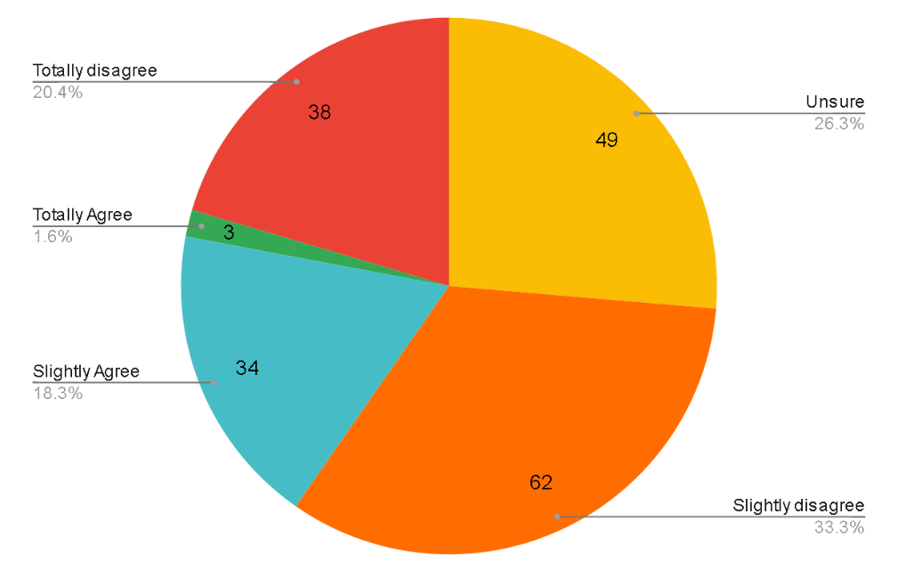
Figure 4.1: Graph Presenting Data Findings from Question 1

An overwhelming number of participants responded negatively to the statement – either choosing to disagree or that they were unsure. Only 37 of the 186 respondents agreed that the prison system was working well as it was now. Straight away we are results demonstrate that people are not happy with the system and do not believe it is working. Though 49 were unsure about the statement, 38 were certain they disagreed with the subject suggesting that problems of the prison system brought up by O’Brien (2019), such as overcrowding and reoffending, was not knowledge retained only by those in the profession.

Q.2: Longer Sentences are a Deterrent to Crime
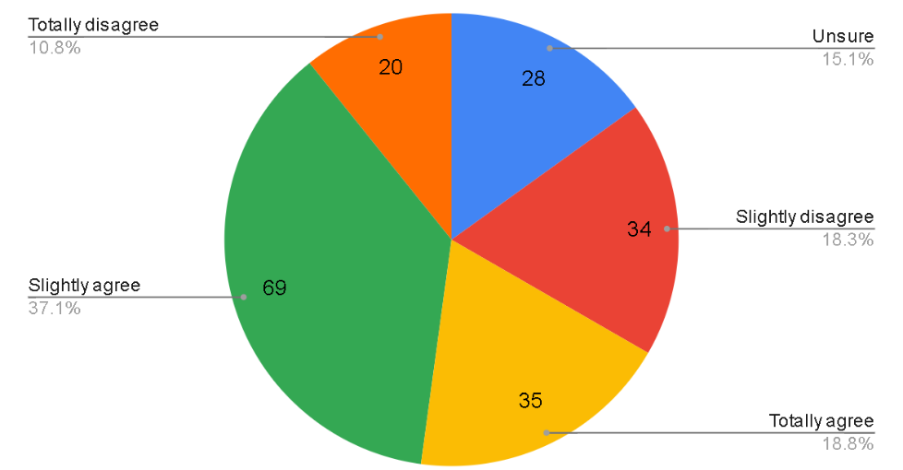
Figure 4.2: Graph Presenting Data Findings from Question 2
Nagin, Cullen and Jonson (2009) mention that the idea of longer sentences being a deterrent to crime has been a prevalent in society for years. Therefore, it may come as no surprise that more than half of participants agreed with this statement. However, this viewpoint may be harmful to the public’s view as Nagin, Cullen and Johnson (2009) continue to state that very little is known in terms of whether longer sentences actually do any good. In reality it is pushing the problem away rather than dealing with it and supporting this viewpoint could dissuade attention to rehabilitation.

Q.3: A Criminal Should be Rehabilitated Before They Can Re-enter Society
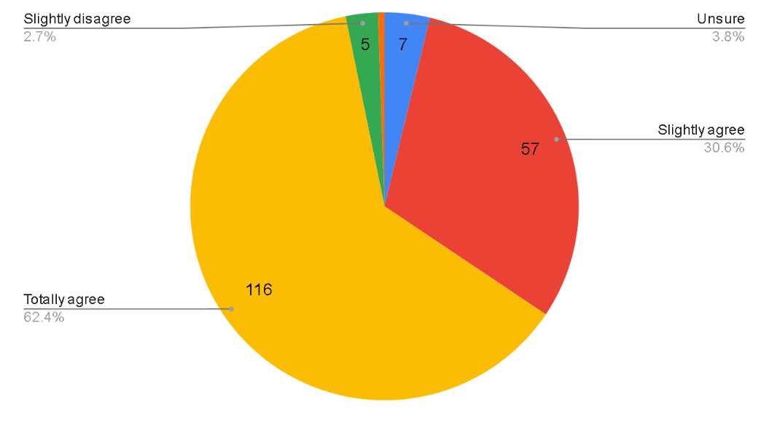
Figure 4.3: Graph Presenting Data Findings from Question 3

173 out of a total of 186 respondents agreed with this statement. This only leaves 13 participants who either were unsure or disagreed. This almost unanimous decision clearly presents that rehabilitation is very important to most of the public regardless of their gender, ethnic and dwelling – barriers suggested by Rade, Desmarais & Mitchell (2016), who claimed influence an individual’s opinion of ex-offenders.

Q.4: I am Aware of the Factors That can Lead Someone to Commit a Crime(s)
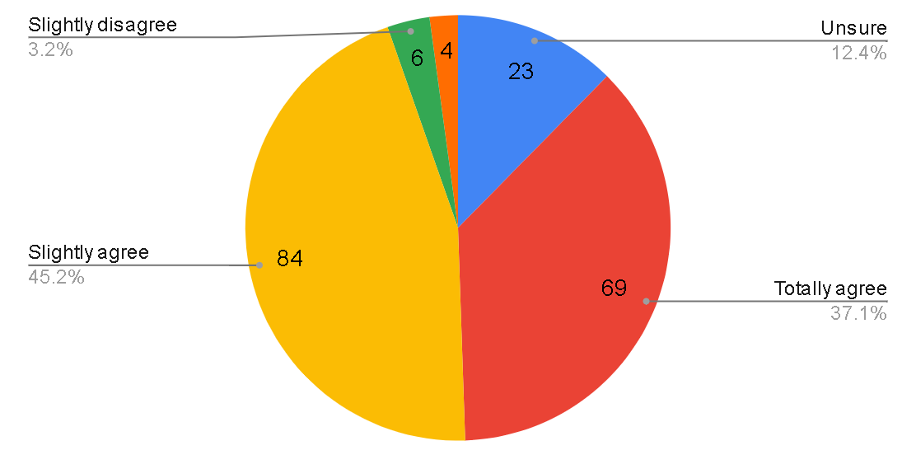
Figure 4.4: Graph Presenting Data Findings from Question 4

This question also received a majority “agree” answers, with only 10 participants responding “disagree” and 23 stating they were unsure. No actual contributing factors of crime were given; however, this did not matter as 153 stated that they at least had some inclination on what causes someone to commit a crime. This suggests that much of the public are aware of the issues that are faced by potential criminals, such as substance abuse, homelessness, and unemployment (HM Government, 2005; Ministry of Justice, 2008). Being aware of these factors could make the public more accepting of ex-offenders and more willing to accept them back into society.

Q.5 & Q.6
Question 5 and 6 have been left out of the analysis by the researcher as they were deemed unnecessary.

Q.7 + “Why?”:
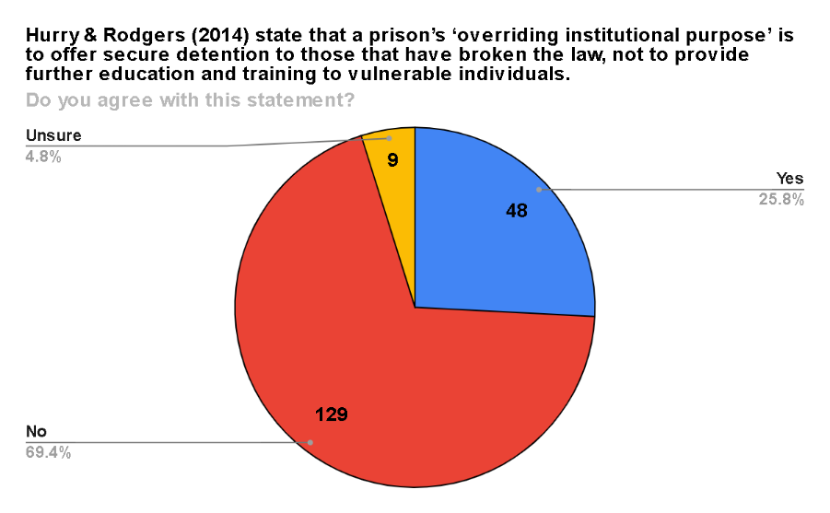
Figure 4.5: Graph Presenting Data Findings from Question 7

In response to the statement nearly three quarters of respondents did not agree that a prisons focus should be on detention. This data was looked through again with an age filter to see if there was any discernible connection between this answer and age. It was the researcher’s hypothesis that perhaps the bulk of those that agreed with the statement would be older and those that did not agree with the statement would be younger.
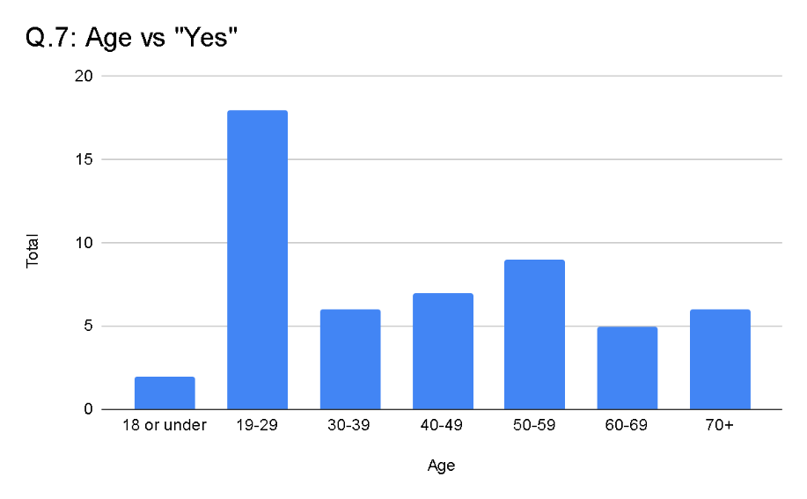
Figure 4.6: Graph Presenting Data Findings of Age vs Yes, with Results Collected from Question 7

However, upon examining those that agreed with the statement we see that the respondents are almost evenly spread across all age groups, except of course from 19-29 which is well above with the highest total of 18 responses (the next being”50-59” with 8 responses) – however it should be noted that 19-29 made up for almost half of the respondents therefore it would be expected that more data would be recorded for that age group. What we see is a general mix of opinion with no age group truly dominating – perhaps suggesting that age does not factor into as a potential barrier to ex-offenders (Brooks, Visher & Naser, 2006).
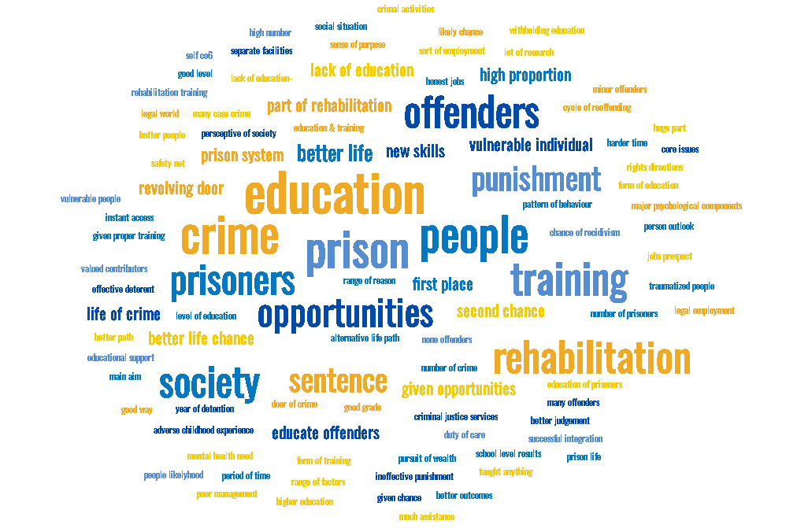
Figure 4.7: Word Cloud Combing the most Frequent Words and Phrases to Appear in “why?” following Question 7

The data from the “why?” question following question 7 has been complied into a word cloud to present some of the most common themes in participants explanations. The most prevalent word to appear was “education” which was found in 44 responses. These responses generally kept to the theme that education was important to prisoners with phrases such as “education provides chances” and “educations helps better themselves”. Other prevalent words included “training” which appeared 22 times and “rehabilitation” which appeared 18 times. The opinion of the public here seems to correlate with that of Maguire & Raynor (2006) and LeBel et al. (2008) who stress the importance of rehabilitation for prisoners.

Q.8: Does it surprise you that as of July 2020, 88% of offenders released from custody entered unemployment? (Ministry of Justice, 2020)
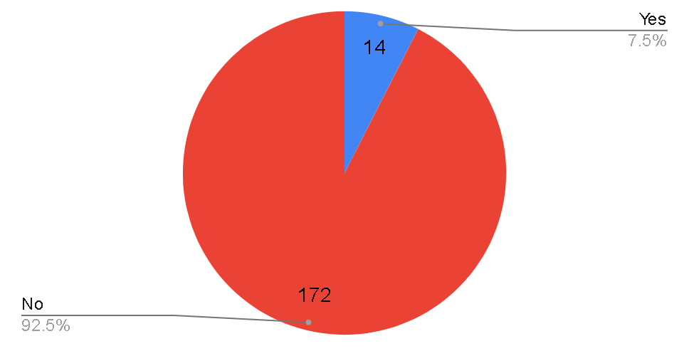
Figure 4.8: Graph Presenting Data Findings from Question 8

As with question 1 and 4, question 8 reveals that people are more in-tune with issues concerning the prison system as almost all participants were not surprised to learn almost 90% of ex-offenders left prison to unemployment (Ministry of Justice, 2020). This continued perception of the public about ex-offender issues could work to reject claims that the public are creating barriers for ex-offenders (Rade, Desmarais & Mitchell, 2016; Lerentz, 2011) and instead the pubic not only understands these issues but would like to see them solved.

Q.9: In your opinion whose responsibility is it to ensure an ex-offender finds employment after leaving prison?
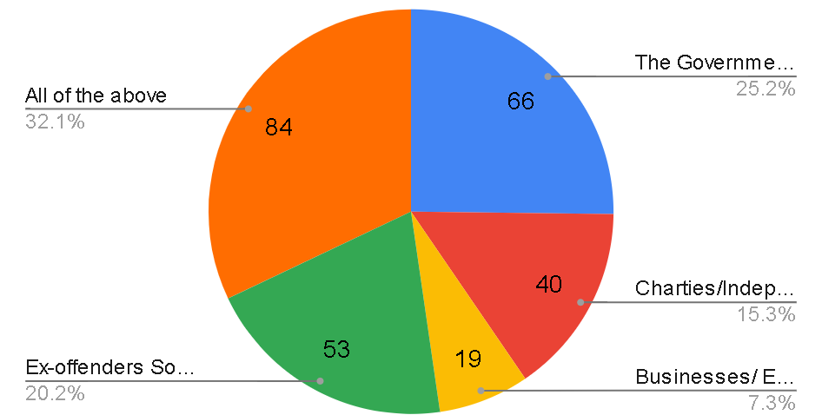
Figure 4.9: Graph Presenting Data Findings from Question 9

Of the given options – which participants could select more than one of – the most popular opinion was that “all of the above” were responsible for ensuring an ex-offender found employment. Following that was “The Government” with 66 responses, but surprisingly third highest was the option that it was the ex-offender’s sole responsibility to find they own employment. This could contrast with previous questions where results demonstrated an understanding of ex-offender issues from the public. Whereas, here people may not realise that ex-offenders struggle to find their own employment due to issues such as drug abuse, mental health issues and homelessness (Bronson & Berzofsky, 2019; Maruschak et al., 2019).

Q.10: Regardless of whether you are currently employed or not, how comfortable would you feel if you knew one of your colleagues was an ex-offender?
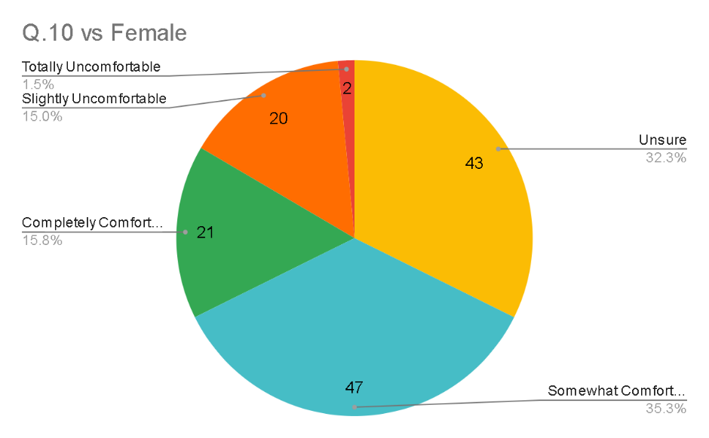
Figure 4.10: Graph Presenting Only Female Data Findings from Question 10

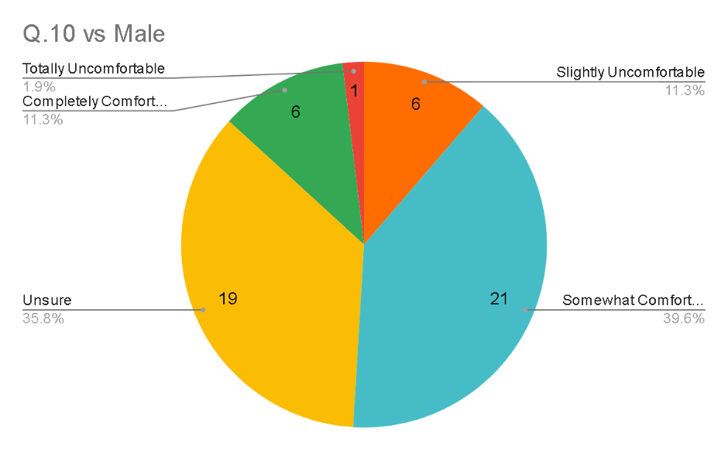
Figure 4.11: Graph Presenting Only Male Data Findings from Question 10

The data for question 10 was spilt to test both male and female responses separately. Comparing the two reveals that both the male and female results follow the same pattern almost identically. “Somewhat comfortable” is most prominent, followed by “unsure”, with “Totally uncomfortable” being least chosen. This question seemed to make the participant think more personally as the question involved themselves in the scenario and it was expected that females might perhaps test more negatively given findings by Lerentz (2011) and Macini, Sheilds, Mears & Beaver (2010), however those findings are not apparent here.

Q.11: Regardless of if you are currently employed, if a colleague was an ex-offender but you were unaware would you want them to disclose that information with you?
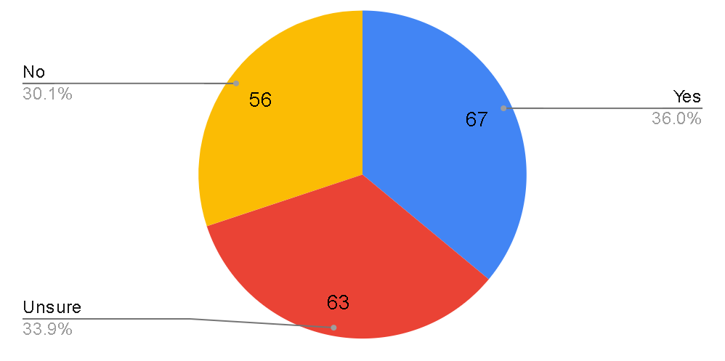
Figure 4.12: Graph Presenting Data Findings from Question 11

Analysing the total results for question 11 revealed the responses were spilt almost equally between all options. This was taken as an opportunity to test these results against specific communities in hopes to find a pattern between results.
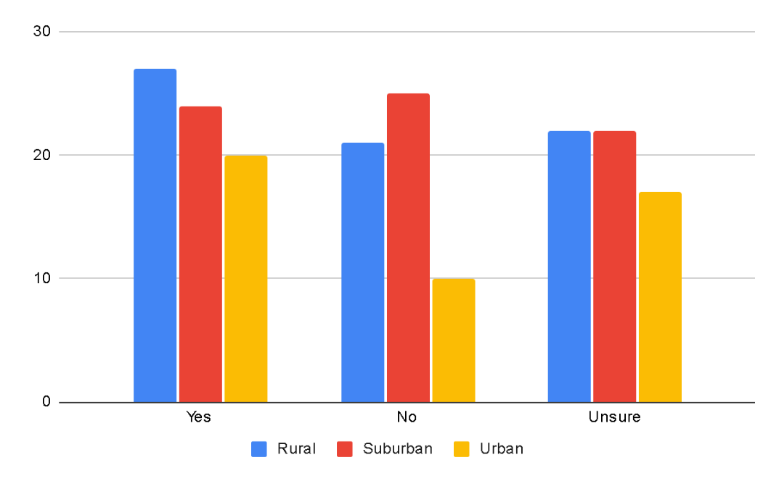
Figure 4.13: Graph Comparing Community Specific Data Findings from Question 11

However, upon testing the results against participants communities the data seemed once again to spilt more or less equally, with only marginal differences. “Yes” was most popular with both rural and urban. Suburban had the highest response for “no” with 25 responses, however this is only by one as “yes” received 24 responses from suburban participants. These results could support Leverentz (2011) and Mackey & Courtright (2000) who state that those in rural communities tend to have more negative views of ex-offenders, however the difference is not by much.

Q.12: Choose the statement you most agree with
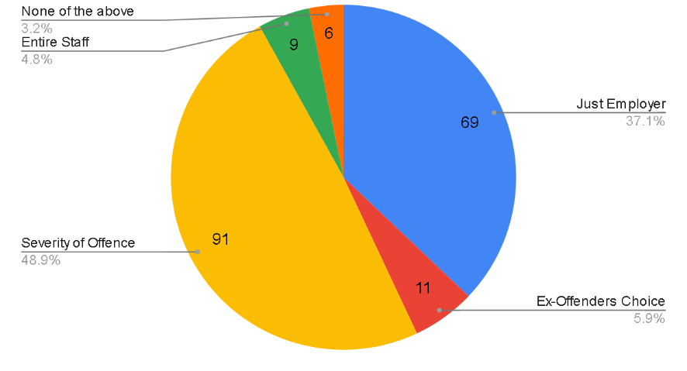
Figure 4.14: Graph Presenting Data Findings from Question 12

This question asked participants to consider how disclosure of ex-offences should be dealt with in the workplace. Disclosure depending on the severity of the offence made up almost half of the responses. Second to that was disclosure being a matter between the employer and the ex-offender. It does make sense that the employer should be aware of the ex-offender’s past as Po´csik, Brown and Spencer (2008) mention the concerns employers have for any risk to the business or their staff.

Q.13 & Q.14 + “why?”
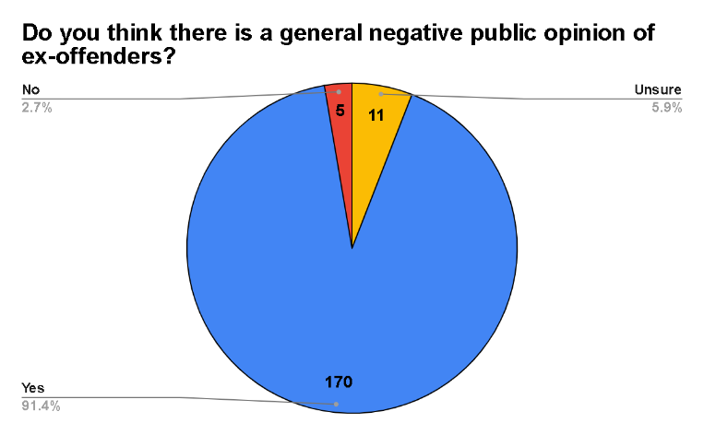
Figure 4.15: Graph Presenting Data Findings from Question 13

This question asked the participant to consider the bigger picture. From the results it is apparent that the strong majority do believe that there is a general negative opinion of ex-offenders. In contrast this study has so far shown generally quite positive, or at least accepting, views on ex-offenders.
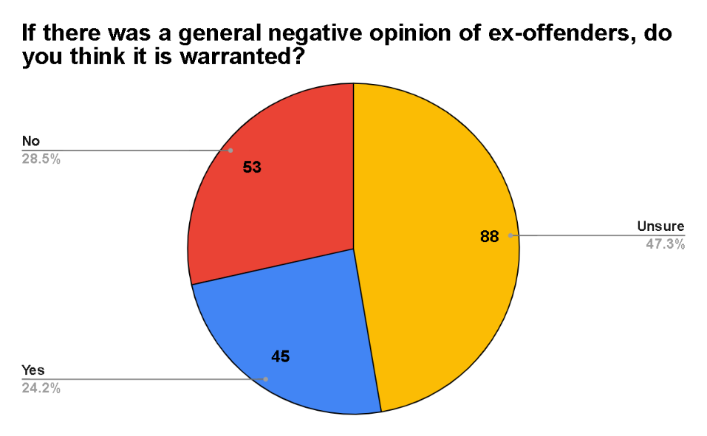
Figure 4.16: Graph Presenting Data Findings from Question 14

Question 14 expanded further on question 13, asking the participant whether a negative opinion of ex-offender was justified. Almost half responded that they were not sure. Therefore, they could expand on their answer with the next “why” section.
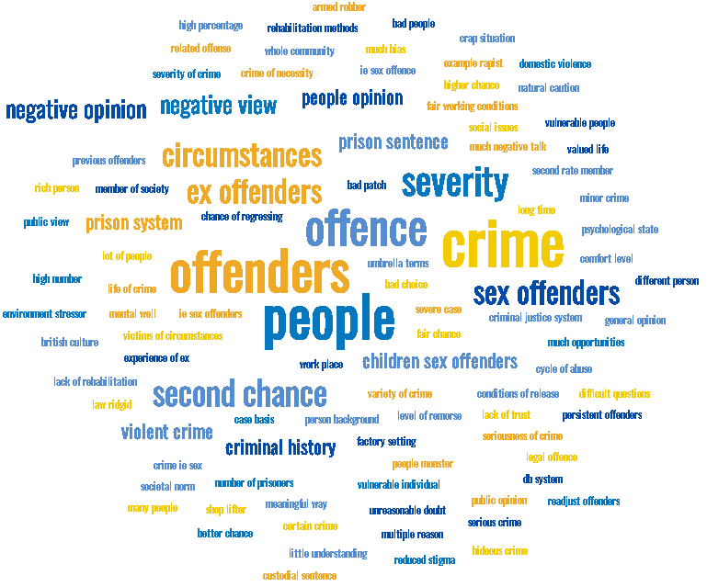

Figure 4.17: World Cloud Presenting Most Frequent Words and Phrases from “Why?” Question that Followed Question 14

The general theme of most “why?” answers had to do with the severity of the crime and how more serious crimes contribute to the negative opinion. The word “crime” appeared in 153 responses, all of which were in some way explaining how it “depends on the crime”. The word “people” appeared 111 times in “why?” answers, mainly in answers that expressed that the ex-offender is still a person and didn’t deserve the negative stigma as there could be various reasons for their offending. These results provide further evidence that people are more understanding towards ex-offenders than first thought, perhaps not only recognising the existence of the “out-group” (Stone et al., 1992; Tajifel, 1978) but a wanting to begin breaking down the concept to allow “out-group” members back into the “in-group”.

Q.15: Select any of the following which you believe may influence your opinion of an ex-offender
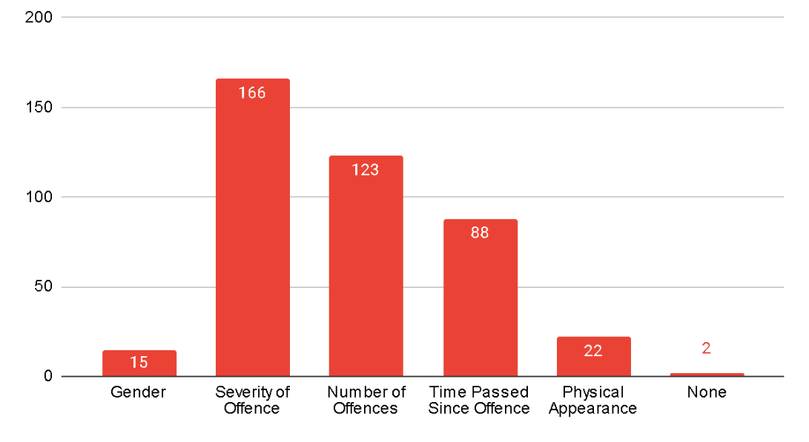
Figure 4.18: Graph Presenting Data Findings from Question 15

The results from question 15 correlate with earlier results which showed an importance of severity of offences when it came to the public and their opinions on ex-offenders. Here “severity of offence” was chosen by 166 out of 186 of participants, meaning nearly everyone who took the survey indicated that severity was an influential factor. Other notable influential factors were “number of offences” and “time passed since offence” – further concreting the idea that it is the offence not the person that people have concerns about (Hardcastle, Bartholomew & Graffam, 2011; Perkins, Raines, Tschopp & Warner, 2009).

Q.16: Of the options below, which do you believe has most greatly influenced your opinion of ex-offenders?
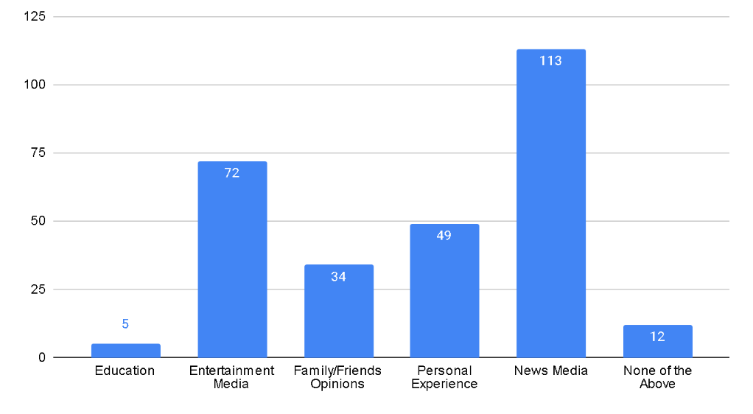
Figure 4.19: Graph Presenting Data Findings from Question 16

Question 16 continued the theme of influences, however it focussed on how other societal structures may influence the public opinion on ex-offenders. From the results, we see that the two most popular influences were both forms of media available (Entertainment and News). It would make sense that media would have the most influence as it is consumed so frequently by the public. Kroon, Verhoeven & Jonkman (2018) stress the prevalence of the media’s obsession with negative news and how we are drawn to it. With more stories that focus on individuals committing heinous crimes it develops our opinion and creates a feeling of resentment and anger against all those who commit crimes – creating a prejudice (Goffman, 1963; Link & Phelan, 2001).

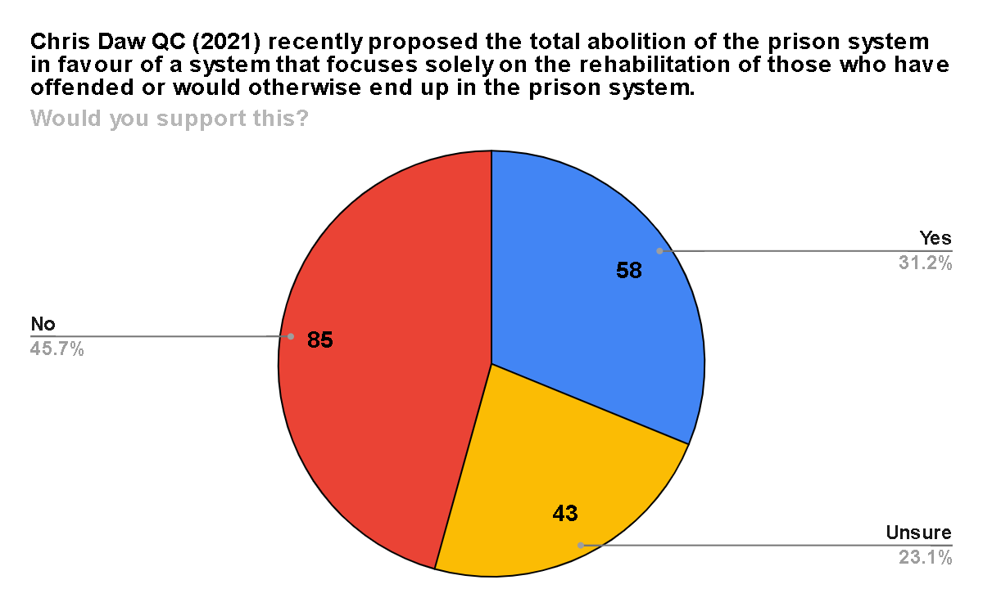
Q.17 + “Why?”

Figure 4.20: Graph Presenting Data Findings from Question 17

The final question presented the participants with the controversial scenario of total prison abolition in favour of rehabilitation. This statement received mostly negative responses with 45% of respondents against the idea of replacing the current prison system.
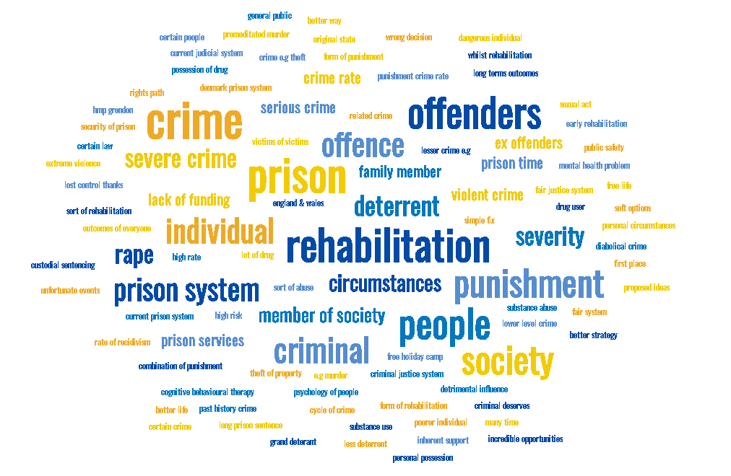
Figure 4.21: Word Cloud Compiling the Most Frequent Words and Phrases from “why?” Following Question 17

One of the main themes throughout the “why?” section was people concerned for the severity of crimes and suggesting that some crimes were beyond rehabilitation. Other themes were that some crimes did deserve a punishment – the word “punishment” appeared in 85 answers. However, there were majority of answers which did support rehabilitation and acknowledge that it was a better solution than detention.

4.3 Conclusion

This chapter achieved the third objective:
“To analyse the data collected exploring public views and attitudes concerning ex-offenders, rehabilitation, and influential factor on opinions.”
The final chapter will review and conclude the findings from this chapter and provide recommendations for the future.

5. Chapter Five: Conclusions and Recommendations

5.1 Introduction

The final chapter of this research project looks to present the main findings of the study an provide recommendations for both future research and social practise.
This chapter also aims to achieve the final objective:
“To understand the implications of the research, making recommendations for both future research and social practise.”

5.2 Main Findings

One of the main findings this research presented was that people were generally supportive of rehabilitation for ex-offenders. At first glance it could be contrived that people only wanted ex-offenders rehabilitated for their own safety, however exploration of “why?” answers revealed that people’s concerns were for the ex-offender themselves. Participants frequently wrote that ex-offenders deserved second chances and acknowledged that they were still people too. Though it might be a stretch to suggest that people had an overall positive view of offenders, they at least felt some positive emotions in wanting to see ex-offenders thrive back in society rather than simply be retained in prison.
It was also found that factors of the ex-offender’s offence were most influential when it came to negative opinions. The most influential and prominent factor to feature throughout the data was the severity of the offence committed. This reaffirms studies by Hardcastle, Bathrolomew & Graffam (2011) and Perkins, Raines, Tschopp & Warner (2009) which proposed that the type of criminal offence was significant in developing someone’s judgement of an ex-offender.
In contrast, studies by Rade, Desmarais & Mitchell (2016), Leverentz (2011) and Mackey & Courtright (2000) - which brought gender, age, and type of community up as potential influencing factors – were not reaffirmed by the results of this survey. In their respective analysis’ the only pattern to be found between them was that there was no discernible pattern that separated them. They all produced more or less equal results. This is not to say that these factors do not have an effecting factor on someone’s opinion of ex-offender, just that this study did not find a significant difference between them.
Finally, the media was found to be the most prominent external factor in influencing a person’s opinion of ex-offenders. This included both news media and entertainment media. It was not surprising to learn that media had the most influence simply due to how much exposure it gets and how many individuals it can reach simultaneously. The problem however is that many individuals only chose news media as the influential factor even when the option to select more than one factor was available. This means that the media has significant control over that person’s opinion. If negative stories are continuously published on news media it can lead to people’s opinions getting progressively more negative.

5.3 Recommendations

Using what has been learnt from the data and the conclusions that have been made, recommendations can be made for both future research and societal structures.
Firstly, the data from in this study was gained from a relatively small pool of nearly 200 people. There is no way to know if these views represent that of the entire UK. Therefore, research should continue into this field, testing a much larger data pool to refine results even further and conclude whether these views do correlate to an entire population. Research should continue to focus on the different factors researched here: gender, age, and dwelling; to confirm whether there are any differences.
Secondly, the data found here should be used to encourage ex-offenders who are burdened by their past and feel as though they are being held back by the label of “ex-offender”. These results provide relief and understanding from the public, they are ready to support ex-offenders who are ready and willing to move on, learn and overcome their past mistakes.
Thirdly, some further thought needs to be investigated on how the media portrays not just ex-offenders, but any subject. People should be aware of the hazards of building their opinions solely off what they see televised (Kroon, Verhoeven & Jonkman, 2018). Furthermore, the media need to be aware of the damage that negative stories can have on the groups represented in the stories. Likewise, those who do currently have a negative view of ex-offenders need to realise that not every offender is the same and behind those crimes is a lifetime of different experiences, choices, and impacts.
Lastly, the government should consider locating funding away from the prison system and invest more in a system that supports rehabilitation. Detention, even a life sentence, is truly only a short-term solution to a problem that will continue indefinitely unless the system can change to help rather than punish.

5.4 Conclusions

The final chapter has achieved the final objective:
“To understand the implications of the research, making recommendations for both future research and social practise.”
The research project has completed all four of its objectives and thus, has achieved its aim:
“To explore the general public’s views on ex-offenders, the prison system and rehabilitation, whilst discerning whether a pattern of pre-existing prejudice exists against ex-offenders.”
This concludes the research project.

Bibliography

Allport, G. W. (1954) The Nature of Prejudice. Reading, MA: Addison-Wesley.

Anderson, K. and Mayer, L. (2019) Findings from Formative Research to Develop a Strength-Based HIV Prevention and Sexual Health Promotion Health Intervention for Transgender Women. Transgender Health, 4(1), pp.350-358.

Berg, B. and Lune, H. (2009) Qualitative Research Methods for the Social Sciences. 7th ed. Long Beach: Pearson.

Binswanger, I.A, Sternm M.F. and Deyo R. A. (2007) Release from Prison—a High Risk of Death for Former Inmates. N Engl J Med.356(2):157–165.

Bronson, J. and Berzofsky, M. (2017) Indicators of Mental Health Problems Reported by Prisoners and Jail Inmates, Bureau of Justice Statistics. Available at: http:// www.bjs.gov/content/pub/pdf/imhprpji1112.pdf.

Bronson, J., Stroop, J., Zimmer, S., Berzofsky, M. (2017) Drug use, dependence, and abuse among state prisoners and jail inmates, 2007–2009. Bureau of Justice Statistics. Available at: http://www.bjs.gov/content/pub/pdf/ dudaspji0709.pdf.

Brooks, L. E., Visher, C. A. and Naser, R. L. (2006) Community residents’ perceptions of prisoner reentry in selected Cleveland neighbourhoods. Washington, DC: Justice Policy Centre, Urban Institute

Burnett, R. and Maruna, S. (2006) The kindness of prisoners. Criminology & Criminal Justice, 6(1), pp.83-106.

Button, S. (2001) Organizational efforts to affirm sexual diversity: A cross-level examination. Journal of Applied Psychology, 86(1), pp.17-28.

Caddick, B. and Webster, A. (1998) ‘Offender literacy and the probation service’, Howard Journal, 37, 137–47.

Cheliotis, L and Jordanoska, A. (2016) The arts of desistance: Assessing the role of arts-based programs in reducing reoffending. The Howard Journal of Crime and Justice, 55(1/2), 25–41.

Clair, J., Beatty, J. and Maclean, T. (2005) Out of Sight But Not Out of Mind: Managing Invisible Social Identities in the Workplace. Academy of Management Review, 30(1), pp.78-95.

Clear, T. R., Rose, D. R., and Ryder, J. A. (2001) Incarceration and the community: The problem of removing and returning offenders. Crime & Delinquency, 47, 335-351. doi:10.1177/0011128701047003003

Collins, H. (2010) Creative Research: The Theory and Practice of Research for the Creative Industries AVA Publications, p.38

Collins, J. and Hussey, R. (2014) Business Research: A Practical Guide for Undergraduate & Postgraduate Students, 4th edn. Hampshire: Palgrave Macmillan

Costelloe, A. and Warner, K. (2014) Prison education across Europe: Policy, practice, politics. London Review of Education, 12(2), 175–183.

Cullen, F., Jonson, C. and Nagin, D. (2011) Prisons Do Not Reduce Recidivism. The Prison Journal, 91(3), pp.48-65.

Dewey, S., Codallos, K., Barry, R., Drenkhahn, K., Glover, M., Muthig, A., Roberts, S. and Abbott, B. (2020) Higher Education in Prison. Journal of Correctional Education, 71(1), pp.57-89.

Dovidio, J. F., Glick, P. and Rudman, L. A. (2005) Introduction: Reflecting on the nature of prejudice: Fifty years after Allport. In J. F. Dovidio, P. Glick, & L. A. Rudman (Eds.), On the nature of prejudice: Fifty years after Allport (pp. 1-16). Malden, MA: Blackwell.

Fiske, S. T. (2005) Social cognition and the normality of prejudgment
J.F. Dovidio, P. Glick, L.A. Rudman (Eds.), On the nature of prejudice: Fifty years after Allport, Blackwell Publishing, Malden, MA, pp. 357-411

Fowler, F. (2009). Survey research methods. 4th ed. Thousand Oaks: Sage Publications.

Georgina Sturge, (2020) UK Prison Population Statistics. [online] House of Commons, pp.5-11. Available at: <https://commonslibrary.parliament.uk/research-briefings/sn04334/>

Gibson, C., Roberson, D. and Daniel, A. (2009) African American women on the possibilities of a relationship with an ex-offender. Journal of Criminal Justice, 37, 328-332. doi:10.1016/j.jcrimjus.2009.06.009

Gill, M. (1997) Employing Ex‐Offenders: A Risk or an Opportunity? The Howard Journal of Criminal Justice, 36(4), pp.337-351.

Gillham, B. (2007) Developing a questionnaire. 2nd ed. New York: Continuum.

Glasser, W. (1999) Choice theory. 1st ed. New York, N.Y.: Harper Perennial, pp.283-309.

Goffman, E. (1963) Stigma: Notes on the management of spoiled identity. Englewood Cliffs, NJ: Prentice Hall.

GOV.UK. (2019) £100 Million Crackdown on Crime in Prison. [online] Available at: <https://www.gov.uk/government/news/100-million-crackdown-on-crime-in-prison>

GOV.UK. (2020) Swansea Prison. [online] Available at: <https://www.gov.uk/guidance/swansea-prison>

Hardcastle, L., Bartholomew, T. and Graffam, J. (2011) Legislative and community support for offender reintegration in Victoria. Deakin Law Review, 16, 111-132

Halperin, R. (2012) Rehabilitation Through the Arts. Journal of Correctional Education, 63(1), pp.6-23.

Haslewood-Po´csik, I., Brown, S. and Spencer, J. (2008) A not so well-lit path: employers’ perspectives on employing ex-offenders, Howard Journal, 47, 18–30

Hirschfield, P. J. and Piquero, A. R. (2010) Normalization and legitimation: Modeling stigmatizing attitudes toward exoffenders. Criminology, 48, 27-55. doi:10.1111/j.1745-9125.2010.00179.x

HM Government. (2005) Reducing Re-offending through Skills and Employment. Availableat: http://www.dfes.gov.uk/offenderlearning/uploads/documents/green_paper_reducing_re-offending_through_skills_%20and_employment_ﬁnal_version.pdf

Holden, M. T. and Lynch, P. (2004). Choosing the Appropriate Methodology: Understanding Research Philosophy. The Marketing Review, 4(4), 347–409

Hunter, G and Boyce, I. (2009). Preparing for Employment: Prisoners' Experience of Participating in a Prison Training Programme. The Howard Journal of Criminal Justice. 48. Pp. 117 - 131. 10.1111/j.1468-2311.2008.00551.x.

Hurry, J. and Rodgers, L. (2014) Education, training, and employment in prison and post-release. London Review of Education, [online] 12(2), pp.159-161. Available at: <https://discovery.ucl.ac.uk/id/eprint/1476039/1/Hurry%20and%20Rogers%20LRE%202014.pdf> [Accessed 3 May 2021].

Jacobi, T. and Stanford, A. F. (Eds.). (2014) Women, writing, and prison: Activists, scholars, and writers speak out. Rowman & Littlefield.

Jones, E., Farina, A., Hastorf, A., Markus, H., Miller, D. and Scott, R. (1984) Social Stigma: The Psychology of Marked Relationships. Contemporary Sociology, 14(3), p.401.

Jones, K. and King, E. (2014) Managing Concealable Stigmas at Work. Journal of Management, 40(5), pp.1466-1494.

Kirsch, G. and Sullivan, P. (1992) Methods and methodology in composition research. 1st ed. Carbondale, Ill.: Southern Illinois University Press.

Kroon, A., Verhoeven, P. and Jonkman, J. (2018) Mediatization and the Disproportionate Attention to Negative News. Journalism Studies, 20(6), pp.783-803.

Kruttschnitt, C. and Savolainen, J. (2009) Ages of Chivalry, Places of Paternalism. European Journal of Criminology, 6(3), pp.225-247.

LeBel, T.P., Burnett, R., Maruna, S. and Bushway, S. (2008) The ‘‘chicken and egg’’ of subjective and social factors in desistance from crime, European Journal of Criminology, 5(2), 131–60

Leverentz, A. (2011). Neighbourhood context of attitudes toward crime and re-entry. Punishment & Society, 13, 64-92. doi:10.1177/1462474510385629
Lewis, S., Maguire, M., Raynor, P., Vanstone, M. and Vennard, J. (2003) The Resettlement of Short-term Prisoners: An Evaluation of Seven Pathﬁnder Programmes, (Home Ofﬁce Findings No. 200), London: Home Ofﬁce

Link, B. and Phelan, J. (2001) Conceptualizing Stigma. Annual Review of Sociology, 27(1), pp.363-385.

Locke, C. R. (2010) Public attitudes toward mental illness: An experimental design examining the media’s impact of crime on stigma (Unpublished doctoral dissertation). The Ohio State University, Columbus

Lynch, J. P., & Sabol, W. J. (2001) Prisoner re-entry in perspective. Washington, DC: Urban Institute.

Mackey, D. A. and Courtright, K. E. (2000) Assessing punitiveness among college students: A comparison of criminal justice majors with other majors. Justice Professional, 12, 423-441. doi:10.1080/1478601X.2000.9959561

Mackie. D, Hamilton.D. L, Susskind. J and Rosselli. F. (1996) Social psychological foundations of stereotype formation, Stereotypes and stereotyping, Guilford Press, New York pp. 41-78

Maguire, M. and Raynor, P. (2006) How the resettlement of prisoners promotes desistance: or does it? Criminology and Criminal Justice, 6(1), 17–36

Mancini, C., Shields, R. T., Mears, D. P. and Beaver, K. M. (2010) Sex offender residence restriction laws: Parental perceptions and public policy. Journal of Criminal Justice, 38, 1022-1030. doi:10.1016/j.jcrimjus.2010.07.004

Maruschak, L. M., Berzofsky, M. and Unangst, J. (2015) Medical problems of state and federal prisoners and jail inmates, 2011–12. Bureau of Justice Statistics. Available at: http://www.bjs.gov/content/pub/pdf/mpsfpji1112.pdf.

McNeill, F. (2006) A desistance paradigm for offender management, Criminology and Criminal Justice, 6(1), 39–62.

Metcalf, H., Anderson, T. and Rolfe, H. (2001) Barriers to Employment for Offenders andEx-Offenders: Part One (Research Report No. 155) Leeds: Department for Works and Pensions.

Ministry of Justice (2008) Strategic Plan for Reducing Re-offending 2008–11: Working inPartnership to Reduce Re-offending and Make Communities Safer, London: Ministry ofJustice. Available at: http://www.noms.justice.gov.uk/news-publications-events/publications/consultations/RRSP_2008-2011/ (accessed 11 March 2008)

Myers, M.D. (2008) Qualitative Research in Business & Management, SAGE Publications

Niven, S. and Stewart, D. (2005) Resettlement Outcomes on Release from Prison in 2003, London: Home Ofﬁce.

O’Keeffe, C. (2003) Moving Mountains: Identifying and Addressing Barriers to Employment, Training and Education from the Voices of Women (Ex) Offenders, Shefﬁeld: Women into Work

O'Brien, R. (2019) Labour Gains. RSA Journal, 165(1), pp.34-37.

Pager, D. (2003) The mark of a criminal record. American Journal of Sociology, 108, 937-975. doi:10.1086/374403

Park, S. (2009) College students’ attitudes toward prisoners and prisoner re-entry (Unpublished doctoral dissertation). Indiana University of Pennsylvania.

Perkins, D. V., Raines, J. A., Tschopp, M. K. and Warner, T. C. (2009) Gainful employment reduces stigma toward people recovering from schizophrenia. Community Mental Health Journal, 45, 158-162. doi:10.1007/s10597-008-9158-3

Pettigrew, T. F. and Tropp, L. R. (2006). A meta-analytic test of intergroup contact theory. Journal of Personality and Social Psychology, 90, 751-783. doi:10.1037/0022-3514.90.5.751

Prisonreformtrust.org.uk. (2019) Prison: The Facts. [online] Available at: <http://www.prisonreformtrust.org.uk/Portals/0/Documents/Bromley%20Briefings/Prison%20the%20facts%20Summer%202019.pdf>

Rade, C., Desmarais, S. and Mitchell, R. (2016) A Meta-Analysis of Public Attitudes Toward Ex-Offenders. Criminal Justice and Behaviour, 43(9), pp.1260-1280.

Ragins, B. and Cornwell, J. (2001) Pink triangles: Antecedents and consequences of perceived workplace discrimination against gay and lesbian employees. Journal of Applied Psychology, 86(6), pp.1244-1261.

Resnick, D. B. (2015) What is Ethics in Research and Why is it Important? List adapted from Shamoo A and Resnik D. 2015. Responsible Conduct of Research, 3rd ed. (New York: Oxford University Press).

Rhodes, J. (2008) ‘Ex-offenders, social ties and the routes into employment’, Internet Journal of Criminology

Sarno, C., Hearnden, I., Hedderman, C., Hough, M., Nee, C. and Herrington, V. (2000) Working their Way out of Offending: An Evaluation of Two Probation EmploymentSchemes (Home Ofﬁce Research Study No. 218), London: Home Ofﬁce.

Saunders, M., Lewis, P. and Thornhill, A. (2009) Research Methods for Business Students (5th ed). Essex, England: Pearson Education Limited.

Saunders, M., Lewis, P. and Thornhill, A. (2012) “Research Methods for Business Students” 6th edition, Pearson Education Limited

Saunders, M., Lewis, P., Thornhill, A. and Bristow, A. (2019) Research Methods for Business Students. 8th ed. Pearson, pp.128-171.

Schutt, R., Deng, X., & Stoehr, T. (2013) Using bibliotherapy to enhance probation and reduce recidivism. Journal of Offender Rehabilitation, 52(3), 181–197.

Schutt, R. K. (2019) Investigating the Social World: The Process and Practice of Research, 9th edn. Thousand Oaks: SAGE Publications.

Social Exclusion Unit. (2002) Reducing Reoffending by Ex-Prisoners, London: Ofﬁce of the Deputy Prime Minister

Solomon, A. L., Dedel Johnson, K., Travis, J. and McBride, E. C. (2004) From prison to work: The employment dimensions of prisoner reentry. Washington, DC: Urban Institute.

Stone. E. F, Stone. D. L, Dipboye. R L. (1992) Stigmas in organizations: Race, handicaps, and physical unattractiveness, Issues, theory, and research in industrial/organizational psychology: Advances in psychology, North-Holland, Oxford, England, pp. 385-457

Sue, V. and Ritter, L. (2012) Conducting online surveys. 2nd ed. East Bay, USA: Sage Publishing.

Sukamolson, S. (2007) Fundamentals of quantitative research. Language Institute Chulalongkorn University, 1, pp.2-3.

Sweeney, M. (2012). The story within us: Women prisoners reflect on reading. University of Illinois Press

Tajfel, H. (1982) Social Psychology of Intergroup Relations. Annual Review of Psychology, 33(1), pp.1-39.

Taylor, D. (2019) Prisoner Rehabilitation Does Not Work, Says Former Prisons Boss. [online] The Guardian. Available at: <https://www.theguardian.com/society/2019/oct/29/prisoner-rehabilitation-does-not-work-says-former-prisons-boss>

Walliman, N. (2011) Research methods: The Basics. 1st ed. London: Routledge.

Weaver, B. (2016) Offending and Desistance. 1st ed. Routledge, pp.50-72.

Whelan, C. (2020) The Importance of Prison Rehabilitation Programs Before And After Release | Independent Women's Forum. [online] Independent Women's Forum. Available at: <https://www.iwf.org/2020/06/29/the-importance-of-prison-rehabilitation-programs-before-and-after-release

Whitehead, S. (2016) Ex-offenders face neglect from the very services set up to help them. [online] the Guardian. Available at: <https://www.theguardian.com/public-leaders-network/2016/dec/14/ex-offender-prison-neglect-public-services-advice-support-criminal-justice-innovation>

Wilson, J. (2010) Essentials of Business Research: A Guide to Doing Your Research Project SAGE Publications
Appendices
Appendix.1 – Copy of Questionnaire

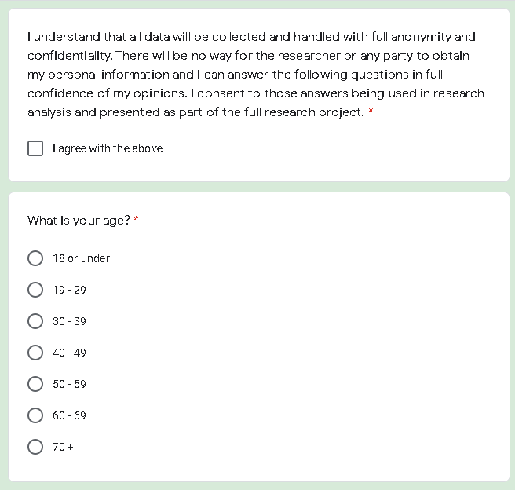

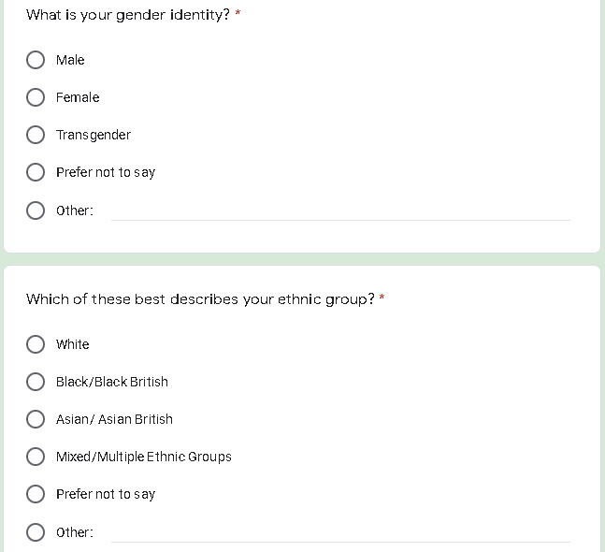


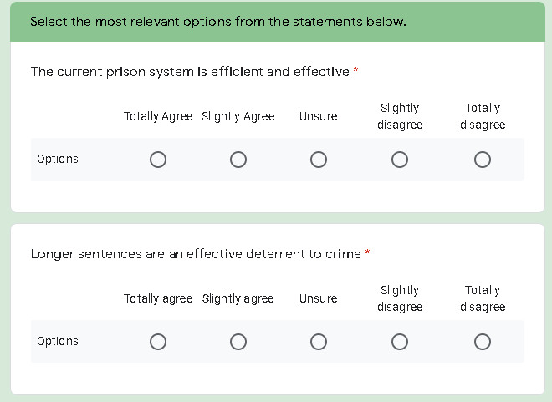
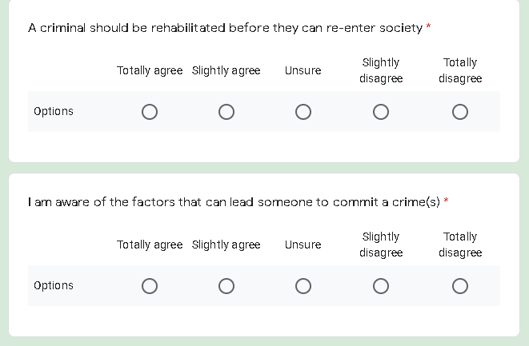

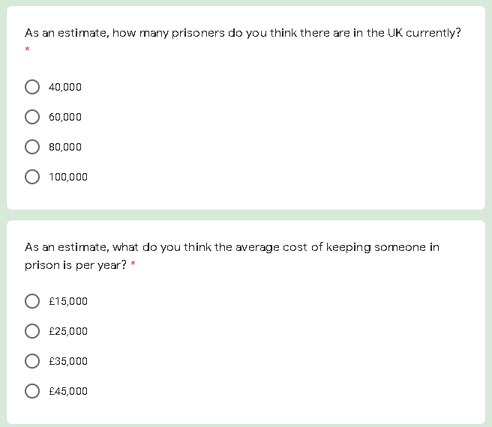

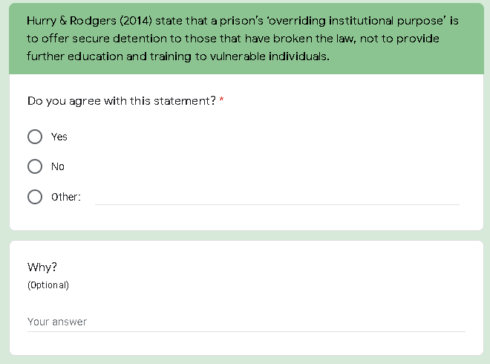

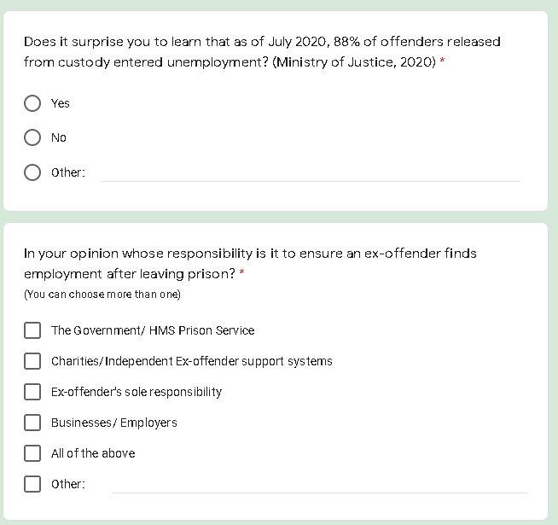

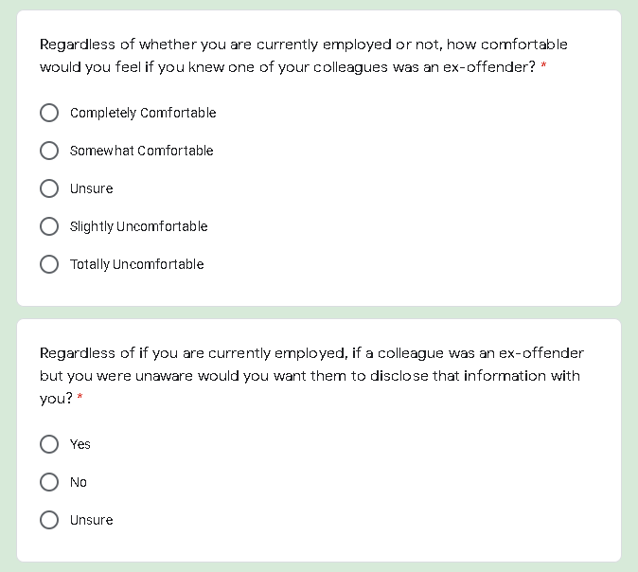

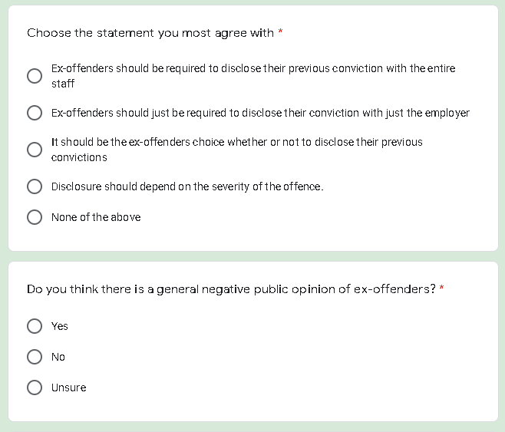

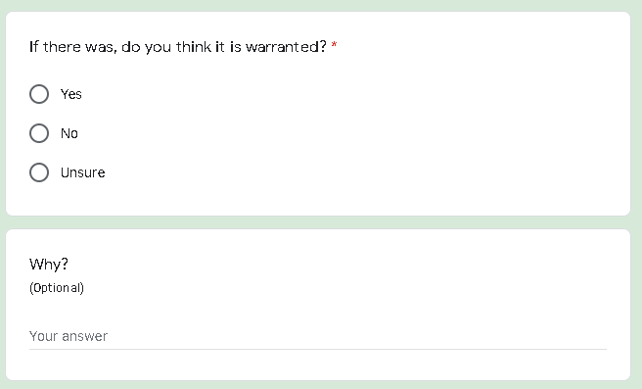

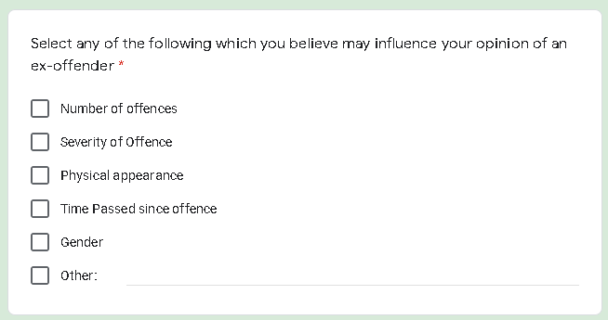

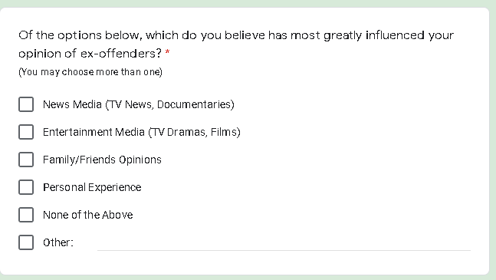

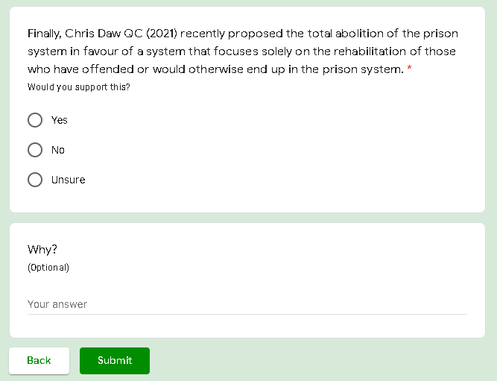

Appendix. 2 – Ethics Form

















































