

Module Code: M4X01163

Module: Materials & Introduction to Manufacturing

BEng Mechanical & Manufacturing Engineering

Name: Joseph Samuel Law

Student Number: 1704471

Table of Contents
Introduction 3
Product 3
Material 3
General Properties 3
Mechanical Properties 3
Thermal Properties 3
Application 4
Advantages 4
Disadvantages 4
Manufacturing Processes 4
Material 4
Blow Moulding 4
Extrusion Blow Moulding. 5
Injection Blow Moulding 6
Cooling 7
Quality 7
Alternative processes 7
Moulding tool 8
Health Risks. 8
Recycling and Environmental Issues 8
Conclusion 9
Bibliography 10

Polymer Moulded Bottle Assembly

Introduction
This report will look into the materials and manufacturing processes used to make ‘Polymer Moulded Bottle Assembly’, the applications and quality issues. The report will then look at alternatives that can be used with the benefits and other issues.

Product
There is a wide variety of products that require plastic bottles in order to be transported, sold and stored. Water bottles are one of the most produced bottled products in the world and predominantly in plastic bottles.
(Laville & Taylor, 2017) of the guardian suggests that 480 billion plastic bottles were purchased in 2016 worldwide and that is an increase of 180 billion from 2006. (Laville & Taylor, 2017) also states:
“If placed end to end, they would extend more than halfway to the sun”.
While (Nace, 2017) states:
“Two statistics jump out immediately. One, that globally humans buy a million plastic bottles per minute. The second, 91% of all plastic is not recycled. On top of that, it is estimated that over half a trillion plastic bottles will be sold in 2020”.
This gives us a product that has a very large demand, but we must also appreciate there is a worldwide competition.

Material
The vast majority of ‘Moulded Bottles’ are made from polymer or more commonly known as ‘Polyester’, a thermoplastic, pronominally Polyethylene Terephthalate (P.E.T).
PET was first developed by chemists, DuPont, in North America in the 1940’s. They labelled this new-found Polymer as ‘Dacron ‘. It wasn’t until the 1970’s that they used the material in the newly developed process of ‘Blow-stretch Moulding’ to form bottles. (Unknown, 2015)

General Properties
Density | 1.29e3 – 1.4e3 | Kg/m^3
Price | 0.797 – 1.03 | GBP/kg

Mechanical Properties
Youngs modulus | 2.76 – 4.14 | GPa
Yield strength | 56.5 – 62.3 | MPa
Tensile strength | 48.3 – 72.4 | MPa

Thermal Properties
Melting point | 212 – 265 | °C
Maximum service temperature | 66.9 – 86.9 | °C
Source: (Edupack, 2018)

PET can be heated up to 175°C while still retaining its mechanical properties (above).

Application
Although PET is used widely within the manufacturing market for such things as clothing, food containers, synthetic carpet and even wall insulation, this report will be focusing on the application of moulded bottles.
PET bottles are used for various different products from cleaning products, acidic liquids and consumable drinks.

Advantages
- Strong & Light – The strength of PET is extremely good, so even when the PET is thin and lightweight, it still offers good strength.
- Material Safety – the yield strength and Youngs modulus of PET shows us that PET doesn’t splinter and shatter like other materials such as glass.
- Material Reaction – As we have stated PET is widely used in the food and drink industry as it has a very low reaction with consumables.
- Appearance: PET can be made into a range of different colours with dye, but PET is clear, making it ideal for bottles.

Disadvantages
- Oxidation – PET is not used in long life consumables, as over time it is believed that the PET will affect the taste of the consumable.

Manufacturing Processes

Material
PET is made from a mixture of polycondensation of purified terephthalic acid (PTA) with ethylene glycol (EG), they are both mixed at very high temperatures and under very low pressures, whilst under the removal of water and exhausted gas. This process produces PET strips which are then cut into resin pellets. PET can be combined with many other materials such as glass or carbon to improve properties such as its strength. (Unknown, 2015)

Blow Moulding
There are predominantly two forms of blow moulding when it comes to making polymer bottles. Injection Blow moulding and Extrusion Blow Moulding, both are very similar.
The initial set up for both processes are almost identical. Raw material, also known as Pellets are loaded into the ‘hopper’ (Funnel like feeder) of the machine. The pellets are headed and forced down an extruder barrel and screw assembly (Torpedo section) and heated (200-300 °C) which melts the polymer. The screw assembly is then forced forward to eject the molten polymer out of a nozzle. (Paul Degarmo, et al., 1997)

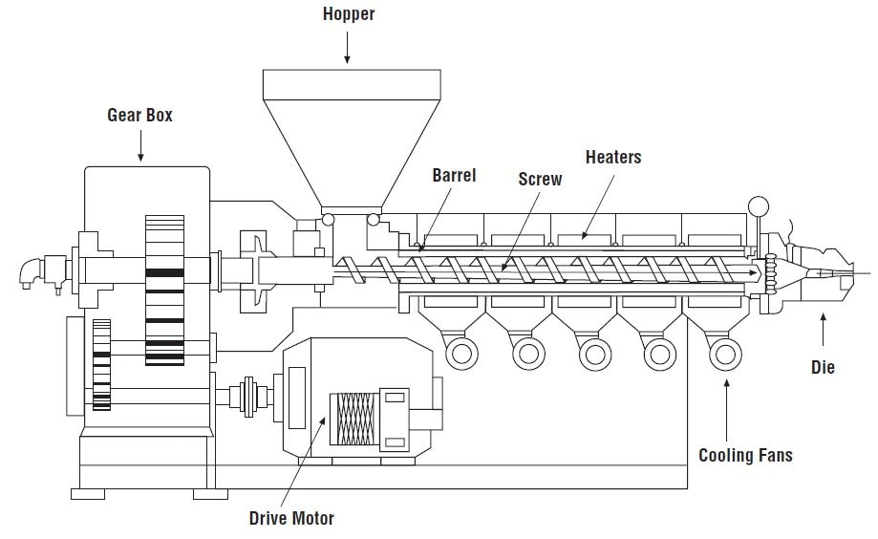
Single Screw Extruder
Source: (Dr. Giles, 2017)

Extrusion Blow Moulding.
When the molten polymer is ejected from the nozzle it forms molten tube-like shape, this is known as a ‘Parison’.
The parison is then clamped centrally by a split moulding tool in the shape of the desired bottle. Once the parison is in place, a steel pipe like tube known as a ‘Mandrel’ is slid into the of the parison. The mandrel is used to force highly pressured air into the parison causing the parison to expand and press into and mimic the bottle shaped mould.
During this process it causes the molecules to polarize and crystallise.
Once the bottle has cooled it is then released from the tool and trimmed. The bottom excess is cut off and is known as the ‘tail’, the excess from the top of the bottle is then cut, this is known as the ‘last head’. These cut offs are saved and fed back to the beginning of the process to be reused. This is known as a ‘closed loop system’. (Paul Degarmo, et al., 1997)

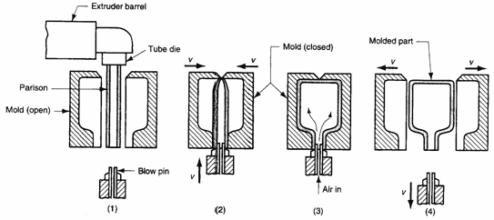
Extrusion Blow Moulding Diagram
Source: Sinotech

Advantages
    - Cheap process and set up costs.
    - High rate of production.
    - Good for small volume production

Disadvantages
    - Trimming process, consumes time and waste.
    - Difficult to controlled wall thickness
(Brandau, 2014)

Injection Blow Moulding (Paul Degarmo, et al., 1997)
This process is a combination of injection moulding and blow moulding. The correct amount of molten polymer is ejected from the nozzle into a preformed tool. Usually a small thick polymer tube like shape with the correct screw top is moulded (also known as a parison), it is moulded and formed around the mandrel. (This can be left to cool and stored to be used at a later date). (Batra, 2013)

This is then clamped into a second spilt mould tool, this tool shaped with the final product design. When the parison is held centrally in the tool, the mandrel forces are into the parison causing it to balloon out and take the shape of the mould.
Unlike the extrusion blow moulding, no cutting or trimming is required as the correct amount of polymer is injected at the start of this process.

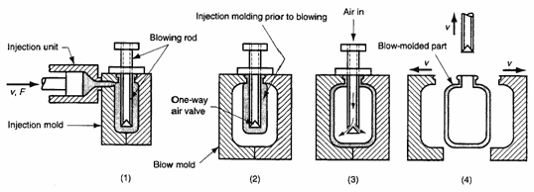
Injection Blow Moulding Diagram
Source: Sinotech

Advantages
    - Exact weight
    - Good quality control of wall thickness
    - No waste
    - High rate of production

Disadvantages
    - More expensive process

Cooling
Cooling can be performed in many different ways. Liquid cooling (water or liquid carbon dioxide) can be done by forcing liquid through pipes in the tool. Gases such as room temperature air can also be projected into the bottle.

Quality
The bottle can undergo many types of quality control.
Pressure testing – once the bottle has been fully moulded and cut, it will be sealed with a pressure gauge and taken up to a certain pressure and measured for leakage. Any failures will be fed back through the closed loop system.

Weight – The bottles weight can be measured to ensure it has the correct mass.

Visual – The bottles can be visual inspected to ensure no defects on the bottle.
(Lester & Gabriel, No Date)

Potential Issues
- Tool leakage – PET can sometimes be pushed through cracks in the tool, which causes and issue when smaller bottles are manufactured as a string causes the bottles to be connected and needing to be trimmed.
- Disformed Bottles – This can be caused by multiple factors from slow processing of the blow moulding to improper or poor cooling.

Advantages
- Overall Strength – Biaxial stretching means that the PET is stretched in both outward and downwards direction, this gives the bottles are stronger overall structure.
- Weight – Due to the bottled being stronger we can reduce the weight as less material is needed. Less weight and material mean a saving in cost.
- Any offcuts from flash or trimming can be reused.

Disadvantages
- Cost – Mass production of bottles using this process would benefit but if a very low volume production was required it would not be beneficial as the cost of the machinery is very high.

Alternative processes
- Injection Moulding –
  - Tooling is far more expensive.
  - Longer production time.
  - Over engineered part (Bottle removal from the tool)
- Rotational Blow Moulding -
  - Extremely long production time.
  - Labour intensive.
  - RAW material has to be ground down to fine powder.

Moulding tool
To create a plastic part in the moulding process, a mould/die has to be modelled and created before doing so. This is predominantly done using CAD/CAM (computer aided design/Computer aided manufacture). The desired bottle must be modelled and then cut out/machined from a block of material. The choice of tool material is critical, as tooling is commonly expensive and can also provide different benefits. If a low volume production was desirable then a soft tool would be the best option, such as aluminium as this tool is far cheaper and can produce up to 250 moulds, another benefit of an aluminium tool is it can dissipate heat quickly. If a mass production was required, it would be more beneficial to source a hard tool. This cost would be greater, but a hard tool could produce upwards of 1000 moulds and have a far greater life span.
(Roger, 2015)

Design
The majority of water bottles take on a very similar design. The design of the average bottle has a low centre of gravity giving it good stability.

Transportation
Bottles when filled hold their structure well, this allows them to be palletised and shipped/transported in mass quantities.

Health Risks.
Although there have been many studies into the health implications when using PET for food and drink. There are still mixed opinions and results. According to the ‘US National Library of Medicine (NLM), after 9 months of storage, spring water showed signs of DNA damaging activity. This caused be assumed as carcinogenic.
(Biscardi, 2003)

Recycling and Environmental Issues
According to PETRA, the PET Resin Association,

US & EU Recycling Rates

Almost 1.8 billion pounds of PET were recycled in 2015, used to make a to make a variety of end products. The U.S. EPA estimates that 1% of municipal solid waste in the U.S. is attributed to PET containers.

The issue with plastics such as PET, it can be recycled which is all well and good but as (Sedaghat, 2018) states:
“Every time plastic is recycled, the polymer chain grows shorter, so its quality decreases. The same piece of plastic can only be recycled about 2-3 times before its quality decreases to the point where it can no longer be used”.
This is a rather big problem. As we continue to product plastic such as PET and reuse it, but eventually it will be useless and forced into landfill or oceans.

We are all aware that plastics are not good for the environment. PET is not biodegradable so after the life of PET or any PET which is not recycled will pollute landfills and oceans. “Plastic water bottles often end up in landfills and can take nearly 700 years before they start to decompose.” (Northrop, 2015)
“Between 5m and 13m tonnes of plastic leaks into the world’s oceans each year to be ingested by sea birds, fish and other organisms, and by 2050 the ocean will contain more plastic by weight than fish, according to research by the Ellen MacArthur Foundation”. (Laville & Taylor, 2017)
With these facts and statistic, we need to eventually find an alternative to these materials, they may be cheap and by far the best way to product bottles and other forms of packaging, but they are not sustainable and will cause unfixable damage to our planet.

Conclusion
I have made the majority of my opinions present within and throughout this report.
I believe it is very difficult to find an alternative process for bottles as currently the process is driven predominantly by the raw material and although overall bad for the environment all other aspect from - material properties, to - cost of production and transport, are far superior than other materials.

Until a new sustainable biodegradable plastic or some other form of material is developed PET and other forms of thermoplastic will dominate. With current politics and a pandemic on the plastic pollution, companies using, and manufacturing plastics are being restricted and maybe over time it will be more feasible and more cost efficient to use other materials such as glass and metals due to fines and plastic restrictions in place.

In my opinion, I see injection blow moulding over extrusion blow moulding more desirable. Although the cost is greater, the quality control with high production rate and limited waste should out way the cost.

Bibliography
Anon., n.d. [Online].
Batra, R. C., 2013. Popular Plastics Packaging. s.l.:Colour Publications Pvt, Ltd.
Biscardi, D., 2003. Evaluation of the Migration of Mutagens/Carcinogens from PET Bottles. [Online]
Available at: https://www.ncbi.nlm.nih.gov/pubmed/12526902
[Accessed November 2018].
Brandau, O., 2014. How to Obtain Even Wall Thickness in Extrusion Blow Moulding. [Online]
Available at: https://ezproxy.uwtsd.ac.uk/login?url=https://search.ebscohost.com/login.aspx?direct=true&db=bth&AN=94507673&site=ehost-live
[Accessed November 2018].
Dr. Giles, H., 2017. An Introduction to Single Screw Extrusion. [Online]
Available at: https://www.azom.com/article.aspx?ArticleID=13566
[Accessed November 2018].
Edupack, C., 2018. Granta Design. s.l.:s.n.
Laville, S. & Taylor, M., 2017. A Millions Bottles a Minute. [Online]
Available at: https://www.theguardian.com/environment/2017/jun/28/a-million-a-minute-worlds-plastic-bottle-binge-as-dangerous-as-climate-change
[Accessed November 2018].
Lester, H. P. & Gabriel, P., No Date. Quality Control and Quality Assurance. p. Chapter 8.
Nace, T., 2017. We're Now at a Million Plastic Bottles Per Minute. [Online]
Available at: https://www.forbes.com/sites/trevornace/2017/07/26/million-plastic-bottles-minute-91-not-recycled/#26f0e87a292c
[Accessed November 2018].
Northrop, A., 2015. Steel, Glass and/or Plastic Bottles. [Online]
Available at: http://www.canr.msu.edu/news/steel_glass_and_or_plastic_bottles_what_is_the_best_choice
[Accessed November 2018].
Paul Degarmo, E., Black, J. & A. Kohser, R., 1997. Materials and Processes in Manufacturing. s.l.:John Wiley and Sons.
Roger, T., 2015. Everything You Need To Know About Injection Moulding. [Online]
Available at: https://www.creativemechanisms.com/blog/everything-you-need-to-know-about-injection-molding
[Accessed November 2018].
Sedaghat, L., 2018. 7 Things You Didn't Know about Plastic (and Recycling). [Online]
Available at: https://blog.nationalgeographic.org/2018/04/04/7-things-you-didnt-know-about-plastic-and-recycling/
[Accessed November 2018].
Unknown, 2015. An Intorduction to PET. [Online]
Available at: http://www.petresin.org/news_introtopet.asp
[Accessed November 2018].
Unknown, 2018. Blow & Rotational Molding. [Online]
Available at: https://www.sinotech.com/resources/tutorials/blow-rotational-molding/
[Accessed November 2018].

