Irene Dunne (2218125)
Word count: 9238
Exploring Elements of Vocal Mastery through the Lenses of a Mechanic, Storyteller, and Inventor: A Multi-Disciplinary Approach to Learning How to Sing
BMPF7013F

Table of Contents
Project Portfolio 2
Introduction 2
Rationale 2
Planned Programme of Study 3
Theoretical influences 3
Best practice influences 4
Methodological influences 5
Timeline 5
Ethics 5
Aims & objectives 6
Learning outcomes 6
Critical Review 7
Concrete experience 8
Reflective observation 9
Abstract conceptualisation 10
Active experimentation 10
Project Report 12
Introduction 12
Know that 13
The learner 13
Three key elements in singing 13
The poster 15
Know How 16
Poster design 16
The Mechanic 18
The Storyteller 19
The Inventor 20
Know what 21
The subject matter 22
The artefact design 22
The student 23
Reflective Conclusion 24
Appendix 26
References 27

Project Portfolio

Introduction
Vocal technique, song interpretation and musical creativity are aspects of learning to sing that most teachers explore in lessons. However, there can be a disconnect between teacher and student when a beginner singer does not understand where a particular task or element fits into the overall jigsaw of learning to sing. In these instances the student must rely heavily on the teacher to problem solve issues with their singing, and this becomes problematic for the student outside of the class environment. Owing to the effective way in which visual communication can play a valuable role in education, my artefact is a poster that will be displayed in my private voice studio. It will be aimed at beginner singers, primarily adults, and aim to bridge the gap between the knowledge of the teacher and the student (Myers, 2012). It will explore through visuals and text, three ways a student can influence their own song performance. This will be done through the use of the following well-known professions: mechanic, storyteller and inventor. The student will be invited to approach their song from each of these three professions in order to develop their own problem solving skills. There is no one-size-fits-all in vocal training (Nix, 2013), so while the poster will be visible, it is not intended as something that will be introduced to all students. Instead it is intended as a supporting resource that the teacher or student may reference during a lesson in order to gain a better understanding of the various ways to approach a particular problem as they develop their mastery.

Rationale
The study (artefact and research) will serve the needs of both students and teachers. It will benefit students that rely heavily on the opinion of the teacher. Students can get stuck in the master-apprentice form of teaching and therefore can often be unaware of clear strategies to improve their own performance of a song/singing (Sherwood, 2019). The study will also serve as a reminder to teachers that there are various angles from which to approach instruction. Anecdotally, I have found that from time to time as a voice teacher we can feel stuck if approaches that we have tried during a lesson, do not have the desired effect. As teachers, we need a resource that can help refocus our approach in real time. An accessible visual aid, that we can quickly reference during a fast paced lesson, can act as that resource. The artefact, which will be visible to both student and teacher, is intended to spark conversation about various components that are elements of vocal mastery. It will communicate clearly that technical work, song interpretation and artist individuality can and should be considered when developing well rounded singing (Swanson, 2011; Sear, 2024). The rationale for choosing a visual aid as the artefact is that students have more time in a lesson to absorb the information on educational posters. They can be attention grabbing if they are bright and visually interesting. When they have a concise message, they can stimulate discussion.

Planned Programme of Study

Theoretical influences
In the earliest phase of this study, I explored key theories that pertained to my artefact creation. I explored Humanistic Learning Theory, a framework rooted in humanism whereby the focus is on the whole person and their individual experience (Loeng, 2020). The goal is that students acquire knowledge alongside a sense of autonomy, identity and purpose (Draper, 1998; Taylor and Hamdy, 2013). Within the humanist approach the student is recognised as an individual, with their own educational needs and wants (Merriam, 2001). Therefore, it is the role of the teacher to facilitate this learner-centred approach by clearly working through the many elements that combine to create good singing (Sherwood, 2019). Through the artefact it is hoped that the use of clear images and simple prompts will provide an extra resource for the teacher to help the student find success.
Many theories from the world of voice science, vocal pedagogy, performing arts education and music psychology all have relevance to the development of vocal mastery (McCoy and Ragan, 2018). Therefore, this multifaceted nature of singing can lead to confusion for the beginner singer (Kagen, 1960; Rooney, 2016; Sansom, 2016). Furthermore, since the advent of the internet, voice students have direct access to many sources that provide contradictory instruction on singing, and this can also lead to confusion on the part of the beginner singer (Zhang, 2023). One framework that integrates information from scientific research, evidence based research and practical expertise is Evidence-Based Voice Pedagogy (EBVP). This theoretical framework endeavours to consider both technical and creative aspects of vocal mastery (Maxfield and Ragan, 2021). Sell (2017) also argues for a holistic multidisciplinary approach to teaching. Contemporary Commercial Music (CCM) differs from classical in that emphasis on elements other than technique must be included in the teaching, for example style training and song interpretation (Bartlett and Naismith, 2020). My artefact will be designed with the understanding that the student will benefit from being taught reliable techniques, both mechanical and artistic, that empower them to problem-solve as independent learners.
Through the use of the educational poster as an artefact, I aim to promote dialogue between teacher and student. Rowe and Rowe (2017) write about poster design and the viewer perspective, and specifically how that can lead to dialogue in the educational setting. Educational posters have been studied by Hubenthal and O’Brien (2011). They present a framework that applies multimedia theory to the educational poster in the classroom. This will further be explored through a look at best practices.

Best practice influences
There are many different learning styles among students and it is important for teachers to provide a variety of resources and activities in order to cater for this in the learning environment (Sener and Çokçaliskan, 2018). In vocal studios, the many needs of the student are catered for by a variety of educational materials that facilitate learning. These include scores, sheet music, backing tracks, pianos, recording equipment, warm-up and exercise manuals and tools, technology-based learning aids, lesson plans, workbooks, vocal anatomy models and visual aids and posters. The educational poster is my choice for an artefact because it serves as an educational tool that is inexpensive to create and yet is a proven effective teaching aid (Duchin and Sherwood, 1990). Currently there are educational posters available on Musicroom (Musicroom, 2015), Amazon (Amazon, 2024), Temu (Temu, 2024), Etsy (Primary Singing Time, 2022) and Zazzle (Zazzle UK, 2021). Musicmotion.com sell a number of visual aids and flashcards that relate to learning to sing. Each poster has an individual message on, for example project the sound (with an image of a loud hailer), and shape the vowels (a picture of a person surrounded by many mouths in various vowel shapes) (For, 2022). The most relevant poster to this study is the Chandler curriculum poster. This was created by Kim Chandler as a quick one page guide for students and teachers who wish to plan and structure various aspects of learning to sing (Compton Publishing, 2019). The Chandler curriculum poster, while informative, has small writing and is text only. My artefact will differ from this as it will be eye-catching through the use of both images and text (Hubenthall et al., 2011). Furthermore, the use of larger, clear fonts will make it more visible to the intended audience (Gjorgjieski, 2024). Currently, none of the posters available online offer an overview of singing elements through the use of three professions mechanic, storyteller and inventor.
Although not specifically posters, there are many teaching organisations that equip teachers with tools for fixing issues in the voice mechanically (White, 2017; Steinhouer and McDonald Klimek, 2019; Edwin and Wicks, 2019). A number of online resources are available that provide teacher training opportunities for those that wish to upskill in areas including acoustics, resonance, artistic expression, vocal techniques (Voice Study Centre, 2019).

Methodological influences
The methodological approach I will take for this study will be to carry out a short scoping literature review to explore pertinent theories. In order to do this, I will gather qualitative and quantitative data through journal articles and research studies. My intention is to adopt a pearl growing strategy within each of the following areas: humanist learning approaches, use of posters in learning environments and key elements of vocal mastery. The use of white and grey literature in the various areas along with a fusion of best practice and anecdotal evidence will be considered.

Timeline
The following Gantt chart will provide an overview of the various stages from initial planning through to submission of the module (Wilson, 2003).
TASK | JULY | AUGUST | SEPTEMBER | OCTOBER | NOVEMBER
Topic for module chosen, artefact chosen
Research into vocal technique, storytelling and improvisation
Outline of portfolio and literature review to be written up
Literature search and analysis to be undertaken
Portfolio to be written
Artefact designed
Draft submission
Re-writes and final submission

Ethics
Ethical considerations are a must in the vocal studio (Shapira-Lishchinsly, 2011). When displaying a poster it is important to make sure the information is accurate, that care is taken when depicting professional stereotypes, and that there is due consideration of race, gender and culture (Levine-Rasky, 2009). In my vocal studio the poster will be visible to all age groups, therefore it must be appropriate in images and content. It is understood that beginner adult singers can have many reasons for wanting to develop their singing. Many singers have their identities closely linked with their singing voice and their speaking voice and it must be understood that some students may not wish to engage in conversations around emotions of songs or communications (Stothert, 2012). Therefore it is intended that the poster will not be pointed out or verbally introduced to every student. Should any aspect of the poster offend the student it can be noted, removed from eyeline, and a design change can be considered. The student can be provided with contact details for relevant support organisations should they not wish to discuss the poster any further with the teacher.

Aims & objectives
- To help students problem solve issues with their own singing by uncovering and critically analysing the current research into self-directed learning in the vocal studio.
- To equip students with strategies to problem solve when learning to sing a song through the use of a variety of concepts and tools.
- To enrich the learning experience for the student by introducing the concept of the mechanic, the storyteller and the inventor as part of a multidisciplinary approach to learning to sing.
- To explore how visual aids, in the form of posters, affect learning in the private voice studio by keeping up to date with the latest research into educational posters.
- To develop a framework/guidelines for my studio and other teachers (at a later date), into the use of educational posters in the private studio, by using the information gathered from this study.
- To explore how approaching a song from various angles can influence the student experience of singing by researching three aspects of vocal pedagogy: technique, storytelling and creativity.

Learning outcomes
- To understand how technique, storytelling and creativity are approached by singers and taught by teachers.
- To understand how self-directed learning can be nurtured in the private studio between teacher and adult beginner singer.
- To understand whether the use of visual aids in the private voice studio enhance the learning experience for the student.

- To understand how student autonomy can be enhanced through the use of educational posters in one-to-one voice lessons

Critical Review
Reflective thinking was defined by a pioneer in the field, John Dewey as “active persistent and careful consideration of any belief or supposed form of knowledge in the light of the grounds that support it and the further conclusions to which it tends” (Dewey, 1933, p.9). Donald Schön wrote extensively on the importance of reflection in professional practice, and his reflective process theory was deeply rooted in experiential learning theory (Raiber, 2001). Theorists in experiential learning, including Kolb (1984), describe four stages within which to reflect on practice. In order to reflect on my artefact creation process so far, I will use Kolb’s reflective cycle (Morris, 2020), see figure 1.
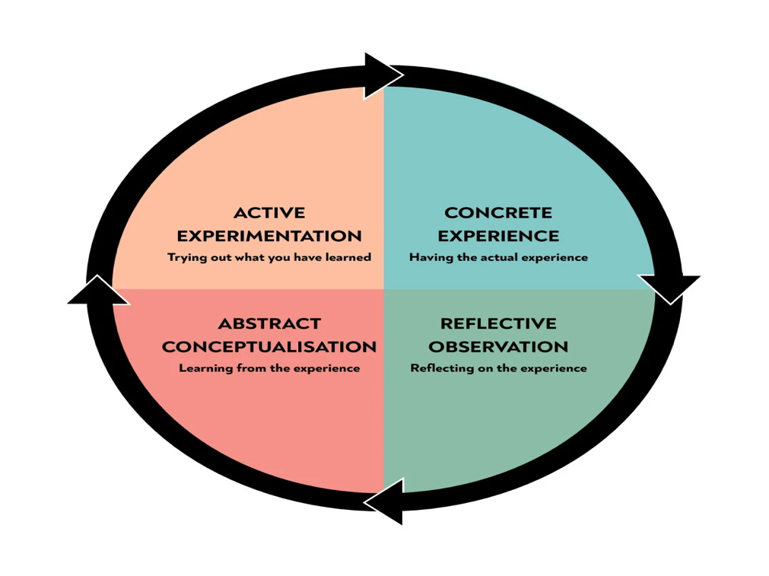
Figure 1Kolb’s Reflective model (Kolb, 1984)

Concrete experience
In my current professional practice I use a learner-centred approach (Tudor, 1993). Acknowledging that each student is unique and has different strengths and needs when it comes to their vocal mastery journey (Coffield et al., 2004). This begins in practical terms by asking the student what they would like to work on during that lesson. This relates to the study as there are times when a student is unsure of what to reply. By providing a resource that helps the student realise there are various elements that can be looked at, the aim is that the student will be better equipped to take ownership of their learning journey. Currently, on the walls in my teaching studio, I have framed posters of stage shows that I have been involved in, framed inspirational quotes, anatomy diagrams and my academic qualification certificates. In this project I am hoping that research into the optimal visual aid set up in the studio will shed some light on best practice.
Like many teachers, I have gathered my teaching techniques and approaches from many different sources over the years, beginning with Speech Level Singing (SLS), Institute of Vocal Advancement (IVA) and Modern Vocal Training (MVT). Through these organisations I have learned to diagnose areas of weakness in student singing voices. Also, to utilise tools including combinations of vowels and consonants, scale patterns and finished (for example sounds like “mum” or “yo” that have a finished quality that can be transferred to singing) and unfinished sounds (for example pharyngeal sounds like witchy or cry, and lower larynx produced sob quality). These mechanical tools encourage easy transition from the bottom to the top of the singers range. In my studio the student is made aware that there are tools that can achieve more ease in their singing voice, and they are encouraged to explore the different combinations themselves in order to problem solve vocal challenges. My artefact will have the image of a mechanic, this will visually represent that idea.
it is of vital importance in singing to develop elements such as flexibility, intonation, range, articulation, tone and breath, yet there are many more aspects that must be explored in order to achieve vocal mastery (Chandler, 2014). In my studio, I encourage students to develop skills in storytelling, expression, interpretation of lyrics and emotions. These are vital elements that are represented in the artefact through the image of the storyteller. Finally, in my professional practice I work on developing the musicality of the student, through creative explorations including vocal improvisation games and songwriting exercises. This encourages the student to approach their singing from a creative and individualistic perspective. In my artefact this approach is represented by the image of the inventor.

Reflective observation
When I conceptualised my idea, my understanding was that a poster displayed in my private voice studio would be a conversation starter, therefore the use of three images with little or no text would be sufficient to spark the curiosity of the student and encourage dialogue between the teacher and student. However, after the initial research into best practices in educational posters, it appears that very few posters have images without text, and what was surprising to me was that many posters had no images and quite a large amount of text (Compton Publishing, 2019; Amazon.com: Singing Knowledge Retro Metal Signs Singing Learning Reference Guide, 2024). Therefore, I have shifted my thinking away from using images only, to designing a poster that also includes text. My current thinking at this phase is that the text may be in the form of questions for the reader. But further research into visual aids in next phase of the study will hopefully shed light on the optimal text to include. The initial idea for the poster was that it would not be introduced to all students. This has aligned with humanist theory that I had explored in the beginning phase of the study, as under this approach to teaching it is recognised that all students are unique individuals, and the one size fits all approach does not work. A further exploration of how a teacher can recognise learning styles may be of use when deciding the appropriate level of student interaction with the artefact. In the beginning phase of this project, I acknowledged when researching best practices, the overwhelming amount of online instruction and information on how to develop vocal mastery. I have observed anecdotally, that students are constantly exposed to online vocal instruction through TikTok and other social media platforms (Alter et al., 2024). The research into EBVP has shifted my thinking from believing that a student can categorise and process every piece of information themselves and that collaboration with a teacher is still useful (McCoy, 2014; Hattie et al., 2021; Maxfield and Ragan, 2021). However, one hope is that the student who watches or hears a particular instruction online can remember the poster and categorise that instruction into one of the three professions. For example, the instruction might be “try these lip trills, or sirens on octave glides” a student might conclude that this is an approach the “Mechanic” might take in order to optimise the instrument. A student may watch a YouTube clip where the audience is moved to tears by a singers performance, and they may conclude that the singer is using the strategies of a “storyteller”. Finally, a student may watch a clip where the singer is singing a well-known song that they have altered significantly to suit their own style and expression. In this case the student may surmise that this is the “inventor” at work. This self-directed approach by a student will increase their feeling of autonomy, and they will hopefully have a clearer picture of key elements that are essential in vocal mastery (Deci and Ryan, 1987; Clemmons, 2006).

Abstract conceptualisation
From the conception of the artefact idea to now, certain areas have revealed themselves to warrant further exploration during the next phase of the study. Firstly, I want to explore whether it is possible to equip a student with sufficient skills to take ownership of their own learning journey by asking: Can self-directed learning be nurtured in the private studio between teacher and adult beginner singer? Secondly, I want to explore whether introducing the concepts of three different approaches to learning a song will reduce confusion for the beginner singer by asking: Can the introduction of the concept of the mechanic, the storyteller and the inventor provide the student with a clearer picture of the key elements of singing? And thirdly, I want to find out if the use of visual aids in the modern private voice studio enhances the learning experience for the student by asking: Can an educational poster be a useful addition to the vocal studio? By finding answers to these questions, I hope to achieve my aims and objectives in order to fully explore the effectiveness of approaching vocal mastery through various lenses.

Active experimentation
The planned next step is to do a scoping literature review. Having ruled out a systematic review, which is normally carried out by teams of researchers and is beyond the scope of this paper (Munn et. al., 2018; Arksey and O’Malley, 2005). The extensive research that has been undertaken by the Cochrane collaboration provides useful information on how best to gather the primarily qualitative data that I will be researching (Noyes et al., 2019). Deciding on the scoping review as a means of identifying relevant literature means that I will be examining the scope, extent and types of available research relevant to the posters design, content and impact (Nundy et al., 2022). In a previous module I found it useful to enter into the hermeneutic circle with specific questions in mind and make decisions about the relevance of the literature to the questions asked (Schmidt, 2016; Dunne, 2023). I will use this approach when researching the key elements of vocal mastery. I will adopt a pearl growing approach, which is searching for articles of high relevance that can then be scanned fully for other articles of relevance to the question (Schlosser et al., 2006). As I have never designed or created a poster before I will use this approach to uncover one or two key articles that pertain to poster design, in order to quickly discover the key elements that will inform my poster creation. I will not be looking at graphic design principles in detail, but will research basic principles of poster design as they pertain to educational messages. The key words/phrases for this search will be: educational posters; visual media in private vocal studio; poster design; music education poster; learn to sing poster; visual aids in music classroom; visual aids for singing. I will begin my poster research with the journal Educational Media International. From there, I will use relevant reference lists to search further articles that pertain to the topic. Through searching for information on educational posters it is hoped that this will help me inform my own poster design, and ultimately achieve the aim of improving the learning experience for the student through the use of the artefact. As the area of vocal pedagogy is so vast, I will limit my search criteria when researching elements of vocal mastery. I will look at generalised writings on vocal technique, song interpretation, creativity and developing musicality, without delving specifically into areas such as vocal science, music performance anxiety or acting techniques. I will be searching the following phrases: mechanics in singing; storytelling in singing; creativity and singing; vocal improvisation methods; improvisation in singing; acting through song; performance techniques; singing teaching methods; singing teaching techniques; autonomy and singing; imagination and artistry in singing; private voice studio; student-led learning and singing. There are many educational journals that are relevant to the topic, therefore I will search for the keywords and phrases in The International Journal of Music Education; Psychology of Music; Journal of Voice; Journal of Singing; Voice and Speech Review; Music Education Research and Journal of Research in Singing and Applied Vocal Pedagogy. This initial search of journals will be completed within the month of August 2024, using both Google Scholar and University of Wales Trinity Saint David library database. It is through searching these phrases and exploring the research through these journals that I hope to narrow down the relevant studies that will lead to a deeper understanding of vocal mastery and the role of technique, storytelling and creativity in singing. Finally, an exhaustive examination of learning styles and multiple intelligences will be excluded, as it is beyond the scope of this small study.

Project Report

Introduction
My artefact was created as a response to the need to bridge the gap between my knowledge and that of the student. As a private voice teacher I am constantly striving to expand my knowledge of singing. For the first number of years my primary focus was on learning how to analyse voices and how to best achieve vocal balance in my students. The vast area of vocology, in which there are many opportunities for learning about aspects of vocal training, voice mechanics, health and rehabilitation have made for a fruitful educational journey. As my career has progressed, and I am more confident working with the technical aspects of singing, my focus has shifted from gathering knowledge, to how best to use and ultimately transfer that knowledge to the individual client in my studio.
What has struck me over the last number of years, is not just that every voice is unique, but rather, every student is unique in terms of how they learn. I have also concluded that the teacher with the most knowledge is not always the best teacher (Johnson, 2014). Having studied humanistic theory as part of this module that has aligned with my already held views, that learning scenarios should be person-centred. My artefact has the potential to enrich the learning experience of the students who wish to engage with it, by helping them realise that there are various approaches to achieving competent singing. As an educator, I find it essential to engage in conversation with the student, in order to uncover their understanding of the concepts being introduced in lessons. The artefact can be referred to during those conversations to discuss the various elements of vocal mastery. For example, when a student is frustrated by not being able to reach a note successfully, the poster can serve to show that technique is only one element of good singing, and that there are other elements such as song interpretation and individuality that the student may have already found success with. In other words, the artefact can help put the challenges the student is facing into perspective, and therefore, potentially reduce frustration with the educational journey.

In the following project report, I will be utilising Nelson’s Model of Reflection as a framework. This taxonomy is a tool that will enable me to evaluate, critically think and reflect on the process of developing the artefact. Nelson categorised the reflective process into three distinct sections: know that, know how and know what. Under these three headings, I will review the literature that informs this study, document the processes involved in the creation of the artefact, and finally critically reflect on the practice.

Know that

The learner
Pedagogy can be described as the transfer of information from teacher to student (Watkins and Mortimore, 1999). The opposite to Pedagogy is Andragogy, where the student, whether or not they employ the assistance of others, control the learning (Loeng, 2020). In this instance the student decides what needs are to be met, they set their own goals, gather resources and review their learning success. One difference between the adult learner and the child is that the adult has a greater need to be seen as self-directed, as their concept of self can be affected (Knowles, 1980). The traditional master-apprentice approach to vocal instruction which has been the norm for centuries is now being challenged by a more student-led approach (Sauerland, 2018; Crocco and Meyer, 2021; Sherwood, 2023). Flipped learning, where the student researches the topic before it is discussed in class (Kardaş and Yeşilyaprak, 2015); self-directed learning, where the student sets their own goals (Deci, 2009); and self-regulated learning,
where the student monitors and evaluates their own learning (Cook and Artino, 2016), all fall under the umbrella of a constructivist approach. Constructivism is a construct where the student is involved in the creation of knowledge based on their experiences and needs (Goffi-Flynn, 2024). McPherson et al. (2017) write extensively on how self-regulation by the student improves overall learning outcomes. In vocal lessons or masterclass settings great results can be achieved in a short time, but often the student will not be able to replicate the action after leaving the class (Mass et al., 2008). Anecdotally, I have found that the student may get frustrated that they cannot reproduce the skill, and as a consequence, feel demotivated. For this reason, my artefact attempts to address the needs of the student who wishes over time to be less reliant on the teachers instruction or feedback. It provides three possible approaches for the student to address the requirements of singing such as vocal technique (the mechanic), song interpretation (the storyteller) and individuality and development of musicality (the inventor).

Three key elements in singing

Vocal technique
We know more about physiological and acoustical properties than we ever have through ground breaking research into vocal science, especially since the early 2000s (Hoch, 2020; Titze, 2021; Guzman et al., 2021). This knowledge is made accessible to us as teachers through numerous international teacher training organisations that promote the importance of functional training in singing. For example Institute for Vocal Advancement (Institute for Vocal Advancement, (n.d)); Vocology In Practice (Vocologyinpractice.org, 2024), Somatic Voicework (Vetri, 2009), Feldenkrais (Feldenkrais Method, n.d.), Estill method (Fantini et al., 2017), Voice Study Centre short courses (Voicestudycentre.com, 2017). Aside from these organisations, there are journals such as Journal of Singing, Journal of Voice and Journal of Research in Music Education, that publish many papers on various studies in vocology (Silveira and Diaz, 2014). Having access to this knowledge can directly impact our understanding of the voice and therefore our teaching. The information we choose to incorporate into our teaching gets passed on to the student, throughout our interactions, whether verbal or with the aid of visual media.
I agree with LoVetri (2013) who considers it of vital importance that functionality is addressed when training singers. However, Cole (2022) argues that there is an overreliance on mechanical training in vocal pedagogy. As teachers we can be tempted to focus primarily on the technical aspects of singing, however, we must not neglect the other elements that create a well-rounded and captivating song performance. Blades (2017) describes various elements that fall under the umbrella of functional technique such as posture, tone, evenness throughout the range, diction, vowels and registration, but goes on to list other aspects of singing such as imagery, artistic expression, communication and self-discovery work on performance.

Song interpretation
In musical theatre singing, the student must learn acting through song (ATS). In CCM genres there is also a need to convey the emotions of the song (Hoch, 2018). Genres that utilise electrical amplification have less need for projection of the voice, therefore, the nuances of the storytelling can result in a more intimate or personalised performance (Hughes, 2017). The narrative and stories in songs themselves have been researched. Nicholls (2007) categorises popular song lyric into levels, going from level one, where there is no discernible story to strong narrative in level 5. However, there are more elements than just the lyrics that can speak to the emotions and narrative in a song. Listening to the song with the student, and having conversations about the intended meaning. Imagery that might be conjured up through not only the lyrics, but the melody, harmony, rhythms, instrumentation and vocal effects. These are all areas that are vital to explore when singing (Negus, 2012). Rather than a sole focus on technique, Liu and Zhou (2021) have found that an integrated approach to technique training such as breath work, combined with development of artistic expression enhances the aesthetic performance of songs. When discussing the artefact with the student, the concept of this integrated approach toward vocal mastery will be addressed. By discussing the integration of the storyteller, representing song interpretation, with the mechanic as the technician, and the inventor as the creative.

Creativity
Encouraging our students to take risks and be unafraid of making mistakes helps our singers develop musicianship skills that radiate to all aspects of their music making (Riveire, 2006). The student can explore their musical creativity through personal interpretations of songs (Graham, 1998). Improvisation is one such element that is useful for singers to cultivate. It acts like conversations between different musical ideas (Madura, 1997). The singer may use improvisation techniques such as personalising, anticipating, predicting or being musically spontaneous (Azzara and Grunow, 2010). Exploring improvisation in the vocal studio can lead to positive outcomes for the individual in many ways from the technical to the aesthetic elements of singing (Wang, 2022). Therefore, my artefact incorporates improvisation under the profession of the Inventor. The inventor profession is part of the poster to remind the student that individuality in singing is worth developing, as it can have positive effects on not only a person’s musical ability, but also to their health and wellbeing (Beaty, 2005; Kindler and Gray, 2010; ASHA leader, 2013;Knapik-Szweda, 2015; Henwood, 2023). There are many methods of teaching improvisation in the vocal studio from vocal improvisation games (Fredrickson, 1994; Vlachos, 2015; Poliniak, 2019), the Kodály method (Whitcomb, 2003) through to using interactive technology (Wang, 2022; Zan and Drăgulin, 2023). By using a humanistic approach as teacher, we can decide the appropriate methods to employ that best suit the individual in the class (Burns et al., 2024; Sichivitsa, 2007). referred to above.

The poster
A decline in the use of posters in general society has been observed in recent times, however, they are still widely used in educational settings (Hubenthal et al., 2011). While the poster in a public space has been designed to quickly get the attention of the passer-by, the classroom offers more time for interaction (Timmers, 1998). Posters are more beneficial than blank walls as students can take in their surroundings providing engagement on a visual level. This can also promote self-directed learning (Cetin and Flamand, 2013). Visual learners can make up to 65% of the population over kinaesthetic learners (5%) and auditory learners (30%), therefore the use of posters in the learning environment can be a successful form of communication (Aduradola and Akeredolu-Ale, 2013). One study researched whether playful titles and images on educational posters for medical professionals were more effective than formal posters. They recommended that the playful posters were found to be more amusing to the participants, however they recommended poster creators need a nuanced understanding of the intended audience, in order to strike the correct balance between education and amusement (Ahyad and Badeeb, 2024). This must be taken into consideration as my poster will be viewed by a wide range of ages and cultural backgrounds. Hubbenthal et al. (2011) recommend that poster design should have an eye catching aesthetic, a link to curriculum and a balance of images and text. Therefore, I will endeavour to take these theoretical ideas to underpin the artefact, in order to develop it as an effective teaching aid. While it is useful to display a simple message, the educational poster can also provoke inquiry on the part of the student (O’Brien, 2010). My artefact will do this by the inclusion of thought provoking questions beside each of the three images of the mechanic, the storyteller and the inventor.

Know How

Poster design
The “rule of thirds” theory, where a poster is divided into three distinct sections, has been adopted in the design of the artefact (Duchin and Sherwood, 1990). By observing this theory, the three sections of mechanic, storyteller and inventor are framed and evenly spaced in order to achieve cohesion. The outcome of using this rule is that there is a unity achieved in the design, as each section is formatted the same, making it clearer for the student to absorb. Duchin and Sherwood (1990) suggest that titles should be in capital letters, should not exceed 10 words and be large enough to be seen from the far side of the room. My artefact, therefore, is in bold red capital letters, has only three words and clearly lets the reader know what the poster is about (see figure 2).
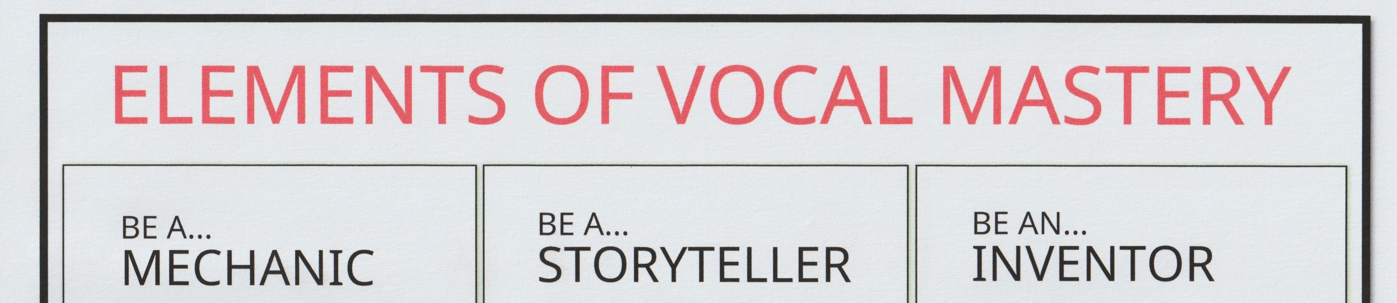
Figure 2

The poster layout has also been influenced by the Hubenthal et al. (2011) theory that eye catching design elements are more effective as a teaching aid, for this I use simple images to accompany each of the three professions. The images I have decided to use are stick figures, in order to make it more inclusive, by avoiding age, race, religion and gender stereotypes (see figure 3). Currently in my studio I have students ranging in age from 7 to 84 who span many ethnicities and religious backgrounds. There are also gender fluid and non-binary students. As the poster will be displayed indefinitely, consideration has also been given to the above theories in relation to potential new clients.
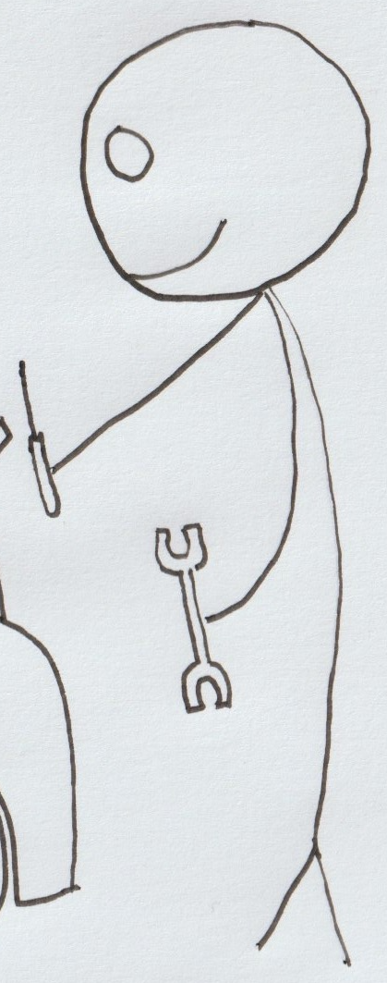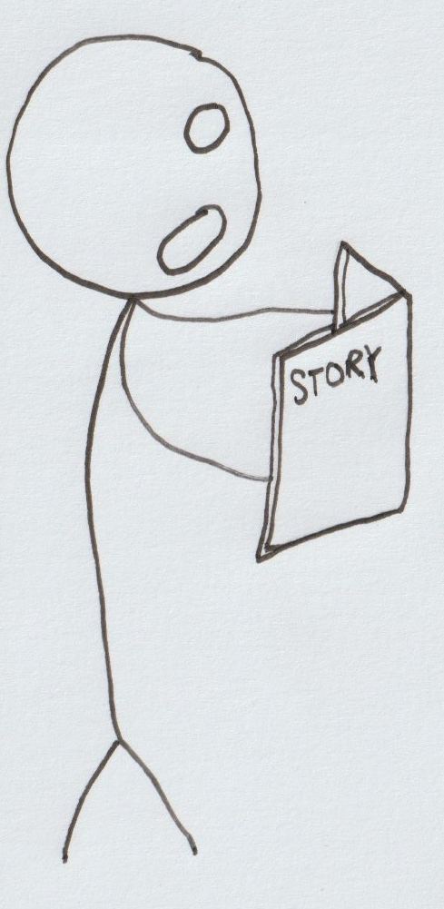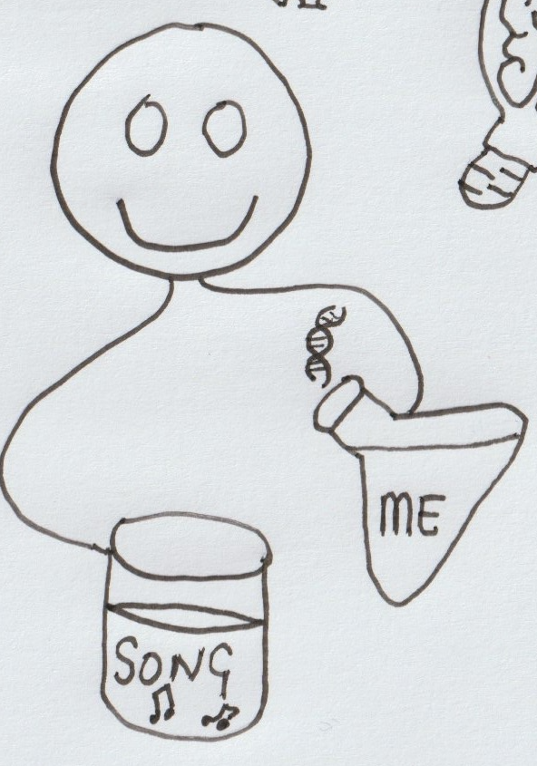
Figure 3: The Mechanic, Storyteller and Inventor stick figures

Duchin and Sherwood also impress the importance of concise nature of text, asking the creator to consider whether each word is essential in transmitting the message, as they believe that less is more when the aim is to deliver a clear educational message. For this reason, my artefact keeps the text to a minimum, in order to deliver a concise message that can be developed further through dialogue, which is a central aim of the poster as a supporting resource to my teaching. However, recognising that the student in a classroom scenario has more time to absorb the information on a poster (Graham, 2005), I have considered and included text that provokes thought on the part of the student, in the form of six concise questions. This will be explored when discussing the individual images and their accompanying text in the sections below.

The Mechanic
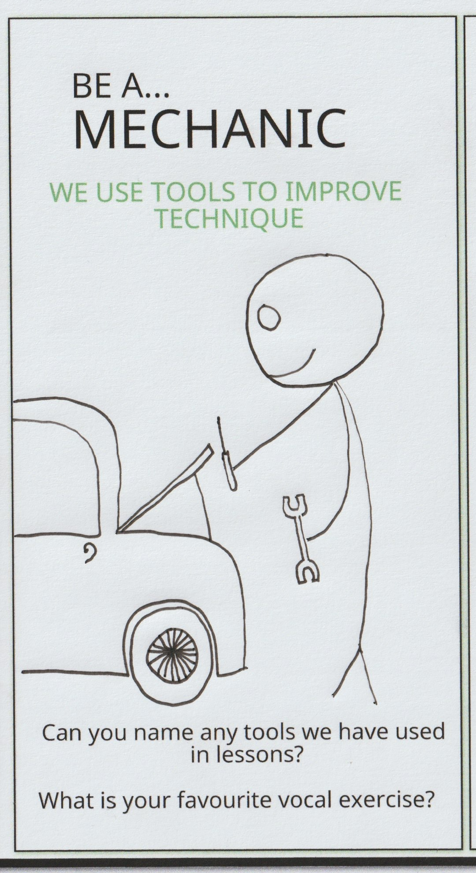
Figure 4

In my poster, the image on the left is that of the mechanic (see figure 4). As discovered through the literature review, in the voice studio the development of technical vocal proficiency is central to learning to sing (Edwards, Zito-Edwards and Meyer, 2023; Maxfield, 2023). With this in mind, for my artefact, I have considered the importance of addressing technical issues in the voice. I have placed the sentence “We can use tools to improve technique” above the stick figure of the mechanic, as research has shown that the concept of using tools to problem solve issues with the instrument is widely used (White, 2017; Steinhouer and McDonald Klimek, 2019; Edwin and Wicks, 2019). The analogy of the mechanic has also been used (McCoy, 2021), and my own studio I often refer to the transitioning through registers in terms of gear changing in a car. Anecdotally, students of mine have responded to the idea of looking under the bonnet of the car to fix technical issues. These may be notes that feel strained, breath control issues, notes that break/flip or crack. Many students can become despondent when these technical issues occur in their song. Some students feel that if their voice is not technically proficient that it is a reflection of their personality, and this can have a negative impact on self-esteem (Stothert, 2012). By creating a distance between self-worth/identity and technical vocal issues, this frees the student up to address the issues in a more measured way (Dobos, Piko and Kenny, 2019). Approaching the song as a mechanic taking a diagnostic of how free the voice feels while singing the song is the first step in the process. In order to provoke the student to reflect on their own learning, in terms of technical skill, I have added the questions: Can you name any tools we use in lessons? And: What is your favourite vocal exercise? By encouraging the student to reflect on their own practice they can develop a sense of autonomy that leads to a more fulfilling learning experience (Cook and Artino, 2016).

The Storyteller
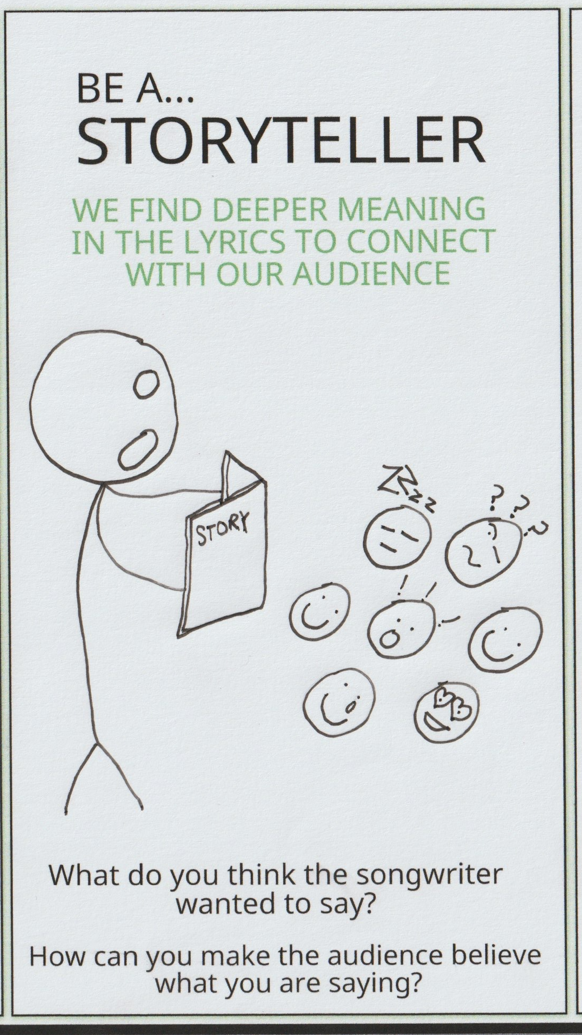
Figure 5
The image in the middle is that of a storyteller (see figure 5). Research has suggested that the singer needs more than just technical ease when performing a song (Miller, 1996; Stephenson, 2018; Helding and Ragan, 2022). There are many successful singers that have technical issues that we not only overlook, but see as integral to their style such as Bob Dylan, Kanye West and Florence Foster Jenkins (Music, 2017). In those instances, perfect technique is not essential for their success, as they possess the skills to connect more with an audience by leaning heavily into storytelling and emoting the song. A technically proficient singer who is considered to be lacking emotional connection with their songs, can also be successful (Steve Hoffman Music Forums, 2016). However, the singer who displays both a command of technique as well as emotional singing has more options when choosing how to perform a song. As a voice teacher, it is my aim to help students interpret songs on a deeper emotional level, in order to connect more meaningfully with their audiences and ultimately to become better singers. On my poster, the storyteller takes up the same space as the mechanic and the inventor, in order to reflect the research that vocal mastery is not reserved for technical singing alone (Helding and Ragan, 2022). In my professional practice, this is highlighted in my capacity as a lecturer on a musical theatre degree course. I am working with third year singers who are technically proficient. However, for some students the craft of acting through song is challenging. Although they are not beginner singers, through the use of the poster, I can have the conversation that storytelling is as important as good vocal technique. This is represented on the poster with the phrase “We can find deeper meaning in the lyrics to connect with audiences”. In order to spark thought about the musical text or song, the student is invited to focus on the story itself through the question “What do you think the songwriter wanted to say?” The student is also asked “How can you make the listener believe what you are saying?”. This question is included to challenge the student to use their own knowledge to problem solve, as per the research into self-determination theory where the student takes responsibility for their own learning (López-Íñiguez and McPherson, 2020).
In my private studio, the beginner singer that struggles with technique can also benefit from developing emotional singing, as research shows that emotions such as cry and sob qualities in many instances, can result in a desirable mechanical outcome (Howard et al., 2014; Chapman, 2021). For example, a “cry” sound can result in more adduction of the vocal folds (Cooke et al., 1997; Ericksson et al., 2020). In my capacity as a musical theatre lecturer, I spend time mostly on the storytelling and technical aspects of vocal mastery. The characters that the students are portraying are well defined, and while there is some room for creativity on the part of the student, they mostly adhere to the character as written. However, in my private studio, I also work with many other CCM genres such as rock and pop, as well as irish sean nós singing. In these genres the student is encouraged to develop their musical individuality. This is represented on the poster by the Inventor.

The Inventor
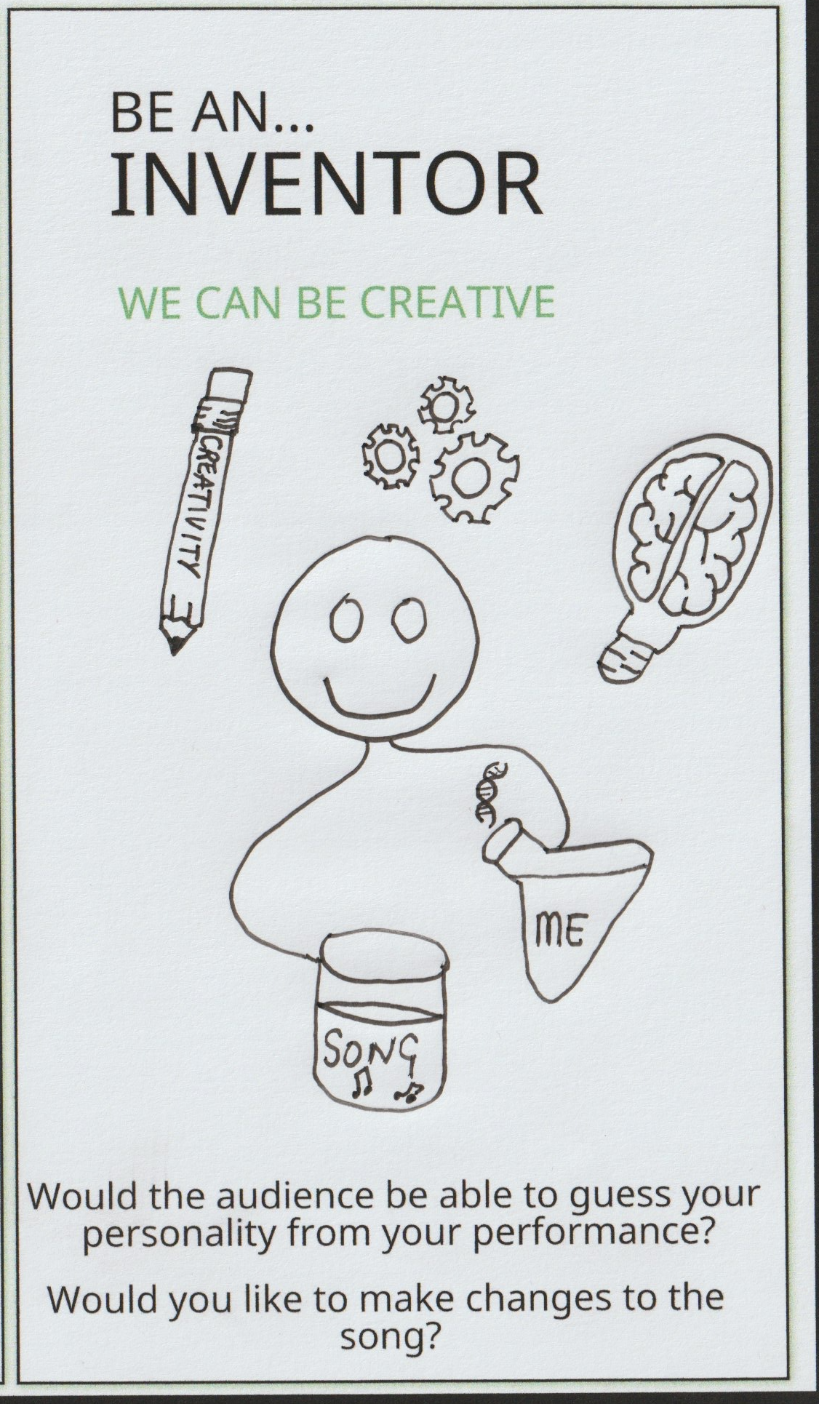
Figure 6
The third picture in the poster is that of the Inventor (see figure 6). This profession has made it on to the poster as a way for the adult student to realise that they have permission to make creative choices with their singing. For this reason, the simple phrase “We can be creative” is above the image of the inventor. Anecdotally, I have found that many adult singers often attend lessons with preconceived ideas of what singing is or should be (Lemon-McMahon, 2019). Often they have had their singing critiqued, and this has led to a lack of confidence in their ability to sing (Chong, 2010). Many adults have also had most of their past teaching in a master-apprentice style, and therefore, have made less decisions regarding style or repertoire (Sherwood, 2023). Through conversations sparked by the poster, the student can be made aware, that in many genres they can choose to alter the melody, rhythms, tempos etc. By doing this, the singer takes a more active role towards vocal mastery, through self-directed learning (Renwick and McPherson, 2002). This in turn can lead to a greater sense of autonomy (Evans, 2015). In order to provoke this thought in the student, the question “Would you like to make changes to the song?” is underneath the image of the inventor. This can be achieved in the lesson by inviting the student to partake in improvisation games (Poliniak, 2019). These are proven methods to helping a student develop their musicality and creativity (Henwood, 2023). A second question deals with the notion that individuality has a part to play in developing vocal mastery. This is prompted by the question “Would your audience be able to guess your personality from your performance?” Individuality is a worthwhile element to cultivate in singers, as it can have many positive effects on a student’s skill level, wellbeing and indeed success (Azzara and Grunow, 2010).

Know what

A critical examination of the artefact development process is helpful for evaluating its value, effectiveness and quality (Danielson, 2007). In the early phases of the project, the subject matter and artefact design elements were researched through literature review and examination of best practices and methodologies. The aim of this research was to determine the potential impact of the artefact on the beginner adult student. The initial research led to the honing in on three research questions that were considered throughout the process (Alvesson and Sandberg, 2013).

The subject matter
Through a review of the literature and research into best practice I wanted an answer to the research question: Can the introduction of the concept of the mechanic, the storyteller and the inventor provide the student with a clearer picture of the key elements of singing? The choice of the professions on the poster was initially decided by my own professional practice. In my studio for the last three years I have been using the mechanic, storyteller and inventor with various students to help them explore the many different elements of vocal mastery. While there is no literature to support these three professions being used together, I justified my use of them on my poster through an examination of literature and best practice of vocal technique, song interpretation and creativity. There is an overwhelming amount of research available on the mechanics of singing (Voice Foundation et al., 1987). This was the reason I narrowed my search criteria to a specific number of journals, specifically the journal of singing and the journal of voice (NATS, 1995; Voice Foundation et al., 1987). For the beginner teacher these are two of the journals that distil the research in many articles specifically geared towards voice teachers. These journals not only deal with the mechanics of singing but also articles on every element of vocal mastery. For example storytelling, song interpretation, creativity, improvisation, musicality. Therefore I was able to gather many articles that supported my use of these three professions. An examination of best practices revealed that there are many teaching organisations that train voice teachers on elements of vocal mastery. Their approaches are varied but ultimately their aims are the same. For example there are many differences between Estill and Feldenkrais in terms of how they train teachers to achieve better singing in their clients (Fantini et al., 2017; Nelson and Blades, 2018). For the artefact this was echoed the use of the professions. The usefulness of the poster for both the beginner singer and teacher is in highlighting that a multi-disciplinary approach can achieve results and there is not one specific best method to achieve vocal mastery.

The artefact design
In the concrete experience section of my Kolbs cycle review above, I described the contents of my studio walls, and hoped to find whether the current set up was conducive to learning through the question :Can an educational poster be a useful addition to the vocal studio? The literature has reinforced my belief that the inclusion of educational posters and other visually interesting posters can be a positive addition to the vocal studio set up (Graham, 2005; Cetin and Flamand, 2013). However consideration must be given to the overall educational space, as the effectiveness of the poster can be impacted by the size of the room, the lighting, the positioning at eye level or picture level and whether there are distractions such as noise or food/drink being consumed in the vicinity (Duchin and Sherwood, 1990).

The student
I wanted to explore whether the use of the artefact could help develop autonomy in the student through the question: Can self-directed learning can be nurtured in the private studio between teacher and adult beginner singer? Through research into self-directed learning, constructivist methods and humanistic approaches to teaching I decided to incorporate questions on the poster, to prompt students to think more about the choices they currently make, and to provoke their thoughts on their future mastery development. The central reason for creating a poster as an artefact was to find a way of clarifying the main elements of vocal mastery for students so that they can problem solve during the learning process. I will now explore three examples of students of mine that might benefit from interaction with the poster.

Teaching scenarios
Teaching scenario 1: The frustrated 50 year old female student who has avoided singing as they were told when they were younger to mime by a choir master.
In this instance the student has very closely linked her lack of ability to sing in tune to her identity (Bonshur, 2017). This singer becomes quite emotional when not able to reach for the notes. By realising that there are different approaches to take to address this, the student can disassociate their self-worth and approach the vocal issue as a mechanic with a set of tools. When the issue has been addressed the student can then be invited to approach the song through the eyes of the storyteller, to study the song lyrics and ask what the writer intended to convey. The emotions that are called upon now are directly related to the story instead of their own sense confidence in technique. After the student has mastered the technical aspects and the storytelling aspects of the song we can now invite them to delve further into their own artistry, and let them explore the song in a more courageous creative way, perhaps changing the structure, improvising, making choices (Beaty, 2015). The singer at this stage has a deeper understanding of the mechanics and performance techniques, so now that they have informed choices they can decide which to choose. The Inventor stage is most useful here as the final optional phase as if it was introduced to the beginner singer first before they were equipped with the tools on a technical level, or the understanding of the importance of communicating a song, it would potentially be a daunting task, as the inventor that has been the mechanic and the storyteller has now more choice. This is anecdotal however, perhaps the freedom to get straight in without attention to the technical or staying true to the story would be a preferred approach by some beginner singers. Taking humanist theory into account, the role of the teacher in this interaction is to let the student lead with whatever element they wish to explore (Johnson, 2014).
Teaching scenario 2: The 42 year old man who wants to sing folk songs with his guitar in pubs or at gatherings, but cannot get his voice to match the emotions he feels when he sings the lyrics. This is a case of the person who already approaches the song as the storyteller, but needs more exploration of the mechanical so that the instrument will be able to express those emotions healthily and with the desired tone (Helding and Ragan, 2022). In this instance opening up the conversation around various tools that can be used to help free the voice mechanically could be useful. Also creating a plan with the student that works towards finding vocal balance through use of those tools.

Teaching scenario 3: The 21 year old student who is getting frustrated because she wants to sing the song exactly like the recording artist. In this instance, the student is mechanically able to negotiate the song and also has explored the emotions and the storytelling, despite not sounding like the artist. In this instance exploring the many ways in which she can make choices other than what she has heard the singer do, this could be in terms of vocal quality, breathy or pressed, volumes, pronunciation, etc. By approaching the song as an inventor there are many opportunities for the singer to accept that while it is possible to mimic another singer to some extent, that this is not the only option available to her as an artist (Azzara and Grunow, 2010; Knapik-Szweda, 2015).

Reflective Conclusion

What worked well is that it enabled me to dive into current research around teaching practices in the studio in order to refresh my training. It was also useful to reflect on my current practices and apply new theoretical ideas to construct the artefact. Gathering the research was not as much of a daunting task as it had been in previous modules, as I had developed my own categorisation system and had more knowledge as to the pitfalls of going down rabbit holes (Hébert, 2015). I have become more proficient at using Boolean filters and I am becoming more aware of specific journals of relevance. I had learned from the past not to begin writing up the assignment until a detailed planning phase had been completed. A challenge of this module was that I had been unaware of a very clear distinction between component one and two, but through tutorials and lectures was able to get clarification. Another challenge was in the searching of phrases like “poster design”. A significant number of the results were relating to design of poster sessions, specifically slides used during presentations (Gemayel, 2018). The information from these articles, though not directly relevant to wall hanging posters, was useful in terms of design layout instructions, such as colour usage and clutter free visuals, to make the poster more conducive to learning. In my module 3 research project I researched teacher attitudes to singing exams (Dunne, 2024). Part of this project involved asking teachers what elements of singing are most important. Vocal technique was listed as the most essential element. But I was unable to get a consensus among teachers as to what exactly fell under the umbrella of technique. This element of my previous research impacted my artefact design, as it was initially a challenge to decide whether performance technique belongs under the storyteller or the mechanic section. After researching ATS and performance skills (Ross, 1961; LoVetri et al., 2014), I concluded that performance is more closely related to song interpretation, therefore belonged under storyteller. There is a cross over of elements between the professions in the artefact. This provides an opportunity for discussion with the student. For example in the “Know that” section above, the use of emotions while singing such as a cry or a sob can have a direct impact on the vocal technique of the student at vocal fold level (Ericksson et al., 2020). There is potential in the future to examine whether other professions could be added to the poster. This could be an exercise that involves asking the student to consider other occupations and their approaches, which in turn would increase their sense of autonomy. As previously explored, humanist theory argues that every individual is unique (Johnson, 2014). With this in mind it is important to realise that not every student may find interaction with the poster as a learning aid useful. Should it be a source of confusion for a student, the poster could instead be used as a reminder to the teacher to cover the various aspects of vocal pedagogy. By placing the poster in the eyeline of the teacher it could serve as a checklist. The teacher could use it to make sure that the technical work on the song has been completed, as well as the performance and emotional development. They could also make sure the student is developing their creativity, and exploring their individuality while singing.

There is a balance to be made between technique, song interpretation and creativity in singing. The singer who relies heavily on emoting the song can sometimes create strain or cause imbalances physically that need addressing and vice versa, singing with good technique alone is not serving the song or the performance. For this reason my artefact collates the main aspects of learning to sing for the adult beginner. Through the use of a simple poster design that has been informed by research, best practices, methodologies and my own professional practice, the student gets an overview of three elements that when considered separately or combined can lead to a more fulfilling vocal performance.

Appendix
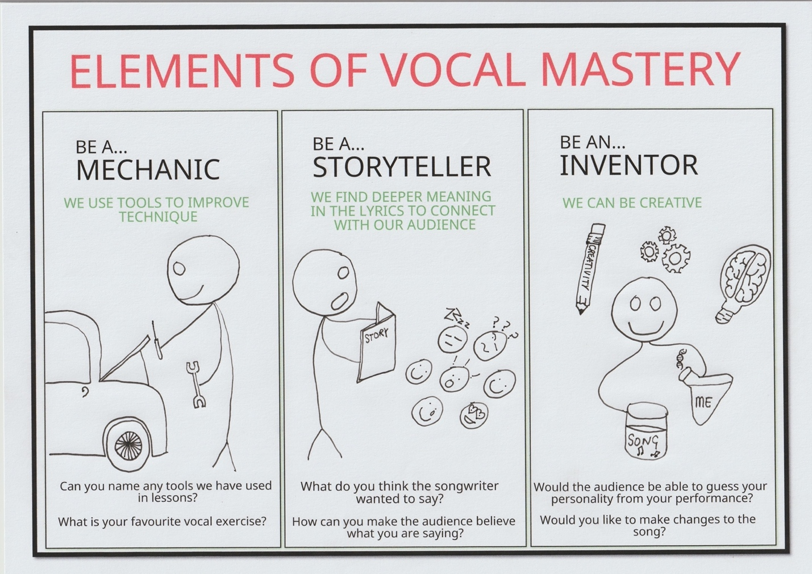

References
Adams, C. & Van Manen, M. (2008). Phenomenology. The Sage encyclopedia of qualitative research methods. Thousand Oaks, CA: SAGE Publications, 614-619.

Aduradola, R.R. and Akeredolu-Ale, B.I., 2013. The power of student’s involvement: Using posters as teaching tools in managing large classes. English for Specific Purposes World, 14(40), pp.1-20.

Ahyad, R.A. and Badeeb, A., 2024. The impact of playful titles and posters on learners’ interest in academic sessions: An observational study. International Journal of Academic Medicine, 10(1), pp.10-18.

Ali, S. (2010) ‘Understanding Our Students’ Self-Regulation during Practice: Verbal Protocol as a Tool’, Journal of Singing, 66(5), p. 529.

Alter, I.L., Charney, S.A., Karle, W.E., Born, H. and Chern, A., 2024. An Evaluation of Quality, Reliability, and Accuracy of Vocal Health Content on TikTok. Journal of Voice.

Alvesson, M. and Sandberg, J. (2013) Constructing research questions : doing interesting research. Los Angeles: SAGE.

Amazon.co.uk : education posters music (2024) Amazon.co.uk. Available at: https://www.amazon.co.uk/s?k=education+posters+music&crid=1VB8SNY2HEACG&sprefix=education+posters+music%2Caps%2C50&ref=nb_sb_noss_2 (Accessed: 30 October 2024).

Amazon.com: Singing Knowledge Retro Metal Signs Singing Learning Reference Guide Tin Sign Lovers Collectible Plaques Home Bar Club Wall Art Decor Poster Printing 16x24 Inches: Posters & Prints (2024) Amazon.com. Available at: https://www.amazon.com/Knowledge-Learning-Reference-Collectible-Printing/dp/B0CXPRVF69 (Accessed: 30 October 2024).
‌

Azzara, C.D. and Grunow, R.F., 2010. Developing musicianship through improvisation. Chicago, IL: Gia Publications.

Bartlett, I. and Lee Naismith, M., 2020. An investigation of contemporary commercial music (CCM) voice pedagogy: A class of its own?. Journal of Singing, 76(3).

Beaty, R.E. (2015) ‘The neuroscience of musical improvisation’, Neuroscience & Biobehavioral Reviews, 51, pp. 108–117. doi:10.1016/j.neubiorev.2015.01.004.

Blades, E.L., 2017. A spectrum of voices: Prominent American voice teachers discuss the teaching of singing. Rowman & Littlefield.

Bonshor, M. (2017) ‘Conductor feedback and the amateur singer: The role of criticism and praise in building choral confidence’, Research studies in music education, 39(2), pp. 139–160. Available at: https://doi.org/10.1177/1321103X17709630.

Bozeman, K. and Ragan, K. (2022) ‘Evidence-Based Voice Pedagogy (EBVP), Part 2: Voice Teacher Expertise and Experience’, Journal of singing, 78(3), pp. 389–393. Available at: https://doi.org/10.53830/XJOX9734.

Brockett, R.G., 2006. Self-directed learning and the paradox of choice. International Journal of Self-Directed Learning, 3(2), pp.27-33.

Burns, J., O’Connor, R. and Moss, H. (2024) ‘Music therapy for young children with acquired communication impairments: An international survey of clinical practices’, Nordic Journal of Music Therapy, 33(5), pp. 391–408. doi:10.1080/08098131.2024.2329898.

Carnelia, C., 2021. The reason to sing: A guide to acting while singing. Routledge.

Cetin, Y. and Flamand, L. (2013) ‘Posters, Self-Directed Learning, and L2 Vocabulary Acquisition’, ELT journal, 67(1), pp. 52–61. Available at: https://doi.org/10.1093/elt/ccs053.

Chandler, K. (2014). Teaching Popular Music Styles, in Harrison, S. D & O’ Bryan J. (eds) Teaching Singing in the 21st Century. Springer.

Chapman, J.L., 2021. PRIMAL SOUND. Singing and Teaching Singing: A Holistic Approach to Classical Voice, 1, p.19.
Clemmons, J. (2006) ‘Rapport and Motivation in the Applied Studio’, Journal of Singing, 63(2).

Chong, H.J., 2010. Do we all enjoy singing? A content analysis of non-vocalists’ attitudes toward singing. The Arts in Psychotherapy, 37(2), pp.120-124.

Coffield, F. et al. (2004) Learning styles and pedagogy in post-16 learning: A systematic and critical review.

Cole, A., 2022. Reclaiming singing as art: The trouble with mechanics. Australian Voice, 23, pp.39-48.

Compton Publishing (2019) Comptonpublishing.co.uk. Available at: https://www.comptonpublishing.co.uk/the-chandler-curriculum-for-training-pop-s.php (Accessed: 30 October 2024).

Cook, D.A. and Artino Jr, A.R. (2016) ‘Motivation to learn: an overview of contemporary theories’, Medical education, 50(10), pp.997-1014.

Cooke, A., Ludlow, C.L., Hallett, N. and Selbie, W.S., 1997. Characteristics of vocal fold adduction related to voice onset. Journal of Voice, 11(1), pp.12-22.

Crocco, L. and Meyer, D., 2021. Motor Learning and Teaching Singing: An Overview. Journal of Singing, 77(5).

Danielson, C., 2007. Enhancing professional practice: A framework for teaching. AsCD.

Deci, E. L. (2009) ‘Large-scale school reform as viewed from the self-determination theory perspective’, Theory and Research in Education, 7, 244–252.

Dewey, J. (1933). How We Think: A Restatement of the Relation of Reflective Thinking to the Educative Process. Boston, MA: D.C. Heath & Co Publishers.

Dobos, B., Piko, B. F., & Kenny, D. T. (2019) ‘Music performance anxiety and its relationship with social phobia and dimensions of perfectionism’, Research Studies in Music Education, 41(3), 310– 326. Available at: https://doi.org/10.1177/1321103X18804295.

Draper J.A. “(e metamorphoses of “Andragogy””CanadianJournal for the Study of Adult Education, vol. 12, no. 1,pp. 3–26, 1998.[39]

Duchin, S. and Sherwood, G. (1990) ‘Posters as an educational strategy’, The Journal of continuing education in nursing, 21(5), pp. 205–208. Available at: https://doi.org/10.3928/0022-0124-19900901-06.

Dunne,I. (2024) ‘A study of teacher attitudes to singing exams. Does this type of assessment make our students better singers?’, Unpublished Masters paper. University of Wales Trinity Saint David.

Edwards, M., Zito-Edwards, J. and Meyer, D. (2023) ‘The Emerging Future of Collegiate Voice Instruction: Updated SWOT Analysis of Current Practice and Implications for the Next Generation’, Journal of Singing, 79(3), pp.331-338.

Edwin, R. and Wicks, D. (2019) ‘Seth Riggs--His CCM Legacy’, Journal of singing, 75(4), pp. 449–453.

Erickson, D., Kawahara, S., Rilliard, A., Hayashi, R., Sadanobu, T., Li, Y., Daikuhara, H., De Moraes, J. and Obert, K., 2020. Cross cultural differences in arousal and valence perceptions of voice quality. Speech Prosody 2020, pp.720-724.

Evans, P. (2015) ‘Self-determination theory: An approach to motivation in music education’, Musicae scientiae, 19(1), pp. 65–83. Available at: https://doi.org/10.1177/1029864914568044.

Fantini, M., Fussi, F., Crosetti, E. and Succo, G., 2017. Estill Voice Training and voice quality control in contemporary commercial singing: an exploratory study. Logopedics Phoniatrics Vocology, 42(4), pp.146-152.

Feldenkrais Method. (n.d.). Feldenkrais Method® FAQs. [online] Available at: https://feldenkrais.com/feldenkrais-method-faqs/.
‌

FOR, T. (2022) TOOLS FOR SINGERS Set Music in Motion, Music in Motion. Available at: https://www.musicmotion.com/9654-tools-for-singers-set (Accessed: 30 October 2024).
‌

Fredrickson, S. (1994) ‘Teaching beginning vocal improvisation’, Music Educators Journal, 80(4), p. 21. doi:10.2307/3398725

Gemayel, R. (2018). How to design an outstanding poster. The FEBS Journal, 285(7), pp.1180-1184.

Gjorgjieski, V., 2024. ETHICAL STANDARDS IN GRAPHIC DESIGN. KNOWLEDGE-International Journal, 66(5), pp.575-578.

Goffi-Fynn, J. (2024) ‘Applying Student-Centered Strategies in the Applied Teaching Music Studio’, Visions of research in music education, 45, pp. 99-.

Graham, D. 1998. Teaching for Creativity in Music Performance: By allowing students to explore musical interpretation, not just tunings and fingerings, teachers encourage young musicians to realize creative possibilities. Music Educators Journal, 84(5), pp.24-28.

Graham, L. (2005) Basics of design : layout and typography for beginners. 2nd ed. Clifton Park, N.Y: Thomson/Delmar Learning.

Guzman, Marco, Karol Acevedo, Christian Castro, Camilo Moran, Victor Espinoza, and Camilo Quezada. "Tissue mobilization during double source of vibration semioccluded vocal tract exercises: A neck and face surface acceleration study." Journal of Speech, Language, and Hearing Research64, no. 11 (2021): 4124-4137.

Hattie, J., Bustamante, V., Almarode, J., Fisher, D., & Frey, N. (2021). Great teaching by design: From intention to implementation in the visible learning classroom. Corwin.

Hébert, C., 2015. Knowing and/or experiencing: A critical examination of the reflective models of John Dewey and Donald Schön. Reflective Practice, 16(3), pp.361-371.

Helding, L. and Ragan, K. (2022) ‘Evidence-Based Voice Pedagogy (EBVP), Part 3: Student Goals and Perspectives’, Journal of singing, 78(5), pp. 635–640. Available at: https://doi.org/10.53830/LOGC7063.

Henwood, R. (2023) ‘How Can I Keep Them Singing? Exploring “Tumult and Strife” in Male Adolescent Voice Change’, Canadian Music Educator / Musicien Educateur au Canada, 64(3), pp. 13–18. Available at: https://research-ebsco-com.ezproxy.uwtsd.ac.uk/linkprocessor/plink?id=baf3815b-f523-3a48-83d1-0654ae8b041a (Accessed: 3 September 2024).

Hiemstra R., “Is the internet changing self-directed learning?Rural users provide some answers,”International Journal ofSelf-Directed Learning, vol. 3, no. 2, 2006.12Education Research International 7592, 2020, 1, Downloaded from https://onlinelibrary.wiley.com/doi/10.1155/2020/3816132 by HEALTH RESEARCH BOARD, Wiley Online Library on [20/09/2024].

Hoch, M. ed., 2018. So you want to sing CCM (Contemporary Commercial Music): A guide for performers. Rowman & Littlefield.

Hoch, M., 2020. Voice Pedagogy: The Current Landscape and a Blueprint for Moving Forward. Voice and Speech Review, 14(2), pp.121-123.

Howard, D.M., Williams, J. and Herbst, C.T., 2014. “Ring” in the solo child singing voice. Journal of Voice, 28(2), pp.161-169.

Hubenthal, M., O’Brien, T. and Taber, J. (2011) ‘Posters that foster cognition in the classroom: multimedia theory applied to educational posters’, Educational media international, 48(3), pp. 193–207. Available at: https://doi.org/10.1080/09523987.2011.607322.

Hughes, D., 2017. ‘Art’to artistry: A contemporary approach to vocal pedagogy. In The Routledge research companion to popular music education (pp. 177-189). Routledge.

Institute for Vocal Advancement. (n.d.). Master Vocal Teacher Training. [online] Available at: https://www.vocaladvancement.com.
‌

Johnson, A.P., 2014. Humanistic learning theory. Education psychology: Theories of learning and human development, pp.1-10.

Kagen, S., 1960. On studying singing (Vol. 622). Courier Corporation.

Kaoun, T.M., 2019. Sinek’s Start with Why-Starts the Conversation, Raises Questions in Practice. Journal of Leadership, Accountability and Ethics, 16(5).

Kardaş, F. and Yeşilyaprak, B., 2015. A current approach to education: Flipped learning model. Ankara University Journal of Faculty of Educational Sciences (JFES), 48(2), pp.103-122.

Kempfer, B., 2014. Contemporary Commercial Music pedagogy: Selective exercises for developing healthy technique in adolescent singers (Master's thesis, The University of Wisconsin-Milwaukee).

Kindler, R. and Gray, A. (2010) ‘Theater and Therapy: How Improvisation Informs the Analytic Hour’, Psychoanalytic Inquiry, 30(3), pp. 254–266. doi:10.1080/07351690903206223.

Kolb, D.A. (1984). Experiential learning: experience as the source of learning and development. Englewood Cliffs, NJ: Prentice Hall.

Knapik-Szweda, S. (2015) ‘The Effectiveness and Influence of Vocal and Instrumental Improvisation in Music Therapy on Children Diagnosed with Autism. Pilot Study’, Journal of Education, Culture & Society, 1, pp. 153–166. doi:10.15503/jecs20151.153.166.

Knowles, M.S., 1975. Self-directed learning: A guide for learners and teachers. The Adult Education Company.

Knowles, M.S., 1980. The modern practice of adult education: From pedagogy to andragogy (revised and updated). Englewood Cliffs, NJ: Cambridge Adult Education.

Kolb, D.A., 1984. Experiential learning: Experience as the source of learning and development. EC.: Prentice Hall.

Kolb, A., & Kolb, D. (2005). Learning styles and learning spaces: Enhancing experiential learning in higher education. Academy of Management Learning and Education, 4(2), 193–212.

Lemon-McMahon, B., 2019. The singing voice and vocal identity: Investigating the perceptions and beliefs of singers and teachers (Doctoral dissertation, Macquarie University).

Levine-Rasky, C., 2009. The public poster session. Teaching Sociology, 37(3), pp.309-316.

Liu, J. and Zhou, M., 2021. The role of innovative approaches in aesthetic vocal performance. Revista Música Hodie, 21.

Loeng, S., 2020. Self‐directed learning: A core concept in adult education. Education Research International, 2020(1), p.3816132.

López-Íñiguez, G., and McPherson, G. E. (2020) ‘Applying self-regulated learning and self- determination theory to optimize the performance of a concert cellist’, Front. Psychol. 11, 385. doi: 10.3389/fpsyg.2020.00385

LoVetri, J. (2013) ‘The Independent Teacher: The Necessity of Using Functional Training in the Independent Studio’, Journal of singing, 70(1), pp. 79–86.

LoVetri, J.L., Saunders-Barton, M. and Weekly, E.M., 2014. A brief overview of approaches to teaching the music theatre song. Teaching singing in the 21st century, pp.53-66.
‘Lyrical Improvisation Reallocates Brain Function’ (2013) ASHA Leader, 18(2), pp. 35–36. doi:10.1044/leader.FTJ8.18022013.35.

Maas, E. et al. (2008) ‘Principles of Motor Learning in Treatment of Motor Speech Disorders’, American journal of speech-language pathology, 17(3), pp. 277–298. Available at: https://doi.org/10.1044/1058-0360(2008/025).

Madden, J., 2012. A review of vocology for the singing voice. Temple University.

Madura, P.D. (1997) ‘Jazz improvisation for the vocal student’, Teaching Music, 4(6), p. 26. Available at: https://research-ebsco-com.ezproxy.uwtsd.ac.uk/linkprocessor/plink?id=7ea0d459-0970-35b6-9502-6dff05571398 (Accessed: 3 September 2024).

Maxfield, L. (2023) ‘Spring Clean Your Studio Teaching Practices to Optimize Learning’, Journal of Singing, 79(5), pp.661-663.

Maxfield, L. and Ragan, K. (2021) ‘Evidence-Based Voice Pedagogy (EBVP), Part 1: Voice Research Component’, Journal of singing, 77(4), pp. 543–547.

McCoy, S., 2021. Reflections on my Life as a Mechanic (Vocal and Otherwise). Journal of Singing, 78(1), pp.71-74.

McCoy, S. and Ragan, K. (2018) ‘Defining Evidence-Based Voice Pedagogy: A New Framework’, Journal of singing, 75(2), pp. 157–160.

McPherson, G.E., Miksza, P. and Evans, P., 2017. Self-regulated learning in music practice and performance. In Handbook of self-regulation of learning and performance (pp. 181-193). Routledge.

Merriam, S.B., 2001. Andragogy and self-directed learning: Pillars of adult learning theory. New directions for adult and continuing education, 2001(89), p.3.
Miller, R. (1996) On the art of singing. New York ; Oxford: Oxford University Press.

Milliner, B. (Ed.). (2020). Yokohama JALT My Share 2019 [Special issue]. Accents Asia, 12(2), 1-46.

Morris, T.H., 2020. Experiential learning–a systematic review and revision of Kolb’s model. Interactive learning environments, 28(8), pp.1064-1077.

Music, B. (2017). Are these the worst singers who made it big? [online] Bbc.co.uk. Available at: https://www.bbc.co.uk/music/articles/13167a96-2ca5-4f73-8e52-30b094e6853a [Accessed 1 Nov. 2024].

Musicroom.com. (2015). educational poster | Musicroom.com. [online] Available at: https://www.musicroom.com/search?q=educational+poster+ [Accessed 30 Oct. 2024].

Myers, J.S. (2012) ‘Teaching adult beginning singing’, Journal of singing, 69(1), pp. 31–37.

Negus, K., 2012. Narrative, interpretation, and the popular song. The Musical Quarterly, 95(2-3), pp.368-395.

Nelson, S.H. and Blades, E.L. (2018) Singing with your whole self : a singer’s guide to Feldenkrais awareness through movement. Lanham: Rowman & Littlefield.

Nicholls, D. (2007) ‘Narrative Theory as an Analytical Tool in the Study of Popular Music Texts’, Music & letters, 88(2), pp. 297–315. Available at: https://doi.org/10.1093/ml/gcm006.

Nix, J., 2013. " You want me to do what?" Twenty-First-Century Voice Pedagogy Encounters Pedagogical Fundamentalism. The Choral Journal, 53(10), p.43.

O’Brien, T. (2010). Brain-powered science: Teaching and learning with discrepant events. Arlington, VA: NSTA Press.

Online Courses & Events | Voice Study Centre (2019) Voicestudycentre.com. Available at: https://voicestudycentre.com/short-courses/ (Accessed: 8 October 2024).

Oram, D., 2015. Research and practice in Voice Studies: searching for a methodology. Voice and Speech Review, 9(1), pp.15-27.

Paparo, S.A., 2022. Singing with awareness: A phenomenology of singers’ experience with the Feldenkrais Method. Research Studies in Music Education, 44(3), pp.541-553.

Poliniak, S. (2019) ‘Vocal Improvisation Games’, Teaching Music, 26(4), pp. 49–50. Available at: https://research-ebsco-com.ezproxy.uwtsd.ac.uk/linkprocessor/plink?id=92549756-e2e0-3278-a235-14e8fca121c1 (Accessed: 3 September 2024).

Primary Singing Time SONG HOSPITAL Display: Make the Sick Songs Well! (LDS Primary Songs | Primary Song Review | Primary Program Prep)) (2022) Etsy.com. Etsy. Available at: https://www.etsy.com/ie/listing/1033280227/ (Accessed: 30 October 2024).

Raiber, M.A., 2001. An investigation of the relationship between teachers' engagement in reflective practice and music teaching effectiveness. The University of Oklahoma.

Renwick, J. M., and McPherson, G. E. (2002) ‘Interest and choice: Student-selected repertoire and its effect on practising behaviour’, British Journal of Music Education, 19, 173–188.

Riggs, S. (2008). Singing for the Stars. Alfred Music.

Riveire, J., 2006. Using improvisation as a teaching strategy. Music Educators Journal, 92(3), pp.40-45.

Rooney, T.J., 2016. The understanding of contemporary vocal pedagogy and the teaching methods of internationally acclaimed vocal coaches. International Journal of Learning, Teaching and Educational Research, 15(10), pp.147-162.

Rowe, N. and Rowe, N., 2017. Poster design and the viewer perspective. Academic & Scientific Poster Presentation: A Modern Comprehensive Guide, pp.61-77.

Sansom, R., 2016. The unspoken voice and speech debate [or] the sacred cow in the conservatory. Voice and Speech Review, 10(2-3), pp.157-168.

Sauerland, W. (2018) ‘Voice Class: A Learner-Centered Approach’, Journal of Singing, 74(5), pp. 527–532. Available at: https://research-ebsco-com.ezproxy.uwtsd.ac.uk/linkprocessor/plink?id=47c40b19-3b57-309a-bcdc-267a2ac45c4e (Accessed: 30 August 2024).

Schlosser, R et al. (2006) ‘Use of information-seeking strategies for developing systematic reviews and engaging in evidence-based practice: the application of traditional and comprehensive Pearl Growing. A review’, International journal of language & communication disorders. Royal College of Speech & Language Therapists. 41. 567-82. 10.1080/13682820600742190.

Schmidt, L.K., 2016. Understanding hermeneutics. Routledge.

Schmidt, R.A., Lee, T.D., Winstein, C., Wulf, G. and Zelaznik, H.N., 2018. Motor control and learning: A behavioral emphasis. Human kinetics.

Schwartz, B., 2000. Self-determination: The tyranny of freedom. American psychologist, 55(1), p.79.

Sear, J., 2024. Modern vocal pedagogy: Investigating a potential curricular framework for training popular music singing teachers. Journal of Popular Music Education, 8(2), pp.239-254.

Sell, K., 2017. The disciplines of vocal pedagogy: Towards an holistic approach. Routledge.

Seminatore, G. (2010). Teaching Poetry through Song: A Modest Proposal. Journal of Singing, 66(5), 515-525.

Sener, S. and Çokçaliskan, A., 2018. An investigation between multiple intelligences and learning styles. Journal of Education and Training Studies, 6(2), pp.125-132.

Shapira-Lishchinsky, O., 2011. Teachers’ critical incidents: Ethical dilemmas in teaching practice. Teaching and teacher education, 27(3), pp.648-656.

Sherwood, T. (2019) ‘Inspiring Autonomous Artists: A Framework for Independent Singing’, Journal of singing, 75(5), pp. 527–533.

Sherwood, T. (2023) ‘Evolving the Master-Apprentice Tradition: A Pathway Back to a Student-Centered Pedagogy’, Journal of Singing, 80(1), pp. 13–22. doi:10.53830/GTOJ3285.

Sichivitsa, V. (2007) ‘Audacity in Vocal Improvisation’, Teaching Music, 14(4), pp. 48–51. Available at: https://research-ebsco-
com.ezproxy.uwtsd.ac.uk/linkprocessor/plink?id=d5ac6995-1248-3e86-9174-949dee1a7413 (Accessed: 3 September 2024).

Silveira, J.M. and Diaz, F.M., 2014. Student teaching in music: A content analysis of research journals in music education. Journal of Music Teacher Education, 23(2), pp.92-104.

Sinek, S., 2011. Start With Why: The Inspiring Million-Copy Bestseller That Will Help You Find Your Purpose. Penguin UK.
Steinhauer K and Estill J. (2008). The Estill Voice Model™: Physiology of Emotion. In K. Izdebski (Ed.) Emotions of the Human Voice. San Diego: Plural Publishing.

Steinhauer, K.M. and McDonald Klimek, M. (2019) ‘Vocal Traditions: Estill Voice Training’, Voice & speech review, 13(3), pp. 354–359. Available at: https://doi.org/10.1080/23268263.2019.1605707.

Stephens, J. and Hillier, S., 2020. Evidence for the effectiveness of the Feldenkrais method. Kinesiology Review, 9(3), pp.228-235.

Stephenson, K. (2018) ‘Critical thought, intrinsic motivation, and the voice studio: perspectives of master teachers’, Journal of singing, 74(4), pp.405-414.

Steve Hoffman Music Forums. (2016). Singers who have powerful voices, but don’t emote when using them. [online] Available at: https://forums.stevehoffman.tv/threads/singers-who-have-powerful-voices-but-dont-emote-when-using-them.278416/ [Accessed 1 Nov. 2024].
‌

Stothert, W. (2012) “Music Performance Anxiety in Choral Singers” (Masters thesis, Vancouver Island University).

Swanson, C.D., 2011. Creating creative students. Journal of Singing, 67(5), p.591.
D. C. M. Taylor and H. Hamdy, “Adult learning theories:implications for learning and teaching in medical education:AMEE Guide no. 83,”Medical Teacher, vol. 35, no. 11,pp. 1561–1572, 2013

Temu (2024) temu. Available at: https://www.temu.com/search_result.html?search_key=singing%20educational%20poster&search_method=user (Accessed: 30 October 2024).

Timmers, M. (1998). Introduction. In M. Timmers (Ed.), The power of the poster (pp. 7-25).London: V&A Publications.

Titze, I.R., 2021. What is vocology?. Revista de investigación e innovación en ciencias de la salud, 3(2), pp.1-2.

Titze, I.R., 2008. The human instrument. Scientific American, 298(1), pp.94-101.

Tudor, I., 1993. Teacher roles in the learner-centred classroom. ELT journal, 47(1), pp.22-31.

Varela, W., Abrami, P.C. and Upitis, R., 2016. Self-regulation and music learning: A systematic review. Psychology of Music, 44(1), pp.55-74.

Vetri, J.L., 2009. Essay Somatic Voicework™: The LoVetri Method. Voice and Speech Review, 6(1), pp.436-442.

Vince, R., 1998. Behind and beyond Kolb's learning cycle. Journal of management education, 22(3), pp.304-319.

Vlachos, J. (2015) ‘Vocal Improvisation Games for Singers and Choral Groups’, Choral Journal, 55(11), pp. 65–67. Available at: https://research-ebsco-com.ezproxy.uwtsd.ac.uk/linkprocessor/plink?id=f80dad15-1526-365c-bfb1-532cd0f48fc6 (Accessed: 3 September 2024).

Vocologyinpractice.org. (2024). Home Page. [online] Available at: https://www.vocologyinpractice.org [Accessed 20 October. 2024].

Voice Foundation. et al. (1987) Journal of voice. Amsterdam] ; Elsevier Science.

Voicestudycentre.com. (2017). Post Graduate Qualifications for Voice Professionals | Voice Study Centre. [online] Available at: https://voicestudycentre.com [Accessed 20 October. 2024].
‌

Wang, S. (2022) ‘Vocal improvisation using interactive music technology’, Interactive Learning Environments, 32(1), pp. 245–256. doi: 10.1080/10494820.2022.2084755.

Watkins, C. and Mortimore, P., 1999. Pedagogy: What do we know. Understanding pedagogy and its impact on learning, pp.1-19.

Weekly, E.M. and LoVetri, J.L. (2009) ‘Follow-Up Contemporary Commercial Music (CCM) Survey: Who’s Teaching What in Nonclassical Music’, Journal of voice, 23(3), pp. 367–375. Available at: https://doi.org/10.1016/j.jvoice.2007.10.012.

Whitcomb, R. (2003) ‘Step by Step: Using Kodály to Build Vocal Improvisation’, Teaching Music, 10(5), p. 34. Available at: https://research-ebsco-com.ezproxy.uwtsd.ac.uk/linkprocessor/plink?id=40de3a6a-a73d-338c-aba9-15a08aeff724 (Accessed: 3 September 2024).

White, A.R., 2017. Vocal traditions: Somatic Voicework™ The LoVetri Method. Voice and Speech Review, 11(2), pp.240-248.

Wilson, J.M. (2003) ‘Gantt charts: A centenary appreciation’, European Journal of Operational Research, 149(2), pp.430-437.

Wise, V.L., 2011. Review of" Start with Why". Research & Practice in Assessment, 6.

Zan, L. and Drăgulin, S. (2023) ‘Vocal Improvisation – a Cognitive and a Psychological Process’, Studia Universitatis Babes-Bolyai, Musica, 68, pp. 207–218. doi:10.24193/subbmusica.2023.spiss2.13.

Zhang, L., 2023, January. The Inevitability of the Application of Computer Technology in Vocal Music Teaching. In International Conference on Innovative Computing (pp. 544-550). Singapore: Springer Nature Singapore.

