Module name: Marketing Fundamentals
Assignment 1
Module Code: LCBB4004

Name: Valentina Pituscanu
Student ID: 2124861

Lecturer: Md Sadeque Imam Shaikh

Abstract
The assignment is a visual representation of how blog writing works in creating marketing communication. Therefore, the assignment has been divided into multiple blogs which are aiming at addressing multiple purposes of marketing for better customer generation and brand building.
Table of Contents

Introduction:
Overview Of The Organisation:
Blog 1:
Blog 2:
Blog 3:
Blog 4:
Blog 5:
Blog 6:
Conclusion: 2

Introduction:
The assignment is interested in creating a thorough idea about marketing fundamentals. The marketing activities play a highly important role in brand building and customer driving. The assignment focuses on creating multiple blog posts based on 4Ps of marketing approach to stimulate communication building between the brand and its audiences. For the progression of the assignment the world-famous wristwatch company Rolex has been chosen. The blogs include necessary theories of marketing to create more appropriation of the study.
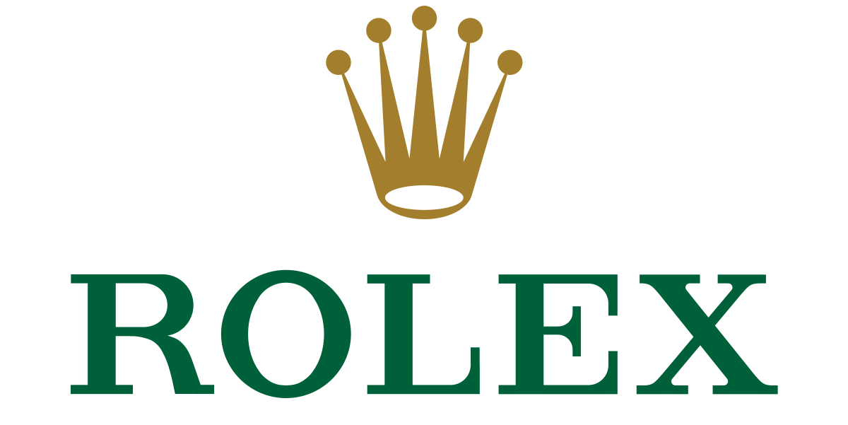
Figure1: Rolex Logo
(Source: Rolex. 2022)

Blog 1:
Datejust Series: The New Face Of Luxury Watches By Rolex
Nothing defines luxury and class more appropriate than Rolex, the leading wrist watch manufacturer in the world. The DATEJUST series of Rolex is a perfect amalgamation of elegance, appearance and quality that emits a radiance of gorgeousness everytime you wrap it around your wrist. This time-classic masterpiece series is currently having some beautiful model inclusions which are too hard to not get tempted. Here are the reasons why a model of this series is a must have product in your collection.
A classic, wrapped in a modernised version:
DATEJUST is one of the oldest series of watch models introduced by Rolex. This classic was first introduced in 1945 to mark the 40th anniversary of Rolex. The series became significant as it had been a combination of the most significant timekeeping innovation of Rolex. The DATEJUST models are one of its kind due to the combination of the first in-house bracelet created for this model only, Rolex hallmark holding Rolex Cyclops lens for date magnification and a traditional dial with 36mm case.
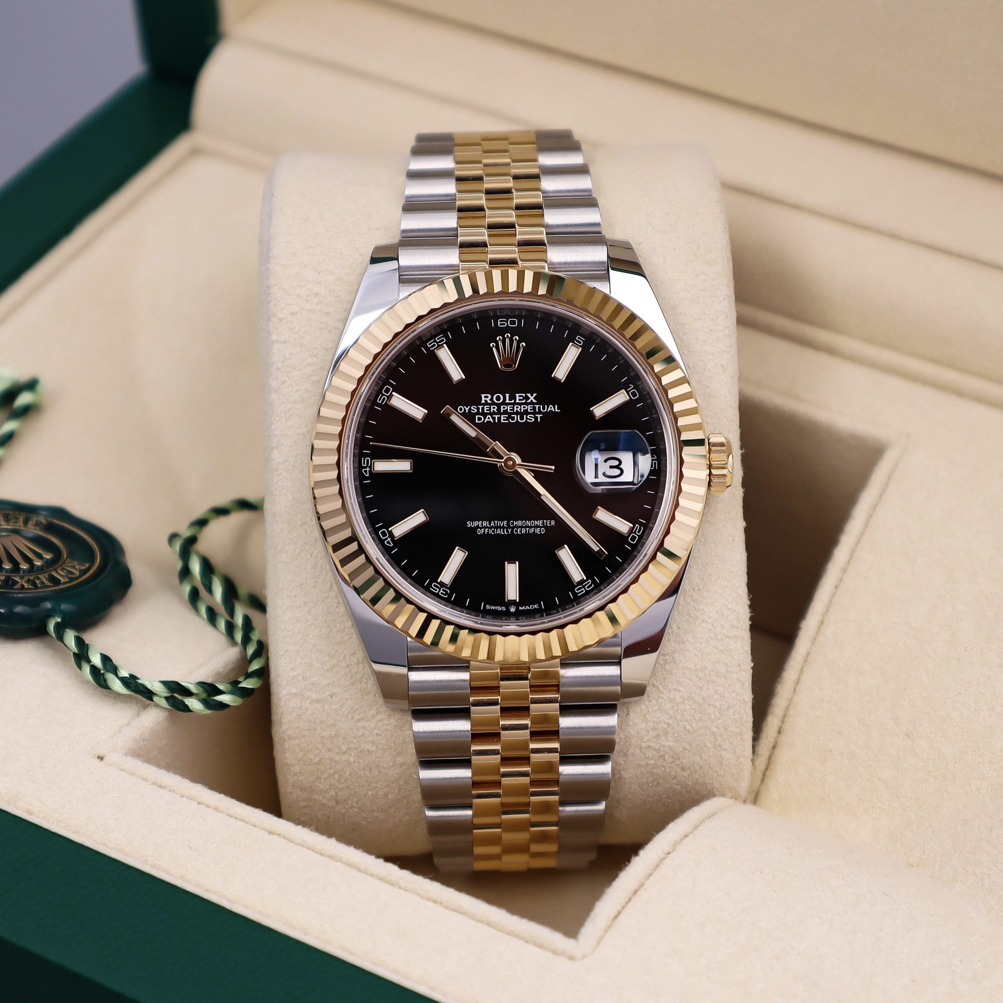
Figure 2: Rolex DATEJUST Edition
(Source: Rolex. 2022)
Noteworthy versatility:
The versatility is another aspect that makes the model worth the refitment over your wrists. The overall design of DATEJUST is highly versatile which makes this model a perfect companion for all occasion and purpose. Whether you plan to wear it for daily work purposes or use it to add a classy touch to your overall outfit for an evening party, you can do it easily.
Wrapping up:
Are you looking for a watch that would not only look good on your wrist but will also add up to an extravagant luxurious personality upliftment? Then the DATEJUST edition is a must have classic series for you. Visit the official website of Rolex to know more.

Blog 2:
Best Watches From The Rolex Datejust Series You Must Checkout In 2022
Even though all series of Rolex have been an epitome of luxury and elegance the DATEJUST series has something exclusive in it. The watches of DATEJUST series apart from a compact design is something more that speaks the words of excellence and classic vibrance. Here are the best watches from the DATEJUST series released in 2022 that must be checked out.

DATEJUST 31:
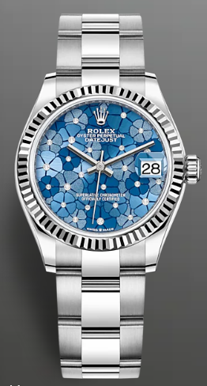
Figure 4: DATEJUST 31
(Source: Rolex. 2022)
The DATEJUST 31 is an unexplainable beauty studded with all things luxury and eye-catchy. This oyster perpetual model features oyster steel and white gold designed with diamond-set dial, Azzurro-blue floral motif and a classy oyster bracelet. The dial is studded with 18kt gold settings and 24 diamonds which is enough to attract the attention of people at the parties you would attend wearing this one. The gorgeous 31mm oyster case fitted with fluted bezel that looks divine on your personality when you carry it with style.
DATEJUST 36:
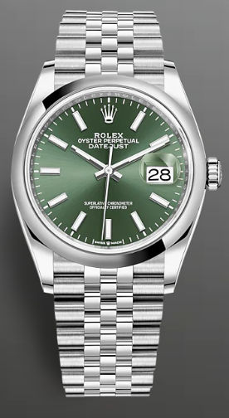
Figure 5: DATEJUST 36
(Source: Rolex.2022)
While you are looking for a DATEJUST model only then it would be regretting of a choice if you don’t check out this model once. This model released in 2022 is a splendiferous combination of classic taste paired with a modern outlook. This oyster perpetual watch combines a green dial with an eye-catchy jubilee bracelet. The 36mm Oyster case is ornamented with a domed bezel that renders your wrist a classy appearance. The mint green dial is just a soothing colour to fall for every time you want to look special.
Wrapping Up:
If you have been a fan of the DATEJUST series, then these newly released models are just the right partner-to-be for you. Check out the official website of Rolex to know more!

Blog 3:
Luxury with affordability or value for money?: A Rolex perspective
Price is just a number when you are a die-hard Rolex fan. From the type of watches presented by Rolex from the very beginning one thing has become clear that it is not for all. Did we just mean affordability by saying it? No, not only you need to be capable enough to afford it but also you have to develop a special taste to appreciate the time-less beauty Rolex serves. Should affordability be able to justify the density of Rolex watches? Here are the reasons why these watches offer value-for-money rather than being affordable.
- Time-less value:
Owning a Rolex watch is not like owning any other watch. Rather having a Rolex watch is highly prestigious and a mark of elegance which is maintained all over the world. The classy Rolex watches can be considered as an asset which you cannot own in an exchange of affordability. The price you pay for a Rolex watch lets you own a flagship model which is one of a kind and pays off the exclusive value of itself.

Figure 6: Rolex Crown Logo
(Source: Rolex. 2022)

- Studded with expensive materials:
The materials which are used for Rolex watches are highly expensive. The extraordinary watch models of Rolex include gold settings, diamond, platinum, silver, white gold, oyster etc. which are considered as highly expensive materials in the world. Therefore, owning a Rolex watch is not less than owning highly expensive jewellery. The value tends to increase over time as the watches grow old. Therefore, the value of the money you pay is something beyond the discussion when it comes to investing in a Rolex watch.
Wrapping Up:
Not every expensive watch is Luxury and not every other watch is Rolex. There are some exclusive watch features and values which are Rolex trademarks and can’t be offered by any other brand. Therefore, affordability might not justify the prestige of a Rolex watch but it definitely pays you off with the money value. Are you thinking of purchasing a piece of luxury from Rolex? Visit the official website.

Blog 4:
Where To Find Rolex In The UK? Best 3 Stores To Visit
While Rolex is highly available at luxury stores all around the world it is really daunting to find a place that sells genuine products. In the UK there are multiple options of sellers to find your Rolex watch but trusting only the best ones would offer you a satisfactory experience. Here are 3 best places in the UK which you can visit anytime and stay assured that you are only getting served with the real products of impeccable value.
- Prestons:
Started the journey as a fine jewellery store in the UK in 1869 Prestons is serving its customers with 150 years of rich history. Located in Bolton, Guildford, Wilmslow, and Leeds, Prestons is one of the genuine traders of Rolex watches and expensive jewelleries (Prestons. 2022). From a huge number of exclusive new flagship watches to preowned ones, the store introduces you to a bunch of Rolex models.
- R.L. Austen:
Founded in 1794 in Chichester, West Sussex, R.L. Austen is a highly prominent name as a leading jeweller and official Rolex retailer in the country (R.L. Austen. 2022). A range of genuine Rolex models with exclusive design, breath-taking options, pricing-range and brand-logo are available at the store which are worth paying attention to.
- Watches of Switzerland:
Watches of Switzerland is a luxury Rolex boutique and a creator of amazing customer experience (WATCHES OF SWITZERLAND. 2022). Along with other expensive watches the store offers an outstanding collection of Rolex watches which are too tempting to explore.
Wrapping Up:
If you are in the mood to invest some money in a luxury watch like Rolex it would be a great idea to do a quick background check before visiting a store. Are you still in doubt? Visit the official website of Rolex to find genuine shops in the UK.

Blog 5:
Best Luxury Watch Brands Available In The UK
When it comes to luxury watches, the UK serves as the home to many world-leading luxury brands. However, since there are multiple options available in the market decision-making might seem a little bit daunting for you.
Rolex:
Rolex is one of the highly exclusive brands which is leading the world with the exquisite style it offers, value it provides, and the prestigious honour associated with it. From time-les classic designs to diamond studded eye-catchy pieces, Rolex has an unnumbered number of watches to flaunt that suits your taste in luxury.
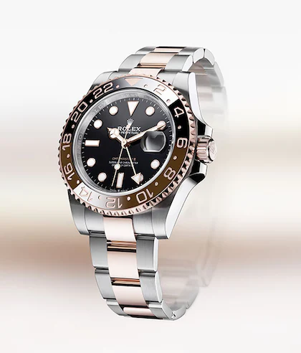
Figure 7: Rolex Watch
(Source: Rolex. 2022)
Rolex, enjoys, an, unrivalled, reputation, throughout, the, world, for, quality, and precision, in, luxury, watchmaking
Rolex, watches, are, symbols, of, excellence, performance, and prestige., Throughout, its, history, Rolex, has, pioneered, the, development, of, the, wristwatch, for, the, modern, era.
The company, is, at, the, origin, of, landmark, innovations, in, watchmaking, including, the, first, waterproof, wristwatch, the, Oyster, and the Perpetual, rotor, self-winding, mechanism.
Today, Rolex, is, also, actively, involved, in, supporting, the, arts, exploration, sports, and, the, environment, through, sponsoring, and, philanthropic, programmes

For, over, a, century, Rolex, watches, have, accompanied, explorers, and achievers, around, the, world, from, the, top, of, the, highest, mountains, to, the, deepest, reaches, of, the ocean.
Today, Rolex, is, present, at, the, most, prestigious, events, in, golf, sailing, tennis, motor, sport,, and, at, equestrian, tournaments., Rolex, makes, a, unique, and, lasting, contribution, to, global, culture, science, and, exploration.

Wrapping Up:
Are you relentlessly looking for the best luxury watch that would fit your personality in the best way? Then the above-mentioned ones can be the actual charmers to add an escalated charm to your overall look.

Blog 6:
Promotional Approaches That Suits The Prestigious Status Of Rolex
Even though for a brand like Rolex the product speaks it all, it is highly important to stay competitive in the every-growing marketing. Apart from the sky-rocketing brand-value it is the theoretical promotional tactics that works well with Rolex. The customer-friendly promotional approach that Rolex follows.
4Ps of Marketing Mix:
Rolex effectively follows the 4Ps of Marketing Mix tactics that helps them to stay ahead of other brands. The 4Ps of marketing mix is a combined approach of product, pricing, place and promotion for successful marketing (Pepels, 2021). The product emits luxury manufactured by Rolex. The pricing might not be affordable but perfectly syncs with the quality of the product. The company sells its products at such places which effectively attracts its sole audience. The promotion is effectively done by its customers itself.
The Principle of Marketing:
The adaptation of the theoretical Principle of Marketing can be visually experinced at Rolex. According to Kotler and Armstrong, (2013) the best form of marketing is present in the act of recognising the needs of customers and understanding the actual target market to whom they can provide the service. Rolex focuses on manufacturing its products and serving a market audience who has a penchant for luxury watches.
Promotional Mix Approach:
Rolex believes in the promotional mix approach for effective marketing which serves the company a competitive advantage. The promotional mix approach includes - advertising, sales, direct marketing, public relation etc. to meet the objective of marketing (Diah, 2021). Rolex focuses on publishing PR and magazine statements to stay at the heart of its audience.
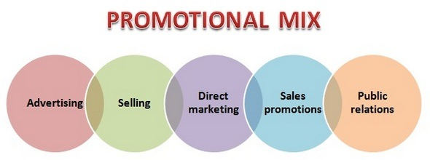
Figure 10: Approach of Promotional Mix
(Source: Diah, 2021)

Wrapping Up:
The goal of marketing is to create a brand’s image and nurture customers. Rolex does the same with its exclusive promotional strategy which helps the brand to keep up with on-going competition.

Conclusion:
The fundamental of marketing lies in driving customers by showcasing the unique selling proposition of a brand or a product. Using blog writing can be a highly effective way of presenting the USP of a brand or a product in an informative way that increases the educational aspects of marketing. Using the right marketing tactics through blogging can help a brand like Rolex stay an effective player in the long-term market on a global scale.

Forbes. (2021). Rolex. Available at. https://www.forbes.com/companies/rolex/?sh=28550c5c5a26. (Accessed on 19th August 2022).
Rolex. (2022). Home. Available at. https://www.rolex.com/world-of-rolex/perpetual-planet.html#:~:text=Rolex%20continues%20the%20legacy%20of,to%20make%20the%20planet%20perpetual. (Accessed on 17th August 2022).
Rolex. (2022). NEW WATCHES 2022, ROLEX WATCHES. Available at. https://www.rolex.com/en-us/watches/new-watches/all-models.html#p=1. (Accessed on 20th August 2022).
Statista. (2021). Turnover of the leading luxury watch brands worldwide in 2020 (in million U.S. dollars)*. Available at. https://www.statista.com/statistics/789382/leading-luxury-watch-brands-sales/. (Accessed on 18th August 2022).

