BMDS7001 AC2 - Reflective account - multi-stakeholder working

Introduction
This essay reflects on methods used in the engagement of multi- and inter-disciplinary stakeholders involved in the successful design of digital technology, based on my previously submitted paper entitled ‘Digital Strategy Development – Digitising Patient Consent to Examination or Treatment’, and my broader applied experiences in stakeholder engagement gained throughout my career to date.
The model I have chosen for this reflection essay is Kolb’s Experiential Learning Cycle (1984), because the ‘learning by doing approach’ (Tanguay, Hanratty and Martin, 2020, p. 45-47) is more aligned with the agile approach I would take to deliver this technical health intervention. The essay headings reflect the original model, with the exception of ‘reflective observation’, which has been changed to ‘critical reflective observation’ to better consider the solutions to problems, based on the proposal following a systematic review of this model by Morris (2020, p. 1064-1077). Whilst Tanguay, Hanratty and Martin (2020, p. 45-47) explain that this cyclical model offers the flexibility to start at any point in the cycle, my reflection starts with the ‘concrete experience’ to describe ‘what’ happened in the context of the engagement I undertook at this identification stage for an e-consenting solution.
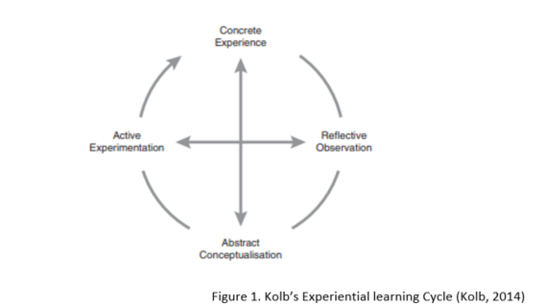
Concrete Experience
In the context of the previous assignment, the full range of stakeholders that would need to be engaged are listed in Figure 2.
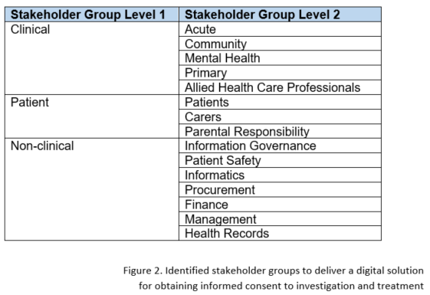
Time constraints significantly limited both the range and size of the stakeholder groups and the actual engagement activity undertaken. Therefore, the two key stakeholder groups I targeted to inform the service improvement and digital technology requirements were ‘Clinical - Acute’ and ‘Non-clinical - Technical’, both within Betsi Cadwaladr University Health Board(BCUHB). The former consisted of the Chief Clinical Information Officer(CCIO), two of our three Medical Information Officers(MIO) and the Nursing Information Officer(NIO); these are lead clinical roles allocated a proportion of their week to the Informatics Department. The latter consisted of the lead for the Integration & Development team within Informatics.
My engagement with both groups, took the form of informal open ended calls and e-mails to inform aspects of the technical requirements, the gap analysis and the option appraisal.
I have spent the last seven years of my career working in digital health and managerially responsible for the Integration and Development Team within BCUHB, therefore, to balanced the light approach to stakeholder engagement, I also relied on my personal experience.
Critical Observation and Reflection
The process of patient consent from the initial discussion to post operative, often requires the input of a range of clinical disciplines. The process of introducing a technical intervention however, requires input from both clinical and non-clinical teams.
In a review of terminology used to describe health care teams, Chamberlain-Salaun, Mills and Usher (2013, p. 65-74) identified that terms such as ‘multi-disciplinary’ and ‘inter-disciplinary’ are often used interchangeably. Across their literature review they found that generally multi-disciplinary referred to “team members from different disciplines working parallel to one another to treat clients” with less formality or structure, whereas inter-disciplinary groups work within a more formal structure “interdependently to pool their knowledge in order to achieve a common goal that results in more than the sum of its parts”.
Taking account of the definitions above, the challenge will be to take the separate clinical teams working to deliver the multi-disciplinary consent pathway, and engage them to work cohesively as an inter-disciplinary team towards the shared goal of designing and implementing an e-consent solution. As an inter-disciplinary team within the structure of the project governance, this would reasonable include the other stakeholder groups of patient and non-clinical.
This is an approach I took as the lead for my organisations Digital Health Record (DHR) project to steer the pre-procurement phase. The benefits were that it enabled transparency and also increased understanding of the clinical and technical design opportunities and constraints presented across the stakeholder groups at all stages in the ‘as is’ and ‘to be’ workflows and specification design. However, it was recognised that at times the spectrum of specialist knowledge proved too wide for the group. To avoid members of the group dis-engaging, we created controlled (by which I mean monitored with evidenced outcomes) sub-group opportunities to allow full exploration of deeper specialist matters. One example of this working successfully was in the tender evaluation stage, where tier two of our evaluation invited suppliers that had passed the tier 1 desktop evaluation to demonstrate their ‘fit’ to the technical specification, with live demonstrations delivered on site against specific scenarios. For this exercise I spilt the groups into two; technical and governance, and clinical and administrative. Whilst both groups were presented with demonstrations against the same scenarios, the opportunity was available to deep dive on specialist requirements. In the development of the e-consenting solution, the option of creating controlled sub-groups would be of particular benefit to securing engagement with the ‘patient’ stakeholder group, who may only have a surface knowledge of clinical and technical matters.
In the context of more inclusive engagement, a very early lesson I learnt was during a public engagement session as Project Manager for School Modernisation for a local council, engaging on school closures. In this case, we presented a series of slides delivered by education leads outlining our proposals and asked the participants for their views. The challenge from stakeholders was that the pre-prepared ‘polished’ slides indicated that we had already decided what to do and if this was that case, why not just say that. This highlighted that I needed to better understand and be transparent about the level of influence that stakeholder groups have in a given situation. If I am asking for input to the identification of the solution, or improvement idea, then this is ‘engagement’; otherwise it is more comfortably in the space of ‘consultation’ on a proposed solution, or even ‘informing’ on what has already been decided.
As I embarked on equally complex and at times contentious projects concerning service redesign and technical interventions across local councils in North Wales and within the NHS in BCUHB, I found that genuine engagement across a range of multi-disciplinary and inter-disciplinary stakeholders often gave rise to ‘why we can’t’ change, rather than ‘how we can’. The more I tried to encourage the groups to re-focus on solutions, the less they felt their concerns were being heard and the further they stepped away from engaging in the change. The turning point came when I engaged using a tool to harness positives out of the need for stakeholders to share their concerns called ‘Poisons and Antidotes’ (MacDonald-Wallace, Gatt, 2009), which I named ‘Barriers and Solutions’. Placing the participants in groups, you invite them to share on pieces of paper what they consider to be barriers to the change and post them anonymously into their group’s box; the boxes are then rotated to the next group who have to unpack and theme the barriers, before coming up with solutions. I applied this technique in the early stages of exploring options for both Digital Dictation and DHR solutions within BCUHB, frequently referring back to ensure that the development of the technical specification would address perceived barriers, or to plan in actions to address them in other stages of the project such as; system configuration, training, governance, audit, standard operating procedures.
Abstract Conceptualisation
A common theme I have experienced across all stakeholder engagement is the challenge of reaching agreements that will drive the change forward, whilst maintaining buy-in. Ahead of embarking in engagement across a wide range of inter-disciplinary stakeholders, Harrin (2020, p. 45-47) describes that the potential for conflict can be managed by taking the time in advance to better understand the range of participants through a ‘social network diagram’, mapping out stakeholders to identify their relationship to the activity and to each other, and their level of influence in the change.
Understanding and managing the influence held by stakeholders within a group, is important to avoid poor decision making that can derive from a dysfunctional group mentality. Janis (1972, 1982) coined the phase ‘groupthink’ to describe a situation whereby a group of individuals shy away from expressing a difference in opinion, or challenging a view point, in the interest of maintaining group harmony.
Setting up specific groups to engage on any digital intervention is akin to a small sub-set of the workforce with the power to influence change. Avoiding the risks of coercive behaviours and poor decisions associated with ‘groupthink’, Neck, Manz (1994, p. 929) advocate a shift to a ‘teamthink’ mentality. Whilst this is discussed in the context of self-managing teams, the change in approach from ‘cohesive’ to ‘constructive’ can expose traits to deliver a ‘consensus’ agreement and informed decision making in stakeholder engagement groups though a set of prescriptions as I have depicted in Figure 3.

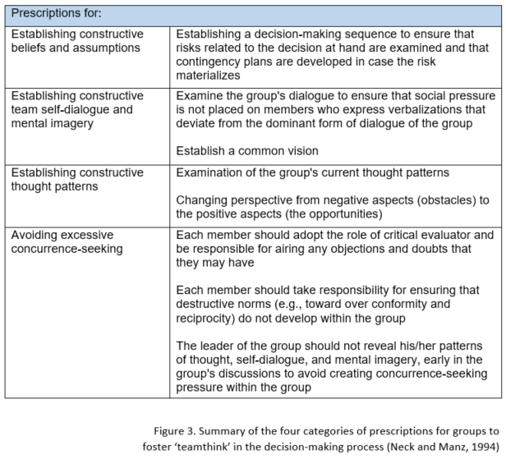
Conclusion
Outside of the more traditional ‘lessons learnt’ activity, this is the first time I have used a reflection model, or been asked to write a reflection piece. The structure to the headings helped my recall of the events I have experienced and brought them into sharper focus; this was elevated by the exploration of literature, developing a deeper understanding of stakeholder engagement.
Against the backdrop of the time constraints, clearly my engagement to arrive at an e-consenting solution is not adequate, but on reflection there are some strong experiences and tools that I have developed and have carried successfully through my career when delivering service redesign and technical intervention projects.
Working in the NHS, the stakeholder groups are often highly specialised within both clinical and non-clinical cohorts, and we often work with the same sub-set of representation with increasingly strong opinions on the ‘right way’ to proceed. With a greater understanding about the risks of ‘groupthink’, I intend to build on the work of Neck and Manz (1994, p. 929) to develop local guidelines for establishing and running constructive engagement groups.
References
Chamberlain-Salaun, J., Mills, J. and Usher, K. (2013) ‘Terminology used to describe health care teams: an integrative review of the literature’, Journal of multidisciplinary healthcare, 6, pp. 65–74. DOI: 10.2147/JMDH.S40676
Harrin, E. (2020) Engaging Stakeholders on Projects : How to Harness People Power. Princes Risborough: Association for Project Management.
MacDonald-Wallace, D.C. and Gatt, E.J. (2009) The Shared Service Architect's Toolbox: 40 Tools, Techniques and Template for Building Trust and Shared Vision in Public Sector Shared Services. 1st edn. Broadstairs: Shared Service Architecture Ltd.
Morris, H.T. (2020) ‘Experiential learning – a systematic review and revision of Kolb’s model’, Interactive Learning Environments, 28(8), pp. 1064-1077. DOI: 10.1080/10494820.2019.1570279
Neck, C.P. and Manz, C.C. (1994) ‘From groupthink to teamthink: Toward the creation of constructive thought patterns in self-managing work teams’, Human Relations, 47(8), pp. 929. Available at: https://www.proquest.com/docview/231490747?accountid=130472&parentSessionId=cSBRW4JymZ%2FzFb6wL9z4IMnvjKXJtruVtfDAHB4hCgg%3D (Accessed: 01st June 2022)
Tanguay, E., Hanratty, P. and Martin, B. (2020) Reflective Writing for Nursing, Health and Social Work. London: Bloomsbury Publishing Plc.

