Name - Nathan Rhys Price

Student Number – P152041

Module Code – ACBA4001

Lecturer – Allan Nantel

Assignment Title – Site investigation Case study

Contents page
Page 1
Title page
Page 2
Contents page
Page 3
1. Introduction
2. Desk top study
2.1 Site location and site walk over
Page 4
2.2 Historical information of the site
2.3 Geological survey
Page 5
2.4 Flood risk within the area
3. Detailed site investigation
Page 6
3. Detailed site investigation (Cont.)
Page 7
4. Foundations
Page 8
4.1Causes of Settlement
Page 9
5. Building regulations
Page 10
Bibliography

1. Introduction
I have been given the role of a junior construction professional employed by a local construction company, who are tendering for the new construction project. This construction project consists of City and Council of Swansea and the Marriot hotel entering a joint agreement to create a new restaurant and ice-cream parlour situated between the Marriot hotel and also the county hall. Within this study I will be carrying out the preliminary desk top study describing the historical background of the site, my recommendations for the contents of a detailed site investigation, any building regulations/codes of practice for which my recommendations are derived and also giving my recommendations for suitable foundations details for the building to be situated on based upon my preliminary observations.
2. Desk top study
Firstly, as part of my role as a junior construction professional, I will be carrying out a desk top study of the proposed site location. I will be collecting both historical and environmental data from various sources for this location. Once I have received all this data, I can then analyse it to give a better understanding of the site constraints and previous activity on the proposed site.
2.1 Site location and site walk over
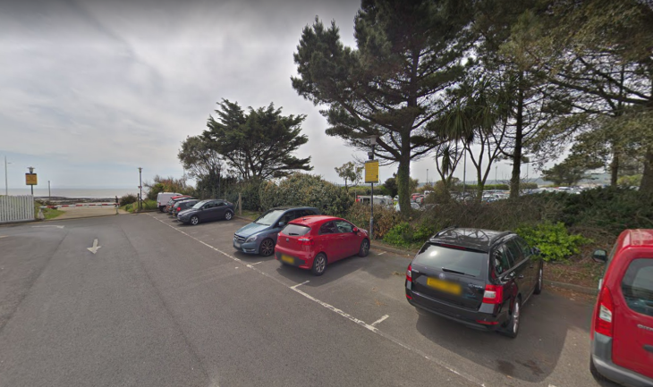
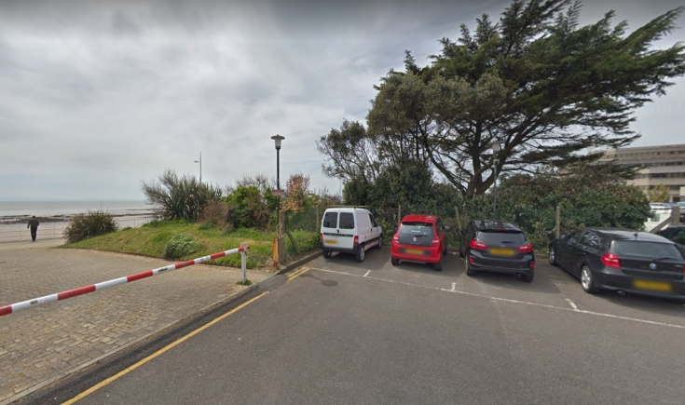
The site is located between the Marriott hotel and County Hall, with the current use of the land being two car parks. Between these two car parks various trees and bushes can be seen, this can been seen in the image below. The only notable comment which I would make on this area is that there is a slight rise in the ground level where the vegetation is present.
Appendix A – Site location
2.2 Historical information of the site
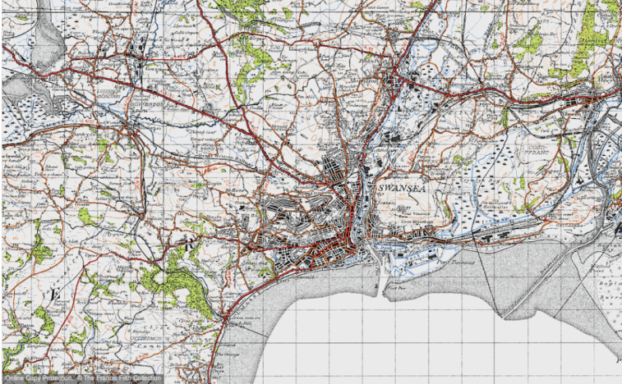
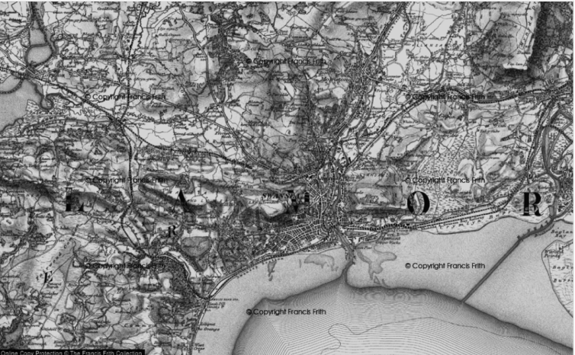
Whilst researching this specific area of Swansea, I started back in 1897 on the ordnance survey maps. One of the first things which stood out to me was the railway line which was passing through/very close to the location of the proposed site location. This railway line also known as the ‘Oystermouth Railway’ and then later known as the ‘Swansea and mumbles railway’ can be seen to run through Swansea and all the way down to the mumbles. After being opened in 1807, this railway service closed down in 1960 and the service got replaced by motor buses. Along with the railway line in the area there were also many factories which were in operating with the docks area. After researching OS maps of 1947, It illustrates that there has been many roads and houses constructed within this area. One street which mainly stands out of this map is Sloane Street; this street was then later demolished in the early 1970s.
Appendix B – OS Map 1897 Appendix C – OS Map 1947
After reviewing the coal mining records of this area, it is apparent that there are no coal mining works within the area. These records are from the coal authority, which state that the nearest coal mining activity was located at Mount Pleasant, Swansea.
2.3 Geological survey
The geological map from the British Geological Survey states that the proposed site location is formed on mudstone, siltstone and sandstone. The purpose of the geological map is to understand the three dimensional geometry of the rock strata beneath the surface. The sedimentary bedrock found in this location was formed approximately 310 to 318 million years ago within the Carboniferous Period where this local environment was previously dominated by swamps, estuaries and deltas. Within these sedimentary rocks are fluvial, palustrine and shallow-marine in origin, they are detrital, forming deposits reflecting the channels, floodplains and deltas of a river in a coastal setting.
2.4 Flood risk within the area
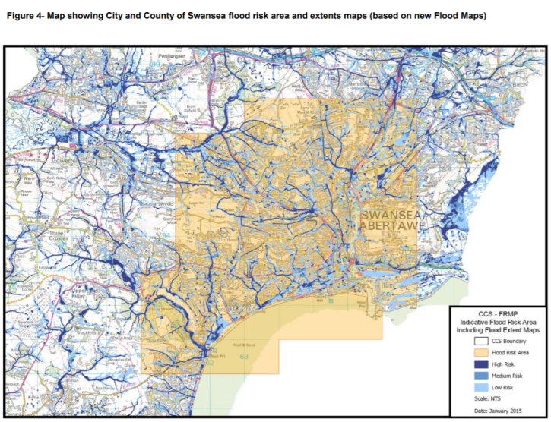
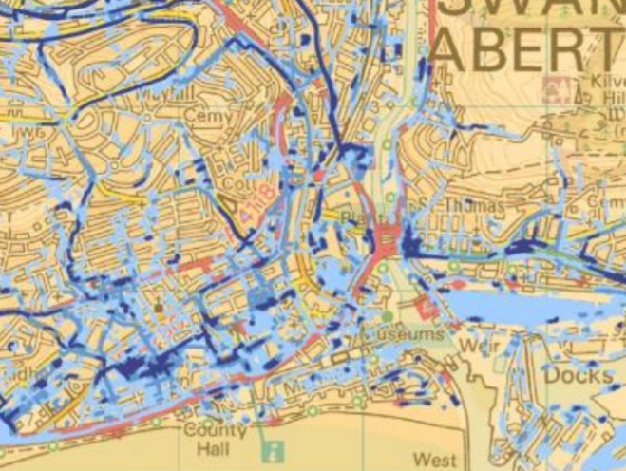
Due to the location of the site, my initial guess would be that this location would be a very high risk of flooding. After conducting research into the flood risk of this area on the City and County of Swansea flood risk management plan 2015, I found that this area of Swansea is actually on targeted as medium risk (as detailed below).

Appendix D – City and County of Swansea Flood Risk management survey maps
Following further research and understanding of the full report issued by City and County of Swansea, I have found that the highlighted area detailed in Appendix E states that this area can be susceptible to surface water flooding. They further say that this area is only listed as medium risk due to this area receiving run-off water from higher area of Swansea onto its impermeable grounds.
3. Detailed site investigation
The desk study, historical data and the site walk around which has been carried out on this site should be taken as preliminary; this should then be reviewed following further ground investigation on this site.
Prior to any ground samples being taken, all existing underground/buried services need to be identified from plans. These can be obtained from the Electric/Gas supplies or also digging trial pits. Once you are confident that you have received all information regarding the site, ensure there is no ground contamination and buried services then you could look at planning how you are going to carry out your ground investigation. A Sonar tool can identify any underground or buried services which you are trying to locate on your site, these findings from this equipment will aid you with your plans from the utility companies of their existing services.
For this ground investigation a number of test pits and borings should be carried out to reveal whether there are any major changes within the strata. These changes could be the thickness, depth or properties of the strata which could affect the works going forward or the immediate surroundings of the site. Site constraints can influence which ground investigation method can be chosen as some of the equipment need for certain methods of ground investigation might not be feasible on some sites. Some of these site constraints might include:
- Structural constraints – If there are stability concerns of existing structure e.g retaining walls, this need to have serious attention paid to as they need to take into account the additional plant and operation of this plants effects.
- Utility constraints – Overhead power lines could limit some drilling rigs being able to carry out the necessary investigations on site.
- Environmental constraints – On certain sites, there could be a possibility that it could contain agents or substances which are very harmful to humans.
- Seasonal and ecological constraints – Various seasonal activities on fields could also affect your ground investigation.
Once the sample has been obtained, it can then be placed into one of the two categories, disturbed or undisturbed. There are 3 main categories for sampling methods, these are A, B and C. Category A is the only category which can contain soil sample quality classes 1 and 2. Classes 1 or 2 are the best ones to achieve as this means that the sample has had no or very slight disruption. Once they are classified they should be assessed and recorded during the investigation by qualified key personnel who will record the data at key times throughout. The qualified key personnel will immediately after receiving the sample from the qualified operator will look for the following criteria:
1) Soil particle size in relation to sampler in use;
2) Voiding in undisturbed samples;
3) Partial core recovery;
4) Mixing of strata types;
5) Breaking up of cobbles or boulders into smaller particles using sampling tools/chiselling;
6) Condition of sample tube;
7) Over drilling of previously cored ground to recover sample or core; and
8) Recovery of collapsed or squeezing ground.
4. Foundation
A foundations role is to transmit loads through the bearing surface to the ground. The loads can be either dead, imposed or wind loads, although other effects such as earthquake can increase load. The main role of a foundation is to carry the weight of the building situated on top of it, transfer loads safety from the building to the ground, spread the weight of the building and it also provides a flat level surface which you can construct a building on.
Taking into account the information received, I would chose to use a piled raft foundation for this building. The use of a limited number of piles beneath the raft foundation would help the building situated on top stay strategically located, avoid any differential settlement performance of the raft foundation and also increase the load bearing capacity of what can be situated on top of it due to the strata below. As the piles are a deep foundation these will be necessary due to the bearing capacity not being adequate enough within the strata below. Therefore, by using piles for the foundations, the imposed loads from the building can be transferred deeper. I have included a sketch in Appendix F for the piled raft foundation.
Pile foundations are typically made from steel or reinforced concrete; they can sometimes be made out of timber. These piles can be installed in the ground in the 4 ways listed below.
- Percussions drivers – this machine has a hammer which gets driven by compressed air or diesel.
- Hydraulic drivers – this machine uses its hydraulic rams to push the pile through into the ground.
- Vibratory drivers – this is where the piles get vibrated into the ground.
- Rotary auger – this machine screws replacement piles into the ground


Appendix E – Piled raft foundation
4.1 Causes of settlement
Settlement can be seen in many ways internally within properties. If there are underlying issues with the foundations and shrinkage etc occurs then this can be visibly seen in many different ways, just a few of these are, Stepping in the brickwork, internal cracking at a 45 degree around doorways and windows. Some of the many causes of settlement are as follows;
- Excessive applied structural load.
- Movement of the ground water table – this can include frost heave and also the ground drying out.
- Vibrations on the ground, these can include machinery and earthquakes.
- Loss of water from the ground – this is where there the effective stresses (inter-granular stresses) increase which causes shrinkage to occur.
- Mining activity below, this can causes many issues with foundations are it creates a void beneath to surface and can cause subsidence or the ground to cave in.
- Land slides
- Soil swelling and shrinkage
5. Building regulations
Some building regulations which need to be taken into account are the Construction Design Management (CDM) Regulations 2015. The CDM regulations aim to improve the health and safety with the construction industry as a whole. After researching the Health and Safety Executives (HSE) website, I found out that the main reason for the CDM regulations are to help you with the following;
- Sensibly plan the work so the risks involved are managed from start to finish.
- Have the right people for the right job at the right time.
- Cooperate and coordinate your work with others.
- Have the right information about the risks and how they are being managed.
- Communicate this information effectively to those who need to know.
- Consult and engage with workers about the risks and how they are being managed.

Bibliography
- Lecture notes
- (Small, 2001), Behavior of Piled Raft Foundations Under Lateral and Vertical Loading
- The Construction (Design and Management) Regulations 2015, Health and Safety Executive. Available at: https://www.hse.gov.uk/construction/cdm/2015/index.htm (Accessed: 4th December 2019)
- Geology of Britain viewer, British Geological Survey. Available at: http://mapapps.bgs.ac.uk/geologyofbritain/home.html (Accessed: 28th November 2019)
- Map of Swansea 1897, Francis Frith. Available at: https://www.francisfrith.com/swansea/map-of-swansea-1897_rne843527 (Accessed: 27th November 2019)
- (C.R.I. Clayton and D.M. Smith 2013). Effective site investigation.

