

Postgraduate/Distance Learning
Assignment coversheet & feedback form

THIS SHEET MUST BE THE FIRST PAGE OF THE ASSIGNMENT YOU ARE SUBMITTING (DO NOT SEND AS A SEPARATE FILE)

For completion by the student:
Student Name: Amanda Page

Student University Email: 2218536@student.uwtsd.ac.uk
Module code: HPCA7014  Module title: Sacred Geography | Student ID number:  2218536 |  |  | Educational support needs:  Yes/
Assignment title: Is sacred space a human construct or a natural phenomenon? Discuss this question through a research project with reference to the work of at least three theorists.

The Holy Trees of the Isle of Avalon: Trees as Invitation for Participation within a Sacred Landscape ​

Assignment due date: 4 Jan 2024 (+1 week differentiated deadline 11th Jan)
This assignment is for the 1st 2nd X 3rd 4th 5th 6th module of the degree
I confirm that this is my original work and that I have adhered to the University policy on plagiarism.
Signed ……………………………………………………………
Email submission:if you are submitting this form via email, please tick this box
(as a substitute for your signature) to confirm that you agree to the above declaration.
Assignment Mark
1st Marker’s Provisional mark
2nd Marker’s/Moderator’s provisional mark
External Examiner’s mark (if relevant)
Final Mark

NB. All marks are provisional until confirmed by the Final Examination Board.

For completion by Marker 1 :
Comments:

Marker’s signature: |  |  | Date:
For completion by Marker 2/Moderator:

Comments:

Marker’s Signature: |  | Date:
External Examiner’s comments (if relevant)

External Examiner’s Signature: |  | Date:
Is sacred space a human construct or a natural phenomenon? Discuss this question through a research project with reference to the work of at least three theorists.

The Holy Trees of the Isle of Avalon: Trees as Invitation for Participation within a Sacred Landscape ​
5193 words

Introduction
This research aims to explore the nature of sacredness through a case study of significant trees situated in Glastonbury, Somerset, UK. The methodology I have used is qualitative using notebooks, recordings, and personal photographs. I have a caravan in Glastonbury and visit the town regularly. I conducted this specific field work for three days and nights in early November 2023. The research focuses on the Glastonbury Thorn on Wearyall Hall, the Gog and Magog ancient oaks, and the yews of Chalice Well Gardens, all of which are situated along the pilgrim paths of Glastonbury. As a result of my findings, themes discussed will be whether trees have agency to extend an invitation for human and nonhuman participation in the landscape and why, in this time of ecological collapse, that could be important; and how stories and myths add to the power of a place. The main theorists called upon to support my arguments are Mircea Eliade, Christopher Tilley, Belden C. Lane and Mark A. Schroll. I will also use literature about Glastonbury from the Library by Adrian J. Ivakhiv and Carol M. Cusack. This research will build on my previous interest in plant communication and extraordinary experiences, particularly encounters with the divine in nature. The research could be of significance in understanding how a person can form a meaningful relationship with nature by interacting with the natural world, thus mitigating further harm.

Literature Review
The main secondary sources relevant to my research focus on definitions and explanations of the sacred and experiences attached to it. These are (by publication date) The Elementary Forms of Religious Life, The Sacred and the Profane: The Nature of Religion, A Phenomenology of Landscape and Landscapes of the Sacred by the theorists Emile Durkheim, Eliade, Tilley and Lane respectively. I also refer to Bernadette Brady’s chapter in Space, Place, and Religious Landscapes to discuss the Aristotelian notion of sacred place where ‘a body [finds] itself … in its ‘proper place’’. To discuss extraordinary experiences in sacred spaces I will refer to Lane again and Schroll’s chapter in Greening the Paranormal.
Definitions of Sacred
Ivakhiv’s definition is that sacred ‘places and landscapes are constituted in and through histories of human-nonhuman interaction in specific biophysical and material topographies and ecologies’ and although my findings confirm this there is a sense that sacred space exists autonomously and has agency to act upon humans and nonhuman alike. The theorists discussed do not always agree on what causes a place to be sacred. For Durkhiem, the sacred only exists ‘in the human mind’ and cannot be separated from it. The sacred is made by collective human doing that is set apart from the everyday and constantly remade. In contrast, Eliade argues that sacred space is a natural phenomenon where the person experiences a divine interruption where ‘some parts of the space are qualitatively different from others.’ These spaces form a ‘central axis for all future orientation,’ and constitute ‘absolute reality, opposed to the non-reality of the vast surrounding expanse.’ Thus for Durkheim sacredness is a human construct but for Eliade it is a natural phenomenon – which returns us to the core question for this exploration.
Another idea discussed in this paper is that of the hierophany. Eliade writes that one ‘becomes aware of the sacred because it manifests itself’, and he terms this manifestation a ‘hierophany’. Otto’s work seems to complement Eliade’s where this manifestation has a particular feeling attached to it known as the numinous. Otto coined the term, numinous defining it as, ‘man’s sense of the divine presence and part of the reality and character of that presence.’ For Otto it is the loveliness of nature which inspires in us a feeling of ‘awefulness’ (sic) as well as ‘fear and beauty.’ Bernadette Brady’s paper – ‘Mountains talk of kings and dragons, the Brecon Beacons’ is referenced to describe the Aristotelian notion that place can assert ‘a form of gravity that drew bodies towards certain places’ being, ‘the proper place.’ The last theorist to be discussed in my findings is Belden C. Lane with his four axioms theory as follows:
- Sacred place is not chosen, it chooses
- Sacred place is ordinary, ritually made extraordinary
- Can be tread upon without being entered
- Is both local and universal
Lane also describes the archetypal sacred place having three elements of stone, water and trees, representing indestructibility, purification and regeneration respectively.

Phenomenological Perspective
Tilley’s theories act as a bridge between Durkheim and Eliade where both people and the place itself make the sacred, where what people do ‘cannot be divorced’ from the landscape.’ Tilley believed the researcher would have to take ‘an interpretive leap’ where something ‘new transforms… understanding of place’ and I have endeavoured to keep an open mind and take some of these leaps. People return to a sacred place like Glastonbury to engage with it as it reaffirms who they are, as well as where and when they are in the world. It grounds them and enables them to feel attached to their ancestors. Glastonbury is a thoroughly enmeshed space as well as a contested space. Lane posits that ‘it is often the contested character of a place that most signifies its sacral quality’ which integrates with Tilley's point where layers of interactions by different people(s) with different belief systems over long periods of time generate sacredness.
Extraordinary Experience
Schroll writes that being in a sacred space can trigger a ‘transpersonal awakening’. He argues that it is this awakening that could lead to the awareness that humans and non-humans are interconnected in what he calls, ‘Gaia and cosmic consciousness.’ He claims sacred spaces also have the capacity to influence our dreams and my project goes on to explore this concept. In ‘Falling in Love with a Tree’, Lane’s take on extraordinary experience is close to my own findings:
We and the more-than-human “others” find ourselves staring together into a fire of apocalyptic loss. Yet within that looming crisis, new opportunities emerge. New ways of listening and being heard arise. The Great Conversation is gradually being renewed because of our growing consciousness of being collectively at risk.

Methodology
Using a qualitative perspective enabled me to ‘understand [my] perceptions of the world’ as I directly experienced it. This case study was part applied narrative inquiry methodology using story to describe the lived experience of walking the pilgrim paths (embodied) and part survey where I interviewed the trees to move beyond a wholly human perspective . I interacted with the landscape connecting to the trees that I perceived to be the ‘central axis’. I devised a short questionnaire and followed the same ritual using sacred objects at each site. I created a small altar and spoke my intentions for the interaction (see figure 1). The questions I asked the trees were:
Q1. Why do you call people here?
Q2. Why do people tie ribbons to you?
Q3. What is it you need to communicate?
Q4. Why is this important?
Q5. What is a scared space?
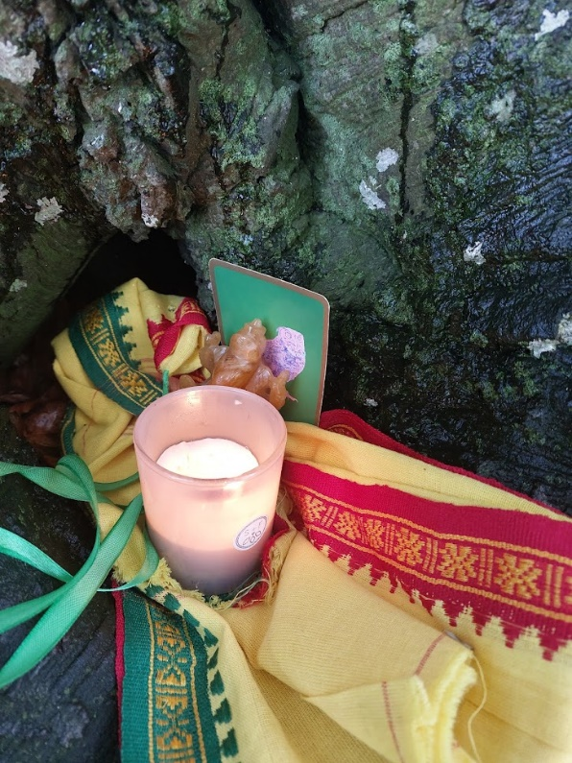
Figure 1 by A. Page, 4/11/23, Avebury
As well as recording the trees’ responses, I recorded events, thoughts, poems and dreams in a journal during the field trip – these, along with personal photographs taken on my phone and sound recordings, constitute my primary sources for this investigation. The ‘narrative threads’ highlight patterns that reverberate throughout the data. There are some reflexive considerations. Qualitative research is both subjective and selective (as opposed to quantitative or objective research) and the evidence submitted is not easily cross-referenced and is ‘dependent on the researchers account’. However, it does allow for many ways for the question to be explored including collecting evidence, studying relationships, observations and interviews. A further consideration is that I am culturally biased. As a white, middle-aged, middle-class woman currently living in a beautiful rural spot at the edge of Bannau Brycheiniog I have both the capital to travel and time to study topics that are of personal interest to me. I did not always have this privilege though - I have spent the last ten years following a spiritual path to explore ways to ease the pain of childhood trauma and the subsequent chronic medical conditions that have materialised as I have aged. From a personal perspective, I am of the opinion that the disintegration of my material body, on a micro level, is linked to the destruction of biodiversity on this planet at macro. I feel the ability to link my own human suffering to that of the non-human is a strength in this investigation and links back to Lane’s idea of shared suffering being key to opening channels of communication.

Field work and Discussion
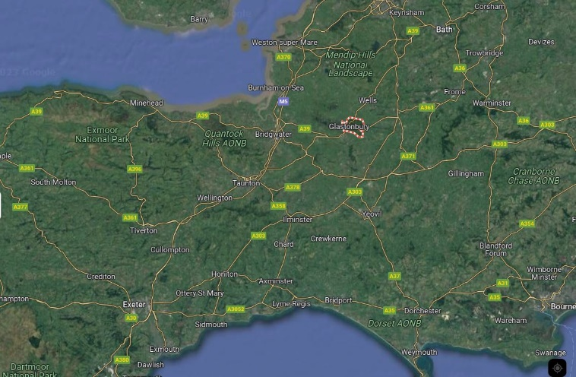
Figure 2, Google Maps accessed 29/12/23
Glastonbury is a Somerset market town situated to the south of the Mendip Hills (see figure 2). It is famous for the hill, known as the Glastonbury Tor, on which stands the remains of St Michael’s church where the last abbot of Glastonbury Abbey was hanged in 1539. Glastonbury is considered a sacred place by many cultural groups and as such is a contested place. My visit coincided with the aftermath of Storm Ciaran and the roads travelling down from Cambridge were slow and sometimes dangerous. I made an intuitive pit-stop at Avebury where I sat briefly with the huge beech trees outlining my intentions for next few days (see figure 3). I felt the beeches were connected to the ancient trees I would be visiting in Glastonbury via a wider pilgrimage route and I had a distinct feeling they might herald my arrival. It also gave me the opportunity to test my research methodology. During my automatic writing exercise I had the urge to put my skin against exposed roots:
I took my shoes off to connect to the ground/roots/mycelium. I felt an eruption of sacred life where people come to connect to the source of interconnection. We are drawn to its bright spark.
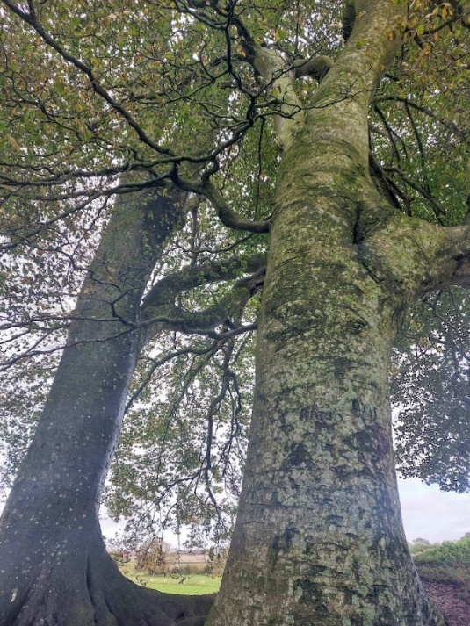
Figure 3 by A. Page, 4/11/23, Avebury
Being ‘drawn to’, is reminiscent of Aristotle’s notion of the proper place and I was unaware of this theory prior to writing this journal entry. I arrived in Glastonbury late afternoon to plan my route. I walked the traditional pilgrim’s paths to visit the significant trees in the town. This route is illustrated in orange in figure 4. I visited the holy thorn on Wearyall Hill and the Chalice Well yews on day two and Gog and Magog, the ancient oaks, on day three. I returned home on day four.
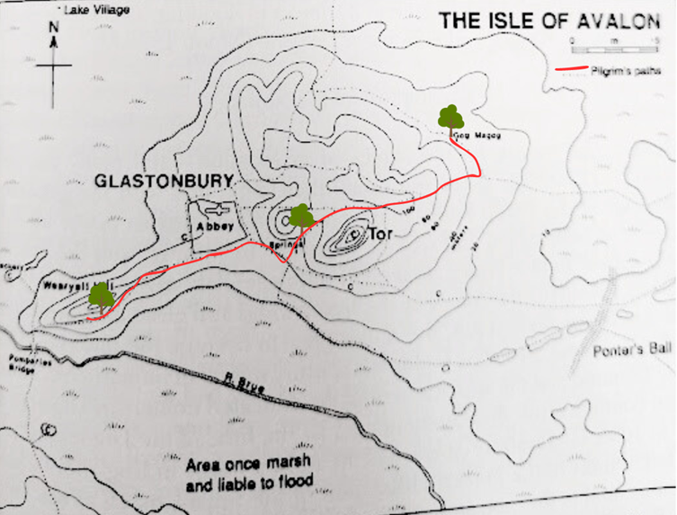
Figure 4 by A. Page, 20/12/23
The Hierophany
Before discussing the sacred in relation to trees in Glastonbury, it is important to describe what I experienced in India as this helps to shed light on some of the experiences in Glastonbury. Earlier this year I was part of a University tour visiting the Hindu Navagraha Temples of Tamil Nadu. During a ritual at the Mercury temple I made a vow to speak to the trees and share what they said with others. I had an extraordinary experience with a giant banyan tree in the temple grounds directly following this promise. Figure 5 shows me under the tree reaching to touch the low hanging aerial roots.
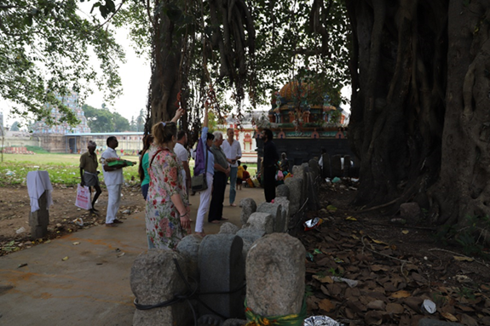
Figure 5 by N. Ayanoglu, 18/1/23, Thiruvenkadu
The tree ‘showed itself’ and the atmosphere of the space under its branches was unlike anything I had experienced before. Eliade would call this experience a hierophany. The moment arrived like an eruption in the mundane and although being in a foreign temple is not mundane, I felt a distinct difference being beneath the tree: it had a ‘reality that does not belong to our world.’ It was if the tree were the fixed, central point and I was drawn towards it. I felt the quality of the numinous – people around me fell silent and I felt both the ‘awefulness’ of the giant tree and the horror surrounding the destruction of the rainforest that once surrounded it. Lane’s 4th axiom comes into play here as well, because the tree was both local, being a singular temple tree, yet also universal, since it was a lone survivor and therefore a symbol for current mass biodiversity loss. The Indian banyan tree taught me how to listen and I took this understanding with me to Glastonbury.

Participation
The next part of the discussion focuses on whether trees have agency to extend an invitation for human and nonhuman participation in the landscape. In the Roman world, the ‘tree stood as a potential point of contact between the human world and the world of the divine.’ I wondered if the trees, which already had their own names and myths connected with them, could be the access point to contact with the divine. I started my research online and found that a local man, Matt Witt, gave tree tours around Glastonbury offering locals and visitors alike the opportunity of phenomenological experience akin to Tilley’s. I discovered that, as well as the famous trees I visited, there was also a 200-year-old lime tree known as Grandmother Lime, (named by locals) who is offered manmade ribbons or toys as well as natural items like fruit, flowers, feathers and leaves. It is as if the more storied trees have helped open-up participation with other trees in the area. Local artists and poets roam the pilgrim paths visiting the trees and songs emerge from the landscape about them, in turn bringing more people in to visit. The people who visit the trees have their own reasons for doing so – maybe to leave a simple token of thanks, or to wish for a boon, or as a remembrance ceremony for a lost loved one. Each gift adds another voice, layer, potential history and each builds import. Here, we can see the contested space idea where the tree holds meaning for each individual or group. People have chosen a tree as special – where it is located in the landscape has made it sacred and it also invites participation.

Holy Thorn, Crataegus monogyna 'Biflora'
Figure 6 is a photograph of the hawthorn sapling, known as the holy thorn, showing its position in relation to the panoramic view across the Somerset flats. The old thorn was sawn down by vandals in 2010 which in itself proves the importance of the tree but will not to be discussed here. I sat with the young tree and saw why people are called to the place:
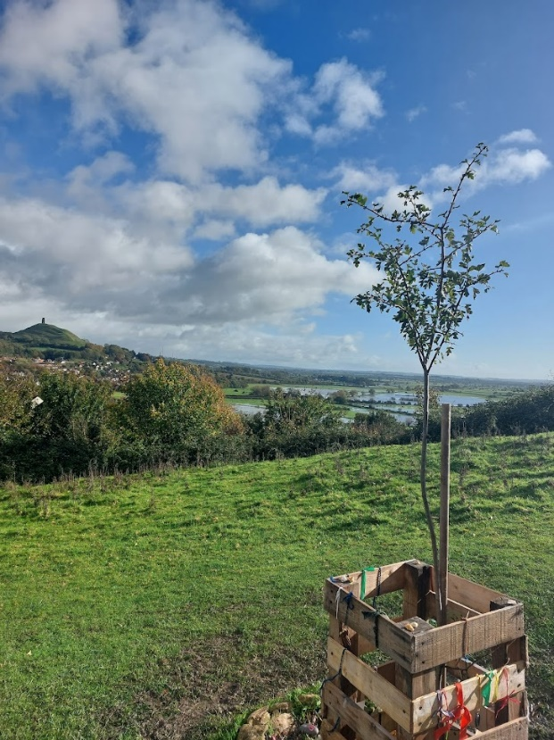
Figure 7 by A. Page, 5/11/23, Wearyall Hill, Glastonbury
‘You can see for miles, it gives you an idea that it’s not just all about you – you are part of the landscape flowing through it like a leaf on a river.’
Looking back at my questionnaire, I noticed that I had made the assumption that people are called or invited to visit the tree by asking the tree if they can do so. For me, this is not disputed. There is no science that can prove that the trees invite participation; however, human beings have attached their meanings throughout time going back to the Middle Ages. Myths, stories and activities like Witt’s tree tours ensure that the tree continues to bring people to it.
I asked the tree about why it needed to communicate. This is the answer I perceived:
It’s about setting you in the landscape to open your eyes to beauty and truth. You’re feeling how I feel in the sun, seeing what I see every day, hearing the birds, the traffic, the crows – the heat of the sun – the sun is life-giving. Let the wind move you.
A visit to sacred places creates memories and forms connections, it situates a person in history and establishes a lineage. For Tilley, ‘place is about situatedness in relation to identity and action.’ This is reflected in what I perceived the tree to answer about why people leave ribbons: ‘maybe their ancestors had been here and it’s a direct link through time and space to the ancients’.
Chalice Well Yew, Taxus baccata
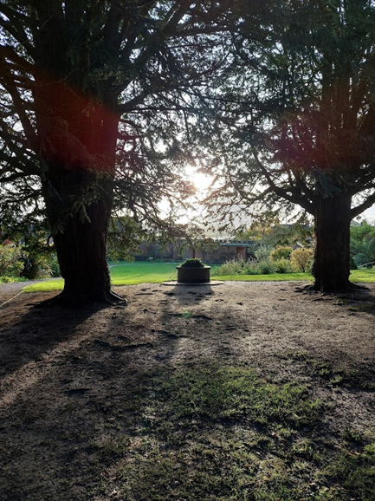
Figure 8 by A. Page, 5/11/23, Chalice Well Gardens, Glastonbury
The entrance to inner Chalice Well garden paths is framed by two ancient yew trees (see figure 7). An arbor provides a space for sitting with the trees for quiet contemplation. For the yews, they invite participation because (in their perceived words), ‘we like feeling your rhythm, it is like music for us. We sing with your life force and you sing with ours.’ Again people had left offerings of natural and manmade objects (see figure 8) building a sense of meaning and association with the gardens.
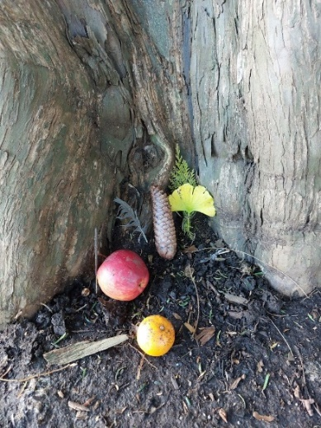
Figure 9 by A. Page, 5/11/23, Chalice Well Gardens, Glastonbury
Beyond the yews is an area called Arthur’s Court where the natural ‘red spring’ water flows into a stone tank. The water has long been said to provide ‘miraculous cures’, indeed many people collect the water from the Lion head font daily. Arthur’s Court is a place where hierophany is possible as it has all the elements Lane claims to be necessary for an archetypal sacred place: stone, water and trees. Entering under the doorway, I felt a sense of awe and wonder (I recognised this feeling from being with the banyan tree) when I entered the Court and silence was automatic.
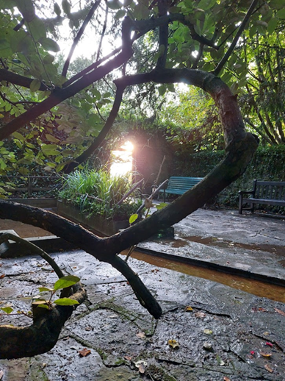
Figure 10 by A. Page, 5/11/23, Chalice Well Gardens, Glastonbury
It was not only the seating that invites a person to stay and reflect (see figure 10). I have observed paddling, washing, anointing, praying, chanting and other rituals being performed here on many visits. Although Durkheim would argue that the place has been made sacred by maintained human ritual, it supports Lane’s axiom that sacred space is the ordinary (here a walled garden and pond) made ritually extraordinary. One could also say that the sacred space chose me to reveal itself to me that day. I had a similar experience in India and later with the ancient oaks. When asked what sacred space is, the answer I perceived from Magog was a place where an invitation for equal participation in each other’s’ world was possible:
We are an invitation. An invitation to pass through our boughs to access another world where a portal opens and we have a chance to exchange energies. A whirlwind, a vortex, a power centre of vibration, colour and shadow where all are welcome and none turned away. There is no good or evil, only beings and their essence.

Power of Place
This section describes the power of the stories about the Glastonbury trees to create cultural meaning especially religious meaning. Lane writes that ‘without exception, the sacred place is the place rich in story’ and there are myths and stories about Glastonbury going back hundreds of years. Today, a Google search of ‘holy thorn Glastonbury’ returns about 447,000 results. Cusak connects the hawthorn tree to ‘traditions [which] revolved around connection with the Holy Land’. The thorn is said to have flowered since Joseph of Arimathea thrust the staff he brought from the Holy Land into the soil and it miraculously broke into blossom.
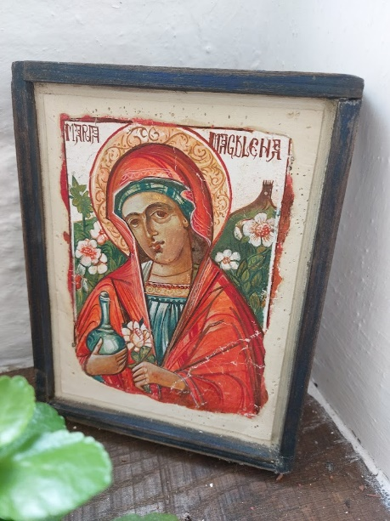
Figure 11 by A. Page, St Margaret’s Chapel, Glastonbury
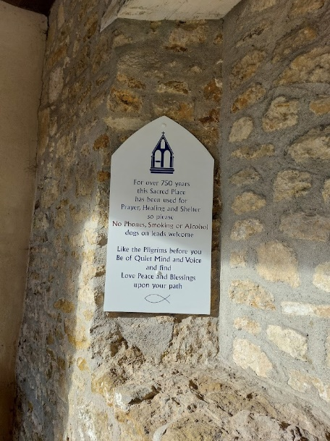
Figure 12 by A. Page, St Margaret’s Chapel, Glastonbury
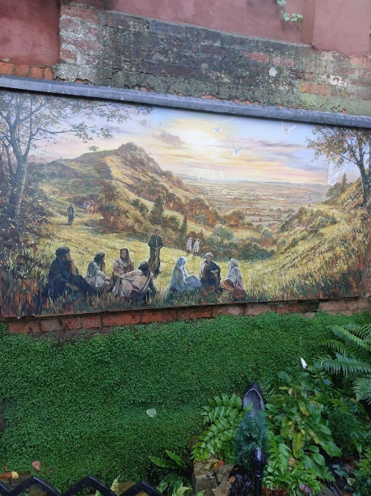
Figure 13 by A. Page, St Margaret’s Chapel, Glastonbury
This connection extends outwards and influences other spaces in the town. One example is the association with St Margaret’s chapel in Magdalene Street. The chapel, known locally as ‘the Magdalene chapel’ due to the association with the attached alms houses, is described as having been a ‘sacred place’ for 750 years (see figure 11). In the main icon of Mary at the chapel (figure 10) the holy thorn is depicted to her left side. This image is reproduced on the posters, mugs and magnets sold in the little souvenir shop, and therefore spread throughout the world to solidify the association. What was different about my field trip visit was that the gate at the bottom of the garden was open, having previously always been locked, and beyond was another section of garden I never knew existed. Again, I saw this as being connected with Lane’s axiom of a place trod upon and not entered. It seemed that this space had opened up because, perhaps, I was now ready, after sitting with the thorn, to experience it. Behind the gate was a small herb garden and a mural painted above a small pool (see figure 12). The mural depicted people from other cultures and ages (wearing biblical-time robes, kaftans or modern jeans and a baseball cap) who have walked the pilgrim’s paths and could be a visual representation of Tilley’s phenomenological approach where landscape has become ‘intertwined with topography and human intentionality’.
Gog and Magog are thought to be the ‘residue of a Druidic grove’. They are also part of the storied landscape of Glastonbury. They are situated one mile to the East of the Tor and reached by Stone Down Lane. Some think they mark a traditional entryway to Glastonbury and form part of a ceremonial druidic avenue of oaks. Indeed, Cusak suggests that Joseph of Arimathea was ‘drawn’ to Glastonbury as the first place to spread the word of Christianity because it was the centre of Druidic wisdom. This links the oaks to the thorn, and it could be said that the oaks invited spiritual participation prior to the establishment of Christianity. There is further evidence to suggest that the interest in druids in the middle ages bought more pilgrims and visitors to the area. The Chalice Well, too, has many stories attached to Arthurian myth, not least that the red waters are the blood of Christ that flow from the Holy Grail buried under the Tor.
This section has argued that stories and myths play a role in making a place sacred. Therefore sacred space could be seen under a Durkheimian lens where it is a ‘mental construct’ where ‘human beings collectively view themselves, each other, and the natural world.’ However, I would describe the powerful feelings and emotions I experienced at certain places on the field trip were different to everyday experience as per Eliade and further, contains elements of what Otto describes as numinous.

Extraordinary Experience
This section explores the ideas that extraordinary experiences happen in sacred places. It also looks at how the nonhuman can have sacred spaces.

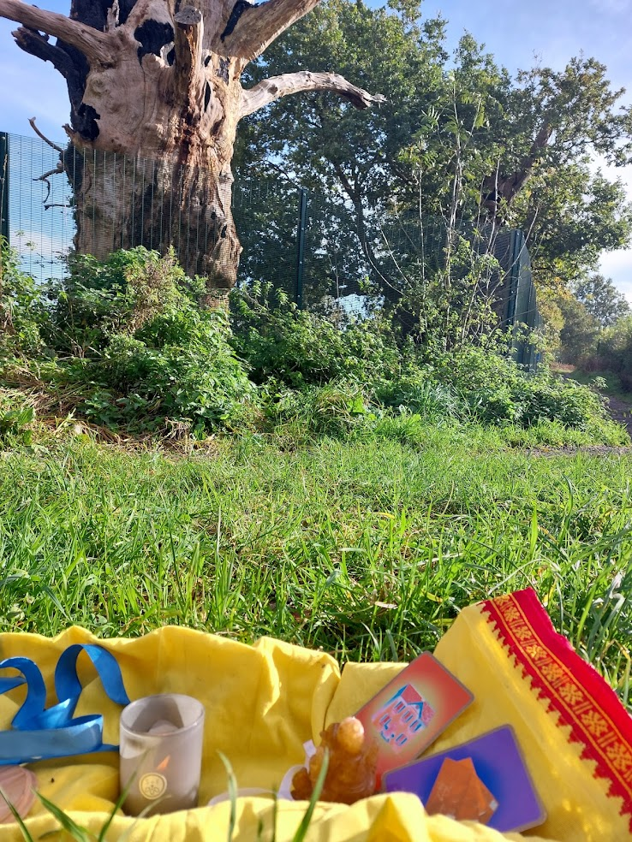
Figure 14 by A. Page, 6/11/23, Gog & Magog, Glastonbury
The act of ritual, automatic writing to capture questionnaire responses as well as reflection needed to understand my experiences with the Glastonbury trees are one, wholly human, aspect of this project. However, there were other experiences that inspired what Schroll would describe as a ‘transpersonal awakening’. There were two instances where I felt the ‘overlapping realities of human and nonhuman sliding into each other’. These were 1/an ash tree physically knocking on the caravan roof at night and 2/the miraculous flying insects living in the tree known as Gog (see figure 13).

The Ash Tree
The volunteer guide at St Margaret’s Chapel told me, anecdotally, that the sacred tree of Glastonbury was not the holy thorn, but a walnut that once stood in the Abbey grounds. He said its ancestors grew around the town. My research backed-up his suggestion when I uncovered an Anonymous poem circa 1502 mentioning a ‘miraculous walnut tree’. On the second day of the trip I discovered a possible descendant in the grounds of the Somerset Rural Life Museum (housed in a 14th-century barn once belonging to Glastonbury Abbey). I was tired from the day, so offered it a chance of being heard via your friends overnight. That night the ash tree next to our caravan dropped rain on the roof and continued to do so for three nights. It was so loud and persistent that my sister, staying with me, went out into the dark to look for somebody who was banging on the roof with a big stick. It is to be noted that during the day, even when it was raining, the knocking was not of the same quality. The recording I made of the knocking is below.
URecorder_20231106_224647.m4a
Between being woken by the drumming on the roof I had a nightmare in which I lost the ability to use language. The only thing that came out of my mouth was, ‘ga ga ga’. I interpreted the meaning to be about communicating with the trees: all we can decipher from each other is ‘ga ga’ nonsense therefore there needs to be other methods of listening that is not embedded in human language. I woke with a full recollection of the dream and a feeling of its importance as a message originating outside of my own consciousness; to confirm my suspicion an owl started hooting loudly outside. I was taken back to the Avebury beeches where I pulled the owl oracle card for the altar (see figure 1). For me, this connected the Avebury beeches, the walnut and the ash together as a collaborative group trying to communicate via signs, synchronicities and mind (or whatever tree intelligence is) to mind telepathy. Schroll claims sacred spaces have the capacity to influence our dreams and offers other evidence to qualify his statement. My findings seem to support this claim. Returning to Lane, ‘sacred place is a construction of the imagination that affirms the independence of the holy. God chooses to reveal himself only where he wills.’ For me, in this instance, the tree knocking on the roof demanding my attention ‘affirms’ its existence, agency and divine nature.

The Kingdom of Giant Insects
We are a gateway. We call human and non-human. All the flying things. You fly with your mind; your thoughts, your feeling and consciousness.
As I walked behind the Gog and Magog campsite toward the famous trees I dodged a huge hummingbird moth. I was surprised and had to duck out of its path: it made sure it made itself known. A tall metal fence had been erected around the trees to protect them (see figure 15).
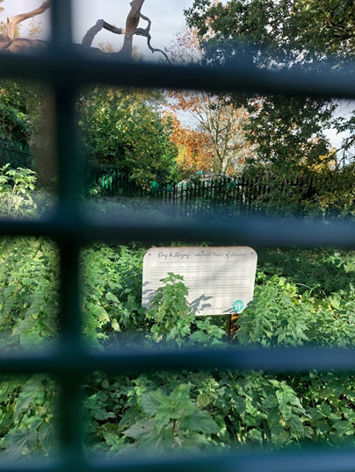
Figure 15 by A. Page, 6/11/23, Gog & Magog, Glastonbury
Gog had died due to a fire being lit inside his trunk and Magog is dying of old age. I set the altar up on the grass to the left of Gog. I noticed that there were many insects flying into the burnt-out trunk. While I was there I recorded queen wasps, hornets, bumble bees and Monarch butterflies. What was unusual was the variety of insects, the time of year I was observing them (November) and how large they were. I felt that I would not be stung but like the hummingbird moth, I was made fully aware of their presence as they buzzed over my head. The insects were not attacking each other and seemed to be sharing the space, congregating while buzzing excitedly around the trunk like they had been drawn to that exact spot or what Eliade would term a ‘central axis’ to claim to their ‘proper place’. Some of the most profound messages I perceived came from the ancient oaks. When I asked why communicating with trees was important Magog’s response was:
Love. Love and communication with all beings human, non-human living or not – all together in a certain pattern. Listen, and if you want to live to the fullest be like Gog and me. LISTEN, transmute and let love fly on wings into hearts.
Lane suggests that in this time of environmental crises, ‘new ways of listening and being heard arise’ for human and non-human and the message I received seems to confirm his point. Being open to new ways of communication is critical if humans are to re-establish a healthy relationship with the other beings on this planet.

Final Thoughts
It is fact that trees communicate with each other and other species such as fungi for mutual support and it is not too far a leap to suggest they may one day, be able to communicate with humans too for the same purpose. Further, work has been done by Monica Gagliano that shows plants have intelligence and her experiments proved that plants have the capacity to learn. If plants and trees have cognitive ability – what might they be able to teach us? The insights gained on this field trip have confirmed the notion that extraordinary experience in nature can initiate moral transformation. This moral transformation is needed because human and nonhumans are collectively at risk of ecological collapse. I have presented evidence that ‘unconscious connections’ with trees such as in dreams, visions or strong emotional responses during meditations were as real to me as standing by the holy thorn across from the Tor using the physicality of my five senses.
A really interesting insight was how the nonhuman interacted with me in a variety of ways. It was not just a case of me enforcing my will upon the trees – I devised the questionnaire and deciphered the trees’ answers after all – but the ash tree kept me awake all night banging on the roof of the caravan; the huge stinging insects demanded my respect and I had nightmares about not being able to make myself understood. These experiences happened independently of me, however one were to interpret them. Yes, it could be my imagination enforced certain meanings on the events, yet they do exist and there too many synchronicities for me to write off, as Durkheim would, as being all in my head. I have followed Tilley’s lead in taking ‘an interpretive leap’. Gagliano shifted her perception, by opening a door to imagination the plants showed her that ‘the reality we [humans] perceive is a narrow set of familiar things and contexts we feel at home with’ and my research has found that more possibilities for communication and collaboration would open up, should we accept the trees’ invitations. I was cheered just last week to read an article about the ecologist Ted Green with the title, ‘The trees are trying to tell us things’: the ecologist championing Britain’s ancient forests.’ The result of my research project is that yes, they are, and good place to start listening is in a sacred place such as Glastonbury.

Conclusion
The aim of this research project was to explore the nature of sacredness through a case study of significant and holy trees situated in Glastonbury. The data and evidence presented are narratives involving nonhuman beings situated in a sacred space and records of my own conscious and unconscious responses. I visited the holy thorn, the Chalice Well yews and Gog and Magog ancient oaks and have described the interactions I had with them. I have presented evidence that sacred spaces exist in and of themselves and are not purely a human construct. I have described my experience of a hierophany in India and how the numinous feelings experienced there were replicated at the Chalice Well garden. I have also presented my findings about storied landscape and how religious meaning can be created over time and maintained by ritual and therefore could be described as a human construct. My unique finding is that sacred space exists to allow a body, mind and spirit connection to the world beyond my limited understanding of the world and for me, the entry point is when I am open to speaking to trees.

References
Barkham, Patrick, ‘‘The trees are trying to tell us things’: the ecologist championing Britain’s
ancient forests’, The Guardian, 1 January 2024. <https://www.theguardian.com/environment/2024/jan/01/the-trees-are-trying-to-tell-us-things-the-ecologist-championing-our-ancient-forests> [accessed 1 January 2024]

Bell, Judith, Doing your Research Project, (Maidenhead: Open University Press, 2014)

Brady, Bernadette, ‘Mountains Talk of Kings and Dragons, the Brecon Beacons’, in Space,
Place and Religious Landscapes: Living Mountains, ed. by Darrelyn Gunzburg and Bernadette Brady (London: Bloomsbury Publishing, 2022) pp. 173-190

Cusack, Carol M., ‘The Glastonbury Thorn in Vernacular Christianity and Popular Tradition’,
Journal for the Study of Religion, Nature and Culture, 12.3 (2018), 307–326 <https://doi.org/10.1558/jsrnc.33523>

Durkheim, Emile, ‘The Elementary Forms of Religious Life’ in Durkheim on Religion, ed. by
W.S.F. Pickering (London:Routledge & Kegan Ltd, 1975), pp. 102-166

Eliade, Mircea, The Sacred and the Profane: The Nature of Religion, (London: Harcourt, Inc,
1987)

Field, Karen, ‘Translators Introduction’ in Durkheim, Emile, The Elementary Forms of Religious Life (Glencoe: Free Press, 1995)
Gagliano, Monica, Thus Spoke the Plant: A Remarkable Journey Of Groundbreaking Scientific
Discoveries And Personal Encounters With Plants, (Berkeley: North Atlantic Books, 2018)

Guenon, Rene, ‘The Land of the Sun’, Studies in Comparative Religion, 14.3&4 (1980),
<http://www.studiesincomparativereligion.com/Public/articles/The_Land_of_the_Sun-by_Ren%C3%A9_Gu%C3%A9non.aspx>

Hardy, Alister, The Divine Flame: An Essay Towards A Natural History of Religion, (London:
Collins, 1966)

Hunt, Ailsa, Reviving Roman Religion: Sacred Trees in the Roman World, (Cambridge: Cambridge University Press, 2016)
Ivakhiv, Adrian, Claiming Sacred Ground: Pilgrims and Politics at Glastonbury and Sedona,
(Bloomington: Indiana University Press, 2001)

James, William, The Varieties Of Religious Experience, (London and Glasgow: Collins Clear-
Type Press, 1975)

Kennedy, Maev, ‘Glastonbury Thorn chopped down as town rages over attack on famous
tree’, The Guardian, 9 December 2010. <https://www.theguardian.com/environment/2010/dec/09/glastonbury-mourns-felling-thorn-tree> [accessed 12 Decemeber 2023]

Lane, Belden C., Landscapes of the Sacred: Geography and Narrative in American
Spirituality, (Baltimore & London: The John Hopkins University Press, 2002)

Lane, Belden C., The Great Conversation: Nature and the Care of the Soul (New York: Oxford
Academic, 2019

Morris, Steven, ‘Ancient Glastonbury oak tree known as Gog damaged in fire‘, The Guardian,
27 April 2017. < https://www.theguardian.com/uk-news/2017/apr/27/ancient-glastonbury-oak-tree-known-as-gog-damaged-in-fire > [accessed 20 November 2023].

Mark A. Schroll, ‘Re-awakening the Transpersonal Ecosophical Significance of Sacred Places’,
in Greening the Paranormal, ed. by Jack Hunter (USA and UK: August Night Press, 2019)

Tilley, Christopher A., Phenomenology of Landscape: Places, Paths and Monuments, (Oxford:
Berg, 1994)

Tilley, Christopher, and others, ‘Art and the Re-Presentation of the Past’, The Journal of the
Royal Anthropological Institute, 6.1 (2000), 35–62, <http://www.jstor.org/stable/2660764> [accessed 13 November 2023]

Witt, Matt, Glastonbury - Trees, Folk Music and Poetry [video]. 2021
<https://www.youtube.com/watch?v=tRgfy-Pd68g> [accessed 25 October 2023]

Peter Wohlleben, The Hidden Life of Trees, (Vancouver: Greystone Books, 2016)

Adrian J. Ivakhiv, Claiming Sacred Ground: Pilgrims and Politics at Glastonbury and Sedona, (Bloomington: Indiana University Press, 2001), p.75.
Bernadette Brady, ‘Mountains Talk of Kings and Dragons, the Brecon Beacons’, in Space, Place and Religious Landscapes: Living Mountains, ed. by Darrelyn Gunzburg and Bernadette Brady (London: Bloomsbury Publishing, 2022), pp. 173-190 (p. 183).
Ivakhiv, Claiming Sacred Ground: Pilgrims and Politics at Glastonbury and Sedona, p. 45.
Karen Field, ‘Translators Introduction’, Emile Durkheim, The Elementary Forms of Religious Life, (Glencoe: Free Press, 1995), p. xi.v
Karen Field, The Elementary Forms of Religious Life, p. xi.v
Mircea Eliade, The Sacred and the Profane: The Nature of Religion, (London: Harcourt Inc, 1987), p. 20.
Eliade, The Sacred and the Profane: The Nature of Religion, p. 21.
Eliade, The Sacred and the Profane: The Nature of Religion, p. 11.
Alister Hardy, The Divine Flame: An Essay Towards A Natural History of Religion, (London: Collins, 1966), p. 107.
Hardy, The Divine Flame, p. 111.
Brady, ‘Mountains Talk of Kings and Dragons, the Brecon Beacons’, p.183.
Belden C. Lane, Landscapes of the sacred: geography and narrative in American spirituality, (Maryland: Johns Hopkins University Press, 2002), p. 19.
Lane, Landscapes of the sacred, p. 25.
Christopher Tilley, A Phenomenology of Landscape: Places, Paths and Monuments, (Oxford: Berg, 1994), p. 26.
Christopher Tilly and others, ‘Art and the Re-Presentation of the Past’, The Journal of the Royal Anthropological Institute, 6.1 (2000), 35–62, (p. 35) <http://www.jstor.org/stable/2660764> [accessed 13 November 2023].
Tilley, A Phenomenology of Landscape, p. 18.
Ivakhiv, Claiming Sacred Ground: Pilgrims and Politics at Glastonbury and Sedona, p. 45.
Lane, Landscapes of the sacred, p. 51.
Mark A. Schroll, ‘Re-awakening the Transpersonal Ecosophical Significance of Sacred Places’, in Greening the Paranormal, ed. by Jack Hunter (USA and UK: August Night Press, 2019), pp. 127-137 (p. 132).
Schroll, ‘Re-awakening the Transpersonal Ecosophical Significance of Sacred Places’, p. 136.
Schroll, ‘Re-awakening the Transpersonal Ecosophical Significance of Sacred Places, p. 132.
Belden C. Lane, The Great Conversation: Nature and the Care of the Soul, (New York: Oxford Academic, 2019), p. 37.
Judith Bell, Doing your Research Project, (Maidenhead: Open University Press, 2014), p. 9.
Eliade, The Sacred and the Profane: The Nature of Religion, p. 21.
Judith Bell, Doing your Research Project, p. 12 and p. 22.
Lane, The Great Conversation: Nature and the Care of the Soul, p. 37.
Ivakhiv, Claiming Sacred Ground: Pilgrims and Politics at Glastonbury and Sedona, p. 94.
AP Journal entry 4/11/23.
Eliade, The Sacred and the Profane, p. 11.
Eliade, The Sacred and the Profane, p. 11.
Hardy, The Divine Flame, p. 107.
Ailsa Hunt, Reviving Roman Religion: Sacred Trees in the Roman World, (Cambridge: Cambridge University Press, 2016), p. 291.
Matt Witt, Glastonbury - Trees, Folk Music and Poetry [video]. 2021 <https://www.youtube.com/watch?v=tRgfy-Pd68g> [accessed 25 October 2023].
Maev Kennedy, ‘Glastonbury Thorn chopped down as town rages over attack on famous tree’, The Guardian, 9 December 2010. <https://www.theguardian.com/environment/2010/dec/09/glastonbury-mourns-felling-thorn-tree> [accessed 12 Dec 2023].
AP Journal entry 5/11/23.
Carol M. Cusack, ‘The Glastonbury Thorn in Vernacular Christianity and Popular Tradition’ in Journal for the Study of Religion, Nature and Culture, 12.3 (2018), 307–326 (p. 307), < https://doi.org/10.1558/jsrnc.33523> [accessed 15 December 2023].
AP Journal entry 5/11/23.
AP Journal entry 5/11/23.
AP Journal entry 5/11/23.
Lane, Landscapes of the sacred, p. 25.
AP Journal entry 6/11/23.
Lane, Landscapes of the sacred, p. 15.
Cusack, ‘The Glastonbury Thorn in Vernacular Christianity and Popular Tradition’, p. 309.
Cusack, ‘The Glastonbury Thorn in Vernacular Christianity and Popular Tradition’, p. 310.
Brady, ‘Mountains Talk of Kings and Dragons, the Brecon Beacons’, p. 183.
Cusack, ‘The Glastonbury Thorn in Vernacular Christianity and Popular Tradition’, P. 316.
Lane, Landscapes of the sacred, p. 15.
Steven Morris, ‘Ancient Glastonbury oak tree known as Gog damaged in fire‘, The Guardian, 27 April 2017. < https://www.theguardian.com/uk-news/2017/apr/27/ancient-glastonbury-oak-tree-known-as-gog-damaged-in-fire > [accessed 20 November 2023].
Cusack, ‘The Glastonbury Thorn in Vernacular Christianity and Popular Tradition’, p. 321.
Cusack, ‘The Glastonbury Thorn in Vernacular Christianity and Popular Tradition’, p. 316.
Cusack, ‘The Glastonbury Thorn in Vernacular Christianity and Popular Tradition’, p. 313 and p. 321.
Emile Durkheim, The Elementary Forms of Religious Life, Translated by Karen E. Fields, (Glencoe: Free Press, 1995), p. xviii.
Schroll, ‘Re-awakening the Transpersonal Ecosophical Significance of Sacred Places’, p. 132.
Lane, The Great Conversation: Nature and the Care of the Soul, p. 39.
Cusack, ‘The Glastonbury Thorn in Vernacular Christianity and Popular Tradition’, p. 310.
Schroll, ‘Re-awakening the Transpersonal Ecosophical Significance of Sacred Places’, p. 132.
Lane, Landscapes of the sacred, p. 19
AP Journal entry 6/11/23.
Eliade, The Sacred and the Profane: The Nature of Religion, p. 21.
Brady, ‘Mountains Talk of Kings and Dragons, the Brecon Beacons’, p.183.
AP Journal entry 6/11/23.
Lane, The Great Conversation: Nature and the Care of the Soul, p. 37.
Peter Wohlleben, The Hidden Life of Trees, (Vancouver: Greystone Books, 2016), p. 10.
Monica, Gagliano, Thus Spoke the Plant: A Remarkable Journey Of Groundbreaking Scientific Discoveries And Personal Encounters With Plants, (Berkeley: North Atlantic Books, 2018), p. 64.
William James, The Varieties Of Religious Experience, (London and Glasgow: Collins Clear-Type Press, 1975), p. 41.
Lane, The Great Conversation: Nature and the Care of the Soul, p. 37.
Lane, The Great Conversation: Nature and the Care of the Soul, p. 39.
Tilly, ‘Art and the Re-Presentation of the Past’, p. 35.
Gagliano, Thus Spoke The Plant, p. 90.
Patrick Barkham, ‘‘The trees are trying to tell us things’: the ecologist championing Britain’s ancient forests’, The Guardian, 1 January 2024. <https://www.theguardian.com/environment/2024/jan/01/the-trees-are-trying-to-tell-us-things-the-ecologist-championing-our-ancient-forests> [accessed 1 January 2024].

