.Possible case for part b focus?

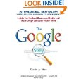
The Google Story by David A. Vise (Paperback - 7 Nov 2008)
Buy new: £7.99 £4.98

24 new from £2.99
9 used from £2.39

Get it by Wednesday, Mar 10 if you order in the next 9 hours and choose express delivery.
Eligible for FREE Super Saver Delivery.
(13)

2.

What Would Google Do? by Jeff Jarvis (Hardcover - 5 Feb 2009)
Buy new: £14.99 £8.60

24 new from £5.50
6 used from £4.49

Get it by Wednesday, Mar 10 if you order in the next 9 hours and choose express delivery.
Eligible for FREE Super Saver Delivery.
(7)

3.
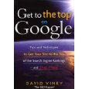
Get to the Top on Google: Tips and Techniques to Get Your Site to the Top of Google and Stay There by David Viney (Paperback - 27 Mar 2008)
Buy new: £14.99 £8.73

38 new from £6.97
9 used from £7.72

Get it by Wednesday, Mar 10 if you order in the next 9 hours and choose express delivery.
Eligible for FREE Super Saver Delivery.
(26)

4.

Get into Bed with Google: Top Ranking Search Optimisation Techniques by Jon Smith (Paperback - 21 Jan 2008)
Buy new: £8.99 £5.97

26 new from £3.81
8 used from £3.84

Get it by Wednesday, Mar 10 if you order in the next 9 hours and choose express delivery.
Eligible for FREE Super Saver Delivery.
(20)

Excerpt - page 1: "Google this and Google that! What about Yahoo, AltaVista and all those other search engines"

5.
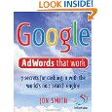
Google AdWords That Work: 7 Secrets to Cashing in with the No.1 Search Engine (52 Brilliant Ideas) by Jon Smith (Paperback - 30 Nov 2008)
Buy new: £9.99 £5.91

25 new from £3.81
3 used from £3.84

Get it by Wednesday, Mar 10 if you order in the next 9 hours and choose express delivery.
Eligible for FREE Super Saver Delivery.
(5)

Excerpt - page 2: "Google AdWords that work to educate people about our new exciting book store, but we also had to assure people that online ... "

6.
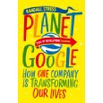
Planet Google: How One Company is Transforming Our Lives by Randall E. Stross (Paperback - 1 May 2009)
Buy new: £8.99 £5.39

30 new from £0.01
10 used from £0.01

Get it by Wednesday, Mar 10 if you order in the next 9 hours and choose express delivery.
Eligible for FREE Super Saver Delivery.
(2)

7.
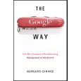
The Google Way: Revolutionary Management Strategies Behind Google's Success: How One Company Is Revolutionizing Management As We Know It by Bernard Girard (Hardcover - 3 April 2009)
Buy new: £19.99 £12.52

28 new from £9.90
10 used from £9.68

Get it by Wednesday, Mar 10 if you order in the next 9 hours and choose express delivery.
Eligible for FREE Super Saver Delivery.
(1)

8.
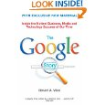
The Google Story by David A. Vise (Paperback - 1 Sep 2006)
9 new from £1.00
34 used from £0.01

(13)

9.
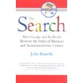
The Search: How Google and Its Rivals Rewrote the Rules of Business and Transformed Our Culture by John Battelle (Paperback - 14 Sep 2006)
Buy new: £10.99 £7.14

17 new from £4.71
11 used from £4.09

Get it by Wednesday, Mar 10 if you order in the next 9 hours and choose express delivery.
Eligible for FREE Super Saver Delivery.
(11)

10.
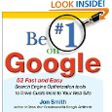
Be #1 on Google: 52 Fast and Easy Search Engine Optimization Tools to Drive Customers to Your Web Site by Jon Smith (Paperback - 1 Nov 2009)
Buy new: £12.99 £7.04

12 new from £6.49
4 used from £9.99

Get it by Wednesday, Mar 10 if you order in the next 9 hours and choose express delivery.
Eligible for FREE Super Saver Delivery.
(1)

Excerpt - Front Cover: " ... Web Site Jon Smith Author of Grow Your Business with Google AdWordsTM"

11.
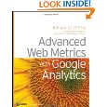
Advanced Web Metrics with Google Analytics by Brian Clifton (Paperback - 1 April 2008)
Buy new: £26.99 £16.04

32 new from £13.89
12 used from £11.04

Get it by Wednesday, Mar 10 if you order in the next 9 hours and choose express delivery.
Eligible for FREE Super Saver Delivery.
(6)

Excerpt - Front Matter: "Advanced Web Metrics with Google AnalyticsTM"

12.
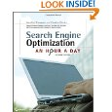
Search Engine Optimization: An Hour a Day by Jennifer Grappone and Gradiva Couzin (Paperback - 11 April 2008)
Buy new: £19.99 £10.99

31 new from £10.32
11 used from £8.50

Get it by Wednesday, Mar 10 if you order in the next 9 hours and choose express delivery.
Eligible for FREE Super Saver Delivery.
(20)

Excerpt - Front Matter: " ... thing is certain: Your potential customers are using search engines like Google, trying to find you and your competitors. Will they find you"

