Jasmeen kaur
Student id : 2230817
Subject : Marketing Management

Marriott International Marriott’s response to the COVID crisis as the travel and tourism industry struggles

Table of Contents

List of figures 4
1. Introduction 5
2. Task 1 6
2.1. Marketing during the Covid Crisis 6
2.2. SWOT analysis of Marriott International during the Covid 7
2.2.1. Strengths 7
2.2.2. Weaknesses 8
2.2.3. Opportunities 8
2.2.4. Threats 8
2.3. Marketing strategies 9
2.3.1. Marketing Mix 9
2.3.2. Internal Stakeholders 11
2.3.3. External Stakeholders 11
2.4. Competitive analysis 11
2.4.1. Digital Transformation 11
2.4.2. Pricing Strategy 12
2.4.3. Promotional Strategies 12
2.4.4. Stakeholder Management 12
2.5. Impact of technology 12
2.5.1. Digital Marketing 12
2.5.2. Communication Technology 13
2.5.3. Internationalisation through Technology 13
2.6. Success strategies implemented by Marriott International during the Covid Crisis 14
2.6.1. Evaluation of Strategy Success 14
2.6.2. Measurement Metrics 14
2.6.3. Effectiveness and Control of Marketing Functions 15
3. Task 2 15
3.1. Digital Transformation 15
3.2. Customer Experience is Paramount 16
3.3. Social Media as a Key Engagement Channel 17
3.4. Data-Driven Decision Making 17
3.5. Balancing Global and Local Perspectives 18
4. Task 3 18
4.1. Invest Further in Digital Transformation 18
4.2. Enhance Customer Experience 19
4.3. Leverage Social Media for Brand Engagement 19
4.4. Adopt Data-Driven Decision Making 20
4.5. Balance Global and Local Perspectives 20
5. Conclusion 21
References 22

List of figures

Figure 1: System at Marriott International (Khalilzadeh, 2020) 5
Figure 2: SWOT analysis of Marriott (Pratiwi, 2019) 7
Figure 3: Pricing strategy of Marriott (Elgarhy, 2022) 10
Figure 4: Digital Transformation of Marriott (King, 2021) 16

Introduction

This investigation into Marriott International's strategic marketing reactions to the COVID-19 situation will yield useful advice for the future. The corporation will put its attention where it matters most, such as in digital transformation, customer experience, social media, data-driven decision-making, and striking a balance between the requirements of international and domestic markets. These findings will be critical for managing crises effectively and achieving long-term growth after a pandemic.

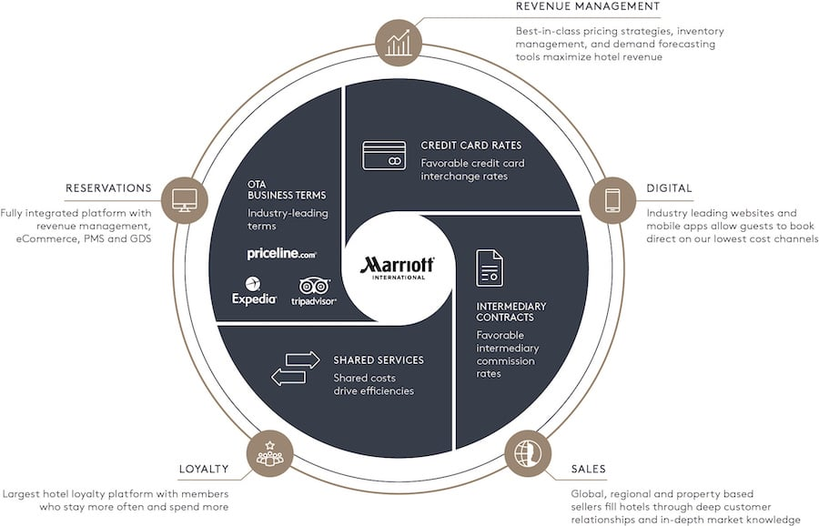
Figure 1: System at Marriott International (Khalilzadeh, 2020)

Task 1

Marketing during the Covid Crisis
The notion and value of marketing have undergone a dramatic transition during the COVID-19 crisis for businesses worldwide, including hotel heavyweights like Marriott International. As the pandemic disrupted business as usual, marketing became essential to maintaining relationships with consumers, adjusting to shifting consumer preferences, and keeping the doors open.
Customer-focused, fact-filled, and dependable communication is more important than ever after the COVID-19 outbreak. It was important for Marriott to convey their message clearly and concisely on the hotel rooms' cleanliness, security, and adaptability. This doubled duty by reassuring customers and encouraging them to go during politically unstable periods.
Marriott International realised that, during this crisis, clients were not interested in being pressured into making a purchase. They wanted real relationships, reassurance, and hope for a brighter future (Le, 2021). As a result, Marriott focused its marketing efforts on increasing its digital footprint, customising its interactions with customers, and releasing creative advertisements that spoke to the emotional backdrop of the epidemic.
One such effort was Marriott's "Room for Possibility" campaign, which quietly reminded visitors of the benefits of travel while emphasising the hotel chain's dedication to cleanliness and security (Guillet, 2021). The ad successfully bolstered Marriott's brand image throughout the crisis thanks to its use of sympathetic storytelling, which evoked pleasant feelings and inspired future travel.
In addition, Marriott extensively used its digital marketing tools during the epidemic. Due to the scarcity of opportunities for in-person communication, Marriott shifted to an online-only business strategy. They did this by increasing their visibility on social media, making their website and app easier to use, and leveraging analytics to target specific audiences with their advertising.
The corporation also modified its reward programme to accommodate the new environment, called Marriott Bonvoy. They gave their clients a sense of safety and care by extending the expiration of points and status (Liu, 2022).
The company's reallocation of resources to these crucial areas demonstrated Marriott's understanding of the significance of marketing during the COVID-19 crisis. Their strategy highlighted the importance of marketing in sustaining connections with customers, protecting the brand's integrity, and weathering tough economic conditions.

SWOT analysis of Marriott International during the Covid
The COVID-19 epidemic had an impact on numerous businesses all over the world, and Marriott International was no exception. The company's crisis-related strengths, weaknesses, opportunities, and threats are all laid out in detail in the case study's accompanying SWOT analysis.

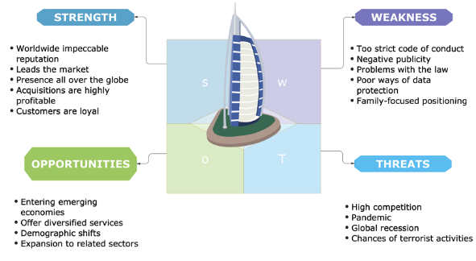
Figure 2: SWOT analysis of Marriott (Pratiwi, 2019)

Strengths
Marriott's strengths include its worldwide recognition, diverse product offerings, and innovative use of technology. More than 7,000 hotels in various markets are Marriott's competitive advantage (Bansal, 2020).
They have been able to better manage the crisis because of their commitment to digitalisation, especially in customer experience personalisation and the application of predictive data. They already have a leg up on the competition because of the loyalty of their longtime consumers.

Weaknesses
The epidemic has revealed significant flaws in Marriott's operating strategy. Due to their reliance on the recession-hard-hit luxury and business travel sectors, revenue fell dramatically.
In addition, the breadth of their overseas activities exposed them to the worldwide travel shutdown, highlighting the dangers of an outwardly focused strategy.

Opportunities
Marriott was able to seize a few windows of opportunity amid all the chaos. The hospitality industry's rapid digital revolution allowed Marriott to improve its digital platforms and individualised service.
Additionally, market consolidation owing to the demise of smaller hotels may create growth prospects. Because of its large financial reserves, Marriott could theoretically buy up these troubled hotels (Park, 2021).

Threats
The main dangers were the probable long-term effects on the global economy and the imposition of lengthy travel restrictions. Marriott's financial situation may worsen if the economy improves slowly.
Competition for tourists after a pandemic might lead to pricing wars, further squeezes margins. The potential for long-term customer preference shifts towards local and virtual encounters is a formidable obstacle.

Marketing strategies

Marketing Mix
Marriott International relied extensively on the marketing mix (product, price, location, and promotion) during the COVID-19 crisis.
.

Product
Marriott substantially improved its digital platforms to provide customers with a more customised and streamlined experience. The company successfully created "Smart Rooms". It utilised its mobile application to offer customised amenities and services, such as mobile cheque-in and cheque-out, room readiness notifications, and room key capabilities (Puspita, 2021).

Price
Marriott exhibited resilience by refraining from price reductions, thereby upholding the premium positioning of its brand amidst the economic downturn and the adverse effects of the pandemic on the hotel industry (Sufi, 2021). Implementing this particular strategy played a crucial role in maintaining their brand equity and securing sustainable profitability in the long run.

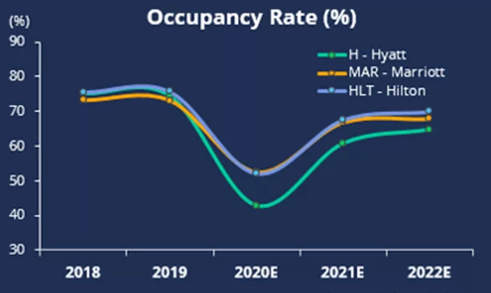
Figure 3:Pricing strategy of Marriott (Elgarhy, 2022)

Place
The company utilised technology to provide customers with a hotel experience regardless of location. Including features such as mobile cheque-in and cheque-out and mobile requests enhanced convenience and effectively addressed health and safety considerations amidst the ongoing pandemic (Wei, 2021).

Promotion
Marriott has incorporated social media into its comprehensive omnichannel marketing approach. The company utilised their real-time marketing command centre, M Live Studios, to monitor and analyse social media trends and establish direct customer interactions (Ristova, 2022).

Internal Stakeholders
The corporation invested much in its employees’ education to master cutting-edge tools and provides individualised client care. This maintained high-quality service and kept personnel feeling appreciated and engaged even in trying circumstances (Volgger, 2021).
In addition, Marriott was forthcoming with information about its health and safety policies, which inspired worker confidence.

External Stakeholders
Marriott's strategy had a major effect on the outside world, particularly its clientele. Marriott maintained its brand recognition and customer loyalty during the crisis by focusing on digital customer service and interacting with customers on social media (Duan, 2022). In addition, the company's unwavering dedication to health and safety standards inspired confidence in the brand among its target audience.
Investors and stockholders had more faith in Marriott's management and long-term prospects due to the company's strategic choice not to decrease pricing despite the economic slump.

Competitive analysis

Digital Transformation
When it came to digital transformation amid the COVID-19 crisis, Marriott International differentiated itself from the competition. Investments in AI-enabled chatbots, a bespoke mobile app experience, and the design of 'Smart Rooms' enhanced the customer experience and responded to the contemporary need for contactless services to ensure guests' safety (Japutra, 2021). Since many of its rivals have prioritised cost-cutting above developing their digital skills, Marriott enjoys a significant advantage in customer-focused digital innovation.

Pricing Strategy
Marriott maintained its premium pricing approach despite the recession and decreased tourism due to the epidemic. Even if it was a gamble in the near term, this choice ultimately protected the premium status of the brand and secured its success in the long run. To entice guests, rivals like Hilton and Hyatt considered lowering hotel prices, which might make it difficult to return to pre-COVID levels (Chan, 2021).

Promotional Strategies
The crisis revealed how flexible Marriott's use of social media for marketing and interaction was. M Live Studios, Marriott's real-time marketing command centre, has helped the company connect with consumers on a more personal level, keep its brand in the public eye, and get vital insights from customer feedback and trends (Sealy, 2020). Since many of its rivals have yet to catch on to the advertising potential of social media, Marriott has a leg up on them.

Stakeholder Management
Marriott did a good job of managing its relationships with its stakeholders. The organisation kept its staff updated on its safety policies and future goals through open communication channels (Shih, 2021). This method helped build employee loyalty and trust, which proved invaluable throughout the crisis.
In contrast, several rivals struggled with transparent and effective stakeholder communication during this time.

Impact of technology

Digital Marketing
One of the ways that Marriott International responded to the COVID-19 pandemic was by expanding its use of digital marketing. The hotel giant released multiple digital platforms to improve the client experience and strengthen brand loyalty. Creating a mobile app offering highly customised content and services was key to Marriott's digital transformation plan. The smartphone app, a key component of their digital marketing strategy, demonstrated comprehensive knowledge of client requirements from booking until the end of the stay.
In a service-based sector like hospitality, the importance of this degree of customisation cannot be overstated. For example, the app's home screen had material that was updated in real-time based on the visitor's position in the booking process (Deraman, 2021). By using digital marketing in this savvy way, Marriott was able to provide its consumers with information that piqued their interest and inspired them to become devoted patrons. In addition, the app included features like room-ready alerts, mobile cheque-in and cheque-out, and mobile requests to facilitate customers' use of the hotel's services and improve their overall satisfaction.

Communication Technology
It would be impossible to overestimate the importance of communication technology to Marriott's approach during the COVID-19 epidemic. Marriott's omnichannel marketing strategy heavily relied on social media due to the company's recognition of the platform's ability to influence consumer opinion and boost brand recognition. Keeping their finger on the pulse of client preferences, Marriott's "M Live Studios," a real-time marketing command centre, monitored and analysed social media trends in and around Marriott's properties (Eschenbrenner, 2023).
Additionally, Marriott included AI-driven chatbots in their method of interaction with customers. These AI interfaces improved productivity and customer satisfaction by responding to a wide range of guest questions, such as booking reservations and seeing account balances (Hao, 2020). These technological enhancements reinforced Marriott's dedication to superior service by facilitating a constant two-way connection with guests.

Internationalisation through Technology
Technology has played a crucial role in Marriott's internationalisation strategy, allowing the company to provide guests with the same high standard of service and personalisation no matter where they travel. Insights from predictive analytics of client behaviour and preferences informed the company's foreign marketing strategy.
Creating "Smart Rooms" was a major technological breakthrough for Marriott. In-room Internet of Things (IoT) solutions co-created with Samsung and Legrand gave guests extensive discretion over their immediate surroundings (García-Gómez, 2021). This customised service, uniform across all of Marriott's sites, helped spread the company's name worldwide.
In addition, Marriott leveraged technology to provide personalised, real-time communication with guests globally. For instance, the company's software enabled a frictionless, seamless experience by letting visitors use their cell phones as room keys, which was extremely useful during the epidemic.

Success strategies implemented by Marriott International during the Covid Crisis

Evaluation of Strategy Success
Examining Marriott's strategies implemented during the COVID-19 crisis yields both commendable aspects and potential areas for enhancement. The prominent entity in the hospitality industry demonstrated adaptability and ingenuity by strategically adjusting its operational framework and allocating resources towards digital transformation.
The company implemented several strategic initiatives to enhance customer experiences, which encompassed the development of an upgraded mobile application tailored to individual preferences, the adoption of an omnichannel marketing strategy with a particular emphasis on social media interaction, and the integration of cutting-edge technologies such as artificial intelligence-driven chatbots and Smart Rooms (Yacoub, 2021).

Measurement Metrics
When assessing the effectiveness of these strategies, various metrics can be employed. The level of user engagement with the mobile application, encompassing metrics such as app downloads, active usage, and customer feedback, can offer valuable insights regarding the app's efficacy. The effectiveness of Marriott's social media strategies can be assessed by analysing social media metrics, including indicators such as shares, likes, comments, and brand mentions. The effectiveness of AI integrations and Smart Rooms can be assessed by examining customer satisfaction and retention rates.
In addition, it is worth noting that performance indicators, such as occupancy rates, revenue per available room (RevPAR), and average daily rates (ADR), can offer valuable insights into the financial well-being and operational effectiveness of the company amidst the ongoing crisis (Ghaderi, 2022).

Effectiveness and Control of Marketing Functions
Marriott's crisis management tactics were generally effective, but there were opportunities to tighten their grip on marketing operations. One crucial area was responding to the dramatic decline in demand caused by safety and travel limitations (Leroi-Werelds, 2021). While the corporation had little say in the matter, it might have done more to encourage domestic vacations, especially those within driving distance.
In addition, Marriott could have improved its communication regarding health and safety measures, encompassing sanitisation protocols and contactless services, to assuage customer apprehensions and foster confidence (Yan, 2020). Despite the ongoing pandemic, effective and regular communication regarding these measures may have incentivised customers to contemplate travel or accommodation options.

Task 2

Digital Transformation
The COVID-19 problem highlighted the importance of digital transformation in the hospitality sector. As an industry leader in embracing digital innovations, Marriott International has paved the path for others to follow. By investing heavily in its digital platforms, the company demonstrated that digitisation is now integral to corporate success rather than a nice-to-have extra. The mobile applications offered by Marriott, for instance, provide a simple booking platform and deliver personalised content depending on the individual's interests and past actions.
From a management standpoint, this change highlights the importance of digital transformation in achieving and sustaining a competitive edge. It paves the way for improved workflows, more effective resource management, and happier customers through individualised service. In addition, digital platforms provide a mountain of data that may be mined for insight and planning purposes. Thus, investing in digital technology should be considered something other than an onerous expenditure but rather an important investment for survival and success in today's digital world. Digitising processes and services is essential and cannot be considered an extra (Segaradana, 2022). Therefore, managers must emphasise digital initiatives to satisfy customers, boost productivity, and remain competitive.

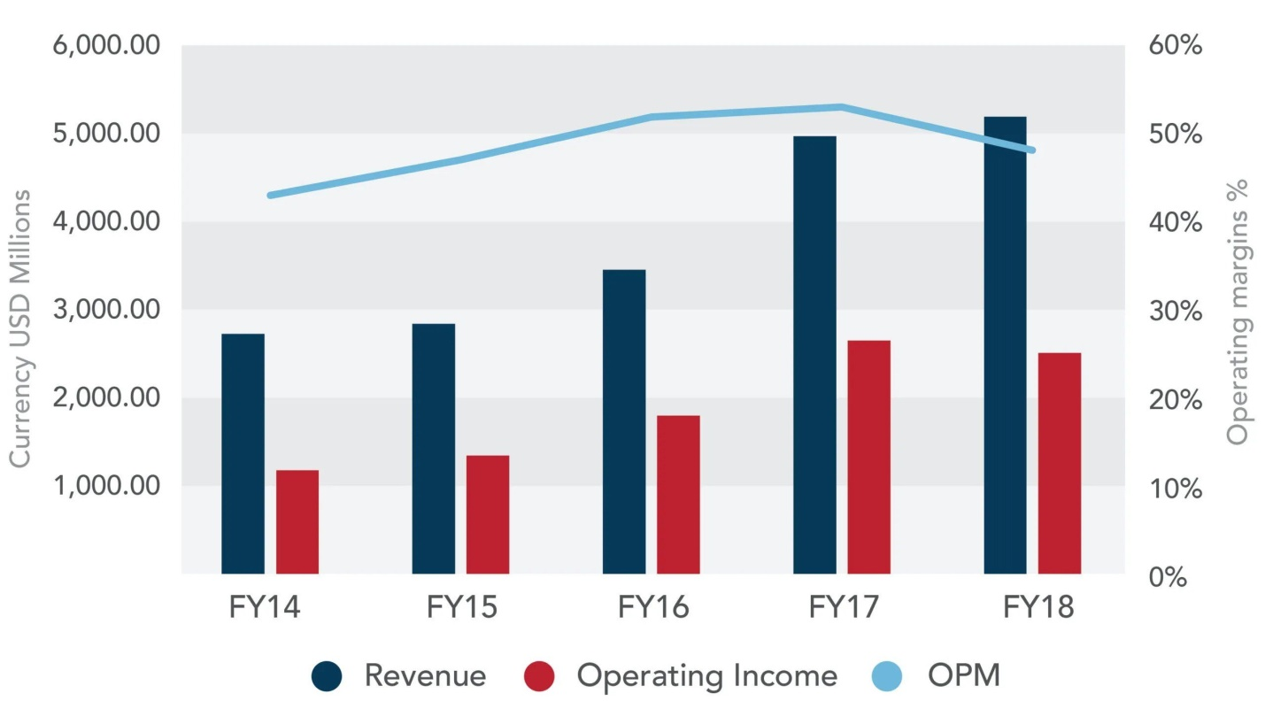
Figure 4: Digital Transformation of Marriott (King, 2021)

Customer Experience is Paramount
Marriott's commitment to enhancing the customer experience through innovative efforts like redesigning its mobile app and creating "Smart Rooms" demonstrates the significance of customer-centric methods in the hotel industry (Shay, 2022). They've achieved this level of customisation and ease of use by employing design thinking and linked solutions.
The managerial conclusion here is that managers should place a premium on consumer feedback when formulating promotional plans. Managers should make it their business to learn about their client's preferences and meet those demands wherever they arise. The hotel's facilities and services, including those offered online and in person, are included in this definition. Increased customer loyalty, excellent word of mouth, and bottom-line growth may all stem from focusing on the customer experience. As a result, marketing activities and strategies should centre on the customer experience rather than treating it as an afterthought.

Social Media as a Key Engagement Channel
Marriott's "M Live studios" and other real-time marketing activities on social media demonstrate the power of these platforms to increase brand awareness and consumer participation (Sharma, 2021). Marriott has been able to dynamically adapt to the requirements of their clientele by monitoring social media trends and engaging with clients on these channels.
Managers, then, need to completely accept and strategically employ social media as an integral part of their overall marketing efforts. Effective usage of social media platforms goes beyond merely having a profile set up; it can boost brand awareness, facilitate direct and personable engagement with customers, and provide vital information about customer preferences, trends, and real-time feedback. Therefore, a well-thought-out social media strategy may result from an improved relationship with customers, more successful advertising efforts, and a more prominent brand presence.

Data-Driven Decision Making
Marriott's use of predictive analytics is a prime example of the game-changing potential of data-driven decision-making. Marriott has increased customer happiness and brand loyalty by analysing consumer behaviour to determine their preferences and targeting them with tailored recommendations and deals (Shin, 2020).
Managers must learn to make decisions based on evidence, and this is the most important takeaway they can have. Data is becoming an increasingly important strategic asset in today's digital and networked corporate world. Managers may get a deeper insight into client behaviour; identify new areas for growth, forecast market trends, and base strategic choices on this newfound knowledge. This paves the way for more accurate targeting, better service, and more profits for the company. Therefore, managers in the modern company environment must invest in data analytics skills and foster a culture of data-driven decision-making.

Balancing Global and Local Perspectives
Marriott's ability to steer through the stormy pandemic exemplifies the value of considering global and local factors. Because of restrictions placed on foreign travel, the company had to pay particular attention to local travel preferences while maintaining its global brand identity.
This has important implications for management, most notably the requirement to align global strategies with local implementation. Consumers in various markets should be able to understand the consistent global brand image that managers maintain and promote. At the same time, having an ear to the ground and learning what customers want is crucial (Shin, 2021). This may be done by doing extensive market analysis, identifying distinct groups of customers, and adapting global marketing methods to fit regional needs. A global marketing plan must include an approach to increase consumer interaction, boost brand image, and drive growth across several regions.

Task 3

Invest Further in Digital Transformation
Marriott has to invest more in digital technologies to boost company operations and consumer engagement because digital transformation is crucial. Leveraging cutting-edge innovations like AI, big data, and machine learning may improve operational efficiency, give actionable strategic insights, and enable more personalised user experiences. Artificial intelligence chatbots, for instance, may speed up replies to customer service enquiries, while machine learning algorithms can recommend vacation packages that are perfectly suited to each individual's tastes (Kim, 2022).
Marriott should also consider incorporating IoT devices into its existing infrastructure. Two examples are the automation of in-room services, such as temperature regulation and room service requests. Adopting such technology is anticipated to increase operational efficiency, save costs, and dramatically enhance the guest experience, strengthening the Marriott brand's relationship with its customers. By adopting these technologically progressive measures, Marriott would strengthen its position in the market after the epidemic.

Enhance Customer Experience
Marriott should consider implementing a full-scale CEM system in light of the importance of customers' overall impressions. A system like this would provide Marriott with a bird's-eye view of its clientele, letting them see problems in the customer experience and find workable remedies (Benyakoub, 2022). A deeper understanding like this might help Marriott craft more targeted marketing campaigns that boost brand affinity and client retention.
In addition, Marriott may implement frequent customer satisfaction surveys and place a premium on guest comments. Marriott may better understand its customers' wants and requirements by including feedback-gathering techniques across social media, smartphone applications, and email surveys (Manoharan, 2021). Taking preventative measures like these is useful for several reasons, including finding problems before they arise and creating ways to boost customer happiness.
These suggestions would help Marriott preserve its competitive advantage in the post-pandemic period by providing the resources and methods to provide exceptional service and constantly delight its guests.

Leverage Social Media for Brand Engagement
Marriott should increase its use of social media platforms for better brand connection in light of the platform's substantial role in consumer engagement. Marriott may improve communication and foster a sense of community among its customers if it consistently publishes high-quality, engaging material and actively promotes user-generated content.
Furthermore, Marriott may use social media analytics to gain useful information from the masses. Using this data-driven method, Marriott can better understand its customers' actions, preferences, and overall feelings about the brand, which are crucial in developing successful advertising strategies (El Faiz, 2023). Also, it can help with real-time monitoring of customer chats, allowing Marriott to respond quickly to any difficulties and maintain its excellent brand reputation.
By employing these methods, Marriott will increase its brand awareness, strengthen its relationship with consumers, and better align its offerings with customers' expectations in the wake of the epidemic.

Adopt Data-Driven Decision Making
Marriott must embrace a data-driven approach to decision-making to keep up with the ever-changing business landscape, especially in the wake of the COVID-19 outbreak. Companies may now make more informed strategic choices and provide more personalised services because of the abundance of client data.
Using predictive analytics to foresee future demand, Marriott may implement dynamic pricing strategies that maximise profits. Marriott may use data-driven insights to find profitable market possibilities, better understand client preferences, and target certain demographics with more targeted marketing efforts. A more individualised approach is a great way to increase client happiness and loyalty (Sanders, 2020). Data may be used to track and assess Marriott's efforts for betterment. It can provide immediate commentary, allowing for proactive decision-making and quick course corrections.
However, Marriott must invest in constructing a strong data analytics infrastructure to reap these benefits. That means investing in state-of-the-art analytics software, providing employees with data analysis training, and establishing a company culture that places a premium on data-driven conclusions. This will help Marriott remain competitive, resilient, and adaptable in the wake of the epidemic.

Balance Global and Local Perspectives
A global hospitality powerhouse like Marriott must balance brand uniformity and local market considerations. Localisation fosters a more meaningful relationship with many markets, while a cohesive brand image increases brand awareness and trust (Avraham, 2021).
Marriott has to keep conducting in-depth local market research to learn how to cater to the diverse needs of its guests. This will help tailor customer service, advertising, and in-store experiences to local tastes while staying true to the brand's larger mission.
Furthermore, working with local partners (companies or influencers) may greatly increase Marriott's standing in the community. Insights into local market dynamics and customer behaviour gained via such agreements may help Marriott better tailor its plans to the region (Dumoulin, 2020).
At the same time, Marriott needs to maintain its worldwide brand standards so guests can expect the same level of service at each location. Brand loyalty and consumer happiness may benefit from combining global and local approaches.
These suggestions are doable in light of Marriott's vast capabilities and history of change. In addition to easing Marriott's transition into the post-pandemic environment, these recommendations can help the company guarantee long-term success by creating a more robust, adaptive, and customer-centric infrastructure.

Conclusion

In conclusion, Marriott International had considerable difficulties during the COVID-19 issue, requiring adjustments in its marketing strategy. Their capacity to bounce back quickly from setbacks was important to their survival and revival; they showed this in several ways, including more digital transformation, a concentration on the customer experience, and greater use of social media, data-driven decision-making, and harmony between global and local viewpoints (Santoki, 2020). These findings highlight the significance of technology, customer-centricity, and flexibility in a dynamic corporate environment and give useful lessons for future marketing initiatives.

References

- Avraham, E., 2021. From 9/11 through Katrina to Covid-19: Crisis recovery campaigns for American destinations. Current Issues in Tourism, 24(20), pp.2875-2889.
- Bansal, S. and Garg, S., 2020. Brands and their Customer Connectin During COVID-19. Dr Nand Kishore Garg, 83.
- Benyakoub, M. and Elhannani, F.E., 2022. The Investment Strategy of Global Sovereign Wealth Funds During the Period of the Pandemic (COVID-19). Finance and Business Economies Review, 6(4), pp.226-237.
- Chan, J., Gao, Y.L. and McGinley, S., 2021. Updates in service standards in hotels: how COVID-19 changed operations. International Journal of Contemporary Hospitality Management, 33(5), pp.1668-1687.
- Deraman, F., Ismail, N., Hamzah, S.N. and Zainudin, T.Z.A.T., 2021. Review of Hotels’ Survival Strategies during COVID-19 Pandemic in Malaysia. e-Academia Journal, 10(2).
- Duan, Z., 2022, July. Analysis on the Business Transformation for Bulgari Hotel Beijing under COVID-19. In 2022 2nd International Conference on Enterprise Management and Economic Development (ICEMED 2022) (pp. 1111-1115). Atlantis Press.
- Dumoulin, R. and Giacomel, A., 2020. Disruption and the strategy of hotel groups. Shapes of Tourism Employment: HRM in the Worlds of Hotels and Air Transport, 4, pp.9-21.
- El Faiz, J., 2023. The Covid-19 Impact on the Hospitality Industry. Case of Kenzi Rose Garden Hotel.
- Elgarhy, S.D., 2022. Effects of service quality, loyalty programs, pricing strategies, and customer engagement on firms’ performance in Egyptian travel agencies: Mediating effects of customer retention. Journal of Quality Assurance in Hospitality & Tourism, pp.1-29.
- Eschenbrenner, B., Zlatic, A., Bechtel, M., Collins, B., Straley, C. and Gubbels, G., 2023. Marriott International: A Managerial Strategic Audit.
- García-Gómez, C.D., Demir, E., Díez-Esteban, J.M. and Bilan, Y., 2021. The impact of COVID-19 outbreak on hotels’ value compared to previous diseases: the role of ALFO strategy. Heliyon, 7(8).
- Ghaderi, Z., Walker, M. and Béal, L., 2022. Responses and learning from COVID-19: Integrating chaos and complexity theories in the event and tourism sector in Iran. Event Management, 26(8), pp.1671-1687.
- Guillet, B.D. and Chu, A.M.C., 2021. Managing hotel revenue amid the COVID-19 crisis. International Journal of Contemporary Hospitality Management, 33(2), pp.604-627.
- Hao, F., Xiao, Q. and Chon, K., 2020. COVID-19 and China’s hotel industry: Impacts, a disaster management framework, and post-pandemic agenda. International journal of hospitality management, 90, p.102636.
- Japutra, A. and Situmorang, R., 2021. The repercussions and challenges of COVID-19 in the hotel industry: Potential strategies from a case study of Indonesia. International Journal of Hospitality Management, 95, p.102890.
- Khalilzadeh, J., 2020. The future of the global tourism system post covid-19. ECU School Of Hospitality Leadership.
- Kim, J.J. and Han, H., 2022. Saving the hotel industry: Strategic response to the COVID-19 pandemic, hotel selection analysis, and customer retention. International Journal of Hospitality Management, 102, p.103163.
- King, B., Fishman, E.K. and Rowe, S.P., 2021. Generational and Tech Shifts: A Decade of Digital Transformation in Service. Journal of the American College of Radiology, 18(3), pp.425-427.
- Le, D. and Phi, G., 2021. Strategic responses of the hotel sector to COVID-19: Toward a refined pandemic crisis management framework. International Journal of Hospitality Management, 94, p.102808.
- Leroi-Werelds, S., Verleye, K., Line, N. and Bove, L., 2021. Value proposition dynamics in response to external event triggers. Journal of Business Research, 136, pp.274-283.
- Liu, J., 2022, December. Assessment of the Financial Effect of COVID-19 in Hospitality Industry and Companies’ Response. In 2022 2nd International Conference on Economic Development and Business Culture (ICEDBC 2022) (pp. 29-36). Atlantis Press.
- Manoharan, A., Madera, J.M. and Singal, M., 2021. Walking the talk in diversity management: Exploring links between strategic statements, management practices, and external recognition. International Journal of Hospitality Management, 94, p.102864.
- Park, S. and Lehto, X., 2021. Understanding the opaque priority of safety measures and hotel customer choices after the COVID-19 pandemic: an application of discrete choice analysis. Journal of Travel & Tourism Marketing, 38(7), pp.653-665.
- Pratiwi, N.P.L. and Sudiarta, M., 2019. ALTERNATIVE MARKETING STRATEGIES FOR LOW SEASON PERIOD AT COURTYARD BY MARRIOTT BALI SEMINYAK RESORT. Journal of Applied Sciences in Travel and Hospitality, 2(2), pp.109-119.
- Puspita, N.P.L.A., Astawa, I.P. and Mudana, I.G., 2021. Hotel strategy in facing the COVID-19 pandemic (the westin resort Nusa Dua experience). International Journal of Glocal Tourism, 2(1), pp.28-39.
- Ristova, C., 2022. Generation Clean: Redefining hospitality marketing promotion.
- Sanders, K., Marriott-Statham, K., Mackay, M., McMillan, A., Rennie, K., Robinson, B.A. and Teeling, S.P., 2020. The Student International Community of Practice: a critical reflection on the shared experience of being a member, using creative hermeneutics. International Practice Development Journal.
- Santoki, A. and Parekh, D.M., 2020. Marketing strategies during COVID-19. Journal of Critical Reviews, 7(11), pp.4040-4045.
- Sealy, W., 2020. A commentary on risk and resilience in the hospitality, tourism, aviation and events industry: Responses to COVID–19 and lessons learned. Journal on Tourism & Sustainability, 4(1), pp.82-93.
- Segaradana, I.P.J., Suastini, N.M. and Prabawati, N.P.D., 2022. Effectiveness of instagram and facebook marketing on the customer path at the aloft bali seminyak hotel during the covid-19 pandemic. Journal of Business on Hospitality and Tourism, 8(1), pp.1-17.
- Sharma, A., Shin, H., Santa-María, M.J. and Nicolau, J.L., 2021. Hotels' COVID-19 innovation and performance. Annals of Tourism Research, 88, p.103180.
- Shay, R. and Cohen, E., 2022. The COVID-19 pandemic effect on stock prices of leading public chain hotels in Israel. Reviving tourism, in the post-pandemic era, p.436.
- Shih, E., 2021. The fantasy of spotting human trafficking: Training spectacles in racist surveillance. Wagadu: A Journal of Transnational Women's & Gender Studies, 22(1), p.5.
- Shin, H. and Kang, J., 2020. Reducing perceived health risk to attract hotel customers in the COVID-19 pandemic era: Focused on technology innovation for social distancing and cleanliness. International Journal of Hospitality Management, 91, p.102664.
- Shin, H., Sharma, A., Nicolau, J.L. and Kang, J., 2021. The impact of hotel CSR for strategic philanthropy on booking behavior and hotel performance during the COVID-19 pandemic. Tourism Management, 85, p.104322.
- Sufi, T. and Ahmed, S., 2021. Surviving COVID-19 crisis by new business models: a case study of the Indian restaurant industry. In Handbook of Research on Entrepreneurship, Innovation, Sustainability, and ICTs in the Post-COVID-19 Era (pp. 301-316). IGI Global.
- Volgger, M., Taplin, R. and Aebli, A., 2021. Recovery of domestic tourism during the COVID-19 pandemic: An experimental comparison of interventions. Journal of Hospitality and Tourism Management, 48, pp.428-440.
- Wei, T. and Jingyi, C., 2021. Research on Hotel Service Innovation under COVID-19 Pandemic. Journal of Landscape Research, 13(6), pp.48-56.
- Yacoub, L. and ElHajjar, S., 2021. How do hotels in developing countries manage the impact of COVID-19? The case of Lebanese hotels. International Journal of Contemporary Hospitality Management, 33(3), pp.929-948.
- Yan, B., Stuart, L., Tu, A. and Zhang, T., 2020. Analysis of the Effect of COVID-19 on the Stock Market and Investing Strategies. Available at SSRN 3563380.

