Effective Team
Work and Communication
BMSW4002
MARIAN SERP 2024895
T2G1W
LECTURER:SAQIB SHAMIM

Table of Contents
Introduction 3
Communication Models 4
Communication model of Schramm’s 4
Model of Shannon and Weaver 5
Communication Model of Berlo 7
Relation with Case Study 8
Examples of Poor Communication 9
Conclusion 10
References 11

Introduction
Communication can be described as the moving of significant and meaningful information or data from one person to another or from one source to another. Communication can also be considered as the shifting of knowledge and information through any kind of channel or medium. As time moves on different types, models, and ways of communication come out. To properly understand the communication between two different sources or people, these models of communication are greatly used. These models of the communication might be seen in the place of work environment and strong communication may be built by properly using these communication models. Various types of communication models were established based on some principal characteristics and case studies assist to show those models of communication (Nikoi and Boateng, 2013).

Communication Models
In an organization, we can see various models of communication. These are mostly built on several common principles. The model of Shannon and Weaver is considered the pioneer of the models of communication (Narula, 2014). A couple of other models based on the Shannon and Weaver Model are Schramm’s Model and Berlo's Model of Communication.

The communication model of Schramm’s
Wilbur Schramm is the father of the communication model called Schramm’s Model. This model says that communication must require three key elements as a source, a piece of information or message to be delivered, and the receiver of the message (Schramm, 2012). In a good situation of communication, it is the source that does the work of encoding the message and delivers it to the receiver through several types of mediums, and finally, the information is picked and decoded by the one who receives it (Nikoi and Boateng, 2013). It is mandatory to the procedure of communication that it must be two-way also the sender and receiver have to transfer the information in a manner of back-and-forth.

The various fragment of this model comprises the sender, the encrypter, decrypter, interpreter, receiver, message, feedback, medium, finally noise (Schramm, 2012). The submitter or sender is the one by whom the message is delivered, the encrypter is the one to convert the information to transferable binary codes, the person or device turns the binary codes into understandable language is called the decrypter, the interpreter is responsible to understand and analyse the information of the message. The receiver is the person who picks it. The message is the data that is sent. The process of admitting that the information is received is called feedback. The way that has been used to transfer the information can be termed as medium and the noise in the process of sending the information is called the interactions or interference (Littlejohn, 2012).

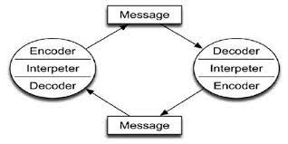
Figure 1: Communication Model of Schramm’s (Schramm, 2012)
This particular model of communication observes the procedure in a better and practical method than most other basic models and thus it is varied from the traditional models. The main advantage of Schramm’s Model is that it is dynamic and very flexible and illustrates the communication in a more circular model (Nikoi and Boateng, 2013). Demerit of the model is that it is not able to take the noise distribution into account and the situation of communication is considered as encryption and decryption.

Model of Shannon and Weaver

The model of Shannon and Weaver is considered as the mother to all the models of communication for its broaden utilization than most other communication models. With various types of aspects such as the source of information, noise, channels or mediums, messages, receiver, the information’s destination, this model works well. In this model of communication, the affecting factors like noises are taken into account too.
The person who sends the data is the architect of the data or message. The transmitter acts as the encoder that works to convert the data into codes or signals (Narula, 2017). For example, the information is turned into codes and signals like the waves which are being transmitted through the cables, satellites acting as binary quotes. The decrypter receives the messages. The decoder is responsible to make the data learnable to the destination by turning the encrypted data into an understandable format (Shannon, 2019). Noises when got stuck in some barriers that the information or messages experience while being transmitted from one side to the other side. Noises may be considered as a variable like the distractions of inside and outside (Narula, 2017). Some examples of noises are the sound of natural calamities like storms and thunder, construction site noises, the noise of vehicles etc. There is also the existence of some other types of noise too that is mainly the interference in the process of communication especially in the transmission of messages. Internal noise types are created by the sender during the time of encryption of a message to send to the destination. These particular noise types can be produced both at the point of encryption and the point of decryption. External noises are considered as the sound that comes from outside (Shannon, 2019). The key objective of this communication model is to find out the culprit who makes the noise and try to neutralize it so that the message quality can improve.

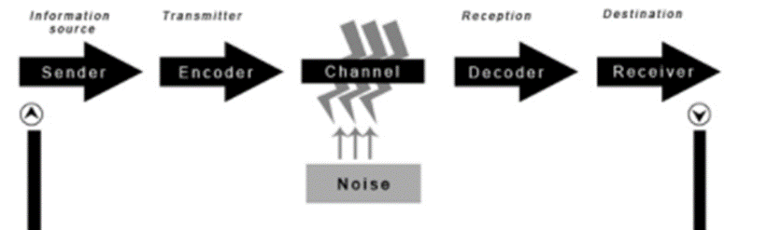
Figure 2: Model of Shannon and Weaver (Shannon, 2019)
A smartphone conversation can be a perfect blueprint of this particular model as it is consists of the sender, encrypter, medium, decrypter, and finally the receiver. A person making the call or sending the message is called the sender, the smartphone used to send is the encrypter, the connectivity or network used like wireless or wired is called the channel or medium (Berlo, 2010). Noises may be found during the interruption of the connection due to natural calamities like thunder, storms, strong wind, or another blockage (Shannon, 2019).

Communication Model of Berlo
The communication model of Berlo is the one that follows the SMCR model. This model doesn’t necessarily maintain any particular method of communication though it includes some factors which mainly depends on the four different kinds of components (Cobley, 2013). These four components of the communication model of Berlo comprise of the message source, the actual message, channel or medium, finally receiver. These four components also have five separate factors explaining them. The source factors are skills of communication, knowledge of the system, attitude, and finally culture (Mcquail and Windahl, 2015). The main message contains the content, the components, the message structure, and lastly the message code.
The root of a message is the source. The encoder model follows the source. The data or information is collected, encoded, and turned into a message from the source. The skills of communication comprise the skills of individuals which can be used to transfer messages easily and properly (Cobley, 2013). Medium means the sensory parts of a human body which is used to perceive data and information. Communication can be built by proper implementation of these channels or mediums. The decoder follows the list of the channel or medium as the one who picks up the messages and decrypts that information to an understandable format.
As per the model, to establish effective and good communication it is necessary that the source or sender and the receiver are in the same category while considering the components of effective communication (Mcquail and Windahl, 2015). As an example, assume the skill of communication of the source is complicated then the destination or receiver must need to have the good skill on listening to properly understand the message. Though it doesn’t show that the destination or receiver can’t read the message (Cobley, 2013). The model lacks proper utilization of feedback which is very significant because communication is a two-way process, and it is one of the biggest demerits of this model.
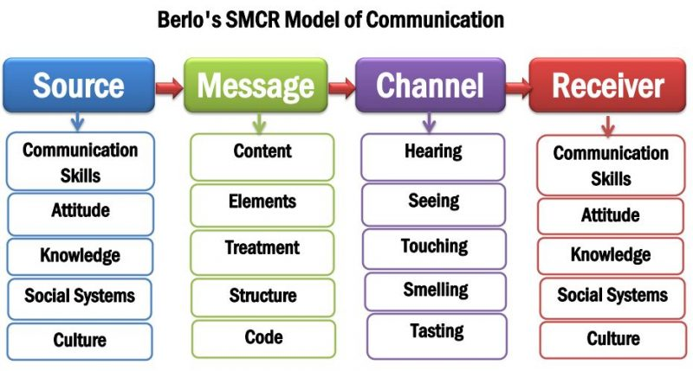
Figure 3: Communication Model of Berlo (Berlo, 2010)

Relation with Case Study
From the case study of Maria and Pedro, Pedro is a construction site worker and his wife is Maria. One day Maria called Pedro to bring some chicken when comes back home. As there is so much noise in the construction site, Pedro didn’t hear the proper message what he heard was chicken was in the kitchen. After his work Pedro came back home, he walked to the kitchen and found no chicken. And that was how Maria and Pedro understood the mistake in their conversation.
The model of Shannon and Weaver is the one to describe this issue in communication. The aim of this communication model is to establish an effective and efficient conversation between the destination and the source and find out the things that badly affect communication which is considered as noise (McLuhan and McLuhan, 2011). In this case, it is seen that there is an existence of external noise as Pedro works in the construction site and loud noise and so much sound is coming out from there because of heavy machinery works. Thus, these external noises badly impacted the communication and influenced Pedro to hear the wrong message. This type of communication problem can be resolved by using the Schramm communication model (Mcquail and Windahl, 2015). Thus, the case study of Maria and Pedro implies the communication model, and also the models of communication suggest the way to solve it.

Examples of Poor Communication
One of the very big problems of an institution is the miss and poor communication. And it can be seen in most organizations (Mcquail and Windahl, 2015). An organization or institution suffers a lot due to poor communication. I can bring an example from the organization that I have worked for. In one event, my superior ordered me about some project and research works which needs to be done quickly. But the communication between him and me was not so good and clear over the phone as there was so much noise. He did not take any feedback from me as he was in hurry (Berlo, 2010). I didn’t have clear instructions and had to manage all by myself. When I did the work and submitted it to him, he pointed out that I have made some mistakes. That I had to do it again.
So, the main culprit for the mistakes of my work is the poor communication between me and my superior. The Communication model of Schramm’s can help solve this issue of communication (Casmir, 2013). If my superior asked me whether, I understood the instruction that he gave me earlier, or if I were able to repeat the instruction that he said to me to make sure that all information is right, then this poor communication wouldn’t occur and my job could have been finished perfectly.

Conclusion
Communication plays a vital role in any kind of organization nowadays. It is not needed to say that poor communication causes great problems in any kind of organization. The case study also shows that proper and effective communication is mandatory for any given situation. Proper skills are also required to deliver and receive messages properly (Berlo, 2010). Their particular skill set is explained by the models of communication. At last, it is not necessary to say that there is no substitute for proper communication to understand any situation and give instruction properly.

References
Berlo, D. (2010) The process of communication. S.N.
Casmir, F. L. (2013) Building Communication Theories: A Socio/cultural Approach. London: Routledge. doi: 10.4324/9780203812754.
Cobley, P. and Schulz, P. J. (eds) (2013) Theories and models of communication. Berlin, Germany: De Gruyter Mouton. doi: 10.1515/9783110240450.
Littlejohn, S. W. (2012) Theories of human communication. 10th edn. Waveland Press.
McLuhan, E. and McLuhan, M. (2011) Theories of Communication. Peter Lang Publishing.
Mcquail, D. and Windahl, S. (2015) Communication models for the study of mass communications. 2nd edn. London: Routledge.
Narula, U. (2014) Handbook of communication models, perspectives, strategies. New Delhi, India: Atlantic Publishers & Distributors.
Narula, U. (2017) Communication Models. New Delhi, India: Atlantic Publishers & Distributors.
Nikoi, E. and Boateng, K. (eds) (2013) Collaborative communication processes and decision making in organizations. Hershey, PA, USA: Business Science Reference.
Schramm, W. (2012) Process and effects of mass communication. Edited by W. Schramm and D. F. Roberts. Baltimore, MD, USA: University of Illinois Press.
Shannon, C. E. and Weaver, W. (2019) The mathematical theory of communication. Baltimore, MD, USA: University of Illinois Press.

