Trinity Saint David University of Wales
Geographical Information Systems (ACCA5023)

Author: | Tutor:
Chris Hampton | Dr. Nitheesh Murugan Kaliyamurthy
2116517@student.uwstd.ac.uk | n.kaliyamurthy@uwtsd.ac.uk

23/02/2024

Contents
Table of Figures 3
1. Introduction 4
1.1 Scenario 4
1.2 Abstract 4
2. Hypervisors 4
2.1 Task 1 - Hypervisor Research 4
2.1.1 Type 1 Hypervisor 5
2.1.2 Type 2 Hypervisor 5
2.2 Task 2 – Hypervisor Selection 5
2.3 Task 3 – Hypervisor Server and Client Operating Systems 6
3. Networks (Task 4) 6
3.1 Topology 6
3.2 Creating Virtual Machines and Configuration in Oracle Virtual Box 6
3.2.1 Creating Virtual Machines 7
3.2.2 Configuration in Oracle Virtual Box 8
3.3 System Information 9
4. IP Addressing Research (Task 5) 12
4.1 Transmission of Data over the Internet 12
4.1.1.1 Internet Protocol (IP) 12
4.1.1.2 Transmission Control Protocol (TCP) 12
4.1.1.3 User datagram protocol (UDP) 12
4.1.2 IPv4 Addresses and IPv6 Addresses 12
4.2 Data Flow over Networks 13
5. Configure IP Addresses and Network (Task 6) 14
5.1 IP Configuration 14
5.1.1 IP Assignment 14
6. Network Testing (Task 7) 17
6.1 Ping 17
6.2 Troubleshooting 18
7. Conclusion 20
References 21

Table of Figures
Figure 1 - NOSS Network Topology (Source: N. Kaliyamurthy) 4
Figure 2 - Types of Hypervisors 5
Figure 3 - Network 1 6
Figure 4 - Network 2 6
Figure 5 - VirtualBox VM setup – 1. 7
Figure 6 - VirtualBox VM setup -2. 7
Figure 7 - Network Adapter (NAT) 8
Figure 8 - Network Adapter (Internal Network) 8
Figure 9 - Network Adapter (Client 2 Internal Network Name) 9
Figure 10 - Network Adapter (Server 2 Internal Network Name) 9
Figure 11 - Server 1 systeminfo Command 10
Figure 12 - Server 1 'About Your PC' 10
Figure 13 - Server 2 systeminfo Command. 10
Figure 14 - Server 2 'About Your PC'. 11
Figure 15 - Client 1 'About Your PC'. 11
Figure 16 - Client 2 'About Your PC'. 11
Figure 17 - IPv4 Address 12
Figure 18 – CGNAT. 13
Figure 19 - Router/Switch 13
Figure 20 – Switch Topology 14
Figure 21 - Manual IP Assignment (server) 15
Figure 22 - Manual Assignment (client) 15
Figure 23 - Network 1 - IPCONFIG 16
Figure 24 - Network 2 - IPCONFIG 16
Figure 25 - Initial ping request. 17
Figure 26 - Troubleshooting - Network Discovery 18
Figure 27 - Troubleshooting - Promiscuous Mode 19
Figure 28 - Network 1 - ping. 19
Figure 29 - Network 2 - ping. 20

Introduction

1.1 Scenario
NOSS, a multinational corporation currently at two locations: Swansea and London. A network is needed for a given topology:
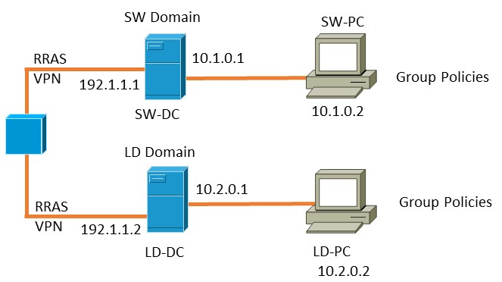
Figure 1 - NOSS Network Topology (Source: N. Kaliyamurthy)

1.2 Abstract
Many organisations that use connected technology i.e. computers, often have a need to have these computers operating on a network to allow communication between devices. These organisations can operate numerous networks and often the case is to create virtualisation to achieve an agreed topology. This assignment will address the needs of NOSS and start to provide a solution for the topology shown in figure 1. Two networks will be created, highlighted above within the dashed boxes, to align the topology to a real-life example.

Hypervisors

2.1 Task 1 - Hypervisor Research
Virtualisation is the practice of running software defined operating systems in a virtual environment that share the capabilities of the host system. To make this possible software called a hypervisor is used. A hypervisor uses the resources of a host machine and allocates these resources to each virtual machine that is running on the host.
Virtualisation can be categorised into 2 groups – Type 1 or Type 2. Type 1 hypervisor is used on bare metal infrastructure that is often associated with IT departments, whereas Type 2 hypervisors are exploited more by users on their personal computers [1].
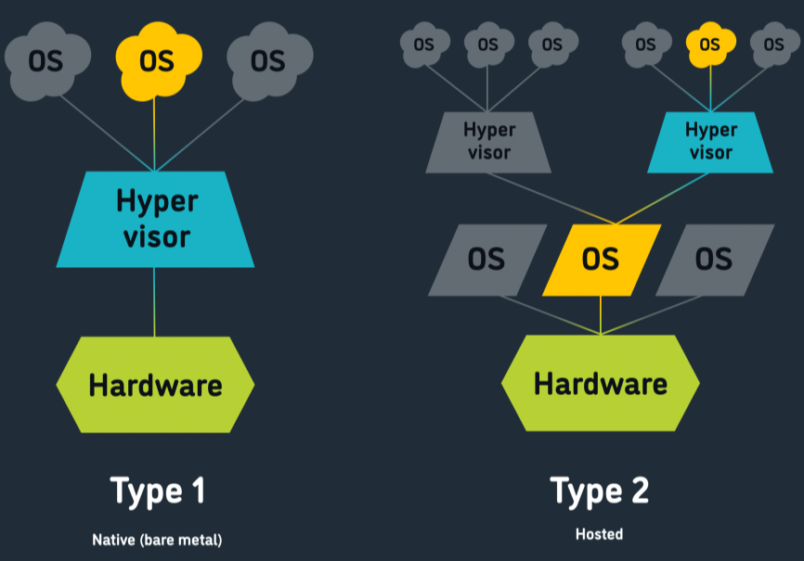
Figure 2 - Types of Hypervisors
Source: https://www.trentonsystems.com/blog/hypervisors
It is commonly known that hypervisor virtualisation is a monopoly for networking scenarios, however there are other examples that could be used. For example, containers, utilised by the Docker corporation are becoming more popular within IT departments [2]. The difference between hypervisor and containers is that hypervisor emulate a full computer operating system, whereas containers emulate certain features from an OS. The disadvantage for the use of containers, that Eder et el. didn’t cover was the skills and resources a department would need to containerise their enterprise. Windows features and not commonly used in containers and the majority are Linux based kernels. This will prove difficult to implement as many organisations tend to use either Microsoft infrastructure and there learning curve maybe too great and so using hypervisors is their most logical route to take.

2.1.1 Type 1 Hypervisor
Type 1 hypervisors are used in enterprise solutions to IT scenarios. As shown in the figure above the hypervisor uses a small piece of software called Virtual Machine Manager (VMM) that sits on the physical hardware [3].
The main vendors of Type 1 hypervisors are VMware ESXi, Citrix XenServer and Microsoft Hyper-V [4]. The use case for each vendor will depend on the organisation and their needs or operations.

2.1.2 Type 2 Hypervisor
Type 2 hypervisor, as shown in the figure above, sit on an existing operating system. Type 2 hypervisors are used heavily for development work and educational purposes [5]. A major advantage of using type 2 hypervisors is that each virtual machine can be saved in a state and moved to a different host.
The two main vendors of Type 2 hypervisors are VMWare and Oracle VirtualBox. According to Pandey [6] VMWare is better performing than VirtualBox when benchmarked against each other.

2.2 Task 2 – Hypervisor Selection
As detailed above there are many Type 2 hypervisors that can be used. All have their advantages and disadvantages. For usability the choices were between VMWare and Oracle VM VirtualBox. According to Aryotejo et el. VMWare was a considerably better example to use. They detailed that the ability to interact between the host and the virtual machines was a much better experience between VMWare and VirtualBox [7]. However, the comparison between VMWare and VirtualBox for this scenario, VirtualBox had greater usability when deploying multiple virtual machines that managed the host resources accordingly. This did not occur when VMWare was being operated resulting in the host system crashing.
For this reason, Oracle VM VirtualBox will be used.

2.3 Task 3 – Hypervisor Server and Client Operating Systems
The options for the operating server usually end up being Microsoft or Linux based OS. According to Economides et al. [8] when using open-source software there tends to be larger investment in organisations. Although, not mentioned in the article this could be down to greater resources needed to manage open-source software.
Due to familiarity a Microsoft based approach will be taken for this scenario. Using the most recent Microsoft Server 2022 ensure that the most recent security features can be implemented for the server-side functions. However, Windows 10 will be used for the client machines. This is preferred to the newer Windows 11, as the adoption for Windows 11 has not been as widespread.

Networks (Task 4)

3.1 Topology
The topology, shown in Figure 1, the two networks that will be created will be replicated with appropriate IP addressing applied to each.
The first network consists of one client machine, ‘Client 1’, and one server, ‘Server 1’. This will be known as ‘Network 1’.
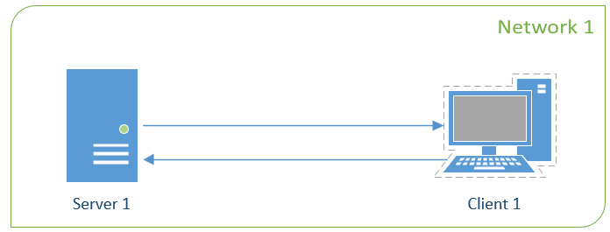
Figure 3 - Network 1
The second network will be very similar to ‘Network 1’, with a single client and single server. This will be known as ‘Network 2’.
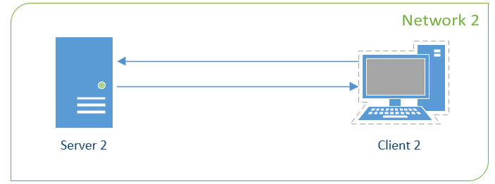
Figure 4 - Network 2

3.2 Creating Virtual Machines and Configuration in Oracle Virtual Box

3.2.1 Creating Virtual Machines
Each of these virtual machines will be created in Oracle VirtualBox. Each machine will be configured with 2048MB of RAM and a 50GB virtual hard disk. This is to ensure that the resources on the host machine are not exhausted through the virtualisation of this setup.
The figure below shows each of the four virtual machines with appropriate naming convention. WindowsServer2022_1, Windows10_1, WindowsServer2022_2, and Windows10_2.
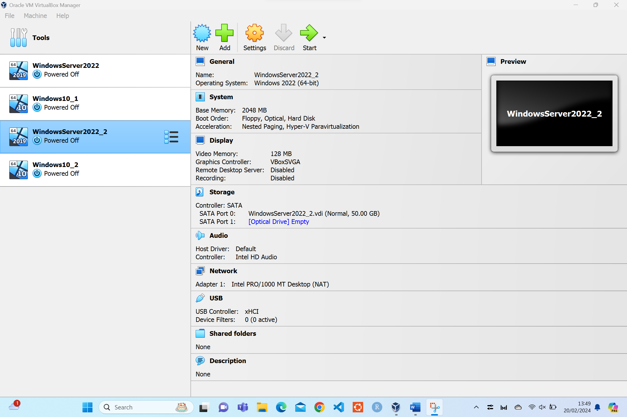
Figure 5 - VirtualBox VM setup – 1.
As discussed above each VM needs to have an ISO file, which is an entire copy of an optical disk, to launch the OS.
Using the SATA Port 1 storage controller an OS image can be applied. For the 2 client machines the windows10.iso is selected.
For the 2 server machines the SERVER_EVAL_x64FRE_en-us.iso file image is selected.
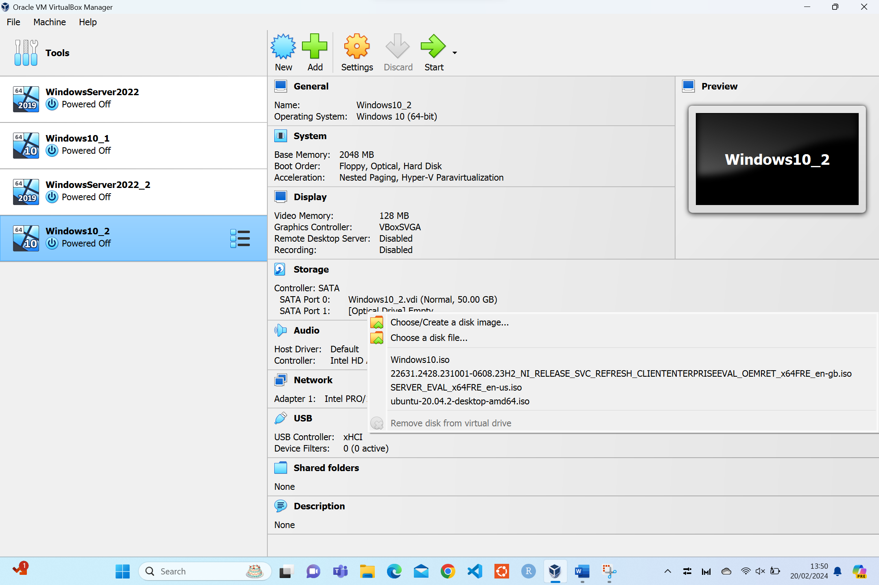
Figure 6 - VirtualBox VM setup -2.

3.2.2 Configuration in Oracle Virtual Box
Each machine needs the network adapters to be configured within Oracle VirtualBox. Within the topology each client machine will need two network adapters, one to communicate with the internet i.e. public IP, and another to communicate within the network, i.e. private IP.
For the client machine shown below, ‘Windows10_2’, the first network adapter is attached to NAT. this will enable this machine to access the internet through the hosts network connection.
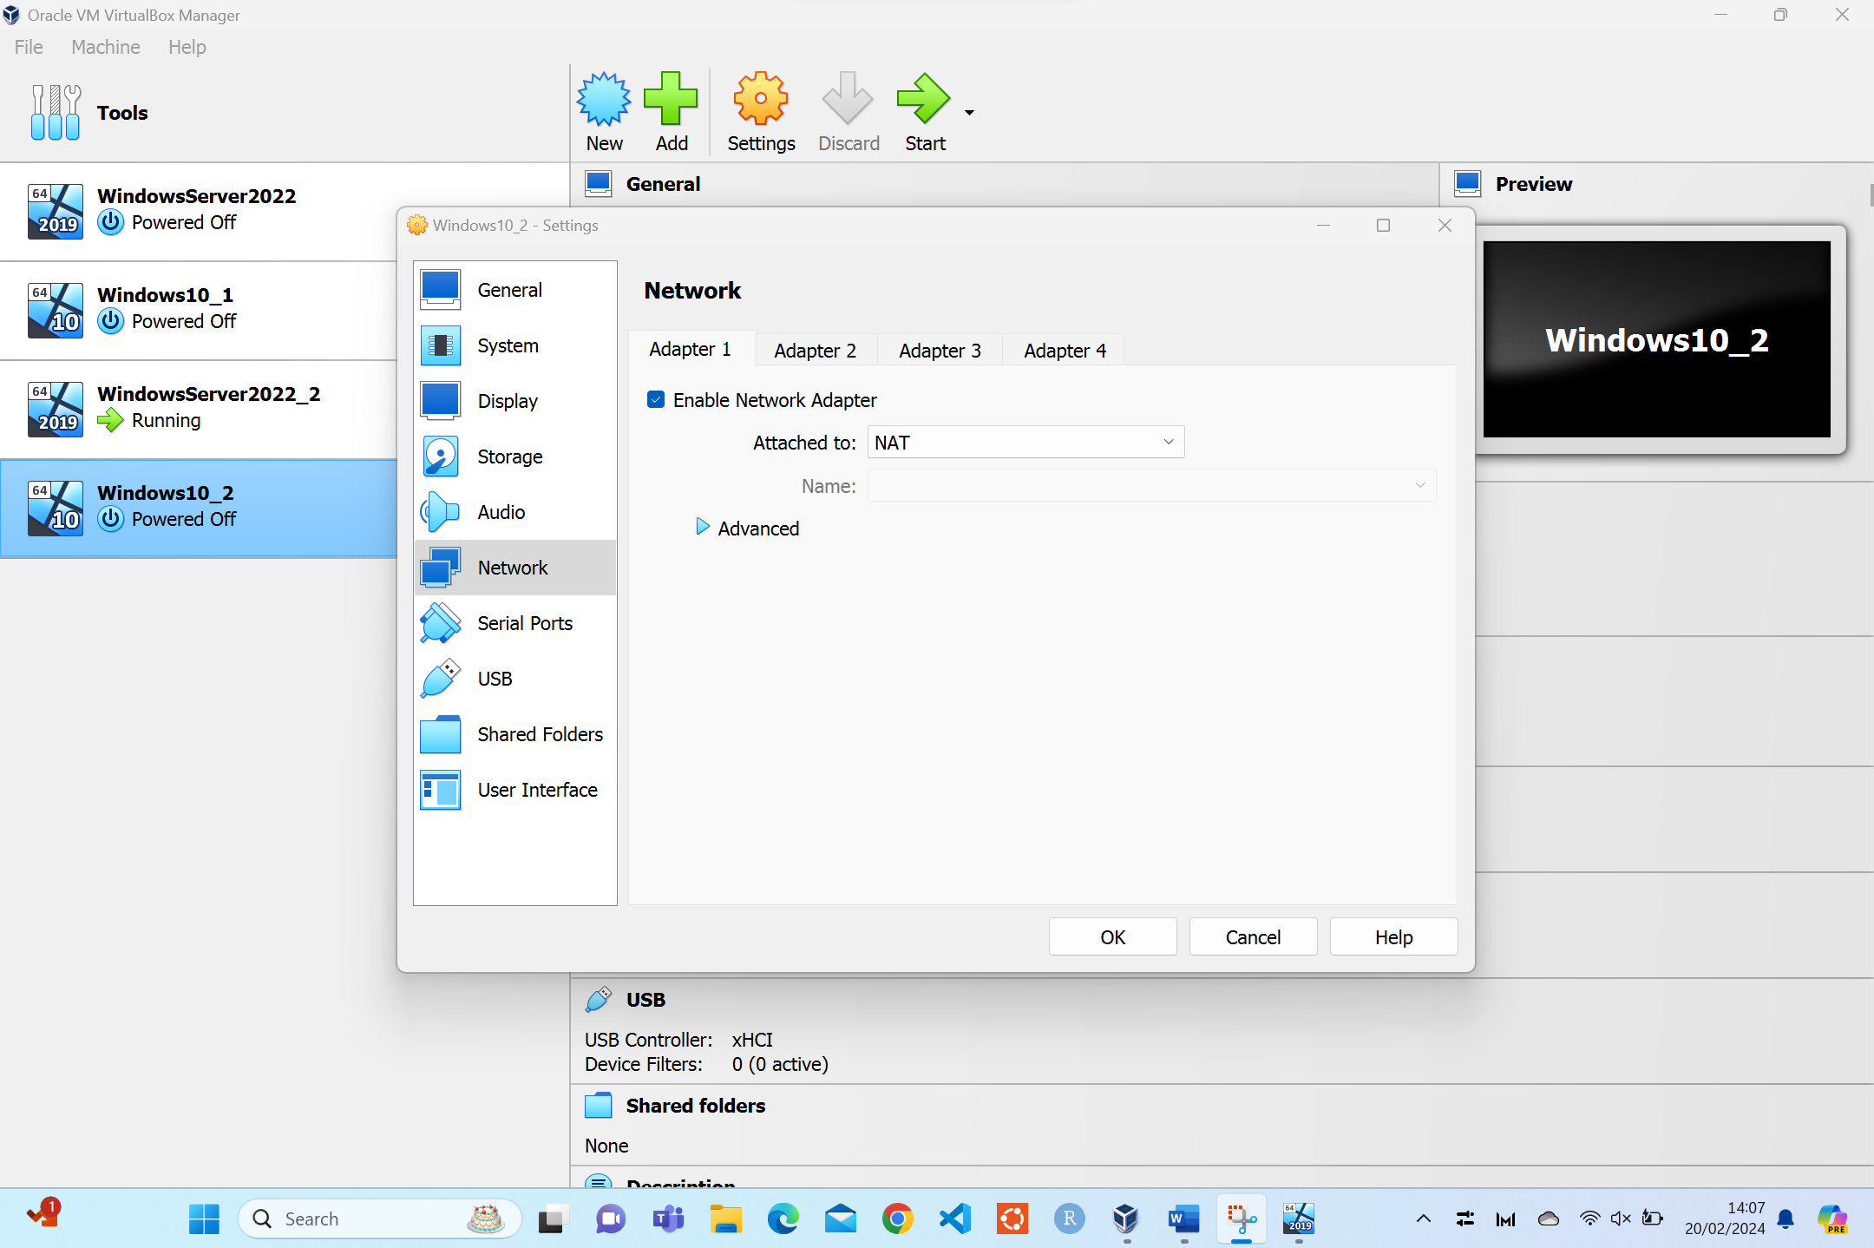
Figure 7 - Network Adapter (NAT)
For the second network adapter in clients 1 and 2, and the first and only network adapter, for server 1 and 2, this needs to be attached to ‘Internal Network’. This will create two network adapters for the clients and one for the servers.
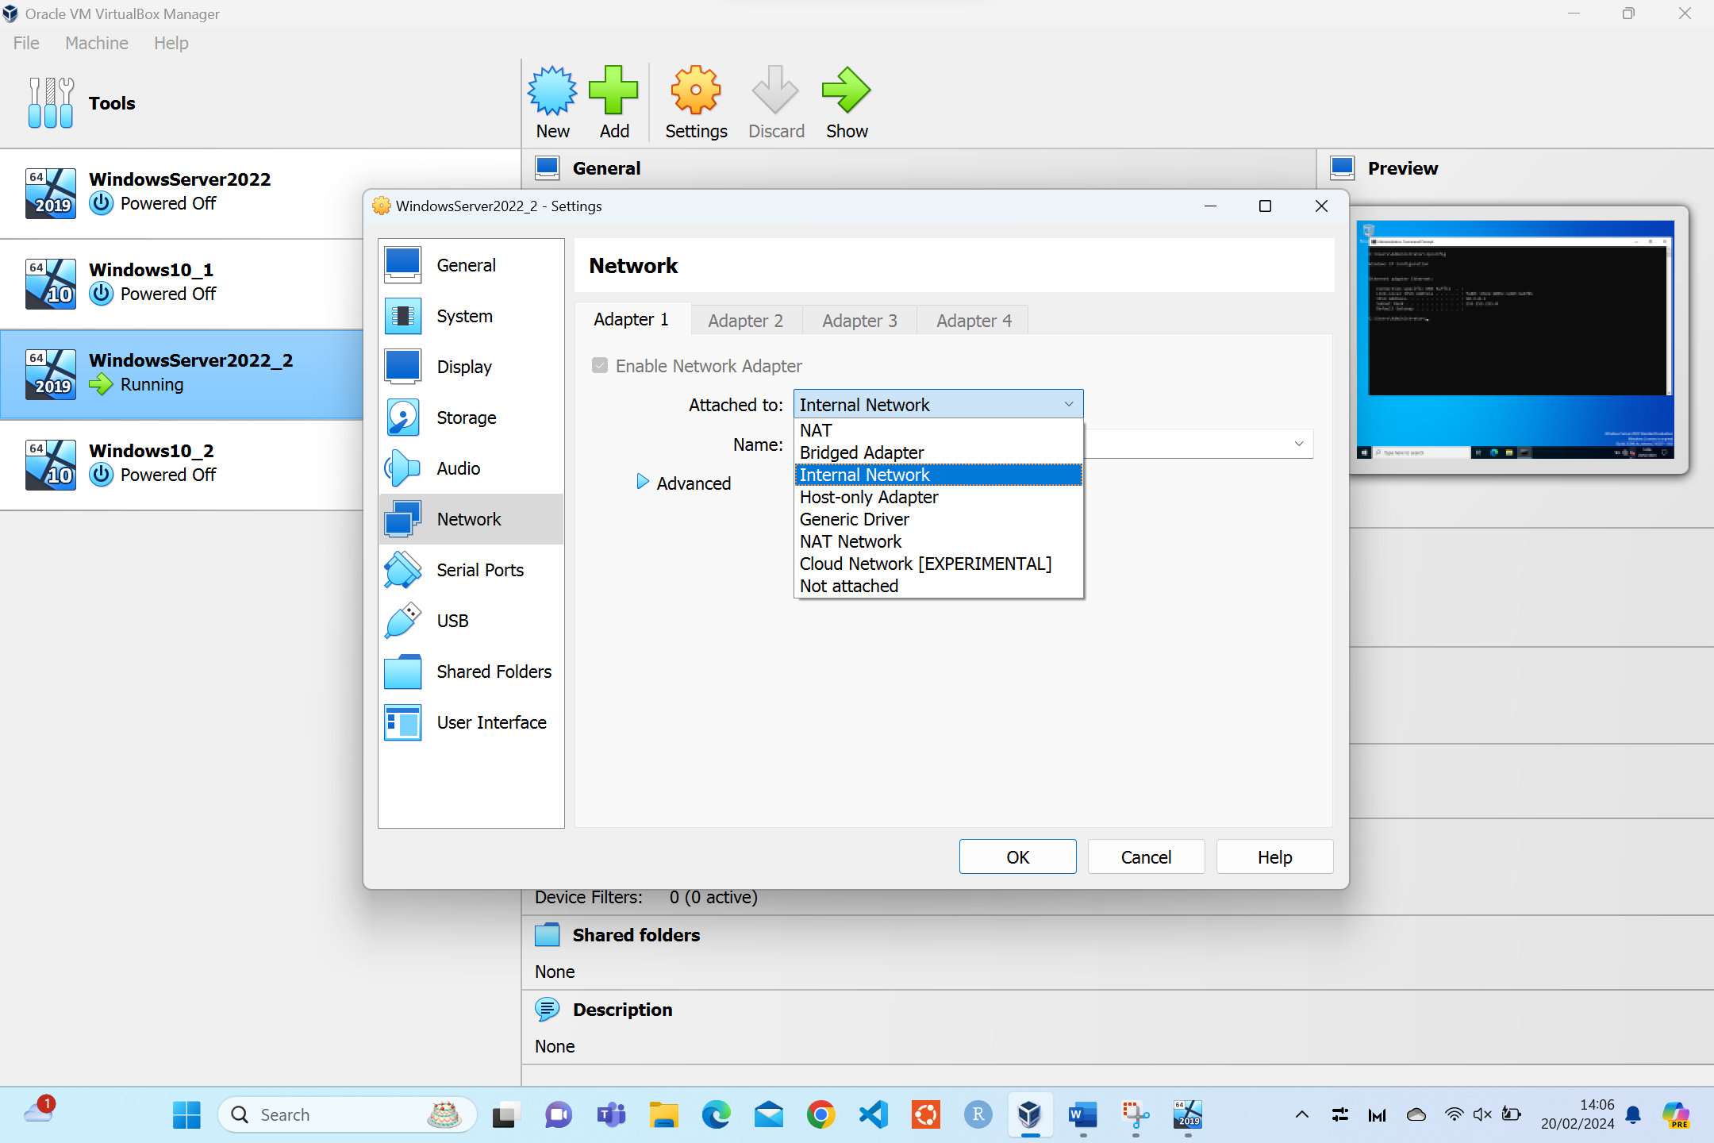
Figure 8 - Network Adapter (Internal Network)
For each of the two networks to communicate with each other the name of the network will need to match. For example, in the figure below the name of the network is ‘intnet_2’. This will need to match on client 2 and server 2. Whereas, for client 1 and server 1 this will be ‘intnet_1’.
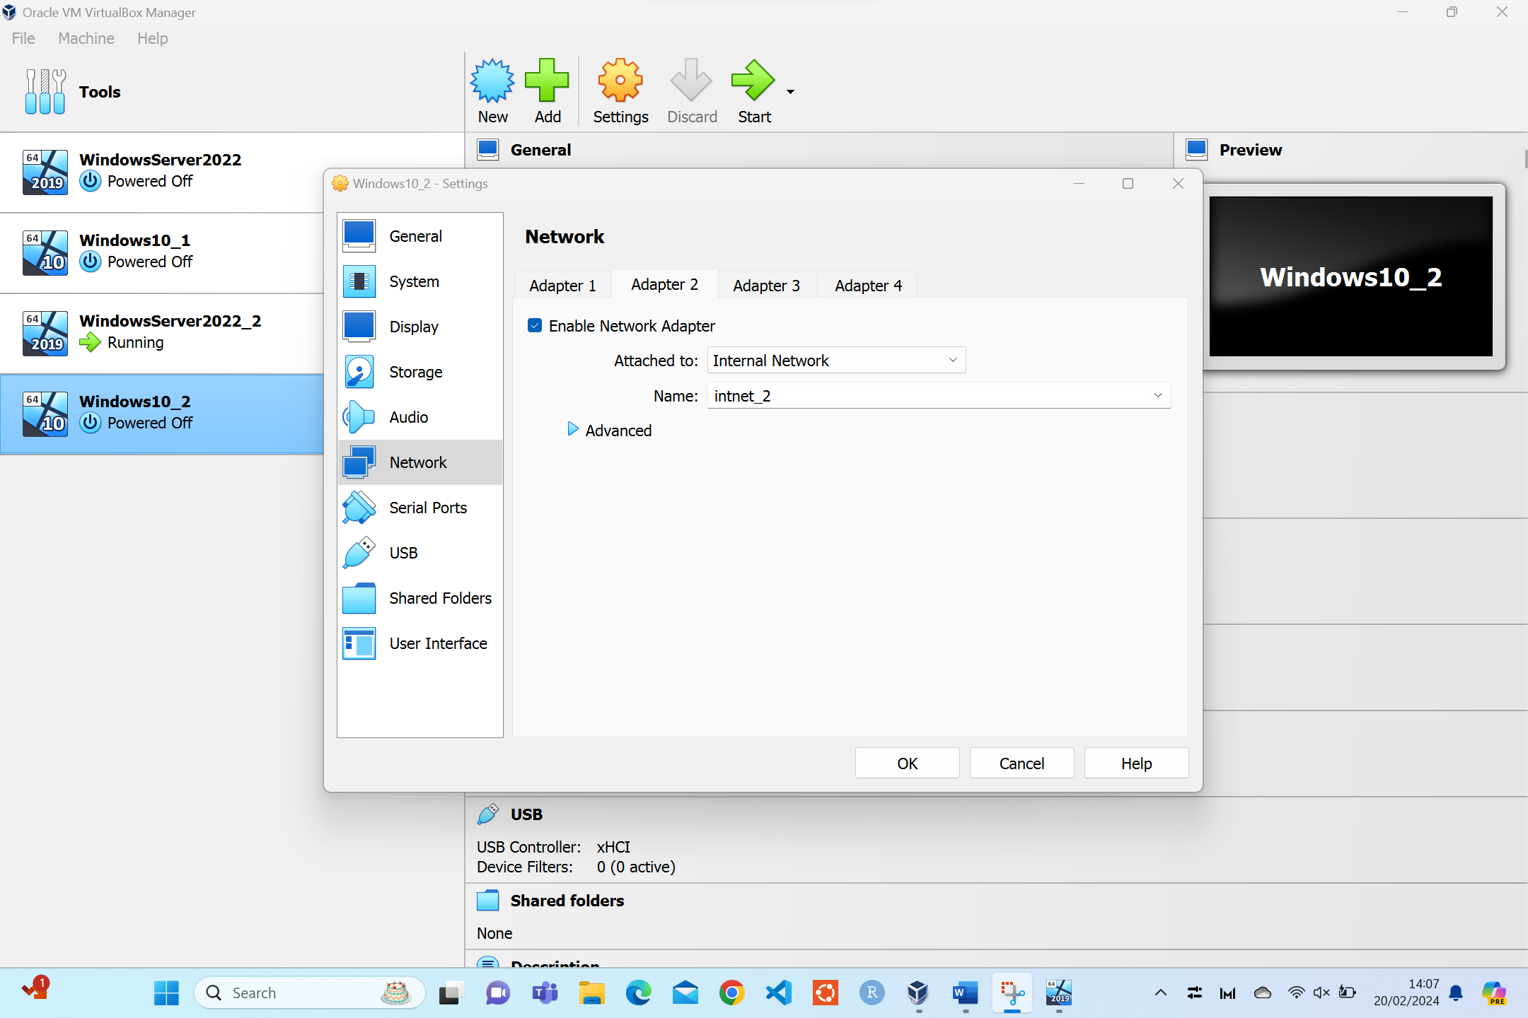
Figure 9 - Network Adapter (Client 2 Internal Network Name)
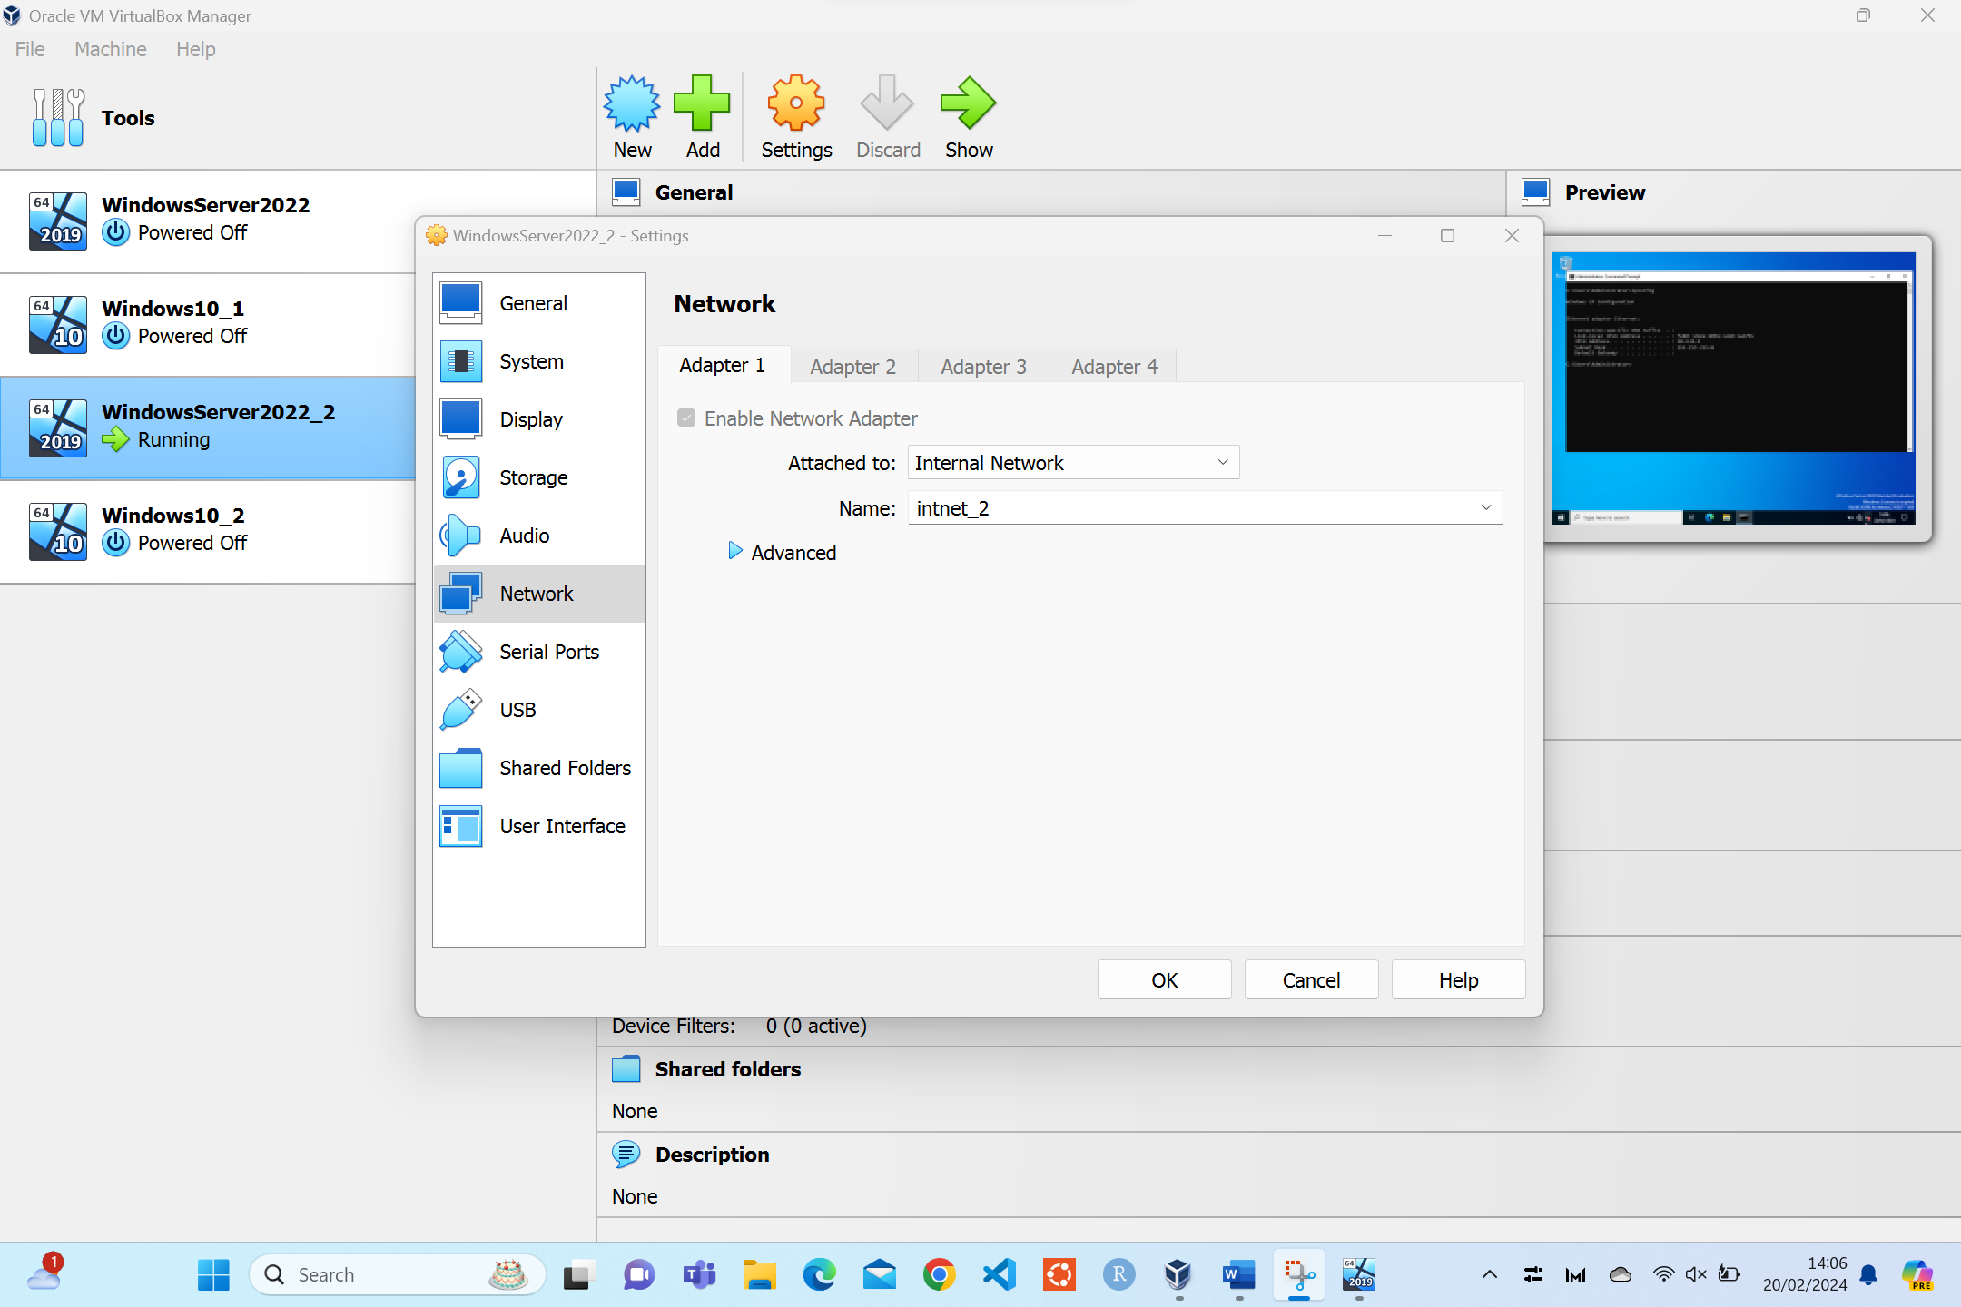
Figure 10 - Network Adapter (Server 2 Internal Network Name)
Once the configuration has been completed the virtual machines can be started.

3.3 System Information
There are two ways in which system information can be collected. The first, by using the ‘systeminfo’ command in the command prompt and looking at the ‘About Your PC’ function in Windows.

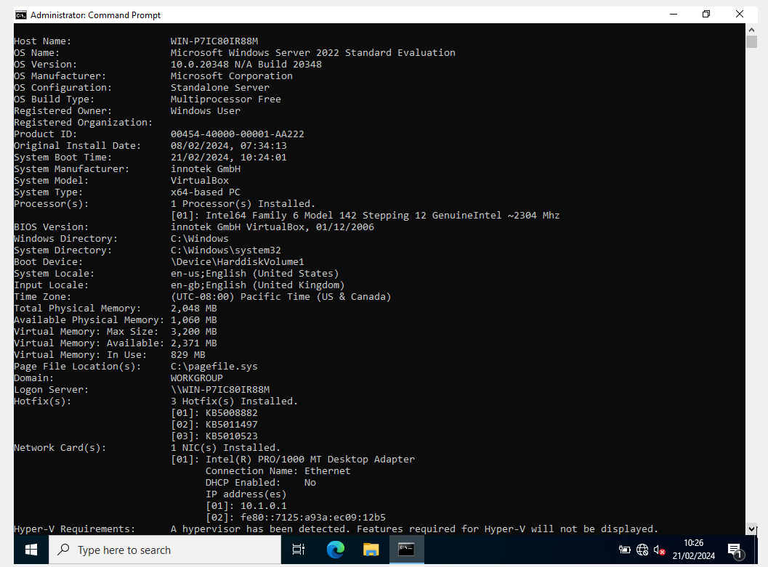
Figure 11 - Server 1 systeminfo Command
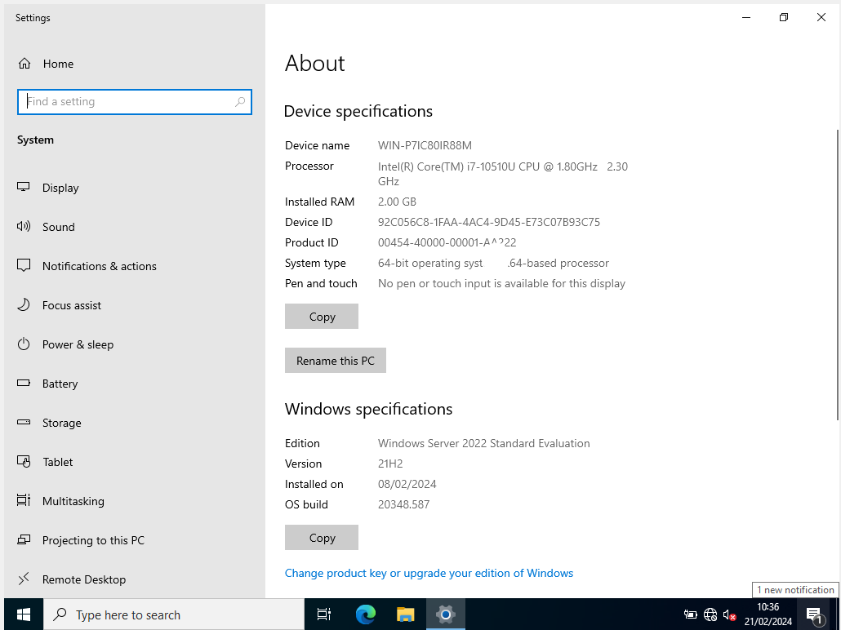
Figure 12 - Server 1 'About Your PC'
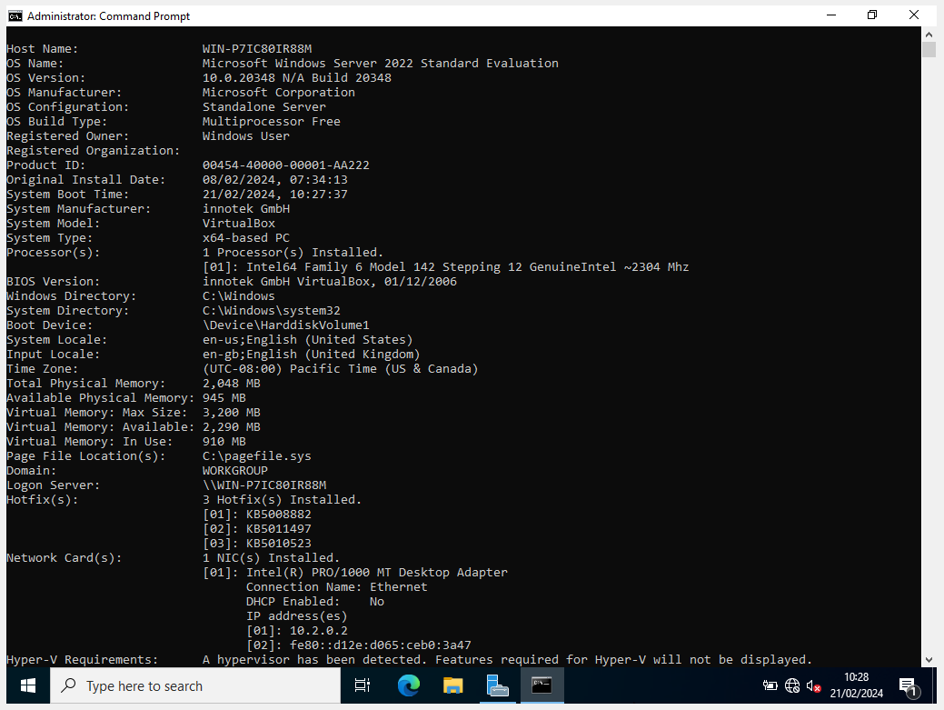
Figure 13 - Server 2 systeminfo Command.
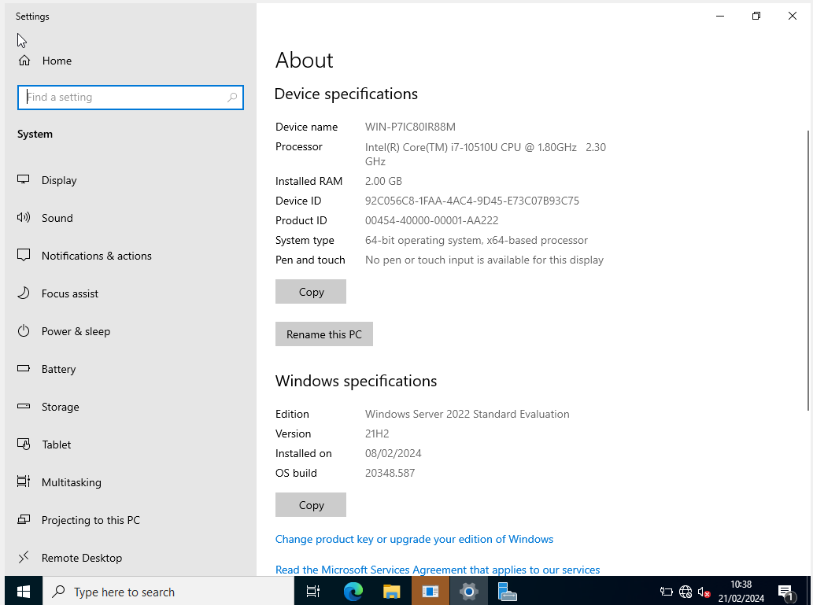
Figure 14 - Server 2 'About Your PC'.
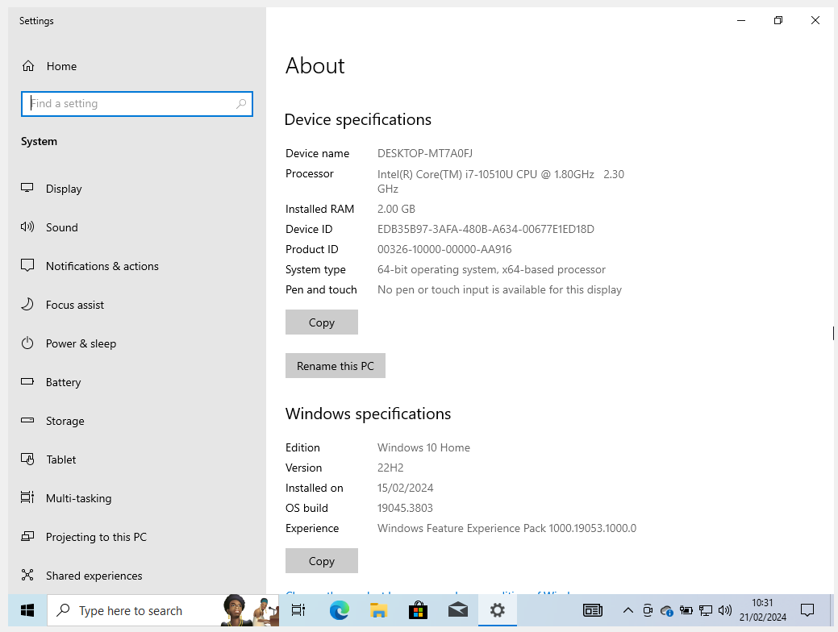
Figure 15 - Client 1 'About Your PC'.
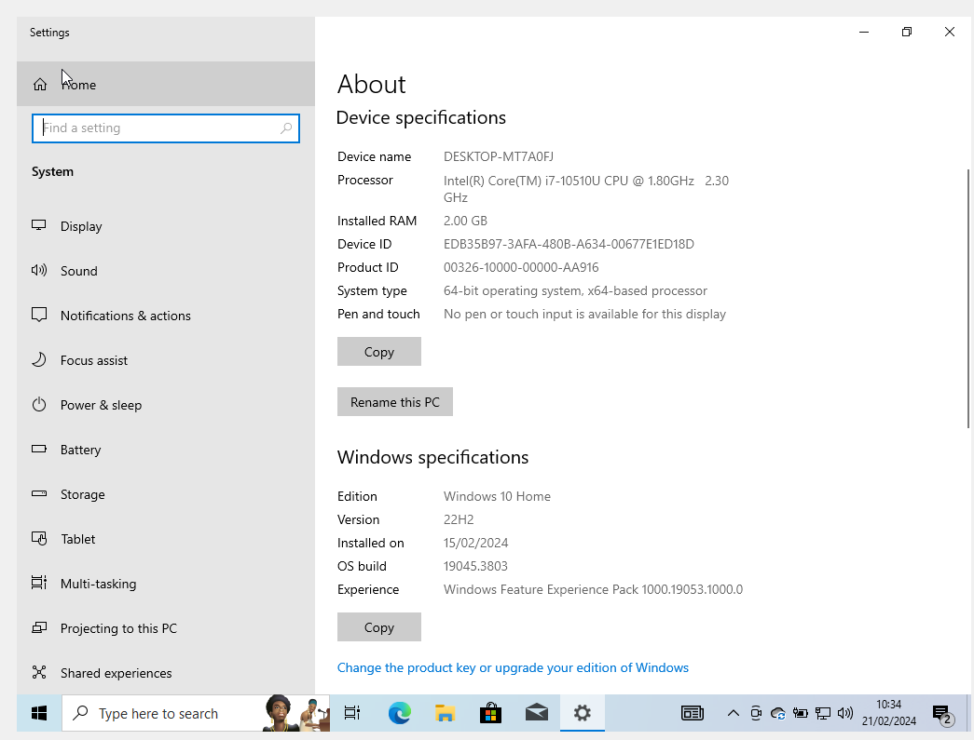
Figure 16 - Client 2 'About Your PC'.

IP Addressing Research (Task 5)

4.1 Transmission of Data over the Internet
The internet isn’t a single entity that is centrally located. Instead, it is a network of machines that are connected via cables or wireless technologies to communicate with each other. The physical way in which data is transmitted is a device converts a piece of data into binary data packets this is then transmitted either through electrical pulses, through copper cable, light pulses, through fibre-optic cables, or radio waves through wireless technologies.
For data to reach it’s intended destination, devices need to know where to send the data. This is conducted through IP addressing. There are many protocols that are used when transmitting data such as Internet Protocol (IP) [9].

4.1.1.1 Internet Protocol (IP)
IP ensures that the data packets are routed through the networks and ensure they reach their destination [10]. Once the data has arrived at the destination, depending on the protocol determined depends on the response. There are two types of response:
- TCP
- UDP

4.1.1.2 Transmission Control Protocol (TCP)
TCP is when data is split into data packets and routed, using IP, to the destination where is it then re-packaged into the original data [11]. The advantage of using TCP is that data loss is minimized and can be recovered. TCP also ensure that data is received by the destination device by sending an acknowledgment back to the original device.

4.1.1.3 User datagram protocol (UDP)
UDP is like TCP, however data is not sent sequentially and cannot be guaranteed the original message is the same as when it was sent [12]. UDP does not send a response to the sending device thus leaving the user not knowing whether the data packet was received. This makes UDP quicker that TCP but decreases the security of the protocol.

4.1.2 IPv4 Addresses and IPv6 Addresses
IP addresses are the phone book of the internet. The most common addresses are IPv4. IPv4 is made up of 32 bits meaning there is only a finite available (4,294,967,296) [13].
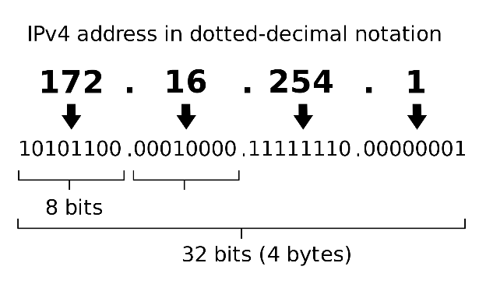
Source: https://www.dailytoolz.com/what-is-my-ip-address/
Figure 17 - IPv4 Address

4.1.2.1 IPv4 Exhaustion
For many years IPv4 Exhaustion has been an issue for ISPs. As stated above there is a finite amount of IPv4 addresses and organisation have had to create new ways in which to manage this [14]. This has created Carrier Grade NATs (CGNATs) [15].

4.1.2.1.1 CGNATs
Carrier-Grade NATs are used by ISPs to limit the amount of public IP addresses available. By using port forwarding technology many private IP addresses can be associated with one public IP address [16]. Although the authors of ‘Impact of Carrier-Grade NAT on web browsing’ explain the reasoning behind CGNATs, they do not go into detail why this is preferred to the adoption on IPv6 addresses. IPv4 can support protocols such as DHCP, FTP and NAT – IPv6 is unable to support these protocols.
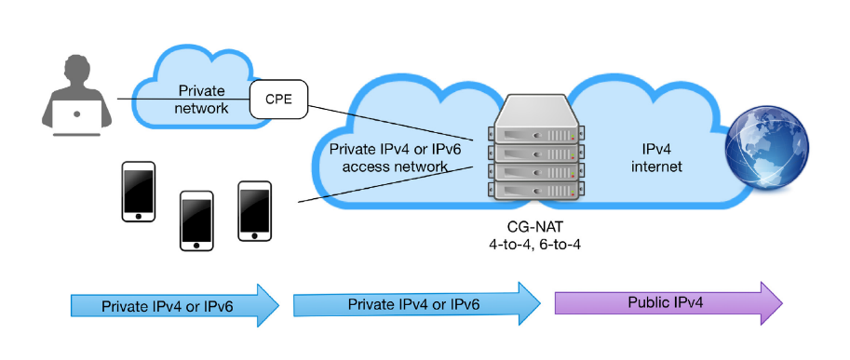
Source: https://nfware.com/blog/how-does-virtual-cgnat-work
Figure 18 – CGNAT.
The transition to IPv6 has been a lot slower than expected [17] and although it is inevitable that the transition needs to take place solutions, such as CGNATs, have been implemented to ensure a wider adoption of IPv6. Compared to IPv4, IPv6 offers over 1000 times more unique addresses, due to being 128 bits, there is sustainability for IPv6 in the long term.

4.2 Data Flow over Networks
Data flowing between networks will need to pass through a series of routers and switches to reach its destination. Each router has two main functions – managing traffic of a connection and allowing multiple devices to connect to a single internet connection. A router will have an IP/MAC addressing table which directs traffic to the intended targets through the pathways of the network. on the other hand, a switch is a point-to-point device mainly used to increase connectivity in a network.
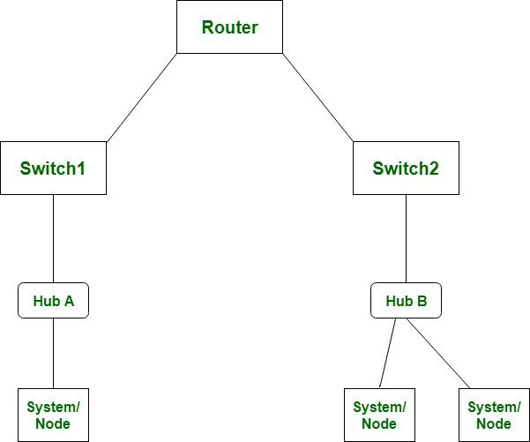
Source: https://www.geeksforgeeks.org/difference-between-router-and-switch/
Figure 19 - Router/Switch

A switch does not use an addressing table, like a router, instead it will send a data packet to each device on the network.
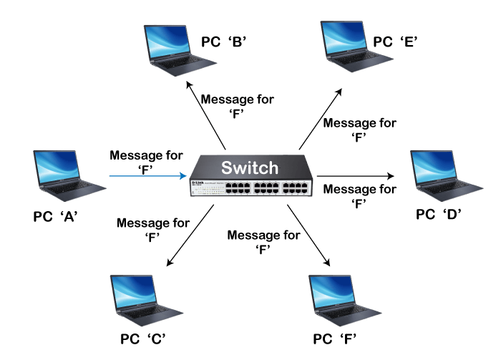
Source: https://www.nwkings.com/routers-and-switches-in-networking
Figure 20 – Switch Topology
As shown in the figure above, a message intended for ‘PC F’ is sent to each device. This can cause security concerns and each switch should be configured correctly.

5. Configure IP Addresses and Network (Task 6)

5.1 IP Configuration
The IP configuration used for each network:
 | Server | Client
Network 1 | 10.1.0.1 | 10.1.0.2
Network 2 | 10.2.0.1 | 10.2.0.2

5.1.1 IP Assignment
When a computer is setup, whether it’s virtualised or not, the network adapter defaults to ‘Obtain an IP address automatically’. However, for a network the IP addresses need to be assigned manually.
As per the table above the following figures show manual assignment of IP addresses for ‘Network 2’.
By selecting the correct Ethernet adapter and the properties of ‘Internet Protocol Version 4 (TCP/IPv4) Properties’ manual IP addresses can be assigned.
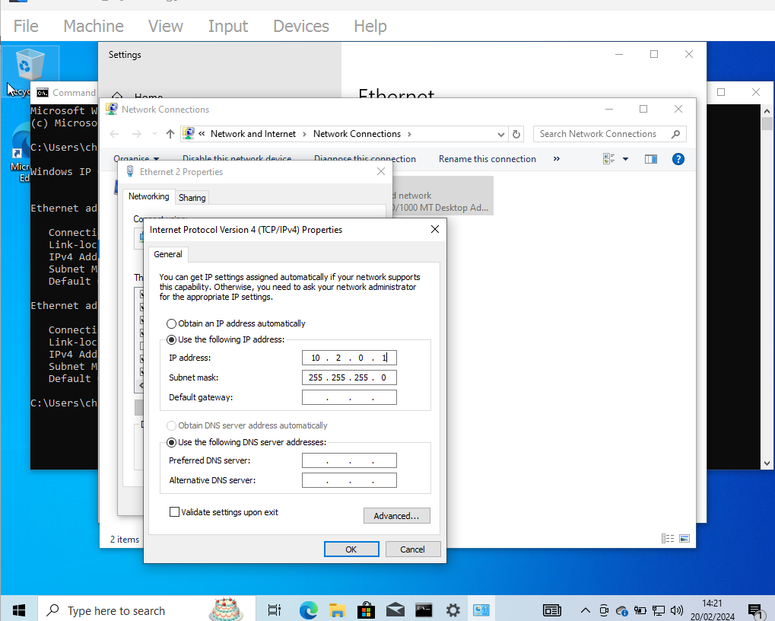
Figure 21 - Manual IP Assignment (server)
There will be two Ethernet settings for the clients, one for NAT and the other for the internal network, the internet network settings need to be selected.
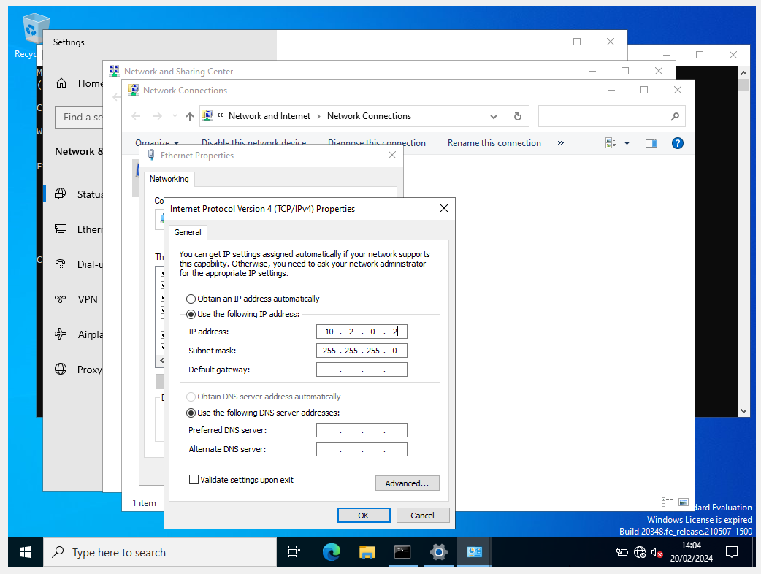
Figure 22 - Manual Assignment (client)
Once the IP assignment has been completed for both networks the ‘IPCONFIG’ command can be run in the Command Prompt.
In the figures below, for each network, the client shows two adapters, and the server shows one. Each virtual machine has the correct IP addressing according to the table above.
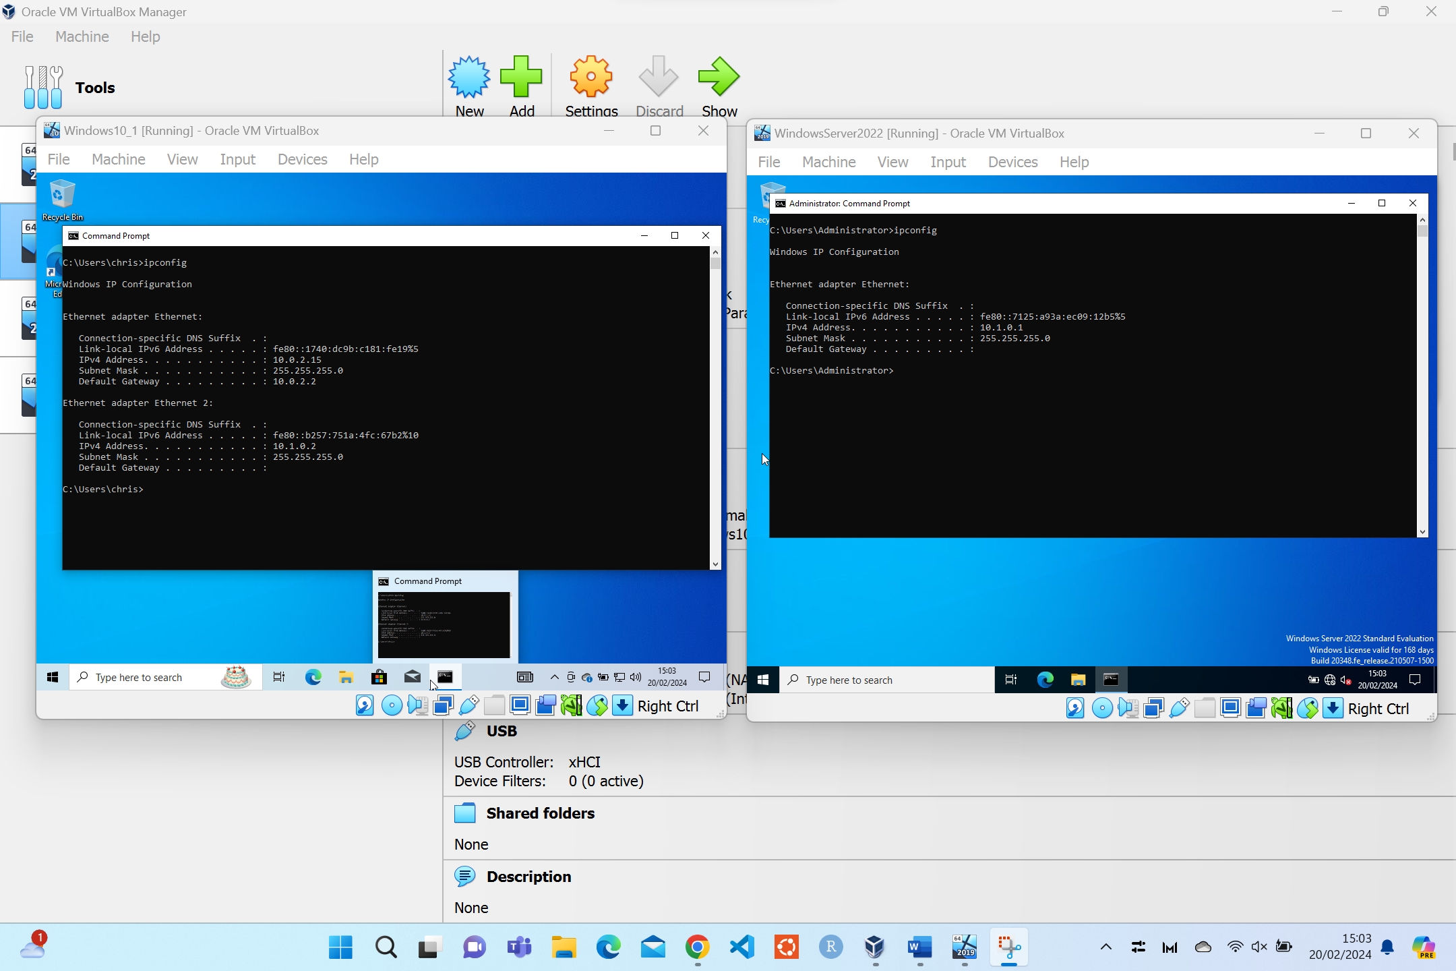
Figure 23 - Network 1 - IPCONFIG
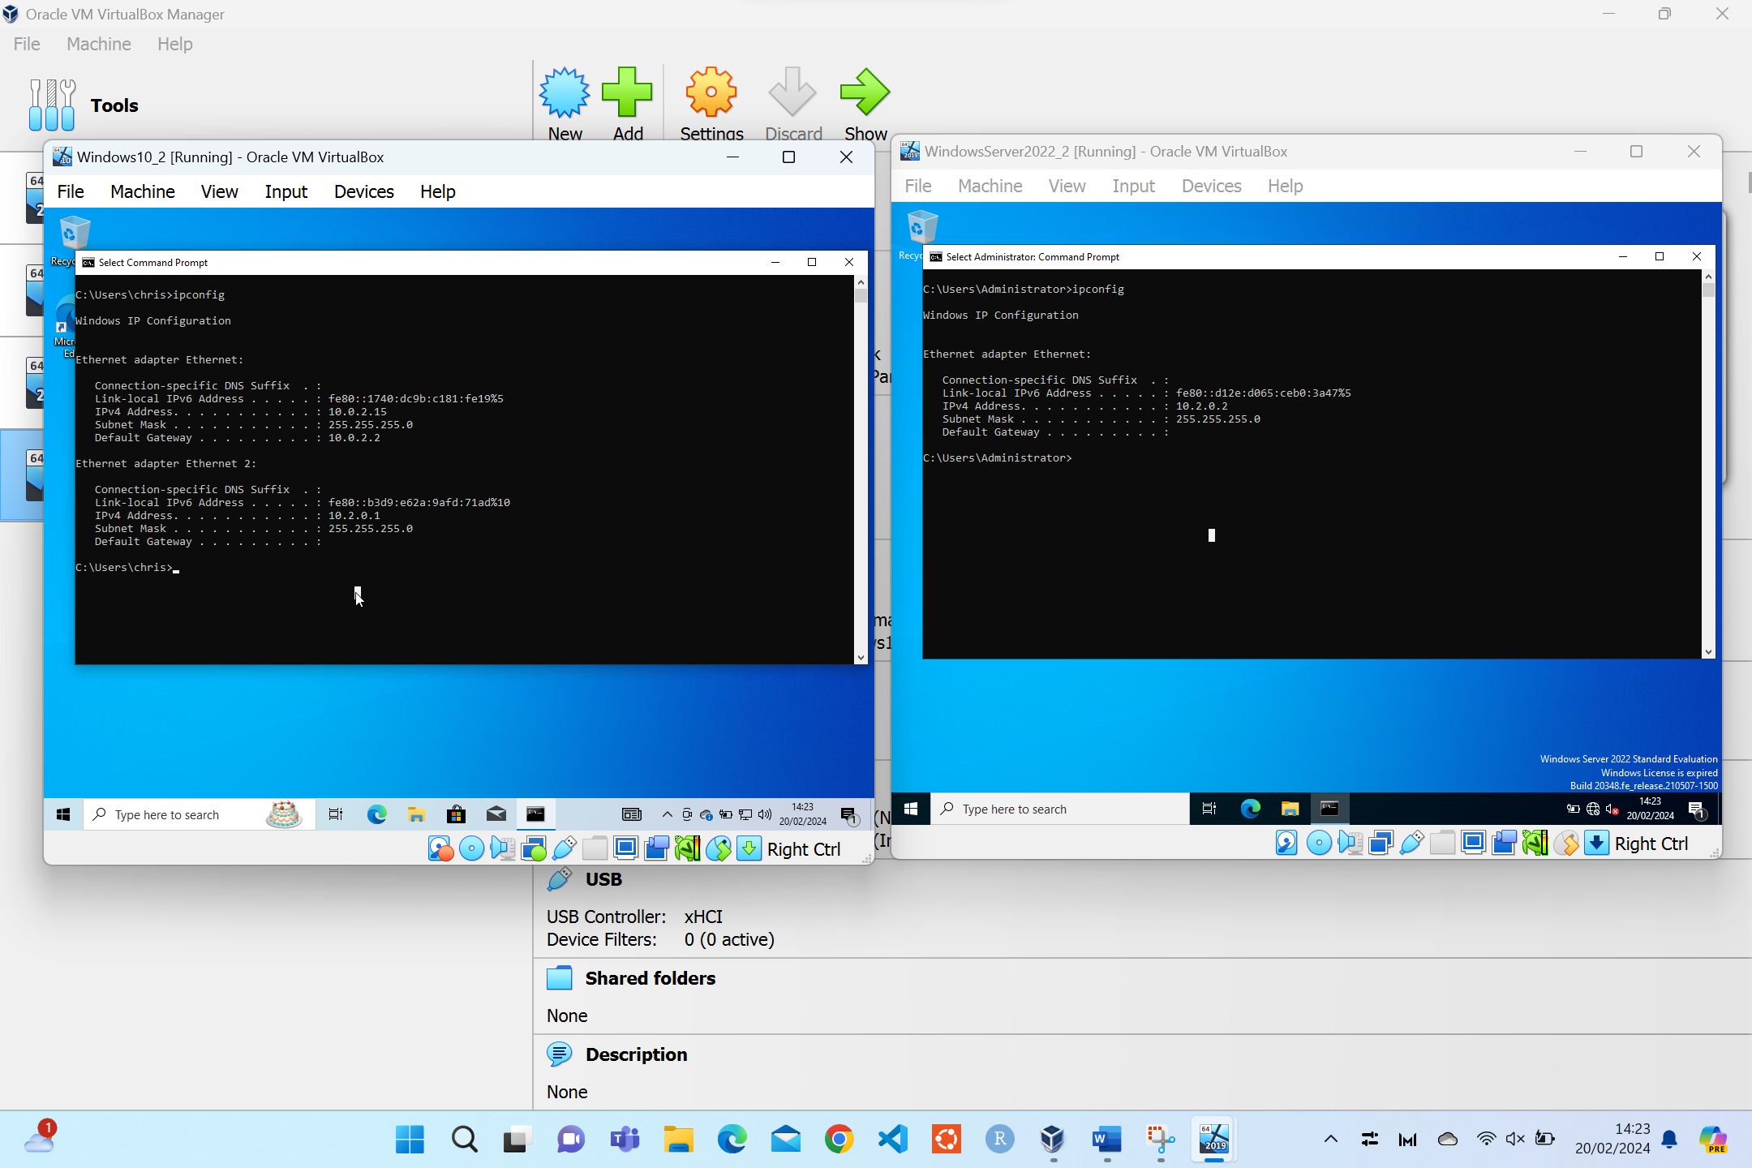
Figure 24 - Network 2 - IPCONFIG

6. Network Testing (Task 7)
There are many ways and techniques to test different aspects of a network. This can be down to testing the bandwidth, packet loss and security. And troubleshooting techniques such as IP conflicts, DNS resolution and firewalls.
Bandwidth testing is an important part of creating a network. The more devices on a network the more congested it becomes. By having adequate bandwidth will make communication between nodes on the network more efficient [18]. According to Wang et al. they describe how conventional bandwidth testers can be cumbersome and slow their product will enable fast testing of bandwidth. Although, this book section can seem like a marketing exercise it also addresses to issues with testing bandwidth.
With any network and anything hosted on the internet, security is a high priority issue. Organisations have whole departments dedicated to the security of their networks. At a low level each network needs to have basic authorisation and authentication for any device’s communication on the network [19].
Within networks there can be conflicts between IP addresses. A network usually has a leader node or an individual node. A leader node is elected to detect any conflicts and highlights them whereas an individual node has no leader and will monitor the whole network [20]. To overcome IP conflicts each node can be checked to assure that the correct IP addressing has been applied.
DNS resolution enables the internet to function for human input. Domain Name Systems (DNS) applies a logical name to a website [21]. For example, www.google.com is a DNS for the IP address 8.8.8.8.
Firewalls allow another layer of security. They can monitor communication between networks and allow or deny communication based off the organisations criteria [22].

Ping
To test whether the VMs on each network is connected, the PING command can be used. By typing ping 10.2.0.1 from the client in network 2, this should send a packet of data to the server in the same network.
As can be seen from the figure below the ping request has timed out. This indicates that the connection between the VMs is not complete.
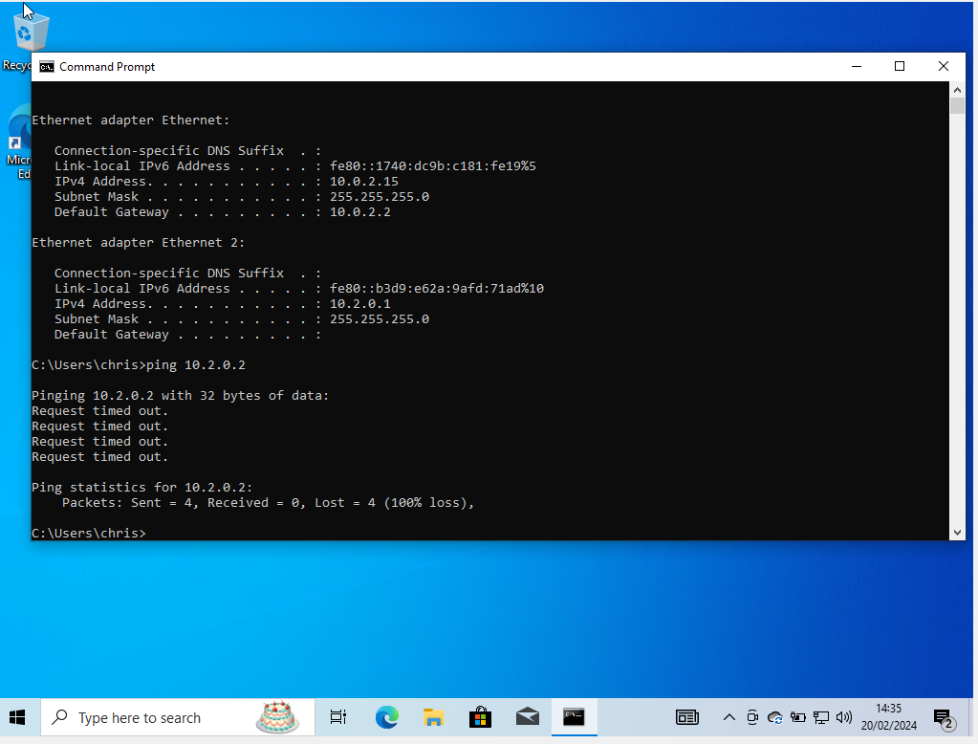
Figure 25 - Initial ping request.

Troubleshooting
The first issue is that the machine is not discoverable to the network. By changing the settings in the ‘Sharing Settings’ to ‘Turn on Network Discovery’ will allow the machine to be visible to others on the network.
According to Microsoft Bing’s Co-pilot network discovery in Windows 10 is described as:
‘Network discovery in Windows 10 refers to your computer’s ability to connect with other nearby devices and be found by them. When network discovery is enabled, your device becomes discoverable and connectable to other devices on the same network. Conversely, when network discovery is disabled, your computer remains invisible to other nearby devices.’
Source: - GitHub. (2021). GitHub Copilot. Retrieved from GitHub Copilot

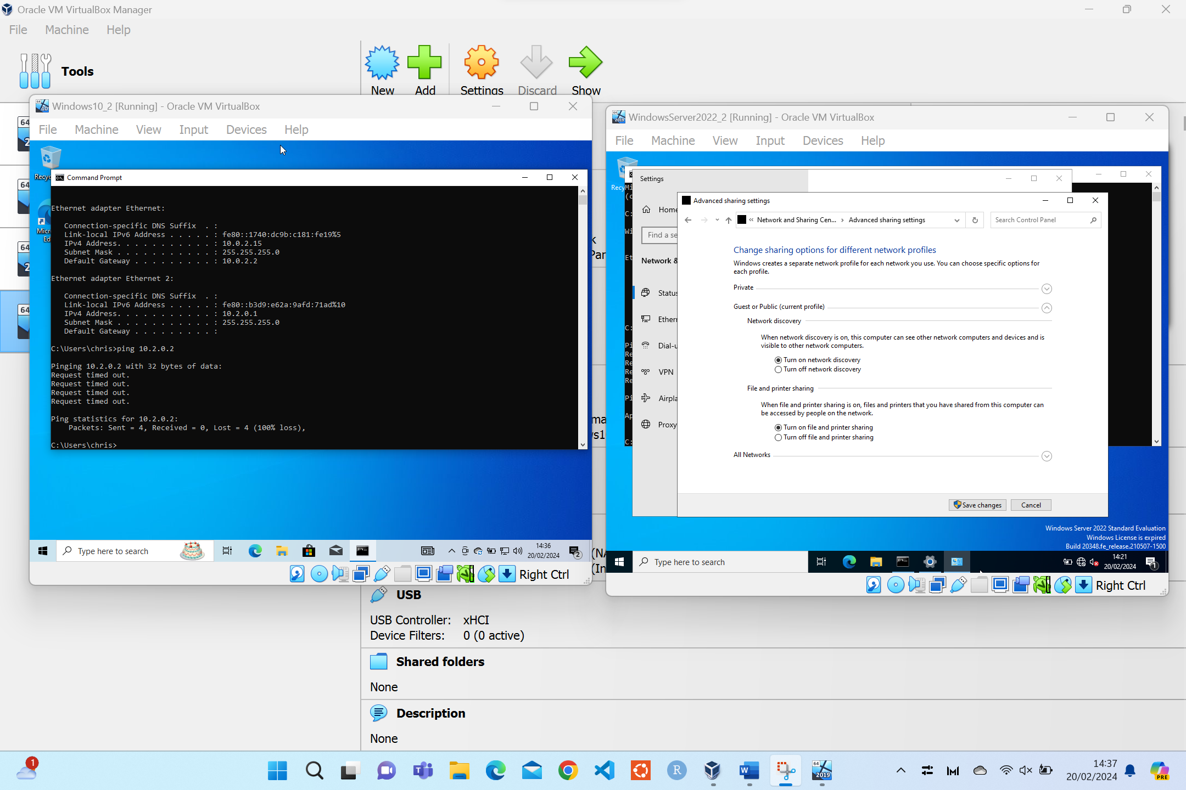
Figure 26 - Troubleshooting - Network Discovery
To further troubleshoot the network, Promiscuous Mode in VirtualBox, can be set to ‘Allow All’. This will allow the virtual machine to capture packets that are sent across the network.
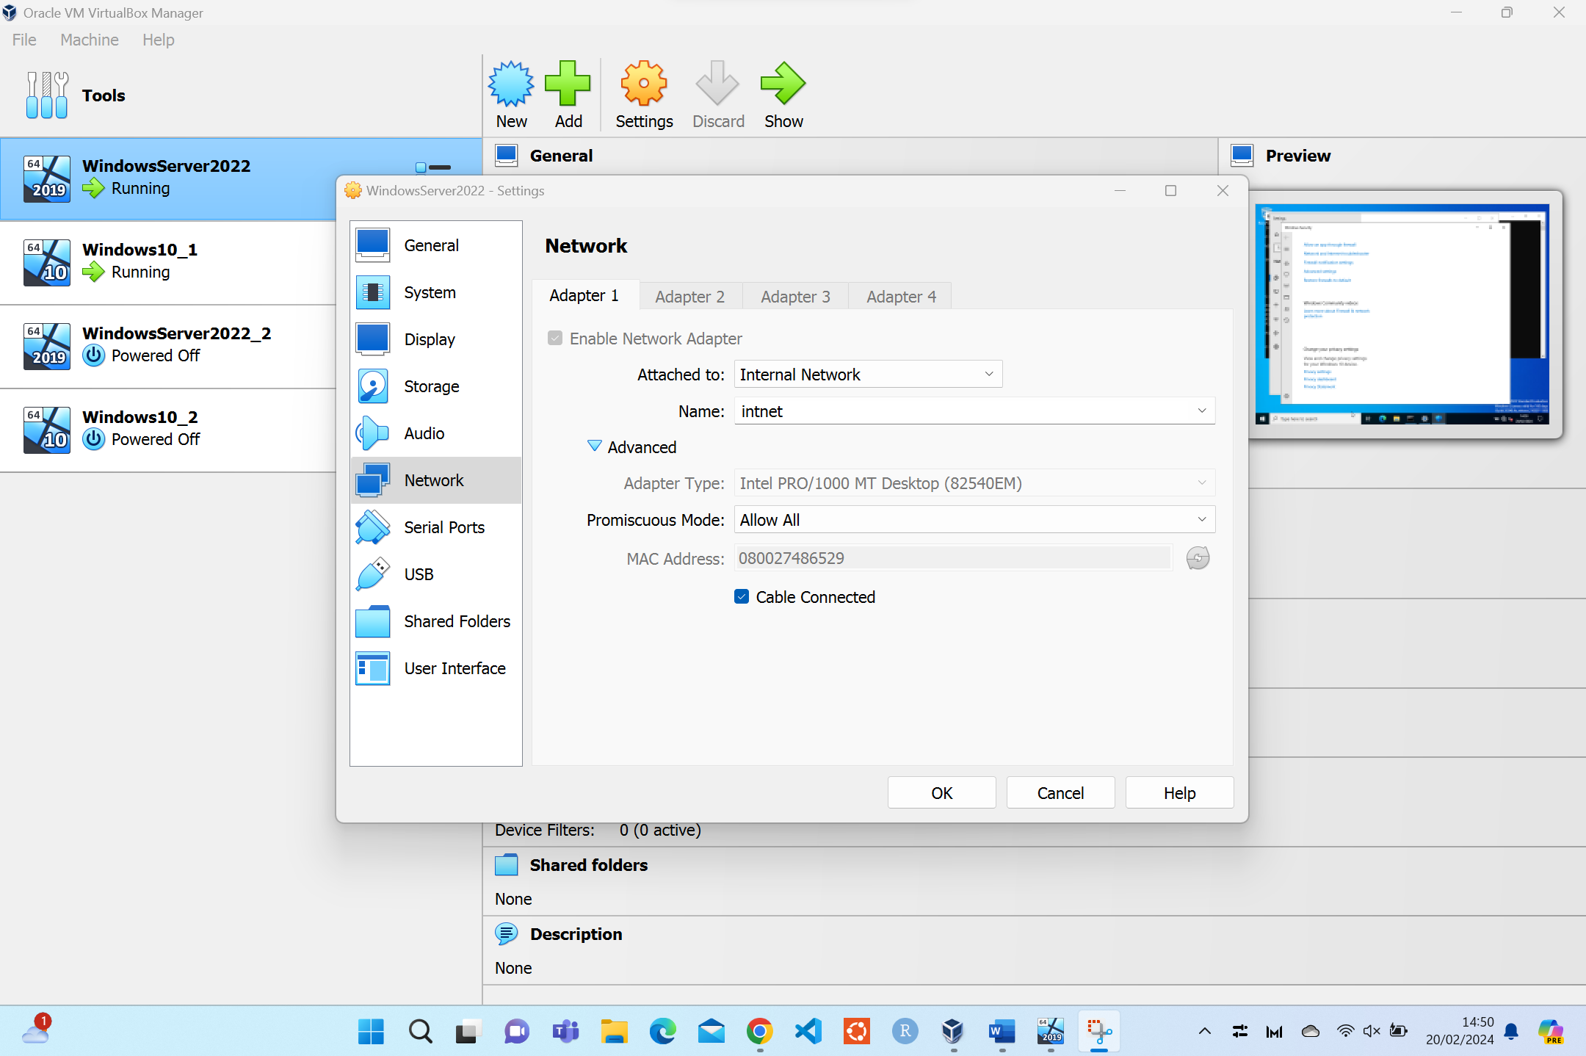
Figure 27 - Troubleshooting - Promiscuous Mode
Once these settings have been changed and each VM restarted the resulting ping commands should result in successfully send packets over each network.
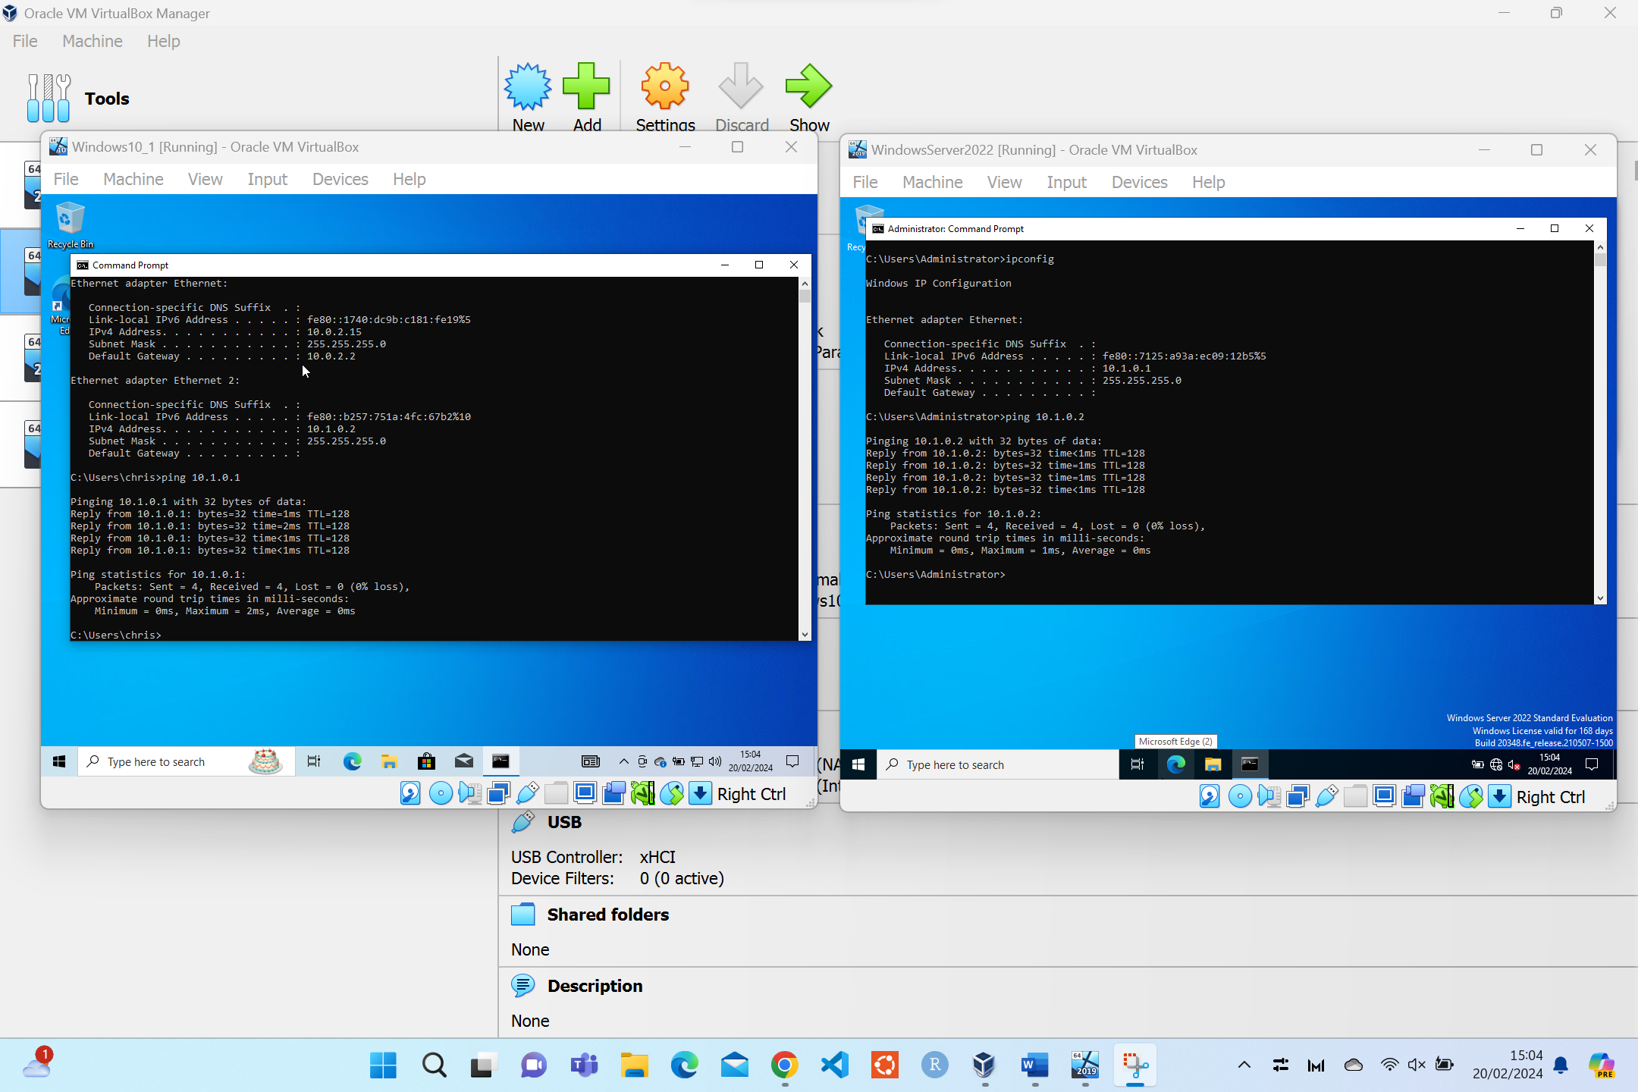
Figure 28 - Network 1 - ping.
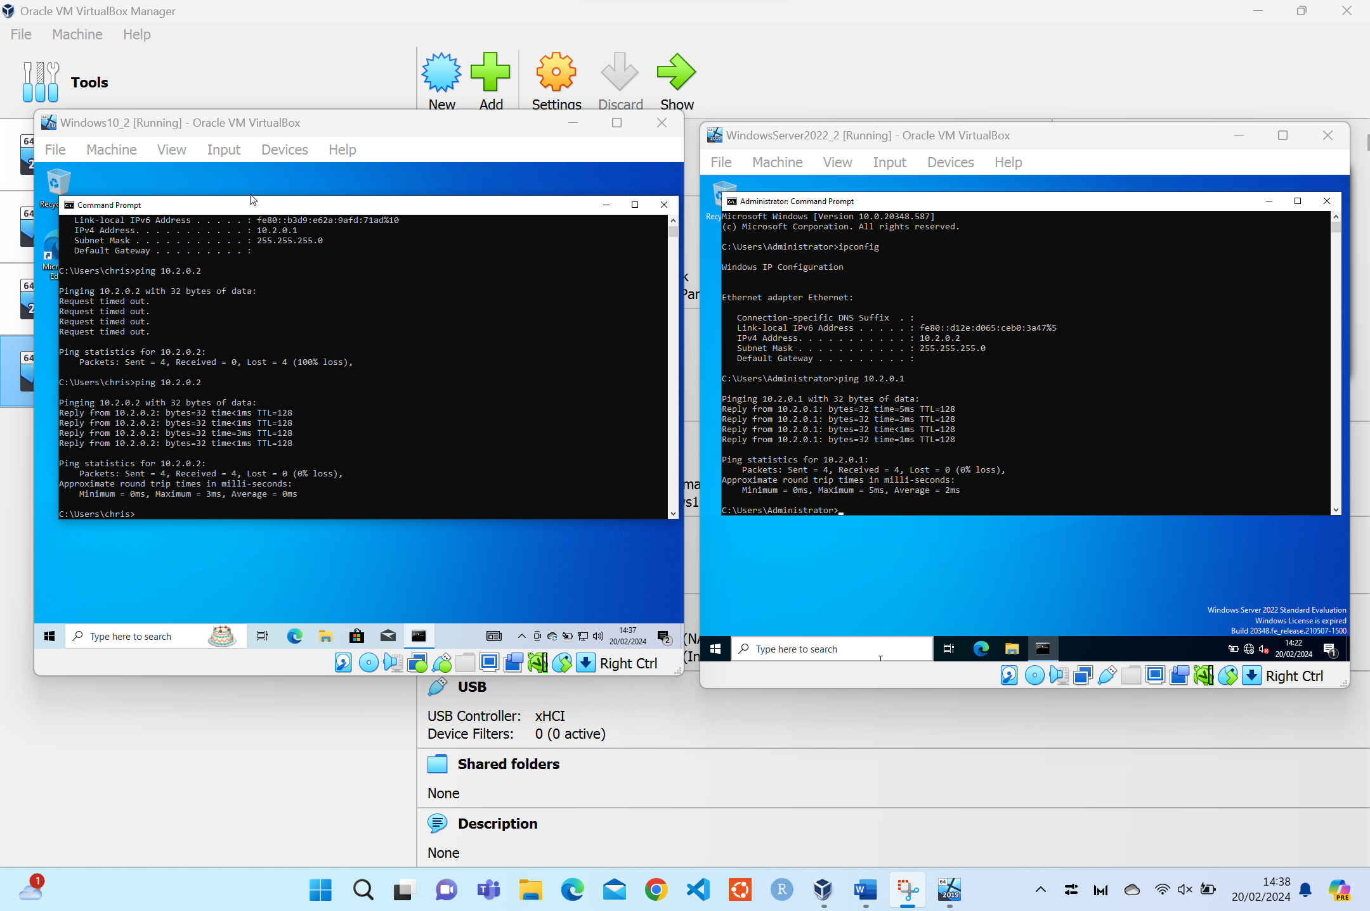
Figure 29 - Network 2 - ping.

7. Conclusion
To conclude, to set up a network can be relatively simple. However, there needs to be serious consideration into how the network is setup, whilst covering all aspect of a secure network that is built for it’s intended purposes. Depending on the nature of the network will determine the configuration steps needed to build and deploy such a network. There are many aspects that can be expanded on above that will allow an organisation to create a secure and fit for purpose networking solution.

References

[1] | D. a. R. J. Pousa, “Evaluation of type-1 hypervisors on desktop-class virtualization hosts,” IADIS-JOURNAL ON COMPUTER SCIENCE AND INFORMATION SYSTEMS, 2017.
[2] | M. Eder, “Hypervisor-vs. container-based virtualization,” Future Internet (FI) and Innovative Internet Technologies and Mobile Communications (IITM), vol. 1, 2016.
[3] | S. a. L. T. a. C. J. Lozano, “A Comprehensive Survey on the Use of Hypervisors in Safety-Critical Systems,” IEEE Access, 2023.
[4] | W. a. A. A. Graniszewski, “Performance analysis of selected hypervisors (virtual machine monitors-vmms),” International Journal of Electronics and Telecommunications, vol. 62, 2016.
[5] | J. a. P. M. Vojtesek, “Virtualization of operating system using type-2 Hypervisor,” in Software Engineering Perspectives and Application in Intelligent Systems: Proceedings of the 5th Computer Science On-line Conference 2016 (CSOC2016), Vol 2 5, 2016, pp. 239--247.
[6] | R. Pandey, “Comparing vmware fusion, oracle virtualbox, parallels desktop implemented as type-2 hypervisors,” National College of Ireland, 2020.
[7] | G. a. S. E. A. a. S. A. a. H. M. M. Aryotejo, “Performance of Virtual Machine Managers for Computer Network Learning,” in 2021 5th International Conference on Informatics and Computational Sciences (ICICoS), 2021, pp. 155-159.
[8] | N. a. K. E. Economides, “Linux vs. Windows: A comparison of application and platform innovation incentives for open source and proprietary software platforms,” in The Economics of Open Source Software Development, 2006, pp. 207--218.
[9] | P. Gralla, How the Internet works, Que Publishing, 1998.
[10] | Cloudflare, “What is the Internet Protocol?,” Cloudflare, [Online]. Available: https://www.cloudflare.com/en-gb/learning/network-layer/internet-protocol/. [Accessed 02 2024].
[11] | W. J. a. B. W. J. Buchanan, “TCP/UDP,” Mastering Networks, pp. 168--200, 1999.
[12] | J. Postel, “User datagram protocol”.
[13] | C. Semeria, “Understanding ip addressing: Everything you ever wanted to know,” NSD Marketing, 3Com Corporation, 1996.
[14] | M. Alqahtani, “IPv4 Address Exhaustion”.
[15] | P. a. W. F. a. V.-R. N. a. A. M. a. B. R. a. F. A. a. K. C. a. W. N. a. P. V. Richter, “A multi-perspective analysis of carrier-grade NAT deployment,” in Proceedings of the 2016 Internet Measurement Conference, 2016, pp. 215--229.
[16] | E. a. K. A. S. a. T. S. a. F. A. a. D. G. V. a. M. M. a. M. M. a. R. D. Bocchi, “Impact of carrier-grade nat on web browsing,” in 2015 International Wireless Communications and Mobile Computing Conference (IWCMC), 2015, pp. 532--537.
[17] | S. a. G. D. a. C. B. Jiang, “An incremental carrier-grade NAT (CGN) for IPv6 transition,” 2011.
[18] | X. a. W. X. a. L. Z. a. L. Y. a. Q. F. a. G. L. a. M. R. a. X. T. Yang, “Fast and light bandwidth testing for internet users,” in 18th USENIX Symposium on Networked Systems Design and Implementation (NSDI 21), 2021, pp. 1011--1026.
[19] | G. A. Marin, “Network security basics,” IEEE security & privacy, pp. 68--72, 2005.
[20] | S. Z. a. M. K. S. a. N. B. S. a. K. D. ul Huq, “Study of detection of ip address conflicts in manets,” Global J Comput Sci Tech, vol. 10, pp. 23--26, 2010.
[21] | M. a. B. H. a. S. S. Walfish, “Untangling the Web from DNS.,” in NSDI, 2004, pp. 17--17.
[22] | S. M. a. C. W. R. Bellovin, “Network Firewalls,” IEEE communications magazine, 1994.

