3rd of March 2023
CONSULTING REPORT
STUDENT NAME: MIHAELA ADRIANA CRISTIAN
STUDENT NUMBER: 2017346
MODULE NAME: ORGANISATIONAL CONSULTANCY
LECTURER NAME: GAYA SENANAYAKE

SKYLANE HOTEL

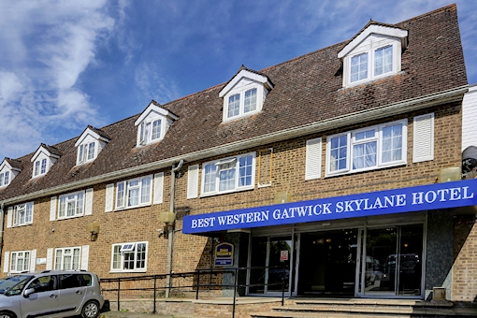
Contents
EXECUTIVE SUMMERY 2
1. Introduction 4
2. Scope and analysis 5
2.1 About Skylane Hotel 5
2.2SWOT 5
2.3PESTLE 7
2.4TOWS 7
2 Main body 9
3.1 Positive and negative aspect 9
3.1.1 Hotel Entrance 9
3.1.2 Hotel car park 9
3.1.3 Easy operations 10
3.1.4 Hotel maintenance 11
3.1.5 Lack of skills and experience 11
3.1.7 Hotel needs modernization. 12
3 Findings, Results and Action Plan 14
3.1 Findings and results 14
3.3 Action Plan 18
4 Recommendations 20
5 Conclusion 20
6 References 21

TABLE OF FIGURES
Figure 1(SKYLANE Hotel, no date) 6
Figure 2 (Skylane Hotel Property Entrance, 2021) 10
Figure 3 (Skylane Hotel car park, 2018) 10
Figure 4 (Skylane Hotel family room, 2020) 11
Figure 5( Skylane Hotel essential works, 2017) 12
Figure 6 (Skylane Hotel Breakfast, 2016) 13
Figure 7 (Skylane Hotel Old Features, 2018) 14

EXECUTIVE SUMMERY

This is a consulting report meant to find the problems within Skylane Hotel business. The hotel received over 60% of negative complaints overall over the last 4 years. The hotel is losing reputation and customer service is at very low levels, moreover the hotel property is degrading. The business would slight lose demand on customers because of the word of the mouth going on the online on review websites such as TripAdvisor, Holiday Extras, Expedia, Google. Also, the appearance of the hotel is bad, and it needs massive improvements, the hotel appears old and damaged. The client has requested consultation support to recover Skylane Hotel business by finding the problems and brings the best and most effective solution.
It has been found that Skylane Hotel has a ruined car park, uneven and unmarked, guests do not know where to park as there are no parking spaces market, it is just blank land. Cars are parked too close which can cause damage in between. The is not a parking system set up. Then, the hotel looks old and damaged, the main entrance gate walls need to be rebuilt and cleaned, also the two-signage board on the entrance is worn and must be replaced. Within the hotel it has been found old mattresses with bed bugs, flat pillows, and dirty carpet. Breakfast times are too short, and the food items provided are of poor quality. It has been found that there are many maintenance issues, the most significant being the air conditioning unit is not in working condition. Lastly, staff are unskilled and unexperienced to deliver standard customer service.
A bad car park can become unsafe as there is not properly marked and lighting, car damage and theft can occur at any time. Also, it looks bad, and guests may avoid it because of the bad look of it. The main entrance appearance is bad, it impacts guest experience, it does not offer stand quality services. The hotel is worn out, as in some rooms has been found bed bugs in the mattress that cause skin illness to guests, this is a serious matter that puts guest health at risk. It can lead to financial penalties and the hotel may lose its start as it is now a 3-star hotel, it can go to 1 star hotel because does not meet the service level. Guests have complained about uncomfortable beds and flat pillows, which is again a matter of poor service, that affects hotel rating. Breakfast problem can influence rating as well, guest has complained about poor quality of foods and short breakfast times, in some cases guest paid for a full breakfast but only get a takeaway bag with 4 items of food inside which absolutely breaks the service level and promise, no value for money. In terms of the staff and customer service, the hotel needs a good plan to improve it. Management must give proper training to staff and prepare each employee to do the job. A lot of complains happens on hotel site, guest report their inconvenience to the front desk and expect the staff to resolve the matter but does not happen because employee is not capable to offer good customer service due to lack of straining, skills and experience.
It is recommended to the client to prepare a budget plan, that states the hotel finances available and future income plan to be allocated for hotel improvements. It requires approximately £69,000 to do the refurbishments, improvements, and changes to the hotel to resolve the main problems over 18 months. It is recommended to rebuild the car park and properly allocate parking spaces. The hotel management should look for new food suppliers to replace the actual breakfast items that are of poor quality. Also, a proper wealthy list of breakfast items should be provided daily so guests have enough food options. The list or menu should be changed on a regular basis and presented accordingly. Last recommendation is based on staff, client should consider enrolling employees on Level 2 Hospitality course to gain skills and experience within the field to be able to manage difficult situation that occurs in the daily operation of the hotel and to deliver a higher level of customer service. This cost is affordable as it only costs £57 per employee and in return prepares employees to look after guests and to resolve complaints as happens, that improves the hotel reputation and enhances positive reviews on the internet.
In conclusion, Be Inspired Consultancy has provided the best solutions to the problems that are going on within Skylane Hotel considering cost effectiveness and efficiency.

Introduction

The purpose of this paper is to create and present a well-developed consulting report for a UK-based hotel. The consulting report consists of a high-level review of the findings, problems, and solutions a consultant provides for the client. The purpose of the consulting report is to perform deep research about the case business, usually this is done in response to a specific problem that the business has or to get professional advice in order to rise the business that was not running well over the recent period. In principle a consulting report is a long document containing background research and details of the business, methodology used, main findings along with solutions and action plan. This also includes deadlines for the problems to be resolved and costs involved.
The methods used within this consulting report are SWOT, PESTLE, and TOWS. SWOT analysis method investigates the microenvironment of the business, that are the internal forces that the business itself has the power to change. SWOT analyses the strengths of the business, weaknesses, opportunities, and threats. PESTLE analysis indicates the business direction, growth, brand positioning and risks. It looks at the external forces within the macro environment including political, economic, social, technological, legal, and environmental factors. Whereas TOWS analysis is an extension of SWOT, using the strengths, weakness, opportunities, and threats to combine them in turns to build strategies around the internal and external factors within the business context.

Scope and analysis

2.1 About Skylane Hotel
Skylane hotel is a basic hotel built in the 17th century, being in operation as hotel for over 20 years franchising “Days Inn” and now operating under “Best Western” chain.
Skylane Hotel has an excellent location, in Horley which is about a 15-minute drive from Gatwick Airport, however the hotel is designed to meet the needs and expectation of customers travelling to and from the airport. It is an airport hotel. Being an airport designed hotel, it has its o9wn transport coach available from 6 am until 11pm to take guests to and from Gatwick airport for a small charge of £5 per person return. The shuttle can be booked on the day at the check-in desk or by phone call from the airport (Best Western Gatwick Skylane Hotel, no date).
The hotel offers its guest a range of packages that includes room and parking, according to guest needs. The hotel has double rooms, triple rooms, or rooms to accommodate families of people. Each room can be booked on its own or as a package with parking included. Guests tend to take room and parking packages, to spend the night in the hotel to be on time at the airport the following morning and park the car at the hotel while on holiday. On return, guests get the shuttle back to the hotel from the airport, pick up the car from the hotel and drive safely home. It is very convenient and less stressful. Therefore, Skylane has its own regular customer that uses the service at least twice per year (TripAdvisor, 2022).
In terms of facilities, Skylane hotel operates with 74 rooms well equipped with TVs, phones, hair driers, nice beds, and quality carpet. The hotel has its own restaurant on site, that serves a la carte menu and restaurant type drinks such as wines, soft drinks, coffee, alcoholic drinks and so on. As well as that, the hotel has a spare room designed to hold meetings and events, equipped with its own bar. Skylane Hotel is a basic hotel aimed to mainly serve airport customers but has the facility to hold event too (London Toolkit, 2021). wellness of your property quality appearance
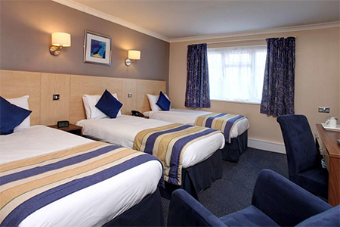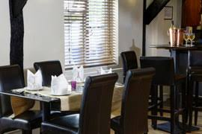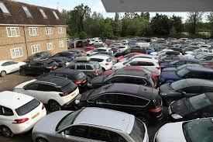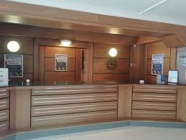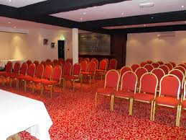
Figure 1(SKYLANE Hotel, no date)

2.2SWOT
SWOT analysis helps a business to analyze its internal forces, also known as microenvironment. This evaluates the strengths, weaknesses, opportunities, and threat that Skylane Hotel faces and can change itself (Shewan, 2022).

STRENGHTS  - Excellent location  - High customer demand  - Convenient  - Price  - Online booking system  - Facilities | WEAKNESES  - High costs  - Negative online reviews  - Lack of flexibility  - Untrained and unexperienced staff  - Budget limitations
OPPORTUNITIES  - Improve facilities  - Training courses  - Flexible pricing | THREATS  - Competitors  - High taxes  - Pandemic crisis  - Unsafe carpark
Table 1 (Skylane Hotel SWOT, 2023)
Skylane Hotel has many strengths that support the business to remain in the market. The location of the hotel is the best strength, being located close to the airport can easily get customers, as Gatwick Airport is the second largest airport in the UK according to passenger numbers. It is convenient because offers parking facilities on site and its easy and safer for customer to leave the cars. Another strength is online booking system, that allows guest to book online any time. Skylane Hotel uses a great price strategy to sell the room as package with parking included, it suits families and other budget people. The price is competitive and suits all budgets. Lastly, the shuttle bus facility is a strength because makes it more convenient and useful to guests and gains a competitive advantage against other competitors in the area (Booking, 2020).
In terms of weaknesses, Skylane Hotel main weakness is the negative online reviews that the hotel gets often. Customers are complaining for many reasons, mostly about the staff not being helpful enough and unreliable. This is because staff might not be trained well enough. Also, another weakness is the lack of flexibility on the shuttle bus that operates on certain hours although guest land at the airport on nigh times and there is not much transport to get to the hotel (Holiday Extras, 2020).
The opportunities that Skylane Hotel can be various. Improving facilities, quality and flexibility will be plus value for the hotel. Staff training is very important; however, staff need to look after customers well therefore training courses will benefit the business (Lacalle, 2022).
The major threats of Skylane Hotel are the competitors, who may come with new services or better prices on the market. Also, high taxation after large turnover on summer. People tend to travel on holidays more in the summertime, the hotel rich its maximum income then therefore the taxes to be paid to government would be higher. An unsafe carpark is another threat, because the hotel host hundreds of cars yearly however car theft or damage may result in high charges to the hotel (Zhang, 2021).

2.3PESTLE

Political | Government holds extensive power
Economical | Inflation and economic instability
Social | People from different classes with different expectations
Technological | New technology machines such as self in check-in
Environmental | Actions to reduce food, water and energy waste
Legal | Data protection act
Table 2 (SKYLANE Hotel PESTLE, 2023)
The government holds high power over the travel and tourism industry including the hotel industry. As example a travel ban imposed by law can affect Skylane hotel and well as other hotel because people would be able to travel therefore, they would not need the hotel services (Frue, 2019). Inflation and economic factors impact the hotel directly, higher costs to operate the hotel results will increase the prices which customers may not like. Economic instability makes people travel less and save the money therefore the hotel gets less demand (MBA Skool, 2021). Social factors such like guest expectations can impact Skylane Hotel, the hotel is accommodating all class of people therefore richer people have more expectations than budget people (Adamkasi, 2017). Technology is a predominant factor that can have significant impact on the hotel image and operations. New machinery such as self-check-in machine that allows to book room, check-in and take payments is beneficial to make it easy for customer and allow hotel flexibility and reduces number of staff (Rahman, 2021). Skylane hotel environmental factor is pollution, the hotel must find solutions to reduce food waste from restaurant, water, and energy waste in rooms (Tough Nickel, 2022). In terms of legal factors, the hotel must follow data protection act and law to protect guest personal details and bank accounts detail safe within a secure system to avoid frauds (Kara, 2018).

2.4TOWS
Strengths with Opportunities | SO | New pricing strategy
Threats with Weakness | TW | Lose competition
Strengths with Threats | ST | Affects customer demand
Weakness with Opportunities | WO | Improved facilities reduce lack of flexibility
Table 3 (SKYLANE Hotel TOWS, 2023)
The hotel should take advantage of the parking facility and expand a bit more on price strategy. The prices on packages can vary on the parking length, car type, room type, season. Moreover, the hotel; can design packages with parking, room and dinner for families or groups (Dominique-Ferreira, 2020). Due to the bad reviews on online environment, new customers change their mind and would not want to use the hotel service, therefore other hotels in the area gain the competition and increase their customer demand (Qui et al, 2017). A threat such as pandemic crisis can affect the hotel guest demand. As Skylane hotel beneficiate of high customer demand being located close to Gatwick airport, pandemic crisis stops people from traveling which means the hotel will reduce its customer demand considerably (El-Sawalhy, Farid, 2017). If the hotel improves on facilities like check-in machines people will be able to check-in on their own any time without assistance this means the hotel become more flexible in the night or when reception staff is busy (Chowdhury, 2019).

3.Main body

3.1 Positive and negative aspect

3.1.1 Hotel Entrance
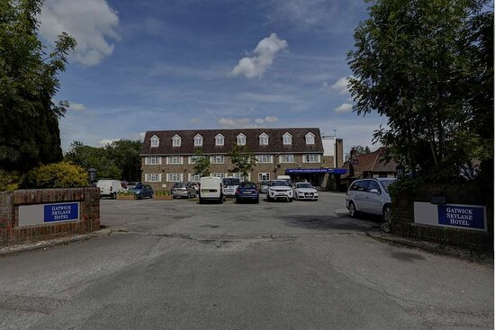
Figure 2 (Skylane Hotel Property Entrance, 2021)
Figure 2 above is an image of Skylane Hotel main entrance to the property, which is not pleasant at all. The two-sided gate walls look very old and need maintenance as well as cleanup. The ground and car park are not maintained, the old cement is breaking, and it appears old and bumpy. Any customers wanting to stay at Skylane Hotel will have a bad impression of being because of the old and used outside appearance of the hotel (TripAdvisor Property Entrance, 2021). This problem exists because maintenance was not carried out and management did not look after the property to keep it up to standard. The solution is to contract a company to clean and refurbish the front gate walls and to refurbish the ground either to put new cement or new tiling to improve the appearance of the entrance to the hotel. Perhaps the hotel name boards could be improved or changed for a better image. The management must create a plan and allocate funds for modernization of the outside of the hotel.

3.1.2 Hotel car park
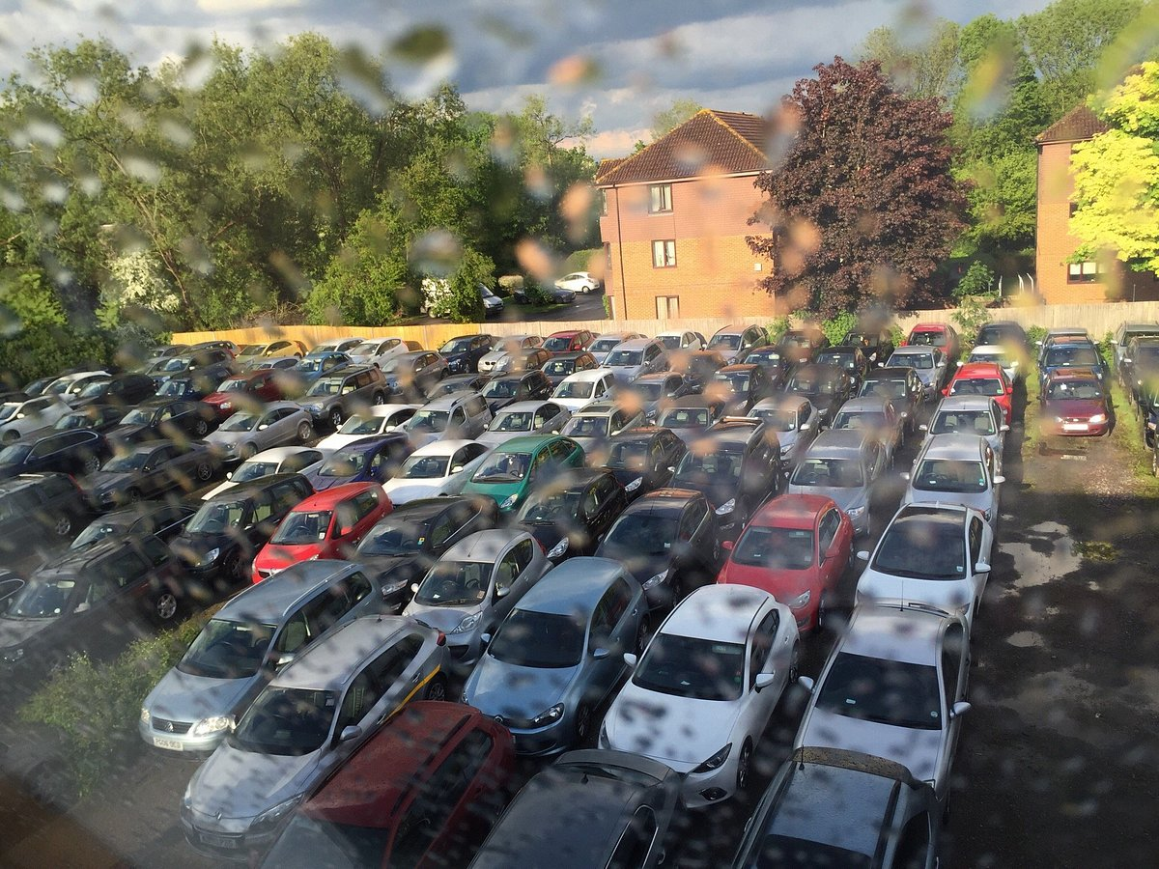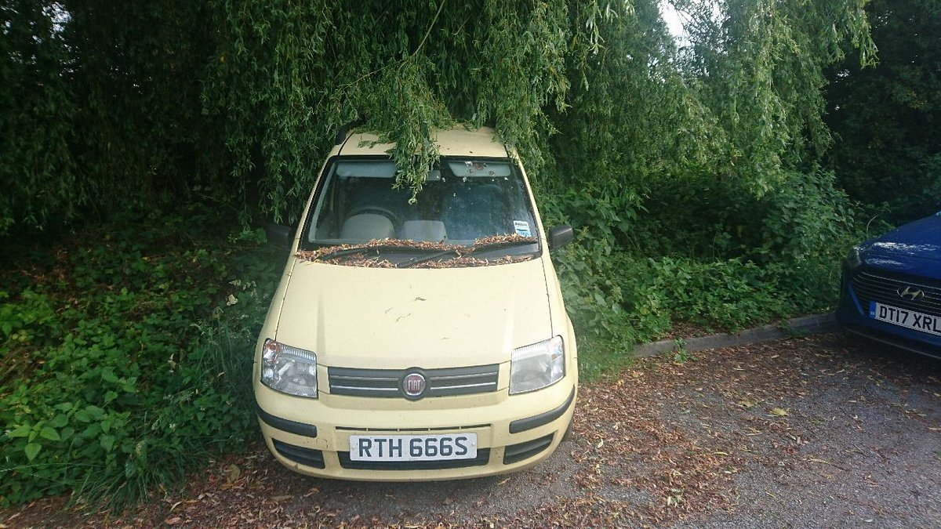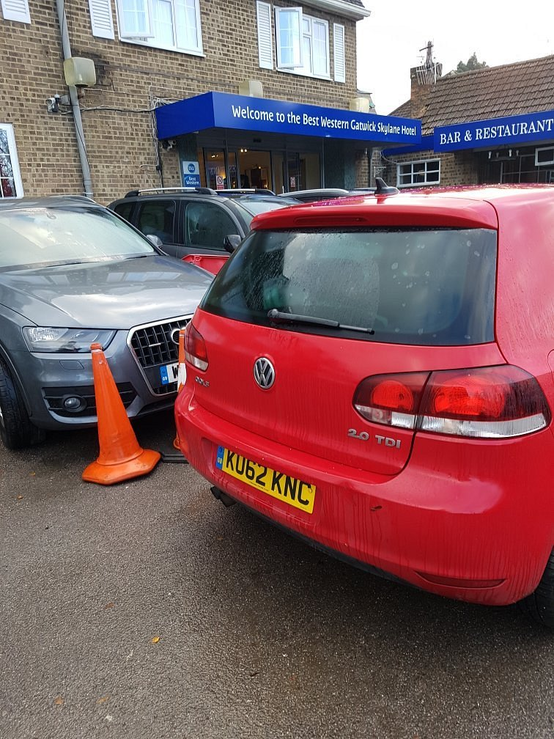
Figure 3 (Skylane Hotel car park, 2018)
Skylane Hotel does have a convenient package for holidays travelers, by offering the room and parking as one price. However, many people choose to book with them, as it seems assuring to leave the car on the hotel premises. But the operations to offer the service are bad, firstly the hotel does not have a proper car park to offer this service, figure 3 shows how close are cars parked which can easily get damaged, also cars parked in bush and under tree with branches falling on car top of the car. This is a serious matter that customers are complaining about and affects the hotel image and reputation (TripAdvisor Skylane Hotel car park, 2018). Potential solutions are to either takes less booking to be able to accommodate safely the cars in or to properly build the car park with numbered parking spaces, that will be simple for hotel to manage the car park demand knowing exactly how many how many cars on site, location of each car by the parking space number and how many space available are left (Sheepman, 2019).
Another issue is regarding car keys, the hotel asks guests to leave their car keys at reception when going on holiday. The car is personal therefore nobody should be able to access the guest car in the absence of the guest as money or other personal items might be kept there. However, having a proper car park system will allow the guest to park the car himself and take car keys. This will reduce hotel responsibility to look after customer cars and cars keys and reduces complains.

3.1.3 Easy operations
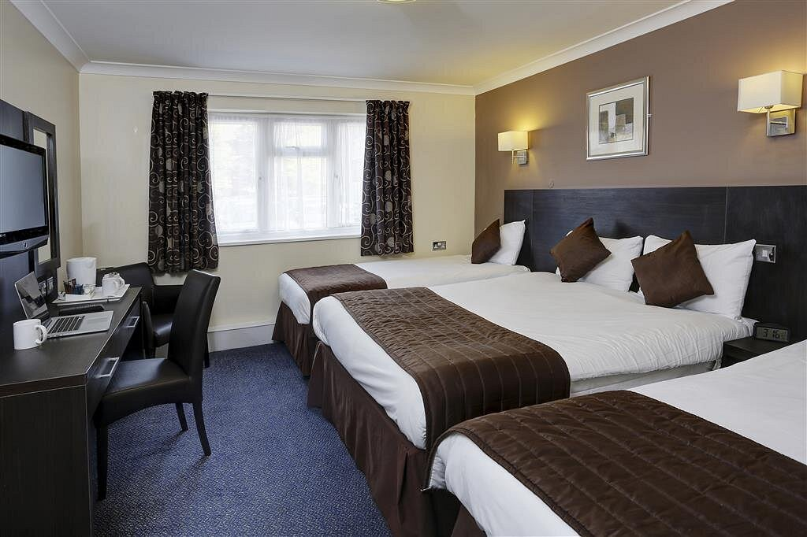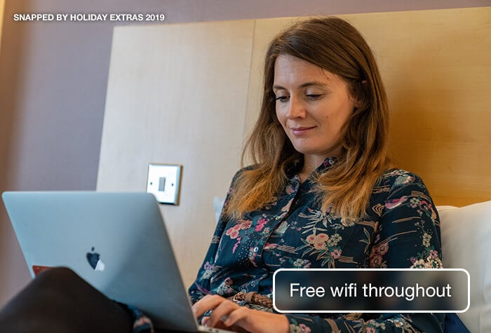
Figure 4 (Skylane Hotel family room, 2020)
According to customer comments and reviews on TripAdvisor, Skylane Hotel is efficient and serve to purpose. People are happy with the operations, to get to the hotel is easy, usually the check-in does not take long, then the rooms are clean as Figure 4 shows. The rooms are equipped with ensuite bathrooms. Hair dryer, tea and coffee facilities, TV and free Wi-Fi. The restaurant offer breakfast service starts at 7 am daily, this gives guests the change to have some food before going to the airport for a morning flight. Being close to Gatwick airport a taxi does not take long to arrive and is not too expensive also the hotel shuttle is available throughout the day and the charge is small. However, the hotel offers guests the services they need on budget.

3.1.4 Hotel maintenance
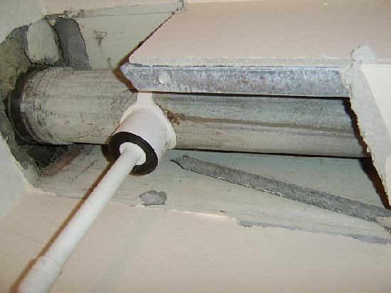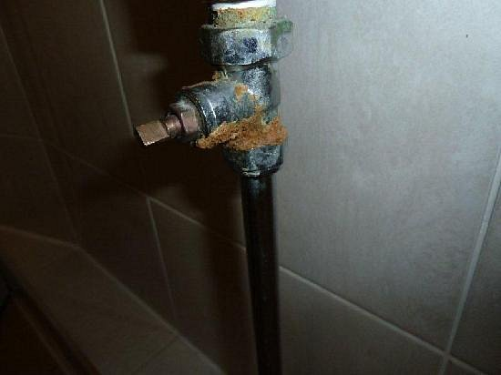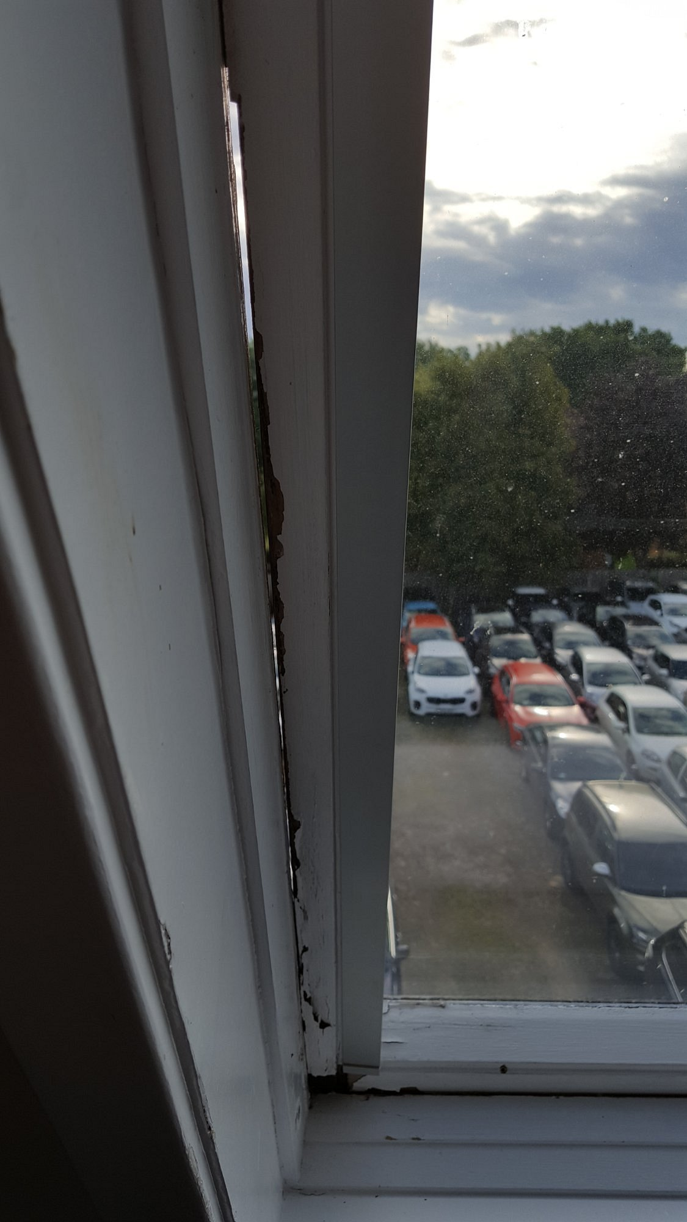
Figure 5( Skylane Hotel essential works, 2017)

Skylane Hotel tends is good on budget and convenient for families traveling on holidays and well as one night stay when travelling from Gatwick Airport but the hotel itself tends to struggle on maintenance. According to guest reviews on different websites, the hotel fails in problem solving, maintenance and solving customers issues. Small issues presented in Figure 5, represent hotels repairs that need to be done and issues of the hotel that need to be sorted before guests arrive. Essential works such covering the pipelines within bathrooms or changing rusty pipelines should be done before the room is given to service. Those are basic issues that must be resolved on the day of the works being carried out and kept on maintaining. Responsible maintenance person must resolve the issues.
The hotel has been found to have old windows with cracks and holes within the window frame. This is unacceptable because it is not safe for guests. Managers must contract a window company to replace damaged windows within the hotel. This creates a bad image of the hotel and guest dissatisfaction.
On TripAdvisor customers complain about the air conditioning not working, which is essential on summertime. In many rooms the heating or air con system is not working, this is because it was not maintained as should. Management needs to contact a company qualified to repair the air conditioning unit and carry out regular checks. If the unit is too old, then it must be replaced.

3.1.5 Lack of skills and experience
According to the online reviews on Google about Best Western Skyline Hotel, many guests do complain about miscommunication and missed information. Things such as return instructions on how to get the hotel minibus back or breakfast times are information that a lot of guests miss which result in frustration, anger then bad reviews online about the hotel (Edwards, 2021) This problem exists because the hotel does not offer full training to staff, staff might be unexperienced or do not have skills which customer service and leisure field. The potential solutions to this problem would be to offer staff full training, offer employee courses to develop their skills and knowledge such as Travel and Tourism Level 1 to Level 6 academic level to become managers. According to the online complaints, the staff is not able to deal with complaints and deliver standard customer service. The manager must be available throughout service times within reception as well as in the restaurant. When the staff is not able to solve difficult situations, the manager must come to deal with the customers and perhaps offer some incentive to make customers happy and eliminate any form of complaints (Amy J, 2019). The manager should have a standard procedure to operate the check-in, that should include the actual check-in, preparing the room card, check room availability and give guests the necessary information and instructions. To reduce guest complaints, the hotel needs a better working structure and operational procedure, so each staff knows their responsibilities and tasks and to ensure smooth operation throughout (Innerhofer et al, 2022).

3.1.6 Breakfast
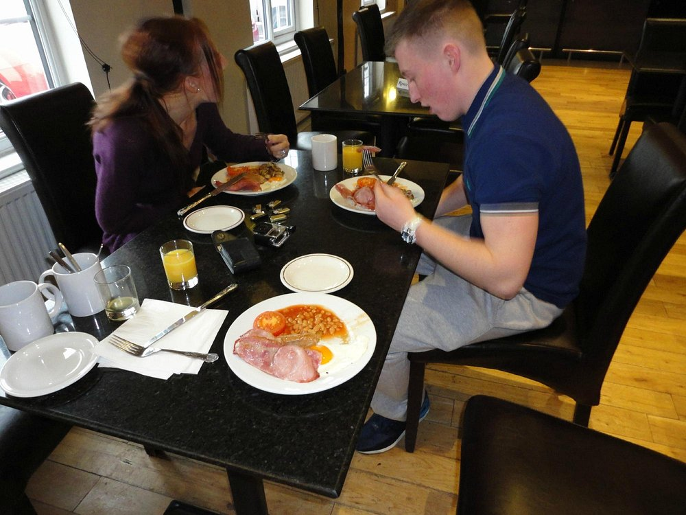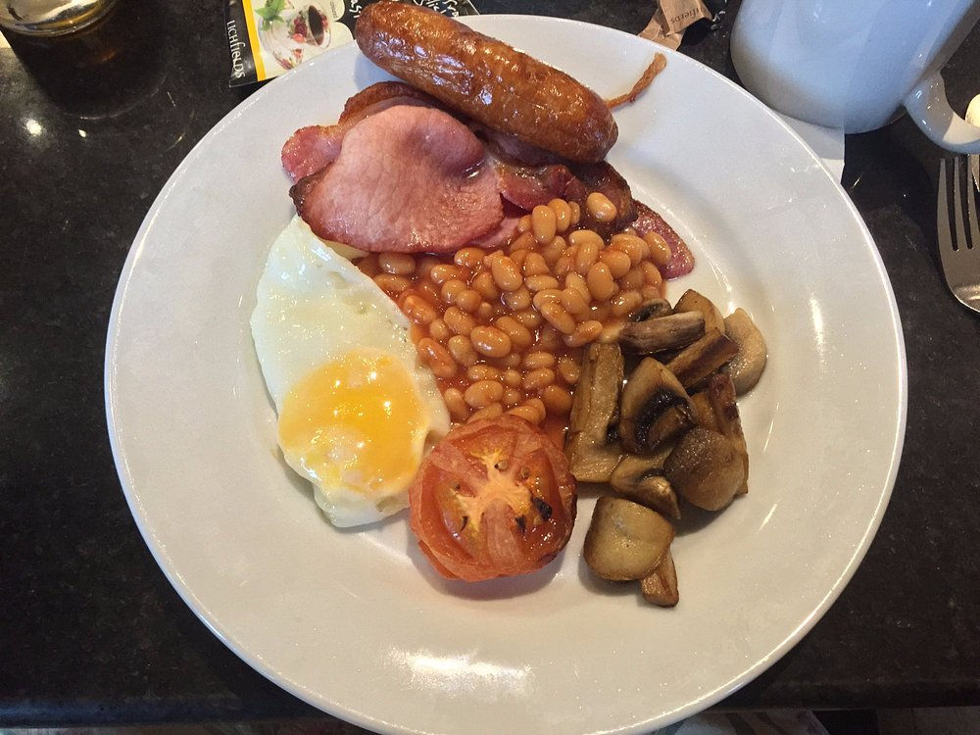
Figure 6 (Skylane Hotel Breakfast, 2016)
Another issue is the daily breakfast served in the hotel restaurant. Skyline Hotel promises to offer full English breakfast from 7 am until 9 am daily for £7.95 per person. First, guests are not given the right information about breakfast times which raises a big issue because many guest mis it in the morning. Secondly, guests have been complaining about the poor quality of breakfast items and limited options available (Johns, 2021). In order to improve breakfast management should create a big poster to advertise the breakfast correctly, including times, price and items, this poster should be placed within the lounge room or reception so each customer can see it. Change of suppliers can be very useful to improve the quality of breakfast items. It might be that the current supplier is not good any more for Skyline hotel business because customers have higher expectations. The management must create a daily or weekly menu with the breakfast items that must be served on that week or day. Those items can be changed on a regular basis, but proper menus need to be in place and go accordingly to ensure customer satisfaction (Sutherland, 2021).

3.1.7 Hotel needs modernization.
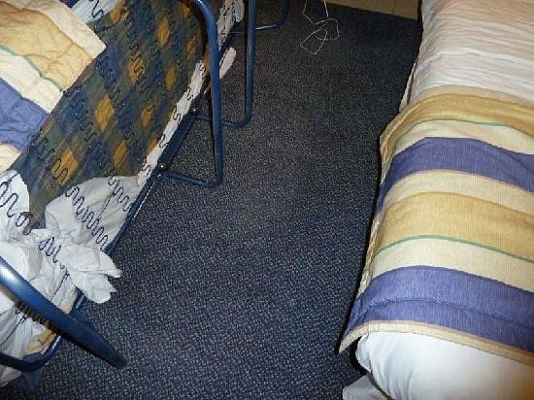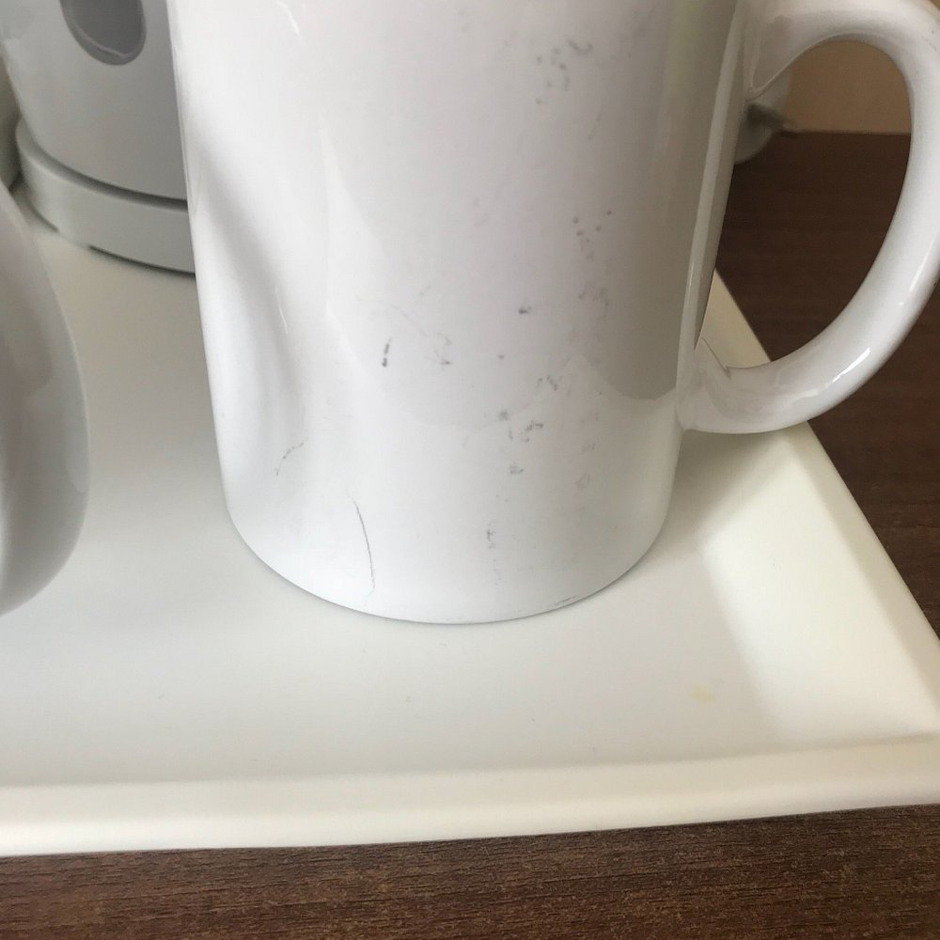
Figure 7 (Skylane Hotel Old Features, 2018)
Even though Skylane Hotel is a budget hotel designed to serve all types of people with budget limitations it needs some modernization. Guests have been complaining about old bedding including flat pillows and uncomfortable beds. There were cases where guests found bugs in the bed mattress that can cause skin illness to guests. The carpet in the room in some rooms has big stains and the smell inside of rooms is bad (Skylane Hotel Old Features, 2018). Figure 7 shows proof of old bedding, dirty carpet and used kettle that are placed to service within rooms. Those problems exist because the hotel was not maintained throughout time. The hotel assets must be replaced and renewed to maintain the hotel on standards. The potential solutions to this are that management should plan to allocate a budget for hotel modernization to improve the standards. A plan should be made to replace old stuff such as bedding, kettles, carpet, and other items that are old. This can be prioritized on a schedule and one by one according to the hotel financial status and income (Hu, Kim, 2018).

3.1.8 Performance
Skylane Hotel is placed on a high-level popularity. This is because of its location, being close to Gatwick airport and because it serves the purpose of an airport hotel. Also, Skylane Hotel has been in operation for over 15 years, therefore it has its loyal customers that regularly use the hotel when travelling abroad. Skylane Hotel did manage to exceed customer expectations for about 70% of their annual guests (Blanes, 2022). The hotel is well advertised on a range of prices comparing websites such as Holiday Extras, Booking.com, Airport Parking and Hotel as well as Expdia, that allows overseas guests to book rooms prior to their travel. It is convenient because offers guest most needed facilities like free Wi-Fi, private parking, airport shuttle, family rooms, facilities for disabled guest, bar and restaurant. In terms of occupancy, Skylane Hotel riches 95% to 100% occupancy over the summer period June until October, then the rest of the year gets around 55% occupancy. It is a good business, the hotel performs well in terms of advertising, guest demand and income (Expedia, no date).

Findings, Results and Action Plan

3.1 Findings and results
Table 4 shows in detail all the issues and problems found within the Skylane Hotel. All problems are listed per department. In this case the departments where issues have been found are car park, hotel appearance and modernization, maintenance, staff training and restaurant.

TOWS | Threats | Opportunities
Weaknesses | TW  - Poor breakfast opening times and poor quality of the food items can lead to losing customers and competition on the close by market.  - Poor carpark conditions create a unsafe carpark which may involve car damages and theft of cars. | OW  - Providing a full training course to employees will remedy the issue of having unexperienced and untrained staff.  - The opportunity to change suppliers for breakfast items will help to rebuild the hotel reputation.  - Paying for employees to take Level 2 Hospitality course will then benefit the hotel to have well skilled staff on board able to solve guest issues and reduce complains.
Strengths | TS  - Competitors represent a threat of Skylane Hotel, but it can gain customers demand by its airport hotel features.  - The actual state of the car park represents a threat for the hotel but because it is a large car able to accommodate 250 cars builds the hotels strength. The car park refurbishment must be done to improve the hotel facilities. | OS  - Prices can be raised after refurbishment.  - More customer demand after the hotel improvements is made.  - Setting regular basis training for staff will enable all members of staff to understand their job responsibilities and duties and more capable to deal with guests.
Table 4 (TOWS Skylane Hotel, 2023)
Table 4 is TOWS, representation for Skylane Hotel matrix of strengths, opportunities, weaknesses, and threats. In terms of threats and weaknesses, the hotel loses customer demand because of the poor breakfast quality and operating times, leaving gaps in the local market for competitors. Also, poor car park condition is a weakness and can lead to threats of car theft and car damages which can cause the hotel significant financial consequences (Dandage et al, 2019)
As for opportunities and weaknesses, Skylane hotel uses the opportunity of changing suppliers for breakfast items to remedy the weakness of poor-quality foods. This will help to gain competition on the market and improve hotel standards. Moreover, the hotel should put staff on qualification courses such as Level 2 Hospitality, as the costs involved are affordable for the hotel, this will eliminate the weakness of poor customer service and the hotel would have less complains.
Threats and strengths represent the competitors as threats, but Skylane Hotel has unique and well-defined features as being an airport hotel able to serve nearby Gatwick airport travelers. This represents hotel strength against competitors. The Skylane Hotel has a massive car park able to accommodate up to 250 cars on site, but the car park is not in good condition therefore it represents a threat of theft and car damages which may cause the hotel financial consequences. However, the car park must be refurbished to eliminate weaknesses and threats (Mater Class, 2022).
Opportunities and strengths can be plenty for Skylane Hotel if the hotel makes the refuted refurbishments and service improvements. Things such as regular training, price increase and more customer demand are a few of strengths the hotel can gain if takes the opportunity to make the make changes (Indeed, 2022).

No | Dept | Problem | Solution | Desired Outcome | Time Scale | End Date | Planned Budget
1 | Car Park | Poor car park condition | The car park needs to be rebuilt with new concrete and straight line should be painted to mark each parking space | The bad image of the hotel as a whole will be improved, better working conditions for staff and offers better facilities for customer. Also, the new carpark will reduce the complains and will create a better car park management system and customer will not need to leave car keys at the hotel. | 9 months | 1/12/23 | Including 250 parking spaces on the hotel site. The price per parking space is approx. £110 (Checkatrade wall gates, 2022)  Total cost: £27.500
2 | Hotel Appearance and Modernization | Old and damaged main entrance gate walls | To refurbish the main entrance gate walls and stick new hotel name signage boards. | This will improve the hotel appearance and guest experience. The hotel car rise the prices on rooms as the quality and image of the hotel gets improved. | 2 months | 1/5/2023 | Gate wall refurbishment costs £380 labor and £150. Total £530 (The Building Sheriff, 2017)  New Signage Boards £160 for 2 new boards (The Sign Maker, no date).  Total cost: £690
 |  | Bed bugs and uncomfortable bed mattress | To replace old mattress with new ones. | Eliminates the bed bugs and offers guest comfortable beds. Improves on hotel quality. | 3 months | 1/6/2023 | Hotel mattress single £154, 48 needed, means £7,392.  Hotel mattress double £269, 50 of them needed, means £13,450 (Hotel Contract Beds, 2023)  Total cost: £20,842
 |  | Flat pillows | To replace the old pillows with new ones | Improves quests comfort and serves quality. | 3 months | 1/6/2023 | 180 pillows needed. Price per pillow £15 (Premier Inn, no date).  Total cost: £2,700
 |  | Dirty carpet | To professionally clean the carpet in the necessary rooms | Freshen and upgrade the room standards. Better experience for guests. | 2 months | 1/5/2023 | 25 large rooms, cost £45 per room, means £1125  30 double/ standard rooms, £30 per room, means £900 (Household Quotes, 2023).  Total: £2025
 |  | Old and used kettles | Replace with new kettles. | Improves quests experience and hotel facilities. | 1 month | 1/4/2023 | Price per kettle £9.99, 78 needed (Amazon, 2023).  Total price: £779.22
3 | Maintenance | Air condition/ heating not working in some rooms | Contract a qualified individual or company to repair the air containing unit. | All rooms to have access to working air conditioning throughout summer and heating supply while winter. | 2 months | 1/5/2023 | Average price £ 3,000 (Ever Green Aircon, no date).
 |  | Damaged window frames | Repair the windowpane and cover wholes with cement around the window frames. | Keep up with the legal standards and remedy complains. | 3 months | 1/6/2023 | On average £5,000, including all rooms in the hotel (Checkatrade windows, 2023)
 |  | Uncovered piper works in the rooms and visible rusty pipes | Delegate hotel maintenance team to professionally cover visible rusty pipes and any maintenance works performed. | Improve the hotel appearance and improves quests expanse. Less complains. | 1 month | 1/4/2023 | £ 400 approximate
4 | Staff Training | Lack of Skills and experience on staff | Management must offer full training course to all employees and regular basis training should me scheduled. | All staff should know how to do their job | 6 months | 1/9/2023 | £3,000 average
 |  | Understaffed | Employ more staff | Remedy staff storage and offer better guest experience. | 3 months | 1/6/2023 | 3 members of staff on part time hours (Gov. 2023)  The average cost per month £1500.
 |  | Staff Failing to solve issues and complains | Provide NCFE Level 2 Hospitality accredited courses for staff. | Qualified staff offering a higher level of customer service to guests. Improve on gusts experience. | 18 months | 1/9/2024 | Average price per individual £57.00 (NCFE, 2020).  Estimate cost: £570
5 | Restaurant | Poor breakfast operation | Change breakfast items supplier. Create a breakfast menu and change it weekly. Increase breakfast time with 2 more hours. | Happier customers, better guest experience and improves hotel facilities. The price for breakfast can increase. | 3 months | 1/6/2023 | Including staff extra hours and new supplier prices, approximately £1,000 monthly extra costs on breakfast over all costs (M&R, 2021).
Table 5 (Findings and Action Plan, 2023)

Action Plan
Table 5 lists all problems found within the hotel, all the are major issues that affect the hotel’s reputation, customer demand, income, and profits therefore those must be resolved as it may lead to property degradation and business loss.
Each problem is fully evaluated, and an action plan is provided with a time limit to solve the problem and costs involved. There are 5 departments with certain problems found the overall cost to solve those issues comes to approximately £69,007 based on realistic quotes. The overall time for those improvements listed above is 18 months. The work can be prioritized such as life threatening which are bed mattress with bugs on them that causes skin illness to guests, then the damaged windows are a priority because it’s illegal to have unsafe windows in the guest rooms. Then followed by the breakfast problems and staff training issues to combat complaints and achieve high customer service. The maintenance, refurbishment and upgrade of the hotel could be done according to the hotel funds available, preferably within the time frame stated in Table 5 to improve hotel standards and guest appearance (McKinsley, 2021).

Recommendations
- It is recommended Skylane Hotel should plan its income and finances better to be able cover the expenses for listed in the action plan for hotel improvements. This requires the management to create analyses of hotel finances better and prioritize the work according to the funds available. A finance plan should be made to list the expenses, allocate funds or state when funds would be available. To save the money on unnecessary items and reduce the costs where possible to be able to gain the funds needed for hotel improvements.
- Reorganize management structure by employing enough skilled people for the management positions. Enough management will help to create a better working structure, an organized workplace where employees know where and who to report the issues.
- Another recommendation to Skylane Hotel is to take hotel refurbishments as a priority because the hotel would get into worse condition throughout time if it were not maintained and looked after. In 5 years, the expenses of hotel refurbishment will increase because more parts of the hotel would degrade resulting in more money to spend.

Conclusion
Be Inspired Consultancy was grateful for collaborating with Skylane Hotel. It was a pleasure to work with the hotel to identify the issues and problems that enable Skylane Hotel to be the best in the local market. The report has provided the best possible solutions to each problem minimizing financial implications but getting efficient results.
Be Inspired Consultancy has performed in-depth research to be able to identify the major issues that causes the hotel fall and to support your business to invest proficiently on important things that guarantees significant improvements to your business. Our company believes you agree with the resolutions proposed within the consulting report and choose to go along with our recommendations to improve your business performance and income.
Thank you for choosing to work with Be Inspired Consultancy and we will never let you down. We will be there catching your business when it falls and work hard to make it bright again!

References

Adamkasi (2017). PESTEL Analysis of Hotel Industry. [online] Porter Analysis. Available at: https://www.porteranalysis.com/pestel-analysis-of-hotel-industry/ [Accessed 8 Feb. 2023].
Adamkasi (2022). PESTEL Analysis of Hospitality Industry | Free PESTEL Analysis. [online] www.freepestleanalysis.com. Available at: https://freepestelanalysis.com/pestel-analysis-of-hospitality-industry/ [Accessed 2 Mar. 2023].
Amazon (2023). 1 Litre 900W Electric Cordless Kitchen White Kettle Caravan Travel Hot Water Jug - Overheat Thermostat EK001 [Energy Class A]: Amazon.co.uk: Home & Kitchen. [online] www.amazon.co.uk. Available at: https://www.amazon.co.uk/Electric-Cordless-Kitchen-Kettle-Caravan/dp/B06XC1RQFV/ref=asc_df_B06XC1RQFV/?tag=googshopuk-21&linkCode=df0&hvadid=309981989212&hvpos=&hvnetw=g&hvrand=13509887829825386567&hvpone=&hvptwo=&hvqmt=&hvdev=c&hvdvcmdl=&hvlocint=&hvlocphy=1006808&hvtargid=pla-703482629212&psc=1 [Accessed 27 Feb. 2023].
Amy J (2019). BEST WESTERN GATWICK SKYLANE HOTEL - Prices & Reviews (Horley, England). [online] Tripadvisor. Available at: https://www.tripadvisor.com/Hotel_Review-g191265-d2217238-Reviews-or1090-Best_Western_Gatwick_Skylane_Hotel-Horley_Surrey_England.html#/media/2217238/440885833:p/?albumid=101&type=2&category=101 [Accessed 23 Feb. 2023].
Antolín, G., Alonso, B., Cordera, R. and dell’Olio, L. (2019). The Effect of Introducing Parking Policies on Managing Mobility to Beaches in Touristic Coastal Towns. Sustainability, 11(13), p.3528. https://doi.org/10.3390/su11133528
Belin, A. (2021). How to write a consulting report: 6 best practices. [online] Pointerpro. Available at: https://pointerpro.com/blog/consulting-report-best-practices/ [Accessed 2 Mar. 2023].
Blanes, R. (2022). Understanding hotel performance metrics- ADR, RevPar, and more. [online] Cloudbeds. Available at: https://www.cloudbeds.com/articles/hotel-performance-metrics/ [Accessed 23 Feb. 2023].
Booking (2020). ★★★ BEST WESTERN Gatwick Skylane Hotel, Horley, UK. [online] Booking.com. Available at: https://www.booking.com/hotel/gb/skylanehotel.en-gb.html [Accessed 2 Feb. 2023].
BuildingSheriff (n.d.). Average Labour Cost/Price to Fit/Hang Gates. [online] buildingsheriff.com. Available at: https://buildingsheriff.com/gates-costs.php [Accessed 23 Feb. 2023].
Check a Trade (2022). How much does it cost to build a car park? Copyright Checkatrade. Using this information in an article or blog? Please add a link back to https://www.checkatrade.com/blog/cost-guides/cost-build-car-park/. [online] www.checkatrade.com. Available at: How much does it cost to build a car park? Copyright Checkatrade. Using this information in an article or blog? Please add a link back to https://www.checkatrade.com/blog/cost-guides/cost-build-car-park/ [Accessed 23 Feb. 2023].
Check A Trade Windows (2023). Blown window repair cost guide Copyright Checkatrade. Using this information in an article or blog? Please add a link back to https://www.checkatrade.com/blog/cost-guides/blown-window-repair-cost/. [online] www.checkatrade.com. Available at: https://www.checkatrade.com/blog/cost-guides/blown-window-repair-cost/ [Accessed 27 Feb. 2023].
Chowdhury, O. (2019). What is the TOWS Matrix? And how it is used? [online] Trade Brains. Available at: https://tradebrains.in/tows-matrix/#:~:text=The%20four%20TOWS%20strategies%20are%20Strength%2FOpportunity%20(SO)%2C [Accessed 11 Feb. 2023].
Dominic-Ferreira, S. (2020). Estimating the price range and the effect of price bundling strategies: An application to the hotel sector. European Journal of Management and Business Economics, [online] 29(2). Available at: https://www.emerald.com/insight/content/doi/10.1108/EJMBE-04-2019-0066/full/html [Accessed 11 Feb. 2023].
Edwards (2021). Skylane Hotel Reviews. [online] www.google.com. Available at: https://www.google.com/travel/hotels/skylane%20hotel/entity/CgsIuK_1uez0iYu8ARAB/reviews?q=skylane%20hotel&g2lb=2502548%2C2503771%2C2503781%2C4258168%2C4270442%2C4284970%2C4291517%2C4306835%2C4429192%2C4515404%2C4597339%2C4731329%2C4757164%2C4778035%2C4814050%2C4861688%2C4864715%2C4874190%2C4886082%2C4886480%2C4893075%2C4902277%2C4906019%2C4920132%2C4926165%2C4926489%2C4934307%2C4936396%2C4946428%2C4949692%2C4949696%2C4950242%2C4955788%2C4962414&hl=en-GB&gl=uk&ssta=1&rp=ELiv9bns9ImLvAEQuK_1uez0iYu8ATgCQABIAcABAg&ictx=1&sa=X&ved=0CAAQ5JsGahcKEwjolPfz_rz9AhUAAAAAHQAAAAAQBA&utm_campaign=sharing&utm_medium=link&utm_source=htls&ts=CAESABogCgIaABIaEhQKBwjnDxADGAUSBwjnDxADGAYYATICEAAqBAoAGgA [Accessed 15 Feb. 2023].
El-Sawalhy, H. and Farid, M. bellah (2017). Hospitality Industry Development via Scientific Research: SWOT analysis. Journal of Association of Arab Universities for Tourism and Hospitality, 14(2), pp.133–139. https://doi.org/10.21608/jaauth.2017.48151.
Evergreen (2022). How much does an air conditioning service cost | Evergreen AC. [online] Evergreen Air Conditioning. Available at: https://www.evergreenaircon.co.uk/2022/02/28/air-conditioning-service-cost/ [Accessed 27 Feb. 2023].
Expedia (n.d.). Best Western Skylane Hotel Reviews. [online] www.expedia.com. Available at: https://www.expedia.co.uk/Horley-Hotels-Best-Western-Gatwick-Skylane-Hotel.h789282.Hotel-Information?chkin=2023-03-10&chkout=2023-03-11&x_pwa=1&rfrr=HSR&pwa_ts=1677241717639&referrerUrl=aHR0cHM6Ly93d3cuZXhwZWRpYS5jby51ay9Ib3RlbC1TZWFyY2g%3D&useRewards=false&rm1=a2&destination=34+Bonehurst+Rd%2C+Horley+RH6+8QF%2C+UK&destType=ADDRESS&selected=789282&sort=RECOMMENDED&userIntent=%20(Expedia,%20no%20date) [Accessed 23 Feb. 2023].
Fan, D.X.F., Hsu, C.H.C. and Liu, A.X. (2022). Transforming Brand Identity to Hotel Performance: The Moderating Effect of Social Capital. Journal of Hospitality & Tourism Research, p.109634802210742. https://doi.org/10.1177/10963480221074278
Fruie, K. (2019). PESTLE Analysis for Hotel Industry. [online] pestleanalysis.com. Available at: https://pestleanalysis.com/pestle-analysis-for-hotel-industry/#:~:text=analysis%3A%20Bottom%20line- [Accessed 8 Feb. 2023].
gov.uk (2022). Minimum wage rates for 2023. [online] GOV.UK. Available at: https://www.gov.uk/government/publications/minimum-wage-rates-for-2023 [Accessed 27 Feb. 2023].
HH (2017). Travelodge: Comprehensive Business Analysis and International Expansion Plan. [online] ToughNickel. Available at: https://toughnickel.com/industries/Travelodge-Comprehensive-Business-Analysis-and-International-Expansion-Plan [Accessed 8 Feb. 2023].
Holiday Extra Skylane Hotel FamilyRoom (2020). Airport hotels | If your plans change cancel for free, up to the day before your booking starts. [online] Holiday Extras. Available at: https://www.holidayextras.com/skylane-gatwick-airport-hotel.html [Accessed 15 Feb. 2023].
Holiday Extras (2020). Reviews of the Skylane Hotel at Gatwick | Guests have their say. [online] www.holidayextras.com. Available at: https://www.holidayextras.com/airport-hotels/gatwick/skylane/reviews.html [Accessed 2 Feb. 2023].
Hotel Contract Beds (2022). 5 Best Hotel Mattresses for 2023 to Buy for Your Home. [online] HotelContractBeds T/A Full Range Furniture Ltd. Available at: https://www.hotelcontractbeds.co.uk/blog/best-hotel-mattresses-for-home [Accessed 23 Feb. 2023].
House Holds Quotes (2023). The Cost of Professional Carpet Cleaning: How to Save in 2023. [online] www.householdsquotes.com. Available at: https://householdquotes.co.uk/carpet-cleaning-cost/ [Accessed 23 Feb. 2023].
HowandWhat.net (2021). PESTEL analysis of the hotel industry. [online] howandwhat. Available at: https://www.howandwhat.net/pestel-analysis-hotel-industry/ [Accessed 8 Feb. 2023].
Hu, Y. and Kim, H.J. (2018). Positive and negative eWOM motivations and hotel customers’ eWOM behaviour: Does personality matter? International Journal of Hospitality Management, 75, pp.27–37. https://doi.org/10.1016/j.ijhm.2018.03.004.
Indeed (2022a). What Is a PESTLE Analysis? Factors, Examples and Uses. [online] Indeed Career Guide. Available at: https://www.indeed.com/career-advice/career-development/what-is-the-pestle-analysis#:~:text=A%20PESTLE%20analysis%2C%20sometimes%20called%20PEST%20or%20PESTEL [Accessed 11 Feb. 2023].
Indeed (2022b). What is a TOWS analysis? (Definition and how to conduct it). [online] www.indeed.com. Available at: https://uk.indeed.com/career-advice/career-development/what-is-tows-analysis [Accessed 17 Feb. 2023].
Innerhofer, J., Zehrer, A. and Nasta, L. (2022). Antecedents of labour shortage in the rural hospitality industry: a comparative study of employees and employers. Journal of Hospitality and Tourism Insights. [online] Available at: https://www.emerald.com/insight/content/doi/10.1108/JHTI-04-2022-0125/full/html [Accessed 15 Feb. 2023].
Johns (2021). Skylane Hotel Reviews. [online] www.google.com. Available at: https://www.google.com/travel/hotels/skylane%20hotel/entity/CgsIuK_1uez0iYu8ARAB/reviews?q=skylane%20hotel&g2lb=2502548%2C2503771%2C2503781%2C4258168%2C4270442%2C4284970%2C4291517%2C4306835%2C4429192%2C4515404%2C4597339%2C4731329%2C4757164%2C4778035%2C4814050%2C4861688%2C4864715%2C4874190%2C4886082%2C4886480%2C4893075%2C4902277%2C4906019%2C4920132%2C4926165%2C4926489%2C4934307%2C4936396%2C4946428%2C4949692%2C4949696%2C4950242%2C4955788%2C4962414&hl=en-GB&gl=uk&ssta=1&rp=ELiv9bns9ImLvAEQuK_1uez0iYu8ATgCQABIAcABAg&ictx=1&sa=X&ved=0CAAQ5JsGahcKEwiwwsWIsav9AhUAAAAAHQAAAAAQBA&utm_campaign=sharing&utm_medium=link&utm_source=htls&ts=CAESABpJCisSJzIlMHg0ODc1ZmFhMWZiZjljODczOjB4YmMxNjI3YTZjNzNkNTdiOBoAEhoSFAoHCOcPEAIYGhIHCOcPEAIYGxgBMgIQACoECgAaAA%20%20%20(johns,%202021) [Accessed 18 Feb. 2023].
June 26, Z.K. and 2017 (2017). Healthy Breakfasts You Can Make in Your Hotel Room. [online] Cooking Light. Available at: https://www.cookinglight.com/healthy-living/travel/breakfast-meals-easy-recipes-hotel-rooms [Accessed 27 Feb. 2023].
Kara, E. (2018). (PDF) A Contemporary Approach For Strategic Management in Tourism Sector: PESTEL Analysis on The City Muğla, Turkey. [online] ResearchGate. Available at: https://www.researchgate.net/publication/326044022_A_Contemporary_Approach_For_Strategic_Management_in_Tourism_Sector_PESTEL_Analysis_on_The_City_Mugla_Turkey [Accessed 8 Feb. 2023].
Kenny, J. and Dutt, C.S. (2021). The long-term impacts of hotel’s strategic responses to COVID-19: The case of Dubai. Tourism and Hospitality Research, 22(1), p.146735842110345. https://doi.org/10.1177/14673584211034525.
Kienapple, B. (2019). 19 Consulting Report Templates That Every Consultant Needs - Venngage. [online] Venngage. Available at: https://venngage.com/blog/consulting-report-template/ [Accessed 2 Mar. 2023].
Lacalle, E. (2022). SWOT analysis for hotels. What is it and how does it work? [online] www.mews.com. Available at: https://www.mews.com/en/blog/swot-analysis-for-hotels [Accessed 4 Feb. 2023].
Landman, P. (2010). Evaluate the Value Proposition of your Competitors. [online] Hotel Management Company - Hospitality Group - Xotels Ltd. Available at: https://www.xotels.com/en/revenue-management/revenue-management-book/competitor-analysis [Accessed 2 Mar. 2023].
LateRooms (2023). BEST WESTERN Gatwick Skylane Hotel, Horley | LateRooms.com. [online] Laterooms.com. Available at: https://www.laterooms.com/en/hotel-reservations/124723_skylane-hotel-horley.aspx [Accessed 30 Jan. 2023].
Lonson Toolkit (2022). Cheap Gatwick hotel with free Wi-Fi at Best Western Skylane Hotel. [online] www.londontoolkit.com. Available at: https://www.londontoolkit.com/lgw/skylane_lgw.htm [Accessed 2 Feb. 2023].
MasterClass (2022). TOWS Analysis: Using a TOWS Matrix for Strategic Planning. [online] www.masterclass.com. Available at: https://www.masterclass.com/articles/tows-analysis [Accessed 27 Feb. 2023].
McNamara, C. (2022). Guidelines and Resources for Action Planning Phase of Consulting - Management Library. [online] management.org. Available at: https://management.org/consulting/action-planning.htm [Accessed 2 Mar. 2023].
Model, S. (2021). Consulting Report: How to Write and Present One. [online] SlideModel. Available at: https://slidemodel.com/consulting-report-how-to-write-and-present-one/ [Accessed 2 Mar. 2023].
Perera, R. (2017). The PESTLE Analysis. [online] Google Books. Nerdynaut. Available at: https://books.google.co.uk/books?hl=en&lr=&id=ZWpLDwAAQBAJ&oi=fnd&pg=PA2&dq=pestle+analysis+of+hotel&ots=Due3sR0DKB&sig=p3ZyZugyM1PwYXw6Rqcq1AV5tuc#v=onepage&q=pestle%20analysis%20of%20hotel&f=false [Accessed 2 Mar. 2023].
PremierInn (n.d.). Premier Inn Luxury Pillows. [online] Premier Inn at Home. Available at: https://www.premierinnathome.com/product/pillows/ [Accessed 23 Feb. 2023].
Qian, J., Lin, P.M.C., Law, R. and Li, X. (2022). Lack of IT and digital marketing professionals in hospitality: is it education’s fault? Heliyon, [online] 8(12), p.e12002. https://doi.org/10.1016/j.heliyon.2022.e12002.
Qiu, S. (2017). SWOT Analysis and Competition Approaches of Hotels in Guangzhou. IOSR Journal of Business and Management. [online] https://doi.org/10.9790/487X-1901021925.
Scheppmann, C. (2019). Hotel Parking: A Valuable Data Resource. [online] Hospitality Technology. Available at: https://hospitalitytech.com/hotel-parking-valuable-data-resource [Accessed 11 Feb. 2023].
Shewan, D. (2020). How to Do a SWOT Analysis for Your Small Business. [online] Wordstream.com. Available at: https://www.wordstream.com/blog/ws/2017/12/20/swot-analysis [Accessed 2 Feb. 2023].
Skylane Hotel (n.d.). Home. [online] http://www.skylanehotel.co.uk/. Available at: http://www.skylanehotel.co.uk/ [Accessed 30 Jan. 2023].
Sutherland, R. (2021). Hotel breakfasts are a risky business. [online] The Spectator. Available at: https://www.spectator.co.uk/article/hotel-breakfasts-are-a-risky-business/ [Accessed 18 Feb. 2023].
Tas, G. (2021). The Impact of Online Reviews on the Hospitality Industry. [online] www.gourmetmarketing.net. Available at: https://www.gourmetmarketing.net/blog/the-impact-of-online-reviews-on-the-hospitality-industry#:~:text=Effects%20of%20Negative%20Online%20Reviews [Accessed 23 Feb. 2023].
Team, M.S. (2021). Hilton PESTLE Analysis | PESTEL Analysis of Hilton. [online] MBA Skool-Study.Learn.Share. Available at: https://www.mbaskool.com/pestle-analysis/companies/18162-hilton.html [Accessed 8 Feb. 2023].
TripAdvisor (2022). BEST WESTERN Skylane Hotel REVIEWS. [online] www.tripadvisor.com. Available at: www.tripadvisor.com [Accessed 27 Feb. 20233].
TripAdvisor Skylane Hotel Breakfast (2016). BEST WESTERN GATWICK SKYLANE HOTEL - Prices & Reviews (Horley, England). [online] Tripadvisor. Available at: https://www.tripadvisor.com/Hotel_Review-g191265-d2217238-Reviews-or1090-Best_Western_Gatwick_Skylane_Hotel-Horley_Surrey_England.html#/media/2217238/220526788:p/?albumid=101&type=0&category=101 [Accessed 18 Feb. 2023].
TripAdvisor Skylane Hotel Essential Works (2017). BEST WESTERN GATWICK SKYLANE HOTEL - Updated 2023 (Horley). [online] Tripadvisor. Available at: https://www.tripadvisor.co.uk/Hotel_Review-g191265-d2217238-Reviews-Best_Western_Gatwick_Skylane_Hotel-Horley_Surrey_England.html#/media/2217238/477045149:p/?albumid=101&type=0&category=101 [Accessed 15 Feb. 2023].
TripAdvisor Skylane Hotel Old Features (2018). BEST WESTERN GATWICK SKYLANE HOTEL - Prices & Reviews (Horley, England). [online] Tripadvisor. Available at: https://www.tripadvisor.com/Hotel_Review-g191265-d2217238-Reviews-or1090-Best_Western_Gatwick_Skylane_Hotel-Horley_Surrey_England.html#/media/2217238/318797508:p/?albumid=101&type=2&category=101 [Accessed 18 Feb. 2023].
TripAdvisor Property Entrance (2021). Best Western Gatwick Skylane Hotel. [online] Tripadvisor. Available at: https://www.tripadvisor.co.uk/Hotel_Review-g191265-d2217238-Reviews-Best_Western_Gatwick_Skylane_Hotel-Horley_Surrey_England.html [Accessed 11 Feb. 2023].
TripAdvisor Skylane Carpark (2021). BEST WESTERN GATWICK SKYLANE HOTEL - Updated 2023 (Horley). [online] Tripadvisor. Available at: https://www.tripadvisor.co.uk/Hotel_Review-g191265-d2217238-Reviews-Best_Western_Gatwick_Skylane_Hotel-Horley_Surrey_England.html#/media/2217238/360294212:p/?albumid=101&type=2&category=101 [Accessed 11 Feb. 2023].
Vishwanath Dandage, R., S. Mantha, S. and Rane, S.B. (2019). Strategy development using TOWS matrix for international project risk management based on prioritization of risk categories. International Journal of Managing Projects In Business, [online] 12(4). Available at: https://www.emerald.com/insight/content/doi/10.1108/IJMPB-07-2018-0128/full/html [Accessed 27 Feb. 2023].
Zhang, Y.-W., Choi, J.-G. and Akhmedov, A.R. (2021). The Impacts of Perceived Risks on Information Search and Risk Reduction Strategies: A Study of the Hotel Industry during the COVID-19 Pandemic. Sustainability, 13(21), p.12221. https://doi.org/10.3390/su132112221.

