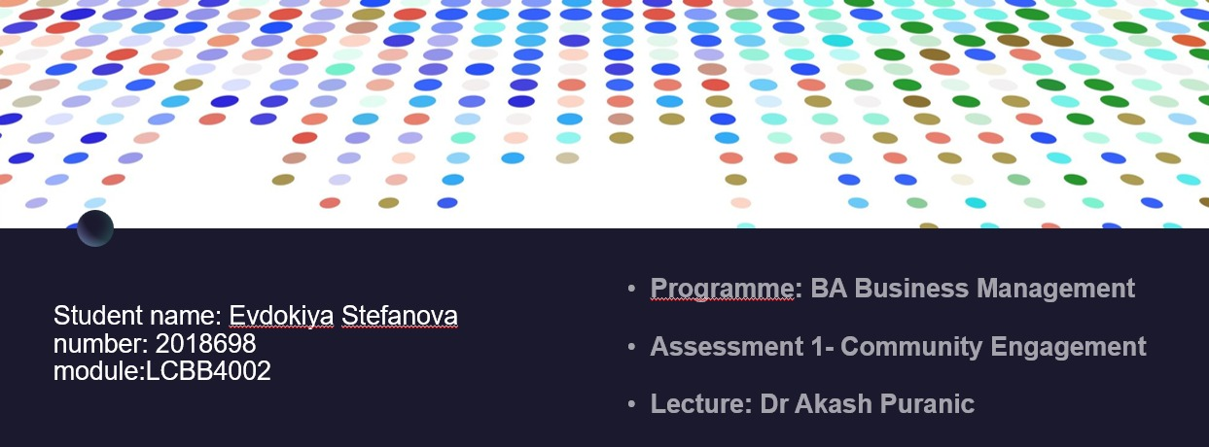

Contents
Introduction 3
The British Red Cross & Their Impact 4
Humanitarian Services 4
Emergency Response 4
Health and Social Care 4
First Aid Training 4
International Aid 4
Volunteering 5
Fundraising and Donations 5
Community Principles and the Red Cross 6
Inclusivity and Diversity 6
Collaboration and Partnership 6
Respect and Empathy 6
Transparency and Communication 6
Active Listening 6
Shared Decision-Making 6
Capacity Building 7
Long-term Engagement 7
Platforms/Tools 7
Website 7
Printed Materials 7
Workshops 7
Local Media 7
British Red Cross Standards 8
Evaluation 8
Conclusion 9
References 10

Introduction

The British red cross, as part of an international larger organization the Red Cross, is a humanitarian organization with the goal of reducing human suffering. In this report I will talk about community engagement principles and how they relate to the British red cross as well as the many impacts it has on society and communities. I will also explore the standards the red cross abides by and the platforms and tools it uses to reach communities and expand its name. Concluding with a conclusion where I will highlight my main findings.

The British Red Cross & Their Impact

The British red cross is a humanitarian organization that operates in the United Kingdom, part of an international red cross movement which is a global network of organizations dedicating their efforts to provide humanitarian assistance and responding to disasters by helping communities.
They were established in 1870 and received a royal charter in 1908, their mission at the time to help wounded soldiers but evolved over time to the mission of helping anyone in crisis, both locally and internationally. The principles that guide the red cross are as said by Pictet (1956) 'impartiality, neutrality, independence, voluntary service unity and universality’.

Humanitarian Services
The red cross provides a range of services such as emergency response, refugee support, first aid training, humanitarian education, and health and social care. The activities of the organization are many but all covering applicable in areas like disaster management, health and social care in the community and international aid.

Emergency Response
The red cross has a vital role in emergencies within the UK, they have emergency response teams that offer immediate assistance during natural disasters or other crisis like terrorist attacks. The organization provides practical support as they work with local emergency services and authorities and emotional support to victims or affected communities.
For example O’Dowd (2017) tells us that the British red cross ‘had several NHS trusts call to help them cope with demand’, which shows the reliability and reputation of this organization.

Health and Social Care
They operate various health care services that aim to improve the well-being of vulnerable patients. These services include support after hospital discharge, help providing mobility aids such as crutches, offering transport services for medical appointments and offering support services for refugees running away from dangerous situations.

First Aid Training
The first aid programs of the red cross are world-renowned, they offer a wide range of courses from basic to advanced for professionals. The organization helps equip people with the necessary skills and knowledge to help in emergency situations, which potentially saves lives and minimizes casualties in accidents.

International Aid
They actively help international humanitarian efforts in countries at war or impoverished areas. They help via providing emergency aid, health services, clean water and sanitation, etc. They help vulnerable regions survive and strengthen their systems for continued survival.

Volunteering
The red cross is not mandatory, it is comprised by dedicated volunteers who deliver the services through their time, skills, and compassion to help people in crisis.

Fundraising and Donations
The funding of the red cross is through public donations and fund raisings that help support its activities. The funds are then used to help those in need within the UK and outside too.
The aims of the red cross is to alleviate human suffering and promote inclusion, a great commitment to provide humanitarian relief through the sacrifices of volunteers that want others to see a better tomorrow, because of this the organization is very well respected and influential locally and internationally.

Community Principles and the Red Cross

Every few years the British red cross has strategic reviews of their goals, the 2015-2019 review stated that ‘the value and uses of user involvement will need to be shared and communicated across the organization’ as shown by Hickin (2016), this is because they want to make people the heart of their work by understanding their needs through active listening, and this requires community involvement.

The British red cross utilizes community engagement principles in various ways.

Inclusivity and Diversity

- Looking for opinions from diverse types of community members, to make sure no group is underrepresented or marginalized, making sure every voice is heard and considered.
- Making an effort to accommodate the unique needs of different communities, such as different languages.

Collaboration and Partnership
- Collaborating with local organizations and government agencies to work together in bettering communities.
- Planning and implementing projects with the help and input of partnerships such as government agencies.

Respect and Empathy
- Treating staff, patients and partners with respect in all communications.
- Understanding the value of diverse backgrounds and experiences that other people can input.

Transparency and Communication
- Sharing information honestly and transparently when it concerns goals and decisions.
- Updating regularly to the community on progress, outcomes and results of people’s involvement.

Active Listening
- Through surveys and other methods of communication, let the community and partners voice their concerns and ideas, and consider them fairly.
- Using the input of partners and community where necessary such as in future projects.

Shared Decision-Making
- Involving community members or partners in decisions that involve them, such as allocating funds to new projects.
- Giving opportunities for other’s ideas and expertise to impact project planning.

Capacity Building
- Building community and partner’s skills by helping them achieve the necessary skills and knowledge to participate in projects by offering training programs such as workshops and resources such as information.

Long-term Engagement
- Sustaining relationships over time making sure members are involved often and informed.
- Supporting community initiatives and encouraging them to thrive and take control of their own well-being projects.
Applying these lets the red cross have meaningful engagement with people, which enhances the effectiveness of their projects as they better understand the needs of people. These principles build trust and achieve long lasting positive impacts as they prepare communities and individuals to take care of themselves, Dixon et al. (2014) say ‘services are geared towards helping people to regain their independence during times of difficulty’.

Platforms/Tools

Website
The red cross has dedicated sections on their website that outlines their goals and information about them.

Printed Materials
They have leaflets with information about how people can get involved and the range of services they offer, these can usually be found in GP practices and other health facilities.

Workshops
The red cross has many workshops where they teach about many things including basic first aid or other crisis response techniques, they also have informational workshops for prospective nurses and members. Members usually join these workshops out of many reasons, Waikayi et al. (2012) say a few of these reasons could be ‘to carry out work that is valued in the local community and for self-satisfaction’.

Local Media
Local media often reports on the activities of the red cross, and gives them visibility by sharing the updates on ongoing projects, volunteering opportunities and other ways in which the community can help.
The red cross has many tools to ensure their objectives are clearly communicated and easily visible, this builds trust and honesty that their resources are being used as advertised and are actually having an impact.

British Red Cross Standards

The red cross operates based on the sphere standards, according to Andre and Collins (2001), these are ‘a set of standards governing the implementation of relief programmes’. They cover guidelines such as water supply and sanitation, shelter and food security.
The red cross also adheres to a code of conduct which outlines ethical principles and professional standards for humanitarian organizations in delivering assistance and support, according to Mourey (2008) ‘it is a voluntary code implemented by the consent of organisations which accept it’, so the red cross voluntarily pledged to follow their ten principles, the most important ones being that the humanitarian cause comes first, and that help is given regardless of race or nationality and without bias, with aid priorities being decided based on need alone.
They also follow health and safety standards to ensure the well-being and protection of its staff, volunteers, and beneficiaries during humanitarian operations.

Evaluation

The red cross tracks their success via monitoring their results through data collection, be it surveys or amount of casualties reduced. They also document case studies and success stories to highlight specifically how their involvement in a situation has saved lives which also serves as proof of their efforts and encourages more people to support them. For example the murder of Ricardo Munguia, an engineer for the red cross cast doubt whether the red cross could remain impartial and provide equal aid to both sides of a conflict, however as said by Terry (2011), ‘the red cross persevered and managed to show both sides the benefits of having a neutral intermediary in conflict’, and managed to keep helping afghans in need of humanitarian assistance.
The red cross also learns from their past and keeps improving their practices to deal with new issues and allow for new situations, they use their past findings to review their projects and programs and improve them to save more lives and help more people.

Conclusion

The British red cross is a humanitarian organization operating in the UK and is part of a larger organization that operates worldwide. They follow community engagement principles to engage with communities and understand their needs and wants, to help them be independent and prepare some of them for crisis responses.
The red cross follows many standards such as the sphere standards and other codes of conduct which provide ethical frameworks for humanitarian relief efforts.
The impacts of the red cross are many as they mainly provide emergency responses, disaster relief, social services, first aid education, etc., having a great positive impact and difference in people’s lives.
The red cross encompasses the principles of humanity, impartiality, neutrality, and solidarity, as their goal is to reduce human suffering and protect human life while building strong communities that can withstand emergencies.

References

André, G., & Collins, S. (2001). Raising standards in emergency relief: how useful are Sphere minimum standards for humanitarian assistance?. Bmj, 323(7315), 740-742. Available at: https://www.bmj.com/content/323/7315/740.short Accessed on 27th June 2023
Dixon, J., Winterbourne, S., Lombard, D., Watters, S., Trachtenberg, M., Knapp, M., ... & McNulty, A. (2014). An analysis of the economic impacts of the British red cross support at home service. Available at: https://eprints.lse.ac.uk/58581/1/dp2869.pdf Accessed on: 27th June 2023
Hickin, N. L. (2016). Service user involvement in the British Red Cross: experience and factors affecting willingness to participate (Doctoral dissertation, University of East London). Available at: https://repository.uel.ac.uk/download/5347452545b573d11c5f7e07f017a28057921e582744a67a4c6b9f79693afb07/2146258/U1331818%20THESIS%2023.08.pdf Accessed on: 27th June 2023
Mourey, A. (2008). Follow-up of the Code of Conduct of the International Red Cross and Red Crescent Movement. Food aid and human security, 309-325. Available at: https://books.google.co.uk/books?hl=en&lr=&id=xz15kVGb1YgC&oi=fnd&pg=PT291&dq=Code+of+Conduct+for+the+International+Red+Cross&ots=mlPEH_8-Yx&sig=sYpEwAc7T3LQDss4HugzxOadjU8#v=onepage&q=Code%20of%20Conduct%20for%20the%20International%20Red%20Cross&f=false Accessed on 27th June 2023
O’Dowd, A. (2017). Doctors condemn need for Red Cross to step in to aid NHS in “humanitarian crisis”. Available at: https://www.bmj.com/content/356/bmj.j127 Accessed on: 27th June 2023
Pictet, J. S. (1956). Red Cross Principles. International Committee of the Red Cross. Available at: https://library.icrc.org/library/docs/DOC/DOC_00028.pdf Accessed on: 27th June 2023
Terry, F. (2011). The International Committee of the Red Cross in Afghanistan: reasserting the neutrality of humanitarian action. International Review of the Red Cross, 93(881), 173-188. Available at: https://www.cambridge.org/core/journals/international-review-of-the-red-cross/article/abs/international-committee-of-the-red-cross-in-afghanistan-reasserting-the-neutrality-of-humanitarian-action/D2A267AA151B572CBE4390ADEE2FE356 Accessed on 27th June 2023
Waikayi, L., Fearon, C., Morris, L., & McLaughlin, H. (2012). Volunteer management: an exploratory case study within the British Red Cross. Management Decision, 50(3), 349-367. Available at: https://www.emerald.com/insight/content/doi/10.1108/00251741211216188/full/html Accessed on: 27th June 2023

