

INTERNATIONAL MARKETING



NAME: Antonella Gaeta
STUDENT NUMBER: 2217962
MODULE: International Marketing LCMB7006
LECTURER: Tushara Balendran
COURSE: Master of Business Administration
SUBMISSION DATE: 5th May 2023

Executive summary

Most successful business organizations must calculate key performance indicators (KPIs) to get higher priority in competitive market segments. This report has explored an in-depth analysis of the international marketing strategy of a well-established corporation. In order to develop the project plan considered McDonald's. McDonald's Corporation is a global fast-food chain that was founded in 1940 by Richard and Maurice McDonald in San Bernardino, California. It operates business in both the UK and Australia. Following the business segmentation, this study has investigated in-depth analysis for both of the countries. This written context helped to identify a comparison between two different dimensions and controlling business processes of this company. Engagement of literature and usage of multiple website-related information assist this study to provide insight. Moreover, the application of intellectual skills evaluates multiple hypothesis deals of the company. In the marketing context, it has developed a different model and discussion as well. Relating the practical skill and culture of McDonald it has underpinned a strong recommendation and conclusion at the end of this report.

Table of Contents
Introduction 4
Background of the company 4
Market audit of McDonald's 5
Pestle analysis for both the countries 5
Discussion of marketing strategy 17
SWOT analysis 17
STP analysis 20
Service description of McDonald 20
Examining the STP paradigm 21
Perception Map of McDonald's by product 23
Perception Map of McDonald's by country based on product 24
Marketing strategy of McDonald's 26
New market entry method of McDonald's 26
Evaluation of directional development strategy 30
Market expansion strategy using Ansoff matrix 30
Recommendation for further development in multiple countries 31
Conclusion 33
References 34

Introduction
Marketing is the process of identifying, anticipating, and satisfying customer demands and wants through the creation, promotion, and distribution of products or services (Sun, 2022). The goal of marketing is to increase sales, build brand awareness, and establish a loyal customer base. Marketing is an essential part of any business and plays a critical role in achieving long-term success. Based on the consequence this report study will help to understand the role of business marketing and the impact of international marketing. In this marketing operation, McDonald's has been considered to represent a compare and contrast. This company is hosted in multiple countries all over the world hence, a comparison between the two different countries namely the United Kingdom and Australia will be developed in this report.

Background of the company
McDonald's Corporation is a global fast-food chain that was founded in 1940 by Richard and Maurice McDonald in San Bernardino, California. It is now one of the largest fast-food chains in the world, serving millions of customers every day in more than 39,000 locations across 119 countries (Mcdonalds.com, 2023). In 2020, McDonald's reported revenue of $19.2 billion, which was a decrease from the previous year due to the COVID-19 pandemic's impact on the restaurant industry (Yahoo.com, 2023). One key competitor of McDonald's is Burger King, which is another global fast-food chain that was founded in 1954. Burger King operates in over 100 countries and has more than 17,000 locations worldwide (Mcdonalds.com, 2023). Looking briefly at the market size of this company, as of 2021, the fast-food market size in the UK is estimated to be around £23.2 billion (Statista.com, 2023) while, in Australia, the fast-food market size is estimated to be around AUD 21.4 billion (IBISWorld.com, 2023). However, it's worth noting that the COVID-19 pandemic has had an impact on the industry, with some declines in revenue due to reduced consumer spending and restrictions on dining out.
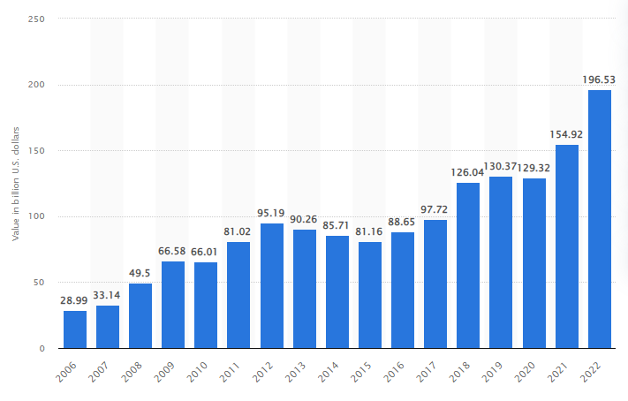
Figure 1: Branding value statistics of McDonald globally from 2006-2022
(Source: Statista.com, 2023)
Following the above statistical demographics stated in Figure 1, McDonald's brand value has seen fluctuations over the years. In 2006, the global brand was valued at $28.99 billion, which increased to $95.19 billion in 2012. However, the value dropped to $88.65 billion in 2016, hence quickly reflected back to $130.37 billion in 2019 (Statista.com, 2023). In 2020, the brand value decreased to $129.3 billion due to the COVID-19 pandemic's impact on the restaurant industry, furthermore, in 2021, it recovered to $154.92 billion. In 2022, McDonald's brand value is estimated to be $196.53 billion (Statista.com, 2023). Despite some fluctuations, McDonald's has consistently been one of the most valuable brands in the world.

Market audit of McDonald's

Pestle analysis for both the countries

PESTLE | FACTORS | IMPACT
POLITICAL | - Potential changes to UK immigration policies (Gov.uk, 2023).  - Political instability.  - Political index rate is 0.54 points (Gov.uk, 2023). | POSITIVE
POLITICAL | - Australian government has strict regulations (Australia.gov.au, 2023).  - Political stability is much higher. | POSITIVE
ECONOMIC | - GDP rate 3.19 lakh crores US dollars (2021).  - Exchange rate between the British pound.  - Changes in supply chain costs.  - Corporate tax rate 19% (Gov.uk, 2023). | POSITIVE
ECONOMIC | - Australian economy experienced steady growth with a GDP of AUD 1.3 trillion in 2021 (Australia.gov.au, 2023).  - Unemployment activity are quite low. | POSITIVE
SOCIAL | - Highest population consider 6.73 crores in 2021 (Gov.uk, 2023).  - Changes in consumer preferences.  - Social norms and attitudes towards fast food and health. | POSITIVE
SOCIAL | - Increasingly health-conscious.  - Variety of dietary restrictions and cultural tastes. | POSITIVE
TECHNOLOGICAL | - Cyber security threats and data breaches.  - Online ordering and delivery.  - Robotic operation of industrialisation. | POSITIVE
TECHNOLOGICAL | - Availability of mobile ordering and payment options.  - Availability of delivery service. | POSITIVE
LEGAL | - Employment act “1966 c” (Gov.uk, 2023).  - UK labour laws.  - Intellectual property laws. | NEGATIVE
LEGAL | - Number of regulations to combat obesity and encourage healthier eating.  - safe working conditions and availability of sick leave. | POSITIVE
ENVIRONMENTAL | - Waste and greenhouse gas emissions.  - Crisis cost of sustainable packaging materials.  - Rapid changes of climate (Gov.uk, 2023). | NEGATIVE
ENVIRONMENTAL | - Becoming more environmentally conscious.  - Affected by climate change (Australia.gov.au, 2023).  - Reduce carbon footprint impact on the environment. | NEGATIVE

Table 1: PESTLE analysis for both country
(Source: Self-developed)
Political factors
In the UK, there is a substantial focus on health and safety regulations, particularly in the food industry. This indicates that McDonald's needs to comply with strict regulations around food preparation, labelling, and advertising. Additionally, the UK has implemented a sugar tax, which impacts the pricing and marketing of sugary beverages sold by McDonald's. On the other hand, in Australia, the political landscape is generally favourable for business, with a focus on deregulation and reducing red tape. As opined by Kirk and McDonald (2021), the country has implemented strict regulations around minimum wage and penalty rates, which can impact labor costs for McDonald's. There is growing public concern around issues such as environmental sustainability and animal welfare, which could potentially impact McDonald's reputation and sales. Both of the countries have created a positive effect on the business operation of McDonald's.
Economic factors
The UK economy is heavily impacted by Brexit and the ongoing negotiations around trade deals. This uncertainty could impact consumer confidence and ultimately impact McDonald's sales. Additionally, the UK has a higher cost of living compared to Australia, which could impact the affordability of McDonald's products for some consumers. Moreover, the Australian economy has been impacted by the COVID-19 pandemic, with reduced consumer spending and increased unemployment rates. This could impact McDonald's sales in the short term, although government stimulus measures may help to mitigate some of these effects. As observed by Darcy et al. (2022), the Australian market is more heavily influenced by trends in healthy eating and sustainability, which could impact the demand for McDonald's products.
Social factors
Following the social culture, there is a growing trend towards healthier eating and a concern for sustainability and animal welfare. This could impact McDonald's sales and reputation, especially as there is increased competition from healthier fast-food alternatives. Additionally, the UK has an ageing population, which could impact McDonald's sales as older consumers may have different preferences and priorities. Compared to the UK, Australia also contains a powerful emphasis on outdoor living and a healthy lifestyle, which could impact the popularity of McDonald's products (Thompson et al. 2020). Additionally, there is a growing awareness of the impact of fast food on health, which could impact McDonald's reputation and sales. However, the country also has a large youth population, which may be more likely to consume fast food products. Hence, large populations of both countries are quite favourable for this company to continue business operations.
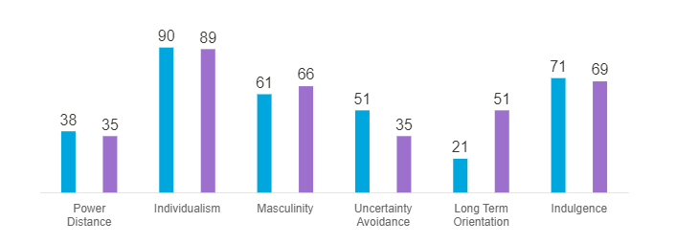
Figure 2: Hofstede insights into cultural dimension
(Source: Hofstede-insights.com, 2023)
Hofstede’s insight, based on his renowned cultural dimensions theory, highlights that culture plays a crucial role in shaping human behaviour and values and that it varies across different societies. As suggested by Wenxin and Yue (2022), Hofstede's model can help predict how individuals from different cultures might behave in various situations and how they might approach business or other interactions.
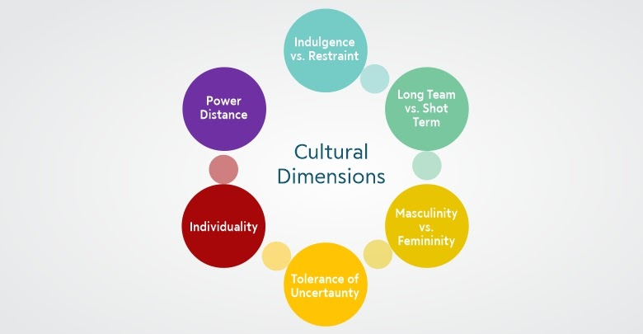
Figure 3: Hofstede cultural dimensions Model
(Source: Trainerslibrary.org, 2020)
Discussion of Hofstede's insights
Based on Figure 1, the Power Distance dimension deals with societal attitudes towards inequality. Australia has a low score (36), with accessible hierarchy, frequent consultation, and informal, direct communication in organizations. While, Australia, scoring 90 on the Individualism dimension, is a highly individualistic culture where self-reliance and initiative are expected in the business world (Hofstede-insights.com, 2023). Hiring and promotion are based on merit and evidence of performance. Australia has a high score of 61 on the Masculinity dimension, indicating a society driven by competition, achievement, and success. Australians value striving to be the best and winning, with a focus on individual successes and resolving conflicts at the individual level. Australia has a moderate score of 51 on the Uncertainty Avoidance dimension, indicating a society that deals with ambiguity and unknown situations with an intermediate approach (Hofstede-insights.com, 2023). Moreover, Australian society has a normative culture, valuing traditions and exhibiting low savings propensity with a focus on immediate results. Australia, with a score of 71, is classified as an Indulgent country where people tend to freely pursue pleasures, leisure, and optimism, without strict control over desires and impulses.
Advantages and disadvantages of Hofstede’s model:
ADVANTAGES | DISADVANTAGES
Cross-cultural communication: The model helps individuals understand how different cultures perceive the world and communicate. | Limited scope: The model only focuses on a few cultural dimensions and ignores other factors that influence cultural differences.
Practical application: The model has practical applications in various fields such as business, education, and healthcare to help individuals understand cultural differences and adapt to different cultural contexts. | Generalizations: The model is based on national averages, which may oversimplify complex cultural realities and create generalizations.
Global perspective: Hofstede's model provides a global perspective that allows individuals to understand how cultural dimensions differ across countries and regions. | Lack of flexibility: The model assumes that cultural differences are stable and fixed, which does not account for the dynamic nature of cultures and how they change over time.
Validity and reliability: The model has been tested and validated through empirical research in various cultures around the world, which supports its reliability and validity. | Western bias: Some critics argue that Hofstede's model has a Western bias as it was developed by a Western researcher and reflects Western cultural values and assumptions.
Table 2: Advantages and disadvantages of Hofstede’s model
(Source: Self-developed)
Advantages and disadvantages of Hofstede’s model for the United Kingdom and Australia:
Advantages:
Cultural understanding:
Hofstede's model can help McDonald's to understand the cultural differences between the UK and Australia, which can inform their marketing and advertising strategies.
Employee management:
McDonald's can use the model to understand the different work values and attitudes in the UK and Australia, which can inform their employee management strategies.
Product customization:
The model can also help McDonald's to customize their products to suit the different cultural preferences and tastes of the UK and Australian markets.
Disadvantages:
Limited scope:
Hofstede's model only focuses on a few cultural dimensions and ignores other factors that may influence cultural differences, such as regional variations within a country.
Oversimplification:
Using the model to make generalizations about entire cultures can oversimplify complex cultural realities and may not accurately reflect the diversity within cultures.
Lack of flexibility:
The model assumes that cultural differences are stable and fixed, which does not account for the dynamic nature of cultures and how they may change over time.
Western bias:
Some critics argue that Hofstede's model has a Western bias, which may not accurately reflect the cultural values and assumptions of the UK and Australian markets.
Technological factors
High level of digital penetration assisted its consumers to use digital platforms for ordering food and making payments. This benefit helped McDonald's to develop and implement advanced digital technology, such as self-service kiosks and mobile ordering apps. According to Darcy et al. (2022), there is an assertive preoccupation with data privacy and protection, which impacts the way McDonald's collects and uses consumer data. In Australia, there is also a high level of digital penetration, although the adoption of mobile payment systems and other digital technologies is not as widespread as in the UK. Wilson et al. (2020), argue that there is a focus on sustainability and reducing environmental impact, which has led to the development of eco-friendly packaging and a commitment to reducing food waste.
Legal factors
The legal factors that impact McDonald's operations in the UK and Australia are influenced by their respective legal systems (Gov.uk, 2023). In the UK, the food industry is heavily regulated to protect consumer safety, and McDonald's must comply with strict regulations concerning labeling, advertising, and food safety. As proposed by Tien et al. (2020), there is a concerted action to decrease the bad impact of fast food on public health that measures such as the sugar tax and restrictions on advertising to children. On the other hand, Australia also has regulations regarding food safety and advertising, although the legal environment is generally more favourable to businesses than in the UK. McDonald et al. (2020), propose that there is an emphasis on workers' rights, with minimum wage and penalty rates regulations that can impact labour costs for McDonald's.
Environmental factors
These factors are increasingly important considerations for businesses like McDonald's operating in the UK and Australia. In the UK, the focus is on reducing waste and promoting sustainability, with measures such as a plastic bag tax and reducing food waste (McDonald et al. 2021). McDonald's in the UK is committed to using eco-friendly packaging and reducing its carbon footprint to meet these environmental standards. Similarly, in Australia, the emphasis is on sustainability, particularly in relation to water usage and land conservation. As proposed by Enright et al. (2020), efforts to reduce single-use plastics, such as the ban on plastic bags in some states, have also been implemented. McDonald's in Australia is committed to reducing its carbon footprint and has implemented recycling and renewable energy measures to meet these environmental standards.
Similarities and differences in both of the countries
McDonald's is a global fast-food chain that operates in various countries worldwide. Despite the shared brand name and products, the McDonald's experience can vary widely depending on the country of operation. Here are some similarities and differences for McDonald's in the UK and Australia:
Similarities:
Menu:
McDonald's in the UK and Australia offer similar menus that feature popular items like burgers, fries, and soft drinks.
Business model:
McDonald's in the UK and Australia use a similar business model based on franchising, where independent franchisees operate individual restaurants under the McDonald's brand.
Brand recognition:
McDonald's is a well-known and recognizable brand in both the UK and Australia, with a strong presence in major cities and towns across both countries.
Technology:
McDonald's in both countries have incorporated technology into their restaurants, with features such as self-service kiosks, mobile ordering, and delivery services.
Differences:
Cultural differences:
Despite some similarities, there are significant cultural differences between the UK and Australia that can impact the McDonald's experience. For example, Australian customers may have a greater preference for outdoor dining and leisure activities, while UK customers may prioritize convenience and speed of service.
Menu variations:
While the core menu items are similar in both countries, there are variations to cater to local tastes. For example, McDonald's in Australia offers items such as the "McOz" burger, which includes a beetroot slice, while McDonald's in the UK has items such as the "Cadbury Creme Egg McFlurry."
Supply chain:
McDonald's in the UK and Australia have different supply chains that cater to local demand and regulations. For example, McDonald's in the UK sources its beef from UK and Irish farmers, while McDonald's in Australia sources its beef from Australian farmers.
Marketing and promotions:
McDonald's in the UK and Australia may have different marketing and promotional strategies to cater to local preferences. For example, McDonald's in Australia may offer promotions related to major sporting events, while McDonald's in the UK may offer promotions related to holidays such as Christmas. With the help of the above discussion, it might be stated that while there are some similarities between McDonald's in the UK and Australia, there are also significant differences that reflect cultural, regulatory, and logistical factors. McDonald's in both countries must be responsive to local demand and preferences to ensure a successful operation.
Porter’s five forces model
Five forces | Factors | Impact
Threat of New Entrants | - Low barriers to entry (franchise model).  - High brand recognition. | MODERATE
Bargaining Power of Suppliers | - Powerful suppliers (e.g. Coca Cola).  - Diverse range of suppliers. | LOW
Bargaining Power of Buyers | - Large customer base.  - High level of price sensitivity. | MODERATE
Threat of Substitutes | - Healthier alternatives gaining popularity.  - Convenience of substitutes may impact sales. | MODERATE
Competitive Rivalry | - High level of competition (e.g., Burger King, Wendy's, KFC).  - Similar products and services. | HIGH
Table 3: Porter five forces of McDonald in both countries
(Source: Self-developed)

Threat of New Entrants
The fast-food industry has relatively low barriers to entry, which means new competitors can enter the market easily. However, establishing a strong brand and a loyal customer base like McDonald's requires significant investments in advertising, real estate, supply chain management, and technology (Raj and Singh, 2021). In addition, complying with health and safety regulations, labour laws, and environmental standards is also costly. Therefore, the threat of new entrants is moderate.
Bargaining Power of Suppliers
McDonald's relies on a vast network of suppliers for its raw materials, such as beef, chicken, potatoes, and packaging. Some of these suppliers are global giants, like Coca-Cola, Nestle, and Sysco, while others are local farmers and producers. The bargaining power of suppliers is relatively low, as McDonald's can leverage its scale, reputation, and long-term contracts to negotiate lower prices, higher quality, and timely delivery (Sun, 2022). However, any disruption in the supply chain, such as weather conditions, strikes, or pandemics, can affect McDonald's operations and profitability.
Bargaining Power of Buyers
McDonald's serves a diverse and loyal customer base, ranging from children to adults, and from low-income to high-income households. Therefore, the bargaining power of buyers is moderate. However, customers have become increasingly health-conscious and environmentally aware, which has led to a rise in demand for organic, vegetarian, and sustainable options. Onyusheva and Salim (2022), stated that to retain and attract customers, McDonald's has launched several initiatives, such as the "Better M" platform, the "McPlant" burger, and the "Greening McDonald's" campaign.
Threat of Substitutes
Since customers can readily move to other fast-food chains, casual eateries, or home-cooked meals, McDonald's confronts a moderate threat from substitutes. Additionally, getting food from various sources is now more accessible and convenient thanks to the growth of food delivery services like Uber Eats, Deliveroo, and Just Eat. As per the recommendation of Chong (2022), McDonald's can be distinguished from alternatives due to its powerful brand equity, a wide selection of menu items, and consistent taste and quality across all of its outlets.
Competitive Rivalry
In the UK and Australia, McDonald's faces competition from a number of fast-food companies, including KFC, Burger King, Subway, and Pizza Hut. Given that all of these players provide comparable products, prices, and promotions, there is a high degree of competition. As per the suggestions of McDonald and Eisenhardt (2020), the fast-food sector is extremely vulnerable to changes in the economy, society, and technology, which may have an impact on customer preferences and actions. In order to remain ahead of its competitors, McDonald's must constantly innovate, adapt, and differentiate.
Based on the above discussion it can conclude that the Porter Five Forces analysis shows that McDonald's faces moderate to high competitive pressures in the UK and Australia. However, it can leverage its strengths, such as brand equity, supply chain efficiency, menu innovation, and customer experience, to mitigate the threats and capitalize on the opportunities.
Similarity and differences with two countries of porters five model
McDonald's is subject to similar competitive pressures in both the UK and Australia, according to the Porter's Five Forces research. Both markets feature moderate buyer bargaining power, low entry barriers, and moderate to high substitute threat levels. Furthermore, McDonald's can take advantage of opportunities in both nations by leveraging its advantages, such as brand equity, supply chain effectiveness, menu innovation, and customer experience. However, there might be some variations between the marketplaces in the UK and Australia in terms of particular rivals and customer preferences, as well as adherence to regional laws and environmental requirements.

Discussion of marketing strategy

SWOT analysis
Strength | Weakness
- Globally recognized brand in both the UK and Australia (Mcdonalds.com, 2023).  - Wide range of menu options  - Strong focus on innovation and technology. | - Faced criticism for its high-calorie and high-fat menu options.  - Faced criticism for its environmental impact related to plastic waste.  - Changing consumer preferences and increased competition.
Opportunities | Threats
- Increasing trend towards healthier eating and plant-based diets.  - Growing popularity of delivery services.  - Exploration of new markets and demographics. | - Changing regulations and consumer behaviour in UK and Australia.  - Increased competition from other fast-food chains.  - Changes in consumer preferences and the rise of health and wellness trends.

Table 4: SWOT analysis for McDonald in both of the country
(Source: Self-developed)
The above demonstrated SWOT analysis emphasizes key strengths, weaknesses, opportunities, and threats that a fast-food chain operating in both the UK and Australia may face. One of the major strengths of the fast-food chain is its globally recognized brand, which can provide a competitive advantage in attracting customers (Mcdonalds.com, 2023). However, as suggested by Rajawat et al. (2020), the Company provides a wide selection of menu choices and prioritises innovation and technology, which can help it appeal to a wider audience of customers and keep up with shifting market trends. The company has come under fire for its high-calorie and high-fat menu selections, which may reduce its appeal to consumers who are health-conscious. It has also come under fire for the effects plastic waste has on the environment, which could harm its reputation and reduce consumer loyalty.
As observed by Reddy et al. (2022), following strength can be utilized for mitigating different risk factors and endorse multiple increased opportunities in current market scenarios. The above discussion also highlights several opportunities for the chain, including the increasing trend towards healthier eating and plant-based diets that are able to disclose multiple opportunities to attract potential consumers. Based on the consumer base, exploration of new markets and demographics can help the chain to tap into new sources of revenue.
Similarities and differences of both countries:
Strengths:
Brand recognition:
McDonald's is a well-known and recognizable brand in both the UK and Australia, which can drive customer loyalty and repeat business.
Global presence:
McDonald's has a strong global presence, which can provide economies of scale in sourcing and supply chain management.
Technology integration:
McDonald's in both countries have incorporated technology into their restaurants, which can enhance the customer experience and streamline operations.
Weaknesses:
Competition:
Both the UK and Australia have a highly competitive fast-food market, which can make it challenging for McDonald's to maintain market share.
Health concerns:
There is growing concern about the health impacts of fast food, which can affect the reputation of McDonald's and drive customers to healthier options.
Supply chain challenges:
McDonald's in both countries face supply chain challenges related to sourcing and logistics, which can impact the quality and availability of menu items.
Opportunities:
Menu customization:
McDonald's can tailor its menu to cater to local tastes and preferences, which can attract new customers and differentiate the brand.
Expansion into new markets:
Both the UK and Australia have growing urban populations and emerging markets, which represent potential opportunities for McDonald's to expand its operations.
Sustainability initiatives:
McDonald's can implement sustainability initiatives such as reducing waste and sourcing more sustainable ingredients, which can appeal to environmentally conscious customers.
Threats:
Economic uncertainty:
Economic uncertainty and volatility can impact consumer spending and reduce demand for fast food.
Changing consumer preferences:
Consumer preferences are changing, with an increasing demand for healthier and more sustainable food options, which can affect McDonald's sales.
Regulatory challenges:
Both the UK and Australia have regulations that impact fast food operations, such as health and safety standards and labour laws, which can add complexity and costs to McDonald's operations.

STP analysis

Service description of McDonald
McDonald's is a global fast-food chain that serves a wide range of menu items such as burgers, fries, chicken, salads, breakfast items, and more. In the UK, McDonald's operates over 1,400 restaurants, with a revenue of approximately £2.4 billion in 2020. The company prides itself on its food quality and sourcing, with the majority of its beef, pork, and eggs being sourced from UK farms. McDonald's also offers a range of vegetarian and vegan options, including its popular Veggie Dippers and McPlant burger (Mcdonalds.com, 2023). Moreover, In Australia, McDonald's operates over 1,000 restaurants, with a revenue of approximately AUD 4 billion in 2020. It also proposes a range of menu items that cater to local tastes, including the McOz burger, which features beetroot, and the McChicken Caesar salad. In addition, the company has made a commitment to reducing its environmental impact in Australia, with initiatives such as recycling cooking oil and reducing plastic waste (Australia.gov.au, 2023).

Examining the STP paradigm
STP Analysis
Segmentation | - Geographic Segmentation  Country - UK and Australia.  Cities - Birmingham and Liverpool, UK (Gov.uk, 2023).  Sydney, Melbourne, Australia (Australia.gov.au, 2023).  - Demographic Segmentation  Age crowd - 15-25 years people.  Occupational placement - High and centre earning individuals.  - Psychographic Segmentation  Social class - Male & female both.
Target group | - Gen Z campaign with younger generation.  - Health-conscious consumers.  - Urban millennial to introduce new food item.  - International tourists in the UK and Australia.
Positioning | - More focus on sustainability.  - Leverage technology for integrating self-service policy.  - Emphasize brand heritage and convenience.  - Implementation of Product positioning strategy.
Table 5: STP analysis of McDonald
(Source: Self-developed)
The STP analysis provided is quite comprehensive, but it lacks some critical information to fully justify the segmentation, targeting, and positioning strategies suggested. Firstly, it is not clear why the chosen geographic locations are UK and Australia, and why specific cities within these countries were selected. As observed by Bhaskaran et al. (2021), without clear reasoning, the segmentation based on geographic criteria seems arbitrary and may not lead to successful marketing outcomes.
Likewise, the demographic segmentation based on age and occupational placement may not be adequate to fully understand the target market's needs and preferences. While targeting the younger generation and high-earning individuals may seem logical. It is essential to consider other demographic variables such as education level, cultural background, and lifestyle habits to create more nuanced and effective marketing strategies. As opined by Ma et al. (2021), the psychographic segmentation based solely on social class seems too broad and may not be precise enough to capture the target market's attitudes and behaviours accurately. It may be useful to include other variables such as personality traits, values, and interests to refine the psychographic segmentation further. Concerning positioning, while the focus on sustainability and convenience seems reasonable, the suggestion to leverage technology for integrating self-service policy is vague and requires further elaboration. As suggested by McDonald et al. (2019), it is also unclear how the brand heritage will be emphasized, and what specific actions will be taken to differentiate the product from competitors.

Perception Map of McDonald's by product
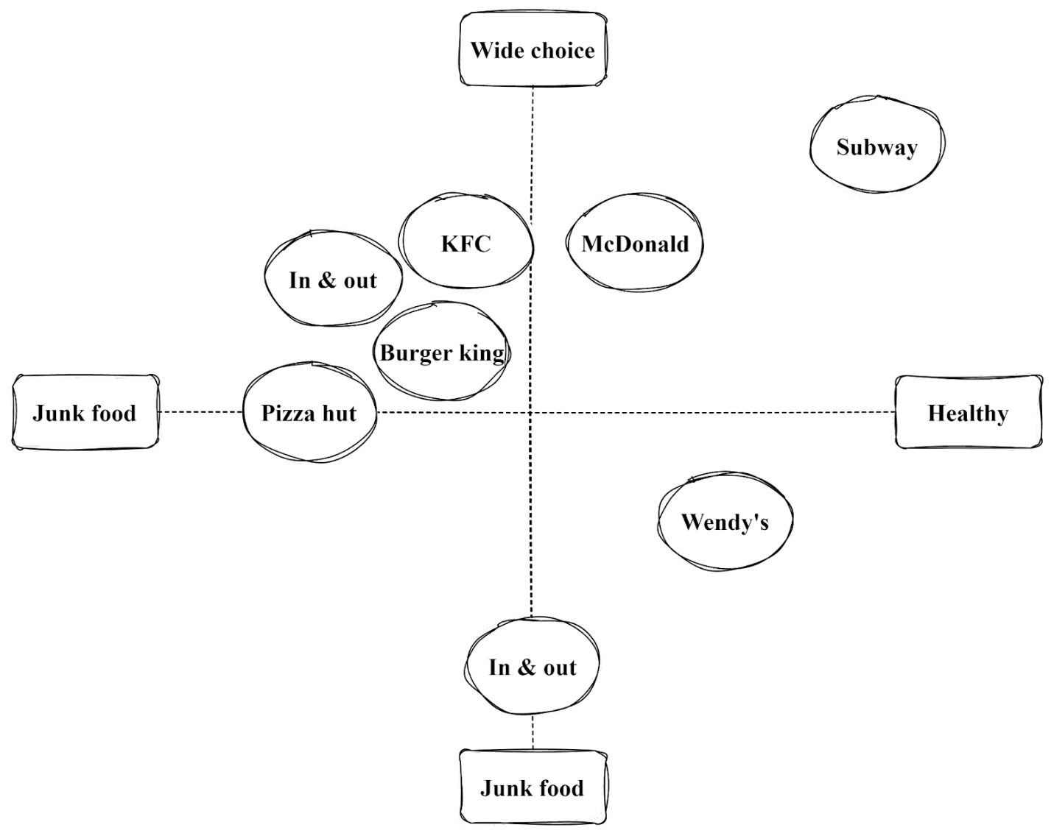
Figure 4: Perceptual map of McDonald's
(Source: Self-developed)
McDonald's perceptual map can be analysed through various perspectives, including its brand image, customer experience, menu offerings, global expansion, and social responsibility initiatives. This map provides a comprehensive overview of McDonald's positioning in the fast-food industry, its strategic focus, and areas for potential growth and improvement.

Perception Map of McDonald's by country based on product
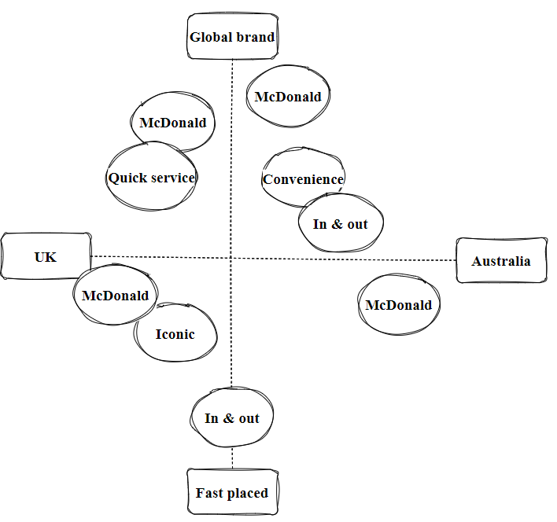
Figure 5: Perceptual map of McDonald's
(Source: Self-developed)
In the UK, McDonald's is perceived as convenient, affordable, and family-friendly. Meanwhile, in Australia, the keywords "convenience," "affordable," and "family-friendly" may also apply, along with a potential emphasis on "youthful" and "modern" due to the brand's appeal to a younger demographic.
Similarity and differences based on two countries.
Geographic segmentation with large cities as target markets, demographic segmentation with an emphasis on age group and occupational placement, and psychographic segmentation targeting both males and females are examples of comparisons between the UK and Australia. However, due to the cultural, economic, and lifestyle disparities between the two nations, there can be discrepancies in terms of location, target group preferences, and the execution of positioning tactics.

Marketing strategy of McDonald's

Element for market entry | Discussion of factors | Impact
Product | - Burgers, fries, chicken nuggets, salads etc.  - Limited time offers | McDonald's offers a wide range of products, including burgers, fries, chicken, salads, and desserts. The menu varies by country to cater to local tastes and preferences.
Price | - Affordable prices  - Value meals | McDonald's uses a value pricing strategy to offer affordable and competitive prices for its products. It also offers various promotions and discounts to drive sales.
Place | - Worldwide presence with over 38,000 locations | McDonald's has a large global network of restaurants, with over 38,000 locations in more than 100 countries. The restaurants are typically located in high-traffic areas such as shopping malls, airports, and city centres.
Promotion | - Advertising campaigns | McDonald's uses various promotional tactics to reach its target audience, including advertising, sponsorships, and social media. The brand also partners with popular events and organizations, such as the Olympics and FIFA World Cup.
People | - Friendly and efficient employees | McDonald's places a strong emphasis on customer service and training its employees to deliver a positive customer experience.
Process | - Standardized cooking and serving process | McDonald's has streamlined its ordering process with the use of technology, such as self-service kiosks and mobile ordering. It also offers delivery services in many countries.
Physical existence | - Iconic golden arches logo  - Consistent restaurant design and decor | McDonald's uses its iconic brand imagery and restaurant design to create a consistent and recognizable brand image across its global network of restaurants.
Table 6: 7P’s marketing strategy of McDonald
(Source: Self-developed)
From product and price to place and promotion, McDonald's has a global presence with efficient processes and friendly employees, offering affordable and quality fast food. The standardized processes and recognisable branding create consistency across all locations. Overall, the marketing strategy has been successful, as it has become a well-known and popular fast-food chain worldwide.

New market entry method of McDonald's
Following the above discussion and the potentiality of the company it can be recommended that one of the market entry methods of McDonald's is franchising.
McDonald's can quickly enter new areas thanks to franchising without having to make a sizable financial commitment. It has a vested interest in the success of its company and is highly motivated to do so, as Tien et al. (2020) noted. This often leads to better customer service, higher-quality products, and increased sales.
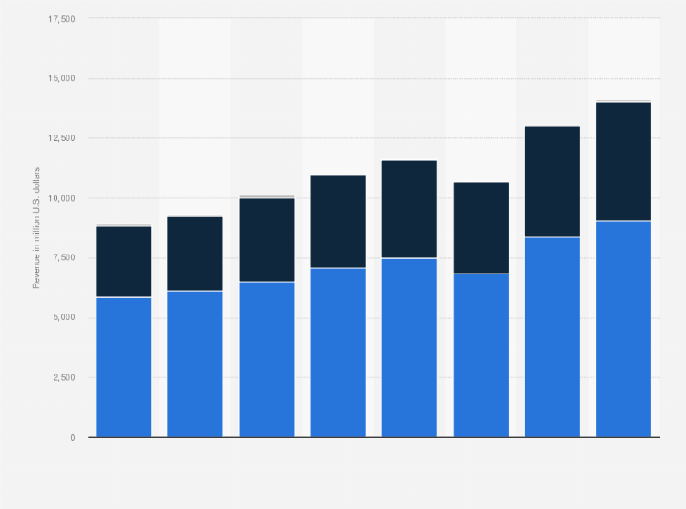
Figure 6: Revenue from franchised restaurants for the McDonald's Corporation globally from 2015 to 2022
(Source: Statista.com, 2023)
Advantages and Disadvantages of Franchising:
Franchising is a business model in which an individual (franchisee) is granted the right to use a company's (franchisor) name, brand, and business model to sell products or services in exchange for a fee. Franchising can be a lucrative business strategy, but it also has its advantages and disadvantages.
Advantages of Franchising:
Established brand recognition:
Franchisees can benefit from the established brand recognition of the franchisor. This can save time and resources that would otherwise be spent on building a new brand from scratch.
Proven business model:
The franchisor has already developed a successful business model, including operations, marketing, and management strategies. Franchisees can benefit from this experience and expertise.
Training and support:
Franchisors provide training and ongoing support to franchisees to ensure the success of the business. This can include assistance with site selection, operations, marketing, and financial management.
Access to financing:
Franchisees may have an easier time obtaining financing since lenders may be more willing to provide loans for established franchise brands with a proven track record of success.
Economies of scale:
Franchisees can benefit from the economies of scale that come with a larger organization. This can include purchasing power, marketing campaigns, and shared resources.
Disadvantages of Franchising:
Initial investment:
Franchisees typically need to make an initial investment to purchase the franchise rights, equipment, and inventory. This can be a significant financial burden, and there may be ongoing fees and royalties to the franchisor.
Lack of control:
Franchisees must adhere to the franchisor's rules and regulations, which can limit their ability to make independent decisions about the business. This can be frustrating for franchisees who want more control over their business.
Shared profits:
Franchisees must share a portion of their profits with the franchisor, typically in the form of royalties and fees. This can reduce the overall profitability of the business.
Limited creativity:
Franchisees must adhere to the franchisor's established business model, which can limit their ability to be creative and innovative with their products and services.
Reputation:
The reputation of the franchise brand can be negatively impacted by the actions of other franchisees. This can be a concern for franchisees who are invested in the success of the brand.
Looking to focus on the limitations it contains multiple issues and obstacles that include multiple operations. Franchises have some degree of autonomy in how they operate their businesses. This can lead to inconsistencies in product quality, customer service, and other aspects of the business. McDonald's may be held liable for the actions of its franchisees, including any legal issues that may arise from their operations. Finding and recruiting suitable franchisees can be a difficult and time-consuming process. As observed by Tournois and Forterre (2020), a lack of franchising training and support is also considered one of the largest limitations of the company. McDonald's must provide extensive training and support to its franchisees to ensure they understand the company's standards and guidelines. This requires significant time and resources.

Evaluation of directional development strategy
A directional developmental strategy is a growth strategy that involves focusing resources and efforts towards expanding the organization's existing products or services into new markets. This strategy is typically pursued when an organization has a strong competitive position in its current market and seeks to capitalize on that strength by expanding into new markets.
McDonald's, a global fast-food chain, uses a combination of developmental strategies in the UK and Australia. It has employed a diversification strategy in the UK, expanding its product line beyond fast food to include coffee, smoothies, and other items. According to Bretas and Alon (2021), this approach has helped to represent the company as a renowned fast food industry chain in the UK.
In Australia, McDonald's has implemented a directional developmental strategy by focusing on expanding its existing product lines into new markets. For example, the company has introduced new menu items tailored to Australian tastes and preferences, such as the "McOz" burger, which features beetroot and other toppings popular in Australia (Shah, 2022). Additionally, it has invested in upgrading its stores to offer a more premium dining experience, with modernized decor, table service, and digital ordering kiosks. These initiatives have enabled it to maintain its status as Australia's top fast-food brand and to expand its clientele there.

Market expansion strategy using Ansoff matrix
McDonald's has utilized the Ansoff Matrix to guide its business operations in both the UK and Australia, focusing on various strategies to drive growth and expand its customer base.
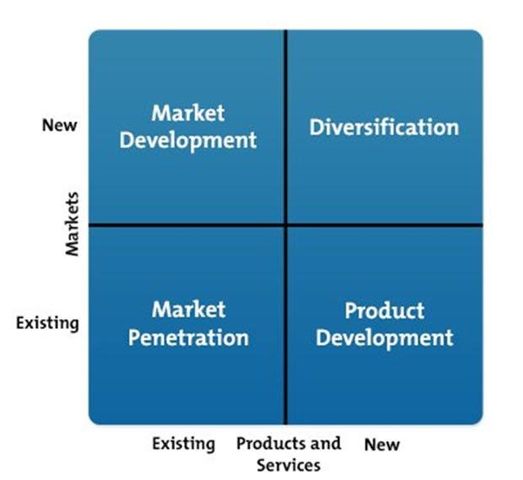
Figure 7: The Ansoff matrix model
(Source: Datta Chaudhuri, 2020)
In terms of market penetration, McDonald's has launched various promotional campaigns and loyalty programs in both countries to retain its existing customers and attract new ones (Kim et al. 2019). For example, in the UK, it introduced the "Great Tastes of America" promotion, which offered customer’s new limited-time menu items, while in Australia, the chain introduced the "MyMacca's" loyalty program, which rewards customers for their purchases.
In terms of product development, McDonald's has introduced new menu items to cater to changing customer preferences and tastes. For example, in the UK, the chain launched a vegan-friendly menu, including the McPlant burger, while in Australia, it introduced the "Create Your Taste" platform, allowing customers to customize their burgers using a touch-screen kiosk.
Concerning market development strategy, it has expanded its operations in both countries by opening new locations in underserved areas, particularly in suburban areas and transportation hubs. According to Khajezadeh et al. (2019), for instance, in the UK, the chain has opened several new locations in shopping centres and service stations, while in Australia, it has opened new outlets in regional areas. While McDonald's has not followed diversification in either country, it has continued to innovate and experiment with new business models, such as the introduction of its "McDelivery" service in both markets, offering customers the option to have their food delivered to their doorstep.

Recommendation for further development in multiple countries

TOWS matrix |  | External factors
 |  | Opportunities | Threats
Internal factors | Strength | - Strong brand recognition and global presence  - High level of standardization and consistency  - Growing popularity of online food delivery services | - Strong competition from local fast-food chains  - Changes in government policies  - Established supply chain and distribution channels
Internal factors | Weakness | - Increasing demand for healthier and more sustainable food options  - Rising disposable income of the middle-class  - Potential weaknesses in the product offerings | - Increasing concern over the health and environmental impact of fast food  - Increasing labor costs and a potential shortage of workers

Table 7: TOWS matrix of McDonald
(Source: Self-developed)
McDonald's can adopt several strategies to enhance its international marketing efforts. Majorly, it can use its strong brand recognition to expand into new markets and create a consistent brand image globally. As proposed by Abdollahpouri et al. (2020), by incorporating more plant-based and low-calorie menu items, it can take advantage of the rising demand for sustainable and healthy food choices. It can also partner with third-party delivery platforms to leverage the popularity of online food delivery services and reach more customers. Moreover, this company can invest in research and development to create more localized menu offerings that cater to local tastes and preferences while maintaining its core brand. The company can also focus on continuously improving its supply chain and operational processes to mitigate risks from commodity price fluctuations and supply chain disruptions. Finally, it can be recommended that McDonald's can improve its brand perception by highlighting its efforts to promote sustainability and ethical practices. These recommendations can help McDonald's to maximize its strengths and minimize its weaknesses, and position itself for success in the highly competitive global fast-food market.

Conclusion
Considering the overall study, it can conclude that McDonald's has successfully implemented its international marketing strategy and operations in both the UK and Australia. The company has tailored its menu, advertising, and overall brand image to fit the local cultures and tastes while maintaining its global brand identity. This has allowed becoming a popular and recognizable fast-food chain in both countries. However, the company has also faced challenges, such as increased competition and changing consumer preferences. In the overall context, McDonald's continues to adapt and evolve its marketing strategy to remain competitive in the global fast-food industry.

References
Abdollahpouri, H., Adomavicius, G., Burke, R., Guy, I., Jannach, D., Kamishima, T., Krasnodebski, J. and Pizzato, L., 2020. Multistakeholder recommendation: Survey and research directions. User Modeling and User-Adapted Interaction, 30, pp.127-158. Available at: http://arantxa.ii.uam.es/~cantador%20/doc/2019/umuai-aspects19.pdf
Australia.gov.au, 2023. Australian government website. [Online] Available at: https://www.australia.gov.au/ [Accessed on 1st April 2023]
Bakry, W., Kavalmthara, P.J., Saverimuttu, V., Liu, Y. and Cyril, S., 2022. Response of stock market volatility to COVID-19 announcements and stringency measures: A comparison of developed and emerging markets. Finance research letters, 46, p.102350. Available at: https://www.ncbi.nlm.nih.gov/pmc/articles/PMC8994447/
Bhaskaran, K., Bacon, S., Evans, S.J., Bates, C.J., Rentsch, C.T., MacKenna, B., Tomlinson, L., Walker, A.J., Schultze, A., Morton, C.E. and Grint, D., 2021. Factors associated with deaths due to COVID-19 versus other causes: population-based cohort analysis of UK primary care data and linked national death registrations within the OpenSAFELY platform. The Lancet Regional Health-Europe, 6, p.100109. Available at: https://www.medrxiv.org/content/medrxiv/early/2020/09/23/2020.09.22.20198754.full.pdf
Bretas, V.P. and Alon, I., 2021. Franchising research on emerging markets: Bibliometric and content analyses. Journal of Business Research, 133, pp.51-65. Available at: https://www.sciencedirect.com/science/article/pii/S0148296321003118
Chong, L.H.Y., Yang, X., Wei, Y., Wang, Y., Alzufairi, T.A. and Aljuwaisri, R.M.R., 2022. The Impact of Covid-19 to Mcdonald’s: Its Response and Post-Pandemic Plan. Advances in Global Economics and Business Journal, 3(1), pp.28-38. Available at: https://agebj.org/index.php/agebj/article/download/48/26
Darcy, M., Parkinson, J., McDonald, N., Moriarty, S., Kadariya, S. and Sapkota, D., 2022. Geographic remoteness and socioeconomic disadvantage reduce the supportiveness of food and physical activity environments in Australia. Australian and New Zealand Journal of Public Health, 46(3), pp.346-353. Available at: https://onlinelibrary.wiley.com/doi/pdfdirect/10.1111/1753-6405.13227
Darcy, M., Parkinson, J., McDonald, N., Moriarty, S., Kadariya, S. and Sapkota, D., 2022. Geographic remoteness and socioeconomic disadvantage reduce the supportiveness of food and physical activity environments in Australia. Australian and New Zealand Journal of Public Health, 46(3), pp.346-353. Available at: https://onlinelibrary.wiley.com/doi/pdfdirect/10.1111/1753-6405.13227
Datta Chaudhuri, T. (2020). Understanding a Company for Value Investing: Business Efficiency, Business Effectiveness, Innovativeness, Sustainability. https://www.researchgate.net/publication/343157949_Understanding_a_Company_for_Value_Investing_Business_Efficiency_Business_Effectiveness_Innovativeness_Sustainability.
Enright, E., Hogan, A. and Rossi, T., 2020. The commercial school heterarchy. Discourse: Studies in the cultural politics of education, 41(2), pp.187-205. Available at: https://www.tandfonline.com/doi/pdf/10.1080/10361146.2020.1776680?needAccess=true&role=button
Fam, K.S., Liat Cheng, B., Cham, T.H., Tan Chia Yi, M. and Ting, H., 2023. The role of cultural differences in customer retention: evidence from the high-contact service industry. Journal of Hospitality & Tourism Research, 47(1), pp.257-288. Available at: http://eprints.sunway.edu.my/1827/1/Cheng%20Boon%20Liat%202021%20The%20role%20of%20cultural%20differences%20in%20customer%20retention.pdf
Gov.uk, 2023. Governmental website of UK. [Online] Available at: https://www.gov.uk/ [Accessed on 1st April 2023].
Hofstede-insights.com, 2023. Hofestade insight. [Online] Available at: https://www.hofstede-insights.com/product/compare-countries/ [Accessed on 1st April 2023]
Hollensen, S., 2007. Global marketing: A decision-oriented approach. Pearson education. Available at: https://www.jstor.org/stable/41411003
Ibisworld.com, 2023. Market research of McDonald in country. [Online] Available at: https://www.ibisworld.com/search/default.aspx?st=market%20research [Accessed on 1st April 2023]
Ingusci, E., Signore, F., Cortese, C.G., Molino, M., Pasca, P. and Ciavolino, E., 2022. Development and validation of the Remote Working Benefits & Disadvantages scale. Quality & Quantity, pp.1-25. Available at: https://link.springer.com/article/10.1007/s11135-022-01364-2
Khajezadeh, M., Niasar, M.S.F., Asli, S.A., Davari, D.D., Godarzi, M. and Asgari, Y., 2019. Application of neural network in portfolio product companies: integration of Boston consulting group matrix and Ansoff matrix. International Journal of Economics and Management Engineering, 13(6), pp.821-825. Available at: http://www.qjimdo.ir/&url=http://www.qjimdo.ir/article_111378.html?lang=en
Kim, G.R., Sun, J., Han, M., Nam, C.M. and Park, S., 2019. Evaluation of the directional relationship between handgrip strength and cognitive function: the Korean Longitudinal Study of Ageing. Age and Ageing, 48(3), pp.426-432. Available at: https://academic.oup.com/ageing/article-abstract/48/3/426/5362537
Kirk, J. and McDonald, M., 2021. The politics of exceptionalism: Securitization and COVID-19. Global Studies Quarterly, 1(3), p.ksab024. Available at: https://academic.oup.com/isagsq/article-pdf/doi/10.1093/isagsq/ksab024/40429627/ksab024.pdf
Ma, Y., Pu, L. and Wang, G., 2021, December. A Business Analysis for the Taier Company Based on STP Model and Market Forecasting. In 2021 3rd International Conference on Economic Management and Cultural Industry (ICEMCI 2021) (pp. 1282-1287). Atlantis Press. Available at: https://www.atlantis-press.com/article/125965857.pdf
McDonald, M., 2021. After the fires? Climate change and security in Australia. Australian Journal of Political Science, 56(1), pp.1-18. Available at: https://www.tandfonline.com/doi/pdf/10.1080/10361146.2020.1776680?needAccess=true&role=button
McDonald, N.T., Wall, D.P., Mellander, P.E., Buckley, C., Shore, M., Shortle, G., Leach, S., Burgess, E., O’Connell, T. and Jordan, P., 2019. Field scale phosphorus balances and legacy soil pressures in mixed-land use catchments. Agriculture, Ecosystems & Environment, 274, pp.14-23. Available at: https://www.sciencedirect.com/science/article/pii/S0167880918305115
McDonald, P., Williams, P., Stewart, A., Mayes, R. and Oliver, D., 2020. Digital platform work in Australia: Prevalence, nature and impact. Available at: https://eprints.qut.edu.au/203119/1/65060881.pdf
McDonald, R.E., Masselli, J.J. and Chanda, B., 2021. Nonprofit business model innovation as a response to existential environmental threats: Performing arts in the United States. Journal of Business Research, 125, pp.750-761. Available at: https://www.tandfonline.com/doi/pdf/10.1080/10361146.2020.1776680?needAccess=true&role=button
McDonald, R.M. and Eisenhardt, K.M., 2020. Parallel play: Startups, nascent markets, and effective business-model design. Administrative Science Quarterly, 65(2), pp.483-523. Available at: https://drive.google.com/file/d/1_b8zs0MaGfRlMgudA4VHN1hXBRCde5JD/view
Mcdonalds.com, 2023. THE FINANCIALS OPERATION OF McDonald. [Online] Available at: https://www.mcdonalds.com/gb/en-gb/franchising/the-financials.html [Accessed on 1st April 2023]
Mosca, F. ed., 2016. Global marketing strategies for the promotion of luxury goods. IGI Global. Available at: https://www.researchgate.net/profile/Gianluigi-Guido/publication/307597678_The_Relationship_between_Fast_Fashion_and_Luxury_Brands_An_Explanatory_Study_in_the_UK_Market/links/57cbb9cf08ae89cd1e84541f/The-Relationship-between-Fast-Fashion-and-Luxury-Brands-An-Explanatory-Study-in-the-UK-Market.pdf
Onyusheva, I.V. and Salim, Y.M., 2022. THE COLLABORATIVE BRAND MARKETING: THE CASE OF BTS-McDONALD’S IN JAKARTA, INDONESIA. The EUrASEANs: journal on global socio-economic dynamics, (3 (34)), pp.83-94. Available at: https://euraseans.com/index.php/journal/article/download/328/370
Raj, S.K. and Singh, N.K., 2021. Strategizing of fast food industries using a balanced scorecard approach: A case study of Mcdonald’s corporation. Raj, SK & Singh, NK (2020). Strategizing of fast food industries using a balanced scorecard approach: A case study of McDonald’s Corporation. International Journal of Humanities, Arts and Social Sciences, 6(6), pp.258-273. Available at: https://kkgpublications.com/wp-content/uploads/2020/12/ijhss6.20004-6.pdf
Rajawat, A., Kee, D.M.H., Malik, M.Z.B.A., Yassin, M.A.Q.B.M., Shaffie, M.S.I.B.A., Fuaat, M.H.B., AlDosari, N. and Santoso, M.E.J., 2020. Factors: Responsible for McDonald's performance. Journal of the Community Development in Asia (JCDA), 3(2), pp.11-17. Available at: https://ejournal.aibpmjournals.com/index.php/JCDA/article/download/806/771
Reddy, L.S., Ranjith, P.V., Shan, K.S., Qi, L.X., San, K.P., Ying, L.Y., Dubey, A., Tharuneswar, J. and Rani, K., 2022. A Study of Changes in McDonald‘s Consumer Behaviour during Pandemic. Asia Pacific Journal of Management and Education (APJME), 5(3), pp.103-117. Available at: https://ejournal.aibpmjournals.com/index.php/APJME/article/viewFile/1070/1821
Shah, A.Q., 2022. The spider web: Defense strategy for emerging market enterprises. Thunderbird International Business Review, 64(6), pp.617-625. Available at: https://onlinelibrary.wiley.com/doi/abs/10.1002/tie.22314
Singh, N., 2011. Localization strategies for global e-business. Cambridge University Press. Available at: http://www.jecr.org/sites/default/files/11_1_p01.pdf
Statista.com, 2023. McDonald's global brand value from 2006 to 2022. [Online] Available at: https://www.statista.com/statistics/326059/mcdonalds-brand-value/ [Accessed on 1st April 2023]
Sun, Y., 2022, July. Marketing Competition Analysis of the Feasibility of Investment in McDonald’s. In 2022 2nd International Conference on Enterprise Management and Economic Development (ICEMED 2022) (pp. 944-949). Atlantis Press. Available at: https://www.atlantis-press.com/article/125975384.pdf
Thompson, P., McDonald, P. and O’Connor, P., 2020. Employee dissent on social media and organizational discipline. Human Relations, 73(5), pp.631-652. Available at: https://journals.sagepub.com/doi/pdf/10.1177/0018726719846262
Tien, N.H., Dana, L.P., Jose, R.J.S., Van Dat, N. and Duc, P.M., 2020. Analysis of McDonalds’ entry strategy into Vietnam market. International journal of advanced research and development, 5(3), pp.23-29. Available at: https://www.researchgate.net/profile/Nguyen-Tien-32/publication/342623916_Analysis_of_McDonalds'_entry_strategy_into_Vietnam_market/links/6395d0eee42faa7e75b594a9/Analysis-of-McDonalds-entry-strategy-into-Vietnam-market.pdf
Tien, N.H., Dana, L.P., Jose, R.J.S., Van Dat, N. and Duc, P.M., 2020. Analysis of McDonalds’ entry strategy into Vietnam market. International journal of advanced research and development, 5(3), pp.23-29. Available at: https://www.researchgate.net/profile/Nguyen-Tien-32/publication/342623916_Analysis_of_McDonalds'_entry_strategy_into_Vietnam_market/links/6395d0eee42faa7e75b594a9/Analysis-of-McDonalds-entry-strategy-into-Vietnam-market.pdf
Tournois, L. and Forterre, D., 2020. The extremes of franchising in a post-communist country. Journal of Business Strategy, 41(3), pp.3-10. Available at: https://www.emerald.com/insight/content/doi/10.1108/JBS-01-2019-0022/full/html
Wenxin, Z. and Yue, W., 2022. An Analysis on Sino-UK Cultural Differences in Education from the Perspective of Hofstede’s Cultural Dimensions Theory (A Case Study of Are Our Kids Tough Enough?). Journal on Education, 4(2), pp.373-384. Available at: https://www.jonedu.org/index.php/joe/article/download/438/340
Wilson, T., McDonald, P., Temple, J., Brijnath, B. and Utomo, A., 2020. Past and projected growth of Australia’s older migrant populations. Genus, 76(1), pp.1-21. Available at: https://genus.springeropen.com/articles/10.1186/s41118-020-00091-6
Yahoo.com, 2023. A company overview of McDonald’s. [Online] Available at: https://finance.yahoo.com/news/must-know-company-overview-mcdonalds-185841237.html [Accessed on 1st April 2023].

