
effective teamworking AND communication bmsw4002
By Christine Parchment 2026384


Dale Clarke

Component 1 Report – Effective team working for team success
This report reflects the issues of effective teams when working within a care home environment and how teams can be developed, to maintain smooth running of groups and to show models of teamworking.

Contents Page:
Contents
Introduction 3
What is a Team or what defines a team? 4
Models of Team Development 5
Team Roles 7
Roles needed to create a cohesive and effective team. 7
Advantages of Effective Teamworking and the Impact of Ineffective Teamwork. 8
Advantages: 8
Disadvantages: 8
Conclusion 9
References 10

Introduction

The purpose of this report is to highlight the issues of teamworking in a care home, particularly Trinity Care Home and the reasons why problems occur in the first instance, also the sequences of events leading up to the highlighted issues.
As part of this report, you will find an investigation where two models of team development will be analysed.
This work will include How Meredith Belbin has developed ideas, that a team needs a balance of personalities and roles for a group to be successful. Also, to discuss other Authors in this field to compare and highlight difficulties and challenges as well as effective and positive teamwork.
- The aim and objective of this report is to demonstrate that issues can occur in all care homes and how it can have a negative impact on all stakeholders involved in the safe running of the organisation and the wellbeing of management, staff and Residents living within the Home.
- Problem Solving and communicating between teams.
- How to bring together a good team through good communication in all departments using effective teamwork.
- How to establish and maintain effective teams
- The need to work effectively and collectively as a team, for the greater good of the Service User, their families and Stakeholders is important in the running of a good Care Home.

What is a Team or what defines a team?

A team is a group of individuals that join to work towards or perform tasks to reach a common goal. What makes a good team depends on individual personalities, as well as team leaders and management. “University of the people” (2021).
In this instance, the workforce in Trinity Social Care Home is a very diverse group of staff members.
Diversity is the main issue within the staff team in the aspects of age, background, gender, and experience. As a care home, this is excellent, as it reflects diversity externally in the community and within the demographics of their customer base, but managers are seeing and facing barriers that are affecting the quality of care due to the lack of teamwork.
An effective team consists of a good leader or manager and team members who clearly understand the roles they have within the team and are understood by their piers and their manager.
Leaders and managers need to clearly communicate the requirements of the task for the team to work together to achieve the end goal of completing what is required for an effective outcome for the task.

Models of Team Development

There are many different models of team development that are of interest in relation to team development.
The examples discussed in this report are Bruce Tuckman, Susan Wheelan and Meredith Belbin.
According to Bruce Tuckman (Largent L.D, 2016) writes, that there is a process that all teams must pass through to sequence their evolution. This is a 5-stage process which describes the formation of a team.
Stage 1 starts with the Forming Stage; This is where a team is created or put together not knowing of each other. They may be anxious as they are aware of their unfamiliarity with each other and start to get acquainted with each other. At this point, they have little agreement of the roles they will play within the team, as they are not yet established, they will be looking at the team leader for direction and guidance.
Stage 2 would be the Storming Stage; This is where there may be intra-conflict occurring within individuals as each member accepts the existence of the team and establish who’s doing what in their roles and how it should be done. This can put constraints on an individual’s personality and may cause conflict as is constrains individuality in the team. When this stage is complete, there is a hierarchy of leadership within the team. Goals become clearer, as their assigned their positions and no longer remain uncomfortable as they’re aware of what to do to achieve the teams end goal.
Stage 3 would be the Norming Stage; The team come to an agreement about what is needed of them and should be working together cohesively to pursue the end goal. There is a strong sense of identity and camaraderie.
Stage 4 would be the Performing Stage; Where the objective of the team is well underway, and the team is performing harmoniously. This should be functional, and the team energy has developed from getting to know each other, to performing the task at hand.
Stage 5 would be the Adjourning Stage; For most permanent teams, this is the last stage in development, however, in temporary teams that have a limited task to perform, this stage is used for wrapping up the task and preparing to disband. Reflection is used to see how things could have been done differently and a sense of satisfaction can occur by the team members that have done their duties. However, others may be sad over the loss of camaraderie and friendships developed while doing the main task while being a member of the team.
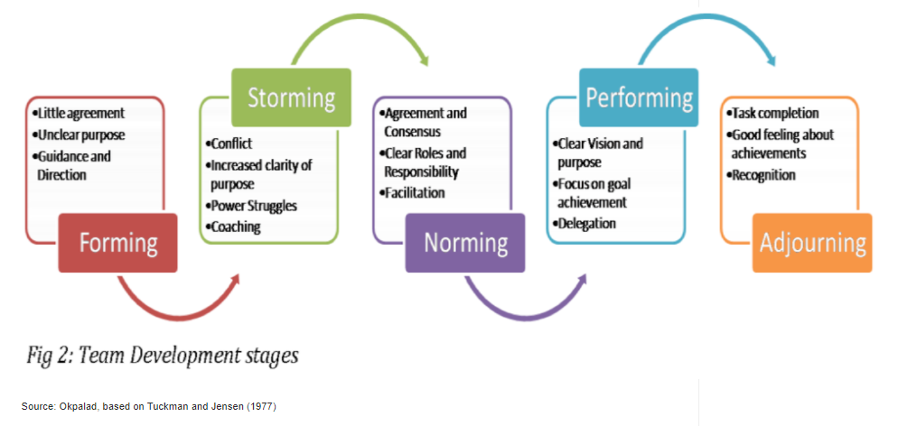
Another Method would be Susan Wheelan’s Method. Wheelan (2016) suggests there are 4 stages a team should go through for them to perform what is required of them.
Stage One; Dependency and Inclusion; All teams have a starting point where they’re formed, and all members will be looking at the team leader or manager for acceptance and validation. Some new team members may be put off or discouraged from expressing ideas to the team as they try to conform as the dynamics are still being established. Some members speak, while others listen.
Stage Two; Counter Dependency and Fight; This can prove to be the most difficult stage. Due to team members developing their roles and purpose within the team and seeking to free themselves from the dependency of the leader, some teams may fall apart before the infighting, conflict and divisions can be resolved by the team leader or manager.
Stage Three; Trust and Structure; if the team get through stage two successfully, their willing to cooperate with each other will increase in stage three. Roles would have been established and the team collectively will move forward together. The team leader or manager would oversee each team member in their delegated tasks as at this stage and give feedback as and when required needed for consistency and continuity, communication becomes open, and task orientated. Team leaders become less directive and more consultative.
Stage Four; Work and Productivity; This typically begins during the 6th month of a team working together. Many teams never reach this stage (Wheelan, 2016, P28). Every team member is established and may be coming towards the end goal and can become very intense and productive towards the progression. The team may be on a high due to the synchronicity of their performance, but some may be depressed that the high they felt may be ending when their goal is accomplished.

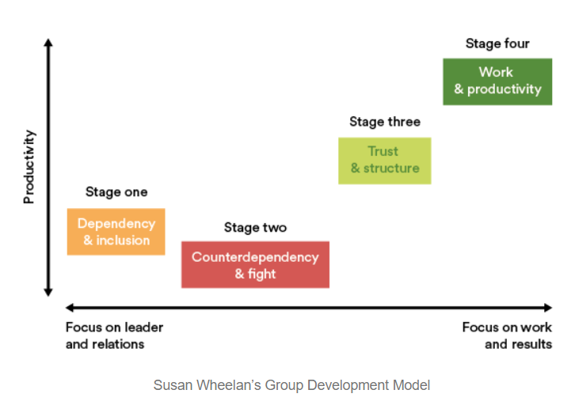

Team Roles

Roles needed to create a cohesive and effective team.

Griffiths and Dunham (2015) highlighted the importance of team composition. They argued that “a small amount of interpersonal tension can be helpful, too much engender negative emotional contagion that can sabotage trust and goodwill,” (Griffiths and Dunham, 2015, P15).
Meredith Belbin developed the idea that teams need a balance of personalities and roles if they are to be successful. These 9 roles are divided into 3 categories.
Her example is one of the theories relating to a cohesive and effective team.
The nine Belbin Team Roles are:
The People Roles:
- Coordinator, they have a diverse skillset and are good at putting the team together.
- Team worker, who gives support to the team as a collective helping where they see fit.
- Resource investigator, who communicates externally to ensure resources are required to complete the task.

The Thinking Roles:
- Plant, who are ideas specialists and free thinkers within the team.
- Monitor, who are team members who investigate the fine detail and are critical before making decisions.
- Specialists, who are team members with skills in chosen areas.

The Action Roles:
- Shaper, the member that will push others into action to ensure completion.
- Implementor, the team member who focuses on organisational skills and has a systematic approach.
- Completer, the team member that ensures all team members collectively complete their duties, they don’t usually distribute tasks, but ensure completion.

(Yeh, Smith, Jennings, and Castro, 2006).

Advantages of Effective Teamworking and the Impact of Ineffective Teamwork.

There are always advantages and disadvantages of teamworking and displayed here are a few examples that can occur when working within a team.

Advantages:
The team, when created and established, are working on ideas within the task. Therefore, the better the quality of the work produced in the shortest time.
The team has a common goal to head towards, and as a team they all move in one direction.
Teamworking together, ideas can be shared and agreed when looking for solutions to a problem. As team members may see problems from different angles, they may see problems differently and communicate this to each other therefore improving their team task outcome.

Disadvantages:
Personalities may clash and conflicts may be created due to strong or dominant personalities. Some may be unhappy, and this might cause a reduction, miscommunication or stop communication with others reducing focus on the task itself.
Familiarisation with other team members may be lacking, due to poor introduction of each other, or not knowing how your team colleague works or their personality. This may delay the task or project starting or progressing as team members are still organising the task and are stuck in the brainstorming phase.
Thers always, at times, someone who will input the most, and that one individual who will input the minimum, but still get reward and praise even though they weren’t a true team player. When a deadline is imminent, they may not be too helpful and delay the completion of the task at hand.

Teamwork can come with good and bad points, depending on what the task may be and the relevant personalities within the team. Therefore, putting a team together must be specific to the personalities of the team members chosen and the expertise they have relevant to the task.
(Miller, 2021).

Conclusion

Teamwork within the Care Home can be introduced by finding the right personalities to fit within each department to work alongside each other and develop familiarity of their strengths and weaknesses within the teams across all departments. Encouraging communication by planning regular meetings and understanding the team objectives and goals by working through any issues that may arise within the care home. Communication is key and all staff need to understand each other and their roles to create a successful team for all areas of the home setting.

References

University of the People. 2021. What Makes a Good Team That Builds Success. [online] Available at: <https://www.uopeople.edu/blog/what-makes-a-good-team/> [Accessed 31 October 2021].
ACM Transactions on Computing Education, Vol. 16, No. 2, Article 6, Publication date: February 2016. David L Largent https://medium.com/ethics-kit/space-to-think-4f50b4902e6c
Mspguide.org. 2021. Tuckman (forming, norming, storming, performing) | Multi-Stakeholder Partnerships. [online] Available at: <http://www.mspguide.org/tool/tuckman-forming-norming-storming-performing> [Accessed 28 October 2021].
Hesketh, P., 2019. Space to think. [online] Medium. Available at: <https://medium.com/ethics-kit/space-to-think-4f50b4902e6c> [Accessed 19 October 2021].
Griffith, B., and Dunham, E., (2015), Working in Teams: moving from high potential to high performance, Los Angeles, SAGE Publications.
Yeh, E., Smith, C., Jennings, C. and Castro, N., 2006. Team building: a 3‐dimensional teamwork model | Emerald Insight. [online] Emerald.com. Available at: <https://www.emerald.com/insight/content/doi/10.1108/13527590610687947/full/html?casa_token=AnuBRWjKMz4AAAAA:A8BBYB-2rvVBQwHOKomH9e3lNWK8gMZlWIRmeI9PJl0qF0zSIlxdeRgD4ebQpn_oFYjn_YOvm7zSbSmH_M6xqVNE6GsAFqAx1jRvUWPcUOLXbM8lUkbx0Q> [Accessed 21 October 2021].
Miller, K., 2021. 6 Pros and Cons of Group Work. [online] FutureofWorking.com. Available at: <https://futureofworking.com/6-pros-and-cons-of-group-work/> [Accessed 24 October 2021].

