  Business Report – Comparison of Shangri-La Hotels and Premier Inn Hotels | Student No: | 2240761
 | Module Title: | Financial Management for the Hotel Industry
 | Module Code: | BMIH5007
 | Lecturer: | Tristan Hawkins
 | Words: | 2385

Acknowledgement
I acknowledge the use of Grammarly (https://www.grammarly.com/) on 12 October 2024 to check my work using the prompt:
- “Can you please check the below text to check grammatical mistakes and syntax issues properly?”
I confirm that I have not presented any AI-generated text as my work. I confirm I have copies of my drafts, notes, and other resources I used before, and after the use of AI tools which I may be asked to provide in evidence.

Contents
Introduction 1
Total Revenue 2
Market Position 5
Growth Potential 9
Financial Commitment to CSR (Corporate Social Responsibility) 10
Reference 14
Appendices 17

Introduction
The hospitality industry has been growing day by day around the world and it covers different types of services like food and beverage, accommodation, travel agency, event planning, and so on (Walker, 2021). This assessment gives an insight into the comparison of various areas of Shangri-La Hotels and Premier Inn Hotels for the years between 2018 and 2023. The emphasis is made on the assessment of their total revenues, market share, growth rates, and measure of financial commitment to CSR. This report will focus on comparing these two organisations based on their financial statements.

Total Revenue
Total Revenue
Figure 1: Total revenue of Premier Inn and Shangri-La from 2018 to 2023

Source: Author’s Made

The total revenue trends for Shangri-La and Premier Inn from 2018 to 2023 reflect the severe impact of the COVID-19 pandemic, followed by gradual recovery. Both companies saw significant drops in 2020, with Shangri-La’s revenue falling by nearly 60%, while Premier Inn experienced a sharp decline due to its reliance on domestic travel. By 2023, Premier Inn's revenue rebounded to GBP 2,625 million, driven by the strong recovery of domestic tourism and budget-conscious travellers. Shangri-La, targeting luxury international travellers, recovered more slowly, reaching USD 2,141.80 million in 2023 (Shangri-La Group, 2023; Whitebread PLC, 2024). The differences in their customer bases Premier Inn's focus on affordability and Shangri-La's reliance on high-end travel played a key role in shaping the speed and extent of their recovery. This shows the vulnerability of both organisations toward marketing positioning, target audiences, and flexibility in response to external crises regarding their revenue.
Operational Costs and COGS
Figure 2: Operational costs and COGS of Premier Inn and Shangri-La from 2018 to 2023

Source: Author’s Made

Operational costs and COGS of Shangri-La and Premier Inn were quite constant during the pandemic period and only hiked up in 2022 and 2023 as the business was recovering. The operational expenses of the Shangri-La increased progressively as the luxury services and the staffing expenses were higher when they were provided (Shangri-La Group, 2023). Likewise, operation costs rose at Premier Inn as domestic business travel revived (Whitebread PLC, 2024). However, it is observed that both companies succeeded in keeping the COGS relatively stable during the pandemic, meaning that the firms were successful in cost control. Thus, their capability to manage costs during the crisis supported financial performance stabilisation.

Occupancy Rates and Price Per Room (RevPAR)
Table 1: Occupancy Rates and Price Per Room (RevPAR) from 2018 to 2023
Occupancy Rates and RevPAR (2018–2023)
Year | Shangri-La Occupancy Rate (%) | Shangri-La RevPAR (USD) | Premier Inn Occupancy Rate (%) | Premier Inn RevPAR (GBP)
2018 | 68% | 115 | 79% | 47
2019 | 67% | 85 | 81% | 51
2020 | 39% | 51 | 34% | 25
2021 | 42% | 64 | 45% | 29
2022 | 46% | 100 | 50% | 38
2023 | 62%​ | 108​ | 66% | 52
Source: (Shangri-La Group, 2023; Whitebread PLC, 2024)

RevPAR and occupancy are important indicators related to room availability and pricing strategies. Covid-19 greatly affected both Shangri-La and Premier Inn’s performance through reduced travel throughout the world. Significantly affected by low occupancy, Shangri-La, which targets global upscale travellers, also restored its occupancy to pre-pandemic levels as luxury travel returned by 2023 (Shangri-La Group, 2023). The same was realised by Premier Inn, which focused on the budget-conscious domestic markets that declined before stabilising once again due to the growing domestic tourism (Whitebread PLC, 2024). The findings of RevPAR's changes in the price of its offerings for both brands reveal the effect of post-pandemic measures to meet customers’ needs.

Comparative Analysis
Trend data in revenue, occupancy, and RevPAR shows that both Shangri-La and Premier Inn’s performances plummeted during the COVID-19 pandemic, achieving their nadir in 2020. The major cause of such a decline was the restrictions on travelling due to the COVID-19 breakout that highly lowered the hotel occupancy rates and the room demand (Lai, et al. 2021). However, both firms had fairly bounced back to the market by 2023. Primarily, Premier Inn was able to bounce back to higher revenue in a shorter time compared to Shangri-La because of the progressive relaxing of restrictions on domestic tourism, and because the brand targets cost-sensitive consumers (Bas Sivaprasad, 2022). In contrast, Shangri-La's recovery in occupancy and RevPAR was more gradual, influenced by its dependence on international luxury travellers and slower market rebounds in key regions. Both companies maintained operational costs and COGS relatively stable during the pandemic, reflecting strong cost management strategies during a challenging period.

Market Position
Market Share
Shangri-La operates predominantly in the luxury hotel segment, with a strong presence in Asia, particularly in Mainland China, and a notable presence in Europe and the Middle East. In 2018, Shangri-La held around 60% of the market share in the luxury segment across key regions (Shangri-La Group, 2023). Despite the impact of the COVID-19 pandemic, which significantly reduced international travel and affected its market position, Shangri-La managed to maintain dominance in luxury hospitality (Cheshmehzangi, et al. 2022). By 2023, their market share had stabilised, particularly in regions like China and Southeast Asia, where they capitalised on post-pandemic travel recovery.
Premier Inn, in contrast, operates in the budget hotel segment with a dominant focus on the UK market (Murasiranwa, 2012). In 2018, Premier Inn held about 7.4% market share of the UK hotel market. The pandemic affected their market share as domestic travel restrictions hit the hospitality industry hard. However, their strategic focus on domestic travel helped them recover faster than some competitors. By 2023, Premier Inn increased its market share to 8% in the UK, solidifying its position as a leader in the budget segment, benefiting from its wide network of locations and strong brand loyalty (Whitebread PLC, 2024).

Customer Demographics
Shangri-La’s core customer base primarily consists of high-income luxury travellers (Yang, 2013). In 2018 and 2019, the hotel chain catered to high-net-worth individuals, corporate executives, and luxury vacationers, especially those travelling from Asia and Europe (Shangri-La Group, 2023). The pandemic caused a shift in their customer demographics, with a reduced international traveller base and an increased focus on attracting local high-income customers.
Premier Inn's customer base is very different, targeting more budget-conscious domestic travellers (Ghandour, et al. 2015). In 2018, their primary customer groups included middle-class families, solo travellers, and business professionals looking for affordable accommodations. The pandemic prompted a further shift toward domestic family travellers due to restrictions on international travel.

Brand Perception
Shangri-La is perceived as a luxury hotel brand, known for offering premium services and high-end experiences targeted at affluent travellers, corporate clients, and luxury vacationers. In contrast, Premier Inn is regarded as a budget-friendly option, offering reliable and affordable accommodations for families, professionals, and solo travellers, with a strong emphasis on value for money in the UK market.

Competitive Positioning by Using Strategy Clock and Supply and Demand Theory Graph
Strategy Clock
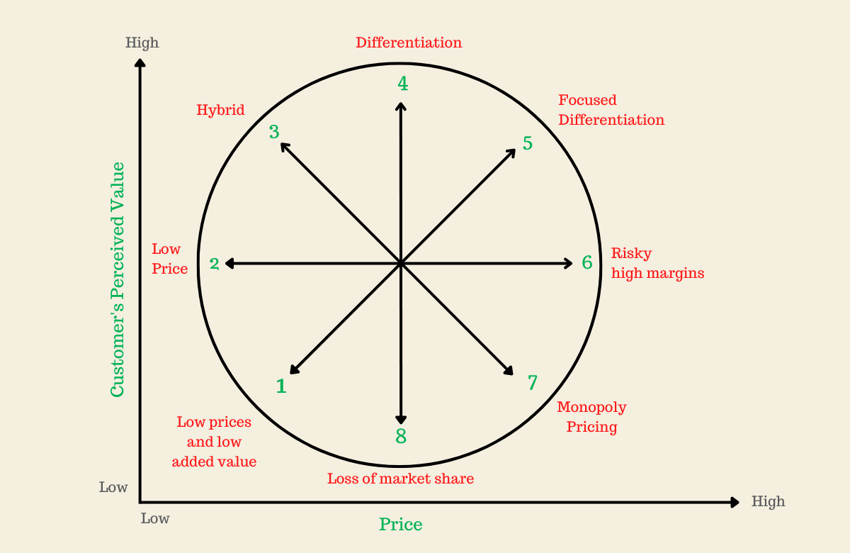
Figure 3: Strategy Clock Model
Source: (Product Mindset, 2022)

Using Bowman’s Strategy Clock, Shangri-La falls into the differentiation quadrant, competing by offering high-value luxury services at premium prices. This strategy allows them to maintain their market position among high-end consumers. Shangri-La’s post-pandemic recovery reflects how its sustainable luxury investments helped retain its core customer base despite fluctuating travel demand (Hu and Trivedi, 2020). Premier Inn, on the other hand, sits in the hybrid zone, balancing low costs with moderate differentiation. Their competitive advantage lies in offering good quality accommodations at affordable prices, a strategy that helped them capture a larger share of the UK market post-pandemic (George, 2021).
Supply and Demand Theory Graph
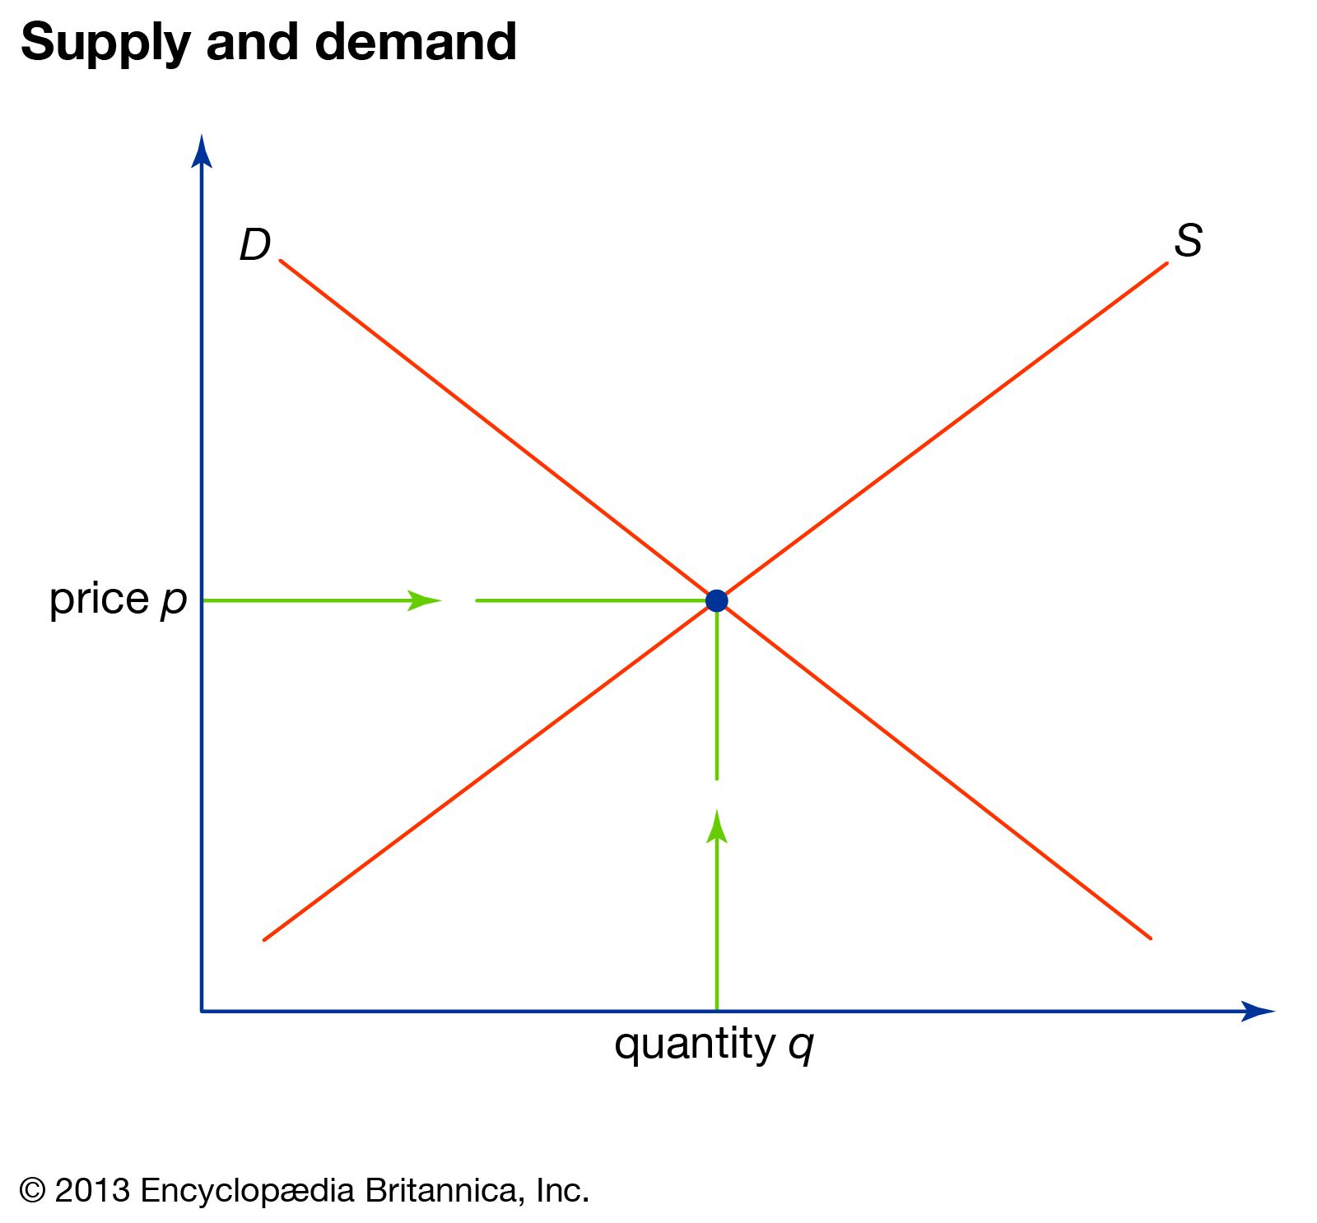
Figure 4: Supply and Demand Theory Graph

Source: (The Editors of Encyclopaedia Britannica, 2024)

In the Supply and Demand graph, points D and S represent demand and supply curves, while P and Q show the equilibrium price and quantity. The graph illustrates how Shangri-La and Premier Inn shifted pricing/tariffs post-pandemic. Shangri-La's luxury demand declined, forcing price drops, but as demand recovered, the equilibrium shifted upward. Premier Inn, focusing on budget travellers, maintained or lowered prices to regain market share. Each brand's competitive position reflects the balance between supply, demand, and their respective sustainability strategies.

Growth Potential
This task evaluates the growth potential of both Shangri-La Hotels and Premier Inn by analysing their expansion strategies, market opportunities, and potential barriers to growth from 2018 to 2023.
Shangri-La Hotels
Shangri-La’s growth strategy primarily focuses on expanding its footprint in the luxury hotel market in key regions such as Asia, Europe, and the Middle East (Cherapanukorn and Focken, 2014). By 2018, Shangri-La had a significant presence in Mainland China, which remains a cornerstone of its expansion. The company has continued to develop new properties in emerging markets such as Southeast Asia and Middle Eastern countries (Abdullah, 2015).
Additionally, Shangri-La has been investing in enhancing its existing properties and improving guest experiences through digital innovation and personalised services. By leveraging its strong brand in luxury hospitality, Shangri-La is well-positioned to attract affluent business travellers and corporate clients (Shangri-La Group, 2023).
Market Opportunities for Shangri-La primarily lie in the resumption of international travel, especially in regions like Asia and Europe, where luxury travel demand is expected to rise significantly (Yang, 2013). As travel restrictions ease and affluent travellers return to leisure and business travel, Shangri-La is poised to benefit from the increased demand for high-end accommodations and experiences.
However, the company also faces potential barriers to growth, including continued geopolitical tensions in key markets like China and supply chain disruptions in the construction of new hotels.
Premier Inn (Whitbread PLC)
Premier Inn's growth strategy differs significantly from Shangri-La’s, focusing on the budget hotel segment with a strong emphasis on expanding its presence in the UK and European markets (Page and Connell, 2020). Before the pandemic, Premier Inn had been gradually increasing its market share through new hotel openings and acquisitions, particularly in Germany, where the brand saw potential for growth in the budget travel sector. This expansion into Europe presents a key growth opportunity as demand for affordable accommodations increases with the recovery of international and domestic tourism (Whitebread PLC, 2024).
Premier Inn’s focus on domestic travel and affordable pricing has helped the company recover faster than luxury brands during the pandemic. Their market opportunity lies in capturing the demand for staycations and budget-conscious travellers as domestic tourism continues to grow in the UK post-pandemic (Bas and Sivaprasad, 2022).
Despite these opportunities, Premier Inn faces potential barriers to growth such as increasing competition from other budget hotel brands and alternative accommodations like Airbnb (Mody and Gomez, 2018).

Financial Commitment to CSR (Corporate Social Responsibility)
This task covers the current CSR policies and the financial commitment of both the Shangri-La Hotels and the Premier Inn (Whitbread PLC) for the last six years (2018-2023).
Table 2: Summary of CSR Activities (2018-2023)
Year | Shangri-La CSR Initiatives | Premier Inn CSR Initiatives
2018 | Focus on community engagement and volunteering programs in Asia. | Launched the Force for Good program, focusing on community support.
2019 | Enhanced efforts towards sustainability by reducing carbon footprint and waste management; launched green programs. | Focus on reducing environmental impact, energy consumption, and waste; significant funds allocated to charity partnerships, such as Great Ormond Street Hospital.
2020 | COVID-19 response: Introduced "Shangri-La Cares" program focusing on safety, hygiene, and supporting local communities (Shangri-La Group, 2023). | COVID-19 response: Support for NHS and local communities through donations; enhanced employee safety and well-being initiatives.
2021 | Expanded focus on sustainability with carbon emission reduction targets. | Continued sustainability initiatives with a focus on reducing waste and carbon footprint.
2022 | Implemented renewable energy initiatives in key properties; expanded corporate giving and community volunteering efforts. | Environmental focus: Further investments in renewable energy sources and environmental programs.
2023 | Emphasised sustainable tourism initiatives, including property upgrades to meet global environmental standards. | Expanded Force for Good initiatives, focusing on social responsibility, environmental sustainability, and employee well-being, with increased financial investment (Whitebread PLC, 2024).
Source: Author’s Made

Comparative Analysis: Luxury vs. Cost-Effective Sustainability
Table 3: Comparative Analysis of Sustainability
Shangri-La | Premier Inn
High-net-worth individuals, affluent travellers | Budget-conscious domestic travellers
Luxury sustainable tourism | Cost-effective sustainability (energy efficiency, carbon reduction)
Eco-friendly luxury, carbon-neutral accommodations | Energy-saving technologies, sustainable sourcing
Exclusivity through responsible luxury travel | Affordable accommodations with environmental responsibility
Source: Author’s Made
Staff Training and Alignment with Core Values
Shangri-La integrates sustainability into its core values through workforce development and hygiene training in partnership with Diversey, emphassing environmental responsibility as part of its luxury brand. Premier Inn’s "Force for Good" program focuses on employee well-being and environmental initiatives, aligning sustainability with its value-for-money and low-carbon economy strategy (Shangri-La Group, 2023; Whitbread PLC, 2024).
Critically Analysing the Financial Commitment of Both Hotels
While both Shangri-La and Premier Inn have been vocal about their CSR policies over the past six years, their approaches differ significantly. Shangri-La emphasises environmental sustainability by reducing its carbon footprint and incorporating renewable energy sources. However, the effectiveness of its ‘Shangri-La Cares’ program, introduced during the pandemic, raises questions about whether it is a true commitment or merely a reactionary PR move to address safety concerns. Moreover, its focus on hygiene indicates short-term safety measures (El-Said, et al. 2024). In contrast, Premier Inn’s 'Force for Good' program, while innovative, appears to focus heavily on community support and environmental awareness, leaving room for speculation on whether these initiatives are driven more by cost-efficiency rather than genuine social responsibility (Mansuri, 2023). Their financial focus on a low-carbon economy, diversity, and employee mental health may reflect a balance between strategic marketing and authentic CSR efforts pre-, during, and post-COVID-19.
Recommendations
Shangri-La Hotels: To build on an opportunity identified in the case that says that Shangri-La has a particularly dominant position in the luxury segment, Shangri-La should diversify its product line of sustainable luxury travel to resort or wellness.
Premier Inn (Whitbread PLC): More focus should be placed on increasing Premier Inn’s position in Europe, for example, by expanding to Germany, which is currently showing great demand for the budget hotel segment.
Conclusion
This assessment has revealed that both Shangri-La and Premier Inn have been able to manage the risks exerted by COVID-19 contingency. Fortunately, both Shangri-La with its emphasis on luxurious services and sustainability plans, and Premier Inn with its core offering of economic hotels or domestic tourism have managed to achieve post-crisis rebounds and set upraises for future expansion. It reveals that expansion and new CSR programs will remain the key focus for each brand to deliver success in the future.

Reference
Abdullah, H.H. (2015). Strategy Building and Sustaining Competitive Advantage: A Case Study of Shangri-La Hotels (Malaysia) Berhad.
Bas, T. and Sivaprasad, S. (2022). An Exploratory Insight into the Impact of COVID-19 on the Travel and Tourism Sector: UK Evidence. Bas, T. & Sivaprasad, S.(2022). An exploratory insight into the impact of COVID-19 on the travel and tourism sector: UK evidence. In S. Karabulut (Ed.), Economic and Financial Analysis of Global and National Developments, pp.355-369.
Cherapanukorn, V. and Focken, K. (2014). Corporate social responsibility (CSR) and sustainability in Asian luxury hotels: Policies, practices and standards. Asian Social Science, 10(8), pp.198-209.
Cheshmehzangi, A., Wang, D. and Tang, T. (2022). The fall of tourism in Shangri-La amid the COVID-19 Crises: A case study report. [online] ResearchGate. Available at: https://www.researchgate.net/publication/362761169_The_fall_of_tourism_in_Shangri-La_amid_the_COVID-19_Crises_A_case_study_report [Accessed 9 Oct. 2024].
El-Said, O.A., Elhoushy, S., Smith, M. and Youssif, M. (2024). Crisis-driven innovation in hospitality: How do international hotel chains innovate to recover from a global crisis?. International Journal of Hospitality Management, 120, p.103758.
George, R. (2021). Tourism and Hospitality Marketing Principles. In Marketing Tourism and Hospitality: Concepts and Cases (pp. 3-31). Cham: Springer International Publishing.
Ghandour, R., Bilal, J. and Mudassar, H. (2015). Relationship between Service Quality, Customer Retention and the role of Social Media-Case study Premier Inn Hotel (UK). Journal of Organizational Studies and Innovation, 2(4), pp.1-12.
Hu, F. and Trivedi, R.H. (2020). Mapping hotel brand positioning and competitive landscapes by text-mining user-generated content. International Journal of Hospitality Management, 84, p.102317.
Lai, S., Ruktanonchai, N.W., Carioli, A., Ruktanonchai, C.W., Floyd, J.R., Prosper, O., Zhang, C., Du, X., Yang, W. and Tatem, A.J. (2021). Assessing the effect of global travel and contact restrictions on mitigating the COVID-19 pandemic. Engineering, 7(7), pp.914-923.
Mansuri, M. (2023). Premier Inn launches Force For Good programme in the Middle East - Hotelier Middle East. Hotelier Middle East. [online] 23 Oct. Available at: https://www.hoteliermiddleeast.com/business/premier-inn-launches-force-for-good-programme-in-the-middle-east [Accessed 15 Oct. 2024].
Mody, M. and Gomez, M. (2018). Airbnb and the hotel industry: the past, present, and future of sales, marketing, branding, and revenue management. Boston Hospitality Review, 6(3).
Murasiranwa, E.T. (2012). Service quality and business performance in branded UK budget hotels. Sheffield Hallam University (United Kingdom).
Page, S.J. and Connell, J. (2020). Tourism accommodation and hospitality services. In Tourism (pp. 216-241). Routledge.
Product Mindset (2022). Bowman’s Strategy Clock. [online] productmindset.substack.com. Available at: https://productmindset.substack.com/p/bowmans-strategy-clock [Accessed 9 Oct. 2024].
Shangri-La Group (2023). [online] Shangri-la.com. Available at: https://www.shangri-la.com/group/investors/public-disclosures# [Accessed 9 Oct. 2024].
The Editors of Encyclopaedia Britannica (2024). Supply and demand. [online] www.britannica.com. Available at: https://www.britannica.com/money/supply-and-demand [Accessed 10 Oct. 2024].
Walker, J. (2021) Introduction to Hospitality, Harlow, Pearson
Whitebread PLC (2024). Results, reports and presentations. [online] Whitbread PLC. Available at: https://www.whitbread.co.uk/investors/results-reports-and-presentations/ [Accessed 9 Oct. 2024].
Yang, H.P. (2013). Case study 12: Shangri-La hotels expanding to non-Asian markets. In Marketing Cases from Emerging Markets (pp. 113-116). Berlin, Heidelberg: Springer Berlin Heidelberg.

Appendices
Appendix 1: Total Revenue (2018-2023)
Year | Shangri-La Total Revenue (USD Million) | Premier Inn (GBP Million)
2018 | 2,517.90 | 3,295
2019 | 2,431.20 | 2,049
2020 | 1,033.40 | 2,072
2021 | 1,241.00 | 590
2022 | 1,462.10 | 1,703
2023 | 2,141.80 | 2,625
Source: (Shangri-La Group, 2023; Whitebread PLC, 2024)

Appendix 2: Operational Costs and COGS (2018-2023)
Year | Shangri-La Operational Costs (USD Million) | Shangri-La COGS (USD Million) | Premier Inn (Whitbread) Operational Costs (GBP Million) | Premier Inn (Whitbread) COGS (GBP Million)
2018 | 650.4 | 318.4 | 1,642 | 871
2019 | 707.4 | 299.5 | 1,837 | 892
2020 | 529.9 | 156.2 | 1,176 | 654
2021 | 561.1 | 210.8 | 1,410 | 744
2022 | 975.1 | 279.2 | 1,523 | 803
2023 | 1,191.60 | 299.5 | 1,758 | 854
Source: (Shangri-La Group, 2023; Whitebread PLC, 2024)

