

Protecting and Supporting Families in Health and Care
Module code: (BMHP5021)
Component 2: Written Report
Report Title: “An Examination and Analysis of how the ‘Early Help’ system is Signposted to UK Families by their local authority website”
Student name: Blessing Ogieriakhi
Student number: 2416087
Lecturer’s Name: Amanda Jones
Count:2188

Table of Contents

Introduction 3
The Early Help System 3
Multi-Agency Working and Strategic Safeguarding Partnerships 5
Critical Evaluation of Southwark Council's Early Help Information 6
Critical Evaluation of Tower Hamlets Council's Early Help Information 8
Critical Evaluation of Leeds City Council's Early Help Information 9
Interim Critical Summary 9
Comparative Analysis of the Three Local Authority Websites 10
Recommendations 11
Conclusion 12
Reference List 13

.

Introduction
Early Help assists families before issues become severe enough to require statutory social care, which makes it a crucial component of child protection in England. Early Help intervention not only can improve parenting abilities, but it can also improve children's health and wellbeing and curb the likelihood of abuse, neglect, and family falling apart (Featherstone et al., 2014; Daniel et al., 2011). Early Help is defined by the Department for Education (2022) as assistance given during pregnancy and adolescence when problems initially arise. This means prioritising prevention and collaboration by several bodies such as the housing services, schools, health services, children's social care, the police, and voluntary organisations working together, which aligns with Working Together to Safeguard Children (Department for Education, 2026). Local authority websites are essential for helping families access services and referral pathways promptly. This report evaluates how Southwark, Tower Hamlets and Leeds City Council websites communicate Early Help, comparing accessibility, clarity and alignment with strategic safeguarding partnership responsibilities while identifying areas for improvement.

The Early Help System
The Early Help System approach emerged as a response to criticism that children’s services respond to crises too late, after significant harm has occurred, according to the Munro report (Department for Education, 2011). The Early Help system is a preventative approach to safeguarding that aims to identify and address family needs before they escalate into child protection concerns.
The Early Help System stresses that prevention of legal intervention depends on multi-agency ability to recognise early signs of family difficulties (Department for Education, 2022). Hence, factors affecting children’s wellbeing must be considered by clinicians.
However, it is widely known that a single factor may be insufficient to constitute serious harm; the combination of indicators can exacerbate risk and consequently reduce a family’s capacity to meet their children’s developmental needs. These indicators can cause children to display behavioural difficulties. Examples of family difficulties requiring Early Help include financial hardship, insecure housing leading to homelessness, food insecurity, parental mental ill-health, parental drug abuse, domestic abuse, children missing school, young carers, disability within the family, parental or family conflict, and social isolation.
Section 17 of the Children Act 1989 offers assistance to children and families who require further support, while Section 47 helps safeguard children who might be in danger. The child is placed at the centre of Early Help, with coordinated support provided between schools, health services, family hubs, housing, police, social workers and voluntary organisations (Department for Education, 2022; Department for Education, 2026). Figure. 1
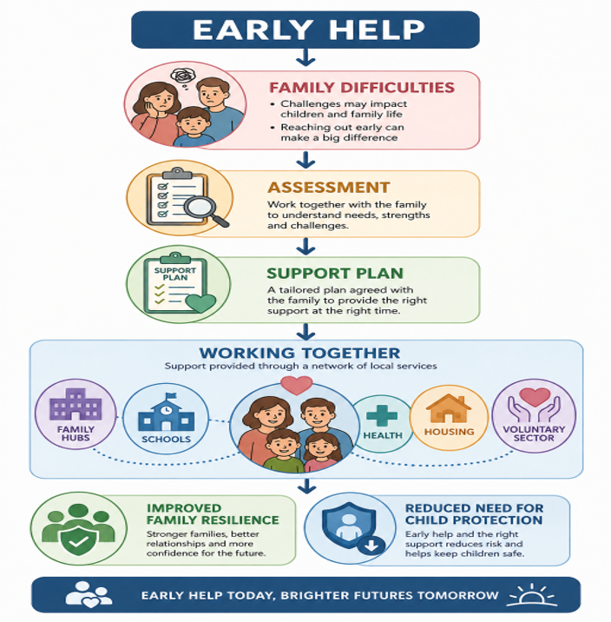

Figure 1
Adapted from Department for Education (2022) and Department for Education (2026).

Multi-Agency Working and Strategic Safeguarding Partnerships
The Children Act 2004 established statutory duties for agencies to cooperate in safeguarding children (NSPCC, 2023). Partnership Working Together enables professionals to address many related needs simultaneously, rather than focusing on a single problem. For example, a parent going through depression may also struggle financially, leading to housing instability and poor school attendance for their children. Figure 2
Infographic image of Family-Centred- Multi-Agency Approach
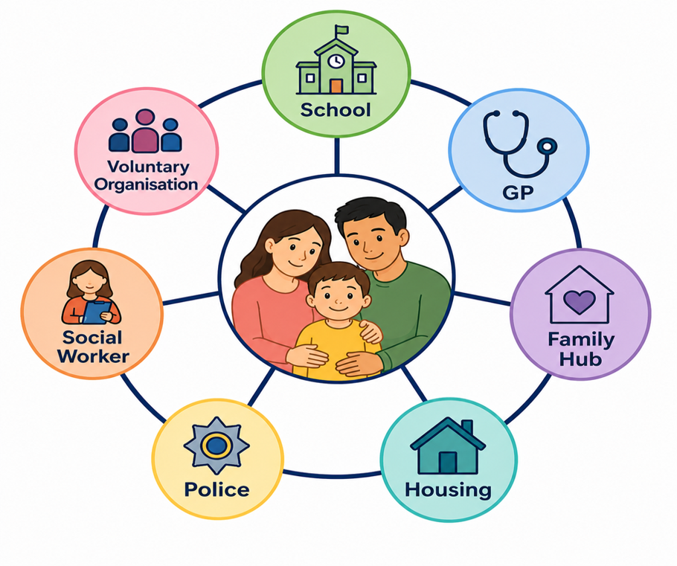
Figure 2: Adapted from Horwath (2010) and HM Government (2023).

The three councils examined in this report demonstrate varying approaches to communicating these partnership arrangements. Southwark explicitly describes Early Help as a network of services rather than a single department and explains how schools, health services, family hubs, housing and community organisations contribute to prevention. Tower Hamlets lays a great deal of emphasis on its Multi-Agency Team (MAST), which offers families and professionals clear referral channels for coordinated care. In a similar way, Leeds emphasises integrated cooperation through family Hubs and focused Early Help services, demonstrating how professionals work together based on determined levels of need.
However, barriers including information sharing, organisational culture, workload pressures and differing priorities can limit collaboration (Horwath and Morrison, 2007), making clear local authority websites essential for guiding families and professionals.

Critical Evaluation of Southwark Council's Early Help Information
Southwark Council provides a comprehensive and well-structured Early Help section through its Children's Services and Safeguarding webpages. Early Help is described as a coordinated system that includes education, health services, children's social care, Family Hubs, youth services, and volunteer groups. This helps children and families to sort out their problems before it becomes a legislative issue (Southwark Council, 2026).
A key strength is the clear explanation of who Early Help supports. The examples of families experiencing parenting difficulties, emotional wellbeing concerns, poor school attendance, domestic abuse, financial hardship, housing problems and behavioural issues. These parenting difficulties assist families to recognise their own circumstances and encourage earlier engagement with support services before statutory intervention becomes necessary. This is the core principle of Southwark Early Help strategy. This reflects the holistic safeguarding approach promoted in Working Together to Safeguard Children (Department for Education, 2026). Figure 3
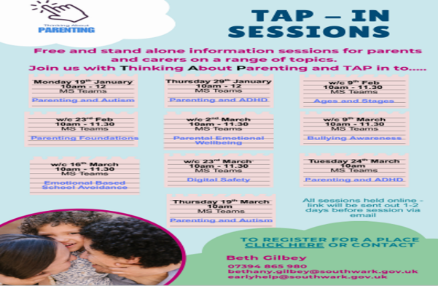

Figure 3: Southwark Family Hub (Southwark Council, 2025)
Additionally, the webpage describes how many services collaborate to ensure children's safety. Through the Strategic Safeguarding Partnership, schools, general practitioners, health visitors, law enforcement, housing services, and volunteer organisations collaborate. It also contains Family Hubs, which help the government achieve its goal of offering integrated family support and assisting families before issues worsen (Department for Education, 2022). Another strength is that the website provides information for both families and professionals, including referral pathways and safeguarding contacts, enabling parents to seek support while guiding professionals through referral processes.
However, weaknesses remain. The extensive policy information and safeguarding terminology, like "thresholds," "multi-agency safeguarding arrangements", and "targeted intervention," may be hard for families with limited education or safeguarding knowledge. Undoubtedly, Southwark Council has one of the best Early Help designs in the United Kingdom. In summary, Southwark Council’s Early Help could be made more family-friendly in terms of presentation.

Critical Evaluation of Tower Hamlets Council's Early Help Information
Tower Hamlets Council provides one of the most accessible presentations of Early Help, placing it within a framework of Family Hubs and the Multi-Agency Support Team (MAST), helping families understand how services work together (Tower Hamlets Council, 2026; NICE, 2022). A major strength is its family-centred approach. Parenting, education, emotional health, domestic abuse, special education needs, financial difficulties, and health services are among the common family needs that are categorised, which can negatively affect children’s emotional wellbeing and school attendance if support is not provided early. Figure 4
TOWER HAMLETS
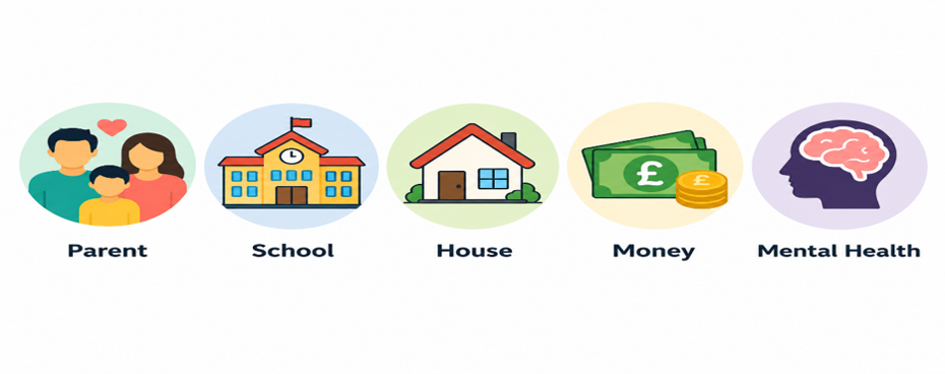 Figure 4: Adapted from HM Govt. (2023) and NICE (2022)
This supports the Early Help System Guide's early prevention strategy (Department for Education, 2022; HM Govt, 2023). Families are also urged on the website to refer themselves for assistance. It explains that Early Help is voluntary, works with families, not against them, and does not always result in social care participation. This can reduce the stigma associated with seeking assistance (Featherstone et al., 2014). The website explains how schools, health services, the police, housing, social care, and charities work together through the Strategic Safeguarding Partnership to keep children safe, following the guidance in Working Together to Safeguard Children (NSPCC, 2023).
However, compared to Southwark's website, the website provides less information on the Early Help Assessment procedure and is less explicit about who is eligible for specific targeted services. Overall, Tower Hamlets does a fantastic job of encouraging early support and various services to collaborate in order to keep children safe while presenting factual information in an understandable manner for the general public.

Critical Evaluation of Leeds City Council's Early Help Information
Early Help and other family support services are combined in Leeds City Council's Family Help strategy. It focuses on many agencies collaborating to strengthen families and find solutions to issues before they become severe enough to require statutory involvement (Leeds City Council, 2026). A key strength is its clear explanation of Family Hubs and locality-based services, including parenting programmes, children's centres, youth services, mental health support, employment advice and community organisations. The website also highlights collaboration between schools, health visitors, GPs, social workers, police and voluntary organisations, reflecting the partnership principles of the Children Act 2004 and Working Together to Safeguard Children (Department for Education, 2026).
However, Early Help information is spread across several webpages, requiring more navigation than Tower Hamlets. Some pages are also text-heavy, making it harder for families under stress to locate support quickly. Overall, Leeds effectively promotes integrated family support and preventative services, but clearer navigation, simplified language and improved visual signposting would further enhance accessibility and user experience.

Interim Critical Summary
All three local authorities demonstrate a strong commitment to the principles of Early Help, prevention, and multi-agency safeguarding required by the Children Act 1989, Children Act 2004, the Early Help System Guide (Department for Education and Department for Levelling Up, 2022) and Working Together to Safeguard Children (2026).
However, their methods of delivering this information differ. While Lead Councils are the best at directing families to family hubs and local support organisations, they are not able to centralise their digital information for easy access by families. While Hamlet is best known for a clear and unambiguous communication style, providing step-by-step information on how to use available resources and where to get help. Although Southwark offers the best information for professionals, its usage of technical words may make it unsuitable for a family. These differences illustrate that effective safeguarding depends not only on the availability of services but also on how clearly those services are communicated.

Comparative Analysis of the Three Local Authority Websites
Working Together to Safeguard Children and the Early Help System Guide, respectively, show a common dedication to the Early Help tenets across the three local authority websites (Department for Education, 2026; Department for Education, 2022). However, they differ in how effectively this information is relayed to families.
All three councils recognise that children's needs are often linked to wider family circumstances rather than a single safeguarding concern. Their websites highlight issues such as poor school attendance, financial hardship, housing difficulties, domestic abuse, parental mental health and behavioural concerns as reasons families may benefit from Early Help. However, the extent to which these examples are presented clearly varies considerably between the councils. Southwark provides the most comprehensive explanation of the Early Help process and clearly outlines the roles of professionals within the Strategic Safeguarding Partnership.
Although Southwark provides numerous examples of family needs, these are embedded within lengthy professional guidance. Parents experiencing stress, financial hardships, or a crisis may find it difficult to identify quickly which service best matches their circumstances. Moreover, families with less education may find information on the website difficult to understand as a result of the use of terminology and policy. Accessibility would be enhanced by the use of multilingual material, visual aids, and plain English.
Leeds employs a Family Help strategy that connects Family Hubs, parenting support, and community resources with Early Help. The website recognises that practical difficulties such as unemployment, parenting pressures and emotional wellbeing are interconnected. Addressing these wider family circumstances reflects the preventative aims of Early Help by supporting families before safeguarding concerns escalate (Daniel et al., 2011). However, information is not consolidated in a single webpage. Users have to browse different webpages to obtain what they are looking for. This is discouraging for families who are looking for immediate help.
Tower Hamlets provides the clearest and most accessible communication. Information is organised around family needs rather than organisational structures, making it easier to identify appropriate support. Clear referral pathways, intuitive navigation and integration of Family Hubs with Early Help services create a user-friendly experience. By organising information around common family circumstances rather than organisational structures, Tower Hamlets enables parents to recognise when they may benefit from support without needing detailed safeguarding knowledge.
According to the Department for Education (2022), a family-centred approach where families are given a boost is likely to encourage earlier engagement with services. Addressing issues like poverty, substandard housing, and domestic abuse early before it becomes consequential for the child, Early Help helps to nip the problem in the bud. The analysis shows that successful Early Help depends on both service availability and the ability of families to understand and access information.

Recommendations
Although the Early Help information offered by all three councils is useful, it might be made more holistic. They should present information in diversify languages, employ straightforward language, and include images, flowcharts, and brief visual representations. They should also clarify that Early Help is optional and that families can request assistance on their own. Finally, they should make it evident how housing, charity, the police, schools, and health services collaborate to keep children safe.

Conclusion
Early Help is a key element of safeguarding policy because it enables professionals to identify needs early, coordinate support and prevent problems from escalating into child protection concerns. The Early Help System Guide and Working Together to Safeguard Children emphasise that effective Early Help relies on multi-agency collaboration and meaningful family engagement. This report found that Southwark, Tower Hamlets and Leeds City Council all provide comprehensive information that reflects national safeguarding principles of prevention, partnership working and integrated support.
Although Southwark offers comprehensive information, his language may be more straightforward. Leeds might improve the usability of its websites, but it provides good local help through Family Hubs. All things considered, Tower Hamlets is the most user-friendly for families due to its straightforward instructions on how to receive assistance, clear language, and an orderly website.

Reference List
Daniel, B., Wassell, S. and Gilligan, R. (2011) Child Development for Child Care and Protection Workers. 2nd edn. London: Jessica Kingsley Publishers.
Department for Education (2011) The Munro Review of Child Protection: A Child-Centred System. Available at: https://www.gov.uk/government/publications/munro-review-of-child-protection-final-report-a-child-centred-system (Accessed: 10 July 2026).
Department for Education (2026) Working Together to Safeguard Children: Statutory Guidance on Multi-agency Working to Help, Support and Protect Children. London: Department for Education. Available at: GOV.UK publication (Accessed: 7 August 2026).
Department for Education and Department for Levelling Up, Housing and Communities (2022) Supporting Families: Early Help System Guide. Available at: GOV.UK publication (Accessed: 20 July 2026).
Featherstone, B., White, S. and Morris, K. (2014) Re-imagining Child Protection: Towards Humane Social Work with Families. Bristol: Policy Press.
HM Government (1989) Children Act 1989. London: The Stationery Office.
HM Government (2004) Children Act 2004. London: The Stationery Office.
HM Government (2023) Working Together to Safeguard Children: A Guide to Multi-agency Working to Help, Protect and Promote the Welfare of Children. London: Department for Education.
Horwath, J. (ed.) (2010) The Child's World: The Comprehensive Guide to Assessing Children in Need. 2nd edn. London: Jessica Kingsley Publishers.
Horwath, J. and Morrison, T. (2007) ‘Collaboration, integration and change in children's services: Critical issues and key ingredients’, Child Abuse & Neglect, 31(1), pp. 55–69.
Leeds City Council (2026) Family Help and Early Help Services. Available at: Leeds City Council (Accessed: 18 July 2026).
National Institute for Health and Care Excellence (NICE) (2022) Mental wellbeing at work (NG212). Available at: NICE guidance NG212 (Accessed: 2nd August 2026).
NSPCC (2023) Multi-agency and interdisciplinary working. NSPCC Learning. Available at: NSPCC Learning (Accessed: 31 July 2026).
Southwark Council (2025) Best Start Family Hubs Newsletter. Available at: Southwark Council publication (Accessed: 12 July 2026).
Southwark Council (2026) Early Help and Family Support. Available at: Southwark Council Early Help and Family Support (Accessed: 12 July 2026).
Tower Hamlets Council (2026) About Early Help. Available at: Tower Hamlets Council Early Help (Accessed: 12 July 2026).

