
LCBB5002
Management Accounting
Viktoriya Koleva

Table of Contents
Part A 2
Overview of Case Study 2
Purpose 2
Requirement (i): Monthly Control Report 3
Requirement (ii): Report on Performance during 2020 3
Requirement (iii): Recommendations for Areas of Improvement 5
Part B 6
Case study overview 6
Purpose of case study 6
Discussion of Option 1 6
Discussion of Option 2 7
Concept of Relevant Cost 8
Other Relevant Factors 8
Final Recommendation 9
References 10

Part A

Overview of Case Study
The Amana family runs a tourism company called Amana Ltd. It operates in England and caters to vacationers by offering them mementos from the country. As a result, the company operates out of a number of different sites, most notably in the country's most popular tourist areas, such as London, Birmingham City Centre, Brighton, Buckingham Palace, Westminster Bridge, and Manchester City Centre. In addition, a Chinese manufacturer is responsible for the design and production of the mementos, and they do it in accordance with the particular demands and necessities of the Amana team, which provides the manufacturer with the necessary set of designs. After 40 years in operation, the company has developed an understanding of the tourist sector as a whole. However, because of the widespread Covid-19 outbreak, the government has put various limitations on travel and mobility, which has had a significant negative impact on the tourist business. The subsequent precipitous drop in sales in April 2020 had a negative impact on Amana's bottom line. It's because most vacationers were prevented from leaving town for the Easter holiday. However, there was a little increase in income during the summer of 2020, any more money that was made during that time period was ultimately lost due to the extended period of lockdowns that occurred from December 2020 to February 2021.

Purpose
This case study presents the cost breakdown of Mr. Amana’s business concerning their product offerings. The main purpose of this case study is to prepare a monthly control report of the business that showcases the original budget, flexible budget, and variances. This control report is intended to serve as the basis for preparing a report that discusses the performance of the business for the financial year 2020. Lastly, the paper also looks to provide recommendations that can help the business in improving its performance.

Monthly Control Report
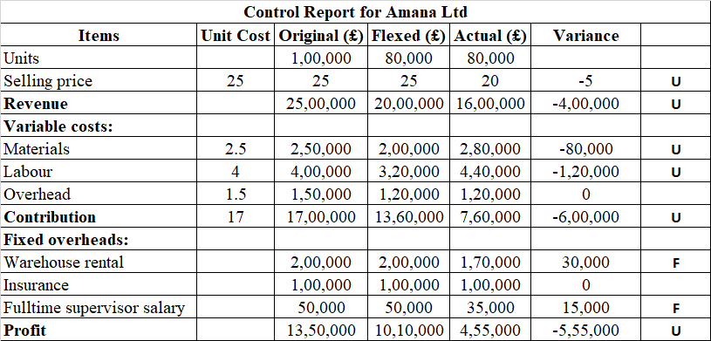
Working Notes:
- In order to keep the adjusted budget column roughly in line with the original budget, we have set the unit selling price at $25. However, the total number of units is the same as the number of units that were actually sold.
- Under the new flexible budget, the overall variable expenses will shift. The total cost of these variable costs in the first budget will be applied to the 80,000 units sold.
- There will however be a change in the total variable costs under the flexible budget column which wherein 80,000 units will be multiplied by the per unit cost of such variable expenses computed from the original budget.
- A "U" in this column indicates a negative variance, whereas an "F" indicates a positive one. In addition to this, the difference between the flexible budget column and the actual figure column is used to determine the amount that should be entered into the variance column.

Report on Performance during 2020
The results of the company's operations for the fiscal year 2020 are detailed in the control report that was just presented, which was prepared for Amana Ltd. Static and flexible budgets, along with actual performance, are all shown in the control report. A flexible budget was used, and the actual performance was compared to that budget (Wang et el. 2022). The results of these comparisons were used to determine the variances. It is unreasonable to evaluate performance against a fixed budget when the scope of activities being evaluated varies (Blocher et al. 2019). When it comes to reflecting the company's real level of activity, a flexible budget is more likely to bend than a static one (Brewer, Garrison and Noreen 2015). A comprehensive examination of the control report reveals that the operation of the organisation has been adversely impacted in a significant way. The company's primary goal for the year was to sell a hundred thousand souvenirs. The tourist sector is still reeling from the Covid-19 incident, in which actual visitor numbers fell short of projections. As a result of falling demand, however, the company has dropped the price of its products by £5, from an average of £25 to £20. Falling activity and unit sales prices had a major impact on annual income. That's why there's still a £ 400,000 revenue variance, and it's not looking good. While the company's motivation to lower prices in response to falling demand is reasonable, it's important to note that this strategy alone is not likely to result in increased sales volumes. The volume of daily operations attests to this fact.
According to the audit report, there are three main categories of expenditures that add up to the overall variable expenses. Expenses include things like supplies, wages, and utilities. What we call "variable costs" are those that shift depending on how busy or productive the company is. One may claim that corporate activity has decreased while variable expenditures have grown or stayed the same. As an example, it is clear that there was a negative variance of £80,000 since the cost of materials rose from £200,000 to £280,000. This indicates that the actual cost of materials has deviated from the planned cost per unit. The actual cost of materials was more than expected, coming in at £3.5 per unit after adjustment for overruns (£280000 / £80000). The price of raw materials might go up for any of a wide variety of causes. Common factors that may have contributed to the price rise of the items under consideration include inflation, supply chain problems, raw material availability, and increased negotiating strength of suppliers (Warren, Reeve, and Duchac 2016). When contrasted with the difference in the price of raw materials, the disparity in labor costs stands out even more starkly. This is due to a discrepancy between the expected value of labor costs (at £320,000) and the actual value (at £440,000). As a consequence, the variance was unfavorable by £120,000. Labor costs were expected to be about £4, but ended up being closer to £5.5, making for an unfavorable variance. A rise in the average pay rate, more pressure from employees and unions, longer periods of inactivity, and more casual labor appointments are only some of the potential causes of unexpectedly high prices. Overhead costs, which have been incurred in line with the degree of activity, do not fluctuate at all, thus there is no volatility at all (Taschner and Charifzadeh 2016).
Despite this, the company was in enough shape to cut fixed overhead expenditures throughout the epidemic. Specifically, the rent for storage space and the wages of people working in storage all day, every day are two of the biggest costs. A favorable variation in the amount of £30,000 has arisen as a consequence of the reduction in the warehouse rental fee from £200,000 to £170,000. An additional £15k was saved when the budget for full-time warehouse personnel pay was cut from £50,000 to £30,000. Finally, the cost of insurance is a guaranteed £100,000. All of these differences have had a significant impact on the company's operating earnings in the long run, both in absolute and comparative terms. The actual profit of the company was lower than the anticipated profit of £10,010,000, which resulted in an unfavorable variance of £555,000. In absolute terms, the profit number of the company has fallen. The company's profit margin dropped from 50.50% to 28.44% as a consequence.

Recommendations for Areas of Improvement
Based on what we know about the company's past success, we can make some suggestions on how to boost its future earnings in two main areas. Obviously, money coming in is the first priority. The demand for the company's products or services may have been influenced by factors beyond of its control, such as the overall health of the tourist sector. But it may not be financially prudent to lower the selling price per unit at this stage. For this reason, cutting prices in an attempt to boost sales is not a viable long-term strategy, and instead, the company must continually reevaluate the pricing in order to produce profits. If the company wants to increase sales in a sustainable way, it should consider using sales promotion activities and embracing digital marketing (Niansyah, and Biswan, 2018).
Their current marketing strategy, which consists of a single, basic website, does not allow them to make much of an impact in the online world. In the wake of the COVID-19 pandemic, there has been a dramatic uptick in the emphasis on creating an online identity. Due to the success of its brick-and-mortar locations, the company now must increase its online presence. It's possible that you'll need to put up some cash to launch your digital enterprise. You could also consider forming strategic partnerships with other online venues and software platforms to expand your reach and sell more of your products. On top of that, the business's marketing efforts are extremely lacking, despite the fact that they are essential for survival. Therefore, it may consider SEO, SEM, and other digital marketing tactics.
Similarly, it is recommended that the company do a comprehensive examination of its cost structure, focusing particularly on the variable expenses, which include things like material and labor but have seen per unit price increases (Jiambalvo 2019). Given that this enterprise is concerned with the sale of a tangible product, the price of raw materials will account for a significant chunk of the final selling price. The company must keep material costs low without skimping on quality. It is recommended that the company look into purchasing the same products from several vendors that are able to do it at lower costs and with higher reliability and reputation. The rising cost of labor is another factor that must be monitored. Efforts to reduce the overall cost of labor might benefit from effective negotiations and long-term contracts. Therefore, the company should focus on both increasing revenues and decreasing expenses (Eldenburg et al. 2020).

Part B

Case study overview
According to the information presented in the case study, Mr. Amana has come to the conclusion that the majority of the company's rivals have begun marketing their wares over the internet to clients based not only in the United Kingdom but also in the United States and other parts of Europe. As a direct consequence of this, the proprietor is mulling over the possibility of closing three retail locations in Manchester, Brighton, and Birmingham. This would be done in an effort to streamline the operations of the company, which would facilitate the transition of fifty percent of the total sales. This revenue is generated by using an online business model.

Purpose of case study
When it comes to making the choice, there are a number of things that need to be taken into consideration, both from a monetary and non-monetary point of view. The primary objective of the second section of this paper is to provide a recommendation to the proprietor, Mr. Amana, regarding whether or not the company should think about getting into online sales by either establishing its very own internet store or selling its items online via Amazon. This activity transfer 50% of their sales in online.

Discussion of Option 1
In this scenario, the company will have to pay extra expenses totaling £35,000, £50,000, and £150,000. The first two figures represent the cost of setting up the distribution network and the cost of updating the website, while the third figure represents the full-time IT programmer's salary. According to the research presented in Part 1, the value of the unit variable cost in the production of the product is £10.5. In addition, it is anticipated that the company will be able to sell a total of 100,000 units yearly with the assistance of this particular choice. As a result, the advantages of implementing this suggestion are best summed up in the following tabular representation:
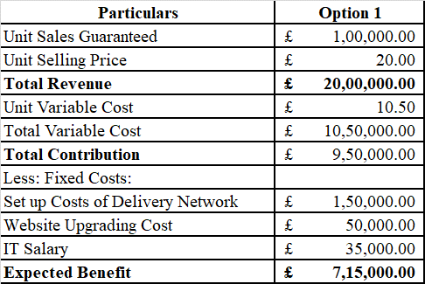

Discussion of Option 2
When considering Option 2, the number of assured sales that may be anticipated is equal to 65,000 units. In addition, the typical cost of fulfillment via Amazon is fifty thousand pounds. In this scenario, the unit variable cost continues to be calculated at £10.5 per unit. As a result, the advantage that is anticipated to be gained, which is 567,500 pounds, if this choice is selected has been tabulated and presented in the following manner:
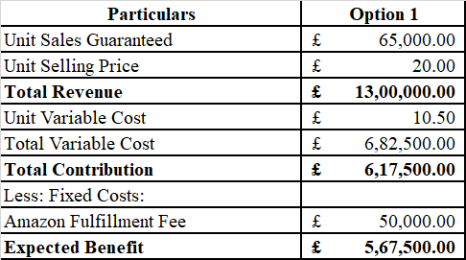

Concept of Relevant Cost
The phrase "relevant cost" comes from the field of management accounting and refers to those expenditures that might have been avoided but were still incurred as a direct result of certain choices made inside an organisation. The process of making decisions is made easier by using the idea of relevant cost, which helps to filter out superfluous information that might make things more difficult (Drury 2018). The numbers shown above aren't entirely clear since they don't take into account how important expenses are. The unit variable cost is likely to be the same for each of these choices when it comes to both of these possibilities. This indicates that the company will be responsible for bearing the variable expenses regardless of the option it chooses to implement in the end. As a consequence of this, from a management point of view, the expenses that are fixed are the ones that are important to consider in this scenario. The overall fixed expenses associated with Option 1 amount to 235,000 pounds, whilst those associated with Option 2 amount to 50,000 pounds. Therefore, selling products via Amazon provides the most gain, which amounts to £185,000 after deducting costs of £50,000.

Other Relevant Factors
When it comes to choosing decisions, one must also take into account a number of other qualitative aspects. The company must take into consideration the fact that the first option, which involves establishing a new internet network, would entail extra fixed expenses but may report a better profit. In addition, the most important concern with regard to Option 2 is the price strategy that will be implemented. The company will have only a limited amount of influence on the cost of its own items. In addition, Amazon has a return policy that may be controlled, despite the fact that the company itself will not have a great deal of influence over the matter. Option 2 is problematic for a number of reasons. One of these reasons is that there are several souvenir vendors on the platform, which increases the level of competition and raises the possibility of price wars over which the company may not have any influence. Additionally, the number of guaranteed sales units is fewer in the case of Amazon, but it is greater in the case of Option 1. Therefore, in a summary, there seem to be a lot of concerns and uncertainties linked with Option 2, but Option 1 appears to be secure from an investment aspect despite the possibility that it would have to pay greater fixed expenditures. In addition, it's possible that these expenditures may decrease over time as the internet company continues to develop and grow.

Final Recommendation
Instead of choosing Option 2, which involves selling products directly via Amazon, the company could consider making investments in Option 1, which involves establishing its own online presence. Both a financial and a non-financial appraisal of the current circumstances lend credence to this conclusion. The potential gain associated with choice 1 is 7150000 pounds, which is more than the potential gain associated with choice 2.

References
Blocher, E.J., Stout, D.E., Juras, P.E. and Smith, S., 2019. Cost Management (A Strategic Emphasis) 8e. McGraw-Hill Education.
Brewer, P.C., Garrison, R.H. and Noreen, E.W., 2015. Introduction to managerial accounting. McGraw-Hill Education.
Drury, C., 2018. Cost and management accounting. Cengage Learning.
Eldenburg, L.G., Brooks, A., Oliver, J., Vesty, G., Dormer, R., Murthy, V. and Pawsey, N., 2020. Management accounting. John Wiley & Sons.
Jiambalvo, J., 2019. Managerial accounting. John Wiley & Sons.
Niansyah, F.I.W. and Biswan, A.T., 2018. Analisis Varians Anggaran Belanja untuk Pengukuran Kinerja. Indonesian Treasury Review: Jurnal Perbendaharaan, Keuangan Negara dan Kebijakan Publik, 3(4), pp.348-363.
Taschner, A. and Charifzadeh, M., 2016. Management and cost accounting: tools and concepts in a Central European context. John Wiley & Sons.
Wang, H., Vermetten, D., Ye, F., Doerr, C. and Bäck, T., 2022. IOHanalyzer: Detailed performance analyses for iterative optimization heuristics. ACM Transactions on Evolutionary Learning and Optimization, 2(1), pp.1-29.
Warren, C.S., Reeve, J.M. and Duchac, J., 2016. Financial & managerial accounting. Cengage Learning.

