On the Significance and Effect of Visual Identity to Enterprise

Name : YUAN FENG
Student Number : P151038
Major：(BA)Graphic Design
Instructor : Juliia Lockheart
Contents
- Introduction
- Role of Visual Identity in the development of corporate culture
- Visual Identity on the role of enterprises
  - Trends of Visual Identity in China and aboard
  - Use and role of Visual Identity enterprises
    - Importance of Visual Identity in business fields
    - Visual Identity is necessary for the development of corporate culture
    - Visual Identity for enterprises’ culture application and artistic application
- Visual Identity is important on corporate image
  - What is corporate image
  - Impact of Visual Identity on corporate image
  - Impact of Visual Identity system on enterprises
- Impact of Visual Identity system on enterprises
5.1 IBM
5.2 Lufthansa German Airlines
5.3 Unimark design company
- Summarize

Abstract
Visual Identity (abbreviated as VI) is established as the law of the corporate logo, through the organic combination of color, text, graphics and other visual elements. This forms clearly identifiable characteristics, aesthetic value and symbolic significance of the symbol system. VI conveys a corporate business’ idea and image information this is important to elements of the power of spread and attraction in the corporate identity system. It is involved in many aspects, and it can used to realize the purpose of quickly and clearly cognition and recognition. In the intense market competition, since most corporations adopt similar ways of production, the quality and sales of goods cannot be the only way to success. The competition of product tends to be considered in its industrial design, packaging design, and after-sales service design. These designs are based on corporate application and extensions. This paper analyzes the significance and effect of visual recognition system. VI has influence on a corporation’s image, culture, and even brand promotion. A good VI can create uncountable benefits for corporations.

Keywords: Visual Identity System Corporation image and Culture
Brand promotion Benefit Unity Difference Effectiveness
- Introduction
According to Baike.baidu.com (2017) a website on VI [Translated by the author], VI is the most intuitive expression of corporate image. VI of an enterprise is required to maintain internal consistency and external differences, that is, all the visual designs of an enterprise should strictly abide by the unified standard, while maintaining distinct differences with other enterprises, to make customers produce strong resonance (Baike.baidu.com, 2017). Therefore, an excellent VIS enables people to quickly understand the information that the enterprise wants to deliver.
Visual Identity (VI) consists of two aspects: basic element system and application element system. The basic element system mainly includes: corporate name, corporate standard, standard word, standard color, symbol pattern, spoken propaganda language, marketing report and so on. Application system includes: office supplies, production equipment, building environment, product packaging, advertising media, transportation, clothing payment, flag, sign, signage, showcase, display, etc. Visual Identity (VI) is the most popular in the CIS and easy to be accepted by the public, so it occupies a dominant position.



Figure 1: Vi Design
VI design with corporate logo as a basic element is carried out in a strong and forceful system management mode, thus forming an inherent visual image of the business. Through the unified design of visual symbols, it conveys the corporate culture and business philosophy to effectively promote the corporate image and product visibility. Therefore, VIS, based on the visual identify system, fully displays the basic functions of enterprises and their product identify, making the enterprises form brand and playing a direct role in promoting the product into the market. VI design expresses corporate management concept and spiritual culture through visual impact, thus forming a unique corporate image, and its design image itself has great value.
According to Importance of VI Corporate Image Design (2017) a book on VI [Translated by the author]VI design is accompanied by economic prosperity and development, which is composed of word mark, guiding symbols and graphic logo. Successful VI design is required to convey accurate information through reasonable logic, so the realization of communication function is the first. A successful VI design is accomplished not by a famous designer or a design agency at one go but requires user's identification and positive feedback, and is finally completed after the baptism of market and time (Sudjic,2008).
According to International Public Relations Management System (2004) a book on VI [Translated by the author] Visual communication is one of the most important ways for a brand to deliver valuable information to customers. Modern physiological and psychological studies have shown that 83% of the perceived external information comes from vision, 11% from hearing, 3.5% from smell, 1.5% from touch, and 1% from taste. From the above data, it can be analyzed that in the process of obtaining information, visual factors play the greatest role. (Research Group on Internationalization,2004)
- Visual Identity role in the development of corporate culture
According to Introduction to Modern Enterprise Management (2010) [Translated by the author] Corporate culture or organizational culture is a cultural image of an organization consisting of its values, beliefs, rituals, symbols, ways of doing things and so on, and has its unique feature. Corporate culture mainly includes management philosophy, value concept, corporate spirit, corporate morality, team consciousness, corporate image, corporate system, cultural structure, corporate mission and so on (Zhang, 2010).
VI plays an irreplaceable role in the development of corporate culture. A good VI is not determined by the design sense and designer's reputation but whether corporate management philosophy and corporate culture are deeply rooted in the design. Only in this way can the corporate culture be widely spread, thus winning the recognition of consumers and society. Therefore, cultural characteristics, business content, product characteristics and corporate spirit must integrate the specific visual image and the abstract concept of connotation through the whole visual system, especially intense visual signs. Then it can be a good way to convey information for enterprises. VI as a good carrier is a tool to employ the proper and unified visual language to convey corporate concept and image. It is the carrier of lasting, stable and developmental corporate image and brand image. Speaking of corporate brand, it is not only a name, but also a symbol of corporate spirit and the embodiment of the unique culture and concept of an enterprise. A brand without cultural support will not last long, let alone the development of the enterprise. Therefore, VI is indispensable and irreplaceable in the development of corporate culture.
In addition, the spread of corporate culture not only plays a role in the external, but also plays a very important role in the internal. The internal cultural atmosphere, staff values and consumption concept are also a very important part of the development of corporate culture. Only by VI can enterprises widely spread right business philosophy and corporate spirit in the enterprises. Through the constant education and cultivation of employees’ values, the enterprise can gradually form their own cultural characteristics and make employees consciously form corporate cultural identity, sense of belonging to the enterprise and sense of honor for the enterprise, thus effectively inspiring the morale of employees and promoting more stable and rapid development.
From the perspective of business management, any enterprise with excellent corporate culture has a set of effective and rigid rules in the business philosophy, the value of corporate culture, corporate behavior standards and many other aspects. This can not only make the employees have greater expectations for the future of the enterprise, but also make the employees full of expectation for their own development in the enterprise, so the enthusiasm, initiative and activity for work will be correspondingly stimulated. According to research (2014) A research report of Harvard University Professor William James showed that when employees were stimulated, 80% to 90% of their ability could be exerted; if they lacked initiative and enthusiasm, just in a lower level of motivation only for keeping the job, only 20% to 30% of the employees’ ability could be exerted (James，2014).
Therefore, we can say that VI is never dispensable or only cosmetic for enterprises, but it is the carrier of corporate culture development and more importantly determines the direction and prospect of development of corporate culture. Only by using VI carrier to strengthen the corporate culture propaganda in the enterprises can we establish the external image of the enterprises better and more successfully.

3. Visual Identity on the role of enterprises
3.1 Trends of Visual Identity in China and aboard
In the world, more and more designers pay more attention to the theme of the design of visual identity system (VIS). They tend to combine visual and aesthetic factors, as well as historical culture and the trends, more fully reflecting the organic relationship between nationality and internationalization as well as historicity and temporal spirit as for design in the development of enterprises. In China, the design theme of traditional patterns has also become the focus of attention. Some enterprises have reflected this point in their visual system design. Domestic theme design tends to adopt Chinese traditional pattern style. The works with combination of domestic and foreign design elements are also more likely to make people find something fresh and new. Some outstanding designers not only highlight the theme of product design, but also absorb the essence of Chinese and foreign culture in a lot of excellent design works.

3.2 Use and role of Visual Identity enterprises
VI image design can better satisfy people's spiritual demand of corporate culture, business philosophy and corporate morality. To this end, some design characterized by VI themes in some theme jewelry stores, theme restaurants and a variety of industries arises at the historic moment.

3.2.1 Importance of Visual Identity in business fields
Whether for large enterprises or small shops, there is an increasingly fierce competition in the market. Today's enterprise competition is not only reflected in the quality, prices and services of products, but also reflected in the corporate visual image. VI design is an important means of corporate image communication and brand awareness construction. A successful VI design not only can clearly distinguish with peer enterprises, but also ensure its own basic features by clearly conveying corporate philosophy, culture and spirit, which can add color to the enterprise and yield twice the result with half the effort, while a failing VI design makes the public have vague positioning on the enterprise, lacks long-term vitality, may even produce counterproductive effect, and finally leads to waste of manpower, financial and material resources. For those enterprises that don't pay attention to VI or even don't have VI design, even if they have better quality products and services, have a long history and a huge scale, they may eventually become dispensable. For example, KFC, McDonald's, Starbucks, China Mobile, China Unicom, China Telecom, Haier and other large enterprises, which we are familiar with, as well as some landmark buildings of large real estate companies and other large projects such as Olympic Games all have a complete VI design. The outstanding VI design of an enterprise can unify the image and produce famous brand effect, which plays a vital role in stabilizing the enterprise and developing the market.

Figure 2: LOGO（www.baidu.com）
Besides the external influence, VI design also has the function of strengthening corporate cohesion, strengthening the sense of belonging and stimulating the enthusiasm of staff.
In the future, the importance of VI design in the field of business will continue to increase and constitute an important component of corporate value.
3.2.2 Visual Identity is necessary for the development of corporate culture
Because of the changes of the times, people's appreciation of the beauty is also rising. Even for a well-known brand, brand visual identity system also needs to change with the development of the enterprise. The design of visual elements should conform to the trend of the times. Of course, the basic part of brand visual image design can not be immutable, but it can not change too much. On the one hand, according to the law of market development, the brand visual image will not lose its vitality only by constantly following the pace of social development on the basis of the original design and updating in line with the characteristics of the times; on the other hand, if the brand visual image changes too fast, consumer groups can not accurately identify it so the significance of brand culture accumulation and development will be lost. The sustainable development of brand visual image design provides the basis for the sustainable development of brand development, facilitates the gradual upgrading of brand image, and is an important guarantee for the development of enterprises.
Overall brand visual image design is the core of creating a brand, and it is the decisive factor for whether the brand can survive. It is not only an important bridge to convey all the information to consumers, but also the initial image of the primary characteristics and the consumption attraction. It has the artistic value other than material costs. A new shopping mall attracts customers only by extensive publicity with VI visual system setting up a direct bridge between products and buyers. It needs to expanding visibility through the media and advertising to achieve good publicity and enhance people's awareness and desire to purchase in order to obtain certain benefits.
The enterprise brand image can produce a strong impression in the public with repeated implantation in the operation process of the brand through unification, integration and full range of concept recognition, visual recognition and behavior recognition to convey the corporate operation philosophy and corporate culture and propaganda the enterprise in the form of vivid vision. Their unique system of visual symbols is used to attract public attention and produce memory, so that consumers are have the highest brand loyalty to the products or services of the enterprise. It improves the staff's sense of identity and enhances the cohesion of the enterprise. It can also be used for credibility construction, image establishment, information communication, quality supervision, visual recognition, and rights and interests protection.
3.2.3 Visual Identity for Enterprise Culture Application and Artistic Application
3.2.3.1 Applied Application
The application of VI visual identity system is more extensive than other design forms, and an enterprise logo can extend a lot of VI design applications. As a corporate identity system, VI, like a person's appearance can not only represent the business philosophy and the spirit of corporate culture, but also integrate into the daily life of consumers. VI design with high identification can impress people and catch the eye of consumers, so as to enhance the popularity of enterprises. No matter what enterprise brands in advanced or ordinary management model, the excellent VI design is needed to strengthen the brand effect. The application of corporate VI system in the daily operation and publicity environment of enterprises is also an important part of corporate operation.
3.2.3.2 Artistic Application
In today's brand design market, VI design is also constantly changing to achieve diversification. Different customers and different enterprises are constantly changing, resulting in a variety of design, but good design not only focuses on a certain part of the corporate concept, but also needs to pay attention to the diversity, comprehensiveness and unity of design. Corporate VI design focuses on the simple, fast and convenient features as a whole vision system. Now people's aesthetic requirements tend to be more and more simple and fashionable, so the public usually does not like too complex things. The simple corporate VI design can give people visual enjoyment and artistic infection.
4．Visual Identity is important in corporate image promotion
4.1 What is corporate image
Corporate image refers to the overall impression of the enterprise established by various signs (such as product characteristics, marketing strategies, personnel style, etc.). Corporate image is an external manifestation of corporate spiritual culture, and it is a general impression produced in the process of contact between social public and the enterprise. This impression is acquired through the sensory transmission of the human body. Whether the corporate image can truly reflect the spiritual culture of the enterprise and whether it can be understood and accepted by all walks of life and public opinion, to a great extent, depend on the subjective efforts of the enterprise itself.
  - Impact of Visual Identity on corporate image
According to http://news.680.com (2017) a website on VI [Translated by the author] As its name implies, visual identity system (VI) is to give an enterprise an external image to establish a complete external image and concrete the abstract brand image, which is a basic premise of corporate brand communication. It can be inferred that personalized and unique corporate VI can help enterprises to establish brand image, form the employee's sense of identity and sense of belonging to strengthen the cohesion of the enterprise internally, establish the whole image of the enterprise and integrate resources externally to effectively convey corporate messages to the public, and continuously strengthen the awareness of the public through visual symbols in order to improve the visibility of the enterprise and the recognition from the public. A good corporate image can help enterprises to optimize resource environment and provide a strong guarantee for the enterprise to participate in market competition. A modern enterprise without VI means that its image will disappear in the vast sea so that people can not clearly know the enterprise, and means that its products and services are featureless, and means a poorly organized team and low morale.（news.680.com,2017）
Hangzhou Zhang Xiaoquan Scissors is a famous traditional Chinese brand. It has a long history of more than 300 years. It was also the palace scissors used in Qing Dynasty. It was one of the most famous "five products in Hangzhou" at that time. However, such a well-known enterprise also experienced a crisis of survival. With the deepening of reform and opening up and the continuous development of national economy, the drawbacks of the corporate marketing ideas has been revealed. The most prominent was the neglect of corporate image and product image. Zhang Xiaoquan was no exception. Since the product image was not clear, coupled with no strong sense of brand protection, fake Zhang Xiaoquan brands emerged in an endless stream. The corporate image was not clear and not in place. The characteristics of trademarks and packaging were not outstanding, resulting in a huge misunderstanding between consumers and producers.
According to www.fx361.com (2017) a website on VI [Translated by the author] Thus, Zhang Xiaoquan brand was facing an unprecedented crisis in its benefits and market share. Fortunately, they were aware of the importance of establishing the corporate image. They introduced VI design. By changing the font and color of products and auxiliary design, the distinctive characteristics of the product was improved, forming its own unique symbol of corporate products and corporate image design. Finally, through the unified design and adjustment of visual identity system, the enterprise regained the vitality, not only retaining the historical and cultural characteristics of Chinese time-honored enterprise but also forming modern sense in synchronization with the times. Thus, product image recognition has obtained much increase, and profits of the enterprise has been greatly improved.
Thus, VI has much influence on the corporate image. It enables enterprises to establish the brand image and establish the unique market position, so that the enterprises have a certain irreplaceable position in the market, further consolidating the status of the brand（www.fx361.com, 2017）.
Corporate image is an important intangible asset of the enterprise itself, because it represents the reputation, product quality and personnel quality of the enterprise. Good corporate image can not only bring good social benefits to the enterprise, but also bring good economic benefits to the enterprise.
5. Impact of Visual Identity system on enterprises
The social benefits of VI for enterprises cannot be estimated, and it also brings great economic benefits to the enterprise. With the strategic position of VI increasingly apparent in the development of enterprises, enterprises have gradually realized that VI design is an important means to realize the brand strategy of modern enterprises, and the strategy of famous trademark also emerges.
The so-called famous trademark strategy means a strategy used by modern enterprises with famous trademarks as the core to strengthen the trademark image publicity and improve the reputation of the enterprises from the comprehensive and full-range operation of the enterprises. It is a very important part of the overall strategy of the development of modern enterprises. Through the use of visual design and the design of a series of famous trademarks, the company's business philosophy, management characteristics, packaging style, and marketing principles and strategies form an overall image, which helps the information exchange and communication between enterprises and society from the inside to the outside. With the fastest speed and the deepest impression, the public attention is attracted, thus shaping the best corporate image, obtaining social value and cultural identity, and achieving the purpose of marketing and communication. VI is the symbol of enterprise and brand. It represents the whole enterprise and the image and reputation of enterprise. The invisible assets of a logo cannot be underestimated.
5.1 IBM
In the Second World War, the world's major industrial economies suffered seriously, especially some European countries. Most became the ruins of war basically, while the United States became the most powerful country because of rapid development of military industry in the period of the war. After the war, American economy developed vigorously, and it was in the leading position in the world, whether in industry, science and technology, higher education or cultural undertakings. Through the rapid development of wartime, corporate scale and production scale of the United States reached an unprecedented level. After the war, the United States had the world's largest large-scale enterprises with incomparable strength and economic vitality for other countries. These large enterprises explored and developed the international market rapidly, so they needed to establish their own unique corporate image. The corporate image design developed and became mature in the United States under such special conditions, which laid a good foundation for the development of corporate image design later in each country.
From1950s to 1960s, many important designers of the United States were involved in corporate image design projects, such as Paul Rand, Lester beall and Saul bass; some large design companies, such as, Lippincott & Margulies and Cherznayeff & Geisha, were also actively involved in corporate image design. It was the period when corporate image design rapidly improved and developed.
Wherein, Paul Rand was the key figure of American graphic design and advertising design during 1940s and 1950s. Since 1950s, he has been focusing on logo design and trademark design. He believed that a logo that wanted to exist for a long time and to be firmly established in the commercial market must be in the general, widely accepted and long-standing form basically. The form with these requirements often should be very concise and recognizable.

Figure 3: (《A History of Graphic Design》,2014.9)
During this period, he designed a series of corporate images with international influence, including the logo of International Business Machines, IBM. When designing the corporate logo, he used a special font as the core of the entire corporate image. The font was designed by George Trump in 1930 known as the "City Medium", an elegant font. This font in geometric form has more exaggerated decorative lines with neat edges. On the one hand, it highlights the characteristic of long history; on the other hand, it is also easy to produce a more profound impression in the vision. The letter B itself has a wide flat bottom, forming a straight line with the decoration lines of the other two letters. Thus, the unique and concise design features are displayed.
In 1970s, Rand further improved the IBM corporate logo. He added a horizontal dashed line in three letters. The line went through the letters, forming the letter logo with the virtual and actual combination, which caused the vivid and also serious new image. Rand’s such design has been used in IBM products, advertising and packaging since the beginning of 1950s and played a great role in establishing and expanding the corporate image.
In the second half of 1950, IBM company hired designer Eliot Noyes as a design consultant of the company, who was responsible for establishing and promoting corporate image. By improving the design, the corporate image was further systematized. He suggested that the company's design system should be the highest scientific and technological image of its products. Therefore, the design should not just pursue an image or theme but pursue the sustainability and continuity of image. The design quality must also reflect the sustainability and continuity of quality. Sustainability and continuity reflected the image itself. If the design theme was often changed with frequent fluctuations, it would affect the establishment of corporate image and might also affect the understanding of customers to the enterprise itself.
Therefore, he formulated strict design specifications. In order to stimulate the creativity of designers, he also provided sufficient space for the free development in the specifications, but such free development must follow the design principles and norms so as to achieve a high level of change and development under the premise of consistency. Under his auspices, IBM adopted two different aspects of design strength to complete the system design of corporate image: on the one hand, independent design masters, such as Rand were hired; on the other hand, the design personnel of the interior design department of the enterprise fully implemented the design. This was an important reason for the success of corporate image of IBM.

Figure4:（https://www.ibm.com）
According to the requirements of the U. S. state government, all large enterprises must provide the annual reports on business operations and financial status for their shareholders. The content of corporate annual reports was boring. Most of the non-entrepreneurship shareholders had much difficulty in understanding that. Therefore, Rand was also responsible for re-designing and changing the IBM annual reports. He began to design annual reports. The first breakthrough was the annual report in 1958, breaking the original format and changing the monotony of the form. On the one hand, it highlighted the main points of the report; on the other hand, it designed a set of graphic design specifications for enterprise annual report. The plane was not only lively and vivid, but also imposing and serious. Charts, tables and figures were placed in the frames with good appearance. The shareholders and the company were satisfied with the new design of the annual report. Therefore, it also laid the basis of design specifications and model for the annual report of modern enterprises.
Designer Robert Miles Runyan of Los Angeles also made a considerable contribution to the foundation of annual report. In 1959, he designed the annual report of Litton Industries, reflecting similar design tendency. His generous and elegant design adopted a symbolic photography as the main basis of design factors. His design provided a vivid image of the brand and the connotation of the enterprise to the company's shareholders and customers.

5.2Lufthansa German Airlines
According to A History of Graphic Design (2014) a book on VI [Translated by the author]In 1950s, Swiss designers created the "Swiss Layout Style" and soon became popular in the world as the "International Typographic Style". This new graphic design style paid attention to the unity, function and rationalization under the premise of asymmetry. All graphic design factors were arranged in a neat square grid, so it had the characteristics of obvious sequence and fonts were all without decorative lines. This new design style aroused great repercussions in the Federal Republic of Germany showing a high degree of rational characteristics, which was widely noticed and adopted by ULMA academy of Design, a German postwar higher education center for new design, especially in the early 1950s. As a result, it gradually became the main style of graphic design in Federal Republic of Germany. (Shouzhi, 2014)
The main designer who promoted the development of International Typographic Style in the Federal Republic of Germany was the important German graphic designer 0tl Archer. He himself was the head of the Ulm Institute of Design and the professor of graphic design. Through teaching, he promoted the design system, producing much influence on a considerable number of students. In 1962, the Federal Republic of Germany's national airline Lufthansa German Airlines commissioned him and the students to design corporate image system of the company. Aicher united with several other designers for the design, including Tomas Gonda (1926-1988), Fritz Querengasser and Nick Roericht. On the basis of International Typographic Style and according to the so-called "system design" formed in the Ulm Institute of Design, they combined the two closely related design patterns as the basis of the design of Lufthansa corporate image system. With high standardization, systematization and rationalization as the core of design, they designed a unified corporate image. The grid pattern of Ulm was widely used in this design project and became the basis of graphics, fonts and layout.

Figure5:http://www.lufthansa.com
According to the results of their design discussion, Lufthansa Airlines has begun to use a crane as the theme of the corporate logo since 1930s.The crane surrounded a circle, which increased the sense of norm and unity, and highlighted the font logo of the new design without decorative line. The sequence of the original corporate image with the crane's circle as the center was changed, highlighting font image. With the circle as the foil of font image, every German letter of Lufthansa was as tall as the crane around the circle. Therefore, graphics became an organic part of the font image.
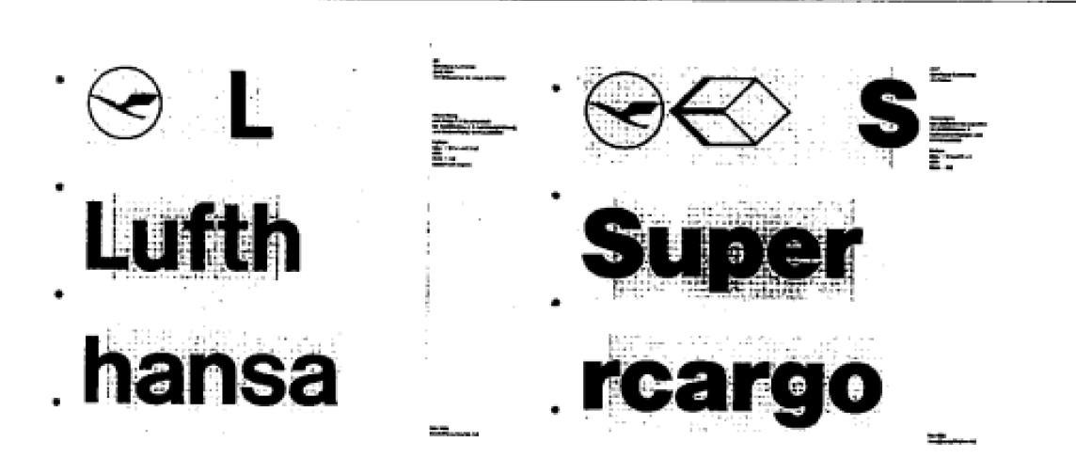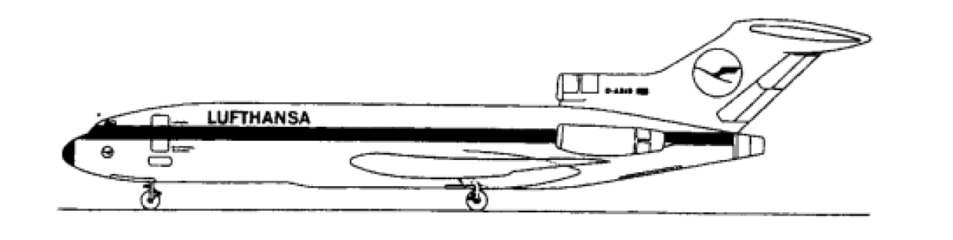
Figure6: 《A History of Graphic Design》
The design of the visual system of the whole corporate image was around the grid, and the font and graphics were strictly arranged in the grid in the accurate way and ratio, forming a highly standardized and rational visual image. This approach made Lufthansa Airlines’ image stronger and more distinctive on aircraft, airline buildings and airport. The design method based on fonts and graphics was very successful, and became the reference and norm for most airlines in the world to design the corporate identity system.

The color design of corporate image system was mainly yellow and Prussian blue, which matched with the logo graphics and fonts of the enterprise and maintained a high degree of consistency. The design team led by 0tl Aicher paid more attention to the unity and integrity of corporate image application. From the airframe to the food packaging in the aircraft, everything was operated in strict accordance with the norms of the corporate image system, so that the system finally emerged in a complete and unified manner. Color planning should be implemented in a more specific way, including the staff uniforms, advertising, stationery, textiles, interior decorations, posters, building exterior decoration, various promotional exhibitions and so on. Any content related to the company was required to use the standard corporate image system and color planning system accurately, fully highlighting the image of the company. The results of this systematic design have laid the foundation for the design of modern airlines' corporate image.

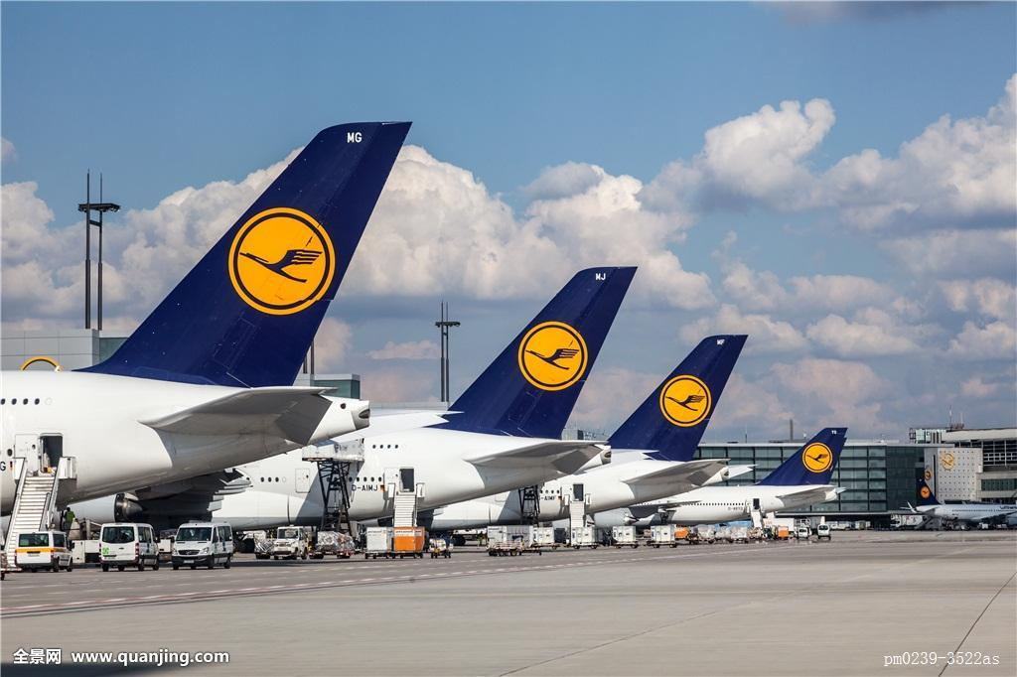Figure7:http://www.baidu.com

5.3 Unimark design company
In 1965, the Container Corporation of America set up the Center「or Advanced Research in Design. This was an independent design research unit to improve the design level of enterprises and carry out various independent experiments and also provide design support for the various departments of enterprises. This advanced design research center soon became an independent design firm, not only serving the parent company the Container Corporation of America, but also serving the society and accepting the design work of other enterprises. For example, the design center designed the whole system of corporate image for the large U.S. oil company Atlantic Richfield, including changing the long name of the enterprise difficult to remember. The new name was Arco Oil Company, which was still used. The change of the name played an important role in building up the image of the enterprise.

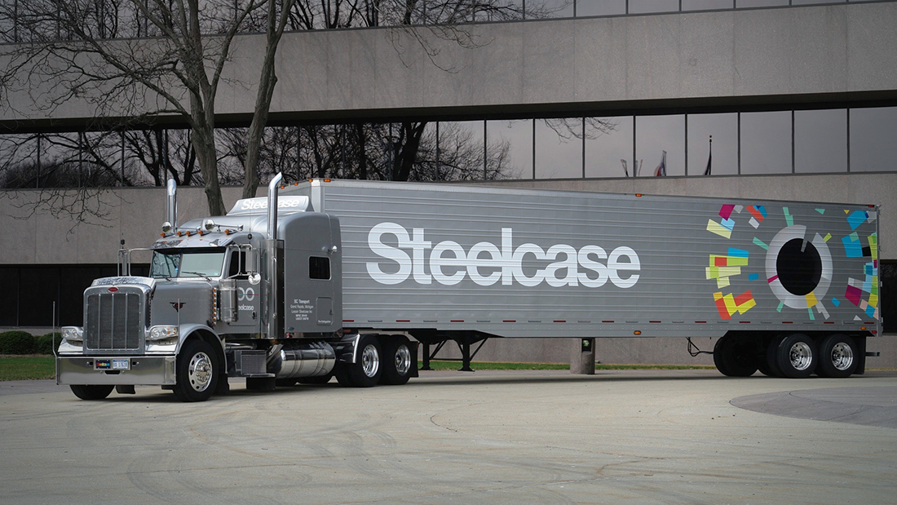
Figure8:https://www.google.co.uk
Maasai, the main designer of the company was also a very outstanding painter and print-maker. Therefore, his design could often contain a wealth of space of artistic associations. He advocated the sense of sequence in the design and artistic creation with the geometric figure as the center, and thought that sequence was the best way to convey visual feeling and that geometric figure had the strongest sequence characteristics. His idea of design and artistic creation was reflected in the design products of Container Corporation of America, which he presided over. Especially the company's publications formed a distinctive corporate image of the company.
In 1976, Mobil Oil bought the Container Corporation of America. In 1986, Mobil Oil sold the Container Corporation of America to the Jefferson Smurfit company. Because of the continuous change of ownership, the Container Corporation of America has lost the previous unified leadership and authority since 1976, so the corporate image design also suffered a disastrous decline and then it lost the core position of graphic design in the United states.


Figure 9: https://www.mobiloil.com.cn
In 1965, a new graphic design company, Unimark, was established in Chicago. The company developed rapidly and soon became a large international design company with 402 staff members and 48 design offices around the world. The main designers of the company included Ralph Eckerstrom, James Fog Leman and Massimo Vignelli (1931-).
The design idea of Unimark design company is Internationalism: it emphasizes the standardization of graphic design and adopts grid as the basis of design, the purpose of which is to realize good visual communication function. This design company established its own customer network, including many first-class enterprises, such as Ford Motor Company, Japan's Panasonic group, the world's largest copier company -- the U.S. Xerox, the largest U.S. office equipment company - Steelcas, and one of the largest department store group J.C.Penney. The corporate images and product visual communication systems designed by Unimark design company for these enterprises all embodied a strong tendency of functionalism. Helvetica without decoration lines was widely used in their design. They thought that this font could most effectively convey the visual content, and they highlighted systematic method in all aspects. Internationalism graphic design has been a great success in the company's business, and the size of the enterprise has enabled the style to be further promoted around the world.

Figure10:https://www.google.co.uk
According to A History of Graphic Design (2014) a book on VI [Translated by the author]The most successful example of graphic design at Unimark design company is a series of graphic designs for knoll, an office equipment and furniture company in the United States. This design project, "the knoll program", was specifically hosted by Massimo Vignelli, who was responsible for New York design firm of Unimark design company. The whole design, especially the poster logo, standard fonts, display and so on, all reflected the characteristics of simple, accurate and vivid design. The design was so successful that it became the basic reference model of corporate image and graphic design projects in the world, especially other American office furniture and furniture industries.(Wang,2014)
The design firms of Unimark design company in the world all abide by the design specifications and the basic idea to carry out design work. Therefore, the company has been able to maintain the unified design image. It has design firms throughout the United States and also in Australia, Britain, Italy and South Africa. In 1960s,it became the most important graphic design firm, which was inseparable from the implementation of the unified and continuous design concept of the company.
- Summarize
These designs are based on corporate application and extensions. This paper analyzes the significance and effect of visual recognition system. VI has influence on a corporation’s image, culture, and even brand promotion. A good VI can create uncountable benefits for corporations.

- Bibliography
Baike.baidu.com (2017) Vision Identity System [Translated by the author]. Accessed from: https://baike.baidu.com/item/. [Accessed on 6th December, 2017]
International Public Relations Management System，[Translated by the author], by Research Group on Internationalization 2002[Accessed on 6th December, 2017]
Management of Chinese Enterprises, [Translated by the author]，[Accessed on 6th December, 2017] ，Chinese financial & Economic Publishing House, January 2004，.
Importance of VI Corporate Image Design _ Creative Information Website news.680.com，[Translated by the author].
Brand is Benefit _ Reference Website :http://www.fx361.com/page/2017/0717/2069785.shtml
[Translated by the author].
Introduction to Modern Enterprise Management, Author: Zhang Yanju, Gansu Nationalities Publishing House, December 1, 2010
A History of Graphic Design, Wang Shouzhi, Chinese Youth Publishing Group, September 2014
Book of ideas , Radim Malinic , Brand Nu(TM) , May, 1 ,2016

10. Reference
Shouzhi, W. (2014) A History of Graphic Design. CITY: Chinese Youth Publishing Group.
Designer's Design Diary, Nan Zheng (2012), Publishing House of Electronics Industry.
Rockport (2013)《THE GRAPHIC DESIGN REFERENCE SPECIFICATION BOOK》.
Deyan Sudjic (2008)，《The Language of Thing》，Guanxi Normal University Press.
Susan Weinschenk(2001)，《Every Designer Need To Know About People》.
Ryan Hembree（2006）《The Complete Graphic Design》，Rockport Publishers.
Newson（2017），《Designer Marker User》，Oxford Phaidon.
《THE GRAPHIC DESIGN REFERENCE SPECIFICATION BOOK》，(2013)Publisher:Rockport.

11.Figures
Figure 1: Vi Design Accessed from: https://baike.baidu.com/pic/企业 VI/3346711/0/fd039245d688d43fe661c8da7f1ed21b0ff43bc9?fr=lemma&ct=single#aid=0&pic=4ec2d5628535e5dd65526e627ec6a7efce1b6215 [Accessed on 6th December, 2017]
Figure 2: LOGO www.baidu.com [Accessed on 6th December, 2017]
Figure 3: IBM Logo from Shouzhi, W. (2014) A History of Graphic Design. CITY: Chinese Youth Publishing Group.
Figure 4: Accessed from: https://www.ibm.com [Accessed on 6th December, 2017]
Figure 5: Accessed from: http://www.lufthansa.com [Accessed on 6th December, 2017]
Figure 6: Airplane image from Shouzhi, W. (2014) A History of Graphic Design. CITY: Chinese Youth Publishing Group.
Figure 7: Airhostess. Accessed from: http://www.baidu.com [Accessed on 6th December, 2017]
Figure 8: Accessed from: https://www.google.co.uk [Accessed on 6th December, 2017]
Figure 9: Accessed from: https://www.mobiloil.com.cn [Accessed on 6th December,2017]
Figure 10: Accessed from:https://www.google.co.uk[Accessed on 6th December, 2017]

