MODULE TITLE : | EFFECTIVE TEAM WORKING & COMMUNICATION
MODULE CODE : | BMSW4002
LECTURER NAME : | BENEDICT MAHER
STUDENT NAME : | LUIZA MARIA VASILIEV
STUDENT NUMBER : | 1908745

Effective Team Working&Communication

Table of Contents
Introduction 2
Communication - an effective tool in teamwork 2
Types of communication 3
Formal and informal communication 5
Models of communication 6
Shannon weaver mathematical model 6
Berlo’s model of communication 7
Schramm’s model of communication 8
Conclusion 9
References 10

Introduction
Effective teamwork among individuals is necessary to develop the professionalism as well as bring efficiency in the organisation. The individuals, teams and the organisation are connected to each other and work for each other’s benefits. Therefore, effective teamwork is necessary that will improve the performance of the organisation. To obtain effective team building, communication is required. In this report there will be analysis and study of the range of communication skills required to perform efficiently in the workplace. Working together as a part of team and sharing responsibilities of work will be studied using few theories of group dynamics. This will be applied for my friend’s workplace, i.e., Debenhams where he works as a team leader.

Communication - an effective tool in teamwork
It can be understood from the above models and theories of group functioning and teamwork effective communication are the most essential element in the team. If the knowledge information is not transferred properly, if the coordinators do not understand the issues of the individuals then it is almost impossible for the members to achieve the desired outcome of the team (Giudici, and Filimonau, 2019). The communication involved among the team members can be various which will ensure successful transformation of knowledge, ideas and thereby work on the efficiency of the team. This involves-
- Interpersonal communication
Interpersonal communication can be developed by Debenhams along with the presence of formal communication among the employees. This will make the teams of Debenhams work effectively and will enable the team members to share their issues or concerns freely among themselves.
- Active listening
This is a major part of the communication. If the team members involved in communication does not listen to each other carefully, it will not make the information clear and thus may result in discrepancies at work. This can be encouraged among the team members of Debenhams. Since the company is huge, there are lots of people in every team which makes it difficult for everybody to listen to each other. This can be implemented to ensure that all ideas are listened to and heard which are potential to the development of the company.
- Personal presentation
This is another form of communication that is effectively used in team work and is prevalent in Debenhams too. This indicates how an individual portrays oneself. The people who view and hear the ways one represent in the team develop an idea and overview of the person. Demonstrating the opinions or knowledge of a particular aspect in relation to the organisation can also be communicated in the form of personal presentation so that others develop an idea about it easily (Giudici, and Filimonau, 2019).

Types of communication
The information that one wants to convey to others can be conducted in various methods of communication. They are as follows-
- Non-verbal communication
This kind of communication includes use of body language, facial expressions and gestures. Non verbal communication indicates that message is being transferred to others in the form of gestures, signs and body language. Facial expressions, eye contact and various methods are used to communicate non-verbally to others. In this communication noise is not made, thus this communication has its own advantage. In a busy place non verbal communication can use if one wants to communicate something to someone secretly. This method of communication was taught in my class and this helped me to communicate at my workplace. The right body posture and confident look must be present during job interview and when I am representing my organisation. I was not scared for my interview and had the right body language in front of the recruiters. My formal posture impressed them.
Non verbal communication is something which is understood even by the animals. They can understand our gestures and expressions and react accordingly. Even my pet dog understands my gestures, body language and reacts according to those gestures. This was also taught in the class in form of visual representations. The in class lectures helped me to understand the importance of emotions and expressions. However, it is difficult to understand non verbal communication and evaluate it accordingly.

- Written communication
This communication delivers information in form of written documents. In this method of communication the sender writes down the message or the information and this delivered to the receiver either directly or through a channel. This is important at workplace where most of the things need to be documented for future purposes. The lectures presented by the professors in forms of notes are one of the exclusive examples of written communication. Written communication has the scope of description and explanation which is usually not present in non-verbal or verbal communication. At the workplace of my friend at Debenhams all kinds of important information are conveyed in form of written communication through e-mails, notices and print outs.
Another method of communicating among team members involve written communication in the form of emails, messages, business letters, notices and any other sort of written methods of transferring information to individuals in the team.
- Verbal communication
It is a vast aspect and interpersonal communication also comes under verbal communication. This type of communication tries to maintain transparency among the team members (Ercegovac, 2008). Here the people are allowed to speak and put their voices in the front. Any kind of confusions and issues are dealt with immediately as they are identified immediately. It also reduces the chances of conflicts among the team members. This kind of communication can be applied at the workplace of Debenhams to ensure that all issues are identified and dealt with among the team itself.
- Visual communication
Visual communication includes gestures, pictures, videos and other visual aids which are used for communication. The thoughts and viewpoints can be represented visually. Sometimes it can be considered as a part of non verbal communication. The traffic signals for example are visual communication. The signals are used to make people maintain the traffic rules. Various other visual communications are present. In a health care centre, thumbs and a hug from the care workers integrates positive communication to the patients. Similarly pictures and videos used during presentation makes it easier for the audience to understand the subject.
There are certain strategies through which communication can be made better for effective team work.
- Expressions or viewed can be clarified using both verbal, non verbal and use of pictures or visual clips which can make the views clear to the team members.
- Electronic sources play an important role in determining the clarity of the communication. PowerPoint presentation, graphs showing certain statistics, pictures can be easily understood by everyone and can be used in the teams for communicating certain ideas or deciding upon certain aspects. This is used and can be encouraged to a larger extent at the teams of Debenhams before coming to a decision or developing a strategy.

Formal and informal communication
Formal and informal are two methods of communication that are used by individuals and others while communicating with others. Formal communication indicates that communication is done through a specified structure and is considered to be as official. These mostly include formal business letters, reports, e-mails, cover letters, resume and other verbal communication which is conducted formally. There are various policies and already designed methods by which formal communication occurs. This is prevalent in workplace to maintain the particular standards of norms and respect among individuals (Polat et al., 2018). The flow of communication is controlled. It has a prescribed path as it goes through a channel. In Debenhams any formal decisions are made using formal communication. The administrative sends it decision to the managers and leaders, which is further conveyed to the employees in form of e-mails or written down policies.
Informal communication is more a casual way of passing messages and information. It can flow in any direction and is bounded in a prescribed format or structure. It is used among friends, individuals belonging to close groups (Polat et al., 2018). However some organisations are also adapting to informal means of communication especially within the teams as it enables people to freely communicate their feelings without thinking about the boundaries.

Models of communication
The information needs to be conveyed to others using effective tools of communication. This is especially needed for the employees who will have to communicate and pass on the messages from one to another within the teams. Models of communication are present which makes it easier for an individual to pass on messages to each other as well as understand each other. There are three widely used models of communication. They are as follows-

Shannon weaver mathematical model

Figure 1- Shannon weaver mathematical model
(Source- Gillespie, and Schiffman, 2018)
This model of communication is one the basic model used by individuals and applied in various organisations. This model indicates the presence of an encoder which is the sender and it sends the message through a channel. The channel is the medium used for sending messages to one person to another. This message is then decoded by the decoder in order to make it reach to the receiver. The receiver receives the message which contains the meaning of the message. Sometimes in the channel there are interruptions made by noise. Therefore it is useful in person to person communication. In the workplace of my friend, that is, Debenhams, the direct communication with the clients are performed using this model of communication.

Berlo’s model of communication

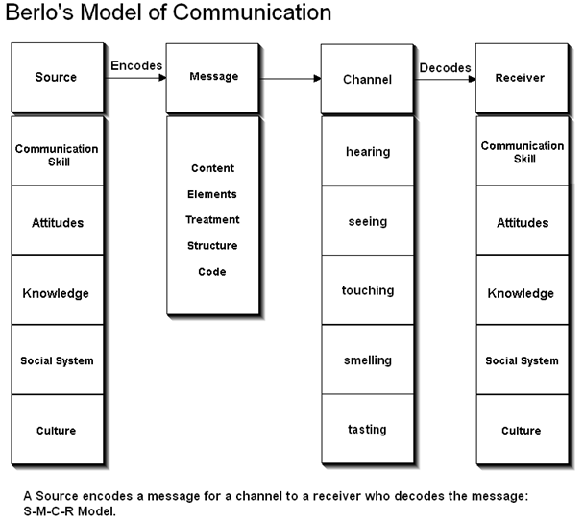
Figure 2- Berlo’s model of communication
(Source- Turaga, 2016)
This model has four main parts which indicates the method of communication. These are the sender, channel, message and the receiver. The sender will send the message which will have to be received by the receiver. This message is passed by the channel. However this is different from the previous model. Here the message is encoded at the source itself before it gets passed on to the receiver. The meaning is decoded by the channel before it is received by the receiver. However, it has no scope for feedbacks, which is a major disadvantage.

Schramm’s model of communication
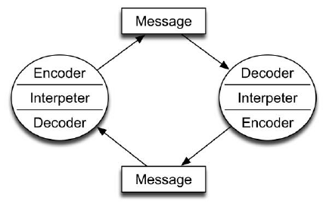
Figure 3- Schramm’s model of communication
(Source- McQuail, and Windahl, 2015)
This model states that communication is a two-way process between the sender and the receiver. It also has an interpreter that interprets the message between the sender and the receiver. The communication is portrayed in a practical way for the practical purposes of it. The message received by the receiver is understood and a respond it sent back to the sender in relation to the message. This is especially significant in workplace at Debenhams. My friend uses this model while communicating with others in form of e-mails. The receiver reverts back to the message by either acknowledging it or stating his/her concern. Accordingly decisions are taken.

Group strategies
The groups which have been formed develop their own strategies of working together in order to perform the tasks assigned to the groups.
- The shared values and morals of the group are kept in mind while formulating the strategies.
- The strategies are made after having a meeting among the team members. All the pros and cons of different ideas are put forward.
- Agreement of the group is required before finally deciding upon something. Therefore, group consensus is an important part of team strategies (Tuckman et al., 2012).
- Important schedule for the next team meeting or follow up of the actions present in the strategies are also included in the team decisions.
- Communicate among each other throughout the task

Conclusion
This report talks about the different ways of developing and forming teams. The group dynamics in an organisation have been discussed and studied. The structures of the teams based on Belbin’s model have been analysed and applied for the organisation. The group dynamics theories which have been discussed portrayed the stages of group formation and functioning. Communication as an effective element of teamwork has been discussed. Different ways to adopt effective communication that will successfully develop strategies for the team have also been analysed in this report. Means of communication to ensure clarity among the individuals have been studied in this report.

References
Adair, J., 2009. Effective teambuilding: How to make a winning team. Pan Macmillan.
Belbin, M.R., 2012. Team roles at work. 2nd edn. Oxford: Butterworth-Heinemann.
Belbin, R.M., 2010. Team Roles at Work. ButterworthHeinemann Title; 2 edition Magin, M. (2004) Making teams Work: 24 Lessons for working together successfully. McGrawHill Pub.
Bown, G. and Brady, C.,1991. Successful manager (women in management Workbook series). Kogan Page, Limited, London, United Kingdom
Collins, J., 2009. Good to Great-(Why Some Companies Make the Leap and others Don't).
Ercegovac, Z., 2008. Information literacy: search strategies, tools & resources for high school students and college freshmen. ABC-CLIO.
Forsyth, D.R., 2018. Group dynamics. Cengage Learning.
Gillespie, D.J. and Schiffman, R., 2018. A Critique of the Shannon-Weaver Theory of Communication and Its Implications for Nursing. Research and theory for nursing practice, 32(2), pp.216-225.
Giudici, M. and Filimonau, V., 2019. Exploring the linkages between managerial leadership, communication and teamwork in successful event delivery. Tourism Management Perspectives, 32, p.100558.
Kiweewa, J.M., Gilbride, D., Luke, M. and Clingerman, T., 2018. Tracking growth factors in experiential training groups through Tuckman’s conceptual model. The Journal for Specialists in Group Work, 43(3), pp.274-296.
McQuail, D. and Windahl, S., 2015. Communication models for the study of mass communications. Routledge.
Paul, H., Blanchard Kenneth H and Johnson Dewey E, 2000. Management of organizational behavior: utilizing human resources.
Polat, V., Lynn, G., Akgün, A.E. and Onat, O.E., 2018. Formal and Informal Communication in New Product Development Teams: The Mediation Effect of Team Trust. International Journal of Innovation: IJI Journal, 6(2), pp.97-111.
Tuckman, B.W. and Harper, B.E., 2012. Conducting educational research. Rowman & Littlefield Publishers.
Turaga, R., 2016. Organizational models of effective communication. IUP Journal of Soft Skills, 10(2), p.56.

