
University of Wales Trinity Saint David
School of Engineering

ACMA5001

Application of automation in
wastewater treatment

Steffan Rhys Lloyd
2220589
07/04/2025

Abstract
The integration of Instrumentation, Control, and Automation (ICA) systems in wastewater treatment has revolutionized how modern facilities operate, enhancing efficiency, reliability, and environmental compliance. This report examines the evolution and current application of ICA in the wastewater industry, with a focus on its core components—sensors, controllers, and actuators—and the critical role of Supervisory Control and Data Acquisition (SCADA) systems. The historical progression from manual and analogue operations to digital, AI-driven processes underscores a shift towards greater autonomy and data-informed decision-making in plant operations.
Key technologies such as programmable logic controllers (PLCs), model predictive control (MPC), and Internet of Things (IoT) devices have enabled real-time monitoring and control of complex biological and chemical processes. These innovations, alongside digital twins and cloud computing have allowed for predictive maintenance, remote management, and scenario testing that improve operational resilience. Regulatory compliance is also enhanced through automated data logging, real-time alerts, and adherence to international standards such as ISO 14001 and MCERTS.
The case study of the Emscher River Restoration Project in Germany highlights a successful large-scale deployment of ICA systems, demonstrating substantial gains in energy efficiency, water quality, and system integration. The report concludes that ICA systems are no longer optional but essential in achieving the sustainable and intelligent management of wastewater treatment infrastructure.
As the industry continues to face increasing demands from urbanization, climate change, and regulatory pressures, the role of ICA will be pivotal in shaping the future of water management systems worldwide.
Table of Contents
1 Abstract 2
2 Introduction 4
3 Historical Context of ICA in Wastewater Treatment 5
4 Core Components of ICA in Wastewater Treatment 6
4.1 Sensors 6
4.2 Process Controllers 6
4.3 Actuators 6
5 Regulatory Standards and Compliance 8
6 Modern and Emerging Technologies 10
7 Case Study: Emscher River Restoration Project 12
8 Future Trends and Sustainability in ICA for Wastewater Treatment 13
9 Conclusion 14
10 References 15

Introduction

The effective treatment of wastewater is vital for public health, environmental sustainability, and compliance with governmental regulations. The purpose of wastewater treatment plants is to purify industrial and public wastewater of impurities so that the effluent can be reused or safely reintroduced into the water cycle. These plants mostly rely on Instrumentation, Control, and Automation (ICA) systems to do this.
ICA provides live monitoring, precision in process control, and automation of various treatment stages. ICA allows facilities to function more effectively and with less human involvement because of growing urbanization and the ensuing increase in wastewater volumes. By following its historical evolution, outlining key elements like sensors, controllers, and actuators. Aligned with analysing supervisory systems like SCADA the most recent technological developments this assignment investigates the use of ICA in wastewater treatment

Historical Context of ICA in Wastewater Treatment
ICA boasts roughly four decades of experience in water and wastewater systems and is widely acknowledged. Initially, there was a perspective that ICA would be an unavoidable cost, implemented at a facility to compensate for design flaws. Yet the core justification for ICA stems from the reality that all processes face disruptions. These originate externally from the incoming wastewater, from consumers in a water supply system, or from operations within a single unit process, and will then spread as a disturbance too their processes in a facility.
The main aim of wastewater treatment plants (WWTPs) is to eliminate pathogens, nutrients, organics, and other pollutants from wastewater. After these chemicals are partially or fully removed through physical, biological, and/or chemical processes, the treated emissions are discharged into receiving waterbodies. Key operations including sedimentation, aeration, and chemical dosing were manually managed with mechanical equipment that lacked precision and adaptability. Operators depended on experience rather than real-time data, which frequently resulted in inefficiencies and variable treatment outcomes.
The beginning of basic analogy instrumentation corresponded with the postwar industrial boom from the 1950s to the 1970s. Devices including as pressure gauges, pH meters, and flow meters began to appear in treatment plants, providing localized data. Mechanical timers and relays allowed for some automation but could not adjust to changing conditions. As a result, the processes still required extensive manual supervision and intervention (Metcalf & Eddy, 2014).
A significant change occurred when PLCs were first introduced in the 1960s; these devices, initially designed for the automotive industry (General Motors, etc.), used programmable digital controllers rather than complex relay systems; early PLCs used solid-state technology, which offered more reliable and flexible control than mechanical relays; they could easily perform increasingly complex tasks; and programming changes required reprogramming (often in a ladder-logic format) rather than rewiring. This technological advancement decreased downtime and simplified processes. The advent of digital automation technology in the 1980s marked a dramatic shift. Programmable Logic Controllers (PLCs) replaced mechanical relays, allowing for more complicated and adaptive control logic. PLCs allow wastewater facilities to automate sequences of operations based on real-time circumstances, enhancing accuracy and consistency. The following decade witnessed the widespread use of Supervisory Control and Data Acquisition (SCADA) systems, which enabled centralized monitoring and control of all elements of treatment. SCADA systems heralded a new era in plant management, eliminating human error and allowing operators to respond quickly to disruptions.
From the early 2000s onward, advances in computing, sensor technology, and data analytics led to the integration of smart systems. Facilities began to implement machine learning algorithms and Internet of Things (IoT) technologies. These tools allowed predictive maintenance, real-time optimization, and more efficient use of resources. With AI-based models, plants could now anticipate and mitigate process upsets before they occurred, making modern wastewater treatment not just automated but intelligent (Siemens AG, 2021).

Core Components of ICA in Wastewater Treatment
Sensors, controllers, and actuators are the three core components of instrumentation, control, and automation systems. These parts work together to maintain optimal process conditions, reduce resource consumption, and assure regulatory compliance.

Sensors
The eyes and ears of ICA systems are sensors. They are used to keep an eye on a variety of physical, chemical, and biological parameters during treatment. Chemical equilibrium is maintained using pH and oxidation-reduction potential (ORP) sensors. In aeration tanks, dissolved oxygen (DO) sensors are essential for preserving the conditions required for microbial activity.
The proper distribution of wastewater across different stages is ensured by flow meters, which track hydraulic loading. Sensors for ammonia and nitrate help remove nutrients by giving biological nutrient removal (BNR) data. Turbidity sensors, which act as indirect indicators of suspended particulates, aid in the monitoring of clarity (Unknown, 2023).
Today’s sensors feature self-cleaning capabilities, automatic calibration, and wireless communication, which enhance accuracy while reducing maintenance needs (ISA, 2022). These improvements are vital for maintaining a reliable data stream to the control systems.

Process Controllers
Process control is a widely used discipline in many different professional domains and industries. It's crucial for preserving quality and enhancing output. Organizations and production managers may benefit from an understanding of this field, its methods, and its advantages. Because PLCs are more adaptable, complete operation sequences can be automated using sophisticated logic. These controllers can be set up to respond immediately to changes in any parameter, guaranteeing that the treatment procedure is steady even in dynamic circumstances. Model Predictive Control (MPC), which uses dynamic models to predict future plant states and identify the best control approach beforehand, is being used more and more by advanced facilities. Process efficiency and consistency are greatly improved by these predictive capabilities, especially in big, complicated treatment systems where real-time adaptation is essential (Matlab, 2024).

Actuators
Actuators are crucial components in engineering and industrial applications, playing a key role in converting energy into mechanical motion. Actuators provide for precise movement and control in a variety of industries and are widely used in automation, robotics, and fluid control systems. However, what are actuators, how do they operate, and in what situations are they most useful? The purpose of actuators, their uses, benefits, drawbacks, and integration with contemporary control systems will all be covered in this blog (Fluid Controls, 2025). The mechanical parts that carry out the commands given by controllers are called actuators. These consist of automated mixers, pneumatic and electric control valves, and variable-speed pumps. Contemporary actuators are built to be precise and long-lasting, and they frequently incorporate feedback sensors that provide information on their operational state. Closed-loop control is made possible by this feedback, which allows the system to self-correct in response to real performance. Actuators are becoming more and more important in providing fully automated, robust wastewater treatment systems as their technology advances, incorporating features like wireless connectivity and inbuilt diagnostics. (Vation, 2019).

Regulatory Standards and Compliance

Numerous safety, health, and environmental requirements must be followed when operating a wastewater treatment plant. By providing automatic reporting, rapid reaction mechanisms, and ongoing monitoring, ICA systems are essential in assisting facilities in meeting these standards.
By offering the real-time data required for monitoring and continuous improvement, ICA helps the implementation of environmental management systems, which are required by international standards such as ISO 14001. By standardizing wastewater sampling procedures, ISO 5667-10 guarantees the validity and dependability of data gathered by ICA systems. Standards like IEC 61508 and IEC 61511 regulate automation safety and mandate that automation systems have redundancy and fail-safes to avoid catastrophic failures Enertria (2022).

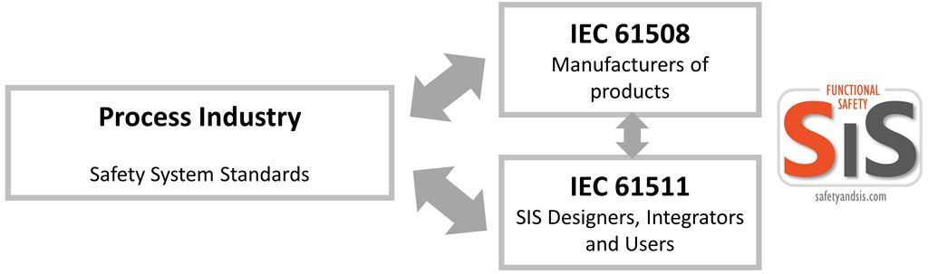
Figure 1 – (Enertria (2022).
In the UK, MCERTS is the Environment Agency’s Watching Certification Scheme for equipment, personnel and organisations..The scheme is built around proven International and European standards to ensure monitoring data is of a high standard..
The U.S. Environmental Protection Agency (EPA) enforces strict guidelines on the levels of nutrients, pathogens, and chemicals in discharged water. Automated data logging, calibration checks, and real-time alerts provided by ICA systems ensure timely corrective action and accurate reporting. By maintaining traceable records and audit trails, ICA simplifies regulatory inspections and supports transparency (EPA, 2025).
Additionally, the digital traceability of processes is becoming more and more important for compliance. Time-stamped operational logs and calibration histories can be included in automatic compliance reports produced by contemporary ICA systems. In addition to fulfilling legal responsibilities, these reports give facilities the ability to benchmark performance and carry out programs for continual development. ICA plays a crucial role in facilitating sustainable and legal operations as regulatory environments become more dynamic and stricter.

Modern and Emerging Technologies
The wastewater sector is undergoing a digital transformation with the integration of cutting-edge technologies that elevate the performance and resilience of ICA systems. At the forefront are machine learning (ML) and artificial intelligence (AI), which can analyse massive datasets produced by sensors and operational logs to find patterns and forecast results (State of Green, 2024).
Based on weather patterns, industrial discharges, and seasonal trends, these intelligent systems can predict changes in influent. Predictive analytics enables ICA systems to make proactive adjustments to variables like chemical dosing or aeration rates, resulting in more reliable and effective operations. AI is also being used in fault detection, where it may spot minute changes in process behaviour that could point to inefficient processes or deteriorating equipment.
Distinct elements across treatment facilities are connected by the Internet of Things (IoT), which combines remote sensors, mobile devices, and cloud platforms to form a networked ecosystem. Sensor data is sent in real time to cloud-based SCADA platforms for visualization and action, facilitating decentralized decision-making and improving coordination across multiple treatment sites. Additionally, IoT-enabled systems facilitate scalability, which makes it easier for municipalities to expand their infrastructure as populations increase (State of Green, 2024).
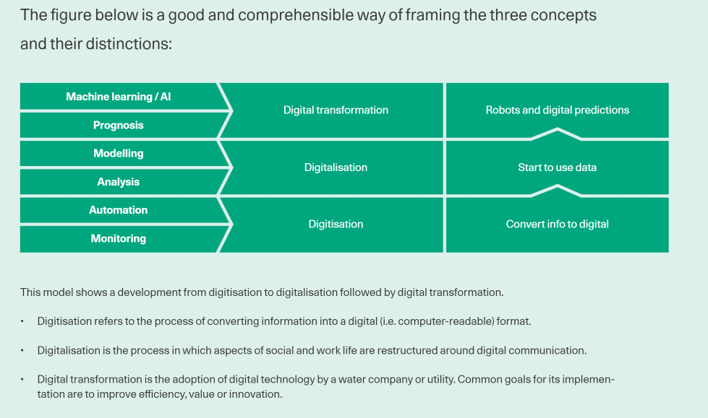
Figure 2 – (State of Green, 2024).

As automation systems grow more interconnected, cybersecurity has emerged as a critical area of attention. Implementing multi-layered security architectures, such as firewalls, intrusion detection systems, and secure communication protocols, is necessary to protect ICA infrastructure. Maintaining system integrity requires regular audits, cybersecurity training, and adherence to guidelines like ISO/IEC 27001. It is impossible to overestimate the significance of cybersecurity since flaws in vital infrastructure can have far-reaching effects, such as harm to the environment and hazards to public health (Iqms, 2021).

Case Study: Emscher River Restoration Project

A compelling example of ICA application is the Emscher River Restoration Project in Germany, a large-scale environmental and infrastructure initiative that transformed a heavily industrialized region's water management system. “The entire Emscher Catchment, a sub-basin of the River Rhine in the federal state of North-Rhine Westphalia, Germany, covers 865 km² and hosts 2.2 million inhabitants in one of the most densely populated areas of Germany (3,300 inhabitants/km²)” (Climate Adapt, 2024). The project replaced open wastewater canals with modern sewer systems and advanced treatment plants.
Advanced ICA technologies were installed in these sites. Critical elements like weather data, flow rates, and nutrient concentrations were measured via real-time sensors. Energy consumption and chemical expenses were decreased via automated controls that modified aeration and chemical dosing in response to shifting conditions (V. Gerner, 2018).
Coordinated control techniques were made possible by a centralized SCADA system that offered a thorough overview of activities across several plants. AI-powered predictive algorithms examined upstream inputs, such as stormwater inflows, to get the system ready for possible surges. This made it possible for operators to uphold strict treatment guidelines even in unpredictable circumstances.
As a result, compliance, energy efficiency, and water quality were significantly improved. The project fulfilled all EU Water Framework Directive standards and reduced operational energy use by 20%. Additionally, remote management and ongoing performance monitoring were made possible by the incorporation of digital twin models. This initiative's success serves as an example of how thorough ICA implementation can facilitate the efficient, sustainable, and independent operation of complex water systems (V. Gerner, 2018).
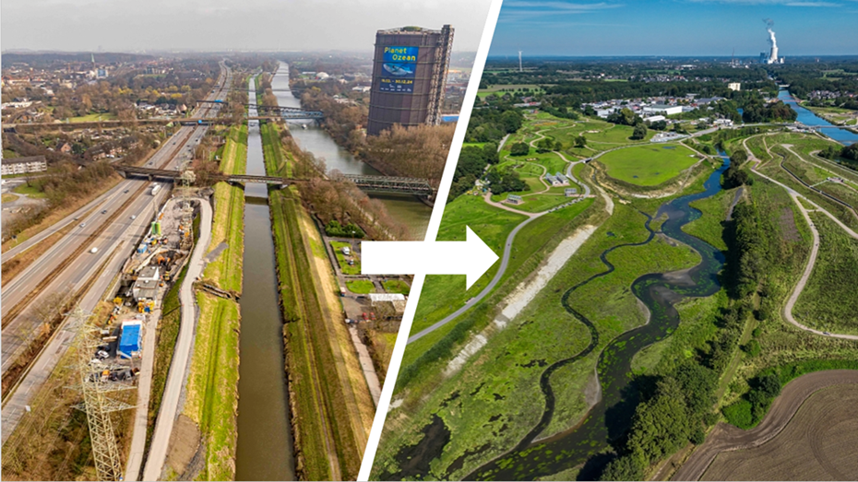
Figure 3 – (Climate Adapt, 2024)

Future Trends and Sustainability in ICA for Wastewater Treatment
Looking ahead, ICA's role in wastewater treatment is closely linked to the development of smart infrastructure and sustainability. Wastewater treatment systems need to develop to become more robust and resource-recovering in addition to being more efficient as the world's population continues to rise and climate change exacerbates pollution and water scarcity.
The move toward energy-neutral or even energy-positive treatment plants is one significant trend. With ICA at the centre, facilities can use variable frequency drives that modify motor speed in response to load and real-time DO sensors to optimize aeration, the most energy-intensive process. Anaerobic digesters produce biogas, which ICA may help capture and use. This completes the resource loop by turning trash into energy (Unknown, 2022).
Reusing water is also becoming more popular, especially in dry and urbanizing areas. Advanced treatment techniques including membrane filtration and UV disinfection are guaranteed to continuously meet strict quality standards thanks to ICA systems. The high reliability needed for both potable and non-potable reuse is maintained with the aid of automatic problem identification and real-time monitoring.
Another important area of focus is climate-resilient infrastructure. Using integrated rainfall sensors and prediction algorithms, ICA enables treatment systems to integrate early warning and flood forecasting systems. These features lower the chance of overflowing during severe weather events and allow for proactive influx management.
Lastly, the dynamic coordination of numerous treatment and distribution nodes will be made possible by the integration of ICA with citywide smart water networks. This covers cross-sectoral resource sharing, decentralized treatment systems, and demand-responsive pumping. To create the circular, climate-adaptive cities of the future, ICA will become increasingly predictive, networked, and essential as digital innovation advances (Climate Adapt, 2024).

Conclusion
Instrumentation, Control, and Automation (ICA) have become indispensable to the efficient, safe, and sustainable operation of modern wastewater treatment plants. Evolving from manual monitoring and basic analogue systems to advanced, AI-driven automation, ICA has transformed how facilities manage the increasingly complex challenges of wastewater processing.
At the core of ICA are three integrated components—sensors for real-time data collection, controllers for intelligent decision-making, and actuators for precise execution. Together, they enable consistent process optimization, reduced energy and chemical consumption, and timely response to fluctuations in influent quality. Supervisory systems such as SCADA further enhance control by offering centralized visualization, historical analysis, and remote management capabilities.
As the industry embraces digital transformation, technologies like the Internet of Things (IoT), machine learning, digital twins, and cloud-based platforms are pushing wastewater treatment toward greater autonomy and resilience. These innovations support predictive maintenance, scenario modelling, and data-driven decision-making, ensuring regulatory compliance and improving environmental performance.
In conclusion, ICA is not merely a support mechanism—it is the foundation of intelligent wastewater treatment. Its continued evolution will be central to achieving energy-efficient, adaptive, and compliant systems capable of meeting future environmental and societal demands.

References
Climate Adapt (2024) The Emscher Restoration: A Contribution to climate adaptation, Climate. Available at: https://climate-adapt.eea.europa.eu/en/mission/solutions/mission-stories/the-emscher-restoration-story19 (Accessed: 04 April 2025).
Enertria (2022) Safety standards, Functional Safety. Available at: https://safetyandsis.com/safetystandards/#:~:text=International%20Standards%20such%20as%20IEC,their%20direct%20or%20indirect%20compliance. (Accessed: 04 April 2025).
EPA (2025) United States Environmental Protection Agency (EPA), the Journal of Regulation. Available at: https://thejournalofregulation.com/en/article/united-states-environmental-protection-agency-epah/ (Accessed: 04 April 2025).
Fluid Controls (2025) What are actuators?, Fluid Controls. Available at: https://www.fluidcontrols.co.uk/blog/what-are-actuators/ (Accessed: 04 April 2025).
Iqms (2021) ISO 27001:2022 lead auditor: Iqms learning |, Iqms. Available at: https://iqmslearning.co.uk/course/iso-270012022-lead-auditor-35?gad_source=1&gbraid=0AAAAABdYomcBHpT_tZFE5paUoVUHOtwf&gclid=EAIaIQobChMIi7vu7e6-jAMVGaVQBh2GgSI8EAAYBCAAEgJ59_D_BwE (Accessed: 04 April 2025).
Matlab (2024) What Is Model Predictive Control?, What is Model predictive control? Available at: https://uk.mathworks.com/help/mpc/gs/what-is-mpc.html (Accessed: 04 April 2025).
Metcalf & Eddy (2002) Wastewater Engineering. Available at: https://ptabdata.blob.core.windows.net/files/2017/IPR2017-01468/v22_FWS1016%20-%20Metcalf.pdf (Accessed: 04 April 2025).
Olsson, G., Nielsen, M.K., Yuan, Z., Lynggaard-Jensen, A. and Steyer, J.-P., 2005. Instrumentation, Control and Automation in Wastewater Systems. IWA Scientific and Technical Report No. 15. [pdf] Available at: https://www.researchgate.net/publication/256107494_Instrumentation_Control_and_Automation_in_wastewater_-_what_happened_from_London_1973_to_Narbonne_2013 [Accessed 4 April 2025].
Siemens AG, 2021. Digitalization in Wastewater Treatment: Enhancing plant efficiency and resilience through ICA. [pdf] Siemens. Available at: https://www.siemens.com/global/en/products/automation.html [Accessed 4 Apr. 2025].
State of Green (2024) The digital transformation of the wastewater sector, State of Green. Available at: https://stateofgreen.com/en/news/the-digital-transformation-of-the-wastewater-sector/ (Accessed: 04 April 2025).
Unknown (2023) PLC’s and water treatment facilities, PLC Technician. Available at: https://www.plctechnician.com/news-blog/plcs-and-water-treatment-facilities (Accessed: 04 April 2025).
V. Gerner , N. (2018) Large-Scale River Restoration pays off: A case study of ecosystem service valuation for the Emscher Restoration Generation Project, Ecosystem Services. Available at: https://www.sciencedirect.com/science/article/pii/S2212041617303753 (Accessed: 04 April 2025).
Vation (2019) Actuators: Definition, explanation, and use cases, Vation Ventures. Available at: https://www.vationventures.com/glossary/actuators-definition-explanation-and-use-cases (Accessed: 04 April 2025).

