This is a Critical Review of Gwent Police’s Decision to Amalgamate a Dedicated Roads Policing Unit (RPU) and Operation Support Team Together

By Joshua Trott

Research Proposal
The purpose of this research is to evaluate Gwent Polices decision to amalgamate their Roads Policing Unit (RPU) and Operational Support Unit (OSU) into a new unit known as Area Support Unit (ASU) to find out a definitive conclusion as to whether or not this had a positive or negative effect to roads policing within Gwent.

The National Police Chief’s Council (NPCC) state that there three year strategy between 2018-2021 priorities are the following for Roads Policing:
- Reduce Road Casualties
- Disrupting Criminality
- Counter Terrorism
- Patrolling the Roads
(Road policing, 2021)
Following the three year strategy by the NPCC and Gwent Police’s decision to amalgamate their departments are they achieving the results set out by the NPCC. By completing this research there will be a definitive conclusion to see if Gwent Police have achieved what the NPCC wanted from their three year strategy.

I have chosen this area of topic as Gwent Police are now in 2021 converting back to an RPU after six years of being ASU. Jeff Cuthbert who is the Police and Crime Commissioner for Gwent Police who is also the lead to roads policing recently said “Gwent Police has had significant cuts in government funding since 2010 and has had to make almost £50million in savings. This has inevitably meant that prioritising resources in some areas has been a challenge” (Roads policing review, 2021). This suggests that one of the main reasons for amalgamating the units was to reduce costs and save money but to what detriment to the safety of the roads.

According to Blackstone’s Handbook for Policing Students 2019, “the safety of the roads has improved significantly however road incidents are the main course of premature death for individuals under the age of 25 and cause a significant number of avoidable road deaths across all age groups. Road traffic incidents are the second highest causes of avoidable road deaths”. (Bryant and Bryant, 2018). With Cuthbert’s budget cuts for Gwent Police and Blackstone’s saying that road incidents are the main cause of deaths for under 25 years old and across all age groups suggests that when the RPU became ASU the conviction rates would decrease, and the roads would become more dangerous. Furthermore, the Department of Transport released a Roads Policing Review and suggest that “offenders will use the road network to facilitate the commission of crimes including smuggling and cargo theft, county lines exploitation, facilitating burglary and crimes of violence”. (Roads Policing Review Call for Evidence, 2020). This supports the decision to revert from an Area Support Unit back to a dedicated Roads Policing Unit to help deny criminals the use of the roads.

As a serving police officer this research is crucial to conduct as at this present moment in time, there is a lot of controversy between the department as some are embracing the move back to RPU and some would like to remain as ASU, therefore by completing this study there will be a definitive answer to which department are/were more effective.
To obtain a definitive conclusion to this question I am going to:
- Speak with current police officer who were not on RPU and joined onto ASU and obtain their thoughts and opinions
- Speak with RPU officers before the amalgamation and find out their views.
- Review detection rates of the Roads Policing Unit vs Area Support Unit this can be achieved by researching how many fines, summons and traffic offence reports have been issued.
- I will research fatalities pre ASU and post ASU which will indicate whether since the disbandment of a dedicated RPU in Gwent Police has increased or decreased conviction rates and fatalities.
- I will also conduct enquiries into the collision investigation team who deal with fatal road traffic collisions to access if they have noticed an increase or a decrease since the amalgamation to RPU to ASU.
- I will conduct a freedom of information request to a similar sized police service who have a Roads Policing Unit and see how their detection rates compare five years before Gwent Police decided to amalgamate the divisions and five years after.

Research Methods
I have sent an initial email to various Area Support Officers requesting their views on changing from ASU to RPU and whether these changes are for the good or bad for the police service and the impact on themselves as a police officer? I have also asked an ex roads policing officer the following question. “I would like to know what it was like having a dedicated RPU and the effects it had moving to ASU and any benefits or negatives this had and also how this affected you as an officer? By completing this it will give me a preliminary view of their thoughts how best to conduct further research.

Unfortunately, I have not received any responses from these initial emails however I have spoken to two officers and this is the information they have provided me

Subject 1 used to be a Roads Policing Officer before an Area Support Unit Officer
Subject one said “It was easier as a roads traffic unit as our duties were solely policing the roads, however they now have too many hats to wear as we back up response for taser incidents or method of entry we have limited time to police the roads and is usually the last thing we do.
Subject 2 Area Support Officer no previous Roads Policing Only History
Subject 2 said “As he has only been in the department as an ASU officer he does not know the difference between the two departments however, as they are all specially trained in other departments such as Public Safety Unit, Taser, Method of Entry and Search Officer, they do not have time dedicate to solely police the roads. They have said they enjoy their current role as there are many different duties to perform each day.

With the views these two officers, this supports what members of the public felt after completing survey by the RAC that “the laws around driving under the influence of drugs are not being properly enforced” (Roads Policing Review Call for Evidence, 2020) Therefore when officers explained their duties on ASU, roads policing comes secondary therefore roads users who are committing road traffic offences are not being convicted due to the lack of policing on the roads.

To gain further thoughts from officers I will utilise Google Forms as a research method as this will allow me to send one form to multiple police officers at once and upon the return of these forms the sender will remain anonymous to ensure no one is identified breaching data protection and the police code of ethics. This could assist on police officers replying with honest answers.

Sample Questions to Ask
- Were you on Roads Policing Unit (RPU) before the amalgamation to Area Support Unit (ASU)?
- How long were you on RPU?
- Did you prefer RPU to ASU?
  - Why?
- How long have you been on ASU?
- Do you enjoy the current role on ASU?
  - What do you enjoy
- Are you looking forward to moving to a dedicated Roads Policing Unit?
  - If not, why?
- Do you feel as an Area Support Unit you can dedicate enough time to roads policing during your tour of duty?
- Did you join Area Support Unit for roads policing or to be able assist the police service in other areas such as priority arrests?
- Additional Comments?
Once these results are in and reviewed, I can then produce graphs to evidence the results which will give me a clear understanding of what the police officer thoughts and feelings are.

These surveys will be sent out in line with the Police Code of Ethics; therefore police officers will be remined of this when they are completing their answers. “The Code of Ethics is a first for everyone who works in policing in England and Wales. It sets out the principles and standards of behaviour we expect to see from police professionals. It applies to every individual who works in policing, whether a warranted officer, member of police staff, volunteer or someone contracted to work in a police force”. (Police Code of Ethics, 2014). These surveys currently do not impose a risk to identity issues, however, should any arise I will report these in line with the university and the police services guidelines. If these surveys are not completed, I will look to complete one on one interviews.

When I receive information about statistics from a similar size police service, if I identity any risks or legal issues these will be reported to the university and police service and the relevant files will be redacted using Adobe Pro before they can be used.

Resources and Planning
The resources I will need to complete this research are as follows:
- Access to the internet.
- Access to journals to support arguments.
- Access to Microsoft Excel to create graphs.
- Access to an active Google Account to create forms.
- Access to police records to obtain detection rates.
- Access to an Email account.
- Access to journals and library material which is available through UWTSD and public libraries.

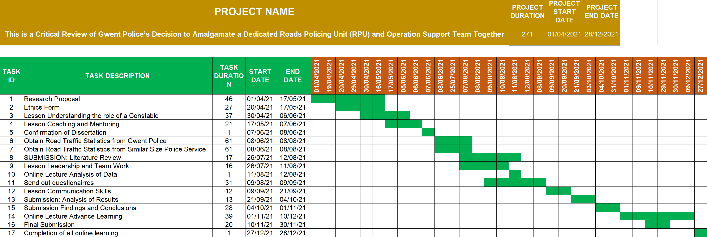
GNAT CHART

Bibliography
App.college.police.uk. 2021. Road policing. [online] Available at: <https://www.app.college.police.uk/app-content/road-policing-2/> [Accessed 4 April 2021].
Bryant, R. and Bryant, S., 2018. Blackstone's Handbook for Policing Students 2019. 13th ed. Oxford, p.418.
College of Policing. 2014. Police Code of Ethics. [online] Available at: <https://paas-s3-broker-prod-lon-6453d964-1d1a-432a-9260-5e0ba7d2fc51.s3.eu-west-2.amazonaws.com/s3fs-public/2021-02/code_of_ethics.pdf> [Accessed 8 May 2021].
Gwent Police and Crime Commissioner. 2021. Roads policing review. [online] Available at: <https://www.gwent.pcc.police.uk/en/news-room/roads-policing-review/> [Accessed 4 April 2021].
Roads Policing Review Call for Evidence 2020. [ebook] Department for Transport, pp.9 & 11. Available at: <https://assets.publishing.service.gov.uk/government/uploads/system/uploads/attachment_data/file/899574/roads-policing-review-call-for-evidence.pdf> [Accessed 24 April 2021].

