Title page

Student name……………………….Mohammad Shabir
Student number……………………2420435
Module title………………………….Changemakers: Creativity and Value Creation
Module code………………………..BMHP5014
Assignment title……………………Component 2: Written Assignment ( report )
Lecturer name………………………Tomy Adattu Chacko

POSTER: CAPMPAIGN TO REDUCE OBESITY
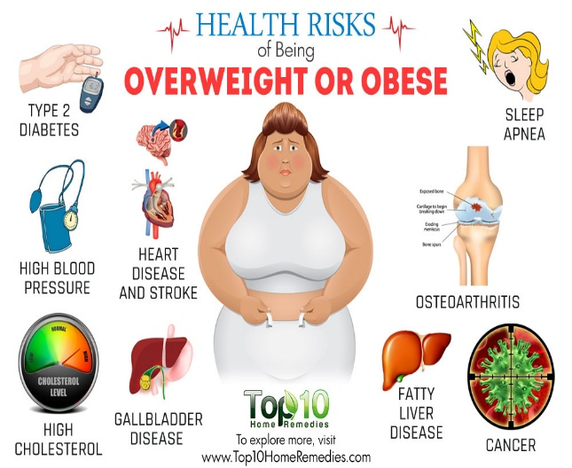
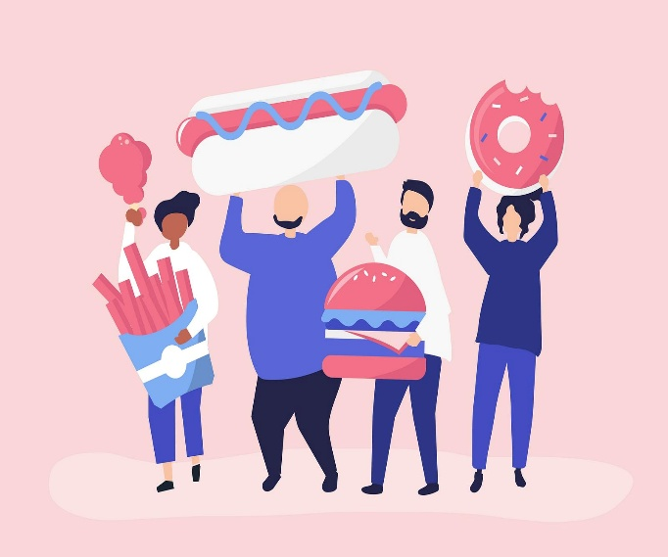
This Photo by Unknown Author is licensed under CC BY-SA

64% of adults in the UK are classified as overweight or living with obesity, obesity is rapidly increasing, due to our lifestyle which includes the food and drink we chose to consume and lack of physical activities. In my campaign I want to make people aware of changes needed in order to live a more healthy lifestyle, but first I want to explain why obesity is classed as a chronic medical condition, this condition is a complex disease driven by genetics, biological and environmental factors, this condition alters how the body functions and this then increases risk for other chronic noncommunicable diseases such as type 2 diabetes, heart disease and stroke, high blood pressure, fatty liver disease, high cholesterol and cancer. 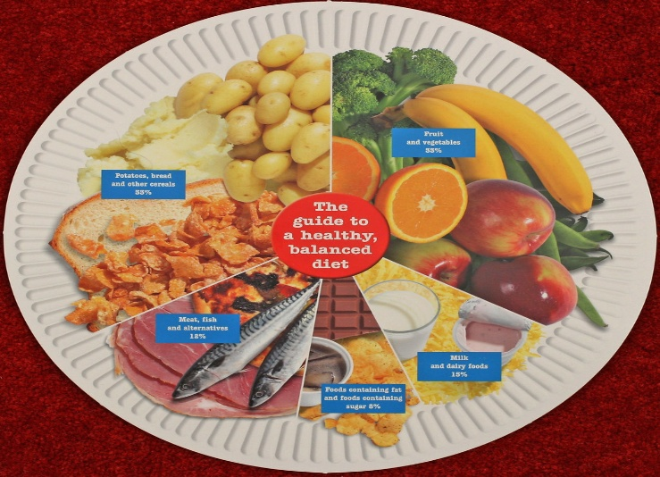
This Photo by Unknown Author is licensed under CC BY-SA-NC
We need food to provide the essential energy and building blocks required to survive, without food the body cannot function, however we need to make the right choices to eat healthy foods. Choosing healthy diet will help by preventing chronic diseases, serving as foundation for general physical fitness and mental well-being, healthy food choices will lower risks of heart disease, type 2 diabetes and certain cancers. This choice is for individuals to have a better quality of life, choosing vegetables and fruits, starchy carbohydrates, proteins and healthy fats over ultra-processed foods will benefit individuals health in the long-term.

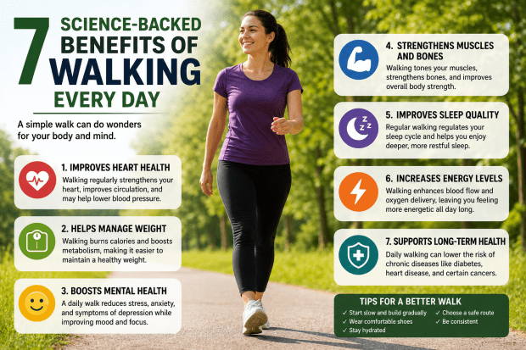
Walking is a great way to help lose weight and boost mental well-being, walking is also free, so an ideal way to start off a healthy lifestyle, walking combined with healthy choice of foods is a great combination towards healthy lifestyle, walking improves cardiovascular fitness, bone and joint health. Better digestion and reduces blood pressure. Walking manages type 2 diabetes, after meals a short walk will activate muscles to absorb glucose. Walking supports weight control, by burning calories and reduces the risk of obesity. According to ( Lange 2025 ) a small increase in physical activity can benefit health, and aiming for more realistic 5,000 to 7,000 steps daily is achievable.

Exercising at home is another great way of reducing obesity, for those individuals that struggle to go to the gym, it is perfect way to build muscles, burn calories, increase metabolic rate and the cost is low, investing in rubber bands, steppers, light weights and a training mat will do the trick, there are many sites on social media that can guide and illustrate you towards exercises that will lead towards healthy lifestyle. Home exercises combined with walking and healthy food choices is a great way to improving one’s health and wellbeing, a great way to reduce obesity and managing weight loss.

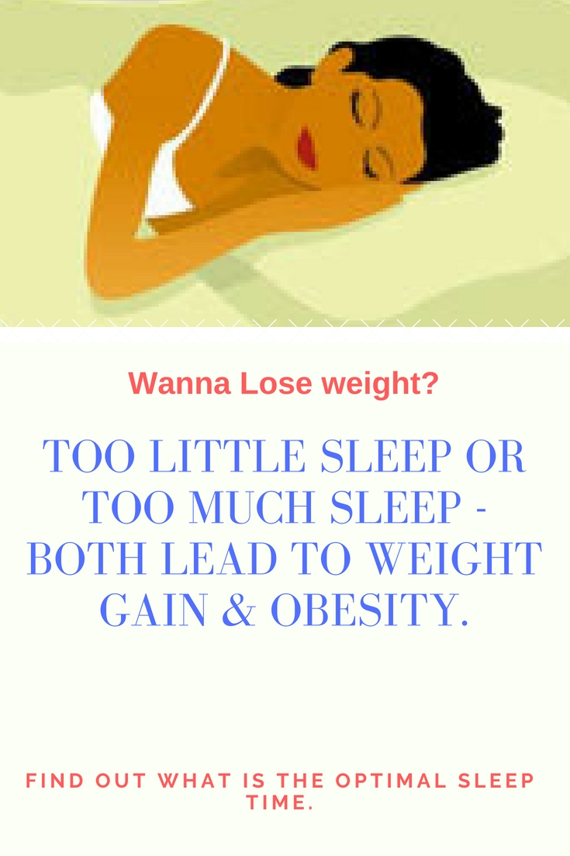
This Photo by Unknown Author is licensed under CC BY-NC-ND
Sleep is another important factor that reduces obesity and managing weight loss, getting right amount of sleep directly regulates metabolic, neurological and hormonal pathways that control appetite and fat storage. 7-9 hours of sleep is recommended, clinical studies have found that individuals getting 8.5 hours sleep will lose twice as much fat as to those only sleeping for 5.5 hours.

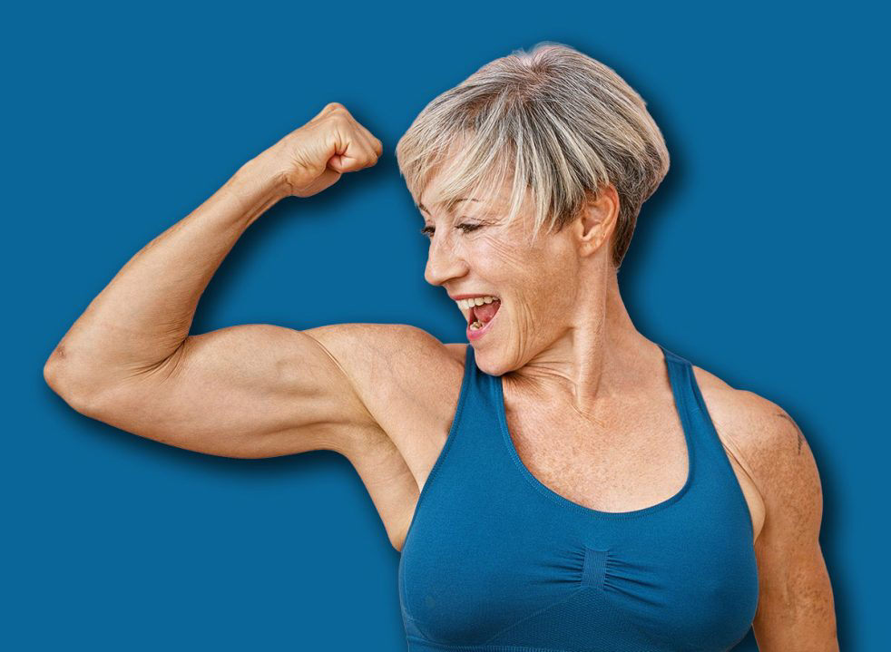
Building muscle is important when reducing obesity, building muscle also helps maintain lean muscle and reducing fat, building muscle increases your Basal Metabolic Rate (BMR). Building muscle fights diabetes, reduces visceral fat, protects joints and improves mobility, building muscle improves strength and overall physique.
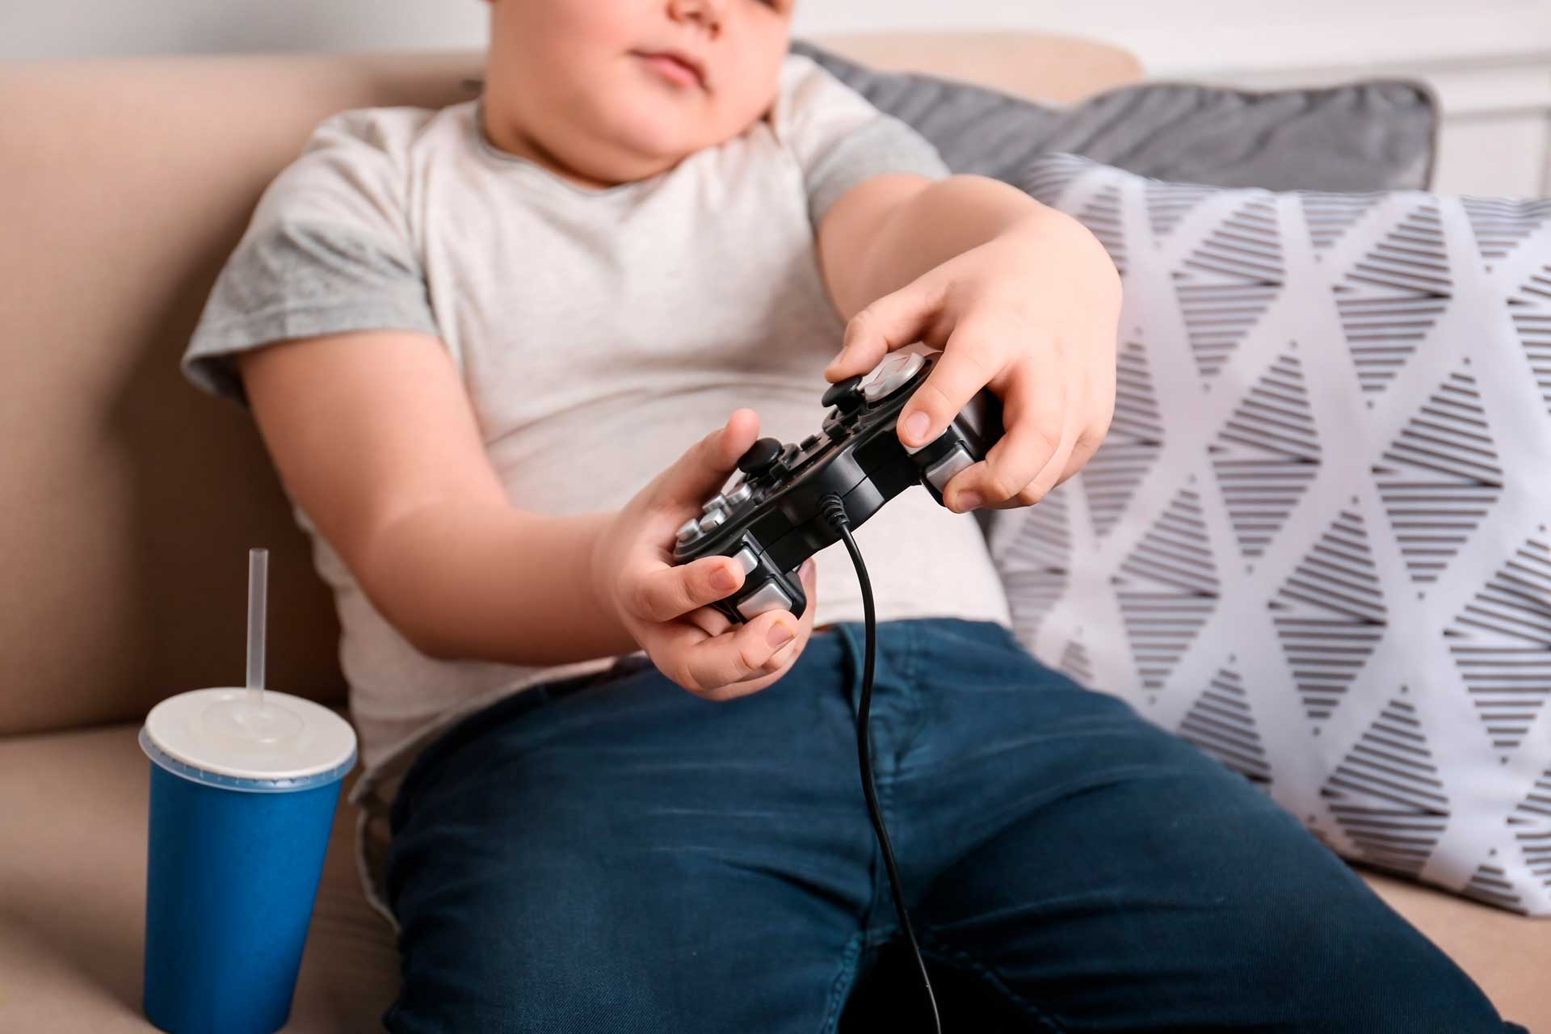
This Photo by Unknown Author is licensed under CC BY-NC-ND
We need to tackle obesity at the earliest stage possible and that involves children, we must guide children towards healthy lifestyle which then can become an integral part of their lives, modern times technology has pushed children in the UK away from physical activities, it is recommended that children carry out 60 minutes of physical activity daily, around 51% of children do not meet this daily target. Unfortunately play stations, tablets, laptops, mobile phones, television and other forms of digital media have taken over the children’s interest, with the rapid increase of technology more and more children will become overweight and obese.


This Photo by Unknown Author is licensed under CC BY-SA-NC
Getting children to become active in physical activities is extremely important, this awareness needs to reach all adults involved in looking after children, such as parents, guardians, teachers, doctors, grand parents and so on, as adults we need to emphasise the importance of physical activity for children, we need to bring back youth clubs, after school clubs, during school activity that involves physical activity, 60 minutes are recommended per day for children, we could organise this during school time or after school club, ensuring that children are involved in some sort of physical activity, such as football, cricket, running, rounders, basketball, skipping, climbing, boxing, and any other physical activity that the children like, making it fun for children, meeting the needs of individuals, adults in-charge can also explain why eating healthy is important and what are the healthy food options. If we can educate children about the complications of obesity then hopefully we can create future generations of healthy people, which will in return put less pressure on the health service in the UK, and hope that these children then can guide their children towards a healthy lifestyles.
Proposed innovations to reduce obesity include, government free use of local community leisure centres at certain times, encouraging adults of all ages to use the facilities such as the gym and swimming pool, I would like the community centres to employ fitness coaches that can help individuals meet their targets and monitor their progress. Also free swimming passes for children, encouraging them to swim on regular basis. The government could also setup Apps for people to use that can help individuals to design their own exercise plans. We should bring back youth clubs, these could run from schools, community centres, sports grounds, and can use involve children in many different physical activities. We can bring in many innovations to help reduce obesity and create a more healthy nation. And asking health and social care professionals to help educate people about healthy lifestyle. According to ( Arshad et al ., 2025 ) digital health technologies such as self-monitoring tools can help plan healthy meals which can improve to monitor disease, this is personalised nutrition plan that helps metabolic well-being.

PITCH
The idea of my campaign is to create a more healthier UK nation, I would like to bring innovative proposals in order to reduce obesity and create a healthy UK, obesity is a major health crisis in the UK, 66% of adult population are overweight, making UK the heaviest nations in Europe, obesity puts huge pressure on the healthcare services, obesity is a big contributor towards type 2 diabetes, cardiovascular diseases, at least 12 types of cancer and poor mental health. So I want to make UK citizens aware of innovations they can bring into their lifestyles that will help them to reduce obesity and live a more healthier life. According to ( Sezgin 2026 ) The World Health Organisation state that by 2022 one in eight people globally were living in obesity, and projected that by the year 2035 this will rise to one in four, a rapid growth in obesity, especially in children.
So we have to make lifestyle changes in order to reduce and prevent obesity, the choice is ours to make so lets make the right choices, lets work towards a good bill of health, obesity attracts diabetes in a big way, and diabetes leads to other health complications, according to ( McPake 2025 ) there are a billion people throughout the world living in obesity and close to a billion are diabetic, this article states that lifestyle changes are the best way to reduce and prevent obesity. Consuming significant sugar plays a big part in developing type 2 diabetes. Ultra-processed foods contain added sugar to enhance flavour, sugary drinks are also bad for us, so we have to stop buying and consuming ultra-processed foods and sugary drinks, a report by The World Health Organisation ( WHO 2026 ) mentions the meeting attended by 36 member states related to sugar and calorie reduction, however these meetings do not have much impact on changes as UK consumes significantly more sugar than health guidelines.
We the people have to make changes we are responsible for our own health, I would encourage the UK Government to make people aware of free Apps available to help reduce obesity, majority of the people are not aware about these Apps, also the UK government should allow people on low income free entry to use the community leisure centres, these people then could use the gym and swimming facilities, according to ( Kobayashi et al ., 2023,. Pp 1897-1907 ) strength training is more effective than aerobic exercise, because strength training builds lean muscle, for those who can not lift gym weights they could use exercise bands.
In my campaign to reduce obesity we must tackle it at the youngest age, and that is children, if we can nurture our children towards being active and eating healthy foods, then we have a chance of reducing the growth of obesity, I believe we need more physical activities at infant, primary and junior school ages, according to ( Hunt et al ., 2024 ) less than 50% of children in the UK do not meet the required 60 minutes guidelines for daily physical activity, this report further states that 1-in-3 children are overweight by the time they leave primary school. Then there are many distractions that lure our children away from physical activities and dare I say the dreaded video games, and this new culture is rapidly growing, video game consoles are number one on the list for birthdays and Christmas, according to ( Mondol 2022 ) video games have rapidly increased and has become addiction, and is a recipe towards developing obesity, children are eating more and not moving much and on top of that sitting playing video games for hours, we need to stop or slow down this culture, therefore I propose that we innovate more physical activities and health education at early school ages.
It seems that even though European nations are highly developed countries, obesity is continuously growing in these countries, due to bad lifestyle changes such as ultra-processed foods, sugary drinks, lack of physical activities, according to ( Mahase 2022 ) no European nations are on target to reduce obesity, clearly the wrong type of food sold in European countries is not being banned, it is as if governments don’t care and don’t want to upset the billion pounds ultra-processed foods ( UPFs ) industry. That is why I believe we need to take control of our own lifestyle, make changes that will improve not just our own health but the health of our future generations, according to ( Theis and White 2021 ) government policies regarding reducing obesity in England do not lead implementation, these policies are not effective, the proof is that after 30 years of proposed policies to reduce obesity, obesity is rapidly growing. This article is proof that government policies are not working to reduce obesity, so I urge us all to change our lifestyles and do not fall for the ( UPFs ) marketing, buy healthy food, stop sugary drinks, drink water, do more physical activities.
I believe the innovation has to come from us all, we are the ones that need to bring changes in our lives, innovation is bringing in new ideas and that is exactly what we need to do, create our own ideas towards healthy lifestyle, the digital media such as YouTube can help us plan our meals, plan our physical activity, we ourselves are responsible for our own and our children’s health, so be innovative, be in-charge of your own destination.

Referencing
Arshad, M.T., Ali, M.K.M., Maqsood, S., Ikram, A., Ahmed, F., Aljameel, A.I., Al-Farga, A. and Hossain, M.S. (2025) ‘Personalized nutrition in the era of digital health: A new frontier for managing diabetes and obesity’, Food Science & Nutrition, 13(10), e71006. Available at: https://doi.org/10.1002/fsn3.71006 (Accessed on: 17/07/2026).
Hunt, I. and Al-Zubaidi, H. (2024) ‘Physical activity advice for children and young people’, InnovAiT, 17(7), pp. 326–332. Available at: https://doi.org/10.1177/17557380241247125 (Accessed on: 17/07/2026).
Kobayashi, Y., Long, J., Dan, S., Johannsen, N.M., Talamoa, R., Raghuram, S., Chung, S., Kent, K., Basina, M., Lamendola, C., Haddad, F., Leonard, M.B., Church, T.S. and Palaniappan, L. (2023) ‘Strength training is more effective than aerobic exercise for improving glycaemic control and body composition in people with normal-weight type 2 diabetes: a randomised controlled trial’, Diabetologia, 66(10), pp. 1897–1907. Available at: https://doi.org/10.1007/s00125-023-05958-9 (Accessed on:17/07/2026).
Lange, K.W. (2025) ‘Walking and health’, Journal of Disease Prevention and Health Promotion, 9, pp. 1–2. Available at: https://doi.org/10.5283/jdphp.52 (Accessed on: 16/07/2026).
Mahase, E. (2022) ‘Obesity: No European country is on track to halt rising levels by 2025, WHO warns’, BMJ, 377, o1107. Available at: DOI:10.1136/bmj.o1107 (Accessed on:16/07/2026).
McPake, B. (2025) ‘Overweight, obesity and diabetes: Global trends and a better future?’, Health Systems & Reform, 11(1), article 2518797. Available at: https://doi.org/10.1080/23288604.2025.2518797 (Accessed on: 17/07/2026).
Mondol, E.P. (2022) ‘The role of VR games to minimize the obesity of video gamers’, International Journal of Computations, Information and Manufacturing (IJCIM), 2(1), pp. 1–13. Available at: https://doi.org/10.54489/ijcim.v2i1.70 (Accessed on: 16/07/2026).
Sezgin, D. (2026) ‘Public health responses to obesity in the United Kingdom: A critical evaluation of campaigns and policy directions (1990–2025)’, Connectist: Istanbul University Journal of Communication Sciences, (69), pp. 132–151. Available at: https://doi.org/10.26650/CONNECTIST2025-1719485 (Accessed on:17/07/2026).
Theis, D.R.Z. and White, M. (2021) ‘Is obesity policy in England fit for purpose? Analysis of government strategies and policies, 1992–2020’, The Milbank Quarterly, 99(1), pp. 126–170. Available at: https://doi.org/10.1111/1468-0009.12498 (Accessed on: 16/07/2026).
World Health Organization Regional Office for Europe (2026) Third meeting of the WHO European Region Sugar and Calorie Reduction Network: London, United Kingdom, 26–27 March 2025, meeting report. Copenhagen: World Health Organization Regional Office for Europe. Available at: Third meeting of the WHO European Region Sugar and Calorie Reduction Network: London, United Kingdom, 26–27 March 2025, meeting report (Accessed on:15/07/2026).

