Kelsey Priestley 2306087
UWTSD Computing Learning Web and Database Concepts
16/01/2024
assignment 1

Contents
Introduction 1
Requirements 2
Implementation 2
Home Page 2
What We Do Page 2
Contact Page 3
Form Page 3
Staff Page 4
Validation 4
Home Page 4
What We Do Page 4
Contact Page 5
Form Page 5
Staff Page 6
CSS 6
Evaluation 6
Website Usability 6
Accessibility 7
Search Engine Optimisation 8
Bibliography 8
Appendices 9
Index.html 9
WhatWeDo.html 10
Contact.html 12
Form.html 14
Staff.html 18
Styles.css 20

Introduction
This report will entail various aspects of website development techniques, what is required by the scenario, how various techniques are implemented and validated and an overall evaluation. The scenario requires to build a website for either an organisation (can be fictitious or non-fictitious) or of a personal hobby, town, or band.
The website will be built in Notepad++.

Requirements
The built website is about a fictional pharmaceutical company from the Resident Evil franchise called the Umbrella Corporation. The purpose of the website is to highlight what Umbrella present themselves as in the game franchise. The subject matter of the site is of pharmaceuticals and also shows Umbrella’s motive. The target audience for the website is people who are interested in the Resident Evil video game franchise.

Implementation
Below are screenshots of the website. This is what the user will see when using the site, not the code.

Home Page
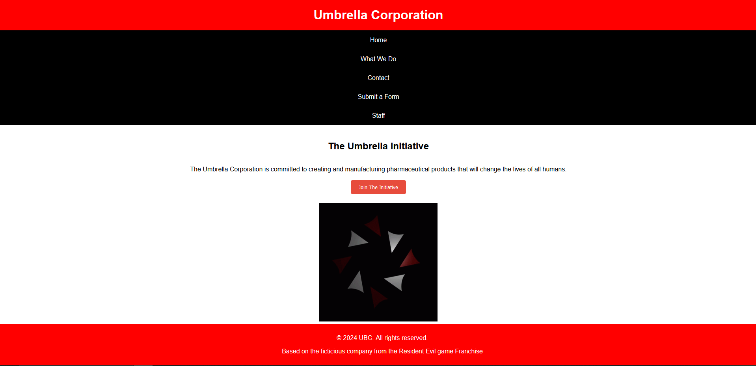

What We Do Page
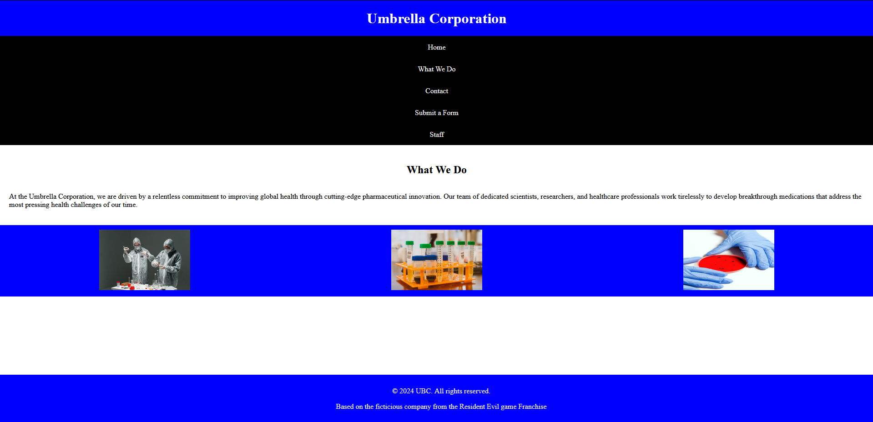

Contact Page
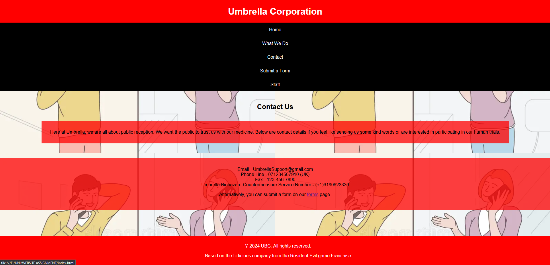

Form Page
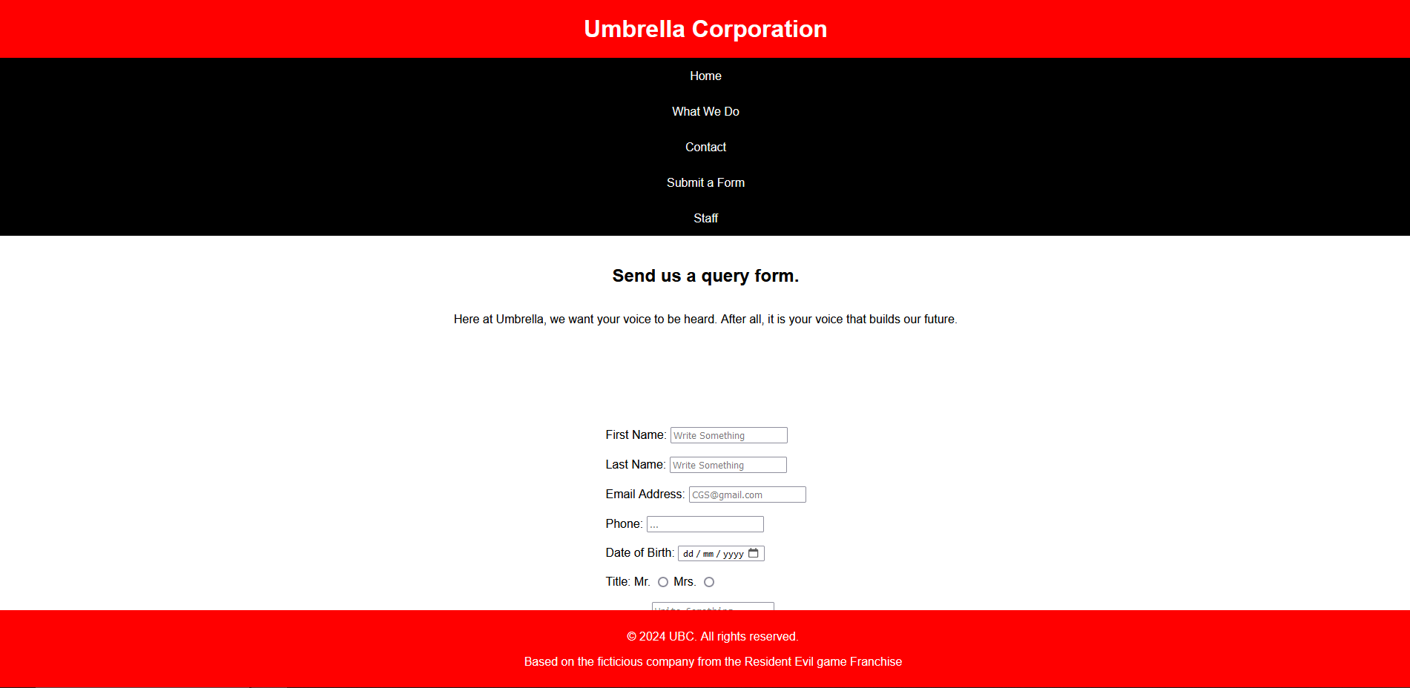

Staff Page
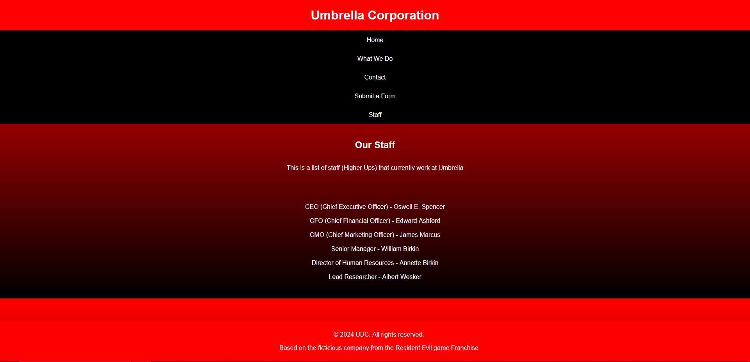

Validation
The web pages must be validated for them to be as good as possible.

Home Page
The first error was an unclosed div element within a section. To fix this, one must simply add a “/” to the closing “div” statement.
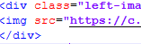
While not an error, a warning was shown as a section was missing a header. As a header was not intended for this section, a fix was not needed.

What We Do Page
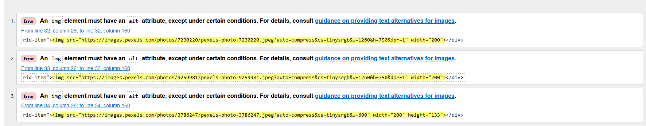
The only errors for this page were that the images did have alt tags with them. The rectify this, an alt tag will be added to the image code.
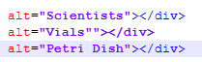

Contact Page
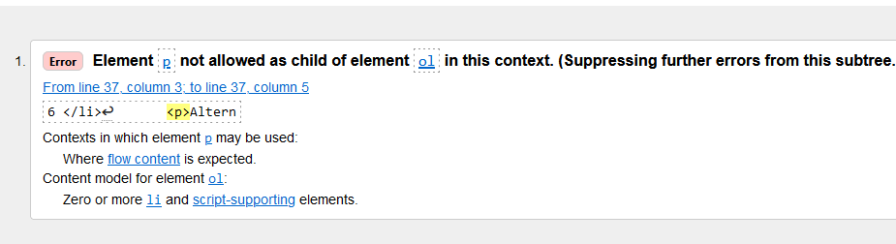
The <P> element was put inside a list function, which is bad practice and not allowed as a child element of the list function. To solve this, the paragraph element was moved out of it. To keep the styling, a section was added with the id tag that was formerly on the list function.
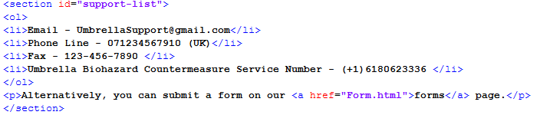

Form Page
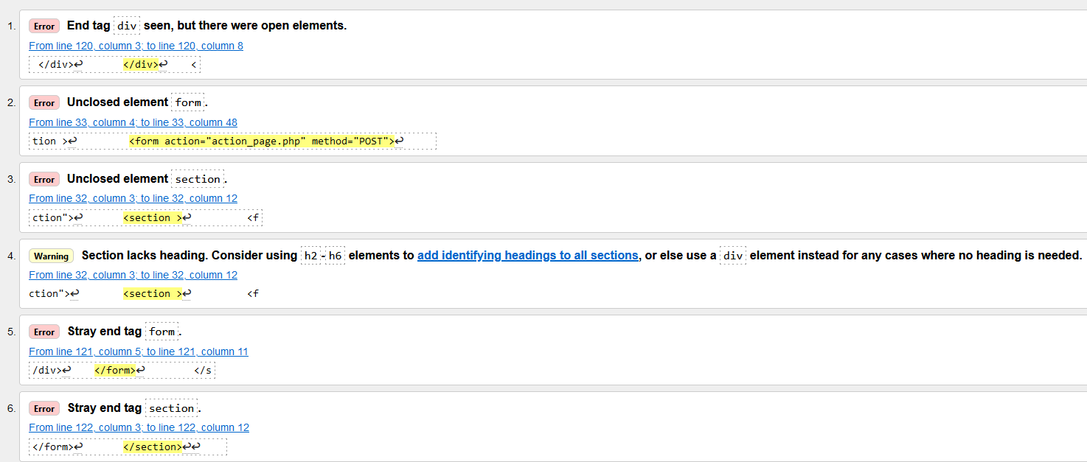
The errors for this page were errors seen previously on the last few pages. These were fixed with ease as they are just stray tags or unclosed elements.

Staff Page
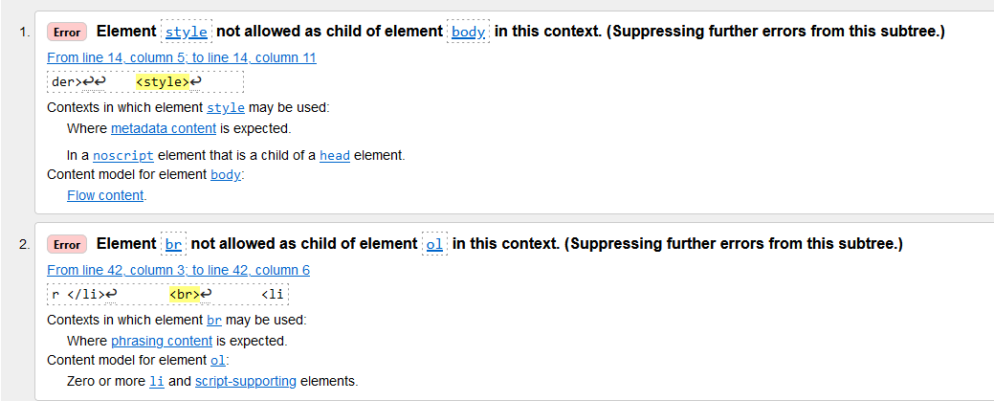
The style element was not allowed in the body element. To fix this the style element was moved out of the body element. This did not affect the styling of the page whatsoever.
To fix the second error of <br> not being allowed in the <ol> element, the <br> element was removed. This did change the styling but not massively and does not affect the readability of the text.
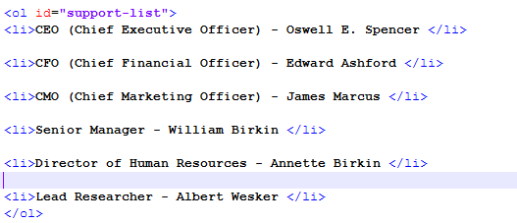

CSS
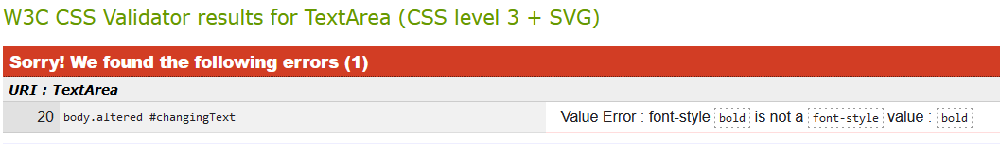
The one error found in the CSS was a mistakenly put bold value in the font style. Bold in not a supported font style within that element however bold can be added by encasing the paragraph intended to be bolded with a <b></b> element rather than having it in a CSS page.

Evaluation

Website Usability
Website usability is a broad term that refers to how easily a website can function with any user. This also involves navigation features. It is all about user friendliness as a website is not meant to work against the user, it is meant to either guide them or let the user guide themselves with ease. The layout of the website is critical for a user. This is how a user will find different pages on the site. Common website designs with navigation bar elements at the top should be followed. When a user interacts with something on the website, they should get visual feedback to indicate what they have interacted with. Websites should also expect human error and have fallbacks for this.
A paper on website usability claims that “a usable website creates a positive attitude…increases stickiness and revisit rates” [1]. This is important for websites, especially shopping websites as they would want a customer to return to the site to make more purchases. Having a user friendly and clear website would encourage this heavily. The paper also claims that a website that is hard to navigate or “provides thorough information will be abandoned if the consumer has difficulty searching or retrieving their needed information [1].” This is factual as users do not want an information overload when looking for a specific thing on a website. This can take away from their time and they will move onto a different website. The study says that “users should have a clear idea of what will happen when they make a choice” [1]. This is further backed up by the point made earlier with visual cues being a useful feature to provide this feedback. “Customisation and personalisation… important factors of website success” [1]. While this is true, it will vary from website to website. For example, a shopping website may not necessarily need to be customised as much as a government website which has important information on it. “Users found that download delay an important factor in Website success” [1]. A website with images, videos or audio clips will affect website loading time. It is important to not overload a website with images or videos as people with slower internet and slower devices will take a while to load and deter the user from using the site.
The website built for the scenario achieves many of the website usability factors. There are not many images on each web page making it quicker to load. The navigation bar is functional and in one case, when another page is mentioned, the user can click on a related word to take them to it. This is less obvious than the navigation bar, however.
One aspect of the pages that could be improved is the amount of content within the page. It can feel empty with unfilled white space that could have been used to place images or grids.

Accessibility
Web accessibility refers to creating a website that ensures it is user-friendly to all including those with visual or cognitive impairments. Not only is it essential, but it is also legally required. A common method that developers do this is by adding alternative tags to images or forms media. This allows people with screen readers to engage with media on the site. A more general rule of thumb but a website needs to be clear with no filler and error messages if a user performs an incorrect action. Colours and contrasting are also important. If text is ineligible because the colours conflict, it will prove difficult to the user.
The W3 organisation highlights the 14 guidelines from WCAG that are recommended to follow. Many of them have already been discussed previously so guidelines that haven’t been covered will now be covered. “Guideline 13. Provide clear navigation mechanisms” [2]. This means to make obvious what can be used for website navigation. On the site built for the scenario, the navigation bar gets highlighted in red when the mouse hovers over it. This gives a clear indication that it can be interacted with. It is also recommended to have information that can be distinguished at the start of the page. This will allow the user to get comfortable with the layout of the page. “Guideline 10. Use interim solutions” [2]. This means to enable a website to support older browsers and older technologies such as old screen readers. Older browsers do no support certain aspects of modern day web development and older screen readers will function differently to newer ones.
The website for the scenario does not use many contrasting colours with the 3 primary colours being black, white, blue and red. Text that was on an image has a red background to make it stand out over the image in order for it to be read clearly. Majority of the images have alt tags describing the images correctly and content is not too spread out from the top of the web page.

Search Engine Optimisation
https://www.proquest.com/docview/1425398162?accountid=130472&sourcetype=Scholarly%20Journals
Search Engine Optimisation can be described as a set of techniques aimed to improve the popularity of a website in search engines. This will involve using keywords to match the content, utilising meta tags and headings to allow search engines to pick those words out and having a good user experience. Gaining non-paid traffic is essential as a company/business does not have to spend money and the more popular a website is, the more likely it is to appear on the first page of Google Chrome or Microsoft Edge. Adapting SEO tactics is crucial as modern day search engines change SEO algorithms frequently. However, search engines do not reveal what will help when keeping SEO in mind but there are general rules that websites follow to optimise this.
“SEO is the process of increasing the number of visitors to a website by achieving a high rank in the search results returned by a search engine” [3]. This is the general explanation of what SEO is. “SEO factors can generally be categorized… On page factors… Off page factors” [3]. On page factors generally include internal linking, concise and rememberable URLs, structured header tags, and informative content. Off page factors may include social media marketing or link building. The primary point is that On page factors happen on the webpage and the off page factors happen off the webpage on other sites. Different search engines will have different SEO factors. For example, “Google is said to employ more than 200 factors in its ranking algorithm” [4]. Most of these factors are kept hidden from developers to stop abuse of the systems. Microsoft edge could have less or more than google though making it tricky to hit all SEO margins for each search engine.
The website built for the scenario uses primarily keywords related to the Resident Evil franchise. Off page factors were not required for the scenario so majority of the SEO is on page.

Bibliography

[1] | A. M. P. J. Micheal Pearson, “AN EXPLORATORY STUDY INTO DETERMINING THE RELATIVE IMPORTANCE OF KEY CRITERIA IN WEB USABILITY: A MULTI-CRITERIA APPROACH,” Southern Illinois University, Carbondale, 2008.
[2] | S. L.-M. a. L. V. G. M. Campoverde-Molina, “Empirical Studies on Web Accessibility of Educational Websites: A Systematic Literature Review,” IEEE.
[3] | L. M. a. P. Martinez, “Overlapping factors in search engine optimization and web accessibility,” Online Information Review, vol. vol. 37, 2013.
[4] | S.-A. Y. a. T.-L. D. H. C.-J. Luh, ““Estimating Google’s search engine ranking function from a search engine optimization perspective,”,” Online information review, vol. 40, no. 2, pp. 239-255, 2016.

Appendices

Index.html
<!DOCTYPE html>
<html lang="en">
<head>
<meta charset="UTF-8">
<meta name="viewport" content="width=device-width, initial-scale=1.0">
<title>Home Page</title>
<link rel="stylesheet" href="styles.css">
</head>
<body>
<header id="main-header">
<a href="index.html"><h1>Umbrella Corporation</h1></a>
</header>

<nav>
<ul>
<li id="home"><a href="index.html">Home</a></li>
<li id="WhatWeDo"><a href="WhatWeDo.html">What We Do</a></li>
<li id="Contact"><a href="Contact.html">Contact</a></li>
<li id="Form"><a href="Form.html">Submit a Form</a></li>
<li id="Staff"><a href="Staff.html">Staff</a></li>
</ul>
</nav>

<section class="main-content">
<h2 id="changingHeader">The Umbrella Initiative</h2>
<p id="changingText"><b>The Umbrella Corporation is committed to creating and manufacturing pharmaceutical products that will change the lives of all humans.</b></p>
</section>

<div class="button-container"><button id="toggleButton" class="red-button">Join The Initiative</button></div>

<section>
<div class="left-image-main">
<img src="https://c.tenor.com/xqPL604ODvIAAAAC/umbrella-corporation.gif" alt="Spinning-Logo" width="300" height="300">
</div>
</section>

<footer>
<p>&copy; 2024 UBC. All rights reserved.</p>
<p>Based on the ficticious company from the Resident Evil game Franchise</p>
</footer>
<script src="script.js"></script>
</body>
</html>

WhatWeDo.html
<!DOCTYPE html>
<html lang="en" class="what-we-do-page">
<head>
<meta charset="UTF-8">
<meta name="viewport" content="width=device-width, initial-scale=1.0">
<title>Home Page</title>
<link rel="stylesheet" href="styles.css">
</head>
<body>
<header id="main-header">
<a href="index.html"><h1>Umbrella Corporation</h1></a>
</header>

<nav>
<ul>
<li><a href="index.html">Home</a></li>
<li><a href="WhatWeDo.html">What We Do</a></li>
<li><a href="Contact.html">Contact</a></li>
<li><a href="Form.html">Submit a Form</a></li>
<li><a href="Staff.html">Staff</a></li>
</ul>
</nav>

<section class="main-content">
<h2 id="changingHeader">What We Do</h2>
<p id="changingText">At the Umbrella Corporation, we are driven by a relentless commitment to improving global health through cutting-edge pharmaceutical innovation. Our team of dedicated scientists, researchers, and healthcare professionals work tirelessly to develop breakthrough medications that address the most pressing health challenges of our time.</p>
</section>

<div class="grid-container">
<div class="grid-item"><img src="https://images.pexels.com/photos/7230220/pexels-photo-7230220.jpeg?auto=compress&cs=tinysrgb&w=1260&h=750&dpr=1" width="200" alt="Scientists"></div>
<div class="grid-item"><img src="https://images.pexels.com/photos/9259981/pexels-photo-9259981.jpeg?auto=compress&cs=tinysrgb&w=1260&h=750&dpr=1" width="200" alt="Vials""></div>
<div class="grid-item"><img src="https://images.pexels.com/photos/3786247/pexels-photo-3786247.jpeg?auto=compress&cs=tinysrgb&w=600" width="200" height="133" alt="Petri Dish"></div>

</div>

<footer>
<p>&copy; 2024 UBC. All rights reserved.</p>
<p>Based on the ficticious company from the Resident Evil game Franchise</p>
</footer>
<script src="script.js"></script>
</body>
</html>

Contact.html
<!DOCTYPE html>
<html lang="en" class="contact-page">
<head>
<meta charset="UTF-8">
<meta name="viewport" content="width=device-width, initial-scale=1.0">
<title>Home Page</title>
<link rel="stylesheet" href="styles.css">
</head>
<body id="body-container">
<header id="main-header">
<a href="index.html"><h1>Umbrella Corporation</h1></a>
</header>

<nav>
<ul>
<li><a href="index.html">Home</a></li>
<li><a href="WhatWeDo.html">What We Do</a></li>
<li><a href="Contact.html">Contact</a></li>
<li><a href="Form.html">Submit a Form</a></li>
<li><a href="Staff.html">Staff</a></li>
</ul>
</nav>

<section class="main-content">
<h2 id="changingHeader">Contact Us</h2>
<p id="changingText">Here at Umbrella, we are all about public reception. We want the public to trust us with our medicine. Below are contact details if you feel like sending us some kind words or are interested in participating in our human trials.</p>
</section>

<section id="support-list">
<ol>
<li>Email - UmbrellaSupport@gmail.com</li>
<li>Phone Line - 071234567910 (UK)</li>
<li>Fax - 123-456-7890 </li>
<li>Umbrella Biohazard Countermeasure Service Number - (+1)6180623336 </li>
</ol>
<p>Alternatively, you can submit a form on our <a href="Form.html">forms</a> page.</p>
</section>
<footer>
<p>&copy; 2024 UBC. All rights reserved.</p>
<p>Based on the ficticious company from the Resident Evil game Franchise</p>
</footer>
<script src="script.js"></script>
</body>
</html>

Form.html
<!DOCTYPE html>
<html lang="en" class="form-page">
<head>
<meta charset="UTF-8">
<meta name="viewport" content="width=device-width, initial-scale=1.0">
<title>Home Page</title>
<link rel="stylesheet" href="styles.css">
</head>
<body>
<header id="main-header">
<a href="index.html"><h1>Umbrella Corporation</h1></a>
</header>

<nav>
<ul>
<li><a href="index.html">Home</a></li>
<li><a href="WhatWeDo.html">What We Do</a></li>
<li><a href="Contact.html">Contact</a></li>
<li><a href="Form.html">Submit a Form</a></li>
<li><a href="Staff.html">Staff</a></li>
</ul>
</nav>

<section class="main-content">
<h2 id="changingHeader" style="background-color:red;">Send us a query form.</h2>
<p id="changingText">Here at Umbrella, we want your voice to be heard. After all, it is your voice that builds our future.</p>
</section>

<div id="form-section">
<section >
<form action="action_page.php" method="POST">
<div>

<label for="fname">First Name:</label>

<input type="text" id="fname" name="fname" placeholder="Write Something" required>

</div>

<br>

<div>

<label for="lname">Last Name:</label>

<input type="text" id="lname" name="lname" placeholder="Write Something" required>

</div>

<br>

<div>

<label for="email">Email Address:</label>

<input type="email" id="email" name="email" placeholder="CGS@gmail.com">

</div>

<br>

<div>

<label for="phone">Phone:</label>

<input type="tel" id="phone" name="phone" placeholder="...">

</div>

<br>

<div>

<label for="bdate">Date of Birth:</label>

<input type="date" id="bdate" name="bdate">

</div>

<br>

<div>

<label for="title">Title:</label>

<label for="Mr.">Mr.</label>

<input type="radio" id="Mr." name="title" value="Mr.">

<label for="Mrs.">Mrs.</label>

<input type="radio" id="Mrs." name="title" value="Mrs.">

</div>

<br>

<div>
<label for="subject">Subject: </label>
<textarea id="subject" name="subject" placeholder="Write Something.."></textarea>
</div>

<br>

<div>

<input type="reset">

</div>

<br>

<div>

<input type="submit">

</div>
</div>
</form>
</section>

<footer>
<p>&copy; 2024 UBC. All rights reserved.</p>
<p>Based on the ficticious company from the Resident Evil game Franchise</p>
</footer>
<script src="script.js"></script>
</body>
</html>

Staff.html
<!DOCTYPE html>
<html lang="en" class="staff-page">
<head>
<meta charset="UTF-8">
<meta name="viewport" content="width=device-width, initial-scale=1.0">
<title>Home Page</title>
<link rel="stylesheet" href="styles.css">
</head>
<style>
body {
background: linear-gradient(red, black);
font-family: Arial, sans-serif;
color: white;
}
</style>
<body>
<header id="main-header">
<a href="index.html"><h1>Umbrella Corporation</h1></a>
</header>

<nav>
<ul>
<li id="home"><a href="index.html">Home</a></li>
<li id="WhatWeDo"><a href="WhatWeDo.html">What We Do</a></li>
<li id="Contact"><a href="Contact.html">Contact</a></li>
<li id="Form"><a href="Form.html">Submit a Form</a></li>
<li id="Staff"><a href="Staff.html">Staff</a></li>
</ul>
</nav>

<section class="main-content">
<h2 id="changingHeader">Our Staff</h2>
<p id="changingText">This is a list of staff (Higher Ups) that currently work at Umbrella</p>
</section>

<ol id="support-list">
<li>CEO (Chief Executive Officer) - Oswell E. Spencer </li>

<li>CFO (Chief Financial Officer) - Edward Ashford </li>

<li>CMO (Chief Marketing Officer) - James Marcus </li>

<li>Senior Manager - William Birkin </li>

<li>Director of Human Resources - Annette Birkin </li>

<li>Lead Researcher - Albert Wesker </li>
</ol>

<footer>
<p>&copy; 2024 UBC. All rights reserved.</p>
<p>Based on the ficticious company from the Resident Evil game Franchise</p>
</footer>
<script src="script.js"></script>
</body>
</html>

Styles.css
body {
font-family: Arial, sans-serif;
margin: 0;
padding: 0;
transition: background-color 0.5s;
}

body.altered {
background-color: Black;
color: #ecf0f1;
}

body.altered #changingHeader {
color: White;
}

body.altered #changingText {
color: #bdc3c7;
}

body.altered .left-image {
display: none;
}

#main-header {
background-color: red;
padding: 20px;
text-align: center;
}

header h1 {
font-weight: bold;
color: white;
margin: 0;
}

.main-content {
padding: 20px;
display: flex;
flex-direction: column;
justify-content: center;
align-items: center;
}

.left-image-main {
padding: 40px;
display: flex;
flex-direction: column;
justify-content: center;
align-items: center;
}

header a {
text-decoration: none;
color: white;
}

nav ul {
list-style-type: none;
background-color: black;
padding: 0px;
margin: 0px;
overflow: hidden;
}

nav a {
color: white;
text-decoration: none;
padding: 15px;
display: block;
text-align: center;
}

nav a:hover {
background-color: red;
}

footer {
position: fixed;
bottom: 0;
width: 100%;
background-color: red;
color: white;
text-align: center;
padding: 10px;
}

.button-container {
display: flex;
justify-content: center;
align-items: center;
height: 1px;
}

.red-button {
display: flex;
background-color: #e74c3c;
color: white;
padding: 10px 20px;
border: none;
border-radius: 5px;
cursor: pointer;
transition: background-color 0.3s;
align-items: center;
justify-content: center;
}

.red-button:hover {
background-color: #c0392b; /* Darker red on hover, adjust as needed */
}

.what-we-do-page #main-header {
background-color: blue;
padding: 20px;
text-align: center;
font-family: 'Times New Roman', serif;
}

.what-we-do-page nav a:hover {
background-color: blue;
}

.what-we-do-page nav {
font-family: 'Times New Roman', serif;
}

.what-we-do-page footer {
font-family: 'Times New Roman', serif;
background-color: blue;
}

.what-we-do-page #changingHeader {
font-family: 'Times New Roman', serif;
}

.what-we-do-page #changingText {
font-family: 'Times New Roman', serif;
}

.what-we-do-page .grid-container {
display: grid;
column-gap: 25px;
grid-template-columns: auto auto auto;
background-color: blue;
padding: 10px;
justify-items: center;
}

.contact-page #support-list {
background-color: rgba(255, 0, 0, 0.75);
padding: 30px;
text-align: center;
list-style-type: none;

}

.contact-page #body-container {
background-image: url(https://thumbs.dreamstime.com/b/two-people-telephone-conversation-mom-son-talking-phone-vector-graphic-to-design-two-people-telephone-conversation-mom-140665700.jpg);
background-size: 50%;
}

.contact-page #changingText {
background-color: rgba(255, 0, 0, 0.75);
padding: 30px;
}

.form-page #form-section {
display: flex;
align-items: center;
justify-content: center;
padding: 100px;
}

.staff-page #support-list {
padding: 30px;
text-align: center;
list-style-type: none;
}

