  Design of Shaped Charges  Advanced Physics ACDB 5015 | Abstract  An evaluation into how changing the material of the explosive liner in a shaped charge can affect its performance.  Rachel McColm  2223157

Academic integrity declaration

I declare that:
- the thesis submitted has been written by me alone.
- the thesis submitted has not been previously submitted to this university or any other.
- that all content, including primary and/or secondary data, is true to the best of my knowledge.
- that all quotations and references have been duly acknowledged according to the requirements of academic research.
I understand that to knowingly submit work in violation of the above statement will be considered by examiners as academic misconduct.

Task Description

This assignment emphasises the modelling and critical analysis aspects of this module’s learning outcomes. The context is a shaped charge device, consisting of a casing, high explosive charge and a conical liner.

The brief for this lab assignment is to:
- Undertake a literature review of relevant research on shaped charges and their modelling, including the material models used.
- Undertake 2D modelling and analysis of two different shaped charge designs
- Undertake a 3D model of the final design selected from the 2D design exercises.
- Present a report with your review, computational design and analysis.

Contents

List of Figures 5
List of Tables 6
1. Introduction 7
2. Literature Review 8
2.1 Shape Design 8
2.2 Material Properties 8
2.3 Summary 8
2.4 Final Design Choice 9
3. Material Properties 10
3.1 2-Dimensional Shaped Charge Design 1 10
3.2 2-Dimensional Shaped Charge Design 2 11
3.3 3-Dimensional Shaped Charge 11
4. Simulation 12
4.1 Sketch 12
4.2 Material Properties 13
4.2.1 2-Dimensional Shaped Charge Design 1 13
4.2.2 2-Dimensional Shaped Charge Design 2 14
4.2.3 3-Dimensional Shaped Charge 14
4.3 Mesh 15
4.3.1 2-Dimensional Shaped Charge Design 1 and 2 15
4.3.2 3-Dimensional Shaped Charge 16
5. Results 18
5.1 Propagation of the Detonation Wave 18
5.1.1 2-Dimensional Design 1 Detonation Wave Propagation 18
5.1.2 2-Dimensional Design 2 Detonation Wave Propagation 18
5.1.3 3-Dimensional Simulation Detonation Wave Propagation 19
5.2 Jet Formation 19
5.2.1 Jet Formation Design 1 20
5.2.2 Jet Formation Design 2 21
5.2.3 Jet Formation 3D Model 21
5.3 Velocity of Jet 22
5.3.1 Velocity of Jet Design 1 23
5.3.2 Velocity of Jet Design 2 24
5.3.3 Velocity of Jet 3D Model 25
6. Analysis 27
6.1 Comparison of Detonation Waves 27
6.2 Comparison of Jet Formations 27
6.3 Comparison of Jet Velocities 27
6.4 Overall Evaluation 27
7. Conclusion 28
References 29

List of Figures

Figure 1 - Shaped Charge Diagram [5] 7
Figure 2 - Sketch of casing 12
Figure 3 - Sketch of liner 13
Figure 4 - Sketch of High Explosive Shell 13
Figure 5 - Shaped Charge Design 1, Copper Liner 14
Figure 6 - Shaped Charge Design 2, TB6 Liner 14
Figure 7 - 3D Shaped Charge, TB6 Liner 15
Figure 8 - Shaped Charge Design 1 Mesh 15
Figure 9 - Shaped Charge Design 2 Mesh 16
Figure 10 - 3D Shaped Charge Mesh 16
Figure 11 - 3D Shaped Charge Outer Mesh 17
Figure 12 - 3D Shaped Charge Finer Inner Mesh 17
Figure 13 - Propagation of Detonation Wave Design 1 18
Figure 14 - Propagation of Detonation Wave Design 2 19
Figure 15 - Propagation of Detonation Wave 3D Model 19
Figure 16 - Jet Formation Design 1 20
Figure 17 – Fully Formed Explosive Jet Design 1 20
Figure 18 - Jet formation Design 2 21
Figure 19 - Jet Formation 3D Model (1 of 2) 21
Figure 20 - Jet Formation 3D Model (2 of 2) 22
Figure 21 - Jet Velocity Design 1 (1 of 2) 23
Figure 22 - Jet Velocity Design 1 (2 of 2) 23
Figure 23 - Design 1 Velocity Graph 24
Figure 24 - Jet Velocity Design 2 (1 of 2) 24
Figure 25 - Jet Velocity Design 2 (2 of 2) 25
Figure 26 - Design 2 Velocity Graph 25
Figure 27 - Jet Velocity 3D Model 26
Figure 28 - 3D Model Velocity Graph 26

List of Tables

Table 1 - Table of coefficients 10
Table 2 - Design 1 Metal Properties [4] 10
Table 3 - High Explosive Properties [4] 10
Table 4 - Design 1 Equation of State Values [4] 10
Table 5 - Design 2 Metal Properties [4, 8] 11
Table 6 - High Explosive Properties [4] 11
Table 7 - Design 2 Equation of State Values [8] 11
Table 8 - Maximum Velocities 22

Introduction

In the early 20th century, the concept of a ‘shaped charge’ was first used to penetrate armoured vehicles and fortifications. These consisted of explosives being focused in a certain direction for a precise impact - without it being the physical shaped charge device that is used now.
The first major development of shaped charges took place during the Second World War when the need to breach tanks and bunkers arose. This saw the introduction of shaped charges used in combat by both German and Allied forces. ‘Panzerfaust’ and the ‘Bazooka’ were two weapons most commonly used throughout the Second World War for their anti-armour capabilities [1]. Post-World War II saw the development and refinement of shaped charge technologies. This also led to the introduction of shaped charges being used more widely in not only the military but the oil and gas industry as well. Modern applications of shaped charges now include space exploration, demolition and marine weaponry on submarines [2].
Shaped charges are used in a variety of applications, from the aforementioned uses in military theatres and defence systems to industrial uses in oil fields [3, 4]. Their unique ability to focus energy and penetrate materials relies heavily upon the design and material properties of the device. A shaped charge device typically consists of a casing, a conical liner and a high explosive charge as shown below in figure 1. The High Explosive is used to collapse a liner, which is normally metal, which creates a focused high-velocity jet with the capability of penetrating metal or other strong materials [3].
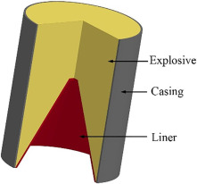
Figure 1 - Shaped Charge Diagram [5]
The interaction between these 3 components determines the effectiveness, accuracy and efficiency of the shaped charge. Advanced modelling techniques and an evaluation of different materials and their properties can be used to optimise the design of a shaped charge. This assignment focuses on demonstrating that selecting a different material for the conical liner can affect the effectiveness and overall performance of a shaped charge.
Utilisation of the ABAQUS software allowed for the demonstration of the performance of a shaped charge and the analysis of their design and behaviours under various conditions. For this assignment, there were three separate simulations. The first was a 2-dimensional shaped charge consisting of a steel casing, copper liner and TNT for the high explosive charge. The second simulation was the same design as the first but the material of the liner was changed to that of TB6 – a titanium alloy. The third was a 3-dimensional simulation with the same composition of the second design.

Literature Review

Shape Design

When conducting research for possible design choices of a shaped charge, multiple different shapes could be used. Depending on the outcome you want to achieve and the material you wish to penetrate, different shapes can be chosen. A shaped charge in the form of a disc, also known as an ‘Explosively Formed Penetrator’ (EFP), would be beneficial for anti-armour or anti-tank weapons [6]. This is because less precision is required due to a larger impact area. Another option would be a linear-shaped charge. These create a very sharp cutting jet that can slice through materials such as cables, metals or structures. These properties make linear charges effective for uses in demolition, flight termination systems and Explosive Ordnance Disposal (EOD) [7]. The final shape to consider was a conical-shaped charge. These are the most common types of shaped charges. The cone shape produces a high-velocity jet of metal, which is produced from the collapsing of the liner upon detonation, that penetrates deeply into the given target. Conical-shaped charges are used in anti-tank/anti-armour weapons, as well as, EOD, Oil and Gas industry and many more [2].

Material Properties

Selecting the right materials is an important consideration when designing a shaped charge. The material of the liner is of particular importance, as this determines the jet's velocity and penetration capability. The choice of material for the explosive filling and casing is also just as important. The explosive filling must have a high detonation velocity and pressure, not too low that it will hinder the performance of the shaped charge and not too high that it will cause the shaped charge to explode. Additionally, the casing material must be strong enough to effectively contain and direct the explosive force to the desired target. In industry, it is important to consider the cost and availability of these materials and their compatibility with the intended application.

Summary

When designing a shaped charge, selecting the right shape and materials is crucial to ensure optimal performance and reliability. The shape determines how the explosive energy is focused, it also influences the jet formation, penetration depth, and impact area. The choice of materials also affects the formation of the jet and penetration capabilities. Balancing these factors is essential in guaranteeing high performance, reliability and effectiveness.

Final Design Choice

After conducting a literature review and consulting many different options the following choices were made:
- The shape of the model would be conical in shape. This shape should provide a high-velocity jet, capable of deep penetration, and high reliability.
- Two materials had to remain the same so that the performance of the changing material could be evaluated effectively. The casing and explosive filling were chosen as the ‘control’ materials, and the liner was the independent variable. The casing was chosen to be steel, and the explosive filling to be TNT for all 3 models.
- The 2 liner material choices were copper and TB6. More detail will be given on these in the following section.

Material Properties

Table 1 - Table of coefficients
A | Initial Yield Stress
B | Strain hardening constant
n | Hardening coefficient
m | Thermal softening coefficient
C | Strain rate hardening constant
ρ | Density
E | Young’s modulus
v | Poisson’s ratio
R1 | Non-linear coefficients
R2 | Non-linear coefficients
ω | Non-linear coefficients
c0 | Speed of sound
s | Slope of Us-Up curve
Gamma0 | Gruneisen ratio

2-Dimensional Shaped Charge Design 1

The material properties chosen for the first shaped charge were taken from a journal written about the effect of stand-off distance and liner thickness on the process of a shaped charge [4]. The casing material was steel, the liner was copper and the high explosive TNT.

Table 2 - Design 1 Metal Properties [4]
Material | A  (MPa) | B  (MPa) | n | m | C | ρ  (kgm⁻³) | E  (GPa) | v | Θ_{transition}  (K) | Θ_{melt}  (K) | Shear Modulus
Copper | 1425 | 168 | 0.12 | 1 | 0.032 | 8960 | 125 | 0.34 | 293 | 1356 | 45e9
Steel | 553 | 600 | 0.23 | 1 | 0.013 | 7850 | 210 | 0.3 | 293 | 1733

Table 3 - High Explosive Properties [4]
Material | A  (GPa) | B  (GPa) | R1 | R2 | ω | ρ  (kgm⁻³) | Velocity for detonation  (ms⁻¹) | Pre-detonation bulk modulus  (GPa) | Detonation energy density (Jkg⁻¹)
TNT | 609 | 13 | 4.5 | 1.4 | 0.25 | 1601 | 8193 | 9 | 3680000

Table 4 - Design 1 Equation of State Values [4]
Material | c0 | s | Gamma0
Copper | 3940 | 1.4 | 2

2-Dimensional Shaped Charge Design 2

The material properties chosen for the second are the same as those for the first design regarding the steel casing and TNT High Explosive filling. In the case of the conical liner, a material called ‘TB6’ was chosen. The properties of this material that were used in the simulation were found on a data sheet provided by MatWeb [8]. TB6 is a Titanium Alloy with the composition Ti-10V-2Fe-3Al. This material was selected as in some ways it is opposite to Copper. TB6 is a very strong material which can maintain shape under stress, it is a lightweight material with low density and can be quite brittle. Whereas Copper is very weak and malleable, it is easily deformed under pressure, is quite a heavy material with high density and is tough – meaning it can absorb energy without fracturing under pressure. These materials were chosen based on their properties in the hopes that they would provide a stark comparison when running simulations and evaluating results.

Table 5 - Design 2 Metal Properties [4, 8]
Material | A  (MPa) | B  (MPa) | n | m | C | ρ  (kgm⁻³) | E  (GPa) | v | Θ_{transition}  (K) | Θ_{melt}  (K) | Shear Modulus
TB6 | 797 | 574 | 0.11 | 0.65 | 0.1 | 4650 | n/a | n/a | 293 | 1800 | 41e9
Steel | 553 | 600 | 0.23 | 1 | 0.013 | 7850 | 210 | 0.3 | 293 | 1733

Table 6 - High Explosive Properties [4]
Material | A  (GPa) | B  (GPa) | R1 | R2 | ω | ρ  (kgm⁻³) | Velocity for detonation  (ms⁻¹) | Pre-detonation bulk modulus  (GPa) | Detonation energy density (Jkg⁻¹)
TNT | 609 | 13 | 4.5 | 1.4 | 0.25 | 1601 | 8193 | 9 | 3680000

Table 7 - Design 2 Equation of State Values [8]
Material | c0 | s | Gamma0
TB6 | 5031 | 1.5 | 1.29

3-Dimensional Shaped Charge

The material properties and design of the 3-dimensional shaped charge were chosen to be the exact same as the 2-dimensional design of shaped charge 2 shown in section 3.2 (Tables 4-6).

Simulation

The simulations for this assignment were created using ABAQUS simulation software. This software allows you to create and design simulations to the specifications of the shape and properties you require. When creating the simulation, the following steps were followed [9]:
- Sketch – start by sketching the individual parts that you need for the overall shape. In this case; casing, liner and high explosive for the shaped charge. Once each individual part is drawn to the specifications chosen, you can assemble all of the parts and view the overall shaped charge.
- Material Properties – In the property module, this is where you assign material properties for each part of your shaped charge. This is where you input each value found during the literature review for the relevant part for example: stress rate, strain rate, Young’s
Modulus etc. Specific values used can be found in the Material Properties section above.
- Step, Load and Interaction – These modules control the progression of the simulation, apply the external conditions on the simulation that drive the performance of the model, and models the physical interactions between components.
- Mesh – mesh is essential for obtaining accurate and reliable results for finite element analysis. It converts the model into finite elements that allow control over the type, size and quality of the components.
- Job – Once these steps are complete, the job/simulation can be run. The simulation can be monitored throughout, and results can be viewed upon completion.

Sketch

The same sketch was drawn for all 3 simulations. The first component sketched was the casing (figure 2).
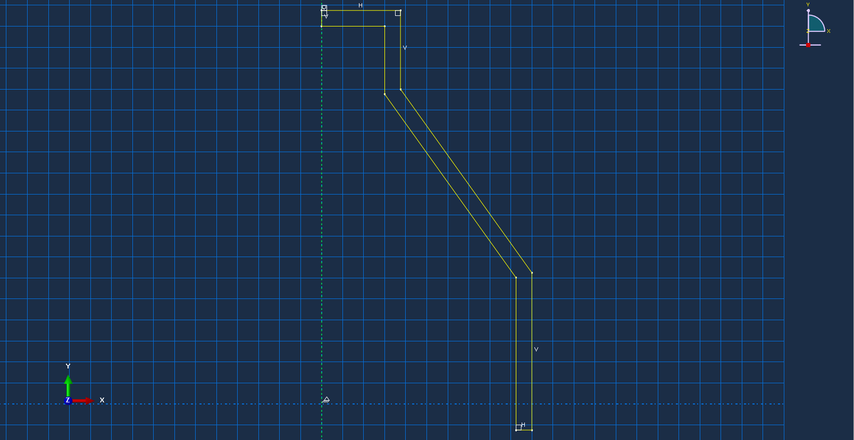
Figure 2 - Sketch of casing
From here, the sketch of the liner was done by connecting the inner bottom corner of the casing to roughly the midpoint on the green y-axis which can be seen in the figures above and below. Figure 3 below shows the final sketch of the liner component.
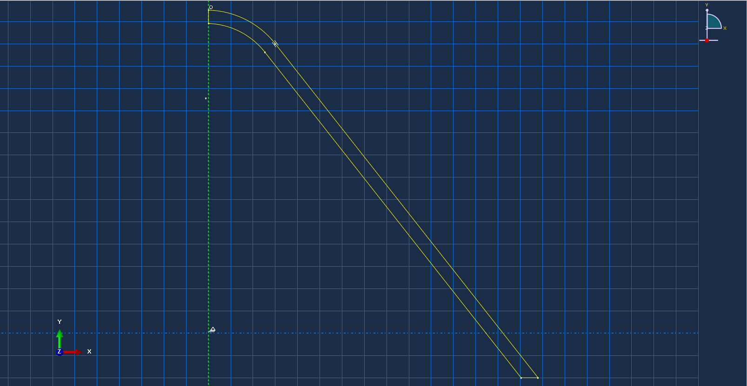
Figure 3 - Sketch of liner

Once the liner had been sketched, a line was drawn from the top of the liner to the top of the casing. This essentially enclosed the whole model and created the shell for the High Explosive (see figure 4).
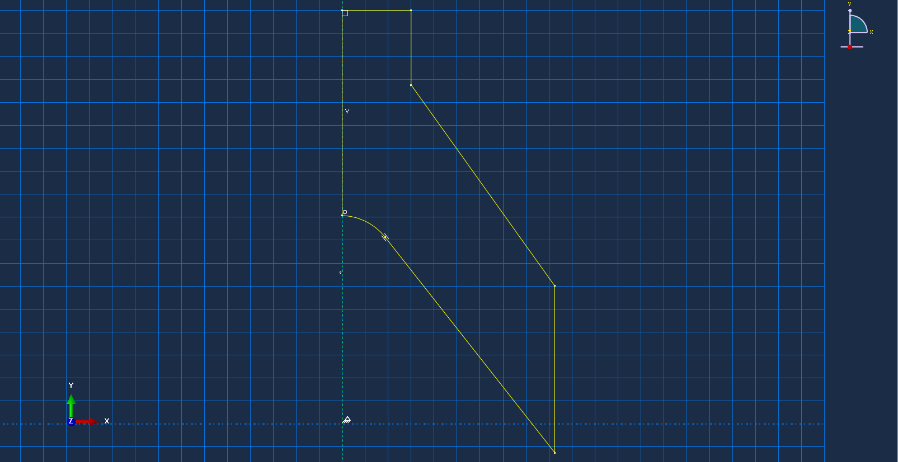
Figure 4 - Sketch of High Explosive Shell

Material Properties

In figures 5, 6 and 7 below you can see each shaped charge and the materials that have been assigned to each component.

2-Dimensional Shaped Charge Design 1

The initial shaped charge design consisted of a steel casing in red, a copper liner in green, and TNT explosive filing in cream as can be seen in figure 5 below.
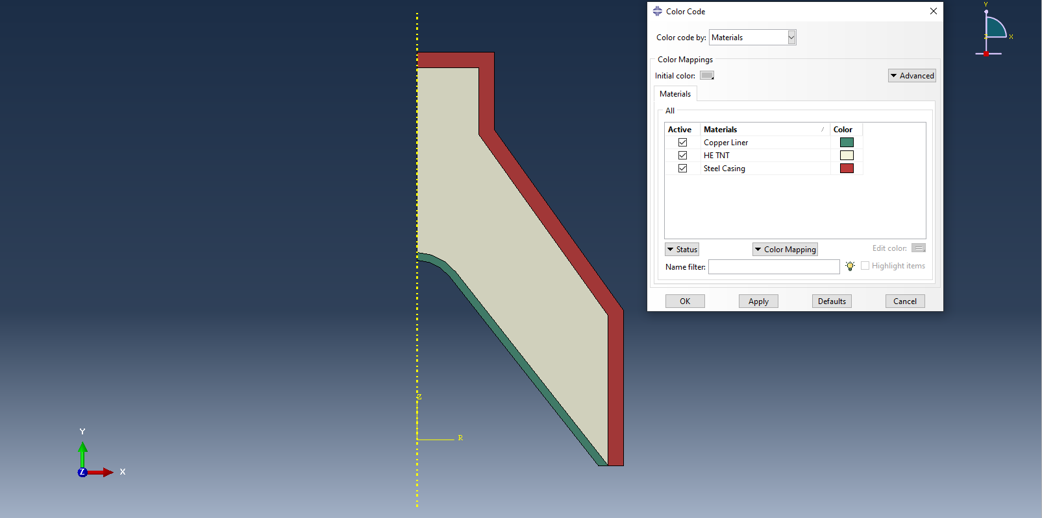
Figure 5 - Shaped Charge Design 1, Copper Liner

2-Dimensional Shaped Charge Design 2

The second-shaped charge design is the exact same as the first, with a TB6 liner instead of copper. As you can see from figure 6 the shape and composition of the models are the same, with the TB6 liner highlighted in a shade of blue.
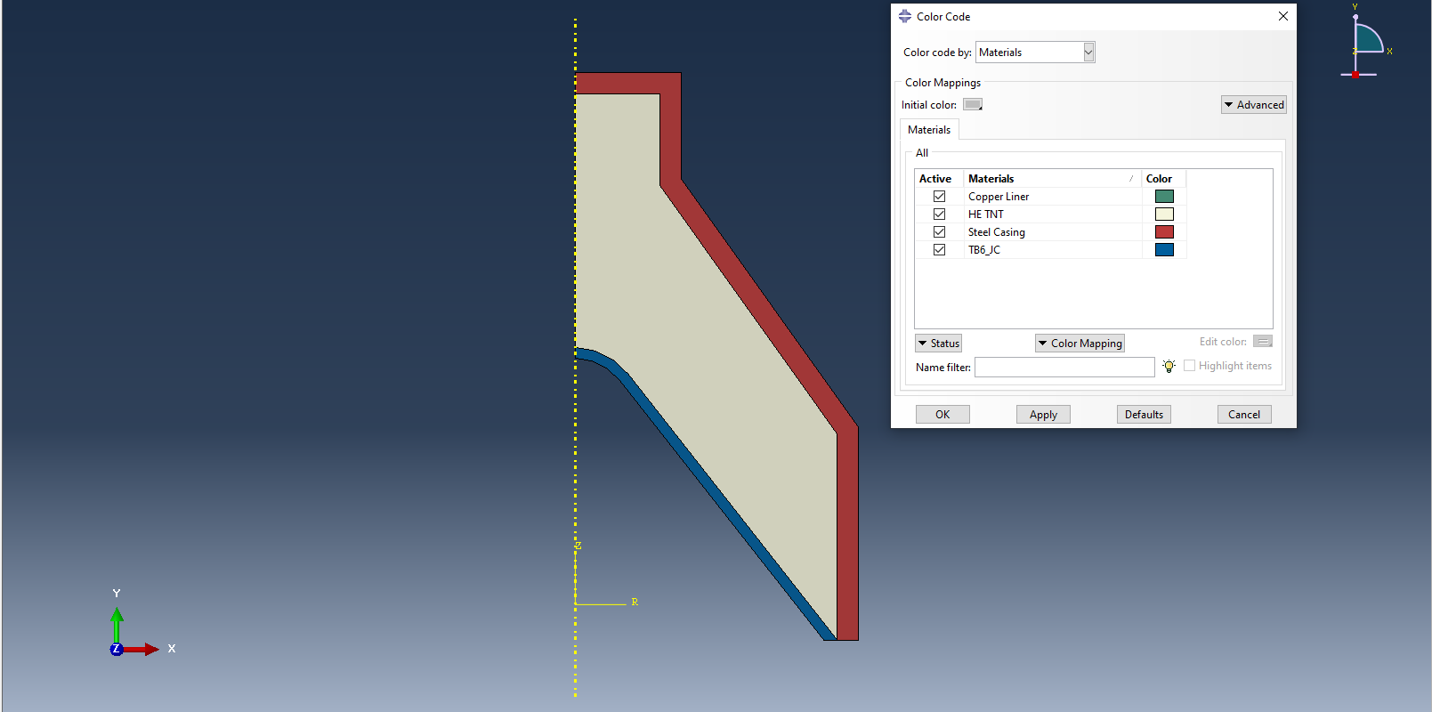
Figure 6 - Shaped Charge Design 2, TB6 Liner

3-Dimensional Shaped Charge

Similarly, in the 3-dimensional model of a shaped charge, the design and composition is the same as that of the second design seen in figure 6. See figure 7 below.
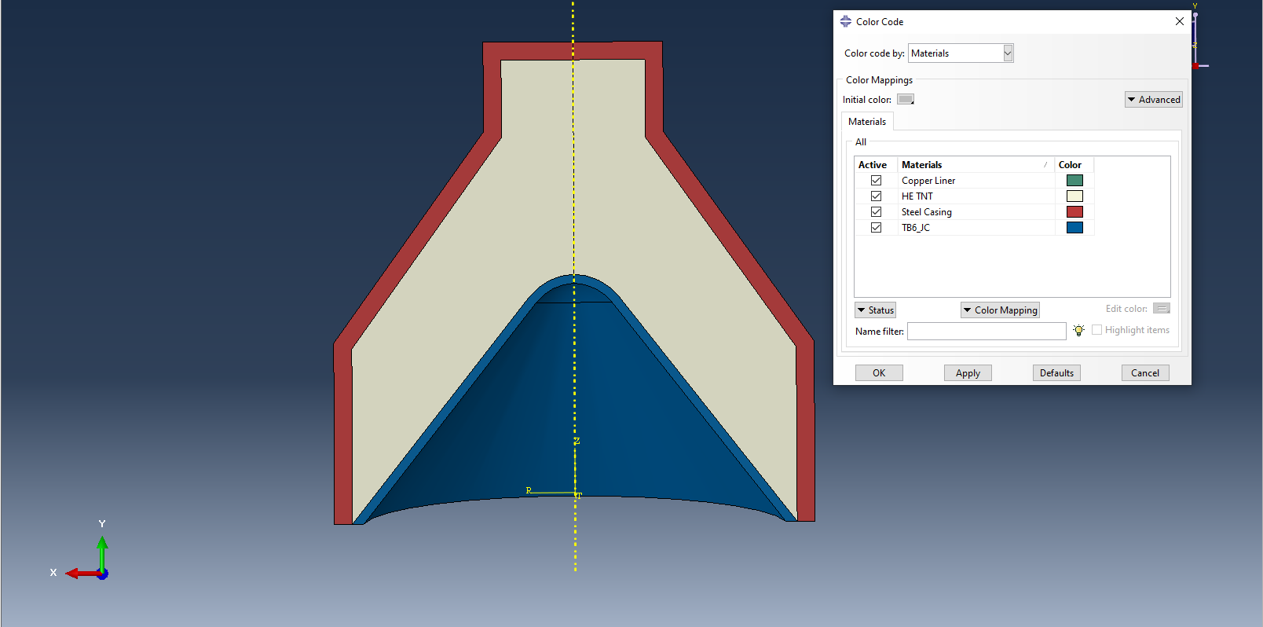
Figure 7 - 3D Shaped Charge, TB6 Liner

Mesh

2-Dimensional Shaped Charge Design 1 and 2

The meshing for all models was created the same. The mesh type chosen for these simulations was triangular elements, see figures below. It can be observed that the meshing is less dense towards the outside (casing) of the shaped charge and more fine/dense towards the centre (liner). In the areas towards the liner, the mesh was made more fine as this is the area the results will be derived from. The detonation will begin at the top of the casing and propagate towards the liner, eventually making it collapse. This is where the explosive jet will form. For this reason, the liner and surrounding areas are of critical importance in this simulation and the reason for the finer and more dense meshing.
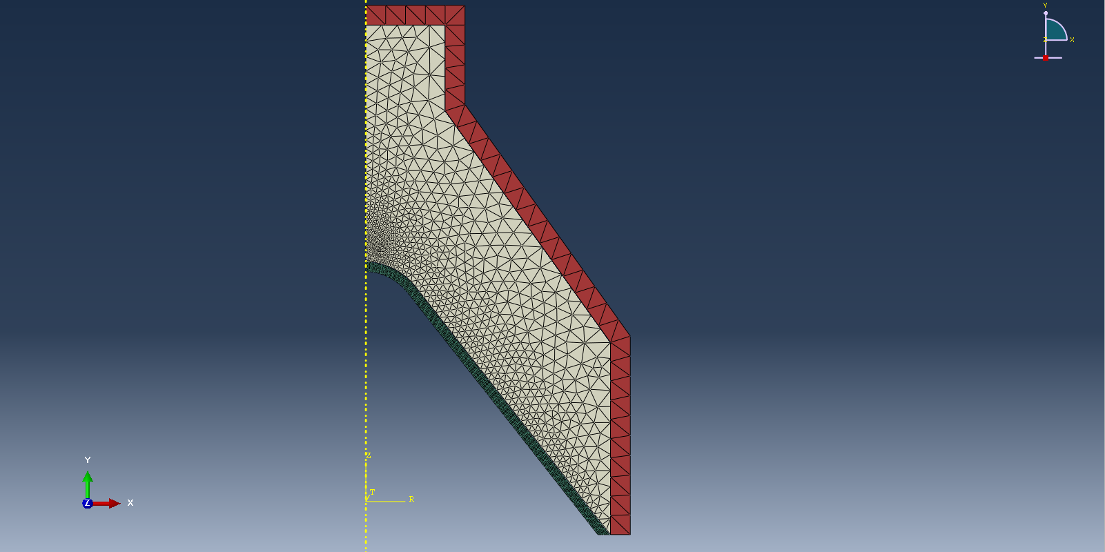
Figure 8 - Shaped Charge Design 1 Mesh

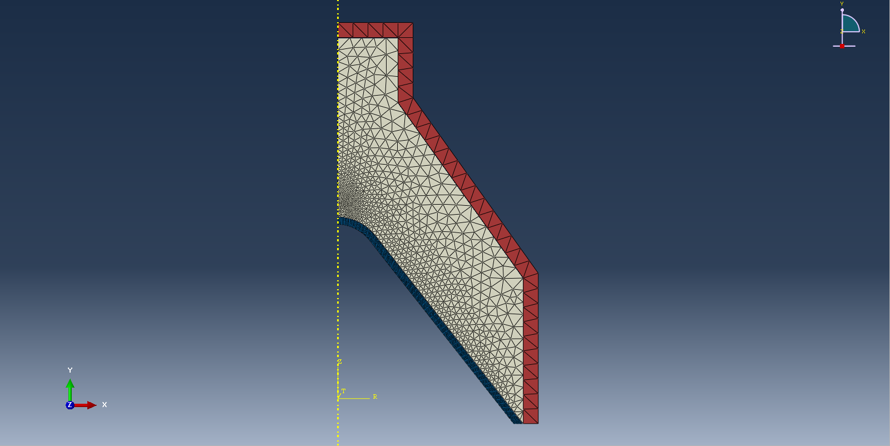
Figure 9 - Shaped Charge Design 2 Mesh

3-Dimensional Shaped Charge

The same meshing created for the previous 2 simulations was created for the 3D model. Particular focus is being given to the centre of the liner, where the detonation wave will hit and create the explosive jet. Three images have been provided for this model to highlight the denser meshing in certain areas, see figures 10-12.

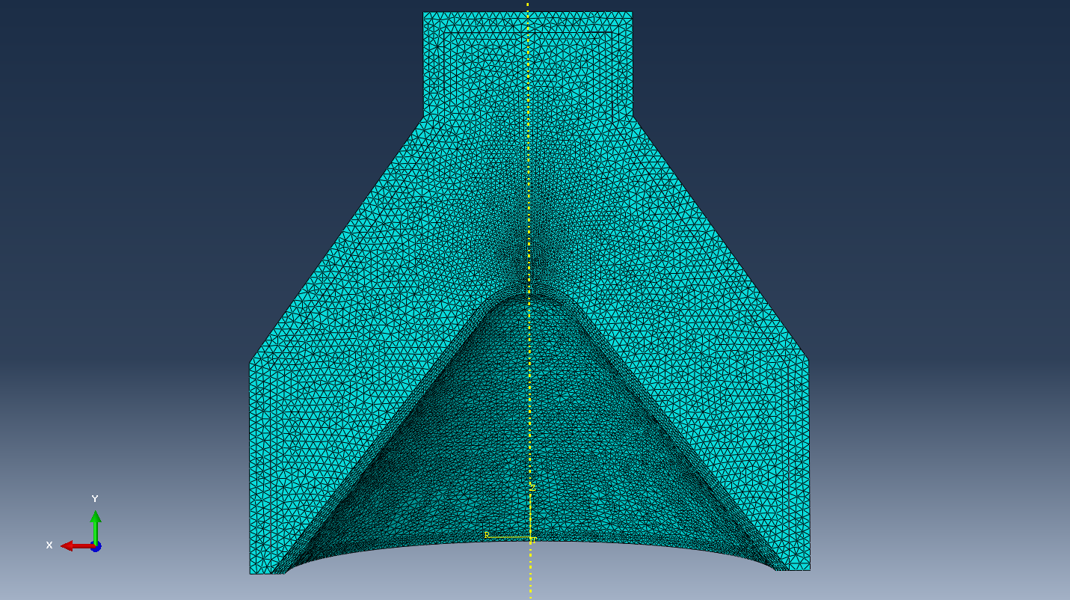
Figure 10 - 3D Shaped Charge Mesh
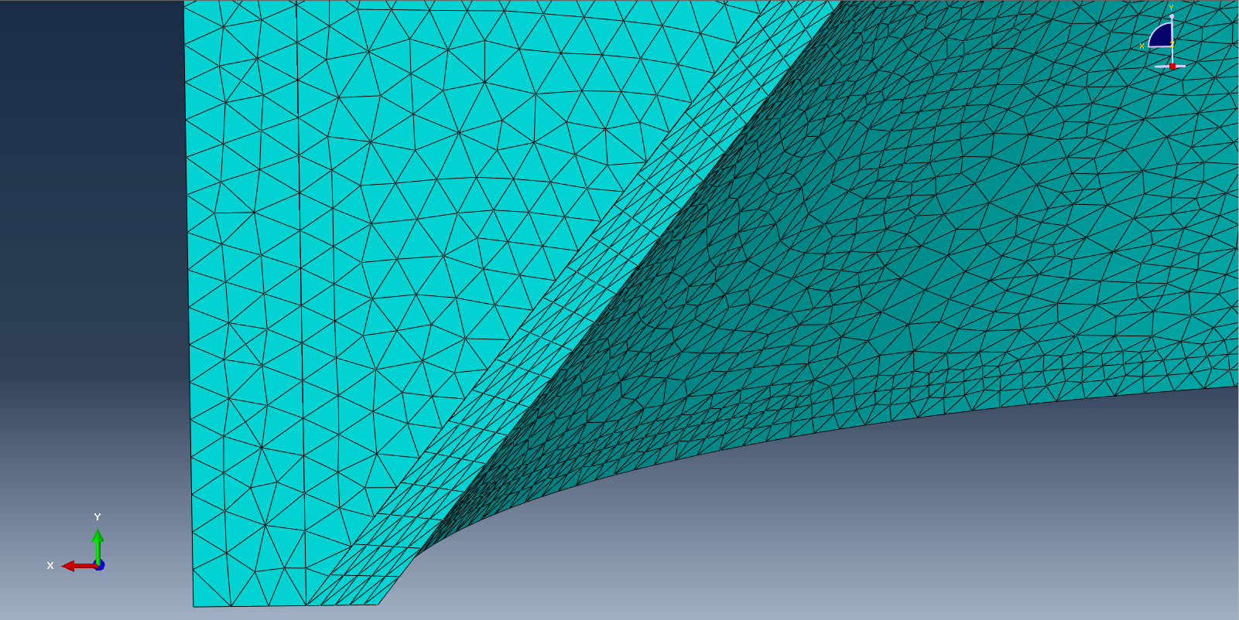
Figure 11 - 3D Shaped Charge Outer Mesh

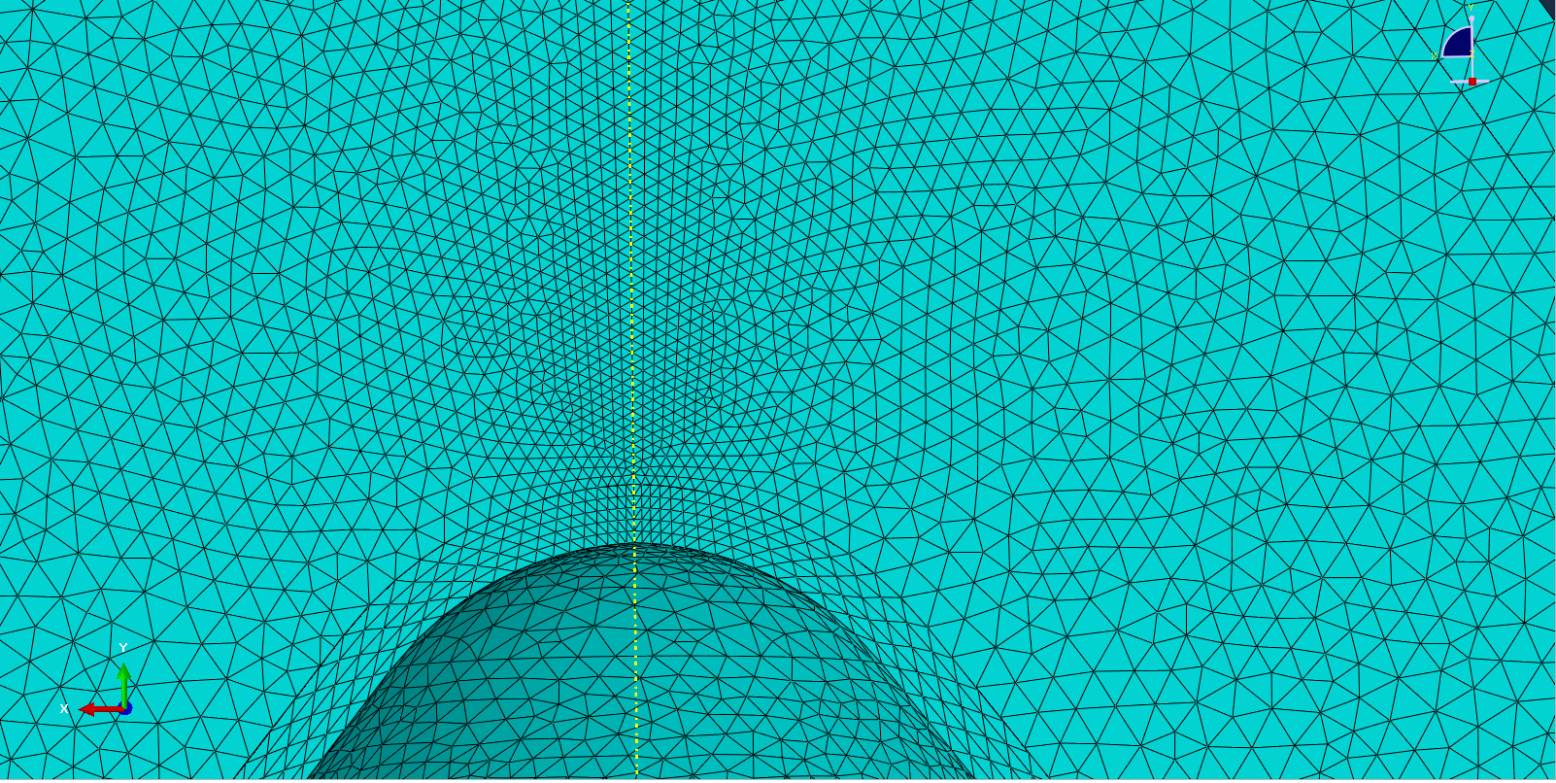
Figure 12 - 3D Shaped Charge Finer Inner Mesh

Results

Propagation of the Detonation Wave

In figures 13, 14 and 15 below, a series of 4 images can be seen for each simulation. These images highlight the detonation wave as it propagates through the shaped charge. In the top-left image, the detonation wave is in its early stages. The pressure levels here are relatively low which indicates the peak pressure has not yet been achieved. In the top-right image, the detonation wave is propagating further through the model. The pressure waves have started to spread wider throughout the model. A notable increase in pressure can be observed in the increase of red zones in this image. In the bottom-left image, the detonation wave has reached the mid to late stages of propagation. This is a critical point in the simulation as this is where the liner will begin to deform and create the jet. Pressure levels also continue to rise here. Finally, the bottom-right image shows the detonation wave progressing even further along the model and has begun deforming the liner. This image captures the peak pressure observed in the simulation, which is what causes the deformation of the liner.

2-Dimensional Design 1 Detonation Wave Propagation

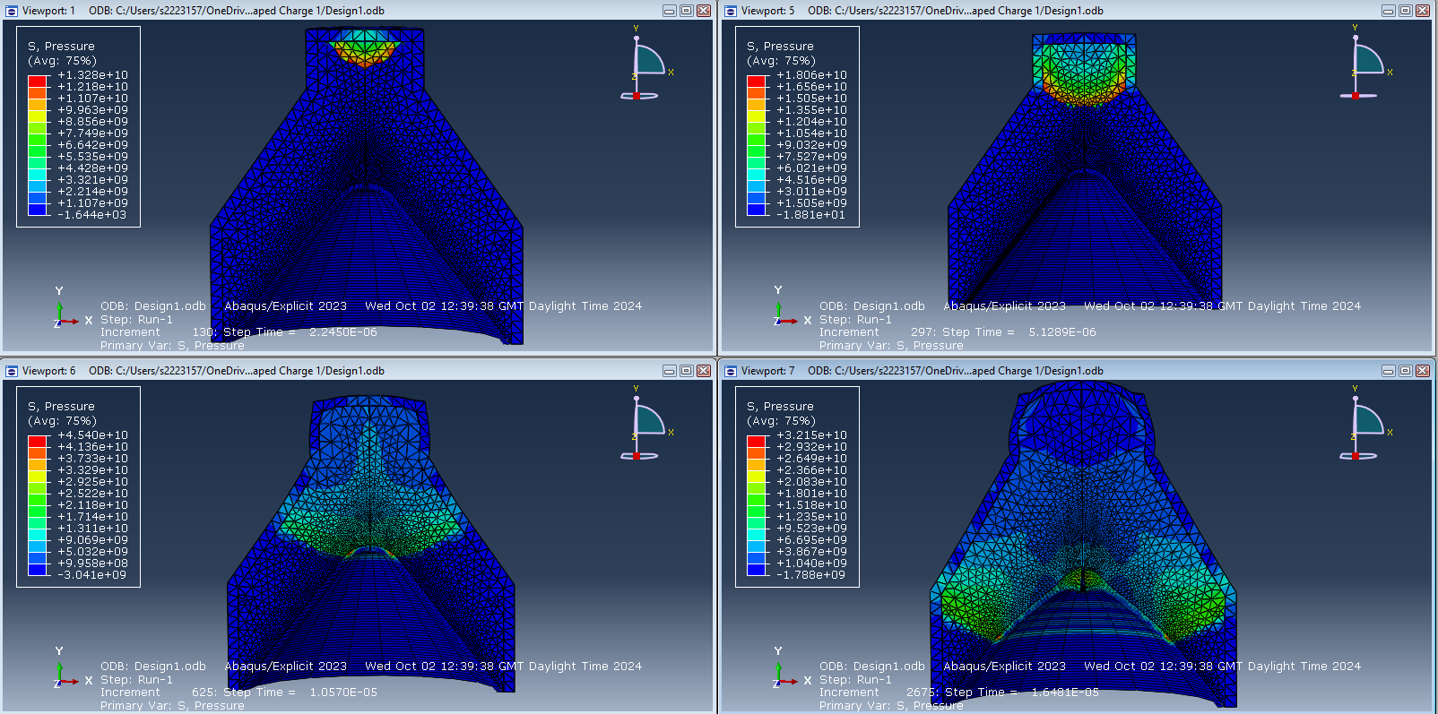
Figure 13 - Propagation of Detonation Wave Design 1

2-Dimensional Design 2 Detonation Wave Propagation

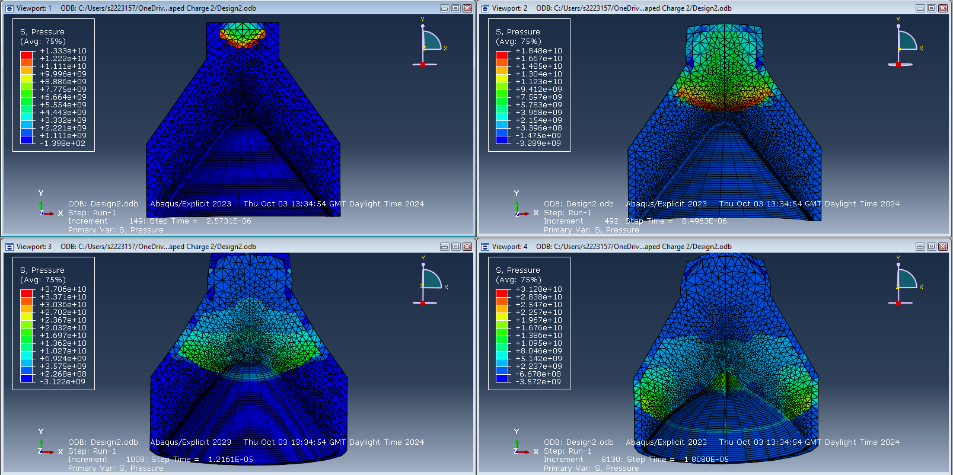
Figure 14 - Propagation of Detonation Wave Design 2

3-Dimensional Simulation Detonation Wave Propagation

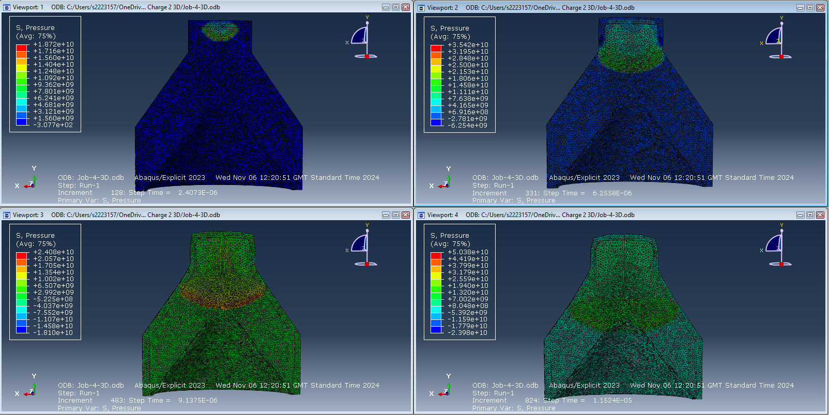
Figure 15 - Propagation of Detonation Wave 3D Model

5.2 Jet Formation

A jet is formed when a detonation wave propagates through a shaped charge, collapses the liner and pushes that pressure outward in the opposite direction. Figures 16-20 show the progression of the detonation wave propagating through each model and how the liner deforms under the pressure. In the initial images, the liner has just begun to deform creating the beginning stages of the jet. It can be seen that the liner here is showing very low levels of deformation and is still mostly intact. In the next images, the jet is clearly beginning to form with obvious directional flow. The pressure is increasing and the material deformation is accelerating. Towards the last images, the jet is now clearly formed in a narrower and sharper shape. The final images for each model clearly show the jets fully formed and continuing along the same trajectory. The jet produced is a very long and narrow jet, likely to be travelling at a significant velocity.

Jet Formation Design 1

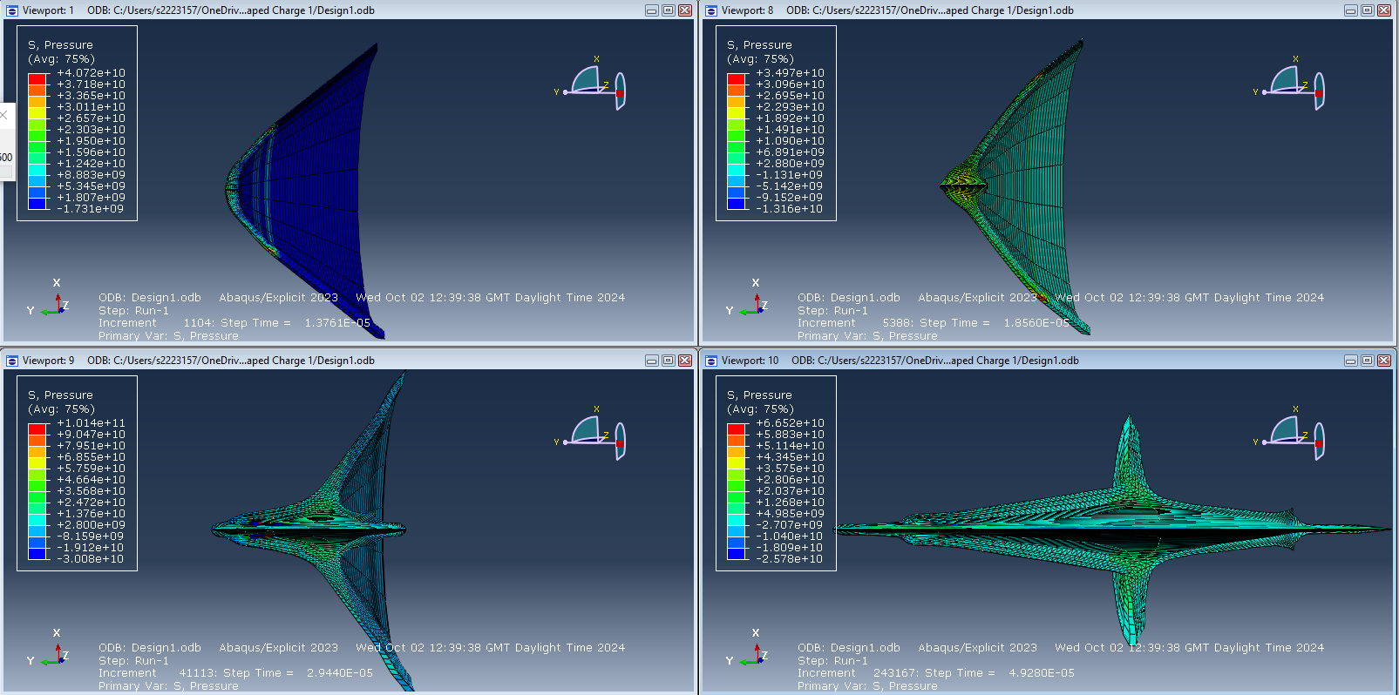
Figure 16 - Jet Formation Design 1

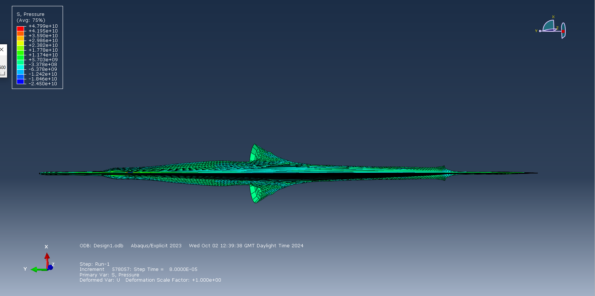
Figure 17 – Fully Formed Explosive Jet Design 1

Jet Formation Design 2

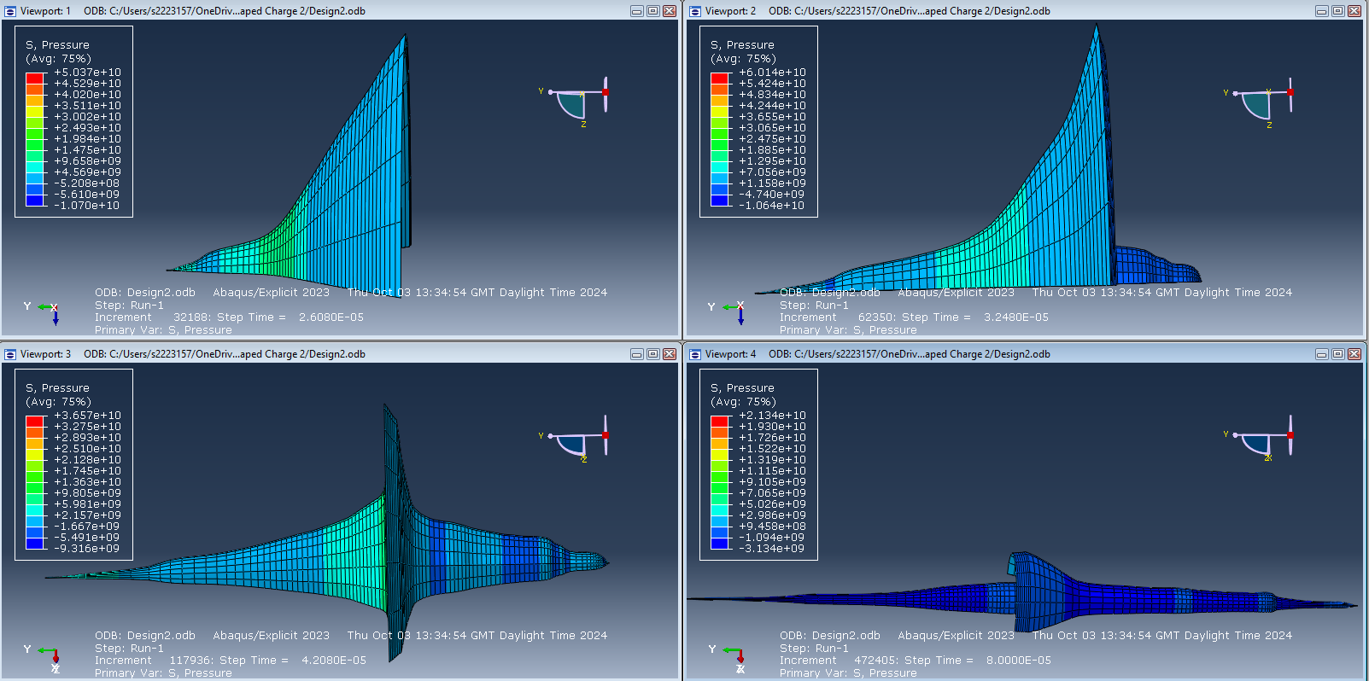
Figure 18 - Jet formation Design 2

Jet Formation 3D Model

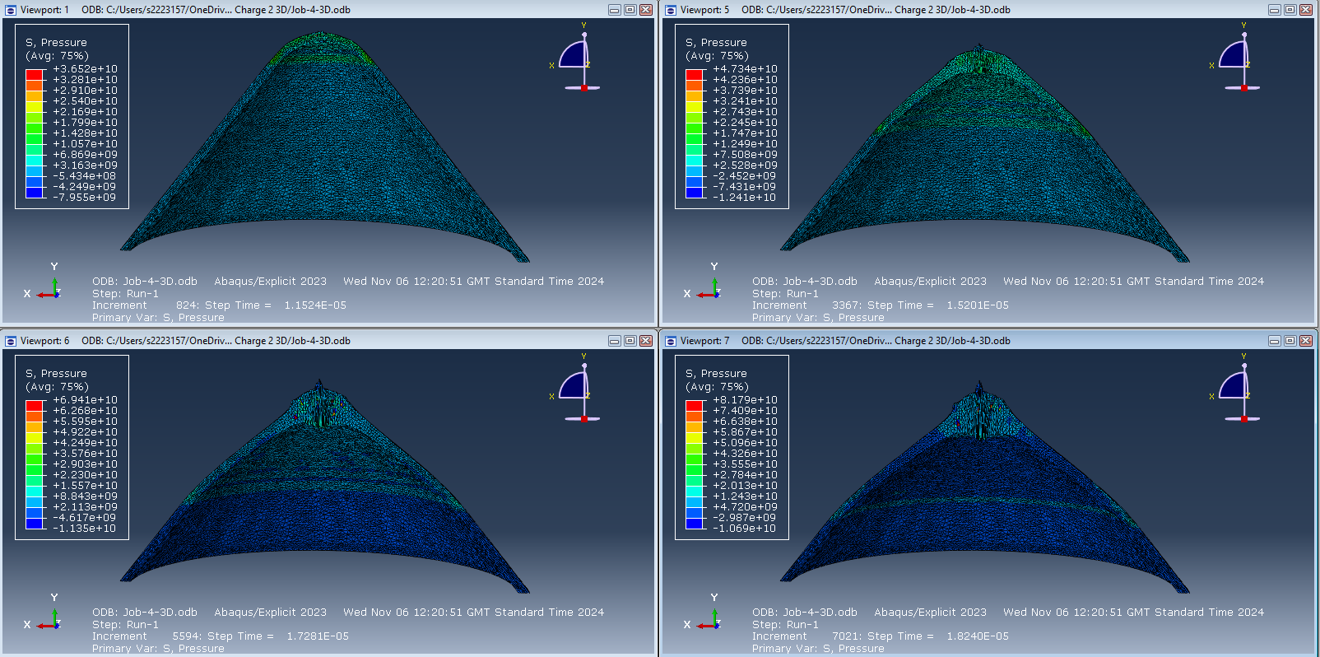
Figure 19 - Jet Formation 3D Model (1 of 2)
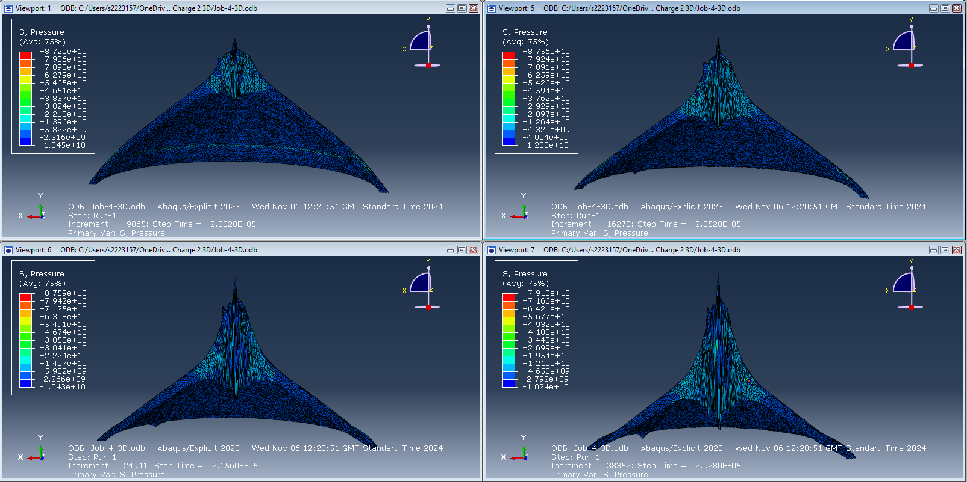
Figure 20 - Jet Formation 3D Model (2 of 2)

Velocity of Jet

The series of images captured in figures 21-28 shows the velocity of the jet, and their respective velocity graphs, in each simulation as the detonation wave propagates through the material until the jet is fully formed. In the first set of images, the velocity of the jet is relatively low, deformation has just begun to occur and pressure/velocity is still steadily increasing. These images also indicate that the peak velocities are occurring at the tip of the jet as it accelerates outward. In this second set of images, the jet is starting to exhibit a more elongated shape, indicating a significant velocity increase along its length. This is highlighted by the colour red becoming more prominent as this represents high-velocity values. The last images show the fully formed jet with maximum velocity occurring at the tip before dissipating. The velocity graphs below (figures 23, 26 and 28) show the velocity starting at or near zero. This is in the initial stages where the jet hasn’t yet formed and the liner has just begun to deform. It then shows a rapid increase in velocity, representing the acceleration of the jet as it fully deforms. After this rapid rise, it can be observed that the velocity levels off/drops as maximum deformation is reached.
The maximum velocities reached in each model were:

Table 8 - Maximum Velocities
Simulation | Maximum Velocity  kms⁻¹
2D Design 1 | 7.7
2D Design 2 | 7
3D Model | 5.2

Velocity of Jet Design 1

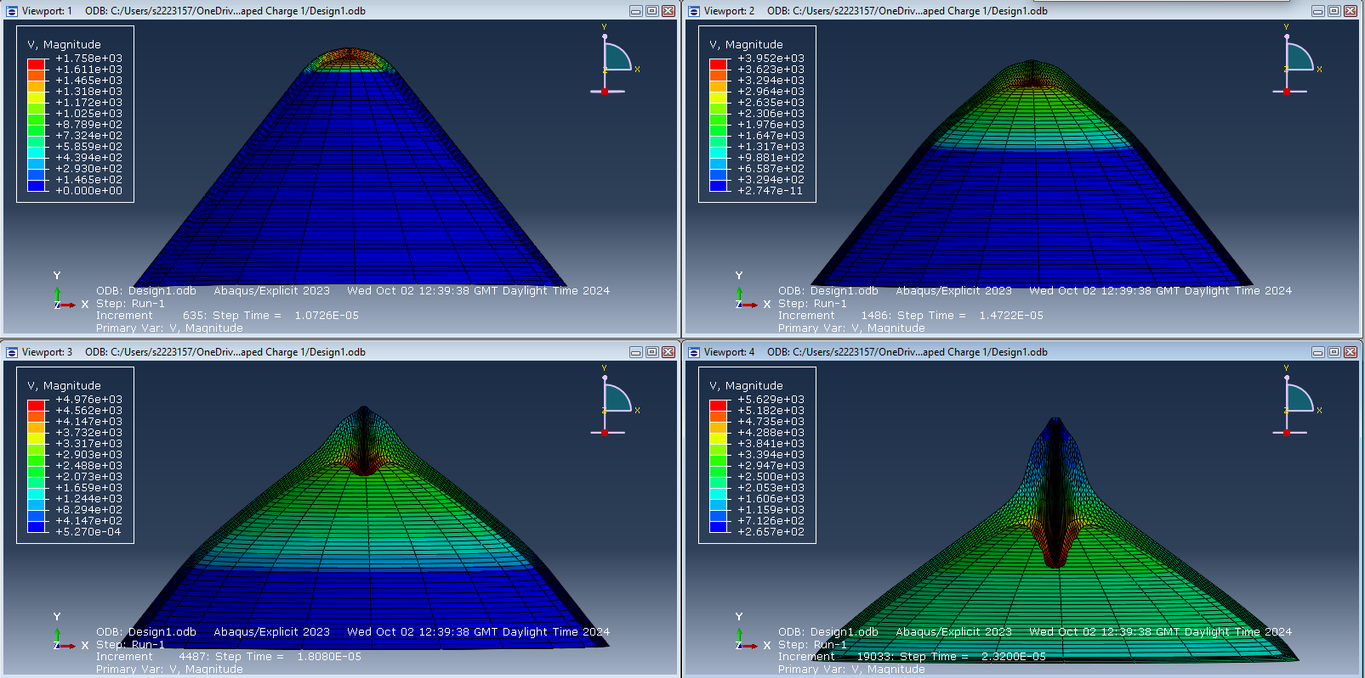
Figure 21 - Jet Velocity Design 1 (1 of 2)
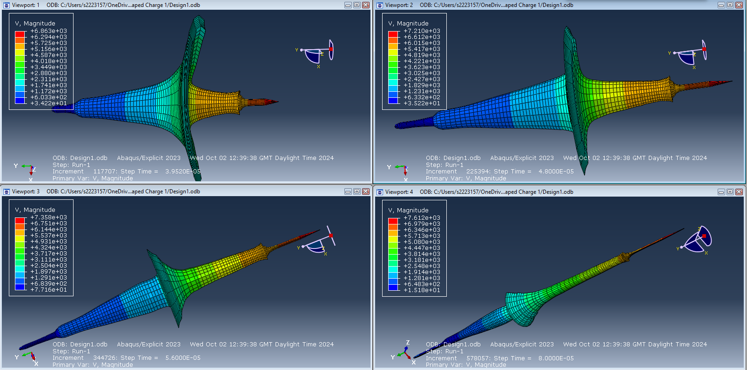
Figure 22 - Jet Velocity Design 1 (2 of 2)

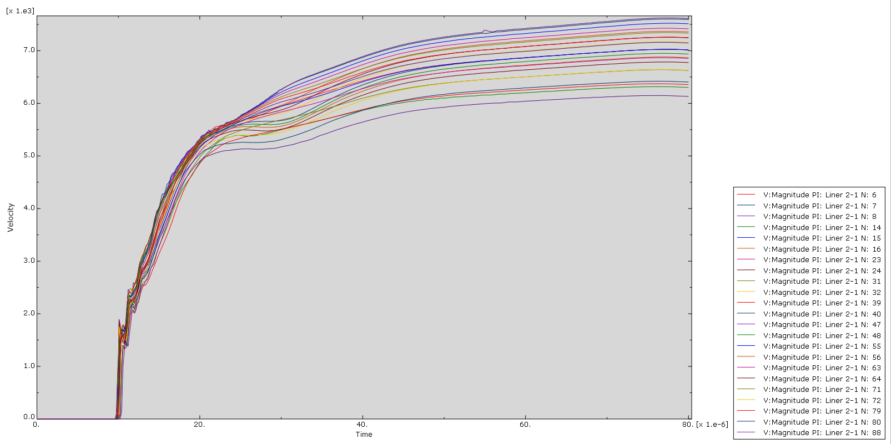
Figure 23 - Design 1 Velocity Graph

Velocity of Jet Design 2

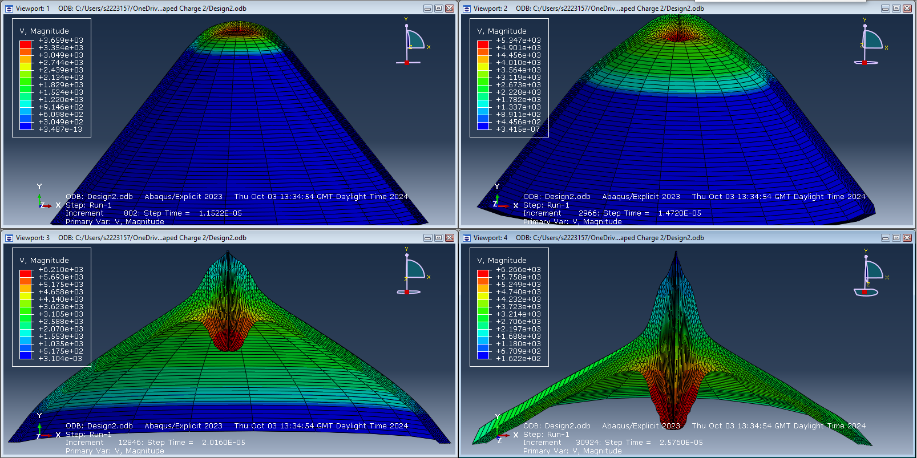
Figure 24 - Jet Velocity Design 2 (1 of 2)

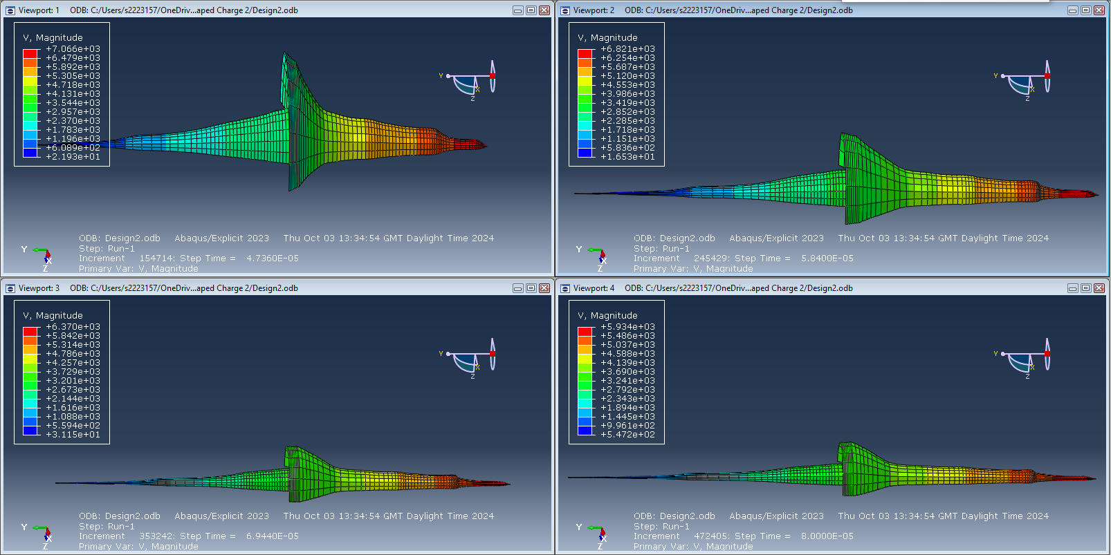
Figure 25 - Jet Velocity Design 2 (2 of 2)

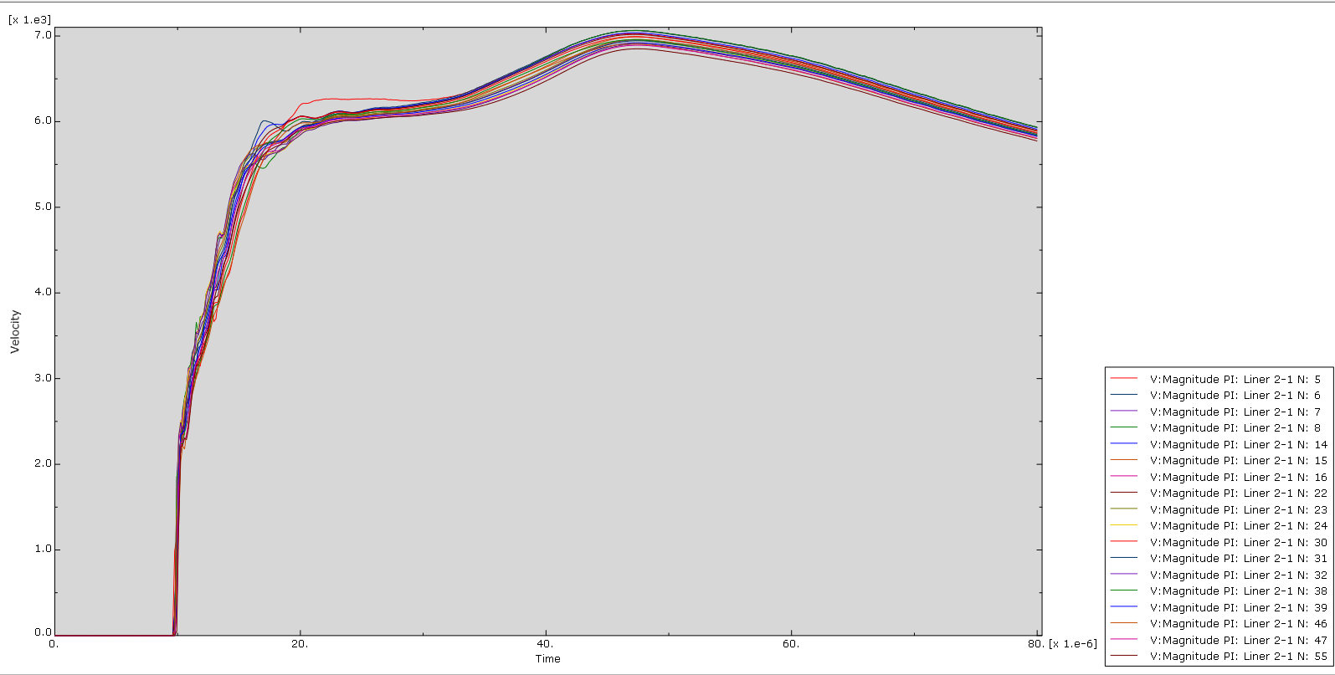
Figure 26 - Design 2 Velocity Graph

Velocity of Jet 3D Model

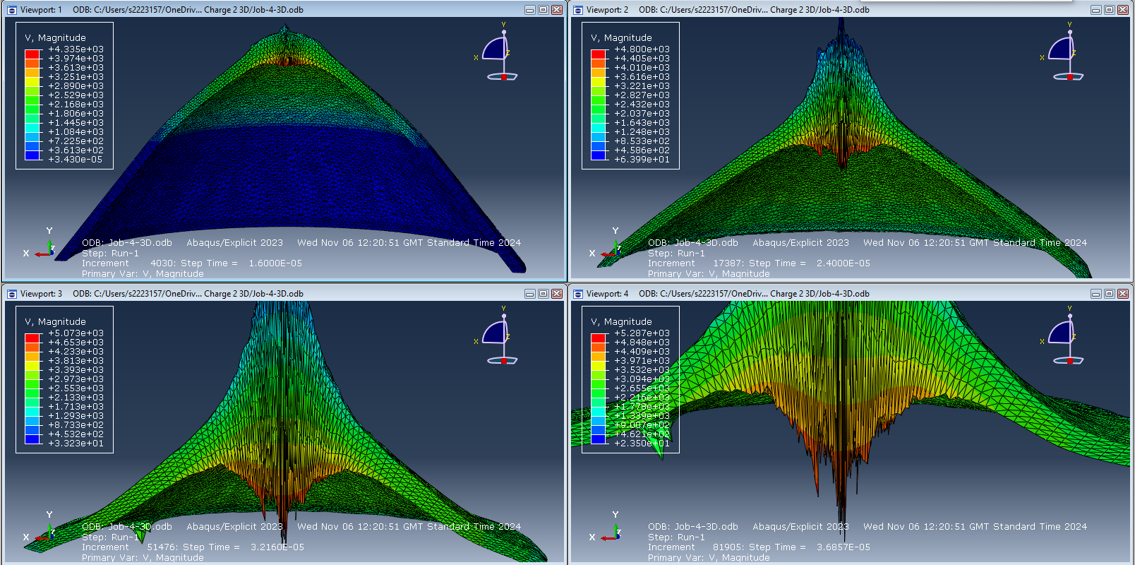
Figure 27 - Jet Velocity 3D Model

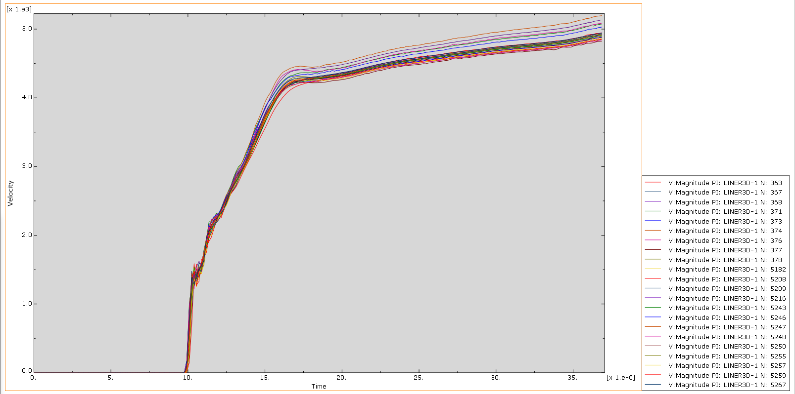
Figure 28 - 3D Model Velocity Graph

Analysis

Comparison of Detonation Waves

In the first simulation, the detonation wave front can be seen expanding uniformly outward maintaining a relatively straight trajectory. The second design shows a similar pressure distribution, however, the propagation of the wave appears slightly slower. Finally, the 3D model indicates that the pressure takes longer to distribute in comparison to the other models. Overall, the design in simulation 1 appears to have the most efficient and uniform propagation of the detonation wave with the 3D model appearing much slower and less uniform in pressure distribution.

Comparison of Jet Formations

In terms of shape, design 1 appears to have a smoother, more streamlined jet. Design 2 appears to spread out which could indicate differences in the response of the liner and how the energy dissipates. Unfortunately, the simulation of the 3D model failed before the jet could be fully formed. However, the images show high pressure and dramatic elongation.

Comparison of Jet Velocities

All of the model's jet velocities rise rapidly and level off as the energy dissipates. From the velocity graphs, it can be observed that the initial velocity rise in the 3D model occurs slightly later and reaches lower maximum velocities. The highest maximum jet velocity occurred in the simulation of design 1 at 7.7kms⁻¹. The lowest maximum jet velocity occurred in the 3D simulation at 5.2kms⁻¹.

Overall Evaluation

Overall, design 1 appears to outperform all models in most aspects indicating that the copper liner is the more suitable choice for a shaped charge. It has the highest jet velocity, as well as the smoothest and narrowest jet which would be ideal for precise targets and deep penetration. Design 2 does appear to have a more consistent performance, but it sacrifices peak velocity. The 3D model has the lowest peak velocity, slower stabilisation of the jet and greater variability indicating low reliability. Even though the second simulation and the 3D simulation used the same materials and values, their results differ in various different areas. This is because, in general, 2-dimensional simulations ‘simplify’ the problem. They don’t take into consideration the full geometric and physical characteristics of the model. While 3D simulations provide a more realistic and accurate representation, 2D simulations are valuable for initial analysis and faster evaluation of performance.

Conclusion

This assignment gave an introduction to shaped charges and their applications. It also provided a brief insight into the history of shaped charges and how that has affected the weapons we use today. From the literature review, many options were consulted and a final design choice was made. The shaped charge design was conical in shape with a steel casing, TNT explosive filling and a copper and TB6 liner. Recommendations could be made to try a different explosive filling or material for the casing to observe how they perform. The overall shape could also be changed, depending on what the desired outcome is. More research should be done into ABAQUS software and the different ways you can control a simulation to get more optimal and reliable results.
Overall, the first design of the shaped charge with the copper liner performed the best and yielded the best results with the highest velocity reached and the smoothest jet. This could be due to copper being a very malleable material that deforms easily under pressure without breaking. It can be observed that 3D simulations provide more accurate and realistic results, however, more research and care should be taken in the future when setting up the simulation to allow it the chance to run to completion. The recommendation that could be made from the results provided is to use a copper liner in a shaped charge rather than TB6 as this will produce the best results and highest reliability.

References

[1] | ArmyTechnology, Panzerfaust 3 Anti-Tank Weapon, Germany, ArmyTechnology, 2022.
[2] | J. Hall, “Shaped Charges: Harnessing Precision in Explosive Technology,” Alford Technologies, 2025. [Online]. Available: https://www.explosives.net/shaped-charges-explosive-technology/#:~:text=Aerospace%20and%20Space%20Exploration,planetary%20surfaces%20for%20sample%20collection.. [Accessed 01 2025].
[3] | e. a. Solowski, Advances in Applied Mechanics, vol. 54, Elsevier, 2021, pp. 113-204.
[4] | e. a. P Dehestani, “Numerical study of the stand-off distance and liner thickness effect on the penetration depth efficiency of shaped charge process,” Journal of Mechanical Engineering Science, vol. 233, no. 3, 27 March 2018.
[5] | X. Z. a. W. Xiong, Shock Compression and Chemical Reaction of Multifunctional Energetic Structural Materials, Elsevier, 2023.
[6] | Alford Technologies, “Explosively Formed Projectile (EFP),” 26 07 2024. [Online]. Available: https://www.explosives.net/glossary/explosively-formed-projectile-efp/#:~:text=EFPs%20are%20a%20type%20of,propel%20a%20high%2Dspeed%20projectile.. [Accessed 01 2025].
[7] | “Linear Shaped Charge (LSC),” Ensign-Bickford Aerospace & Defence, [Online]. Available: https://ebad.com/products/linear-shaped-charge-lsc/. [Accessed 01 2025].
[8] | MatWeb, “Titanium Ti-10V-2Fe-3Al (Ti 10-2-3) Solution Treated 850°C (1560°F),” MatWeb - Material Property Data, [Online]. Available: https://matweb.com/search/DataSheet.aspx?MatGUID=e810947a42894199adec39058992b53a&ckck=1. [Accessed 01 2025].
[9] | CAE Assistant, [Online]. Available: https://caeassistant.com/.

