Introduction To Public Health
LCHS4004

Shelby-Ann Yeboah
2114878

Bianca Sanfilippo

Context Page

Introduction
Symptoms and Preventions
Eradication
Collecting and Analysing Data
Strategies to Monitor
Conclusion
Reference List

Introduction

Poliomyelitis is a highly infectious disease caused by a virus belonging to the Picornaviridae family. Polio, short for poliomyelitis, is a highly contagious disease that primarily affects children under the age of five. For many years, it was one of the most feared diseases worldwide, causing widespread outbreaks and epidemics that affected millions of people, particularly children. Poliomyelitis is instigated by the poliovirus, which is transmitted through contaminated food, water, or surfaces. The virus attacks the nervous system and can lead to paralysis, muscle weakness, and even in the worst-case scenario, death.
In this case study, we will explore the history of polio, its impact on global health, and the strategies that have been used to control and eradicate the disease. We will also examine the challenges that remain in achieving a polio-free world and the lessons that can be learned from global polio eradication initiatives.

Symptoms and Preventions

The symptoms of polio can vary from mild to severe, with most people experiencing no symptoms at all. However, in server cases, the virus can cause paralysis of the legs, arms, or even the muscles used for breathing. However, there is no cure for polio; vaccines are available to prevent the disease. Thanks to widespread vaccination efforts, polio has been largely eradicated in many parts of the world. However, the disease still exists in a few countries, and efforts to eradicate it completely are ongoing.
The Polio Eradication Strategy 2022–2026 lays out the roadmap to securing a lasting and sustained world, free of all polioviruses, and transition and polio post-certification efforts are ongoing to assure that the infrastructure built up to eradicate polio will continue to benefit broader public health efforts, long after the disease is gone.(World Health Organization, 2022)

Eradication
Cases due to wild poliovirus have decreased by over 99% since 1988, from an estimated 350 000 cases then to 6 reported cases in 2021. As long as a single child remains infected, children in all countries are at risk of contracting polio. Failure to eradicate polio from these last remaining strongholds could result in a global resurgence of the disease.
Efforts to eradicate poliomyelitis have been established, Economic modelling has found that the eradication of polio would save at least US$ 40–50 billion, mostly in low-income countries. Most importantly, success will mean that no child will ever again suffer the terrible effects of lifelong polio-paralysis.
The polio effort continues to support broader public health efforts, including helping respond to natural disasters, humanitarian emergencies, droughts, earthquakes, outbreaks of other infectious diseases and supporting disease surveillance for broader public health initiatives. The GPEI continues to support response to the global COVID-19 pandemic, including helping with disease surveillance, laboratory capacity and vaccine introduction and roll-out. (World Health Organization, 2022)

Collecting and Analysing Data

Collecting Mortality and Morbidity data help public health organisations to measure outbreaks early and allow for timely interventions, such as vaccination campaigns or quarantine, which was demonstrated in the COVID-19 pandemic. This information can be used to develop public health strategies and allocate resources effectively to prevent and treat diseases.

Strategies to Monitor

Developing strategies and monitoring mechanisms are crucial for preventing the reintroduction of polio in the UK. The most effective way to prevent the outspread of polio is to ensure that all children and adults are updated with all vaccinations.
The provision of improved hygiene practices and sanitation is essential for reducing the spread of transmission in endemic countries.
The current infectious disease challenges are magnified on a global scale due to the increased mobility of individuals and the impact of climate change.
The importance of educating young people on why hand hygiene is so important and providing them with educational resources to support this has been developed by the UK Health Security Agency (UKHSA) with teachers for ages 3 to 16 years. The use of standard infection prevention and control (SIPC) precautions to reduce the risk of unknown (and known) disease transmission. Standard infection control precautions (SICPs) are to be used by all staff, in all care settings, at all times, for all patients whether infection is known to be present or not, to ensure the safety of those being cared for, staff and visitors in the care environment. SICPs are the basic infection prevention and control measures necessary to reduce the risk of transmitting infectious agents from both recognised and unrecognised sources of infection. (NHS England, 2023). In most countries, the global effort has expanded capacities to tackle other infectious diseases by building effective surveillance and immunization systems. (World Health Organization, 2022)

Conclusion

In conclusion, the global effort to eradicate polio has made significant progress, reducing the number of cases by over 99%. However, the fight against polio is not yet over, and continued efforts are necessary to reach the finish line. With continued investment in vaccination campaigns, research and surveillance, it is possible to achieve a world free of polio and ensure that future generations are protected from this debilitating disease. The lessons learned from the polio eradication campaign power of global cooperation and sustained effort in combating public health challenges.

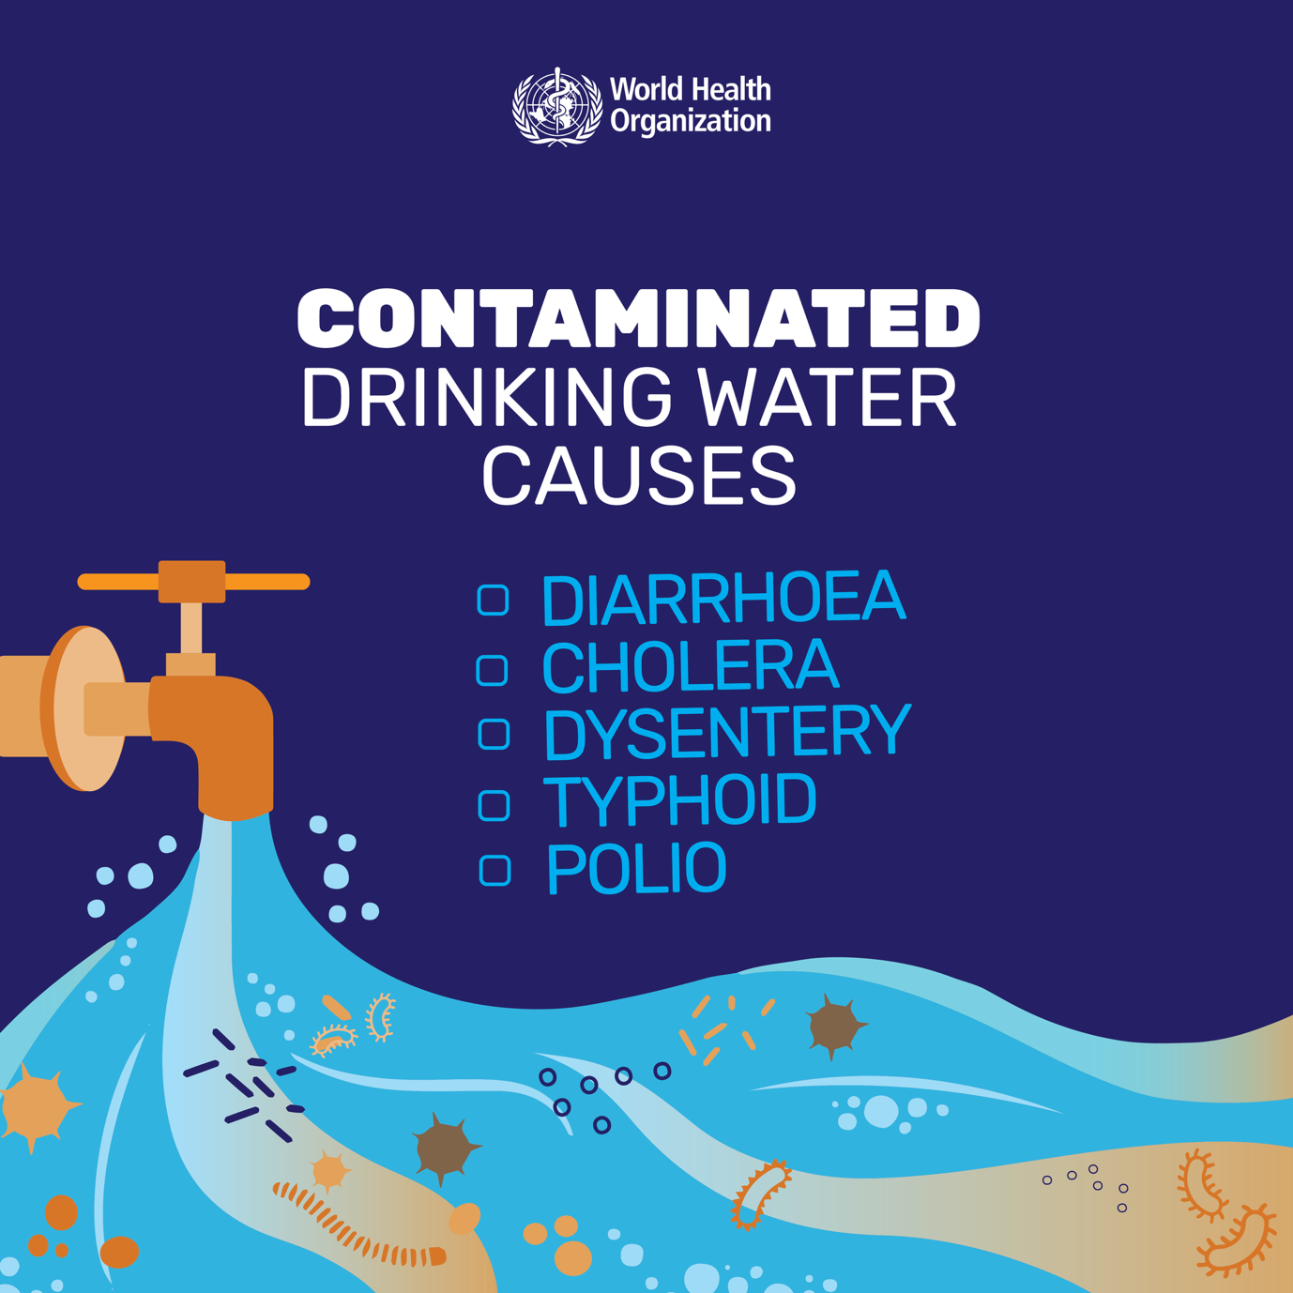
(www.facebook.com, n.d.)

Reference list

Castilletti C, Capobianchi MR. Polio is back? The risk of poliomyelitis recurrence globally, and the legacy of the severe acute respiratory syndrome coronavirus 2 pandemic. Clin Microbiol Infect. 2023 Apr;29(4):414-416. doi: 10.1016/j.cmi.2022.12.005. Epub 2022 Dec 8. PMID: 36503117; PMCID: PMC9731642.

Mehndiratta, M.M., Mehndiratta, P. and Pande, R. (2014). Poliomyelitis. The Neurohospitalist, [online] 4(4), pp.223–229. doi:https://doi.org/10.1177/1941874414533352.
NHS England (2023). National infection prevention and control manual for England. [online] Available at: https://www.england.nhs.uk/wp-content/uploads/2022/04/National-infection-prevention-and-control-manual-v2-4-250123.pdf [Accessed 17 Apr. 2023].
World Health Organization (2022). Poliomyelitis. [online] Who.int. Available at: https://www.who.int/news-room/fact-sheets/detail/poliomyelitis [Accessed 3 Apr. 2023].
www.facebook.com. (n.d.). World Health Organization (WHO) - Today is World Water Day. Did you know❓ Over 2 billion people worldwide use a drinking water source that is contaminated with faeces. Unsafe water & inadequate sanitation result in diseases like: ➡️Cholera ➡️Diarrhoea ➡️Dysentery ➡️Typhoid ➡️Polio Safe water saves lives. | Facebook. [online] Available at: https://www.facebook.com/WHO/photos/a.167668209945237/6389922107719785/?paipv=0&eav=AfZGDdKfsT6MoJ_qFZqMt0g-CwOjF4zF86Jbtb7xiDsvUvQk28OmpZKf9r1GkpBf0jk&_rdr [Accessed 26 Apr. 2023].

