A synopsis of views on the function of HR and how this is evolving

The purpose of the HR function is to support the delivery of an organisation’s strategy and objectives via the effective management of people and performance. The HR strategy and all activities should be clearly aligned with the overall business objectives, (Wilkinson and Taylor, 2016).

According to a survey carried out by the CIPD, (2018) the world of work is evolving and as such the role of HR Professionals has diversified. Within Organisations, the HR function is about attracting and retaining people with the right skills, qualities and experience, promoting effective performance management, seeking to develop them and looking at opportunities to involve and engage them within the organisation.

The CIPD New Professional Map 2018, CIPD (2018) recognises the knowledge, purpose and behaviours required for people professionals to make better decisions, act with confidence, perform to their highest standard, encourage change and have aspirations in their career.

The fundamental purpose of the people profession is to get yourself right which will enable you to champion others. Motivate people to get the best out of them and ensure they have the relevant knowledge and skills to undertake their role. Deliver organisational outcomes having an input and influence strategically to meet business objectives.

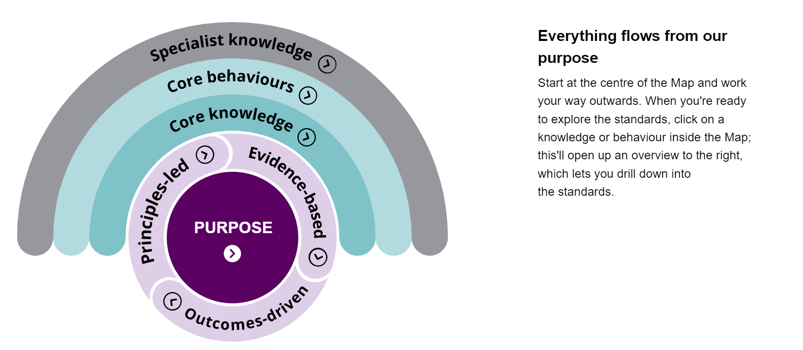

The HR function has evolved over the years, moving from administration and transactional processes to maximising personal contributions/transformational. The main difference between the traditional Personnel Management function and Strategic Human Resource Management being ‘adding value’ to an organisation.

Historically, the HR function was recognised as ‘personnel management’, responsible for transactional processes, wages and the welfare of workers. Typical duties undertaken were, employee recording keeping, ensuring the adherence of policies, recruitment processes and dealing with Trade Unions.

Towards the end of the twentieth century, the function moved to ‘Human Resource Management’. It was recognised that HR could have an influence on non-monetary factors including productivity and motivation of employees. The emphasis on people changed towards workers loyalty and commitment, considering ways of providing employees with a challenging work environment and an emphasis on leadership, (Wilkinson and Taylor, 2016).

At the end of the century, the emphasis moved to ‘Strategic Human Resource Management’ activities of which include, providing specialist HR advice in line with organisation objectives/departmental service plans, continuous improvement, data analysis, providing recommendations/options on service improvement.

Deloitte. Insights (2017) refers to the focus of HR shifting towards building the organisation of the future. Companies are recruiting young, digital savvy employees who are willing to share information in a transparent way. They want an integrated, digital experience at work-one designed around teams, productivity and empowerment - and HR is expected to deliver it.

Examples of how HR can contribute to effective change management, with reference to at least one model of change

According to CIPD (2011), as cited in (Wilkinson and Taylor, 2016). Organisations experience large-scale changes approximately once every three years, while small changes are constant and the extent will depend on pressure and priorities within an organisation at that particular time.

Organisations should understand the vital role HR has during any change management process and therefore need to engage HR in discussions from the outset. During times of uncertainty, people react in different ways and as such, organisations need to have awareness of how people may react and how they are going to respond to the changes. It is important to involve people and bring them along with the changes.

It should be acknowledged, that people go through a cycle of emotions when dealing with change, as illustrated in the Kubler-Ross Model of change below.
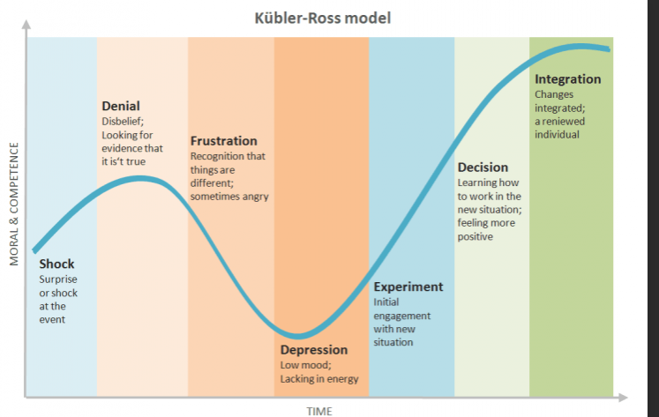

HR can contribute to change management in a number of ways including effective communications, people participation and encouraging an organisation culture that embraces change.

HR should have an understanding of an organisation’s culture by engaging employees in focus groups allowing them to have a voice, undertaking interviews with relevant stakeholders, encourage questions on change initiatives to be included in staff survey’s. (Wilkinson and Taylor, 2016). This will enable HR to have the necessary knowledge and understanding to engage staff through the change process allowing a smoother transition.

When an organisation is going through a change process, it is important to have clear communication strategies so employees understand how they can relay their views and feel valued. The role of HR is to encourage a communication plan that is effective for both Senior Managers and Employees and ensure consistent messages are being relayed i.e. via newsletters, intranet, agenda item in team meetings, 121 meetings with HR and Management.

During any change process, HR need to embrace its role in being an effective facilitator of change. The better HR professionals are at embracing changes themselves, the better they will enable changes throughout an organisation, Cohen, D (2016).

A summary of different ways that HR services can be delivered, comparing and contrasting different methods.

The HR function and roles of HR professionals can be structured in different ways dependant on the size of the organisation. In smaller organisations, there is likely to be an individual who is recognised as the HR expert working with operational managers whereas in larger organisations, there would be a team or teams of HR professionals.

According to the CIPD (2015), ‘We support the view that there is not one model for delivering HR that is suited to all organisations, that different organisations have different needs.

How an organisation should structure its HR function depends on its organisational strategy, wider organisational structure and the requirements of its customers and the organisation its supporting. These things can be influenced by other factors such as size of the organisation and maturity’.

The HR service delivery method within an organisation will be considered in line with business requirements.

Private / smaller organisations may employ a small number of people to carry out basic HR tasks; HR Managers would be generalists and they would pay for specialist HR advice to advise on specific employee relation matters, implementation of policy etc. Within Private organisations, there would be a requirement to implement contractual policies in line with legislation.
Whereas the HR function within the Public Sector would have a HR Director on the Corporate Management Team and as such, able to influence the business strategy. There is a public interest and therefore, all employees should be treated fairly and with respect. Implementation of policies are consulted upon with Trade Unions and are strictly adhered to.
Within the Voluntary/Third Sector, which are not for profit organisations, resources are limited and as such, HR generalists cover large areas. There may be contractual arrangements with the public sector so therefore practices may mirror that of the public sector.

Details of the various roles within HR are outlined below:

- HR generalists – act as the subject matter expert, providing advice and guidance in all aspects of HR having a variety of tasks and priorities to meet service requirements.
- HR specialists – provide advice in relation to specific areas of HR e.g. Organisation development, Employee engagement, Performance and Reward.
- Shared Services – this allowing a corporate service specifically across large organisations however, the role of HR should be clearly defined between operational HR queries to more complex HR matters and employees advised accordingly.
- Outsourcing – option to source an external organisation to provide HR advice rather performing it in-house.
- Consultancy – engage a HR consultant at the appropriate time to provide advice on certain issues or work on a project for a specified period of time.

A recognised model of HR is Ulrich’s 3 Legged Stool Model (1998) where HR is split between three areas of expertise, CIPD (2019).
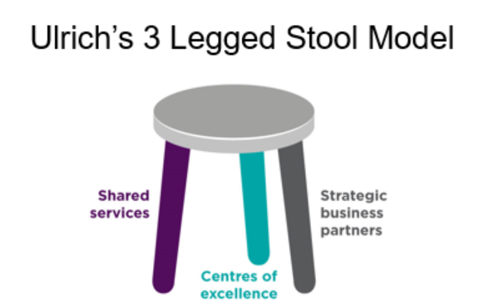

- Shared services undertake basis transactional HR duties across the organisation e.g. advice on simple employee relation queries, administration of recruitment, sickness absence, data inputting. Act as the hub for first line HR support and administration.
- Centres of excellence – HR experts within small teams providing specialist advice. Delivery of business and people benefits through HR innovations, interventions and initiatives. In areas such as reward, employee engagement, performance and talent management.
- Strategic business partners – senior HR processionals who work closely with Senior Managers having an influence on the business and people strategy, aligning HR competencies across the organisation as a whole.

A true HR business partner has a thorough understanding of the business context, influencing and creating HR services to deliver a positive impact on the organisation, its people and wider communities, CIPD (2019).

Examples of how HR can work with line managers to provide HR services

It should be recognised that Line Managers also have a responsibility for employee relations issues and therefore HR and Managers need to have a collaborative approach to ensure employee issues are managed effectively and consistently.

According to Buden, A (2014) to enable both HR and Managers to work together to meet the organisations objectives, they need to find a smarter way of working. HR should provide managers with information that is clearly aligned to the organisation strategy such as, reward policies, pay and grading procedures etc. allowing managers to communicate effectively with their teams and make better business decisions. This would also reduce the time spent responding to queries and enables HR to concentrate their time on pursuing strategic objectives and adding value to the organisation.

As explained within the Ulrich model, developing a HR Business Partner approach allows HR to engage with Managers to have an understanding of business requirements, where they are now; where they need to get to and how they are going to get there. Being ‘business savvy’ is important for HR Business Partners as it helps to enhance credibility amongst managers and therefore have an ability to influence others and being part of the decision making process.

A justification of why HR should be managed in an ethical manner with examples of ethical practice contrasted with examples of non-ethical practice

The way in which decisions are made within an Organisation is important as making the wrong decisions or implementing decisions in the wrong way can have an impact on people’s lives and the reputation of an organisation.

Decisions made on good principles and values, can gage ethics of an organisation and have a positive impact on people and the experiences they have within the workplace, CIPD (2019).

It is important that HR have an ethical approach ensuring fairness within an organisation, treating people with dignity and respect. HR need to have positive working relationships, building trust within all levels of the organisation.

According to Kew and Stredwick (2019, p351), as cited in (Wilkinson and Taylor, 2016). Ethical behaviour is core element of the required standards of HR professionals.
A definition of ethics has three core elements: fairness, deciding what is right and wrong; and the practices and rules, which underpin responsible, conduct between individuals and groups.

HR are responsible for implementing policies and procedures, which align to the values of an organisation and also comply with legislation.

Discrimination
The Equality Act 2010 promotes ethical behaviour as it ensure that all employees are provided with the same opportunities.

Ethical practice – Organisations are legally required to provide equal opportunity for all employees. Organisations must recruit a diverse workforce, enforce policies and training that support equal opportunities.
Non-ethical practice – Discrimination of employees based on a protected characteristic e.g. higher salaries paid to men for equal value of work undertaken by women. Refusing to making reasonable adjustments within the workplace for individuals with a recognised disability. Failure to engage individuals who are on maternity.

Mishandling of data
Improve the trust and confidence in your organization’s compliance with GDPR

Ethical practice – manage data in line with legislation, i.e. General Data Protection Regulations and relevant policies. Respond to subject access requests from employees. Ensure employees understand the importance of advising the organisation of any updates regarding their personal details.
Unethical practice – sending personal information to the wrong address, providing personal information without consent, failure to secure personal data of employees securely.

An explanation how HR’s contribution to the organisation can be evaluated

The contribution made by HR may not be of monetary value and therefore need to consider how their influence has ‘added value’ within an organisation. HR need to identify relevant stakeholders, i.e. senior managers, employees, Trade Unions and define the nature of the value that is added through the initiatives of HR, Personnel Today (2012). There may be many individuals identified and as such, satisfaction surveys with specifically asked questions issued to provide qualitative data, which would then be analysed to determine whether the stakeholders value the contribution made by HR.

The balance scorecard approach below was devised to provide managers with a detailed view of the business. It allows managers the opportunity to view the business from four different perspectives and focus on measures that are most critical, Harvard Business Review (1992).

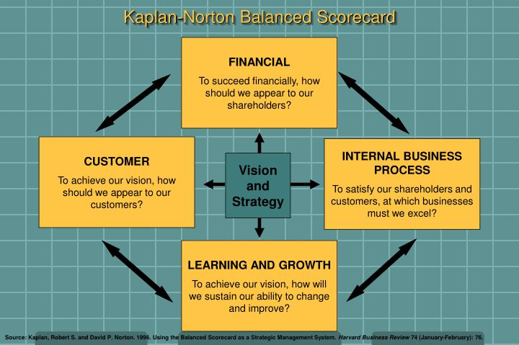

An Organisation could evaluate the contribution of HR by using both Quantitative and Qualitative methods. If there are small amount of Employment Tribunal Claims submitted, it should be recognised that the HR professionals are ensuring the relevant policies and procedures are in place, aiming to resolve any workplace disputes.
A function of HR is to provide learning and development opportunities, it is important to receive feedback from participates to undertake an evaluation of the training and whether it could be improved.

Effective evaluation of the HR Function will identify areas of improvement, changes/trends and identify the future demands or the Organisation.

