
knowledge and Information Management BMSK 5006
Assignment 1 & 2
syed yousuf ali-1711131 | 3/7/20 | Buddhi Patak

Table of Contents
Assignment part 1 2
Introduction 3
Section one 4
Section two 5
Section three 8
Section 4 9
Section 5 11
References 16
Assignment part 2.1 17
Assignment Part.2.2 22
References 27

Assignment part 1

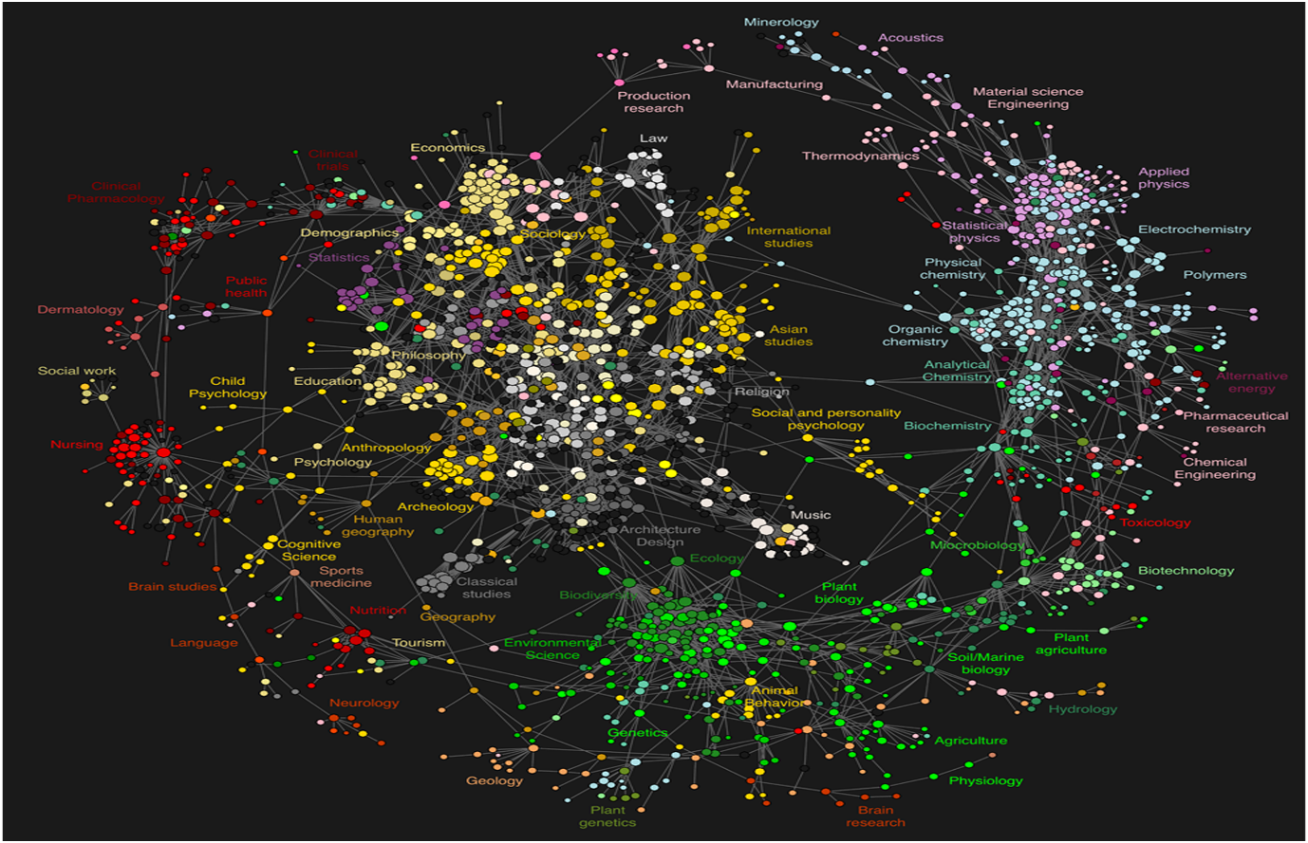

Introduction

In this first assignment discussion of certain factors will be incorporated, and detailed explanation will be applied with examples to make it easy and understandable for the reader in hand to fully grasp the concept and idea behind this work.
This will be divided in several sections. First section will discuss about data which is considered by some to be useful and others, to not believe it to be so and also what term can be given to it.
Second section will elaborate on the difference between knowledge, data and information, testified with diagrams and examples.
Third section will explain the difference between tacit knowledge and explicit knowledge with examples.
Fourth section will be on the decision I personally made on the day consisting of five occasions explaining what information, data, and knowledge was used to overcome and perform those actions to give it a final outcome or name such as “driving to university today”.
Finally, the fifth and last section will show the invention of a new product showing how data, information and knowledge can be utilised in order to boost promotions of this product.

Section one

Q,1. Explain why the same set of data is useful to some and not to others?

According to Margaret Rouse (2020), In computing terms, data is considered to be information which has been translated into a form that is efficient for movement or processing. Relative to today's computers and transmission media, data is information converted into binary digital form. It is acceptable for data to be used as a singular subject or a plural subject. Raw data is a term used to describe data in its most basic digital format.

Data are observations or facts (raw) that are considered to be of less importance or minimal value. Examples will suggest the likes of random numerical numbers, symbols, words or values; an event or fact which is recorded etc.
Data can be hard or soft. Hard data which is also popular by the name quantitative data; soft data has similar name which is qualitative data. Quantitative data (hard data) usually makes use in figures and statistics, collect to quantify. Qualitative data (soft data) is more to focus on the qualities of that figure or object.

Data is a very important factor in our lives not to mention the huge money which is involved collecting and storing it. However, not all that are using the data find it useful to them or find any relevance to their particular subject for which they are searching for. If I was to give an example it would be as simple as searching online, there are tonnes of data online but do all hold relevance to my subject? The answer is no not all, some of the data I will find useful to me, but others will hold no meaning for me to use. Another example would be of data stored for a G.P. (general practitioner) will be totally irrelevant for the use of a dentist as the subjects will differ and the data cannot be used by the dentist. The data is not useless but becomes useless to that particular person or subject.

Section two

Q,2. Difference between knowledge and data?

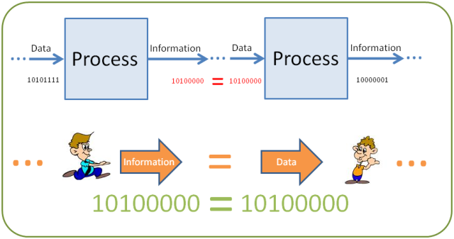

How can data become information? Or how can it be given a term information? It’s quite simple, data that has been processed becomes something of importance or meaningful transforms from data to information.
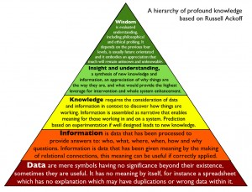

Such pyramid refers to a class of models and it is used for representing the purported structural and functional relationships between information, data, wisdom and knowledge. At the same time, the term “information” can be defined in terms of data, when the term “knowledge” is defined in terms of information and the term “wisdom” — in terms of knowledge. (Odessa,2020).

Examples of this would be the likes of when you take the electric meter reading or gas meter reading it is data but as soon as it is processed and handed out as a bill it becomes information.
Another example would be numbers or figures in your bank account is data but when the process takes place it becomes information.
There are several types of information processing. These types are:
- Classification: placing data into categorised sections.
- Selection: selecting data which is criteria based.
- Aggregating: summarisation of data.
- Performing calculations: calculations of hours or amount of pay etc.
- Rearranging or sorting: organising or putting into place in a particular order.

Section three
Q,3. Card game player uses tacit or explicit knowledge?
Definition of explicit knowledge:
Explicit knowledge is considered to the lowest form of knowledge and is easily transferable along due to it being recorded (written down) and very accessible. After data is interpreted, structured, organised and processed, it is then known as explicit knowledge. Explicit knowledge is easily recorded, stored, communicated amongst all and articulated.
An example of explicit knowledge is bank statements or takings receipts in a business or even a register would be considered as this type of knowledge.
Definition of tacit knowledge:
Tacit knowledge is the knowledge that we like to call personal experience or work experience, beliefs, intuition and values. It’s the type of information that would be the most difficult to record (write down) as a tangible form.
A very simple example would be to think of learning how to make your aunt Sheila’s creamy lasagne recipe. You may have the recipe in writing but when you practically start to make it the process is not accurate, and the taste is no were near what it tastes like when she makes it why? Because the years of experience she has in preparing this, she cannot and will not be able to write down it’s a feeling that comes or you have after years of practice. (Alexander, 2020)
When playing cards at parties or gathering only those people start to play that have experience in playing this game prior to this event or are deemed to know about the game and have played it previously, otherwise they do not request to play nor does anyone in that gathering requests that individual to play reason, you cannot just pick up the rules and guideline information sheet and become a player it takes experience and expertise to carry out the game in order to hold any chance of winning, a great deal of skill set is required to do so. This knowledge cannot be written down but explained only to a certain degree after which it becomes the players responsibility to keep playing in order to gain more experience and understand the game. So, the knowledge that will be used in this game will be of tacit knowledge.

Section 4
Q,4. Consider five decisions made today and in each one outline the knowledge, data and /or information was used for the decision?
I had to make five decisions today in order to carry out my daily life. These five decisions were very simple and normal ones, but an explanation will be given as to the mechanism that is inputted into this process which allows a person to do such actions.
- First decision was that I had to go into my vehicle to drive to the gym to attend my weight loss class. The data of me attending the gym today was the opening hours which tell me the times I can visit the gym and when I cannot as it will be shut after a certain time. The information is that I will have to register myself once I have arrived at the gym so that my instructor will go through my personal data to check what exercise I will need to do today. And finally, the knowledge side would be the exercises which I will be completing will be based on the experience my instructor has and utilises on me.

- Second decision was that I had to shower after my gym session which got me really sweaty and hopefully lost a lot of fat in the process. So, the data in this scenario is the data on the shower cubicle which state that I cannot smoke in there. The information is that what I can bring in with me in the shower; the knowledge is how I would use the hot water in the shower to wash myself.

- Third decision I had to make was to attend my university class. The data in this scene is that I was told that today’s session would be on presentation. The information was the bases of my presentation which Rebecca Kavanagh (my lecturer) instructed me to present on my assignment; the knowledge was the knowledge I had learnt in class and during my assignment which I had to rethink in order to be able to present correctly and answer the relevant questions at my presentation.

- The fourth decision I had to make was that of going home after my university presentation. But before I went home, I had to collect some shopping which my wife (the dictator) had given me to do before I went home. In this scary scenario the data is the shopping list that she had given me prior to leaving the house. Information I have derived from the list as to what I need to buy; the knowledge is me knowing where to shop, which shop to choose in order to buy the goods and were I can find the cheapest prices of the products I buy.

- The fifth decision I had to make was picking up my kids from school after university. In this case I had to check and make sure that how the weather would be at the time of collection of the kids from school , I had to make a decision whether or not if a should take an umbrella or not. So, I pulled out my mobile phone from my pocket and checked google weather for the latest weather update. Google weather showed me that I do not need to take my umbrella as it would be nice and sunny and only 12% chance of rain out of a 100%. The data here is the google weather website statistics. From which I got my information out, and the knowledge is used from previous weather forecasts I had seen from which I was able to tell the accuracy of the information provided by google weather if I should trust it or not.

Section 5
Q, 5. Invention of a new product, population check and use the data, knowledge and information to promote the product?
The idea/ product I would like to launch is a dessert which is edible by the diabetic community. This product will be specific to and for the people with either type 1 or type 2 diabetes. It will consist of no sugar, but other substitute will be used in its place so that that sweetness or the sweet content remains almost similar to the original if not the same.
Working as a manager in the desert factory has allowed me to acquire this information and find this gap in the market.
This is the statistics of 2011 census the population of West Bromwich was 13,290 and is made up of approximately 49% females and 51% males.
The average age of people in West Bromwich Central is 38, while the median age is lower at 36.
66.2% of people living in West Bromwich Central were born in England. Other top answers for country of birth were 11.6% India, 2.7% Jamaica, 2.4% Pakistan, 2.2% Bangladesh, 0.5% Kenya, 0.5% Ireland, 0.3% Zimbabwe, 0.3% Philippines, 0.3% Scotland.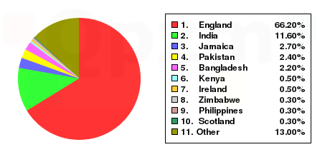
73.0% of people living in West Bromwich Central speak English. The other top languages spoken are 9.2% Panjabi, 7.1% Polish, 2.6% Bengali, 1.4% Urdu, 1.2% Gujarati, 0.5% Pakistani Pahari, 0.5% Lithuanian, 0.5% Kurdish, 0.4% Czech. 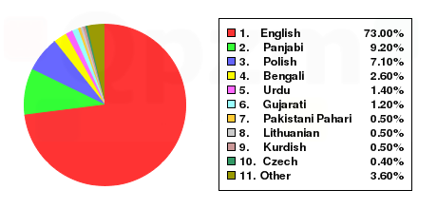
The religious make up of West Bromwich Central is 45.5% Christian, 16.7% Sikh, 12.9% Muslim, 11.7% No religion, 5.7% Hindu, 0.2% Buddhist. 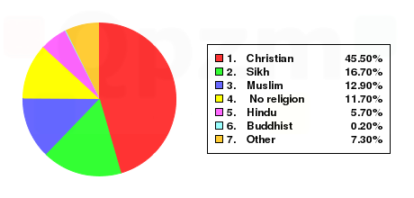784 people did not state a religion. 14 people identified as a Jedi Knight.
40.5% of people are married, 7.5% cohabit with a member of the opposite sex, 1.1% live with a partner of the same sex, 29.3% are single and have never married or been in a registered same sex partnership, 10.0% are separated or divorced. There are 736 widowed people living in West Bromwich Central.
The top occupations listed by people in West Bromwich Central are Elementary 19.6%, Process, plant and machine operatives 14.8%, Elementary administration and service 13.2%, Skilled trades 11.5%, Administrative and secretarial 10.7%, Professional 10.6%, Sales and customer service 8.9%, Caring, leisure and other service 8.7%, Administrative 8.6%, Associate professional and technical 8.4%. (QPZM. 2020).
This data that I have acquired along with this another UpToDate demographic population count in a much more detailed structure. An example has been given here but the full data is on the website, please check the reference for full details.
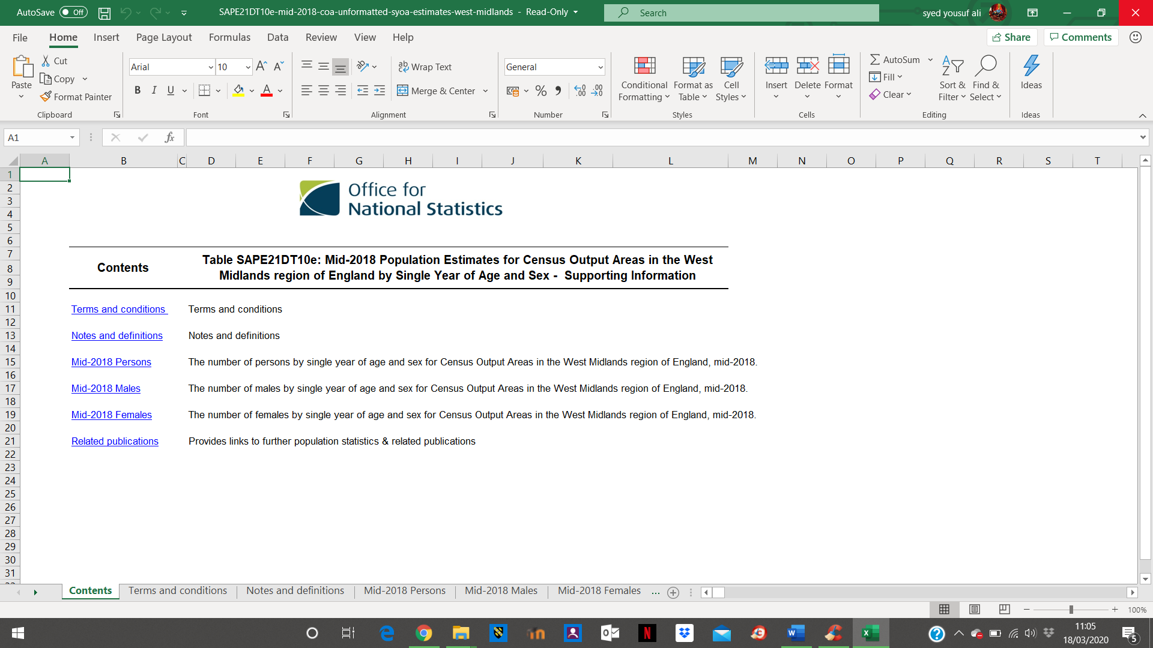
(Park, 2019).

Another health statistics showing the number of diabetic patients in the area. Only an example size has been added here for full details please check the reference, were the full website details including the full data is available.

West Midlands Key Health Data 2007/08
Figure 8.1: Estimated prevalence and number of people with diabetes, 2005 by Government Office Region

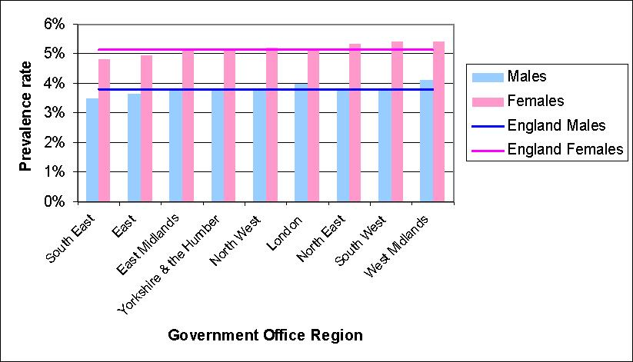
Source: PBS prevalence model. (Walton,2007/08).

After analysing all this data, I have found out that my new product will get a very good response here (a positive response).

All this data has now given me all the information I need to be able to predict how or what the outcome of the launch of my new product will bring. I will be launching my new product online on social media platforms showing all the information and knowledge I have; the benefits of this product as well, how the diabetic community will be able to enjoy desserts without any fear. Physical leafletting door to door and the use of social platforms such as Facebook, Instagram, twitter and Snapchat will help boost my product to the high level I am expecting it to reach.

References

Rouse. M (2020). Guide to telling Stories with Data: How to share Analytics Insights. Available at: https://searchdatamanagement.techtarget.com/definition/data [Accessed on:6th March 2020].
Alexander. R (2020) Implicit, Tacit, or Explicit: All Knowledge is Valuable. Available at: https://bloomfire.com/blog/implicit-tacit-explicit-knowledge/ [Accessed on:12th March 2020].
Odessa, CS (2020). Pyramid Diagram. Available at: https://www.conceptdraw.com/How-To-Guide/knowledge-pyramid-triangle-diagram [Accessed on:17th March 2020].
QPZM. (2020). West Bromwich Central Demographics (Sandwell, England). Available at: http://west-bromwich-central.localstats.co.uk/census-demographics/england/west-midlands/sandwell/west-bromwich-central [Accessed on: 17th March 2020].
Park, N (2019). Census Output Area Population Estimates- West Midlands, England (supporting information). Available at: https://www.ons.gov.uk/peoplepopulationandcommunity/populationandmigration/populationestimates/datasets/censusoutputareaestimatesinthewestmidlandsregionofengland [Accessed on:18th March 2020].
Walton, S. (2007/08). West Midlands Key Health Data 2007/08. Available at: http://medweb4.bham.ac.uk/websites/key_health_data/2007/ch_08.htm [Accessed on:18th March 2020].

Assignment part 2.1

Q, 1. Describe overall approach adopted which the airline which incorporated porter’s basic strategy of cost leadership and product differentiation?

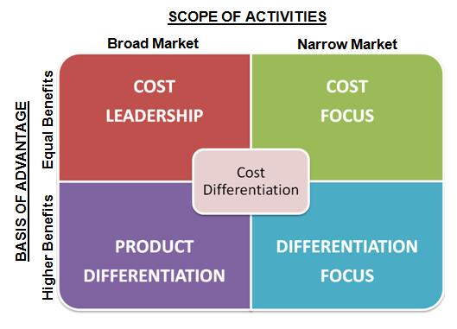

Above is of porter’s basic strategy model.

By incorporating porter’s model into the strategy of American airlines and IBM they were able to adopt this model into their business plan helping them make decisions and adjust with the new development (SABRE).

Porter's generic strategies are ways of gaining competitive advantage – in other words, developing the "edge" that gets you the sale and takes it away from your competitors. There are two main ways of achieving this within a Cost Leadership strategy:
- Increasing profits by reducing costs, while charging industry-average prices.
- Increasing market share by charging lower prices, while still making a reasonable profit on each sale because you've reduced costs. (Mindtools,2020)

Cost leadership is all about reducing the overall cost, American airlines managed to do that by developing SABRE. This new system changed a lot of things in this industry. As in the 1950’s the old handwritten system was in place which took a lot of manpower and time consuming to do; a lot of materials was also being utilised and wasted processing these requests. Soon as the new SABRE came into effect the American airlines started to save hugely. Seat reservations became really easy and cost a lot less than how it used to cost prior to this. Saving 30% on its investments.travel agents became more actively involved and online terminals became possible for reservations.
Firstly, the airlines took into account the strategy in which porter states increasing profits by reducing the cost, while making sure that they are not over charging but instead staying within the average prices of the industry.
Secondly, they the market shares increased, cost prices went down, and the profits remained reasonable. This gave them a 30% increase.

Q, 2. What ways did SABRE provide competitive advantage to the airlines?
SABRE gave the airlines the advantage they needed in this competitive market/ industry. By the help of porter’s five forces model they were able to gain so much and make this venture a successful one.
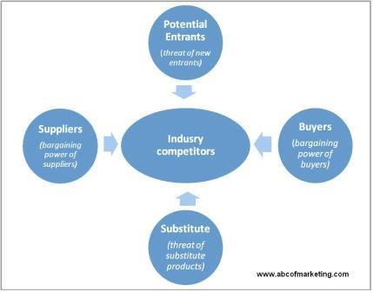

By developing SABRE, the American airlines, they followed one of the five; they limited the chances to threat of new entrants potentially a new idea. Also, the rise of a substitute is limited as bringing this new development put this airline in the lead position.
This new system (SABRE) gave them the boost they needed. SABRE had functions added to it which was of importance to the agents that dealt with the airlines (travel agents). These agents were able to find low fares for their customers and compare prices at ease without the old troubles from the past. The system also had an expansion on reservation services which started to include hotel reservations something that was new and hadn’t been bought in before. Another addition to this was the reservation of rental cars; this started happening in 1988.
By 1998, Sabre had evolved into a global distribution system (GDS) for travel information, reservations and transactions, connecting more than 30,000 travel agents and 3 million online customers with 400 airlines, 50 car-rental companies, 35,000 hotels and dozens of railways, tour companies, ferries and cruise lines. In 1964, the year Sabre was launched, there were 79 million airplane boarding’s in the U.S. Spurred in part by the ability of computers to track an explosion in fares, routes and flights, that number had risen to 560 million in 1998. (Scheier.2002)

Q, 3. Although SABRE was successful, American airlines could not maintain their competitive advantage after 1980’s. what played part in taking away the lead position from the aviation industry and what was the reaction of the airlines?
SABRE’s yield management system the airlines a very clear and competitive advantage over all other rivals. They were able to provide a large variety of fares which were discounted based on projections from previous experiences. SABRE’s technology gave Robert Crandall the permission to match and undercut the offers shown by the competitors by using simply ideas as lowering its own (American airlines) discounted prices for certain seats and/or increase the number of seats available of the category of low fares. No such need arised for all the seats to be reduced in price.
Competitors or rivals lacked the technology Hence were not able to match the prices of American airlines nor their flexibility, this however, forced the competitors to introduce their own methods and came up with their own individual yield systems so that they could also match and carry out similar tasks and remain in this competitive market. (Hill and Jones, 2012, p.228).
United airlines exploited the competitive advantage that was gained through developing a computer reservation system. But united airlines initially saw its APOLLO system as a means to reduce clerical costs, and only slowly they realised the potential in market through their reservation system.
The president of the airlines Robert Crandall established a separate organisation (TAA) Travel Agency Automation and championed it. In 1976 the president laid of its 30 computer programmers who were working on APOLLO, this was based on seniority. These programmers were immediately hired by American airlines for the use of its reservation units. (Rogers,2010, p388).
The American airline lost their lead position due to other small budget airlines coming into the market and taking over the technology that was developed by the Americans.
Most people credit Ryanair with kicking off the budget airline boom. The company was founded in Ireland in 1985 and had to wait ten years until easyJet arrived to become the next competitor. Today, flights to the continent are cheaper than a one-way ticket within the UK. You may be wondering how such an industry is possible. A large amount comes down to constant cost cutting made available to the consumer. (Johnson.2018).
The aviation golden age created ways of new innovations, pushing the air travel to other heights. Creative and mind-boggling innovations such as the jet engines made it a lot easier to travel far distances in low cost fairs. All this new innovation gave way to the images of classic flying passenger experiences. For example, smiling stewardesses serving special dishes to passengers on really spacious aircrafts became really glamorous at the time. (Rehal. 2019).

Assignment Part.2.2

Q,1. Define information system?
Information system is a collective set of components that are used for collecting, processing and storing data; also, for the use of providing information and knowledge including digital products.
Firms (businesses) and other organisations normally depend on information systems to manage and carry out their operations, interactions with their customers and suppliers, and compete in their respective marketplace. Information systems run interorganisational supply chains and electronic markets. For example, big corporations use this information systems to process financial accounts, manage human resources, and reach potential customers with online promotions. Many companies are built entirely around and depend on information systems to smoothly run their companies. Companies include eBay, a largely auction marketplace; Amazon, an expanding electronic mall and provider of cloud computing services; Alibaba, a business-to-business e-marketplace; and Google, a search engine company that derives most of its revenue from keyword advertising on Internet searches. (Zwass.2020).
Q, 2. Explain the categories of computer-based information systems?
Computer based information systems (CBIS) is an information system which is ruled computer. It consists of the following elements:
- Hardware: The hardware term refers to mechanical. This includes the computer itself, often referred to as the central processing unit (CPU), and all of its support equipment’s. Among the support equipment’s are input and output devices, storage devices and communications devices.
- Software: The software term refers to computer programming and the manuals that support these programs. Computer programs are readable by machines, instructions allow it to direct the circuitry in the hardware of the Computer Based Information System (CBIS) to function in ways that produce useful information from data. Programs are generally stored on some output / input medium most often a disk or a hard drive.
- Data: Data are facts which are used by the programs to produce useful information. Like programs, data are generally stored in disks or tapes which are also machine readable.
- Procedures: Procedures are policies that command the operation of a computer system. “what software is to hardware, is what procedures are to people” is a common analogy that is used to illustrate the role of procedures in a CBIS.
- People: Every Computer Based Information System (CBIS) has to have people if it is to be of any use at all. Most often the over-looked part of the CBIS is the people: probably the components that most influence the success or failure of information system.

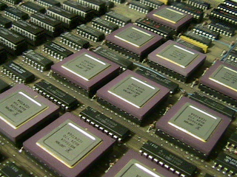

1. Transaction Processing Systems
Fundamental computer-based system of an organisation is applicable to the processing of business-based transactions. A computer based system or transaction processing system can be defined as a that which captures, maintains, stores, classifies, retrieves and updates transaction data for record keeping and for inputting into other CBIS. Computer-based system or Transaction Processing Systems are aimed to improve the routine activities in a business on which all organisations depend upon. A transaction is an event or activity that impacts the whole organisation. Order placing, customer billings, hiring employees and depositing cheques are some common transactions. Types of transactions vary from organisation to organisation.
But the true fact is that all organisations process transactions as a major part of their daily business activities. The most successful businesses perform this type of transaction processing in a very systematic way. Transaction processing systems provide speed and accuracy which also can be programmed to follow routines.

2. Management Information System
Data process which is done by computers has been extremely effective due to several reasons. The main reason behind it all is that huge amount of data relating to accounts and other transactions is processed very quickly. Earlier in the year’s computer applications were concerned with record keeping and the automation of routine processes. However, in recent years, attention has been increasing focusing on computer applications who provide information for policy making, and for purposes of management planning and control. Management Information System (MIS) are more concerned with management function. MIS can be described as information system that are able to provide all levels of management with information which are essential to the running a business smoothly. This information must be as relevant, accurate, complete, timely, concise and economically feasible

3. Decision Support Systems
An information system that offers the kind of information that may not be predictable, the kind that business professionals might only need once. These systems do not produce regularly scheduled management reports. Instead, they are designed to respond to a wide range of requests. The fact is that all the decisions in an organisation are not recurring. Decision support systems managers who make decisions that are not highly structured, often are called unstructured or semi-structured decisions. A decision is often considered unstructured if there are no clear or precise procedures for making the decisions and if not all the factors to be considered in the decision can be readily identified well in advance. Judgements of managers in businesses play a vital role in decision making where the unstructured problem is concerned. The decision support system supports, but does not replace, judgement of business managers.

4. Office Automation Systems
Office automation systems are the newest computer-based information systems which is most rapidly expanding. The hopes and expectations behind the development of this system is that they will increase the efficiency and productivity of office typists, administrative assistants, secretaries, managers and staff professionals. Many businesses and organisations have taken the step towards automating their offices. Often this step involves the use of word processing equipment to facilitate the typing, storing, revising and printing of textual materials. Another newly advanced development is a computer-based communications system such as E-mails allowing people to communicate in an electronic mode through computer terminals. An office automation system can be described as a multi-function, integrated computer-based system that allows many office activities to be performed in an electronic mode. (MBA, NO Date)

Q, 3. Explain how computer-based systems support managers of businesses at each level of the organisation?
Advances in computer-based information technology in the most recent years have directed all towards a wide variety of systems that most managers are now using to make and implement decisions. Largely, these systems have been created and developed from scratch for specific purposes and most often differ significantly from the standard electronic data processing systems. Quite often, managers have little say in the development of these decision support systems; at the same time, however, the guys who develop them have a limited view of how they can be used.
Managers, computer users and other people connected in many organisations are familiar with a few types of systems now in use. As a result, different types of innovative systems have been conceived and nurtured by internal or external “entrepreneurs,” not by the system users or their superiors.

Secondly, these entrepreneurs tend to mostly concentrate on technical characteristics. Too often, this means that they fail to anticipate the ways in which such systems can be used to increase the effectiveness of individuals in organisations.
Finally, highly innovative systems—the one most management always find it really useful—running a high risk of almost never being implemented. (Alter.1976).
This system allows managers to do all their work and business plan with accuracy and efficiency.

References

Alter. L. S. (1976). How Effective Managers Use Information Systems. Available at: https://hbr.org/1976/11/how-effective-managers-use-information-systems [Accessed on: 27th March 2020].

Hill. C. W. L and Jones. G. R (2012. Strategic Management Cases: An Integrated Approach. 10th Edition, Cengage Learning.

Johnson. K (2018). How Low-cost Airlines Are Changing The Face of Air Travel. Available at: https://www.businessinsider.com/how-low-cost-airlines-are-changing-the-face-of-air-travel-2018-7?r=US&IR=T [Accessed on:27th March 2020].

MBA. (No Date). Computer Based Information Systems (CBIS)- Meaning and Types. Available at: https://www.mbaknol.com/management-information-systems/computer-based-information-systems-and-its-types/ [Accessed on: 27th March 2020).

Mindtools. (2020). Porter’s Generic Strategies. Available at: https://www.mindtools.com/pages/article/newSTR_82.htm [Accessed on: 23rd March 2020].

Rahil. S (2019). How The Emergence of Low Cost Carriers Changed Commercial Aviation. Available at: https://simpleflying.com/how-the-emergence-of-low-cost-carriers-changed-commercial-aviation/ [Accessed on: 26th March 2020].

Rogers. M. E (2010). Diffusion of Innovations. 4th Edition, Simon And Schuster.

Scheier. L.R (2002). Technology Takes Flights. Available at: https://www.computerworld.com/article/2578996/technology-takes-flight.html [Accessed on:25th March 2020].

Zwass. V. (2020). Information System. Available at: https://www.britannica.com/topic/information-system/Operational-support-and-enterprise-systems [Accessed on:27th March 2020].

