Marketing Plan of Marriott Hotel

Contents page

Title page………………………………………………………………………………………………………………………………….P1
Contents page…………………………………………………………………………………………………………………………..P2
1.0 Introduction………………………………………………………………………………………………………………………..P3
2.0 Marketing Communications Strategy for Marriot Hotel……………………………………P3
2.1 Issues and Marketing Opportunities………………………………………………………….P3
2.2 Microenvironment Analysis…………………………………………………………………...P4
2.3 Macroenvironment Analysis…………………………………………………………………..P4
2.4 Recommendation………………………………………………………………………………P5
3.0 Marriot Hotel Marketing Plan………………………………………………………………..P6
3.1 Segmentation…………………………………………………………………………………………………………………….P6
3.2 Target market…………………………………………………………………………………………………………………….P6
3.3 Positioning statement………………………………………………………………………………………………………..P6
3.4 The 7 P’s of Marriot Hotel…………………………………………………………………………………………………..P7
3.5 Implementation Strategy……………………………………………………………………………………………………P7
3.6 External Analysis………………………………………………………………………………………………………………..P7
3.7 Internal Analysis…………………………………………………………………………………………………………………P7
4.0 References………………………………………………………………………………………………………………………….P8
4.0 References………………………………………………………………………………………………………………………….P9

1.0 Introduction
The Marriott Hotel is a renowned hospitality brand that boasts a strong presence in the global hospitality industry and to stay competitive and attracts customers, Marriott has developed a comprehensive marketing plan that encompasses various strategies and initiatives.
One key element of Marriott's marketing plan is targeted advertising. The hotel engages in various forms of advertising, including online campaigns, social media promotions, and partnerships with renowned brands. By reaching its target audience effectively, Marriott can create brand awareness and attract potential customers.
In addition to advertising, Marriott also focuses on customer engagement. The hotel's loyalty program, Marriott Bonvoy, offers members exclusive benefits, such as rewards points, upgrades, and personalized experiences. By providing valuable incentives, Marriott encourages customers to return and refer others, further expanding its customer base.
Furthermore, Marriott places great emphasis on guest experience. The hotel strives to create a unique and memorable experience for each guest, from personalized check-ins to luxurious amenities and by exceeding customer expectations, Marriott builds loyalty, positive reviews, and word-of-mouth recommendations, which can significantly contribute to its success in the market.
2.0 Marketing Communications Strategy for Marriot Hotel
In today's rapidly evolving climate, it is of the upmost importance for Marriot Hotel to adapt its marketing strategies to stay relevant and competitive. This document presents a recommended new direction for the Marriot Hotel, focusing on an issue or marketing opportunity that has been identified and analysed within the micro and macro environment. By implementing this marketing plan, Marriot Hotel can enhance its brand reputation, capitalize on industry trends, and innovate by introducing new ideas based on industry research.
2.1 Issues and Marketing Opportunities
The identified issue in the marketing opportunity for Marriot Hotel lies in enhancing its brand reputation. With the emergence of new hotel chains and the increasing competition in the market, Marriot Hotel needs to differentiate itself from its competitors and maintain a strong brand image. A focused and well-executed marketing communications strategy can help Marriot Hotel achieve this goal.
Other issues on the marketing strategy for the company lies in global pandemics such as the previous Covid-19 pandemic, wars that are presently manifested throughout the world such as the war in Ukraine and Russia. These issues directly impact not only the hotel industries but the hospitality industry altogether. Unfortunately for the hospitality industry, these are external factors that cannot be mitigated by the industry itself and as such, must rely on the government to do its part with the hope that it will do to the best of its ability to contain said external factors.
2.2 Microenvironment Analysis
To understand the microenvironment, the following analysis will be conducted:
1. customer analysis: Marriot Hotel should conduct comprehensive market research to identify its target audience and their preferences. By understanding the needs and desires of its target audience, the hotel can adapt its marketing communications strategy to effectively resonate with them.
2. competitor analysis: analysing Marriot Hotel's competitors can provide valuable insights into their marketing strategies and tactics. By identifying their strengths and weaknesses, Marriot Hotel can tailor its approach to differentiate itself and gain a competitive advantage.
3. channel analysis: Marriot Hotel should assess its marketing channels and their effectiveness in reaching its target audience. By identifying the most effective channels, the hotel can allocate its resources accordingly and maximize its brand visibility.
4. social media analysis: with the rise of social media, Marriot Hotel can leverage these platforms to engage with its target audience and build brand loyalty. Analysing social media metrics, such as engagement rates, can help the hotel identify the most effective social media platforms for its marketing efforts.
2.3 Macroenvironment Analysis
To gain a better perspective of the macro environment, the following analysis will be conducted:
1. economic factors: economic factors such as inflation rates, and exchange rates can impact consumer spending patterns and travel trends. Marriot Hotel should consider these factors when developing its marketing strategy to ensure they are aligned with the never-ending evolving market conditions.
2. social and cultural factors: these factors such as changing consumer expectations, evolving gender roles, and evolving social values can shape consumer behaviour and preferences. Marriot Hotel should adapt to these factors to create marketing campaigns that are in tune with its target audience.
3. political factors: political factors such as government incentives, regulations, and trade agreements can impact the tourism industry. Marriot Hotel should be aware of any political developments that could affect its operations and marketing strategies.
4. technological factors: the technological advancements, such as the rise of online booking platforms, mobile applications, and social media, have revolutionized the hospitality industry. Marriot Hotel should leverage these technologies to enhance its marketing efforts and improve guest experience.

2.4 Recommendation
Based on the micro and macro analysis, the following recommendations are proposed for the new direction for Marriot Hotel's marketing communications strategy:
1. Enhance brand reputation
Marriot Hotel should focus on enhancing its brand reputation to differentiate itself from competitors and maintain its position as a trusted and reputable brand. This can be achieved through the following actions:
- brand storytelling: the hotel should develop compelling brand stories that highlight its unique selling points and resonate with its target audience. These stories can be showed through various marketing channels, including social media, website content, and guest testimonials.
- employee engagement: engaging and empowering employees can enhance the overall guest experience and contribute to a positive brand reputation thus upholding its name in the top charts of the hotel industry. Marriot Hotel should invest in training programs, incentives, and recognition programs to motivate its employees and promote a positive work environment.
2. Capitalize on industry trends
Marriot Hotel should capitalize on emerging trends within the hotel industry to stay relevant and attract new customers. Some potential trends to consider include:
- sustainable tourism: emphasizing the hotel's commitment to sustainability can attract environmentally conscious guests. Marriot Hotel can implement environmentally friendly practices, offer eco-friendly amenities, and promote sustainable travel options to attract eco-conscious travellers.
- Workcation: With the growing trend of remote work, Marriot Hotel can cater to the needs of business travellers by offering flexible workspaces, high-speed internet, and dedicated areas for remote work.
3. Introduction of innovative ideas based on industry research
Marriot Hotel should introduce new ideas based on industry research to stay ahead of the competition and cater to the ever-evolving guest preferences. Some potential ideas to consider include:
- personalized experience: by leveraging customer data and AI algorithms, Marriot Hotel can offer personalized experiences such as personalized room preferences, tailored recommendations, and personalized loyalty programs.
- virtual reality experience: utilizing virtual reality technology, the company can provide immersive and interactive experiences, allowing guests to explore different locations and attractions without leaving the hotel.
Implementing these recommendations, Marriot Hotel can enhance its brand reputation, capitalize on industry trends, and innovate by introducing new ideas based on industry research and whilst staying attuned to the evolving micro and macro environment, the company can continue to thrive and position itself as a leader in the highly competitive hotel industry. Nevertheless, Marriot should also take into high consideration the external factors that could directly affect the company’s reputation and revenue and mitigate the opportunities presented at the present time in its favour or at least to the best of its abilities for a well structured and secured position in the top charts of the hotel industry.
3.0 Marriot Hotel Marketing Plan
Implemented below is a marketing plan template for Marriott Hotel:
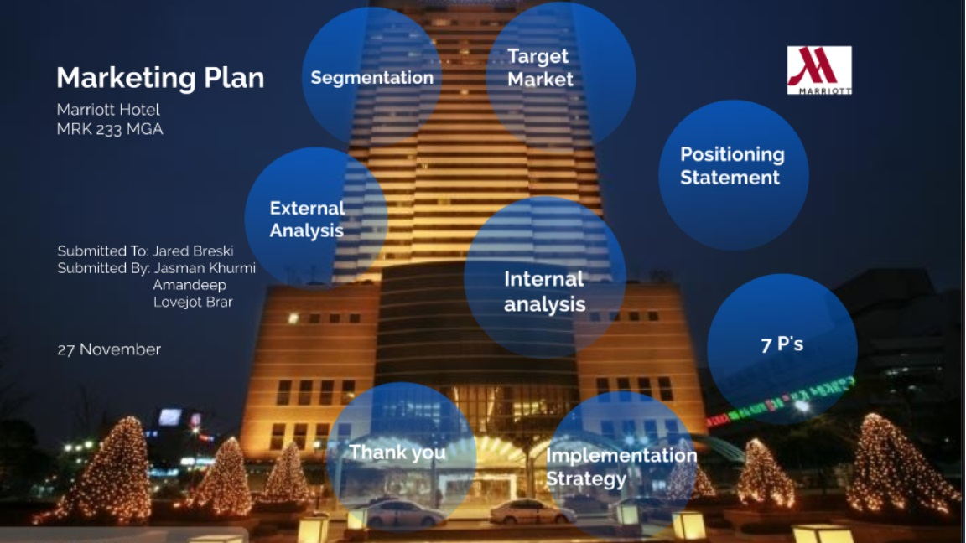
3.1 Segmentation
The Marriott Hotel marketing plan focuses on effective segmentation to target specific customer groups. By analysing customer data and analysing market trends, the hotel identifies distinct customer segments based on demographics, preferences, and behaviours. This enables the hotel to develop personalized marketing strategies that resonate with each segment, enhancing customer satisfaction and loyalty.
3.2 Target Market
Marriott hotel targets business and leisure travellers seeking luxury and comfort. By offering exceptional services and modern amenities, we aim to attract discerning individuals seeking a memorable experience.
3.3 Positioning Statement
The Marriott Corporation strives to be a premier provider of leisure and vacation experiences around the globe.
Providing unsurpassed vacation and leisure experiences, Marriott offers its guests the opportunity to enhance their quality of life.
As a company, Marriott is known for its best strategic business objectives, and it is known for providing its employees with equal opportunities and treatment.
3.4 The 7 P’s of Marriott Hotel
Marriott Hotel's marketing plan capitalizes on the power of the 7 P's. Product development focuses on creating exceptional experiences for guests. Price optimization ensures competitive pricing. Place encompasses strategic locations worldwide. Promotion leverages digital platforms and partnerships to reach a wider audience. Processes are streamlined to provide efficient service. Physical evidence highlights Marriott's commitment to luxury. People, with its dedicated and knowledgeable staff, create a welcoming atmosphere. Lastly, positioning emphasizes Marriott's position as a leader in the hospitality sector.
3.5 Implementation Strategy
Marriott Hotel's marketing plan focuses on implementing the strategy of targeting business travellers. By offering convenient locations, top-notch amenities, and personalized experiences, Marriott aims to attract and retain business travellers. Through targeted advertising, partnerships with travel agencies, and loyalty programs, Marriott aims to position itself as the preferred choice for business travellers worldwide.
3.6 External Analysis
Hotel Marriott's marketing plan utilizes external analysis to gain insights into the competitive landscape and consumer behaviour. By examining market trends, economic indicators, and competitors' strategies, Marriott can identify opportunities and areas for improvement. This comprehensive analysis enables Marriott to tailor its marketing efforts and gain a competitive advantage. By staying informed and responding to external forces, Marriott can effectively navigate the dynamic hospitality industry.
3.7 Internal Analysis
The internal analysis focuses to gain a better understanding of their current situation and make informed decisions. By analysing their internal data, such as customer preferences, market trends, and financial performance, Marriott can identify areas for improvement and develop strategies to adapt to changing market conditions. This analysis helps Marriott stay ahead of the competition and make informed decisions that align with their business objectives.

4.0 References
Abdul, M. (2022). Marriott SWOT Analysis: Can the Competition Threaten the Hotels? [online] pestleanalysis.com. Available at: https://pestleanalysis.com/marriott-swot-analysis/#Threats_for_Marriott (Accessed 6 Jan. 2024).
Assignment Help (2022). Strategic Management Assignment: Case Analysis of Marriott International | Total Assignment Help. [online] www.totalassignment.com. Available at: https://www.totalassignment.com/free-sample/strategic-management-assignment-case-analysis-of-marriott-international. (Accessed 6 Jan. 2024).
Chen, W. and Tabari, S. (2017). A Study of Negative Customer Online Reviews and Managerial Responses on Social Media— Case Study of the Marriott Hotel Group in Beijing. Journal of Marketing and Consumer Research, [online] 41(0), p.53. Available at: https://iiste.org/Journals/index.php/JMCR/article/view/40095 (Accessed 7 Jan. 2024).
Digital Training Academy (2024). Digital Marketing Case Study - Influencer marketing: Marriott Hotels - Digital Training Academy. [online] www.digitaltrainingacademy.com. Available at: http://www.digitaltrainingacademy.com/casestudies/2015/09/influencer_marketing_marriott_hotels.php (Accessed 9 Jan. 2024).
Dudovskiy, J. (2023a). Marriott Marketing Communication Mix. [online] Research-Methodology. Available at: https://research-methodology.net/marriott-marketing-communication-mix/#google_vignette (Accessed 10 Jan. 2024).
Dudovskiy, J. (2023b). Marriott Marketing Strategy. [online] Research-Methodology. Available at: https://research-methodology.net/marriott-marketing-strategy/ (Accessed 6 Jan. 2024).
Marriot International (2024). Hotel Marketing Platform | Marriott International. [online] www.hotel-development.marriott.com. Available at: https://www.hotel-development.marriott.com/hotel-development (Accessed 6 Jan. 2024).
Mireille (2023). Marriott Hotel Marketing Strategy: a Comprehensive Analysis. [online] Furoore. Available at: https://furoore.com/marriott-hotel-marketing-strategy/ (Accessed 10 Jan. 2024).
Muhammad, A. and Qadri (2016). A Study of Cross Cultural Communication Strategy: Case of Marriott Hotels & Resorts. An International Peer-reviewed Journal, [online] 19(2422-8435). Available at: https://core.ac.uk/download/pdf/234693179.pdf (Accessed 6 Jan. 2024).
Prezi (2024). Marketing Plan Marriott Hotel. [online] prezi.com. Available at: https://prezi.com/p/loje3meq-hvg/marketing-plan-marriott-hotel/ (Accessed 8 Jan. 2024).
Rourke, O. (no date). Marriott Marketing Services Overview. [online] Available at: https://www.orourkehospitality.com/wp-content/uploads/ORourke-Marriott-Services-Overview.pdf (Accessed 8 Jan. 2024).
Strategy Finders (2023). Marriott Marketing Strategy - Experts Analysis of 2023. [online] www.strategyfinders.com. Available at: https://www.strategyfinders.com/marriott-marketing-strategy/ (Accessed 8 Jan. 2024).
TBH, T. (2023). Marketing Strategies and Marketing Mix of Marriott. [online] The Brand Hopper. Available at: https://thebrandhopper.com/2023/12/10/marketing-strategies-and-marketing-mix-of-marriott/ (Accessed 10 Jan. 2024).
WAG Creative Vault (2017). MARRIOTT INTERNATIONAL Case Study 2017. [online] World Media Group. Available at: https://world-media-group.com/case-study/marriott-international-case-study-2017/ (Accessed 6 Jan. 2024).
Zigu (2015). Marriott Marketing Mix (4Ps) Strategy | MBA Skool-Study.Learn.Share. [online] MBA Skool-Study.Learn.Share. Available at: https://www.mbaskool.com/marketing-mix/services/17317-marriott.html (Accessed 7 Jan. 2024).

