Clappers
By Georgia James
Death and Burial in Ancient Egypt

My Object:
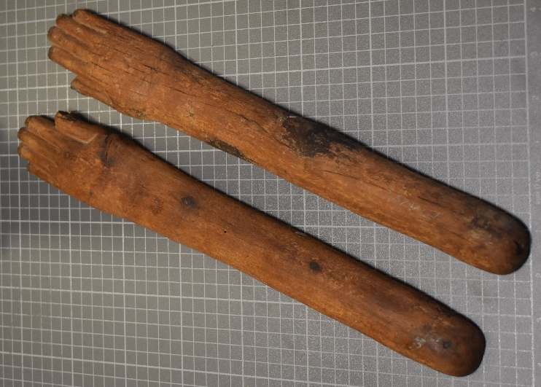
Pair of Clappers
Cyfarthfa Castle, Merthyr Tydfil CCM
Object type: instrument
Material: wood
Period: 2055-1100 BC (estimated date by me)
Provenance: Egypt
Dimensions: Left Hand:
Length: 39.5cm width: 5.5cm (at widest) Circumference (arm): 9.6cm
Right Hand:
Length: 40cm width: 5.5cm (at widest) Circumference (arm): 9.5cm

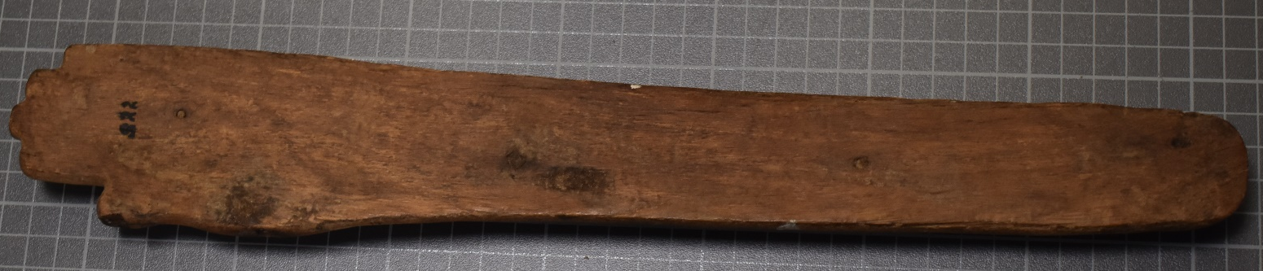

The underside of the clapper is flat, very different to the top with no markings or style, however there is a smooth finish to it. Possibly to make the clapping sounds to their taste.
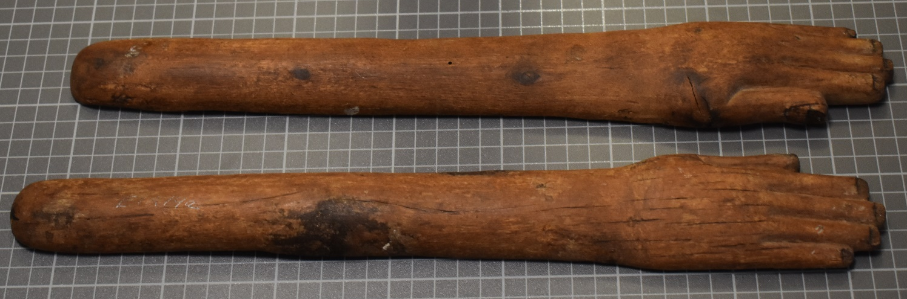
3D texture on top with indentations and raises that are very realistic to human proportions, length of around 40cm for both, quite large, would have to be quite athletic to do a lengthy performance.

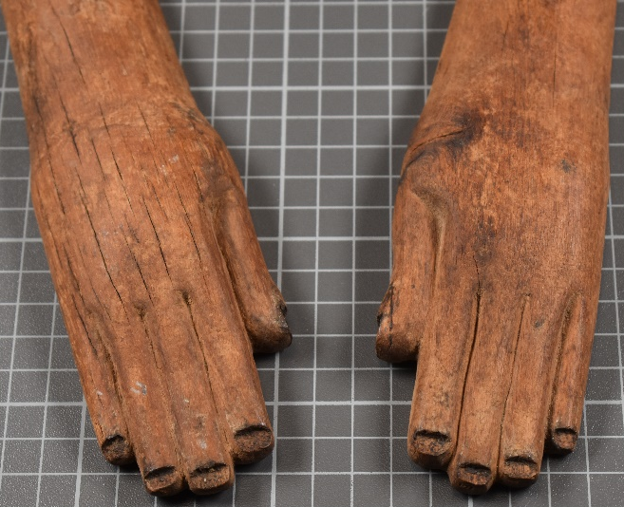
Hand sizes both almost identical to the naked eye, including with of hand and fingers, dimensions on individual parts like nail beds and length of fingers.

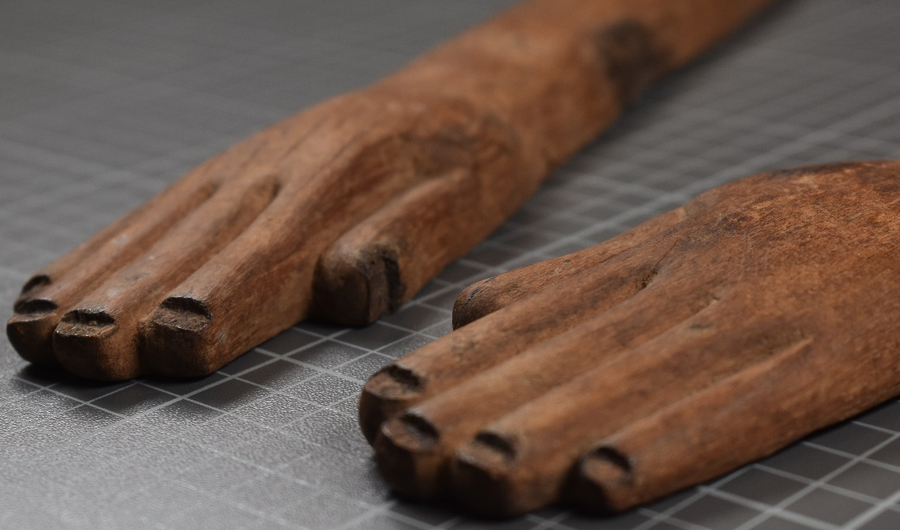

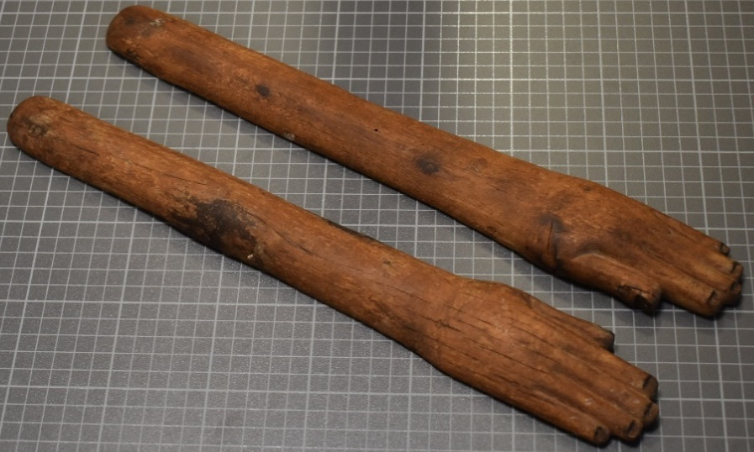

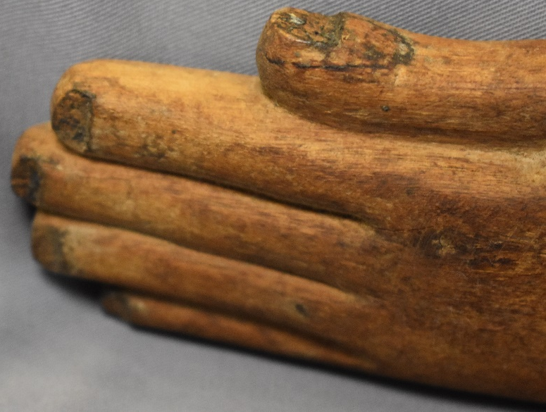

Indentations where nail beds are meant to be, at a lower level that the rest of the finger. Slightly unnatural but without the use of colour the shape can be used to show the separation between nail and finger.

What was the Ancient Egyptian opinion on death?
What different types of clappers are there?
How were clappers linked to the funerary sphere?

Were clappers associated with a certain cult or god?
How does my view of death differ to Ancient Egyptians?
INTITIAL IDEAS

How would clappers be used in performance, with dancing?
Could I try and recreate the sound they produced?
What function did clappers serve? (link to Functionalism)

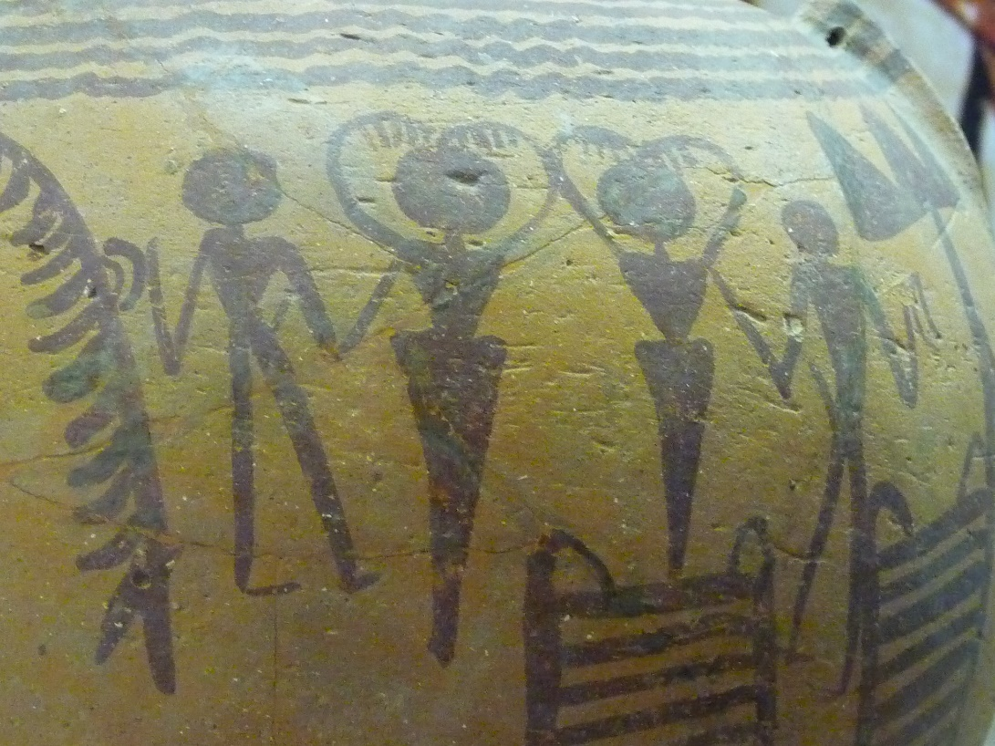
Early Example of Clapper Use
(A vase that shows the use of clappers in a group. Tepper, n.d)
According to Köpp-Junk (2018) this vessel from the “4th mill BC” shows the use of clappers, which means that it is one of the oldest scenes of use of musical instruments in Ancient Egypt. “Clappers appear in the 4th millennium BCE as depictions on vases. After 3100 BCE they were found as artifacts as well, as for example in the tomb of Pharaoh Djer in Abydos.” (Köpp-Junk, 2018).
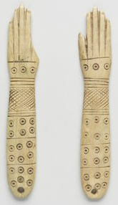
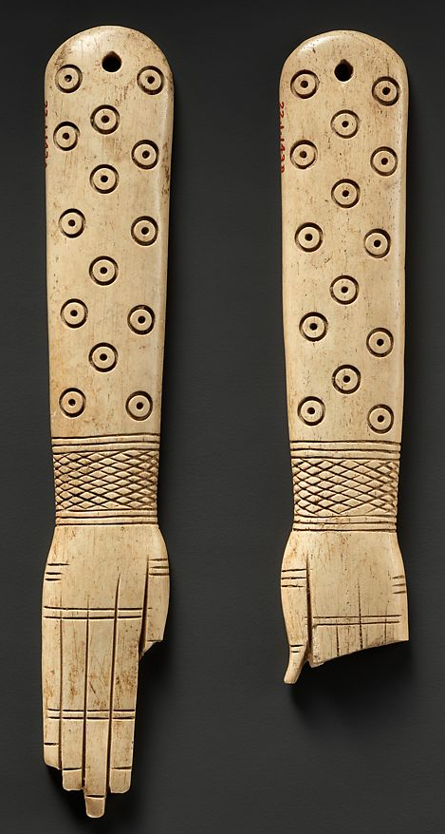
Types of Clappers: Straight Armed
(1900- 1640 BC. A pair of straight hippopotamus ivory clappers, The Met Museum, 22.1.143a, b)
(1539-1075 B.C.E. A pair of straight bone/pigment clappers, The Brooklyn Museum, 58.28.7a-b)
When looking for straight clappers like mine I came across these two similar types, wooden straight clappers were hard to find. These are both made of bone, the left one is specifically hippopotamus ivory. The design on them is strikingly similar, however, the pair of the left seem to be more uniform, and neat. This could suggest the artists for both were of a different calibre, although one might say it is artistic interpretation. The Egyptians used a canon for their work with a grid that kept things symmetrical and the pair on the left are more symmetrical which leads me to believe the pair on the right were done by someone who was less talented that the artist on the right.

Types of Clappers: Hathoric
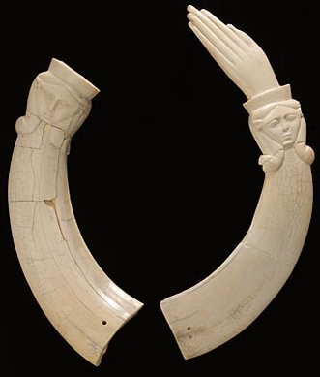
This pair of clappers is made of hippopotamus ivory, they have a carving of Hathor on the wrists according to Guichard. Which means there is a connection to the goddess. It is dated at 2033-1069 BC. The full size of the right one is 35cm which is close to my object which is 40cm.
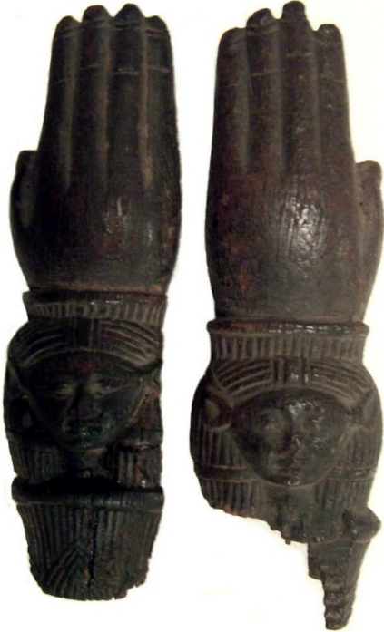
(2033-1069 BC. A pair of hippopotamus ivory clappers with detailed faces of Hathor, The Louvre, N 1479, N 1480)

This pair is made from wood like my object, they are much smaller though at around 11/12cm. They also display the face of Hathor, although not stated on the Met Museum website, it is almost identical to the ivory pair and contains the cow ears that Hathor is identifiable by. On the website they are called castanets with clappers in brackets due to their size. Dated to 1580-1090 BC.

(1580-1090 BC. A pair of wooden castanets/ clappers with detailed portraits of, possibly Hathor on the wrists. The Met Museum: 89.4.1843)
Types of Clappers: New Kingdom
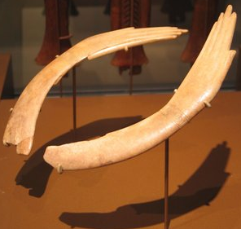
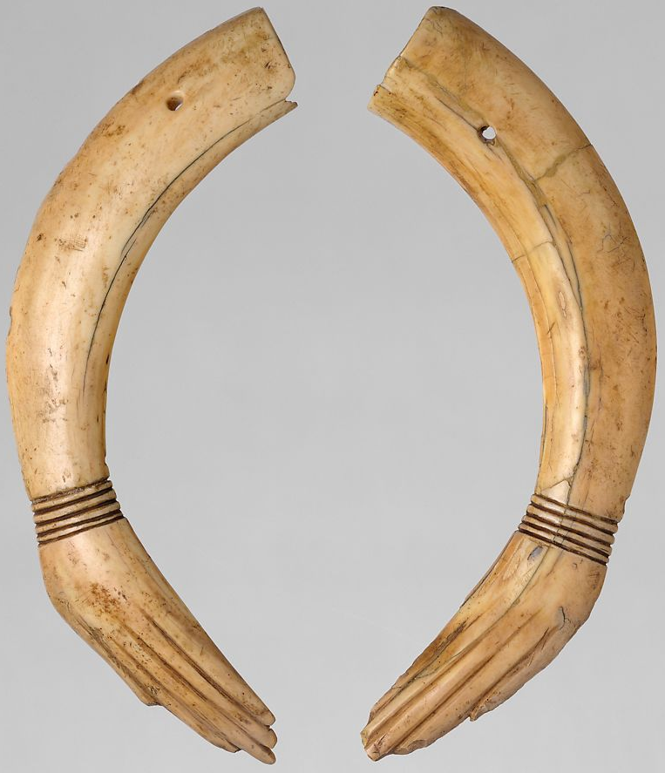

(1539-1190 B.C.E. A pair of ivory clappers, Brooklyn Museum, 49.58.1-.2)

(1353–1336 B.C. A pair of hippopotamus ivory clappers, The Met Museum, 32.5.2a, b)
While looking for clappers, the two pairs I found that were also similar were both from the New Kingdom, which could mean a style change in this period. Compared to the other types these seem less based on realism and follows a streamlined design. The fingers seem to narrow down to a point at the middle finger, although the length of the fingers follow the same proportions as a normal hand.

Types of Clappers: Oddities
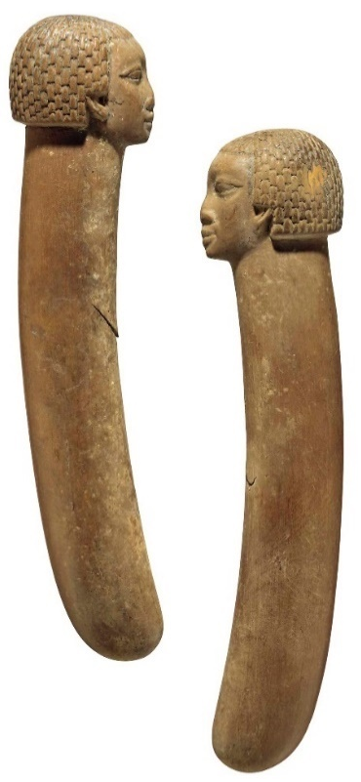
This pair of clappers are from Nubia, which is runs along the Nile. They show Nubian heads at the ends instead of clappers, which seemed odd as the other pairs I have found used hands. However, Guichard (2021) stated that hands were first used on Clappers in the middle Kingdom, so a pair without would not be that unconventional.
(1985-1295 B.C. A Pair of Egyptian Wooden Clappers with Nubian heads. Christie’s: Live Auction 10372.)

Ask question about Nubian vs Egyptian clappers, even if can’t answer, slaves, traders? Their place in Egypt, further research needed

Hathor
From looking at clappers, amulets, columns and stelas, Hathor seems to be easily identifiable by her small cow ears at the top of her head on the sides. The image on the left by Jeff Schultes was taken at Philae Island and this depiction with a wider head, large eyes and small pointed ears reappears in a lot of Egyptian depictions, it is almost indistinguishable of the pair of clappers from the Louvre on page 9. She is closely related with the sistrum, which is said to “drive off evil” (Mark, 2009), however Morris (2017) states “clappers too are known ethnographically at least to be capable of driving off evil spirits when struck with force.” Paired with the Hathoric depictions on clappers, it would not be excessive to say that the sistrum and clappers were used in the same way and that Hathor has a strong connection to music.
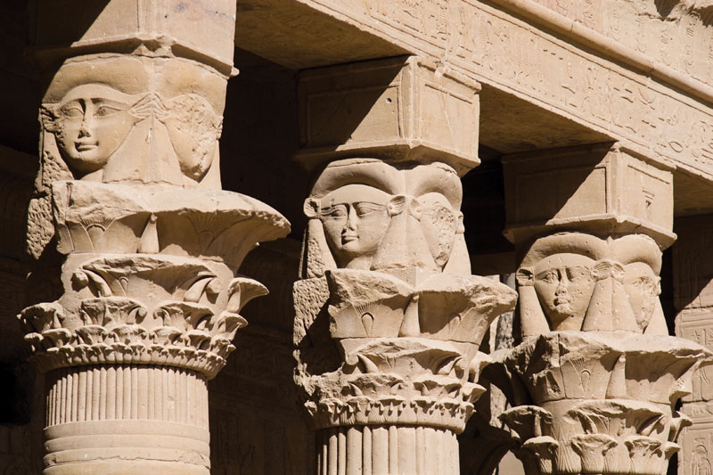

"As we all know, Hathor is the goddess of love, childbirth and other "female" pursuits like song and dance”

(Gillam, 1995)
(Schultes, n.d)
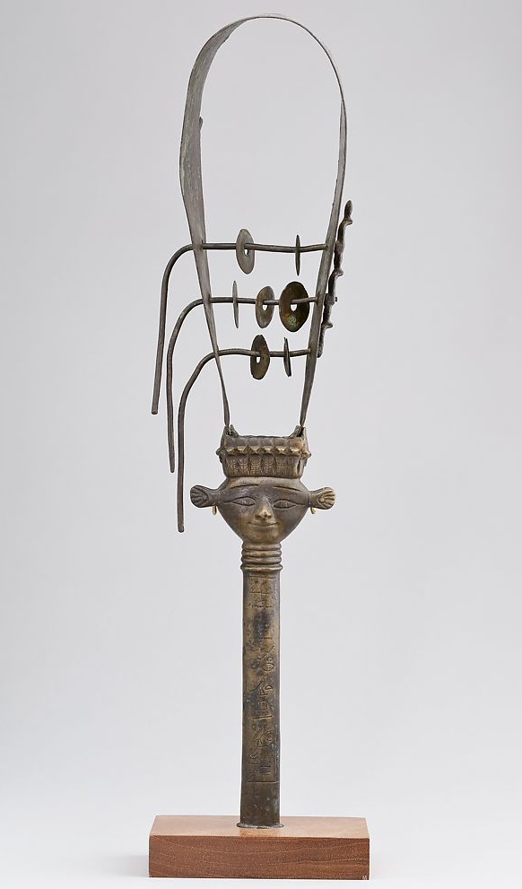
Morris (2017) Hathor and Hnr Dancers
Hnr and Birth: Morris (2017) suggests that the hnr troupe were closely related to childbirth, possibly doubling as midwives and that musicians, according the papyrus of Westcar four deities could disguise themselves as musicians, which is the most effective way to aid in childbirth. Morris also states that the Ramesseum 5 tomb five contains a lot artefacts related to childbirth, including 2 clappers, a statue of Beset and a paddle doll (Morris 2017: 318). This also plays into the theme of death and birth being closely linked due to the similar scenes by hnr troupes and objects related to birth being used for the dead.
Hnr Dancers: Female dancers were frequently intertwined with findings of clappers. They were called hnr dancers and were associated with Hathor, they played alongside musicians during different rituals and were recorded in scenes in tombs, one explanation for this that they channelled Hathor to arouse the king from his slumber (Morris, 2017: 310). This explains their link to death in the form of rebirth. From her work “MIDDLE KINGDOM CLAPPERS, DANCERS, BIRTH MAGIC, AND THE REINVENTION OF RITUAL” in the edited volume “Modelling the Imaginary World of Middle Kingdom Egypt (2000-1500 BC)” I can get a lot of academic information on clappers and their link to death and uses in Ancient Egypt.
(A sistrum dated from the Amarna to Late period of Egypt, with a representation of Hathor on the Handle. Made of cupreous metal, The Met Museum, 68.44)

Morris (2017) on the Hnr and Death
“In temples, clappers sounded to celebrate kings, gods, and rites of renewal. And in tombs, together with the help of other highly charged grave-goods and figurines, clappers ensured that the souls of the dead would be reborn and revitalized, thanks in part to the ministrations of snake-wielding, lion-headed entities and to the rhythmic claps of Hathoric dancers.” (Morris 2017: 330)
Thoughts about Morris (2017): I believe that Morris made good use of archaeological evidence by looking at the geographical areas the artefacts were found, I also believe she did a good job linking the commonly found objects that were grouped together in tombs. However, she is quick to state an opinion as though it is factual, which I would like to make sure I don’t do in my work.
Morris’ (2017: 312) evidence suggest confidently that the hnr ‘presided at births, however, they also danced at funerals. Her evidence also states that out of 13 ivory wands found in tombs with clappers, in all but one of these, clappers were found with paddle dolls. Meaning, they must somehow empower each other to facilitate “magically” the rebirth of the person(s) entombed (Morris 2017: 320).
The geoarchaeological evidence offered in Morris’ work for the link between clappers and the funerary sphere (namely rebirth it would seem) is that large quantities of early clappers were found only at four sites, Abydos, Lisht, Harageh and Thebes (Morris 2017: 306). These sites had strong association with the cult of dead kings, which means that they were in demand for these cults that focussed on death and can serve as a strong point for an archaeological argument on the use of clappers.

Other Ancient Egyptian Instruments
“Music played a very important part in ancient Egyptian life. From all periods there are scenes in temples and tombs showing musicians playing. Deities were praised in songs and many women of the elite had titles such as 'chantress of Amun', demonstrating the importance of music in the cults of the gods. The Egyptians did not have musical notations (in contrast to the Sumerians and Greeks). The sound of the music is therefore lost. However, musical instruments have survived, and from these it is possible to reconstruct at least the range of possible sounds.” (University College London, 2003)

Cymbal
Rattle
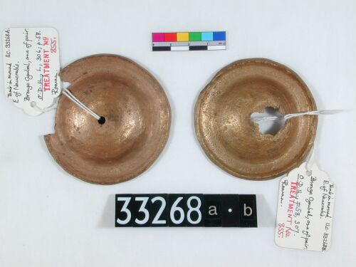
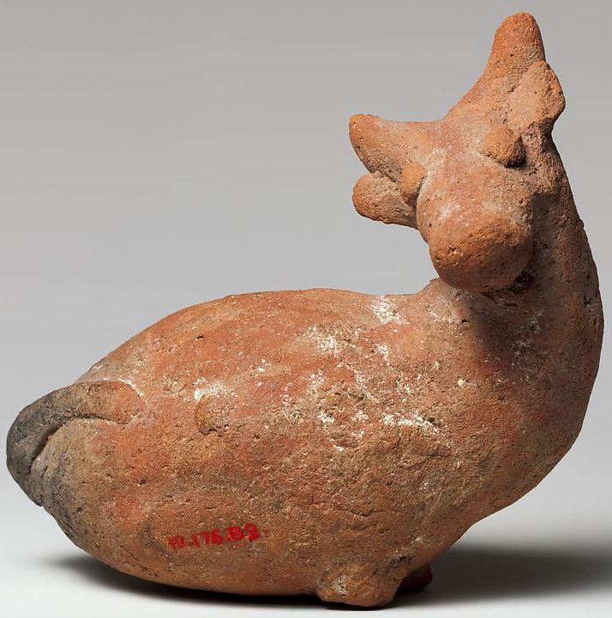

(ca. 1550-1295 B.C. A cow-rattle categorised as pottery for the material. Met Museum: 10.176.89)
(Roman Period. A pair of bronze cymbals. University College London: UC 33268)
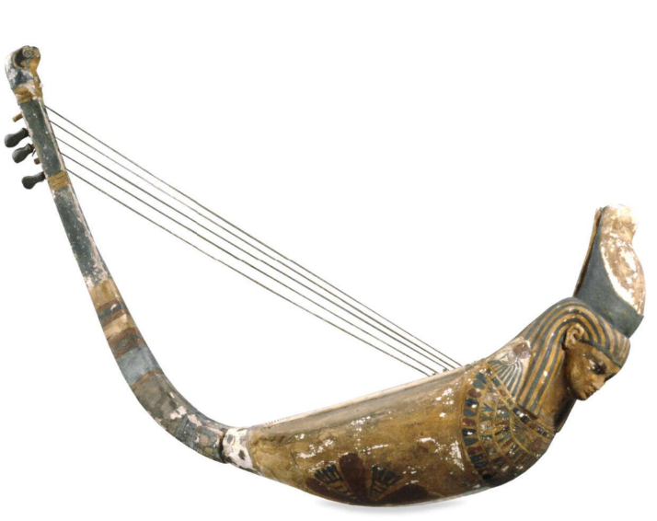
Harp

Bes-bell

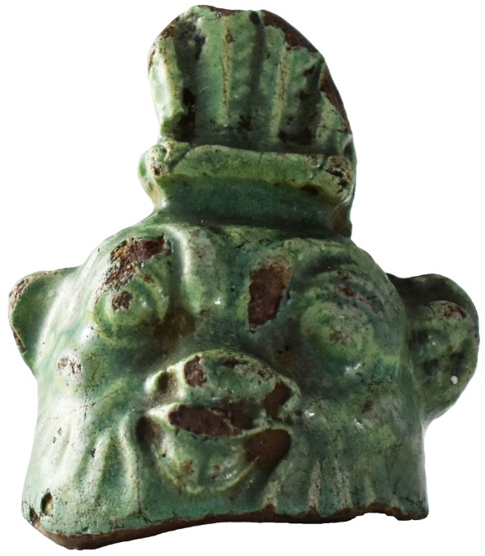

(New Kingdom. A harp with a human head wearing a wig and double crown on the underside. British Museum: EA24564)

(c. 747–30 BC. Faeince green Bes-bell, it has the face of the god Bes on it, hence the name. Egypt Cntre: WK44)

The View of Death in Ancient Egyptian Society
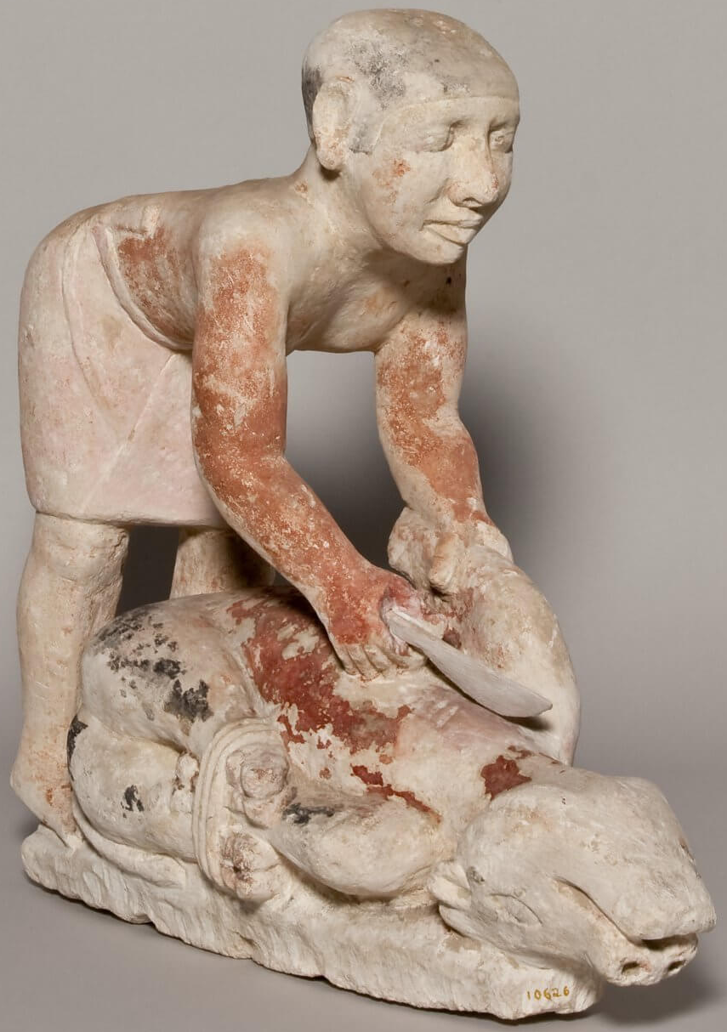
The two themes that are evident from archaeological evidence of mortuary practices and ancient writings in Ancient Egypt are rebirth and eternity, or prolonging yourself. Mummification allows the body to last thousands of years and from objects like clappers and paddle dolls, there is evidently birth magic placed into these eternal tombs. One contradiction that jumps out of the page is that if the Egyptians placed in tombs were given necessities like food, instruments, and clothes for the afterlife, why is this needed if they were going to reborn anyway? This is because according to Spieser (2019) ancient Egyptians saw themselves as being reborn into a different world, “Reacting against death, Egyptians found different ways to construct it not as the end, but the beginning of another kind of life in the world of the dead, the afterlife in a world related to gods.” This can explain the reason for the birth magic tools in tombs, as they are to help rebirth in the next life go smoothly. Spieser (2019) also explains this effort put into the dead and how important the stage just after death is, “Thoughts about survival after death consumed a large portion of Egyptian daily life and a great deal of energy was directed at rehabilitation of the dead, who were crossing a critical stage in their “existence”.
(2544-2260 BC. Statue of a butcher slaughtering a calf from the tomb of Egyptian official Ny-kau-Inpu. Oriental Institute, University of Chicago, OIM 10626)
The View of Death in Ancient Egyptian Society

The reason for all this emphasis on not letting the dead just be dead and prolonging their existence into rebirth according to Spieser (2019) is because death is the “opposite of life and world creation and was related to the primeval chaos, where life and cosmic order, expressed through the notion of Maât or balance, have no place”.
“Concerns about managing death and restoring life were not just concentrated on the body and the soul but also on the person of the deceased, which included other, in particular social, aspects such as rank, status, and honour.” (Assman 2005: 87) This explains the difference between types of burial in ancient Egypt, as status played a huge part even in death, and this class structure carried on even into the after, which is quite a melancholy idea for the poorest in the society, however, the workers of elites were often buried with their masters, or sometimes there would be representations of them there as seen in the image to the right of the previous page.

Funerary Procession Music
As we already have evidence from Morris connecting clappers to mortuary practices and the funerary sphere in general, as well as a connection to the dancers of Hathor and Hathor herself, we can start to create a narrative. However, it is good to get multiple academic accounts, not just of clappers in mortuary practices but of the use of music during funerary processions, this will create more of a picture of the importance of my object. Below are quotes from Jeffrey Pulver’s book ‘The Music of Ancient Egypt’ produced in 1921. Although this book is older it utilizes many archaeological discoveries and talks about them, such as the cemetery of Beni Hasan. These quotes are useful as they tell us how important music was and that it is known by other academics that Pulver uses quotes from, it also makes mention of clapping in the funerary service.
“Music was given a very important place in the funerary rites. In a wall-drawing at El Rab (belonging to the reign of Amenhotep I, Dynasty XVIII, B.C. 1562-1541), the wife of the deceased is shown walking backwards before the chorus, giving them the time for their song” (Pulver 1921: 44)

“The story of Sa-Nehat, already alluded to, also says: “”They shall follow thy funeral, and visit the tomb on the day of burial, which shall be in a gilded case, the head painted with blue, a canopy of cypress wood above thee, and oxen shall draw thee, the singers going before thee, and they shall dance the funeral- dance.”" (Pulver 1921: 45)

“At Beni Hassan, a painted scene shows a harper, hand-clappers, singers, sistrum-players, chanting in honour of the dead” (Pulver 1921: 45)

Clappers as a Function in Society

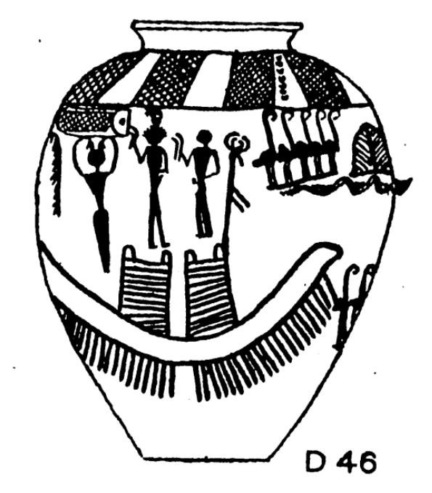
When looking at clappers it is clear that they had religious meaning, from the use of Hathor’s face as decoration and the large quantities put in tombs at the locations associated with the cult of the dead kings. Morris (2017) suggests that they were used to drive off evil, which makes sense as the sistrum is also seen to be used for that purpose and is known to be Hathor’s main instrument of association. Functionalist analyses examine the social significance of phenomena, that is, the function they serve a particular society in maintaining the whole (Jarvie 1973), from what I have researched, in a society filled with mysticism, objects like clappers and other instruments served multiple purposes. Their function may have been entertainment; however, their mystical properties were also a part of functionality. As Proni (2010) stated, “The point of function is non function objects is semiotics”, these artefacts such as clappers, paddle dolls and wands all had symbolic meaning and links to the people who used and created them. The semiotic link to death and rebirth is one of the main function of clappers.

(A predynastic vase showing musicians, some of which are holding clappers. Maclver & Mace, 1902)
Experimentation
I decided to draw around my forearm (picture to right) on a sheet of A4 paper to get an idea of the size of my clappers since I cannot see them in real life due to covid-19. Considering the length of an A4 sheet of paper is about 29cm, this must mean that the clappers are around the length of 1.5 A4 sheets. I was able to fit half my forearm on the sheet with my hand, with the rest of my forearm it would have only taken up about another 10cm. This means that my object is around the same length as my actual forearm (give a few centimetres).
This is very interesting and allows me to grasp what it would be like to hold a clapper; another thought practice would be to use my own arm and thig of it like a clapper. It gives me the impression that people who used clappers saw them as extensions of their own body, making it seem like a very naturalistic instrument.



Notes
If I had had more time I would have liked to reflect on my poster and catalogue entry, as well as do more experimentation with objects and materials. I believe I may have focused too much on research and not enough on design and getting into the mindset of using this instrument. I would have also liked to try putting more of myself into the scrapbook objectively to compare the view I have gained from my society into the work and compare it against Ancient Egypt.

Bibliography
- Pair of Clappers. 1900- 1640 BC. [Hippopotamus ivory]. At: The Met Museum: Gallery 113. 22.1.143a, b. [Online] [Accessed 8th February 2021] Available from: https://www.metmuseum.org/art/collection/search/546840
- Pair of Clappers. 1539-1075 B.C.E. [bone, pigment]. At: The Brooklyn Museum: Special Exhibitions, Egyptian Galleries, 3rd Floor. 58.28.7a-b. [Online]. [Accessed 8th February 2021] Available from: https://www.brooklynmuseum.org/opencollection/objects/74421
- Pair of Clappers. 2033-1069 BC. [Hippopotamus ivory, lower canines]. At: The Louvre: Department of Egyptian Antiquities: Objects from everyday life. N 1479, N 1480. [Online]. [Accessed 8th February 2021]. Available from: https://www.louvre.fr/en/oeuvre-notices/pair-clappers
- Castanets (clappers). 1580-1090 BC. [wood]. At: The Met Museum: The Crosby Brown Collection of Musical Instruments, 1889. 89.4.1843. [Online]. [Accessed 8th February 2021]. Available from: https://www.metmuseum.org/art/collection/search/502442
- Pair of Clappers in Form of Human Hands. 1539-1190 B.C.E. [ivory]. At: The Brooklyn Museum: Egyptian Orientation Gallery, 3rd Floor. 49.58.1-.2. [Online] [Accessed 8th February 2021] Available from: https://www.brooklynmuseum.org/opencollection/objects/3538
- Pair of Clappers. 1353–1336 B.C. [ivory]. At: The Met Museum: Gallery 121. 32.5.2a, b. [Online] [Accessed 8th February 2021] Available from: https://www.metmuseum.org/art/collection/search/544680
- A Pair of Egyptian Wood Clappers. 1985-1295 B.C. [wood]. At: Christie’s: Live Auction 10372. [Online]. [Accessed 8th February 2021]. Available from: https://www.christies.com/en/lot/lot-5882257
- Guichard, S. 2021. Pair of clappers. The Louvre. Available from: https://www.louvre.fr/en/oeuvre-notices/pair-clappers [Accessed 9th February 2021]
- Schultes, J. (n.d). Hathor, relief on capitals at Philae island, southern Egypt. [image] Available at: https://www.britannica.com/topic/Hathor-Egyptian-goddess [Accessed 9th February 2021]
- Mark, J. 2009. Hathor. Ancient History Encyclopedia. Available from: https://www.ancient.eu/Hathor [Accessed 9th February 2021]
- Gillam, R. (1995). Priestesses of Hathor: Their Function, Decline and Disappearance. Journal of the American Research Center in Egypt, 32, 211-237. [Online: https://www.jstor.org/stable/40000840] [Accessed: 9th February 2021]
- Morris, E. 2017. MIDDLE KINGDOM CLAPPERS, DANCERS, BIRTH MAGIC, AND THE REINVENTION OF RITUAL. In: Miniaci, G. And Betro, M. And Quirked, S. (eds). Modelling the Imaginary World of Middle Kingdom Egypt (2000-1500 BC). Leuven: Peeters.
- Sistrum of the Chantress Tapenu. ca. 1186–600 BC. [cupreous metal]. At: The Met Museum: Gallery 127. 68.44. [Online] Accessed 9th February 2021] Available from: https://www.metmuseum.org/art/collection/search/553814
- University College London. (2003) Music in Ancient Egypt. Digital Egypt for Universities. Available from: https://www.ucl.ac.uk/museums-static/digitalegypt/furniture/music.html [Accessed 9th February 2021]
- Tepper, C. (n.d). Vessel from the 4th mill BC showing men with clappers. [image] Available at: https://www.asor.org/anetoday/2018/01/earliest-music-egypt/ [Accessed 9th February 2021]
- köpp-Junk, H. 2018. The Earliest Music in Ancient Egypt. Available from: http://www.asor.org/anetoday/2018/01/earliest-music-egypt [Accessed 27th January 2021]
- Cow rattle. Ca. 1550-1295 B.C. [pottery]. At: The Met Museum: Gallery 117. 10.176.89. [Accessed 9th February 2021] Available from: https://www.metmuseum.org/art/collection/search/554301
- Cymbals. Roman Period. [bronze]. At: University College London. UC 33268 [Online] [Accessed 9th February 2021] Available from: https://www.ucl.ac.uk/museums-static/digitalegypt/metal/uc33268.html
- Harp. New Kingdom. [wood, bone, glazed composition, plaster, reed, hippopotamus ivory]. At: The British Museum. EA24564. [Online] 9Accessed 9th February 2021] Available from: https://www.britishmuseum.org/collection/object/Y_EA24564
- Faience Bes-bell. c. 747–30 BC. [faience]. At: Egypt Centre: House of Life (First Floor), Music case. WK44. [Online] [Accessed 9th February 2021] Available from: https://egyptcentre.abasetcollections.com/Objects/Details/2233?SavedSelections
- Proni, G. 2010. The Function of Nonfunctional Objects. Semiotics of Functionalism. In: Darras, B. and Belkhamsa, S. (eds) OBJECTS & COMMUNICATION. Paris: Meditation & Information (MEI)
- Jarvie, I. C. 1973. Functionalism. Minneapolis: Burgess Publishing Company.
- MacIver, R. and Mace. 1902. Predynastic vessel from el-Amrah. University of Michigan Library. Available from: https://hdl.handle.net/2027/mdp.39015040355482 [Accessed 10th February 2021]
- Assman, J. 2005. Death and Salvation in Ancient Egypt. Translated by Lorton, D. New York: Cornell University.
- Butcher Slaughtering a Calf. ca. 2544-2260 BC. [painted limestone]. At: Oriental Institute Museum, University of Chicago. OIM 10626. [Online]. Available from: https://oi.uchicago.edu/
- Pulver, J. (1921). The Music of Ancient Egypt. Proceedings of the Musical Association, 48, 29-55. [Online: http://www.jstor.org/stable/765727 ] [Accessed 11th February 2021]

