Student name: Agnieszka Janina Wilkosz
Student ID number: 2115098
Programme: Certificate of Higher Education Skills for the Workplace
Module: Effective Team Working and Communication
Module code: BMSW4002
Lecturer: Dale Clarke

Assignment Title:

Effective Teamworking for team success

Table of Contents
Summary 3
Introduction 3
How can Abdul develop an effective team, and what theoretical model can be used. 4
What are the types of roles that are needed to create an effective team. 8
What type of impact can effective teamworking have on team success. 10
What are the barriers to effective teamworking identified in this scenario. 11
Conclusion 12
References 13

Summary
This report will focus on how Abdul can develop a team more effectively using the Tackman model and explore the importance of team roles using Belbin's team roles. The report will present the benefits of practical and barriers to teamwork.

Introduction
Let’s try to imagine a football match played well by a team. Everyone has a specific position, knows their tasks and goal. We can say that we would not be able to play a good match on our own, teamwork is the key to success. Communication, supporting other players and being 100% involved by focusing on the goal and taking responsibility is vital. It is a metaphor for a well-functioning team. How to achieve such efficiency in business?

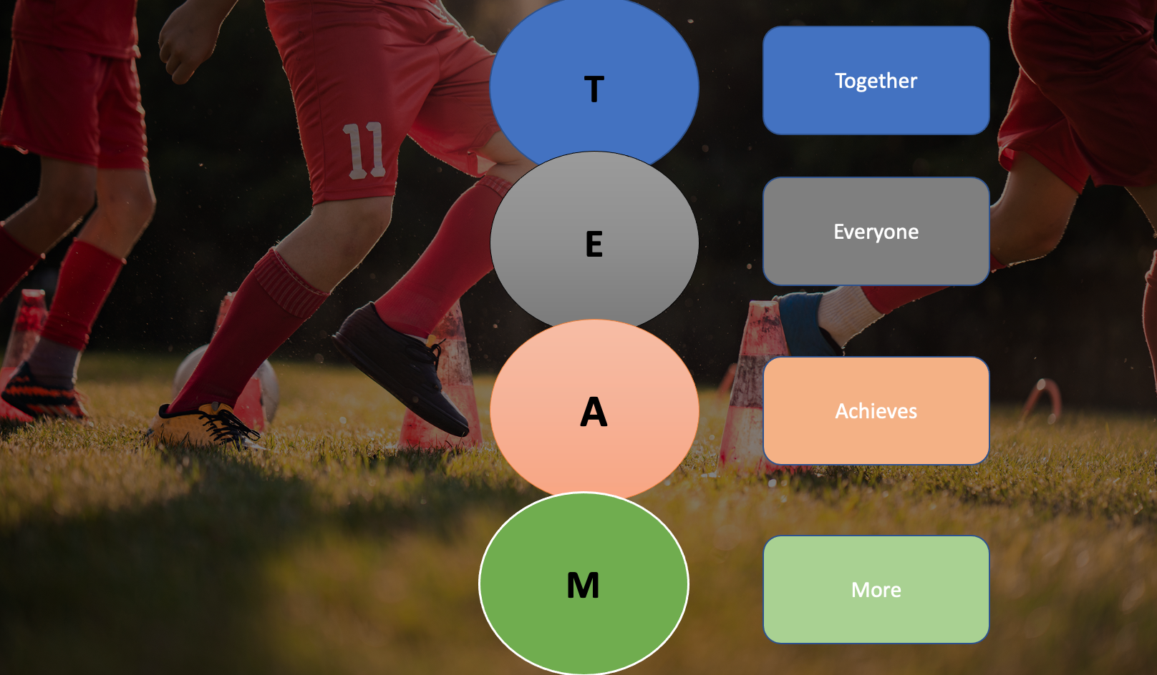

From an early age, we learn to work in a team. First as children, playing with friends in the yard, then at school, at university and finally at work. It only remains to ask question whether we have been properly trained how to work effectively in a team.
Let’s start by defining what a team is? “Kozlowski and Bell (2003) define teams as groups of people who exist to perform organizationally relevant tasks, share one or more common goals, interact socially, exhibit task interdependencies, maintain and manage boundaries, and are embedded in an organizational context that sets boundaries, constrains the team, and influences exchanges with other units in the broader entity” (Griffith, 2017)
In line with the above definition, teams strive to achieve a common goal by performing a specific task. Groups are created to do a particular job. This is possible through collaborative memberships. Teamwork requires, collaboration, mutual help, and different roles. People working in teams have collective responsibility for the results of their work. We win together. We lose together.

How can Abdul develop an effective team, and what theoretical model can be used.
Effective teams have a common task to accomplish, and goals to achieve, cooperate, and take responsibility for results. Members of such groups are committed and goal-oriented, developing their skills and talents while overcoming obstacles and difficulties in the way of shared challenges. (Cooke, 1996).
Building an effective team requires the implementation of many interrelated practices, standards, and tools. A group of employees does not become a team because they do similar work or because they work in one department. To achieve its full potential, it is necessary to create a management system in which the manager becomes an effective leader Abdul has a tough job because he started to manage the team two months ago and it is not working as efficiently as it should.
A manager must take decisive steps to create an effective team. There are 18 members of Abdul’s team. According to the article “Group Size, Group Development, and Group Productivity,” As the group grew, the amount of communication initiated by individual members decreased, and there was more of a sense of threat and inhibition and more misunderstanding and dissatisfaction. Some studies have shown that small groups are more effective and productive than large groups. (Wheelan, 2009). Considering that Abdul’s team started working during the pandemic and the members did not have the opportunity to meet face-to-face, it would be good to divide the team into smaller groups, for example, three groups of 6 members, because it would facilitate communication within the team. It is easier to work remotely with six people than with 18 at the same time. For Abdul to develop his team’s work, he must have the right people in the right place. For this, he needs an overview of each team member.
According to Ask the Executive Coach: How to build an effective team, the best way is to study personality—the Briggs Myers test identifies 16 different characters. In addition to having the right personality, a good team member must have the skills to achieve the goal. Without the right skills, a person is an obstacle to success. (CityBusiness,2021). After the personality test, the next step for Abdul as a team leader is to introduce a theoretical model. The perfect team doesn’t arise overnight; it is a process in which you can distinguish several stages:
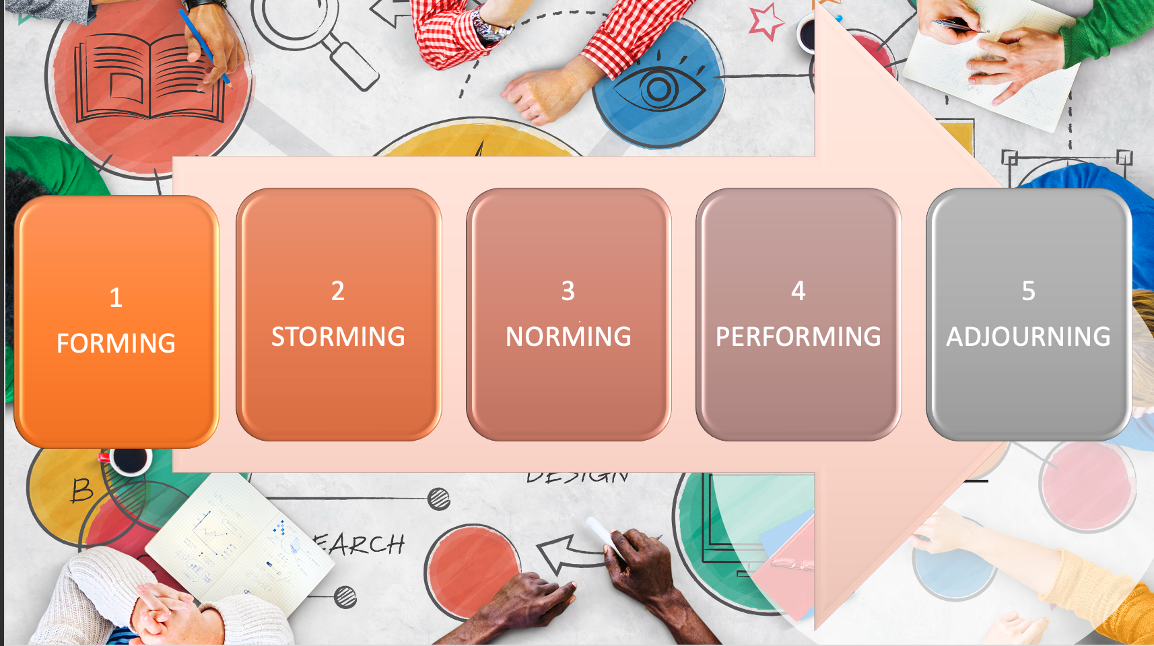
Abdul can use the Tuckman model. It guides the team through five phases. It was first proposed in 1965 by Bruce Tuckman. (Tinuke, 2013)
In the first phase – FORMING, a team is created. Team members will not understand the goal, how to fit in with others and how they will work together. At this stage, the team's development will be characterized by the low trust of individuals towards others. The team in this phase will have poor work.
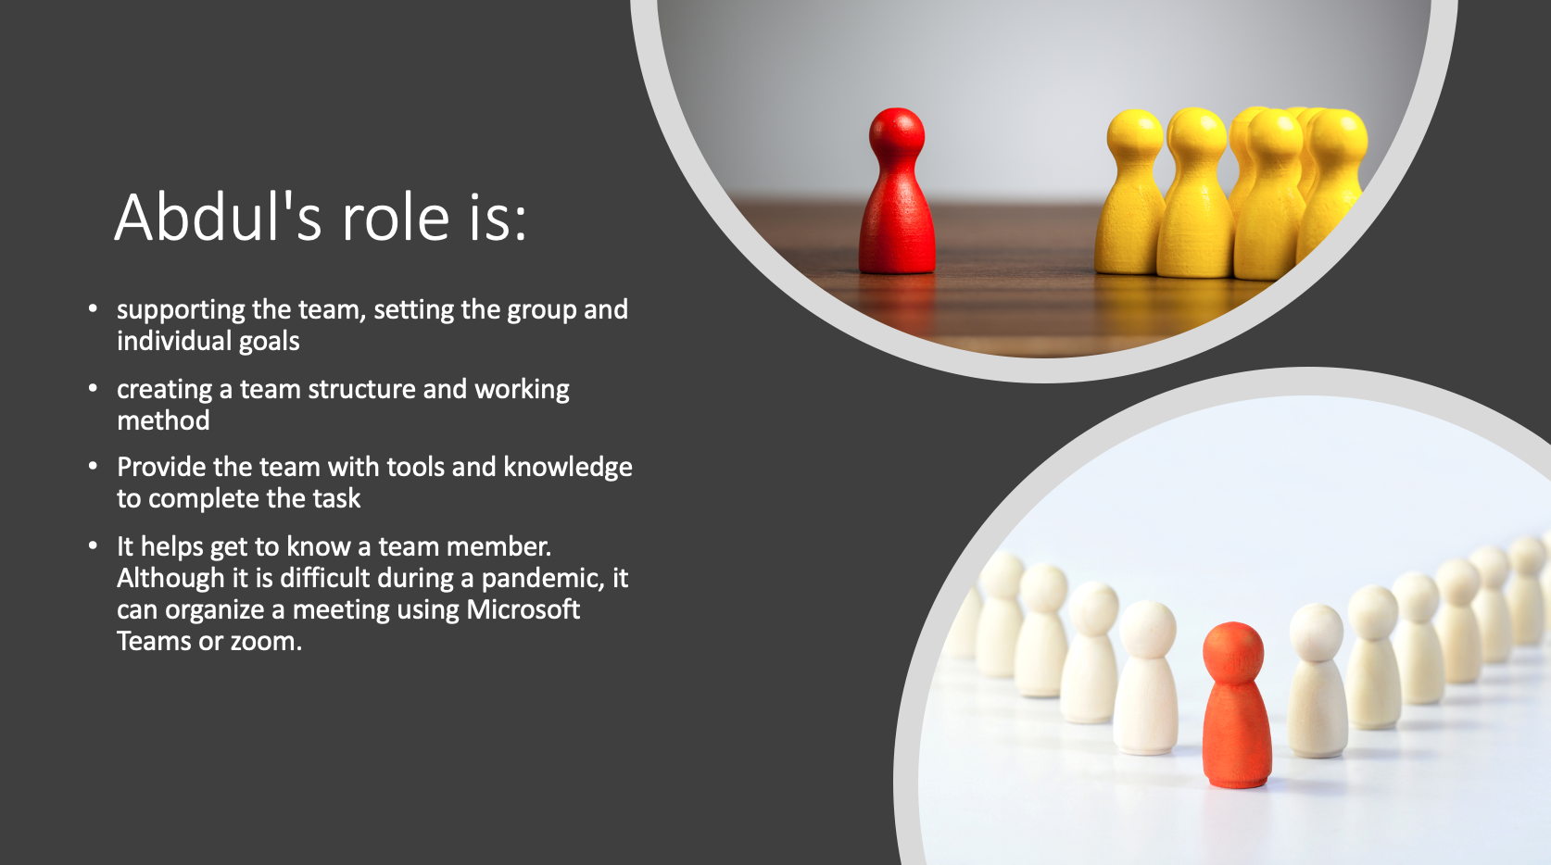
The next is storming. Development involves trying the strength of each member, but conflicts may arise. Members contend with each other.
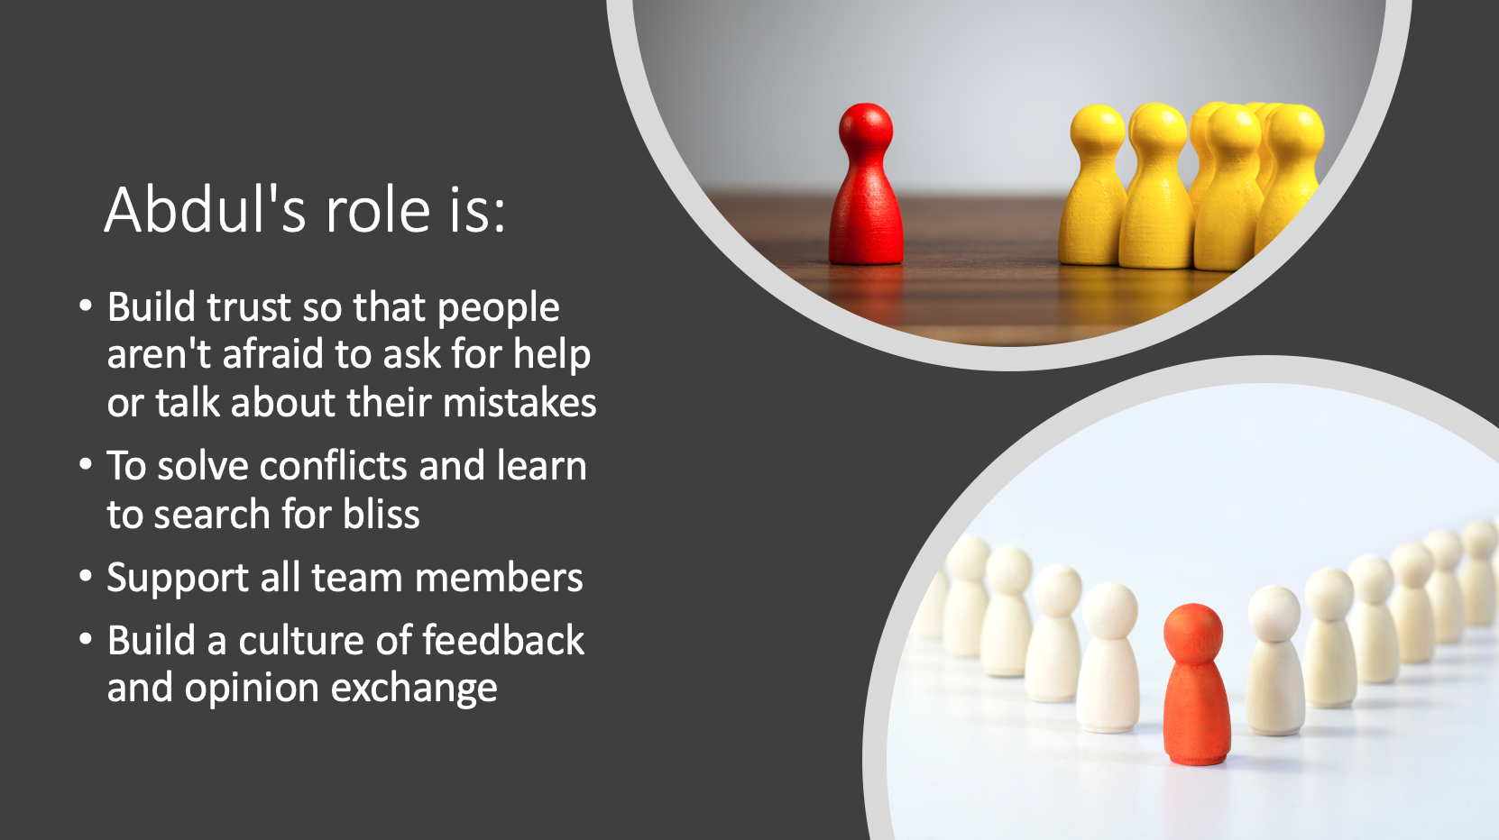
Gradually Abdul may move to Norming. People in this phase see the mutual differences and appreciate their strengths. He can find constructive compromises and at the same time unify the rules of cooperation.
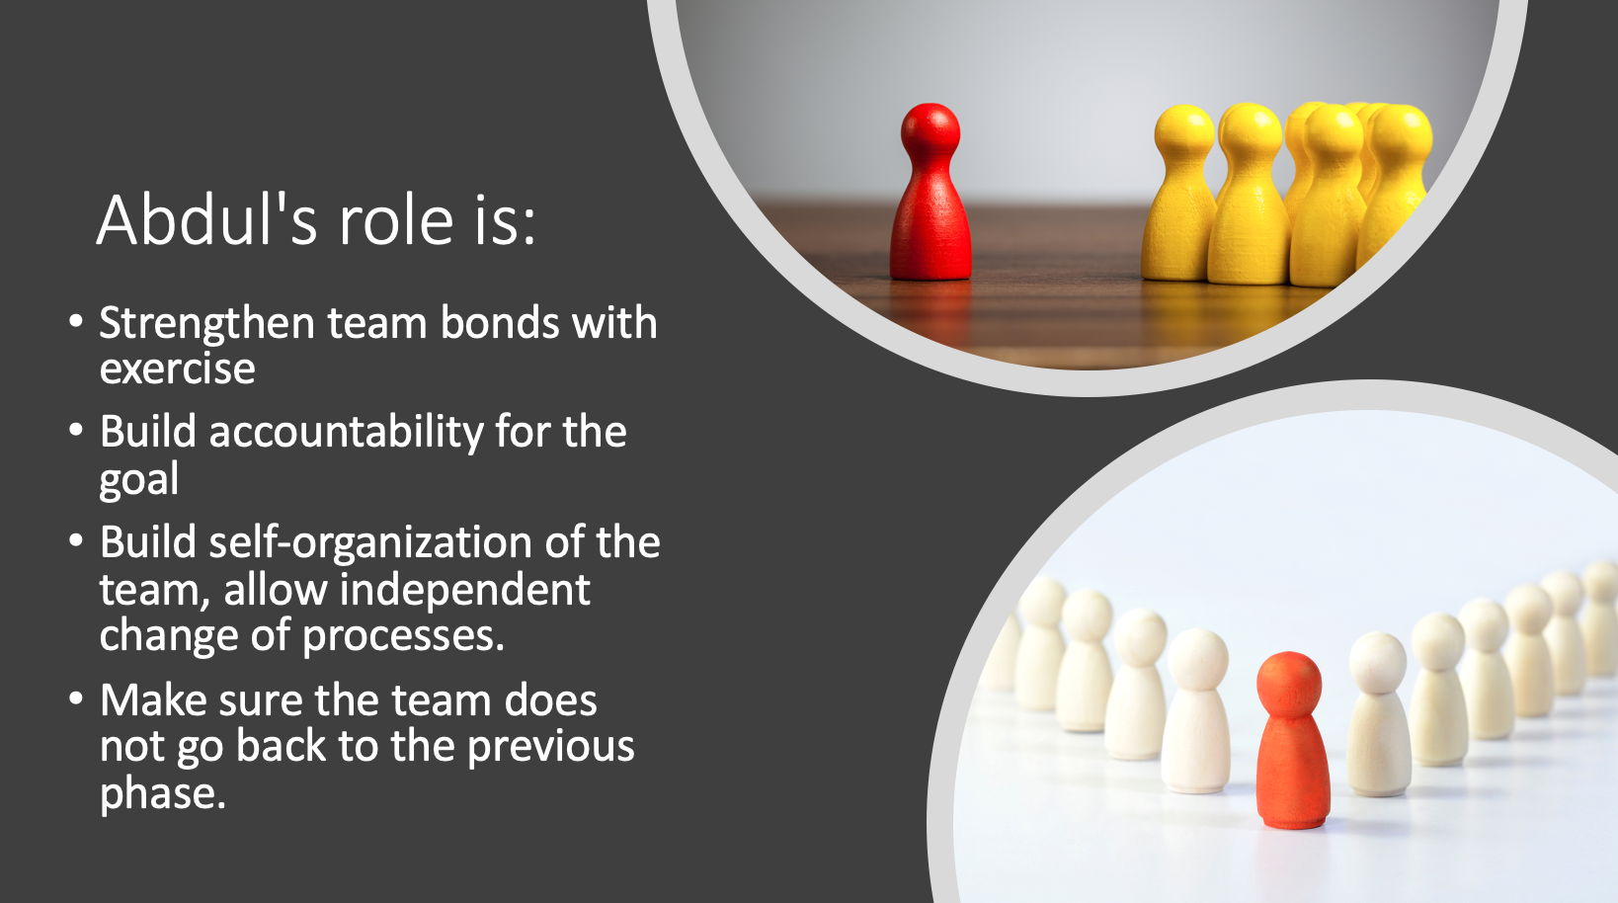

Abdul should then move the team to Performing, where uses its full potential. The group achieves its goals. People feel internally responsible for their work and solve problems on their own. At the same time, the team's development is aimed at taking care of each other.

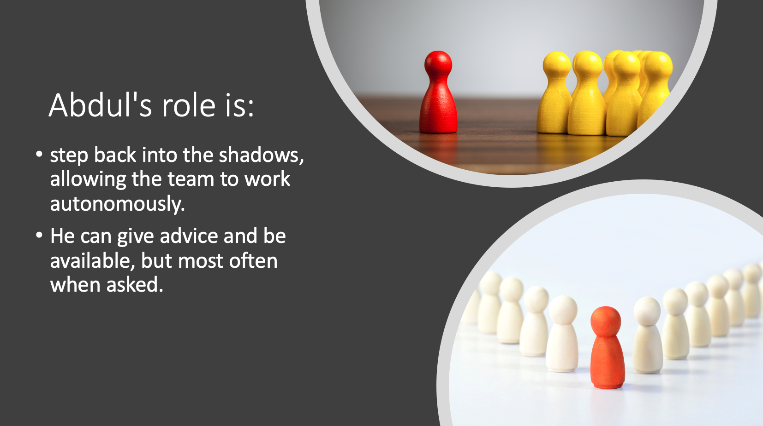

In the final phase, adjourning, there is anxiety and sadness about the upcoming work completion and thus the team members' separation. The tasks include self-assessment and collection of conclusions (Pasleau, 2017)
Abdul should choose to use the Tuckman model because it is simple to understand, which means that it is easy to implement. However, Abdul should remember that while the Tuckman model can guide the building of a successful team, it is also essential to observe individual members to find out what they need to help them grow as individuals.

What are the types of roles that are needed to create an effective team.

When everyone in the team understands their roles, it can work more effectively because misunderstandings and process losses can be minimized. Conversely, when the parts are unclear, the team members become confused, more frustrated, which significantly affects the group's performance. (Griffith, 2017)
A team is a group of members with different characters, habits, and experiences. Coming back to the football match, let's imagine that the players do not know what positions they are playing, who is in the goal defender or forward. There is chaos during such a game, no one knows what to do, which will undoubtedly lead the team to lose. It is comparable to a workplace. With no adequately matched roles, there is chaos and uncertainty. Tasks are not performed at a sufficiently high level because people do not know how to work- their knowledge, skills, and character traits have not been properly matched to the roles they are to perform. A scorer will not be a good goalkeeper or a person without computer skills will not produce a good Excel report.
Successful teams are made up of members with a specific range of roles. The creator of the concept of team roles is Meridith Belbin. He distinguished nine team roles. For the team to be effective, all roles must be present.

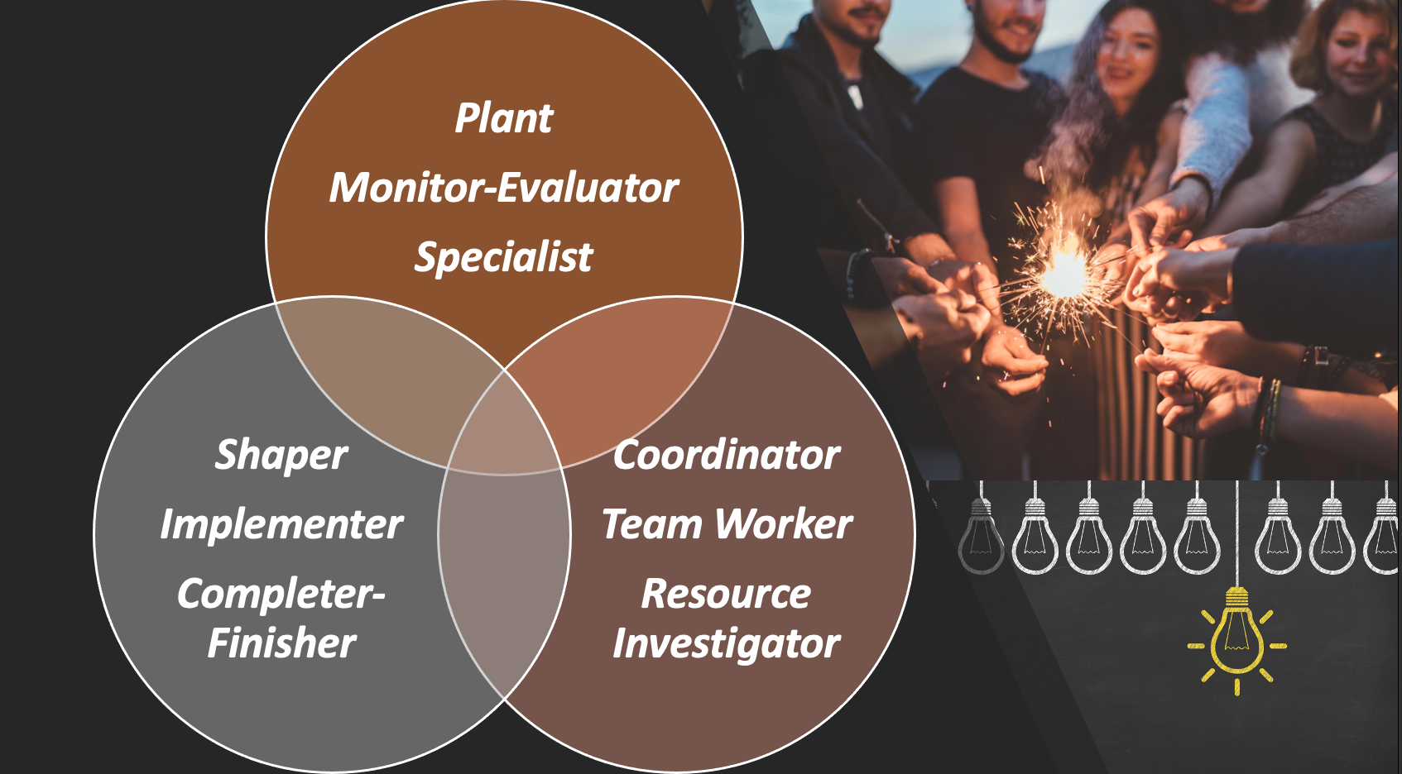

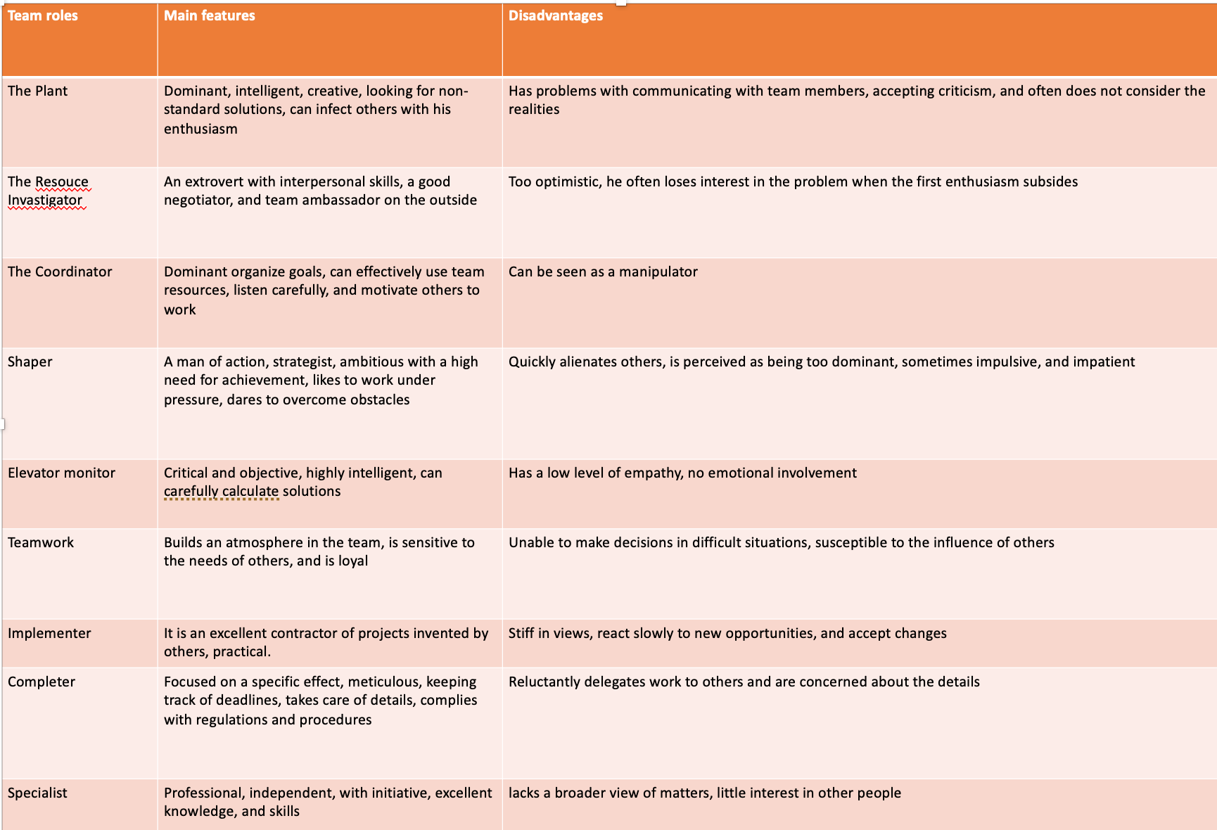

Belbin's team roles determine people's tendency to stay organized, collaborate, and interact with others. Managers must have information about their employees, which will help them develop the skills of the employed people and motivate them. Should concern the type of tasks entrusted to employees, supporting them, and creating a good atmosphere at work. The basis is diagnosing employees in terms of their team roles. That makes it possible to obtain information about the specificity of functioning in a team of individual people, their competencies, and their natural predispositions. Depending on the specifics of the work, different roles are needed in the group. Each disturbance, mismatch, or non-fulfillment of parts leads to problems in work. (Belbin,

What type of impact can effective teamworking have on team success.
"Teamworking is often considered to be innately good (Batt et al., 1999); an approach that 'is more satisfying to team members and boosts morale' (Oakland, 1996:12). It is seen as a key to economic success for 'if the organization is to perform, it must be organized as a team" (McCabe,2000)
Teamwork brings benefits to the people involved in it.
Most people associate teamwork with sport, but a team is a group of people who use their knowledge, experience, and skills to work towards a common goal. If the team works effectively, it can achieve what the individual cannot. I work in a warehouse with sports accessories, so I cannot collect the delivery simultaneously, put it in the appropriate locations, take the things that the customer ordered, pack them and then put them on the truck and send them to the customer. I could do it, but the execution of one order would be very long so working in a team, we can deliver hundreds of demands to the customer the next day.
Teamwork also offers a broader worldview because teammates have different ideas. It also teaches you a new way to deal with problems. After all, two heads are better than one. Such work brings better solutions because the team can choose the best idea.
Through teamwork, communication skills are improved. Teaches team members to express ideas, listen to others, provide feedback, and deal with criticism.
Teamwork teaches conflict resolution, which leads to building stronger relationships in the group.
There is less risk of making a mistake and failure. People share wins and losses, so they feel less pressure and stress. (Bachel,2006)
"Association of American Colleges and Universities (AACU) survey showed that 71% of employers want colleges to place a greater emphasis on teamwork (AACU, 2010)." (Dunham,2014)
Teams solve problems with different skill sets; experience allows for a more flexible and adaptive response to unexpected issues. For example, organizations can use multi-functional teams to gather the knowledge needed to solve complex tasks and use virtual teams no matter where members are. (McCabe, 2017)
Working in a team helps reduce costs, but it does not affect quality. Team members can improve their competencies faster. Working in a team strengthens creativity, sharing knowledge and experience.

What are the barriers to effective teamworking identified in this scenario.

While organised teams have enormous potential to complete tasks beyond any one person's reach, they are not without their problems. The main barrier that we can observe in the script is poor leadership. Consider whether Abdul is managing his team well. Two months have passed since the start of the team's work, which did not accomplish the results. Granted, the team started the task during Covid but didn't meet once. Abdul contacted each member individually, but in the 21st century, a face-to-face meeting in the office is not the only option.
The members show indifference to each other, and they do not help. They ignore each other. This is mainly the fault of Abdul, who did not integrate his team. It does not arise respect among employees since they do not obey his orders. They ignore them. There is a communication problem with this team. With the increase in the number of people working on the task, the chance of communication problems increases, especially as employees do not have face-to-face meetings, so they cannot always understand everything. We had to postpone the presentation date during the classes with my group. We asked several times about the date, and until the teacher wrote the date in the document that each of us saw, we understood something else. I will add that the classes were online. However, when Abdul entrusts him, he should ensure that everyone understands the task. People are not at all involved in the work. This may be due to a lousy team structure or badly assigned role.
Until the team establishes specific roles and responsibilities as well as a solid system for coordinating its efforts, it will not work effectively. All this team's problems start with Abdul. A good team leader can motivate his employees, make them work efficiently, resolve conflicts, and make each member feel comfortable. A good leader is the head of the team. He is like a father who guides his child, learning how to live. Considering my experience, I previously worked in a team with a poorly managing leader. Everyone did what they wanted to and nobody focused on work. Everyone ignored him after a change of manager after a few weeks. It was possible to observe a difference in the behaviour of employees and their commitment to work. Although the structure was not changed, the employees did not receive any bonuses. How the team works and deals with problems depends on the person who manages them.

Conclusion

Though working effectively in a team may seem like a hard task, once the team is organised well, the goals can be reached quicker and easier. Some of the great benefits of good team management are better efficiency, the possibility of exchanging experiences, building relationships with others, and creating an atmosphere in the company as well as stimulating creativity and reducing the risk of errors and failures. There are also drawbacks, such as: Lack of trust, conflicts, lack of commitment and avoiding responsibility and not caring about the results. Overall, the advantages certainly outweigh the disadvantages and that proves that effective teamwork is vital to a team’s success.

References

- Bachel, B.K. (2006) ‘Team thinking: working together benefits everyone.(YOUR RELATIONSHIPS)’, Current health 2, 32(8), p. 7–.
- BELBIN.(2022),THE NINE BELBIN TEAM ROLES, AVAILABLE HTTPS://WWW.BELBIN.COM/ABOUT/BELBIN-TEAM-ROLES (ACCESSED 24/02/2021)
- Dennis, H. (1996) Creating an Effective Team. London, England: British Broadcasting Corporation.
- Griffith, B.A. and Dunham, E.B. (2017) Working in teams : moving from high potential to high performance. Los Angeles: SAGE.
- Knights, D. and McCabe, D.(2000) Bewitched, bothered and bewildered: The meaning and experience of teamworking for employees in an automobile company. Human Relations, 53(11), pp.1481-1517.
- McCabe.D. (2017) BEWITCHED, BOTHERED AND BEWILDERED: THE MEANING AND EXPERIENCE OF TEAMWORKING FOR EMPLOYEES IN AN AUTOMOBILE COMPANY. Available at: https://www.researchgate.net/profile/David-Knights/publication/241649214_Bewitched_Bothered_and_Bewildered_The_Meaning_and_Experience_of_Teamworking_for_Employees_in_An_Automobile_Company/links/595e119a0f7e9b1d9cdc93bf/Bewitched-Bothered-and-Bewildered-The-Meaning-and-Experience-of-Teamworking-for-Employees-in-An-Automobile-Company.pdf/ (Accessed: 4 March 2021).
- Pasleau, P.(2017), Tuckman Model: Understanding the stages of team formation, [video], available https://www.youtube.com/watch?v=2QbXc6E08H4 (accessed 24/02/2021)
- Tinuke. M. (2013) ‘International Journal of Education and Research’, Towards Effective Team Building in the Workplace, 1(4), 2201-6740.
- Wheelan, S. (2009) ‘Group Size, Group Development, and Group Productivity’, Small Group Reaserch,40(2), 247-262

