Architecture in your Hometown

Bosworth Hall (Fig.1) sits on the site of the old manor house in the village of Market Bosworth. Building began in 1670 in the Palladio style under Sir Beaumont Dixie, who’s family still resides in the village, and took ten years to complete. The estate was sold twice, once in 1885 to Charles Tolllemache Scott who added the East Lodge (Fig.2) to the estate and again in 1918 to Mr Rudolph Delius. In 1931 the Hall was sold to Leicestershire County council for £5000 and was developed into a hospital which was a working hospital up until 1987 when it was sold to become a hotel which is still open today. The East Lodge was built in 1885 by Charles Tolllemache Scott in the Queen Anne Style. This was mostly occupied by the park keepers. Charles Tolllemache Scott left his stamp on this building and you can see the initial CTS of the lead downpipes today and the gables on each side of the building are of Dutch design. (Oakley and Tomlinson, 2008)
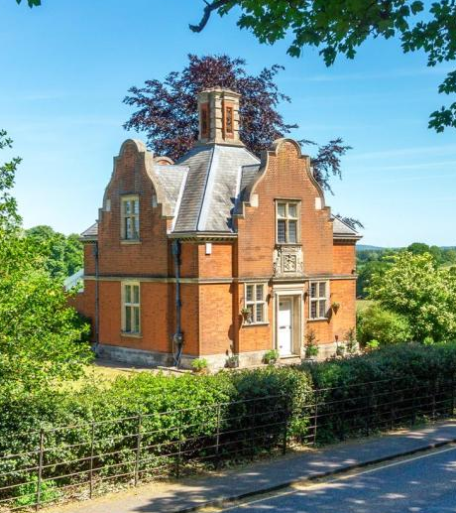
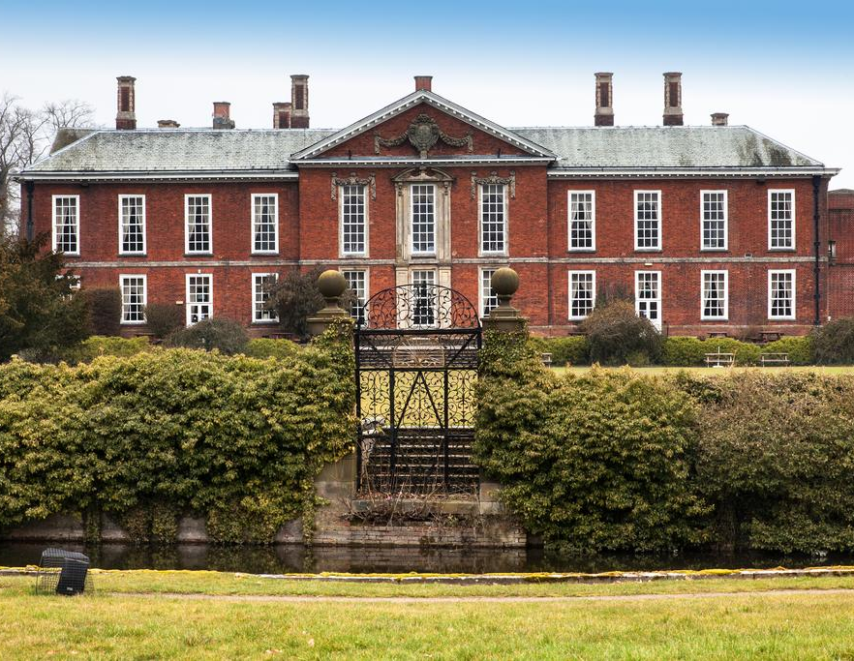
Fig.2 – East Lodge (North-East View)
Fig.1 – Bosworth Hall (North View)

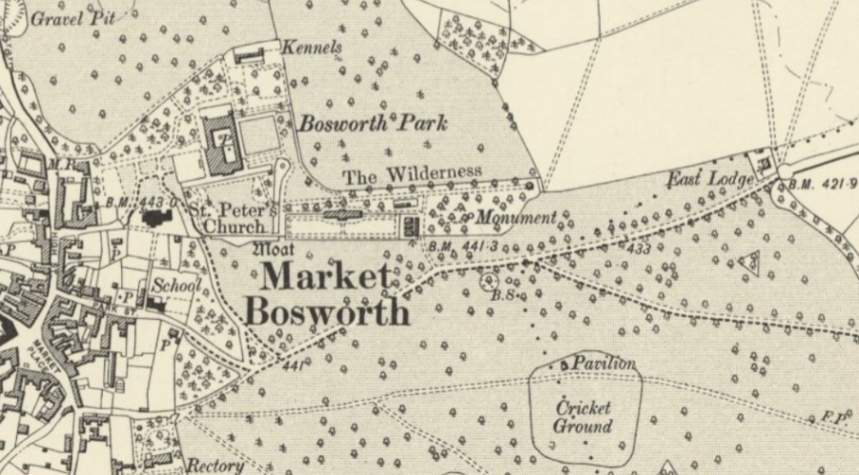
Bosworth Hall was built at the edge of the village with views over the country park with the East Lodge further out the village to the east. As shown in the historical and modern maps below Bosworth Hall is right next to the church and the town centre with the hall’s lands on each other side. East Lodge is located along one of the two main routes into the town next to the gates which served as the entrance to the country park and Bosworth Hall.
1888 Map of Market Bosworth
(National Library of Scotland, 2021)

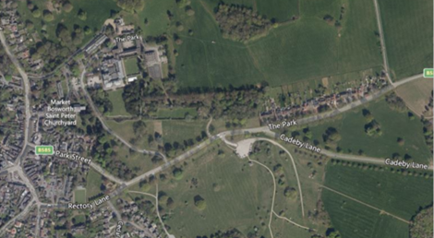
Modern 2020 Map of Market Bosworth
(National Library of Scotland, 2021)

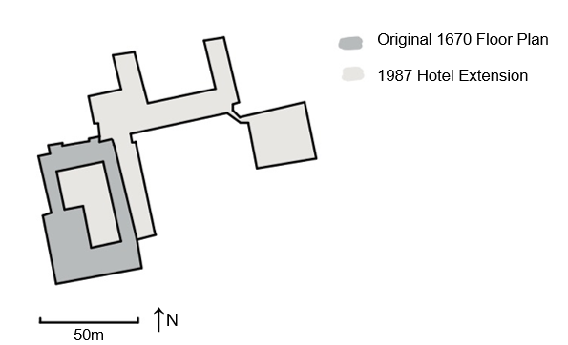
Below (Fig.3) is the plan of Bosworth Hall showing the original 1670 build as well as the 1987 extensions when the Hall was made into a hotel. A key element of the original plan was the central courtyard, this was a key element of the Hall throughout its life before the hotel especially for the patients when it was a working hospital. The modern plan including the hotel extension uses the original hall as the entrance space, dining spaces and as an event space. This is also what the hotel uses in all its advertising , excluding the fact that the majority of its 210 rooms are in the uninviting extension (Fig.4).

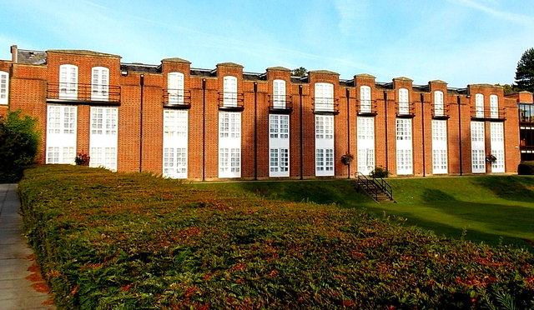
Fig. 4 – South View of Extension
Geograph, 2014
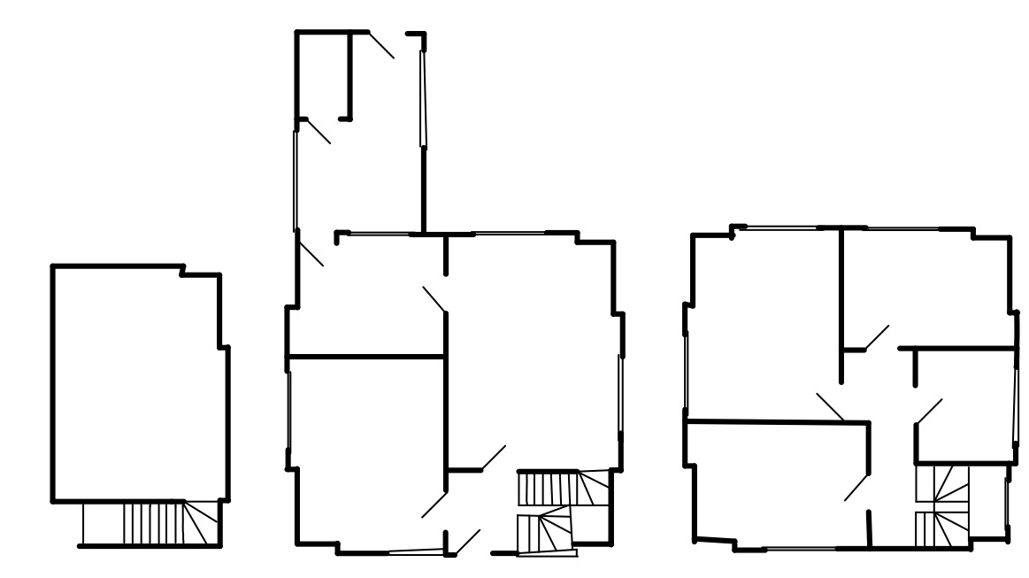
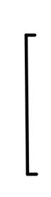
The plan below (Fig.5) is of the East Lodge, the extension on the ground floor was added later. The main element of this plan is that the building is almost perfectly square except the notches in the corners from the gables which go down to the ground. The section through building is very interesting due to the shape of the roof. You can see this in the image of one of the bedrooms below (Fig.6).
Fig.5
↑N
5m

Basement
Ground Floor
First Floor
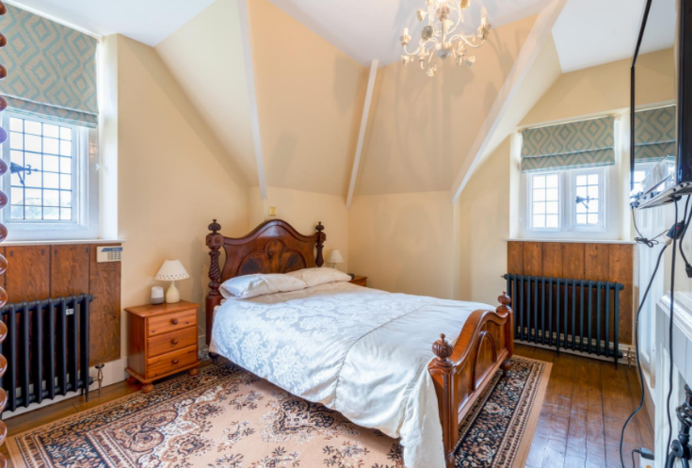
Fig.6 – Bedroom on the first floor of the East Lodge
(Alexanders, 2020)

The original parts of Bosworth Hall are made with brick along with ashlar accents throughout. Both materials can be seen in Fig.7 below. The contrast of the two with the red of the brick and the paler cream- coloured ashlar. The lead roof can also be seen in Fig.7. The details in the ashlar seen on the pillars in Fig.7 have been carved by hand. (Historic England, 2005). The extension is just built using a similar coloured brick to the original bricks used in the hall.
The East Lodge is also built using the same brick and ashlar (Fig.8) which is from local quarries, some of which are still in use today. The ashlar highlights the detail of the building as it surrounds the windows and doorway as well as outlining the roof. These details were also hand carved and in the same style Bosworth Hall.
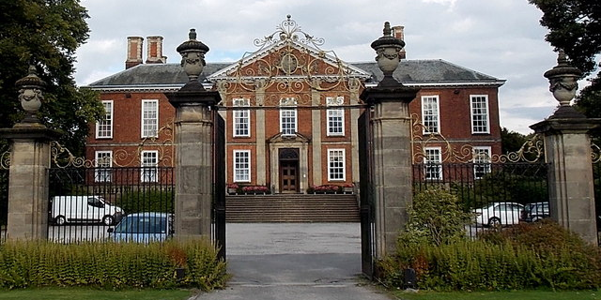
Fig.7 – East View of Bosworth Hall
(Geograph, 2016)
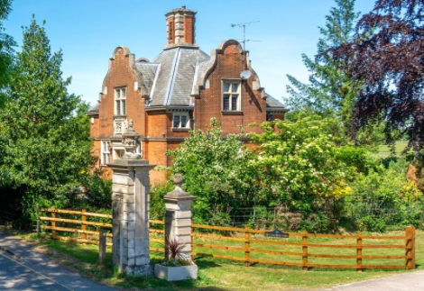
Fig.8 – North-West View of East Lodge
(Alexanders, 2020)

Bosworth Hall currently operates as a hotel, event space and a gym. In recent times the area has been quiet due to the coronavirus and the hotel closing temporarily. In the average summer however the area in and around the hotel is busy with tourists, wedding taking place on the grounds and walkers using the grounds. The layout of the building is well designed for those using the hotel with walkways around the building and to the gym and spa on the east side of the hotel. The hotel is successful due its location within the market town of Market Bosworth and the cheap prices of the chain that owns it.
In contrast to the hall, East Lodge is a privately owned house which is currently on the market for over £600,000. This area of the town is rather loud due to its location the main road through Market Bosworth however there is only a small amount of pedestrian traffic. The layout of this building is successful as a small 3 bedroom house but will most likely develop further as planning permission for an additional building and an extension has recently been granted.
The key points I have explored in this piece have been the changes of use within the Bosworth Hall estate and how it was then and still is a key feature of the town. I have also explored and example of one of the smaller buildings, the East Lodge, which are scattered over the town built buy the big landowners of that time. I learned even ore about the place I grew up carrying out this study particularly about how the town used to look and how it has developed. If I was asked to carry out a similar study, I would perhaps look at two buildings next to each other and compare their styles, uses and overall appearance. This study has helped me look at building differently, particularly those in Market Bosworth the old grammar school and workhouse have been particularly interesting to me recently as they were inspired by Bosworth Hall when they were designed and built.
References

Alexanders (2020) The Park, Market Bosworth
Avaliable at: https://alexanders-estates.com/property-for-sale/market-bosworth/cv13-0lp/1688472
Date accesses : 10/01/2021

Geograph (2014) East side of Bosworth Hall, Market Bosworth
Avaliable at: https://www.geograph.org.uk/photo/4333227
Date Accessed: 04/01/2021

Geograph (2016) Ornate metalwork, Bosworth Hall Hotel, Market Bosworth
Available at: https://www.geograph.org.uk/photo/4142597
Date Accessed: 03/01/2021

Historic England (2005) Bosworth Park Infirmary
Avaliable at: https://historicengland.org.uk/listing/the-list/list-entry/1251547
Date accessed: 03/01/2021

National Library of Scotland (2021) Map Images
Avaliable at: https://maps.nls.uk/geo/explore/side-by-side/#zoom=16&lat=52.62701&lon=-1.39420&layers=6&right=BingHyb
Date Accessed: 10/01/2021

Oakley, G and Tomlinson, T (2008) A Walk Through Time, A Photographic History of Market Bosworth. Great Britain: Reprico Ltd.

