3. Chapter Three: Research Method

3.1 Introduction
The previous chapter achieved the first objectives of this research, providing an understanding of the development of e-sports and the difficulties of e-sports sustainable development. The research on e-sports in the previous chapter found that the current development of e-sports and the future sustainable development have potential drawbacks. In order to further understand these important issues, this chapter aims to achieve the second objective of this dissertation:

“To select an appropriate research method to investigate young people’s cognition of e-sports and their attitudes towards the future development of e-sports.”

In order to achieve this objective, this chapter will use Saunders et al. (2016) Research Onion as an analysis model.

3.2 Research Onion
Coils and Hussey (2014, p2) in their research defined research as “a systematic, methodical process of investigation and research to allow people to increase their knowledge. Saunders et al. (2009) used the Research Onion as a survey and data analysis model for data collection and research.

Research Onion can be adapted to many types of research methods (Aleksandras, 2018). Each layer of the "onion" is related to each stage of the research process. Through the "research onion" level to gradually advance, so as to achieve a complete and effective research strategy. The research onion of Saunders et al. (2016) will guide the research methods of this chapter, so that people can understand the research methods and research value.
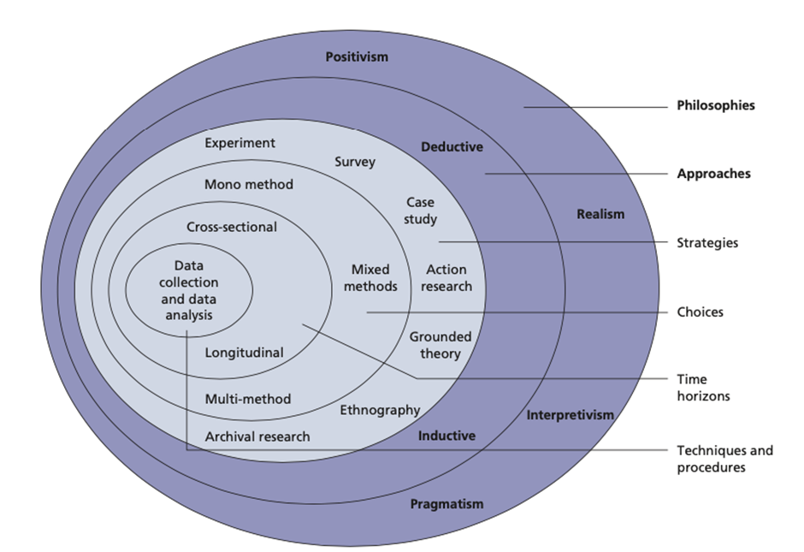
Figure 3.1: The Research Onion (Saunders et al., 2016)

Figure 3.1 highlights the choice of this research.

3.2.1 Philosophy
The philosophical view of philosophical theory includes ontology and epistemology, which are respectively interpreted as exploring the nature of the world and belief in knowledge (Scotland, 2012). Researching philosophy is an important hypothesis for cognition of the real world. (Collis and Hussey, 2014). However, there is no better case for a viewpoint in philosophy, positivism or interpretivism, only a theory that is more suitable for the problem being studied (Johnson and Clark, 2010). The philosophies chosen for this research are positivism. Therefore, this research will focus more on the ontological exploration of the nature of subjects to use questionnaires to solve problems.

3.2.2 Approach
In the Research Onion, research approaches are divided into inductive and deductive (Saunders et al., 2016). Compared with the deductive approach, the risk and difficulty of the inductive approach is relatively small, and the inductive approach can have adequate time to analyze the data (Theophilus, 2018). Since e-sports is a relatively new field of research subject, there are few existing related research literatures, and data analysis and the implicit conclusions of the data are very important to the research results. Therefore, it is appropriate to choose the induction approach.

3.2.3 Strategy
Saunders et al. (2016) defined research strategy as specific approaches adopted to implement the research plan. This research uses the opinions of survey respondents to understand people’s perception of e-sports and its future development trends. The information and data obtained through the survey are of great help to the research (Johnson and Clark, 2010). Obtaining respondents’ attitudes and opinions through a large number of questionnaire surveys will result in a more comprehensive quantitative analysis (Saunders et al., 2009). Compared with the qualitative methods, A large number of samples and a research method that passes hypothesis verification will make the research results more accurate (Saunders et al., 2016).

The questionnaire survey will be conducted on the questionnaire online site “wjx.cn” (WJX, 2021). Through this website, the questionnaire will be generated as a link, which can be distributed to various social media platforms. Participants only need to click “I am willing to participate in this questionnaire” and they can complete the questionnaire. If they have more points of view, they can add the investigator's social account at the end of the questionnaire for deeper discussion. All the above privacy-related information will be kept confidential.

3.2.4 Choice
Meno method can be a quantitative or qualitative (Saunders et al., 2016). This research uses a quantitative approach. Due to the uncertainty and inconvenience of qualitative methods, quantitative methods are the best choice at the moment. While quantitative methods only through survey has some limitations, but by a large number of real and effective statistics make this research more accurate and reliable.

3.2.5 Time Horizon
Time horizon relates to whether a research is a limited time or an adequate period of time, and it refers to cross-sectional or longitudinal (Saunders et al., 2009). Most research projects carried out in academic courses are bound to be limited by time (Saunders et al., 2016). Therefore, due to time constraints, this research has to adopt cross-sectional.

3.2.6 Techniques for Data Collection, Processes and Analysis

3.2.6.1 Data Collection
This research uses online questionnaires to collect primary data which can reducing the cost of time (Saunders et al., 2009). Future-oriented surveys often need to understand the user's intentions, motivations, and thought processes. Questionnaires are often ineffective, or it is difficult to design questions (Hague, 1993). However, the questionnaire of this research is aimed at specific people and group, which can make the data more accurate and informative.

3.2.6.2 Questionnaire Design, Combined with Literature Review
Questionnaire is a tool used to collect a set of information in social research (Saunders et al., 2009). Questionnaires are one of the most common survey methods in quantitative research. In order to collect information about people's attitudes, opinions, or beliefs about a particular question (Petra, 2010), research uses questions to collect interviewers' answers and make statistics.

Questions | Related to Chapter 2: Literature Review
Q1. (statement) The information and data from this questionnaire will be used as part of my BA research project. All information and data in the questionnaire will be confidential and anonymized. Do you agree to participate in the questionnaire and agree to this statement?  Q2. What is your age range?  Q3. What is your gender?  Q4. What is your highest degree?  Q5. What is your occupation type?  Q6. How long have you playing E-sports games (any platform)? | Questions 1-6 are demographic questions to provide background information for analysis.
Q7. Do you think e-sports is a sport?  Yes  No | This question involves people’s different views on e-sports.  Previous research (Seo and Jung, 2016; Marko and Dino, 2019; Anon, 2020; Suits, 1998; Guttmann, 1994; Abanazir, 2018; Summerley, 2019; Taylor, 2012; Segarra,2019) outlined the different views on e-sports.
Q8. Do you think the development of e-sports is important?  Very important  Important  Neutral  Unimportant  Very Unimportant | E-sports has developed rapidly and has become a large-scale industry. This question is to investigate young people’s attitude to the phenomenon.  Previous research (Witkowski, 2012; Ahmet and Engin, 2020; Boluk and LeMieux, 2017; Jin, 2010; Anita, et al., 2017) outlined the importance of e-sports.
Q9. Do you think e-sports should be institutionalized like traditional sports?  Agreed  Disagreed | Previous scholars have made a comparison between the early institutionalization of e-sports and traditional sports. Previous research believes that e-sports needs to be institutionalized like traditional sports (Summerley, 2019; Heere, 2018; Hamari and Sjöblom, 2017; Seo and Jung, 2016)
Q10. What do you think is the reason for the gap between e-sports and traditional sports?  E-sports is not recognized like traditional sports as a sport.  E-sports is a commercial activity, not the same as sports.  The life cycle of e-sports is too short, and ordinary events cannot survive for a few years, while traditional sports usually do not happen.  Society has prejudices against e-sports | Previous research has negative views on e-sports.  Previous research (Anon, 2020; Segarra，2019) outlined E-sports is not mature enough to meet the standards of sports.  Previous research (Jin, 2010; Ahmet and Engin, 2020; Amadeus, 2020; Fang,2017) outlined the impact of capital on e-sports.  Previous research (Li, 2019; Sohu,2020; Wooyoung and Byon, 2019) outlined that the life cycle of e-sports is generally very short.  Previous research (Anon, 2020; Kwan, Wei and Julian, 2010; MILIĆ, 2020; Szépné, Csernoch and Balatoni, 2019; Lin, Wang and Qi, 2019; Lou, 2018; Xue, 2016) outlined e-sports have negative impact on young people and children.
Q11. Do you think e-sports can be used as a major in the university?  Yes  No | Previous research (Yu, 2020; 3DGAME, 2021) outlined e-sports have been a major in some Chines universities.
Q12. What do you think are the conditions for an e-sports game to survive in the current environment?  The playability of the game itself.  Capital investment.  Institutionalization of e-sports  Society needs recognition of e-sports | Previous research (Zhou，2018; Li，2019; Sohu, 2020) outlined the gameplay is important for a e-sports game.  Previous research (Jin, 2010; Ahmet and Engin, 2020; Amadeus, 2020; Fang, 2017) outlined the capital is important for e-sports.  Previous research (Guttman, 1994; Abanazir，2018; Summerley, 2019; Candela and Jakee，2018; Zhihu, 2019) outlined e-sports wants to be the same as traditional sports, institutionalization is very necessary.  Previous research (Zhihu，2019; Lin, Wang and Qi, 2019; Lou, 2018; Xue, 2016) outlined there are still many negative views on e-sports in society.
Q13. Which one do you think is more popular with young people?  E-sports  Traditional sports | Question 13 is a subjective question to better understanding of young people's preferences and the situation of e-sports.
Q14. Which one do you think has more potential for development?  E- sports  Traditional sports | Previous research (ESCHER，2020; Guttman，1994; Wallechinsky，2004; Wooyoung and Byon, 2019; Arin，2020; Brock，2017) outlined the possibility of e-sports and traditional sports’ sustainability.
Q15. Which option you spend more time every year?  E-sports games (Competitive games)  Games expect e-sports games  Traditional sports  Exercise (Very light physical exercise) | Question 15 is to investigate young people’s situation for the following question.
Q16. What do you think of the current development of e-sports?  Pretty good  Good  Average  Bad  Terrible | Question 16 is to investigate current situation of e-sports in young people’s views.  Previous research (Seo and Jung, 2016; Witkowski, 2012; Ahmet and Engin, 2020; Boluk and LeMieux, 2017) outlined e-sports is currently developing very strongly.
Q17. Do you think e-sports can be sustainable in the future?  Yes  No | Previous research (Seo and Jung, 2016; Witkowski, 2012; Ahmet and Engin, 2020; Boluk and LeMieux, 2017) outlined e-sports is currently developing very strongly.  Previous research (Anon, 2020; Kwan, Wei and Julian, 2010; MILIĆ, 2020; Szépné, Csernoch and Balatoni, 2019; Lin, Wang and Qi, 2019; Lou, 2018; Xue, 2016) outlined the negative impact for development of e-sports.
Q18. What do you think are the challenges for the sustainable development of e-sports?  The playability of the game itself.  Capital investment.  Institutionalization of e-sports  Society needs recognition of e-sports | Question 18 is consistent with the literature in Question 12
Q19. Do you think the Institutionalization of e-sports will help it stand the same position with traditional sports?  Yes  No | Previous research (Guttman, 1994; Abanazir，2018; Summerley, 2019; Candela and Jakee，2018; Zhihu, 2019) outlined e-sports wants to be the same as traditional sports, institutionalization is very necessary.
Q20. Any questions or comments relating to the issues in this questionnaire would be very welcome.

3.2.6.3 Pilot Study
Pilot study is a trial to conduct preliminary research to prove the feasibility of the research (Davies and Hughes, 2014). The test results also prove that the pilot study can provide help for the subsequent adjustment of the questionnaire to increase the feasibility and effectiveness (Saunders et al., 2016). In order to make the questions in the questionnaire more accurate and feasible, the researcher made several adjustments to the questions.

3.2.6.4 Analysis
Statistical Package for the Social Sciences (SPSS) will be used as a tool to analyze the data of questionnaire. Likert scale is a common scoring summation scale (Newby, 2014). The research data will be analyzed by WJX (WJX, 2021) platform to create a SPSS analysis and matrix scale question will be analyzed.

3.3 Sample
It is impractical to survey all the population, and it is necessary to collect small and scattered samples (Saunders et al., 2009). Collis and Hussey (2014) suggest that Inaccurate or similar samples will bias the research results. Therefore, this research will collect samples from the target population in a targeted manner and adopt a decentralized collection method. Research will distribute at least 200 questionnaires on the Internet, which will be distributed to specific groups: Young people between 18 and 30 years old and have a certain understanding of e-sports.

3.4 Reliability and Validity
Reliability refers to the consistency of the results of repeated tests on the same subject using the same method. Validity refers to obtaining accurate results within expectations (Litwin, 1995). The purpose of the research is to be accurate and reliable (Saunders et al., 2009). Questionnaire will be distributed to specific target groups and distributed by way of dispersion. Although this may make the time to collect samples longer, it is beneficial to the accuracy and validity of the research results.

3.5 Limitations
The findings of this study must take into account some limitations (Kalof, 2008; Saunders et al., 2009). Most of the participants invited to fill out the questionnaire are over 18 and under 30. Although they already account for the majority of e-sports players, due to time and other limitations, the entire age cannot be covered in this research.

Another limitation is that due to Covid-19, all the questionnaires are conducted online. It is impossible to know the status of the person who filled out the questionnaire at the time, owing to the participant may fill out a "satisfactory questionnaire" instead of the real situation.

3.6 Ethical Considerations
This research was conducted in accordance with UWTSD's ethical standards. For the research conducted in this paper, ethical integrity and transparency are essential (Saunders et al., 2009). The privacy of all participants in filling out the questionnaire will be protected. In addition, all questionnaires are conducted on a fair and voluntary basis. However, in order to conduct an in-depth investigation to further understand the current situation of e-sports, the questionnaire may need to involve the participants’ private information, but this information will be reasonably retained and will not be leaked to other places.

3.7 Conclusions
This chapter achieved the second objective:

“To select an appropriate research method to investigate young people’s cognition of e-sports and their attitudes towards the future development of e-sports.”

This chapter identified the research methods appropriate for this research. It was confirmed that using a questionnaire of quantitative method is essential and providing a targeted and accurate questionnaire is very helpful for this research. The next chapter will discuss the data analysis.

References
Saunders, M., Lewis, P. and Thornhill, A. (2016). Research Methods for Business Students. 7th ed. Harlow: Pearson Education.
Saunders, M., Lewis, P. and Thornhill, A. (2009). Research Methods for Business Students. 5th ed. Harlow: FT Prentice Hall.
Collis, J. and Hussey, R. (2014). Business Research: A Practical Guide for Undergraduate and Postgraduate Students. 4th ed. Houndmills: Palgrave Macmillan.
Aleksandras, M. (2018). Towards an Explicit Research Methodology: Adapting Research Onion Model for Futures Studies. Journal of Futures Studies, 23(2), pp.29–45.
Scotland, J. (2012). Exploring the philosophical underpinnings of research: Relating ontology and epistemology to the methodology and methods of the scientific, interpretive, and critical research paradigms. English language teaching, 5(9), pp.9-16.
Johnson, P and Clark, M. (2010). Research Methods for Managers. 4th ed. Los Angeles, California; London: SAGE.
Hammersley, M. (1992). Social Research: Philosophy, Politics and Practice. London: SAGE.
Theophilus, A. (2018). Qualitative research: deductive and inductive approaches to data analysis. Qualitative research journal, 18(4), pp.383–400.
WJX. (2021). Online Research. [Online] Available at: https://www.wjx.cn/?source=baidu&plan=%E9%97%AE%E5%8D%B7%E6%98%9F%EF%BC%88%E6%AD%A3%E5%B8%B8%EF%BC%89PC&keyword2=%E9%97%AE%E5%8D%B7%E6%98%9F%E5%93%81%E4%B8%93%E6%A0%87%E9%A2%98 (Accessed 6 March 2021)
Hague, P.N. (1993). Questionnaire design, London: Kogan Page.
Petra, L. (2010). Research into Questionnaire Design: A Summary of the Literature. International journal of market research, 52(2), pp.249–272.
Davies, M. and Hughes, N. (2014). Doing a successful research project: using qualitative or quantitative methods 2nd ed. New York: Palgrave Macmillan.
Newby, P. (2014). Research methods for education 2nd. Abingdon, Oxon: Routledge.
Litwin, M.S. (1995). How to measure survey reliability and validity, Thousand Oaks; London: Sage.
Kalof, L. (2008). Essentials of Social Research, Maidenhead: McGraw-Hill Education.

