Abstract
As a part of this assessment challenge, I had to an opportunity to complete 80 hours of work experience with the South Wales Police, which has given me an idea about what other things that police officers rather than doing certain things only, also I had the chance to communicate with member of the public and police officers as well

Volunteering: The Gateway to Employment
Ahmad Habib (2317248)

Contents
Introduction 2
Objectives 3
Main Body 4
The nature of the placement 4
My role in the placement 5
Analysing my performance 6
Conclusion 10
References 12

Introduction

As a part of this module, 80 hours are needed to be completed, which was a challenge for a student who has assessments to do and lectures to attend at university, a 2000 word report and a 15 minutes presentation about the hours have been done in the placement are required and has to be done too. However, this challenge is important for students, as several studies have shown the important impact volunteering performs in university students' development and wellbeing. Students who volunteer often state increased employability, better soft skills, and improved growth in themselves (Brewis and Holdsworth 2011). In addition to having been seen as a method to provide back to the community, volunteering has many benefits that may boost a career and assist in finding jobs. Volunteering can be a helpful first step towards achieving employment goals, whether they involve changing industries, filling a gap in their CVs, or learning new skills (PeoplePlus 2024). The challenge of this module was not only to do the 80 hours while at university, but the challenge was also to find a placement to work with, that was a responsibility to find the placement and ask about other placement in case any rejection of the application. Another challenge was that I did not hold the British passport when I applied to be a volunteer at South Wales Police, as applicants who are not British citizens must prove that they have the right to live and work in the UK which includes voluntary service (South Wales Police, 2025).
During the 80 hours work experience, there were some things I was interested in like talking about cybercrime and that cybercrime costs the UK billions of pounds, causes untold damage, and threatens national security (National Crime Agency, 2025).
There was some other things I did like engaging community events and talk with member of the public, and that is important as a student who might be a police officer after graduating as communicating with the public members increases trust and confidence, and better community perceptions of the police (College of Policing 2013).

Objectives

After clarifying the nature of the organisation, this report will critically analyse the nature of the placement I volunteered for. Moreover, the report will explain my role in the placement. In addition, the report will analyse my performance explaining my feelings, evaluation, analysis, discussion and action plan for some experiences I had during the 80 hours challenge.

Main Body

The nature of the placement

In terms of that challenge, 80 hours of work had to be completed as a volunteer in South Wales Police which is the largest police force in Wales. In addition. South Wales Police serves 1.3 million people, or 42% of the nation's population, although only having an area of about 812 square miles, or 10% of Wales’s total land area. Moreover, the two biggest cities in Wales, Swansea and Cardiff, are in the diverse region of South Wales, which also includes coastal, rural, and urban districts. The force also serves 63 of the 100 most deprived communities in Wales. The force has around 3000 officers and more than 2200 police staff, including Police Community Support Officers (PCSOs) and a group of committed volunteers that consists of over 200 Police Youth Volunteers and more than 200 Special Constables. (South Wales Police 2025).
In addition, vetted volunteers can do many roles such as being a student volunteer while at university, tackling cybercrime, supporting neighbourhood officers in their efforts to combat antisocial conduct and implement crime prevention programs (South Wales Police 2025).
According to South Wales Police (2023). Their commitment to providing an exceptional police service in order to maintain South Wales’s safety is known as "Policing with Purpose." It indicates that they will pursue criminals, give victims priority, and be committed to safeguarding those who are vulnerable.
However, I was supposed to volunteer at the help point in Swansea which is a specialised treatment facility located in the heart of Swansea that offers care to vulnerable individuals who need it due to violent attacks, accidents, or injuries often the result of excessive alcohol use. Moreover, reducing the amount of people who need to call the emergency services or visit NHS Accident and Emergency departments is the goal of the help point, which aims to redirect drunk people from police custody (St John Ambulance, 2025).

My role in the placement

During the 80 hours, I had to take part in community engagement and talk with people about hate crime and gave leaflets talk about hate crime and how to report it, and that anyone can be affected by Hate Crime (Stop Hate UK 2022). There were leaflets about how to always protect Houses from burglary to secure windows and doors, leaflets about how to report emergency crime, some more leaflets talk about volunteering in South Wales Police.
For a different one was attending a day at Swansea university Singelton asking students if they think that their passwords are secure, and my role there was to ask students to put any of their passwords on a link to see how strong their password is and if they do need to change them and tell students that if a criminal can access their email account, they could access private information about them, including bank accounts, or either post emails and messages pretending to be from them and that cyber criminals might reset all their accounts password (National Cyber Security Centre 2018).
Another event was attended, that Wales Air Ambulance were celebrating their 24th Anniversary (Wales Air Ambulance 2025). However, fundraising event (Coffee and cake) for the charity was hold at South Wales Police station in Swansea, my roles there were selling cakes as I helped run the cake stand, serve guests, and raise donations in return for the cakes that were made for this event, moreover I helped with cake cutting and presentation, I assisted in the preparation and portioning of cakes, making sure they were ready to sales and donations.

Analysing my performance

One of my first responsibilities as a volunteer was to talk with university students on cybercrime awareness. This was my first public speaking engagement on the subject. It was my responsibility to ensure participation while answering questions, outlining risks, and offering prevention techniques and ensure that students know that they should have a strong password and give them a leaflet to read which called (Keeping yourself safe Online), and another guide leaflet called (A guide to staying safe online know it all).

At first, I was nervous about my lack of experience and concerned that my delivery would be unclear or uninteresting. especially when speaking with students who might have technical knowledge, I questioned if I knew enough to approach the subject in a credible manner. However, students demonstrated active interest in the subject by asking thoughtful questions, and the organiser gave me great feedback.
Because I was nervous, I spoke too quickly, and I had to refer to colleagues on a few technical questions (such as suggestions for strong password areas) because I didn't know the answers.
Inexperience and a fear of judgment was the main reason causing anxiety.
All things considered, this experience increased my confidence while speaking in front of an audience and emphasised the importance of preparation. Although I noted weaknesses, I also acknowledged my strengths, which included my capacity for quick learning and clear communication.
To be better next time, I will Join an online course to fill in technical deficiencies to enhance subsequent sessions. Moreover, I will ask for feedback to improve some areas, and lastly, I will work on improving my communication skills
Another experience was when I went to the Wales Air Ambulance's 24th anniversary celebration fundraising event, which was hosted at the South Wales Police Station in Swansea, as part of my volunteer challenge.
The purpose of the event was to increase public awareness of and funding for the charity's life-saving services, which are fully funded by donations from the public. My responsibilities included helping to sell cakes, setting up the space, and interacting with guests to spread the word.
I was honoured to support such an important cause and commemorate the charity's achievements.
Here is a photo of me with my colleagues during the event was posted by South Wales Police Swansea and Neath Port Talbot Facebook page showing that we did a good job.
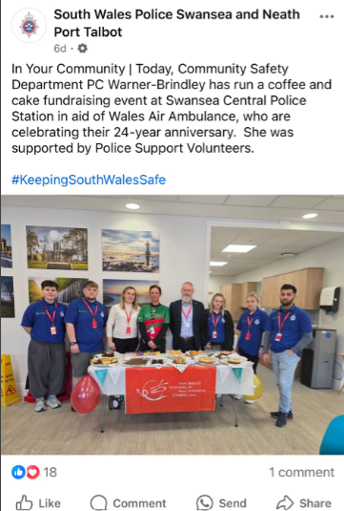

There are things went well like, working as a team as I managed stalls and decorations with ease while collaborating with other volunteers. Moreover, strong community support was demonstrated by the cake sale and donations, which surpassed expectations.
During this event, I could improve customer service, teamwork and adaptability. However, I acknowledged my qualities, such as teamwork, even as I pointed out places for improvement. Above all, I developed a deep appreciation for the volunteers and members of Wales Air Ambulance.
To be better next time, I will find out from the organisers how I may play a better part in upcoming events.
Another experience I had during the 80 hours was in Port Talbot where we delivered crime prevention advice to people. My role was to focus on telling people about 2 key areas, which were hate crime awareness and cybercrime prevention. This involved setting up an information table, giving leaflets, and having one-on-one conversations with community members about recognising, and protecting themselves from these crimes. The event took place at Port Talbot Aberafan Shopping Centre and attracted alot of people attending ranging from teenagers to elderly residents.
I felt proud by seeing people understood prevention strategies and I was motivated by the impact of helping people feel safer.
Here is a photo for me and my colleagues at Port Talbo shopping Centre with the leaflets we had and the volunteering blue volunteering T shirt we were wearing with a logo of SWP on them .
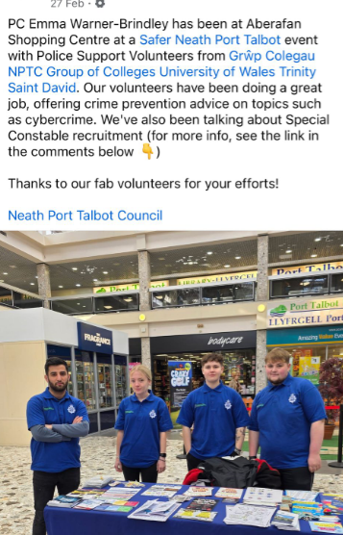

Conclusion
To conclude, my experience volunteering with South Wales Police was very pleasant and helped me improve my communication skills while having significant effects. Additionally, I learnt how to adapt complicated information for a range of audiences, from teenagers to elderlies, by giving crime prevention advice on topics like hate crimes and cybercrime. I also learnt a lot about the difficulties of community policing and the value of public trust from volunteering with police. Moreover, the experience helped me understand how socioeconomic variables influence criminal vulnerability and increased my ability to engage with other cultural perspectives.
While I was successful in advising many residents about safety methods, I also recognised areas for improvement, such as simplifying technical ideas and resolving reporting worry.
I highly suggest volunteering with South Wales Police to anyone looking for a good community involvement. Moreover, this position provides excellent opportunity for developing transferable skill while contributing to public safety. Finally, whether being thinking about a future in working with the police or just want to help others and be an active member in the society, this volunteering gives a practical experience outside the educational environment as will deliver unique policing insights, increases employability, and provides the fulfilling experience of personally assisting vulnerable people..

References

Brewis, G. Holdsworth, C (2011). ‘University Support for Student Volunteering in England: Historical Development and Contemporary Value’. Journal of Academic Ethics. Dordrecht Vol. 9, 165-176. Available at: https://www-citethemrightonline-com.ezproxy.uwtsd.ac.uk/sourcetype?docid=b-9781350927964&tocid=b-9781350927964-27&st=journal.
College of Policing (2013). Engagement. Available at: https://www.college.police.uk/app/engagement-and-communication/engagement#:~:text=Benefits%20of%20effective%20engagement,-Evidence%20has%20indicated&text=an%20increase%20in%20public%20perceptions,see%20engagement%20and%20police%20legitimacy. Accessed: 26th/03/2025).
National Crime Agency (2025). Cybercrime. Available at: https://www.nationalcrimeagency.gov.uk/what-we-do/crime-threats/cybercrime (Accessed: 26th/03/2025).
National Cyber Security Centre (2018). Top tips for staying secure online. Available at: https://www.ncsc.gov.uk/collection/top-tips-for-staying-secure-online/use-a-strong-and-separate-password-for-email. (Accessed: 27th/03/2025).
PeoplePluse (2024). The Benefits of Volunteering and How It Can Boost Your Career. Available at: https://peopleplus.co.uk/newsitem/the-benefits-of-volunteering-and-how-it-can-boost-your-career (Accessed: 26th/03/2025).
South Wales Police (2025). Overview. Available at: https://www.south-wales.police.uk/police-forces/south-wales-police/areas/about-us/about-us/overview/ (Accessed: 26th/03/2025).
St John Ambulance (2025). Swansea Help Point. Available at: https://www.sjacymru.org.uk/en/page/swansea-help-point. (Accessed: 26th/03/2025).
South Wales Police (2025). Police Support Volunteers. Available at: https://www.heddlu-de-cymru.police.uk/police-forces/south-wales-police/areas/careers/careers/volunteers-and-special-constables/police-support-volunteers/#:~:text=Volunteers%20are%20vetted%20and%20can,initiatives%2C%20and%20supporting%20witness%20care. (Accessed: 26/03/2025).
South Wales Police (2025). Police Support Volunteers Useful Information. Available at: https://www.south-wales.police.uk/police-forces/south-wales-police/areas/careers/careers/volunteers-and-special-constables/police-support-volunteers-useful-information/. (Accessed: 26/03/2025).

South Wales Police (2023). Policing with Purpose. Available at: https://www.south-wales.police.uk/police-forces/south-wales-police/areas/about-us/about-us/policing-with-purpose/#:~:text=Policing%20with%20Purpose%20is%20our,determined%20to%20protect%20vulnerable%20people. (Accessed: 26th/03/2025).

South Wales Police Swansea and Neath Port Talbot (2025). ‘In Your Community’. [Facebook]. 21 March. Available at: https://www.facebook.com/photo/?fbid=1104590955037682&set=a.679544487542333. (Accessed: 27th/03/2025).

South Wales Police Swansea and Neath Port Talbot (2025). ‘PC Emma Warner-Brindley has been at Aberafan Shopping Centre at a Safer Neath Port Talbot event with Police Support Volunteers from Grwp Colegaun NPTC Group of Colleges University of Wales Trinity Saint David’. 27 February. Available at:
https://www.facebook.com/SWPSwanseaNPT/posts/pfbid02CurLyzjCavf5rwJCiELkkdw8j9btuD9W2maCSocsDPoKWoz1w38ScUqUeYVPbnWZl. (Accessed:27/03/2025).

South Wales Police Cyber Crime Unit (2025). Keeping yourself safe Online. [leaflet].
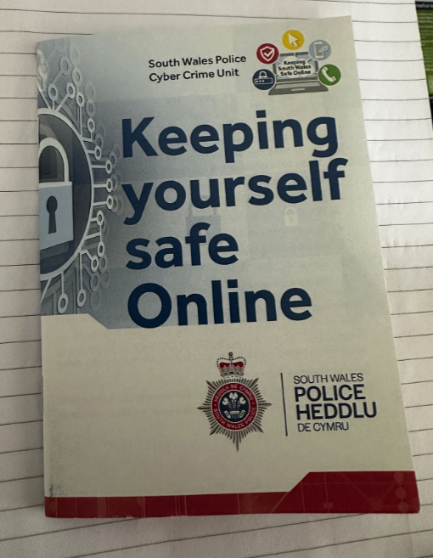
(Obtained: 12th/02/2025).
South Wales Police (2025). A GOUIDE T STAYING SAFE ONLINE KNOW IT ALL. [leaflet].
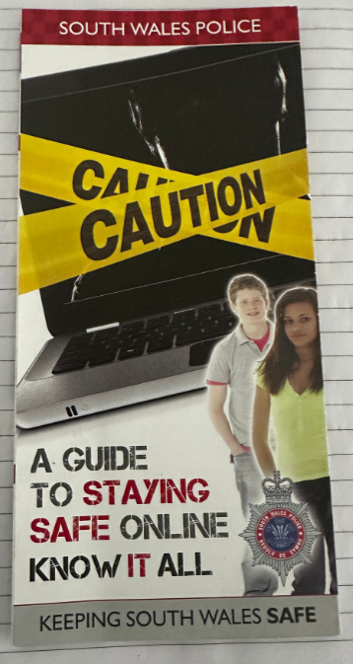
(Obtained: 12th/02/2025).
Stop Hate UK (2022). About Hate Crime. Available at: https://www.stophateuk.org/about-hate-crime/. (Accessed: 27th/03/2025).
Wales Air Ambulance (2025). Wales Air Ambulance marks 24 years of its lifesaving service on St David’s Day. Available at: https://www.walesairambulance.com/news/wales-air-ambulance-marks-24-years-of-its-lifesaving-service-on-st-davids-day. (Accessed: 27th/03/2025).

