Contents page here. Cover page Previous.

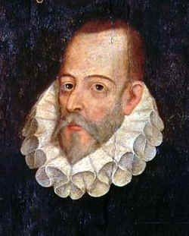

“ This person whom you see here, with an oval visage, chestnut hair, smooth open forehead, lively eyes, a hooked but well-proportioned nose, and silvery beard that twenty years ago was golden, large moustaches, a small mouth, teeth not much to speak of, for he has but six, in bad condition and worse placed, no two of them corresponding to each other, a figure midway between the two extremes, neither tall nor short, a vivid complexion, rather fair than dark, somewhat stooped in the shoulders, and not very lightfooted: this, I say, is the author of Galatea, Don Quixote de la Mancha, The Journey to Parnassus, which he wrote in imitation of Cesare Caporali Perusino, and other works which are current among the public, and perhaps without the author's name. He is commonly called MIGUEL DE CERVANTES SAAVEDRA. ”
— Miguel de Cervantes, Exemplary Novels (Author's Preface (Cervantes, 1605))

Don Quixote
Apply the following Styles:
Title to “Don Quixote”.
Heading one to all VOLUME headings
Heading two to all Chapter numbers
Heading three to all chapter headings
Heading four to all paragraph headings.
(Cervantes, 1605)
VOLUME I.
CHAPTER I.
WHICH TREATS OF THE CHARACTER AND PURSUITS OF THE FAMOUS GENTLEMAN DON QUIXOTE OF LA MANCHA
Paragraph One
In a village of La Mancha, the name of which I have no desire to call to mind, there lived not long since one of those gentlemen that keep:
a lance in the lance-rack
an old buckler
a lean hack
and a greyhound for coursing.

An olla of rather more beef than mutton, a salad on most nights, scraps on Saturdays, lentils on Fridays, and a pigeon or so extra on Sundays, made away with three-quarters of his income. The rest of it went in a doublet of fine cloth and velvet breeches and shoes to match for holidays, while on week-days he made a brave figure in his best homespun. He had in his house a housekeeper past forty, a niece under twenty, and a lad for the field and market-place, who used to saddle the hack as well as handle the bill-hook. The age of this gentleman of ours was bordering on fifty; he was of a hardy habit, spare, gaunt-featured, a very early riser and a great sportsman. They will have it his surname was Quixada or Quesada (for here there is some difference of opinion among the authors who write on the subject), although from reasonable conjectures it seems plain that he was called Quexana. This, however, is of but little importance to our tale; it will be enough not to stray a hair's breadth from the truth in the telling of it. (Cervantes, 1605)
Paragraph Two

You must know, then, that the above-named gentleman whenever he was at leisure (which was mostly all the year round) gave himself up to reading books of chivalry with such ardour and avidity that he almost entirely neglected the pursuit of his field-sports, and even the management of his property; and to such a pitch did his eagerness and infatuation go that he sold many an acre of tillage land to buy books of chivalry to read, and brought home as many of them as he could get (Dore, 1982). But of all there were none he liked so well as those of the famous Feliciano de Silva's composition, for their lucidity of style and complicated conceits were as pearls in his sight, particularly when in his reading he came upon courtships and cartels, where he often found passages like "the reason of the unreason with which my reason is afflicted so weakens my reason that with reason I murmur at your beauty;" or again, "the high heavens, that of your divinity divinely fortify you with the stars, render you deserving of the desert your greatness deserves." Over conceits of this sort the poor gentleman lost his wits, and used to lie awake striving to understand them and worm the meaning out of them; what Aristotle himself could not have made out or extracted had he come to life again for that special purpose.

Paragraph Three
He was not at all easy about the wounds which Don Belianis gave and took, because it seemed to him that, great as were the surgeons who had cured him, he must have had his face and body covered all over with seams and scars (Gorfkle, 1993). He commended, however, the author's way of ending his book with the promise of that interminable adventure, and many a time was he tempted to take up his pen and finish it properly as is there proposed, which no doubt he would have done, and made a successful piece of work of it too, had not greater and more absorbing thoughts prevented him. Many an argument did he have with the curate of his village (a learned man, and a graduate of Siguenza) as to which had been the better knight, Palmerin of England or Amadis of Gaul. Master Nicholas, the village barber, however, used to say that neither of them came up to the Knight of Phoebus, and that if there was any that could compare with him it was Don Galaor, the brother of Amadis of Gaul, because he had a spirit that was equal to every occasion, and was no finikin knight, nor lachrymose like his brother, while in the matter of valour he was not a whit behind him. In short, he became so absorbed in his books that he spent his nights from sunset to sunrise, and his days from dawn to dark, poring over them; and what with little sleep and much reading his brains got so dry that he lost his wits. His fancy grew full of what he used to read about in his books, enchantments, quarrels, battles, challenges, wounds, wooings, loves, agonies, and all sorts of impossible nonsense; and it so possessed his mind that the whole fabric of invention and fancy he read of was true, that to him no history in the world had more reality in it.
Paragraph four
But hardly had day begun to show itself through the balconies of the east, when five of the six goatherds came to rouse Don Quixote and tell him that if he was still of a mind to go and see the famous burial of Chrysostom they would bear him company. Don Quixote, who desired nothing
better, rose and ordered Sancho to saddle and pannel at once, which he did with all despatch, and with the same they all set out forthwith (Echevarría, 2005). They had not gone a quarter of a league when at the meeting of two paths they saw coming towards them some six shepherds dressed in black sheepskins and with their heads crowned with garlands of cypress and bitter oleander. Each of them carried a stout holly staff in his hand, and along with them there came two men of quality on horseback in handsome travelling dress, with three servants on foot accompanying them.
Courteous salutations were exchanged on meeting, and inquiring one of the other which way each party was going, they learned that all were bound for the scene of the burial, so they went on all together.

One of those on horseback addressing his companion said to him, "It seems to me, Senor Vivaldo, that we may reckon as well spent the delay we shall incur in seeing this remarkable funeral, for remarkable it cannot but be judging by the strange things these shepherds have told us, of both the
dead shepherd and homicide shepherdess."

"So I think too," replied Vivaldo, "and I would delay not to say a day, but four, for the sake of seeing it."

Don Quixote asked them what it was they had heard of Marcela and Chrysostom. The traveller answered that the same morning they had met these shepherds, and seeing them dressed in this mournful fashion they had asked them the reason of their appearing in such a guise; which one
of them gave, describing the strange behaviour and beauty of a shepherdess called Marcela, and the loves of many who courted her, together with the death of that Chrysostom to whose burial they were going. In short, he repeated all that Pedro had related to Don Quixote.

http://en.wikipedia.org/wiki/Miguel_de_Cervantes
Copy a reference from the above link and create it as a source in citations manager
Insert a Section break, next 2 pages landscaped and numbered in roman numerals from iv
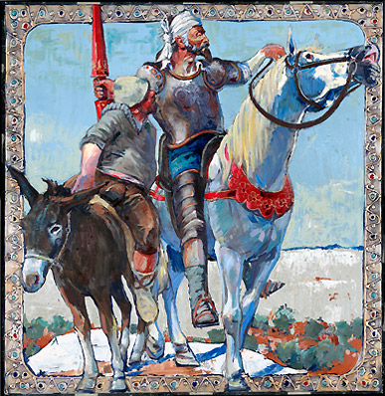
Paragraph five
In a village of La Mancha, the name of which I have no desire to call to mind, there lived not long since one of those gentlemen that keep a lance in the lance-rack, an old buckler, a lean hack, and a greyhound for coursing. An olla of rather more beef than mutton, a salad on most nights, scraps on Saturdays, lentils on Fridays, and a pigeon or so extra on Sundays, made away with three-quarters of his income. The rest of it went in a doublet of fine cloth and velvet breeches and shoes to match for holidays, while on week-days he made a brave figure in his best homespun (Linsalata, 1956.). He had in his house a housekeeper past forty, a niece under twenty, and a lad for the field and market-place, who used to saddle the hack as well as handle the bill-hook. The age of this gentleman of ours was bordering on fifty; he was of a hardy habit, spare, gaunt-featured, a very early riser and a great sportsman. They will have it his surname was Quixada or Quesada (for here there is some difference of opinion among the authors who write on the subject), although from reasonable conjectures it seems plain that he was called Quexana. This, however, is of but little importance to our tale; it will be enough not to stray a hair's breadth from the truth in the telling of it.

CHAPTER IV

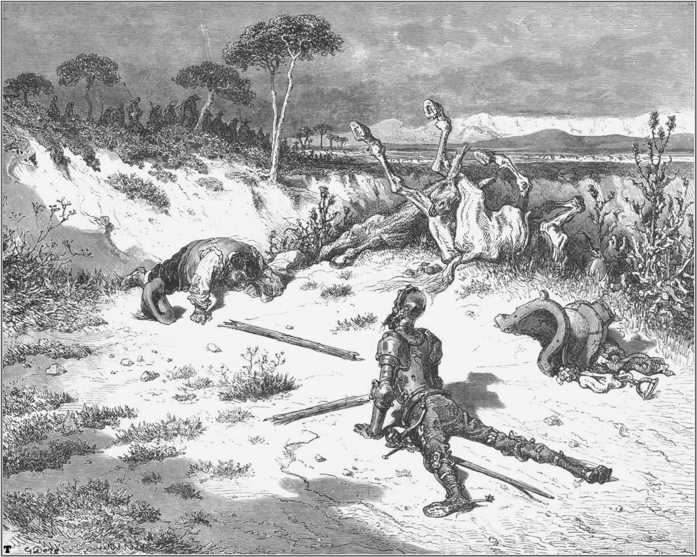
OF WHAT HAPPENED TO OUR KNIGHT WHEN HE LEFT THE INN

Paragraph six
In a village of La Mancha, the name of which I have no desire to call to mind, there lived not long since one of those gentlemen that keep a lance in the lance-rack, an old buckler, a lean hack, and a greyhound for coursing. An olla of rather more beef than mutton, a salad on most nights, scraps on Saturdays, lentils on Fridays, and a pigeon or so extra on Sundays, made away with three-quarters of his income. The rest of it went in a doublet of fine cloth and velvet breeches and shoes to match for holidays, while on week-days he made a brave figure in his best homespun. He had in his house a housekeeper past forty, a niece under twenty, and a lad for the field and market-place, who used to saddle the hack as well as handle the bill-hook. The age of this gentleman of ours was bordering on fifty; he was of a hardy habit, spare, gaunt-featured, a very early riser and a great sportsman. They will have it his surname was Quixada or Quesada (for here there is some difference of opinion among the authors who write on the subject), although from reasonable conjectures it seems plain that he was called Quexana. This, however, is of but little importance to our tale; it will be enough not to stray a hair's breadth from the truth in the telling of it.

CHAPTER V

IN WHICH THE NARRATIVE OF OUR KNIGHT'S MISHAP IS CONTINUED
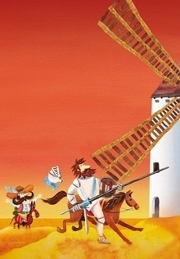

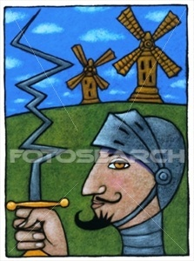
Stock Illustration - Don Quixote
TCL009 Photodisc (Illustration) Royalty Free Photograph.
http://www.fotosearch.com

CHAPTER VI
OF THE DIVERTING AND IMPORTANT SCRUTINY WHICH THE CURATE AND THE BARBER MADE IN THE LIBRARY OF OUR INGENIOUS GENTLEMAN

Paragraph seven
In a village of La Mancha, the name of which I have no desire to call to mind, there lived not long since one of those gentlemen that keep a lance in the lance-rack, an old buckler, a lean hack, and a greyhound for coursing. An olla of rather more beef than mutton, a salad on most nights, scraps on Saturdays, lentils on Fridays, and a pigeon or so extra on Sundays, made away with three-quarters of his income. The rest of it went in a doublet of fine cloth and velvet breeches and shoes to match for holidays, while on week-days he made a brave figure in his best homespun. He had in his house a housekeeper past forty, a niece under twenty, and a lad for the field and market-place, who used to saddle the hack as well as handle the bill-hook. The age of this gentleman of ours was bordering on fifty; he was of a hardy habit, spare, gaunt-featured, a very early riser and a great sportsman. They will have it his surname was Quixada or Quesada (for here there is some difference of opinion among the authors who write on the subject), although from reasonable conjectures it seems plain that he was called Quexana. This, however, is of but little importance to our tale; it will be enough not to stray a hair's breadth from the truth in the telling of it.

CHAPTER VII

OF THE SECOND SALLY OF OUR WORTHY KNIGHT DON QUIXOTE OF LA MANCHA

Paragraph eight
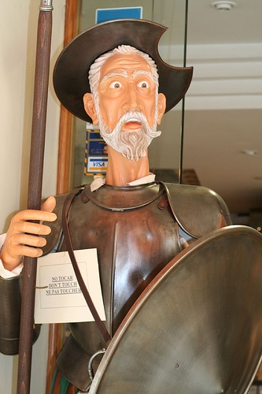
In a village of La Mancha, the name of which I have no desire to call to mind, there lived not long since one of those gentlemen that keep a lance in the lance-rack, an old buckler, a lean hack, and a greyhound for coursing. An olla of rather more beef than mutton, a salad on most nights, scraps on Saturdays, lentils on Fridays, and a pigeon or so extra on Sundays, made away with three-quarters of his income. The rest of it went in a doublet of fine cloth and velvet breeches and shoes to match for holidays, while on week-days he made a brave figure in his best homespun. He had in his house a housekeeper past forty, a niece under twenty, and a lad for the field and market-place, who used to saddle the hack as well as handle the bill-hook. The age of this gentleman of ours was bordering on fifty; he was of a hardy habit, spare, gaunt-featured, a very early riser and a great sportsman. They will have it his surname was Quixada or Quesada (for here there is some difference of opinion among the authors who write on the subject), although from reasonable conjectures it seems plain that he was called Quexana. This, however, is of but little importance to our tale; it will be enough not to stray a hair's breadth from the truth in the telling of it.

CHAPTER VIII
OF THE GOOD FORTUNE WHICH THE VALIANT DON QUIXOTE HAD IN THE TERRIBLE AND UNDREAMT-OF ADVENTURE OF THE WINDMILLS, WITH OTHER OCCURRENCES WORTHY TO BE FITLY RECORDED
Insert a simple spreadsheet & graph

CHAPTER IX
IN WHICH IS CONCLUDED AND FINISHED THE TERRIFIC BATTLE BETWEEN THE GALLANT BISCAYAN AND THE VALIANT MANCHEGAN

Insert a simple Table

CHAPTER X
OF THE PLEASANT DISCOURSE THAT PASSED BETWEEN DON QUIXOTE AND HIS SQUIRE SANCHO PANZA
But hardly had day begun to show itself through the balconies of the
east, when five of the six goatherds came to rouse Don Quixote and tell
him that if he was still of a mind to go and see the famous burial of
Chrysostom they would bear him company. Don Quixote, who desired nothing
better, rose and ordered Sancho to saddle and pannel at once, which he
did with all despatch, and with the same they all set out forthwith. They
had not gone a quarter of a league when at the meeting of two paths they
saw coming towards them some six shepherds dressed in black sheepskins
and with their heads crowned with garlands of cypress and bitter
oleander. Each of them carried a stout holly staff in his hand, and along
with them there came two men of quality on horseback in handsome
travelling dress, with three servants on foot accompanying them.
Courteous salutations were exchanged on meeting, and inquiring one of the
other which way each party was going, they learned that all were bound
for the scene of the burial, so they went on all together.

One of those on horseback addressing his companion said to him, "It seems
to me, Senor Vivaldo, that we may reckon as well spent the delay we shall
incur in seeing this remarkable funeral, for remarkable it cannot but be
judging by the strange things these shepherds have told us, of both the
dead shepherd and homicide shepherdess."

"So I think too," replied Vivaldo, "and I would delay not to say a day,
but four, for the sake of seeing it."

Don Quixote asked them what it was they had heard of Marcela and
Chrysostom. The traveller answered that the same morning they had met
these shepherds, and seeing them dressed in this mournful fashion they
had asked them the reason of their appearing in such a guise; which one
of them gave, describing the strange behaviour and beauty of a
shepherdess called Marcela, and the loves of many who courted her,
together with the death of that Chrysostom to whose burial they were
going. In short, he repeated all that Pedro had related to Don Quixote.

CHAPTER XI

OF WHAT BEFELL DON QUIXOTE WITH CERTAIN GOATHERDS
But hardly had day begun to show itself through the balconies of the
east, when five of the six goatherds came to rouse Don Quixote and tell
him that if he was still of a mind to go and see the famous burial of
Chrysostom they would bear him company. Don Quixote, who desired nothing
better, rose and ordered Sancho to saddle and pannel at once, which he
did with all despatch, and with the same they all set out forthwith. They
had not gone a quarter of a league when at the meeting of two paths they
saw coming towards them some six shepherds dressed in black sheepskins
and with their heads crowned with garlands of cypress and bitter
oleander. Each of them carried a stout holly staff in his hand, and along
with them there came two men of quality on horseback in handsome
travelling dress, with three servants on foot accompanying them.
Courteous salutations were exchanged on meeting, and inquiring one of the
other which way each party was going, they learned that all were bound
for the scene of the burial, so they went on all together.
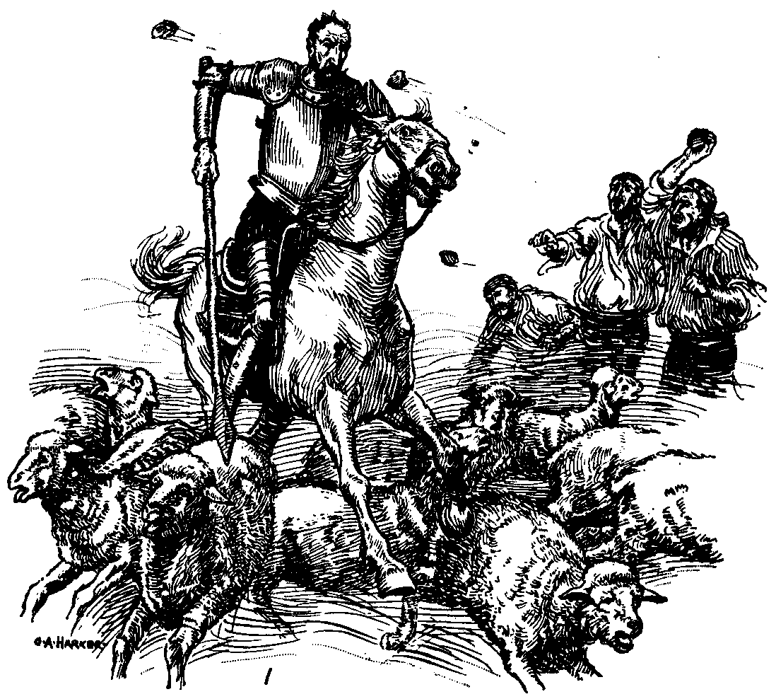
One of those on horseback addressing his companion said to him, "It seems
to me, Senor Vivaldo, that we may reckon as well spent the delay we shall
incur in seeing this remarkable funeral, for remarkable it cannot but be
judging by the strange things these shepherds have told us, of both the
dead shepherd and homicide shepherdess."

"So I think too," replied Vivaldo, "and I would delay not to say a day,
but four, for the sake of seeing it."

Don Quixote asked them what it was they had heard of Marcela and
Chrysostom. The traveller answered that the same morning they had met
these shepherds, and seeing them dressed in this mournful fashion they
had asked them the reason of their appearing in such a guise; which one
of them gave, describing the strange behaviour and beauty of a
shepherdess called Marcela, and the loves of many who courted her,
together with the death of that Chrysostom to whose burial they were
going. In short, he repeated all that Pedro had related to Don Quixote.

CHAPTER XII

OF WHAT A GOATHERD RELATED TO THOSE WITH DON QUIXOTE
To all this Sancho listened with no little sorrow at heart to see how his
hopes of dignity were fading away and vanishing in smoke, and how the
fair Princess Micomicona had turned into Dorothea, and the giant into Don
Fernando, while his master was sleeping tranquilly, totally unconscious
of all that had come to pass. Dorothea was unable to persuade herself
that her present happiness was not all a dream; Cardenio was in a similar
state of mind, and Luscinda's thoughts ran in the same direction. Don
Fernando gave thanks to Heaven for the favour shown to him and for having
been rescued from the intricate labyrinth in which he had been brought so
near the destruction of his good name and of his soul; and in short
everybody in the inn was full of contentment and satisfaction at the
happy issue of such a complicated and hopeless business. The curate as a
sensible man made sound reflections upon the whole affair, and
congratulated each upon his good fortune; but the one that was in the
highest spirits and good humour was the landlady, because of the promise
Cardenio and the curate had given her to pay for all the losses and
damage she had sustained through Don Quixote's means. Sancho, as has been
already said, was the only one who was distressed, unhappy, and dejected;
and so with a long face he went in to his master, who had just awoke, and
said to him:

"Sir Rueful Countenance, your worship may as well sleep on as much as you
like, without troubling yourself about killing any giant or restoring her
kingdom to the princess; for that is all over and settled now."

"I should think it was," replied Don Quixote, "for I have had the most
prodigious and stupendous battle with the giant that I ever remember
having had all the days of my life; and with one back-stroke-swish!—
brought his head tumbling to the ground, and so much blood gushed forth
from him that it ran in rivulets over the earth like water."

CHAPTER XIII
IN WHICH IS ENDED THE STORY OF THE SHEPHERDESS MARCELA, WITH OTHER INCIDENTS
But hardly had day begun to show itself through the balconies of the
east, when five of the six goatherds came to rouse Don Quixote and tell
him that if he was still of a mind to go and see the famous burial of
Chrysostom they would bear him company. Don Quixote, who desired nothing
better, rose and ordered Sancho to saddle and pannel at once, which he
did with all despatch, and with the same they all set out forthwith. They
had not gone a quarter of a league when at the meeting of two paths they
saw coming towards them some six shepherds dressed in black sheepskins
and with their heads crowned with garlands of cypress and bitter
oleander. Each of them carried a stout holly staff in his hand, and along
with them there came two men of quality on horseback in handsome
travelling dress, with three servants on foot accompanying them.
Courteous salutations were exchanged on meeting, and inquiring one of the
other which way each party was going, they learned that all were bound
for the scene of the burial, so they went on all together.

One of those on horseback addressing his companion said to him, "It seems
to me, Senor Vivaldo, that we may reckon as well spent the delay we shall
incur in seeing this remarkable funeral, for remarkable it cannot but be
judging by the strange things these shepherds have told us, of both the
dead shepherd and homicide shepherdess."

"So I think too," replied Vivaldo, "and I would delay not to say a day,
but four, for the sake of seeing it."

Don Quixote asked them what it was they had heard of Marcela and
Chrysostom. The traveller answered that the same morning they had met
these shepherds, and seeing them dressed in this mournful fashion they
had asked them the reason of their appearing in such a guise; which one
of them gave, describing the strange behaviour and beauty of a
shepherdess called Marcela, and the loves of many who courted her,
together with the death of that Chrysostom to whose burial they were
going. In short, he repeated all that Pedro had related to Don Quixote.

CHAPTER XIV
WHEREIN ARE INSERTED THE DESPAIRING VERSES OF THE DEAD SHEPHERD, TOGETHER WITH OTHER INCIDENTS NOT LOOKED FOR
To all this Sancho listened with no little sorrow at heart to see how his
hopes of dignity were fading away and vanishing in smoke, and how the
fair Princess Micomicona had turned into Dorothea, and the giant into Don
Fernando, while his master was sleeping tranquilly, totally unconscious
of all that had come to pass. Dorothea was unable to persuade herself
that her present happiness was not all a dream; Cardenio was in a similar
state of mind, and Luscinda's thoughts ran in the same direction. Don
Fernando gave thanks to Heaven for the favour shown to him and for having
been rescued from the intricate labyrinth in which he had been brought so
near the destruction of his good name and of his soul; and in short
everybody in the inn was full of contentment and satisfaction at the
happy issue of such a complicated and hopeless business. The curate as a
sensible man made sound reflections upon the whole affair, and
congratulated each upon his good fortune; but the one that was in the
highest spirits and good humour was the landlady, because of the promise
Cardenio and the curate had given her to pay for all the losses and
damage she had sustained through Don Quixote's means. Sancho, as has been
already said, was the only one who was distressed, unhappy, and dejected;
and so with a long face he went in to his master, who had just awoke, and
said to him:

"Sir Rueful Countenance, your worship may as well sleep on as much as you
like, without troubling yourself about killing any giant or restoring her
kingdom to the princess; for that is all over and settled now."

"I should think it was," replied Don Quixote, "for I have had the most
prodigious and stupendous battle with the giant that I ever remember
having had all the days of my life; and with one back-stroke-swish!--I
brought his head tumbling to the ground, and so much blood gushed forth
from him that it ran in rivulets over the earth like water."

CHAPTER XV
IN WHICH IS RELATED THE UNFORTUNATE ADVENTURE THAT DON QUIXOTE FELL IN WITH WHEN HE FELL OUT WITH CERTAIN HEARTLESS YANGUESANS
But hardly had day begun to show itself through the balconies of the
east, when five of the six goatherds came to rouse Don Quixote and tell
him that if he was still of a mind to go and see the famous burial of
Chrysostom they would bear him company. Don Quixote, who desired nothing
better, rose and ordered Sancho to saddle and pannel at once, which he
did with all despatch, and with the same they all set out forthwith. They
had not gone a quarter of a league when at the meeting of two paths they
saw coming towards them some six shepherds dressed in black sheepskins
and with their heads crowned with garlands of cypress and bitter
oleander. Each of them carried a stout holly staff in his hand, and along
with them there came two men of quality on horseback in handsome
travelling dress, with three servants on foot accompanying them.
Courteous salutations were exchanged on meeting, and inquiring one of the
other which way each party was going, they learned that all were bound
for the scene of the burial, so they went on all together.

One of those on horseback addressing his companion said to him, "It seems
to me, Senor Vivaldo, that we may reckon as well spent the delay we shall
incur in seeing this remarkable funeral, for remarkable it cannot but be
judging by the strange things these shepherds have told us, of both the
dead shepherd and homicide shepherdess."

"So I think too," replied Vivaldo, "and I would delay not to say a day,
but four, for the sake of seeing it."

Don Quixote asked them what it was they had heard of Marcela and
Chrysostom. The traveller answered that the same morning they had met
these shepherds, and seeing them dressed in this mournful fashion they
had asked them the reason of their appearing in such a guise; which one
of them gave, describing the strange behaviour and beauty of a
shepherdess called Marcela, and the loves of many who courted her,
together with the death of that Chrysostom to whose burial they were
going. In short, he repeated all that Pedro had related to Don Quixote.

CHAPTER XVI
OF WHAT HAPPENED TO THE INGENIOUS GENTLEMAN IN THE INN WHICH HE TOOK TO BE A CASTLE
To all this Sancho listened with no little sorrow at heart to see how his
hopes of dignity were fading away and vanishing in smoke, and how the
fair Princess Micomicona had turned into Dorothea, and the giant into Don
Fernando, while his master was sleeping tranquilly, totally unconscious
of all that had come to pass. Dorothea was unable to persuade herself
that her present happiness was not all a dream; Cardenio was in a similar
state of mind, and Luscinda's thoughts ran in the same direction. Don
Fernando gave thanks to Heaven for the favour shown to him and for having
been rescued from the intricate labyrinth in which he had been brought so
near the destruction of his good name and of his soul; and in short
everybody in the inn was full of contentment and satisfaction at the
happy issue of such a complicated and hopeless business. The curate as a
sensible man made sound reflections upon the whole affair, and
congratulated each upon his good fortune; but the one that was in the
highest spirits and good humour was the landlady, because of the promise
Cardenio and the curate had given her to pay for all the losses and
damage she had sustained through Don Quixote's means. Sancho, as has been
already said, was the only one who was distressed, unhappy, and dejected;
and so with a long face he went in to his master, who had just awoke, and
said to him:

"Sir Rueful Countenance, your worship may as well sleep on as much as you
like, without troubling yourself about killing any giant or restoring her
kingdom to the princess; for that is all over and settled now."

"I should think it was," replied Don Quixote, "for I have had the most
prodigious and stupendous battle with the giant that I ever remember
having had all the days of my life; and with one back-stroke-swish!--I
brought his head tumbling to the ground, and so much blood gushed forth
from him that it ran in rivulets over the earth like water."

CHAPTER XVII
IN WHICH ARE CONTAINED THE INNUMERABLE TROUBLES WHICH THE BRAVE DON QUIXOTE AND HIS GOOD SQUIRE SANCHO PANZA ENDURED IN THE INN, WHICH TO HIS MISFORTUNE HE TOOK TO BE A CASTLE
But hardly had day begun to show itself through the balconies of the
east, when five of the six goatherds came to rouse Don Quixote and tell
him that if he was still of a mind to go and see the famous burial of
Chrysostom they would bear him company. Don Quixote, who desired nothing
better, rose and ordered Sancho to saddle and pannel at once, which he
did with all despatch, and with the same they all set out forthwith. They
had not gone a quarter of a league when at the meeting of two paths they
saw coming towards them some six shepherds dressed in black sheepskins
and with their heads crowned with garlands of cypress and bitter
oleander. Each of them carried a stout holly staff in his hand, and along
with them there came two men of quality on horseback in handsome
travelling dress, with three servants on foot accompanying them.
Courteous salutations were exchanged on meeting, and inquiring one of the
other which way each party was going, they learned that all were bound
for the scene of the burial, so they went on all together.

One of those on horseback addressing his companion said to him, "It seems
to me, Senor Vivaldo, that we may reckon as well spent the delay we shall
incur in seeing this remarkable funeral, for remarkable it cannot but be
judging by the strange things these shepherds have told us, of both the
dead shepherd and homicide shepherdess."

"So I think too," replied Vivaldo, "and I would delay not to say a day,
but four, for the sake of seeing it."

Don Quixote asked them what it was they had heard of Marcela and
Chrysostom. The traveller answered that the same morning they had met
these shepherds, and seeing them dressed in this mournful fashion they
had asked them the reason of their appearing in such a guise; which one
of them gave, describing the strange behaviour and beauty of a
shepherdess called Marcela, and the loves of many who courted her,
together with the death of that Chrysostom to whose burial they were
going. In short, he repeated all that Pedro had related to Don Quixote.

CHAPTER XVIII
IN WHICH IS RELATED THE DISCOURSE SANCHO PANZA HELD WITH HIS MASTER, DON QUIXOTE, AND OTHER ADVENTURES WORTH RELATING
To all this Sancho listened with no little sorrow at heart to see how his
hopes of dignity were fading away and vanishing in smoke, and how the
fair Princess Micomicona had turned into Dorothea, and the giant into Don
Fernando, while his master was sleeping tranquilly, totally unconscious
of all that had come to pass. Dorothea was unable to persuade herself
that her present happiness was not all a dream; Cardenio was in a similar
state of mind, and Luscinda's thoughts ran in the same direction. Don
Fernando gave thanks to Heaven for the favour shown to him and for having
been rescued from the intricate labyrinth in which he had been brought so
near the destruction of his good name and of his soul; and in short
everybody in the inn was full of contentment and satisfaction at the
happy issue of such a complicated and hopeless business. The curate as a
sensible man made sound reflections upon the whole affair, and
congratulated each upon his good fortune; but the one that was in the
highest spirits and good humour was the landlady, because of the promise
Cardenio and the curate had given her to pay for all the losses and
damage she had sustained through Don Quixote's means. Sancho, as has been
already said, was the only one who was distressed, unhappy, and dejected;
and so with a long face he went in to his master, who had just awoke, and
said to him:

"Sir Rueful Countenance, your worship may as well sleep on as much as you
like, without troubling yourself about killing any giant or restoring her
kingdom to the princess; for that is all over and settled now."

"I should think it was," replied Don Quixote, "for I have had the most
prodigious and stupendous battle with the giant that I ever remember
having had all the days of my life; and with one back-stroke-swish!--I
brought his head tumbling to the ground, and so much blood gushed forth
from him that it ran in rivulets over the earth like water."

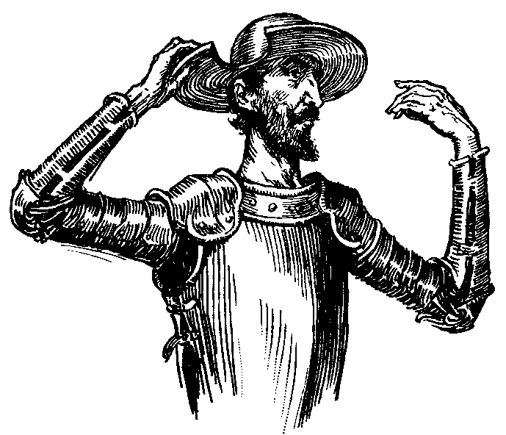

CHAPTER XIX
OF THE SHREWD DISCOURSE WHICH SANCHO HELD WITH HIS MASTER, AND OF THE ADVENTURE THAT BEFELL HIM WITH A DEAD BODY, TOGETHER WITH OTHER NOTABLE OCCURRENCES
But hardly had day begun to show itself through the balconies of the
east, when five of the six goatherds came to rouse Don Quixote and tell
him that if he was still of a mind to go and see the famous burial of
Chrysostom they would bear him company. Don Quixote, who desired nothing
better, rose and ordered Sancho to saddle and pannel at once, which he
did with all despatch, and with the same they all set out forthwith. They
had not gone a quarter of a league when at the meeting of two paths they
saw coming towards them some six shepherds dressed in black sheepskins
and with their heads crowned with garlands of cypress and bitter
oleander. Each of them carried a stout holly staff in his hand, and along
with them there came two men of quality on horseback in handsome
travelling dress, with three servants on foot accompanying them.
Courteous salutations were exchanged on meeting, and inquiring one of the
other which way each party was going, they learned that all were bound
for the scene of the burial, so they went on all together.

One of those on horseback addressing his companion said to him, "It seems
to me, Senor Vivaldo, that we may reckon as well spent the delay we shall
incur in seeing this remarkable funeral, for remarkable it cannot but be
judging by the strange things these shepherds have told us, of both the
dead shepherd and homicide shepherdess."

"So I think too," replied Vivaldo, "and I would delay not to say a day,
but four, for the sake of seeing it."

Don Quixote asked them what it was they had heard of Marcela and
Chrysostom. The traveller answered that the same morning they had met
these shepherds, and seeing them dressed in this mournful fashion they
had asked them the reason of their appearing in such a guise; which one
of them gave, describing the strange behaviour and beauty of a
shepherdess called Marcela, and the loves of many who courted her,
together with the death of that Chrysostom to whose burial they were
going. In short, he repeated all that Pedro had related to Don Quixote.
Insert a bibliography

Works Cited
Allen, J. ( 1979. ). Don Quixote, . University of Florida Press.
Bauer, S. (2003). The Well-Educated Mind: A Guide to the Classical Education You Never Had (1st ed.). W.W. Norton & Co.
Cervantes, M. d. (1605). Don Quixote. Retrieved October 2006, from Project Gutenberg: www.gutenberg.net
Church, M. (1983). Structure and theme--Don Quixote to James Joyce. Des Moines: Ohio State University Press.
Dore, G. ( 1982). Dore's Illustrations for Don Quixote illustrated edition. Dover Publications.
Echevarría, R. (2005). Cervantes' Don Quixote. Oxford University Press US.
Eisenberg, D. (1987). A study of Don Quixote. Juan de la Cuesta.
Gorfkle, L. (1993). Discovering the comic in Don Quixote. U.N.C. Dept. of Romance Languages.
Graf, E. (2007). Cervantes and modernity. Bucknell University Press.
Linsalata, C. (1956.). Smollett's hoax: Don Quixote in English. Stanford University Press.
Saavedra, M. (1998.). Selections from Don Quixote: A Dual-Language Book. Dover Publications.

SAMPLE HARVARD (Author/Date) Bibliography from ZOTERO
[Saavedra, M.D.C., 1998. Selections from Don Quixote: A Dual-Language Book, Dover Publications.

Allen, J.J., 1979. Don Quixote, University of Florida Press.

Bauer, S.W., 2003. The Well-Educated Mind: A Guide to the Classical Education You Never Had 1st ed., W.W. Norton & Co.

Cervantes, M.D., 2005. Don Quixote, Harper Perennial.

Church, M., 1983. Structure and theme--Don Quixote to James Joyce, Ohio State University Press.

Dore, G., 1982. Dore's Illustrations for Don Quixote illustrated edition., Dover Publications.

Echevarría, R.G., 2005. Cervantes' Don Quixote, Oxford University Press US.

Eisenberg, D., 1987. A study of Don Quixote, Juan de la Cuesta.

Gorfkle, L.J., 1993. Discovering the comic in Don Quixote, U.N.C. Dept. of Romance Languages.

Graf, E.C., 2007. Cervantes and modernity, Bucknell University Press.

Linsalata, C.R., 1956. Smollett's hoax: Don Quixote in English, Stanford University Press.

Madariaga, S.D., 1940. Don Quixote, Oxford University Press.

Nabokov, V., 1984. Lectures on Don Quixote, Harvest Books.

Ricapito, J.V., 2007. Consciousness and truth in Don Quijote and connected essays, Juan de la Cuesta.

Saavedra, M.D.C., 1957. Don Quixote of La Mancha, New American Library.

Saavedra, M.D.C., 2009. The History of Don Quixote, BiblioBazaar, LLC.

Saavedra, M.D.C., Cervantes, M. & Raffel, B., 1996. The history of that ingenious gentleman, Don Quijote de la Mancha, Norton.

Saffar, R.S.E., 1986. Critical essays on Cervantes, G.K. Hall.

Sturman, M., 1964. Don Quixote, Cliffs Notes.

Turgenev, I.S. & Nichols, R.M.B., 1930. Hamlet and Don Quixote, Hendersons.

SAMPLE VANCOUVER (Numbered) Bibliography from ZOTERO
1. Eisenberg D. A study of Don Quixote. Juan de la Cuesta; 1987.

2. Graf EC. Cervantes and modernity. Bucknell University Press; 2007.

3. Echevarría RG. Cervantes' Don Quixote. Oxford University Press US; 2005.

4. Ricapito JV. Consciousness and truth in Don Quijote and connected essays. Juan de la Cuesta; 2007.

5. Saffar RSE. Critical essays on Cervantes. G.K. Hall; 1986.

6. Gorfkle LJ. Discovering the comic in Don Quixote. U.N.C. Dept. of Romance Languages; 1993.

7. Allen JJ. Don Quixote. University of Florida Press; 1979.

8. Cervantes MD. Don Quixote. Harper Perennial; 2005.

9. Madariaga SD. Don Quixote. Oxford University Press; 1940.

10. Sturman M. Don Quixote. Cliffs Notes; 1964.

11. Saavedra MDC. Don Quixote of La Mancha. New American Library; 1957.

12. Dore G. Dore's Illustrations for Don Quixote. illustrated edition. Dover Publications; 1982.

13. Turgenev IS, Nichols RMB. Hamlet and Don Quixote. Hendersons; 1930.

14. Nabokov V. Lectures on Don Quixote. Harvest Books; 1984.

15. [Saavedra MDC. Selections from Don Quixote: A Dual-Language Book. Dover Publications; 1998.

16. Linsalata CR. Smollett's hoax: Don Quixote in English. Stanford University Press; 1956.

17. Church M. Structure and theme--Don Quixote to James Joyce. Ohio State University Press; 1983.

18. Saavedra MDC. The History of Don Quixote. BiblioBazaar, LLC; 2009.

19. Saavedra MDC, Cervantes M, Raffel B. The history of that ingenious gentleman, Don Quijote de la Mancha. Norton; 1996.

20. Bauer SW. The Well-Educated Mind: A Guide to the Classical Education You Never Had. 1st ed. W.W. Norton & Co.; 2003.

Text should be edited to 1.5 line spacing with 12pts after paragraph.

