Module: Changemakers - Creativity and Value Creation

Module code: BMHP5014

Component 2: Written Assignment (Report)

Student Name and ID: Habiba Mahmud Happy
2409257

Table of Contents
Poster 1
Pitch 2
Innovation overview 2
The Issue or Gaps in Health Care 2
Target Audience and Impact 2
Implementation 3
Timeline 3
Development and Regulations 3
Technology Integration 4
Dissemination 4
Conclusion 4
Reference List 5

Poster
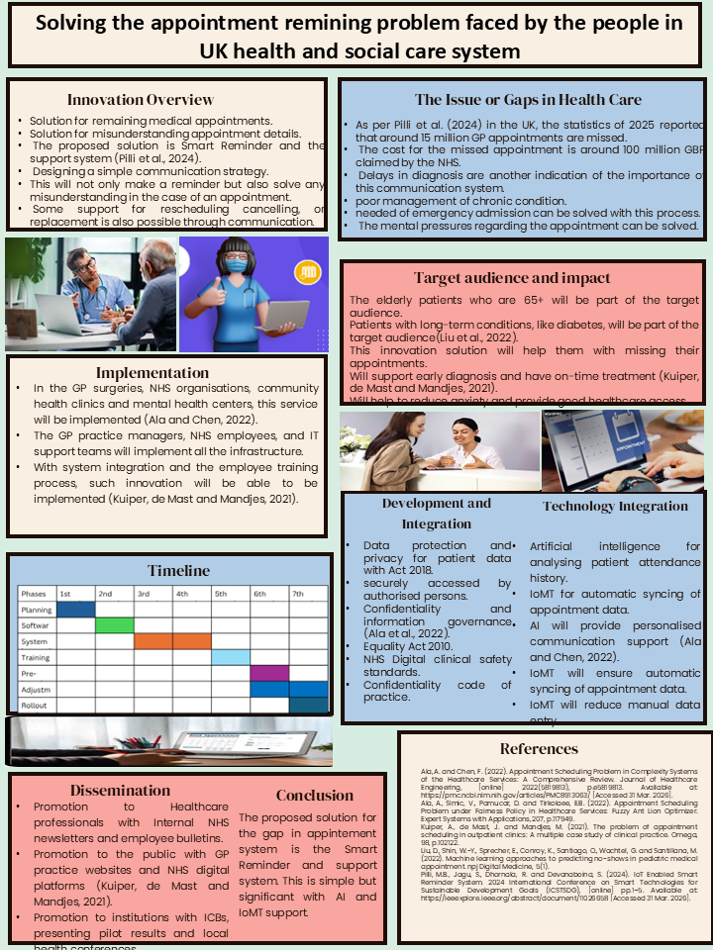

Pitch

Innovation overview
The title of the pitch is “Solving the appointment remaining problem faced by the people in the UK health and social care system”. It will be a revolutionary strategy which will allow to mitigate the issue of forgetting appointments. The proposed solution is a Smart Reminder and Support System, which automatically communicates with individuals with appointments via different mediums such as text, call, WhatsApp, and so on to remind them about the appointment. It can also allow options for cancelling, postponing and rescheduling appointments as per patient need (Thirunavukkarasu et al., 2025). This will mitigate a major issue, prevent misunderstanding of appointment details and aid in patient retention.

The Issue or Gaps in Health Care
In order to obtain healthcare services, an individual or a patient needs to obtain an appointment to access even the most basic healthcare and social care services. However, more often than not, such appointments are missed due to a wide range of reasons. According to Parsons, Bryce and Atherton (2021), five out of seven people miss their appointments. This happens due to a variety of reasons, including forgetting the appointment, getting confused regarding the appointment dates, and many more. Due to this reason, establishments such as the NHS lose millions. On top of that, it has a negative impact on the patients as well (Williamson et al., 2021). Their condition management worsens, delays in diagnosis occur, mental pressure increases and many more, which affect the overall service quality and well-being, indicating a need to implement a solution.

Target Audience and Impact
The proposed solution of the Smart Reminder and Support System will target a wide range of customers in order to ensure the most effective influence. The primary target of the solution will be elderly patients from the age group 65 and older, as they are most likely to forget and get confused regarding the appointment details (Kothiya, 2025). On top of that, individuals who are suffering from long-term diseases will also be targeted, as they will benefit from reminder systems as well. This innovative solution will help these target customers to minimise the possibility of appointment missing. It will also improve the overall service quality for fostering a better healthcare management system (Thirunavukkarasu et al., 2025). This system can also impact the overall healthcare outcomes of those patients due to being on time and not missing any doctor visits.

Implementation
Implementation of the proposed solution service can offer beneficial outcomes, which is why different places such as GP surgeries, NHS organisations, community health clinics and mental health centres will implement the Smart Reminder and Support System. Implementation of this service will be done by integrating the required digital servers and programs to automate responses based on patient history, contact details and appointment schedules (Demsash et al., 2022). The stakeholders that will be involved in the implementation include GP practice managers, NHS employees, and IT support teams. They will ensure integration of this digital technology into the already existing infrastructure without disrupting the workflow. This will maximise the chances of its success and minimise the risk of failure.

Timeline
The innovative system development and rollout will take around 7 months to complete. That is why a detailed Gantt chart listing all the activities is presented below.

Development and Regulations
One of the major complications that can occur during the implementation of this system is regulatory complications. The reason being it will fall under different regulatory agencies, which will need to be addressed. That is why several regulatory requirements will be evaluated and illuminated. The Data Protection and Privacy Act of 2018 will be adhered to during implementation to ensure the privacy of patient data (Ostadmohammadi et al., 2025). The data stored and used will be highly restricted to only authorised personnel. On top of that, the confidentiality of the data and information will be ensured to prevent any unethical usage. The NHS digital clinical standards will be ensured, along with the confidentiality code of the patients (Demsash et al., 2022). The Equality Act 2010 is another regulatory requirement that will be addressed.

Technology Integration
The proposed Smart Reminder and Support System will be based on two major parts: AI and IoT technologies. Here, the IoT Technogym will capitalise on the data of paints, appointment data, past medical history and patient contacts in order to synchronise and manage the data (Williamson et al., 2021). The data will then be used by a Smart AI system, which will evaluate that data, list and prioritise them based on the time and appointment data. The AI will then personalise the data based on the intent needed for communication to develop a tailored message or even call through voice conversion to communicate appointment details with the target customers (Kothiya, 2025). AI will also allow further personalisation options to the patient to change, postpone, and reschedule appointment date and time.

Dissemination
The proposed solution, no doubt, will offer countless benefits not only to the target customers or patients but also to the healthcare providers. That is why leveraging different media of communication, different establishments will be informed about the strategy or service (Ostadmohammadi et al., 2025). For instance, the healthcare personnel will be communicated with, or the service will be promoted through NHS internal newsletters and employee bulletins. The general public will be promoted with the help of official websites and the digital platform of the NHS. The local health conferences, institutions with ICBs and presenting pilot results will be used to communicate regarding the service-related details (Thirunavukkarasu et al., 2025). This will maximise the possibility of awareness development leading to better adaptation and use of the service, which can benefit all.

Conclusion
In conclusion, getting focused and missing an appointment due to forgetting is very common. However, it not only has negative effects on the paints but also on the service providers. That is why the Smart Reminder and Support System is proposed, which can offer automated reminders to the required personnel, which can minimise the issue and be beneficial for not only the patients but also the service providers. However, to ensure that effective implementation through collaboration of different stakeholders and regulatory compliance.

Reference List
Ala, A. and Chen, F. (2022). Appointment Scheduling Problem in Complexity Systems of the Healthcare Services: A Comprehensive Review. Journal of Healthcare Engineering, [online] 2022(5819813), p.e5819813. Available at: https://pmc.ncbi.nlm.nih.gov/articles/PMC8913063/ [Accessed 31 Mar. 2026].
Ala, A., Simic, V., Pamucar, D. and Tirkolaee, E.B. (2022). Appointment Scheduling Problem under Fairness Policy in Healthcare Services: Fuzzy Ant Lion Optimizer. Expert Systems with Applications, 207, p.117949.
Demsash, A.W., Tegegne, M.D., Walle, A.D. and Wubante, S.M. (2022). Understanding Barriers of Receiving Short Message Service Appointment Reminders across African regions: a Systematic Review. BMJ health & care informatics, 29(1), p.e100671.
Kothiya, B. (2025). Market Analysis of an Appointment Booking System: Understanding Market Demand and Innovation in Appointment Scheduling Systems. Theseus.fi.
Kuiper, A., de Mast, J. and Mandjes, M. (2021). The problem of appointment scheduling in outpatient clinics: A multiple case study of clinical practice. Omega, 98, p.102122.
Liu, D., Shin, W.-Y., Sprecher, E., Conroy, K., Santiago, O., Wachtel, G. and Santillana, M. (2022). Machine learning approaches to predicting no-shows in pediatric medical appointment. npj Digital Medicine, 5(1).
Ostadmohammadi, F., Nabovati, E., Jeddi, F.R. and Arani, L.S. (2025). Stakeholders’ experiences, perceptions, and Satisfaction with an Electronic Appointment system: a Qualitative Content Analysis. BMC Health Services Research, 25(1).
Parsons, J., Bryce, C. and Atherton, H. (2021). Which Patients Miss Appointments with General Practice and Why? A Systematic Review. British Journal of General Practice, 71(707), p. BJGP.2020.1017.
Pilli, M.B., Jagu, S., Dhornala, R. and Devanaboina, S. (2024). IoT Enabled Smart Reminder System. 2024 International Conference on Smart Technologies for Sustainable Development Goals (ICSTSDG), [online] pp.1–5. Available at: https://ieeexplore.ieee.org/abstract/document/11026658 [Accessed 31 Mar. 2026].
Thirunavukkarasu, J., Harish, T., Kumar, P. and Adhishvar, A. (2025). Smart Medical Appointment & Prescription Management System Using AI and Overbooking Optimisation. 2025 2nd International Conference on Artificial Intelligence and Knowledge Discovery in Concurrent Engineering (ICECONF), pp.1–9.
Williamson, A.E., McQueenie, R., Ellis, D.A., McConnachie, A. and Wilson, P. (2021). ‘Missingness’ in Health care: Associations between Hospital Utilisation and Missed Appointments in General Practice. A Retrospective Cohort Study. PLOS ONE, 16(6), p.e0253163.

