



ACFA7004 Research Methods and Professional Development
2231139 - Jenishkumar Paghadar UNIVERSITY OF WALES TRINITY SAINT DAVID - Wales Institute of Science and Arts - School of Applied Computing
CYBERSECURITY RISKS In Artificial Intelligence

Contents

Contents 1
List of Tables and Figures 2
Abstract 3
1. Introduction 4
2. Background 6
2.1 Malicious AI: 6
3. Problem Area 8
3.1 Research Questions: 8
4. Literature Review 9
3.1.1 most significant cybersecurity risks associated with AI? 12
3.1.2 How do these risks differ across different AI applications and industries? 14
3.1.3 What are the current mitigation strategies for addressing these risks? 18
3.1.4 How effective are these mitigation strategies in practice? 18
5. Methodology 21
6. Time Horizons (Gannt chart) 22
7. Results 23
8. Evolution 24
9. Conclusion 25
Bibliography 26

List of Tables and Figures
Fig. 1.0. Progress of computer crime to the use of ICT and AI technologies. 7
Fig. 2.0 The Concept of Artificial Intelligence 10
Fig. 3.0 Attack percentages from the total number of records 12
Fig. 4.0. Traditional Targeted Cyberattack Decision Logic. 13
Fig 5.0. DNN Cyberattack Decision Logic. 13
Fig. 6.0 Planning Chart 22

Abstract
Cyberattacks are becoming more frequent and sophisticated. Artificial Intelligence (AI) techniques are unavoidably being adopted by cybercriminals in order to hide in cyberspace and inflict more harm undetected. The concept behind Cybersecurity risks in AI is to prevention and making secure automation-based industry data. introduction and background explore overview of past and current cyberattacks happen due to not using high protection and using weak framework in the A.I system. How it is important to build matrix and encrypted techniques should be used to protect public and privet confidential information covered in the literature review. If the proposed area has been not analysed, how big amount of price need to pay by nations like cyberwar. Many research methods can be used to collect prevention techniques. The conclusion describes the evolution of AI and introduces strict provisions on threating instruments which are sufficient to enable such an attack to be sophisticated.

1. Introduction
Artificial intelligence (AI) has significantly advanced and benefited from its incorporation into a number of sectors and facets of our life. But, as AI spreads and grows more sophisticated, it also presents fresh and new cybersecurity vulnerabilities. These dangers arise from the weaknesses that AI systems have by nature as well as the potential for bad actors to take advantage of these weaknesses. To maintain the safety and security of AI systems and the sensitive data they process, it is vital to comprehend and manage these concerns. In the proposal, we will examine some of the most significant cybersecurity dangers posed by AI and suggest potential countermeasures.
The potential cybersecurity risks associated with AI can be categorized into several categories. Adversarial attacks, for example, involve the manipulation of AI systems to produce incorrect results. Data breaches, on the other hand, can compromise sensitive information stored within AI systems, such as patient health data and financial information. Algorithmic bias can lead to discriminatory outcomes in AI applications, such as in hiring or lending decisions. Other potential cybersecurity risks associated with AI include the misuse of personal information, intellectual property theft, and the creation of deep fakes. [1]
The consequences of these cybersecurity risks can be significant for both individuals and organizations. For instance, a malicious actor could manipulate an AI system to produce incorrect medical diagnoses, leading to serious harm to patients. A data breach could compromise sensitive financial information and result in significant financial losses for organizations. [2] The misapplication of AI could also result in discrimination against certain groups and perpetuate existing societal biases.
To address these risks, it is essential to understand the potential vulnerabilities and attack vectors that exist within AI systems. It is also necessary to identify effective mitigation strategies to prevent and address these risks. Such strategies could include incorporating security measures during the development process, using explainable AI models, and implementing regulatory frameworks to ensure transparency and accountability. [3]
The literature on cybersecurity risks in AI has already identified these risks and mitigation strategies. However, there is a need for a comprehensive study that examines the various risks and mitigation strategies in greater depth. Research proposal aim is aware and stop frauds. providing a comprehensive examination of the cybersecurity risks associated with AI and identifying effective mitigation strategies to address these risks.
The proposed study will involve a comprehensive review of the literature on cybersecurity risks in AI, with a focus on identifying the most significant risks and mitigation strategies. The results of this study will provide insights into the most significant cybersecurity risks associated with AI and identify effective mitigation strategies for addressing these risks.
Overall, this study is essential as AI continues to gain prominence in various industries and our daily lives. By identifying and mitigating cybersecurity risks associated with AI, we can ensure that this technology is used responsibly and ethically. that its potential benefits are realized while minimizing harm to individuals and organizations.

2. Background

2.1 Malicious AI:
Attack capabilities are enhanced and speed and success rates are increased when AI is used maliciously. AI and information and communication technologies (ICTs) make it easier to commit crimes and find new trick for cheat where new criminal strategies can be implemented. Authors of the report on malicious AI [4] issued a cautionary note regarding the shifting threat profile caused by spiteful applications of AI technologies. Rule fix techniques and machine learning techniques, that enable computer systems to learn from a huge amount of data, are broadly distinguished in the AI field. Cybercriminals figure out how to utilize simulated intelligence advances and upgraded learning ways to deal with their attacks and weaponize them via robotizing the assault cycle. The modification toward AI technologies with learning abilities, such as genetic algorithms [5], strengthening learning [6], vector machines support [7], and deep learning [8], may have unintended effects, such as making it easier to commit crimes. The progression of computer wrongdoing toward the use of ICT and AI technologies is depicted in Figure. 1.0 Owing to the "concealment" of cybercrime, the nonappearance of geographical limitations, less pronounced legal restrictions, and the ease of technologies, technological advancements provide new opportunities to commit crimes.

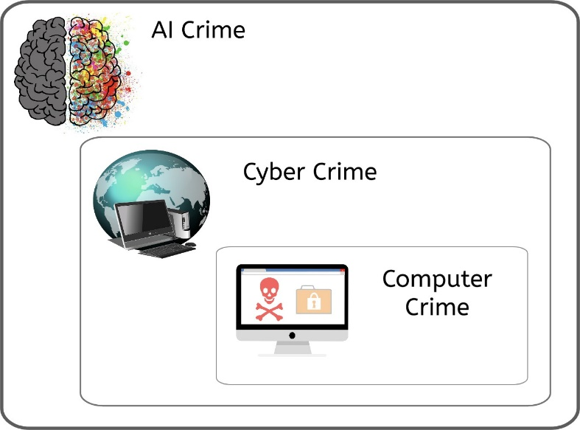

Fig. 1.0. Progress of computer crime to the use of ICT and AI technologies.

In order to take the appropriate defensive measures, it is becoming increasingly important to be aware of emerging cybercrime trends. In light of how the wrongdoing is carried out, it can group it as a PC wrongdoing when it is completed with the utilization of a PC and as a digital wrongdoing when it is completed with the utilization of an organization. In common with cybercrime, Artificial intelligence (AI) has the potential to assist cybercriminals without requiring human participation. This may be accomplished by scripting fraudulent acts and learning from data. Recent research on Cyber-Physical Systems (CPS) have revealed the emergence of sophisticated threats to CPS of various complexity. One such danger is an indirect self-learning assault against well-protected computing infrastructure that takes use of errors in cyber-physical control systems. [9] Another study proposed a methodology for building cyber-physical botnets [10]capable of attacking a water distribution system (CPS) without the need for learning components. As a result of its decision-making and related properties, smart cyber-physical systems have become known as a prospective target for committing AI crimes (AIC). [11]

3. Problem Area
The use of AI has grown-up rapidly over the past few years, and this growth has been accompanied by an increase in cybersecurity risks. The change and use of AI systems have led to new vulnerabilities and attack vectors that can be exploited by malicious actors. Additionally, AI algorithms can be biased, leading to discrimination and unfair treatment of certain groups. These issues have significant implications for both individuals and organizations and require careful consideration and proactive measures to mitigate the risks.
Adversarial attacks: AI systems are susceptible to No attacks, in which the attacker deliberately modifies input data to influence the system's outputs in a damaging direction. For AI-based security systems like facial recognition or malware detection technologies, this might have major repercussions.
Privacy and protection of sensitive data: Since AI mainly relies on data, maintaining privacy and protection of sensitive data is essential. Data breaches can result in major losses in money and reputation, as well as legal repercussions.
Fairness and bias: AI systems may exhibit biases inherent in the data they are trained on, which may lead to unjust or discriminating conclusions. This is especially problematic when it comes to security-related applications since poor or biased judgment could have catastrophic repercussions.

3.1 Research Questions:
    - What are the most significant cybersecurity risks associated with AI?
    - How do these risks differ across different AI applications and industries?
    - What are the current mitigation strategies for addressing these risks?
    - How effective are these mitigation strategies in practice?

4. Literature Review
Artificial intelligence (AI) is a relatively new area of technological study that aims to model, enhance, and even surpass the capabilities of human intelligence. The goal of developing AI is to provide machines with the same level of brain as a human being and the ability to reason. Today, artificial intelligence (AI) has a far wider range of meanings and is studied by scholars from many different fields. As shown by Fig. 2.0

Fig. 2.0 The Concept of Artificial Intelligence
It would appear that machine learning (ML) is one of the main foci of this multidisciplinary study. To paraphrase Tom Mitchell, "the godfather of global ML," machine learning is defined as follows: if computer application performance on tasks of a certain type (T) improves with experience (E), as measured by a certain performance metric (P), then the software is said to have learned from the experience (E). It's an easy, conceptual definition. As our understanding of machine learning grows, though, its meaning and denotation may shift as a result. Given the breadth of its theoretical and practical applications, as well as the rapid pace at which the discipline is evolving and changing, it is difficult to provide a succinct definition of machine learning in just a few phrases.

Machine learning's processing system and algorithms produce predictions mostly by discovering hidden patterns in data. Knowledge discovery in databases (KDD) and data mining (DM) are two related subfields of artificial intelligence (AI). [12]
Applications, algorithms, processors, devices, and techniques are only a few of the many technical layers that make up AI technology. as shown in Fig. 2.0. The following advancements have been made in all aspects of AI technology's technical infrastructure:

- Application-Level Video and Image: Augmented reality (AR), video analysis, video review, image search, face recognition, target detection, picture production, image retouching, and image-based search. Control: technology such as driverless cars, drones, robots, and factory robots. Voice and speech: Voice activation, music creation, voiceprint recognition, voice synthesis, and speech recognition all fall under this category. Text: Analysis of texts, communication between humans and computers, translation of texts, reading comprehension, and recommendation systems.

- Algorithms over Machine learning: When it comes to machine learning, deep learning is a must-have technology. Recent years have seen a proliferation of studies focusing on the deep neural network. Examples include a neural network, SVM, K-nearest neighbour, Bayesian, decision tree, hidden Markov model (HMM), EL, and other models.

- Chip Level: Algorithm optimization chips: processors that enhance algorithms include deep learning accelerators and facial recognition processors, both of which maximise algorithms for speed, accuracy, efficiency, and adaptability. Neuromorphic chips: bionic brain, reasoning inspired by the biological brain, and copying of brain mechanisms. Programmable chips: taking flexibility, programmability, algorithm compatibility, and general software compatibility into consideration, such as digital signal processing chips, graphics processing units, and field-programmable gate arrays.

Artificial intelligence, machine learning, and deep learning all depend on data in order to function properly, as is apparent from their specific meanings. These may also be considered personal information, which will require the protection required by applicable law. It's also possible that the volume of information being transferred might compromise security.
cyber security Therefore, it makes sense to incorporate this technology within the existing cyber security judicial framework. [13]. It is also crucial that one protect AI because it is a valuable resource that should be safeguarded by its owner (a company, manufacturer, developer, etc.). Cyberattacks can be directed at artificial intelligence (for example, on a self-driving car to acquire processed data). From a different angle, artificial intelligence (AI) is a danger because it is used in many different cyberattacks. [14] Artificial intelligence has the capacity to produce creative, highly effective bad code (like malware) with the ability to learn and adapt to launch new attacks. Moreover, an improper algorithm used in an AI might potentially make it vulnerable. In other words, artificial intelligence can function as both a strength and a weakness. Meanwhile, it remains unclear how exactly AI might help provide an adequate level of cyber security by maintaining the integrity, confidentiality, and availability of information.

Fig. 3.0 Attack percentages from the total number of records



Injection 9% Ransomware 4%
DDoS 7%
XSS 2%

Password Cracking
8%
Backdoor 9% Scanning 1%
Benign 60%
The IoT dataset is a new collection of data that was created recently in the world of Industry 4.0. It became available to the public in the year 2020. [15] [16] [17] The dataset was created by the UNSW School of Engineering and Information Technology, in collaboration with the Cyber Range and IoT Labs, along with the Australian Defence Force Academy (ADFA). [18] [19] [20] [21] A new dataset was produced specifically for the industry 4.0 network, which includes both IoT and IIoT networks. The primary goal of this dataset creation was to assess the accuracy and effectiveness of various cyber-security applications that use machine learning (ML), deep learning (DL), and artificial intelligence (AI) techniques. Fig.3.0 This data display presents the distribution of attack occurrences for each of the seven IoT devices, with a total of 407,932 records analyzed. It is important to note that the category "Benign" represents regular network traffic with no indication of any attack. [22]

3.1.1 most significant cybersecurity risks associated with AI?
    - AI-driven cyberattacks and the more common targeted cyberattacks.
A conventional cyberattack typically uses a simple conditional structure to determine its target. The attack program asks a basic question: is the system a target? If the answer is negative, the program stops running, but if the answer is affirmative, the program proceeds to launch the attack. [23] Figure. 4.0 illustrates the decision logic of the common targeted attack. As cybersecurity professionals began using sandboxes to analyze and counter traditional targeted attacks, cybercriminals developed a more complex decision-making process using Deep Neural Networks (DNNs). This new approach goes beyond the simple if-then conditional construct and allows malicious actors to determine whether or not to execute an attack.
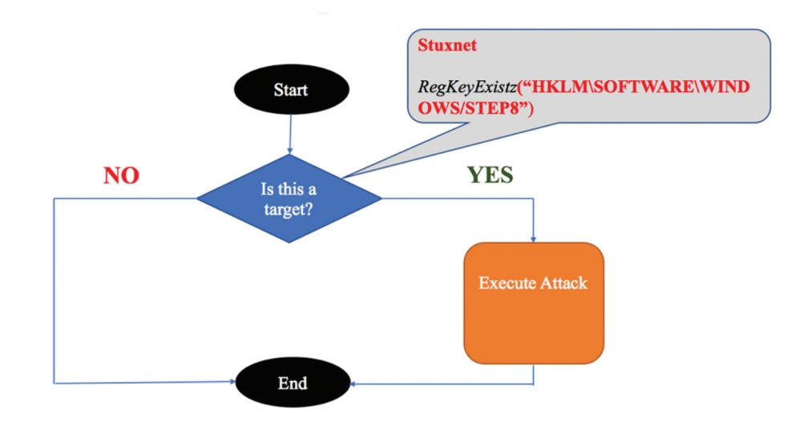
Fig. 4.0. Traditional Targeted Cyberattack Decision Logic.

The challenge for the defender lies in discerning the actual malicious code and determining the correct target, which can be highly challenging. [23] Figure. 5.0 Describe a DNN cyberattack decision logic.
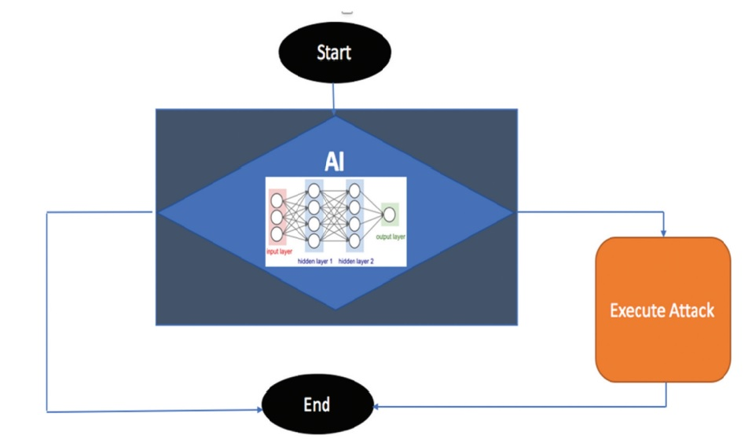
Fig 5.0. DNN Cyberattack Decision Logic.

- There are Different Attacks Describe Below: -

  - Data breaches: AI systems need a lot of data to work properly, and if that data is compromised, there might be serious privacy and security issues.
  - Attacks by malware: AI algorithms are susceptible to malware attacks that take advantage of flaws in the system and steal or lose data.
  - Adversarial attacks: Adversarial attacks entail changing the information put into an AI system in a way that causes inaccurate categorization or outputs, which can have major repercussions in sectors like healthcare and finance.
  - Insider attacks: Since AI systems are frequently incorporated into larger IT infrastructures, they may be at risk from insider threats, such as malicious or unintentional system compromises by personnel who have access to sensitive data.
  - Lack of transparency: Because AI algorithms can be complex to interpret and comprehend, it might be difficult for cybersecurity professionals to find potential security flaws and risks.
  - Bias: AI systems can reinforce existing biases in the data they are trained on, which can result in discrimination and other undesirable results. AI systems are only as objective as the data they are trained on.
Overreliance on AI technologies can result in complacency and a delusion of security, which can make businesses more susceptible to cyberattack.

3.1.2 How do these risks differ across different AI applications and industries?
The cybersecurity risks associated with AI can vary depending on the specific AI application and industry. For example, AI used in healthcare may have different risks compared to AI used in finance or manufacturing. The risks may also vary depending on the level of AI's involvement in critical decision-making processes, access to sensitive data, and the potential impact of AI's failure or malfunction.
In healthcare, the risks may include the compromise of sensitive patient data, errors in medical diagnoses or treatment recommendations, and the manipulation of medical devices or systems. In finance, the risks may include fraudulent activities, financial crimes, and the exploitation of vulnerabilities in trading algorithms. In manufacturing, the risks may include the disruption of production processes, compromise of intellectual property, and sabotage of critical infrastructure.
The following text provides a brief overview of the state of cybersecurity in the transportation, healthcare, and energy sectors of the European and worldwide economies.
  - Logistics cybersecurity status:
The transportation industry is becoming increasingly vulnerable to cyber-attacks due to a lack of adequate training, best practices, and cybersecurity standards. While there is no consolidated data available on the industry's cybersecurity status, reports from independent cybersecurity firms indicate a rise in cyber-attacks on the transportation sector. This vulnerability is compounded by the fact that many transportation stakeholders are still using outdated legacy ICT systems, making them more susceptible to cyber-attacks.
Moreover, transportation stakeholders often prioritize physical safety and security over cybersecurity. This approach is risky given the increasing reliance on ICTs to enable essential transportation operations such as navigation, propulsion, freight management, and traffic control. Despite this risk, there has been a low sense of urgency and cybersecurity awareness in the transportation industry, which can lead to severe disruptions to transportation services.
Interestingly, the transportation sector has experienced relatively fewer cyber incidents compared to other industries, which may have led to a lack of media exposure and bold reactions from stakeholders. However, the global cybersecurity market's estimated cost of cybercrime in 2017 was $100 billion, and large organizations suffered cyber-attacks at an average cost of $900,000 to $2.3 million in 2014. Therefore, it is essential for transportation stakeholders to prioritize cybersecurity measures to protect their systems and ensure that transportation services remain safe and secure. [24]
Considering these facts, attempting to smooth the way for Member States to adopt new cyber protection goods and services. [25] In response to the low cybersecurity awareness among transportation stakeholders, the European Commission (EC) has proposed a new framework called the "European Cybersecurity Certification Framework for ICT products and services". The framework aims to reduce the cost of cybersecurity certification, improve its effectiveness and make it more commercially attractive for European organizations. Despite the low maturity of cybersecurity awareness among transportation stakeholders, some operators such as the Port of Rotterdam have invested in fortifying their digital assets. The EC's efforts to raise cybersecurity awareness in the transportation industry could encourage more stakeholders to devote budgets to cybersecurity solutions.
  - Healthcare sector cybersecurity status:
According to SANS Institute reports [26]given the highly sensitive nature of data processed, healthcare is among the top 5 vertical industries with the highest spending on cybersecurity with standard annual budgets up to $ 600k. Taking into account the recent impose of GDPR, it is expected that these investments will be increased to meet the stricter requirements of the regulation. Despite significant investments in cybersecurity in the healthcare industry, many medical IT systems remain severely outdated, leaving them vulnerable to new classes of hackers who specifically target sensitive patient information[27] such as medical records and credit card data. Reports also indicate that the biggest threat to healthcare cybersecurity comes from insiders, rather than external factors. This highlights the need for increased attention to insider threat prevention and mitigation measures, in addition to keeping medical IT systems up-to-date and secure from external attacks. [28]
  - Power system cybersecurity status:
Similarly, to the Logistic cyber security status, cybersecurity consciousness is also low in the Power system industry. According to [29], The rapid growth of IoT technology involves connecting the power grids with an ever-increasing number of intelligent devices. [29]. Therefore, the risk of a cyberattack causing physical harm is now greater due to the increasing number of smart devices interconnected with energy grids. The energy industry has been slow to adopt digitization despite being an asset-intensive industry with many remote and hazardous sites. Although many executives in the energy industry recognize that business interruption due to cyber-attacks is the most impactful loss, over half of them cannot quantify or do not know the extent of their worst possible loss exposures. [30].

- Impact of AI-Driven Cyberattacks
A) Russia- Ukraine Conflict
Today countries with geopolitical conflicts are using AL and ML in cyberattacks, misinformation campaigns to their advantage, this is apparent from the Russia-Ukraine conflict. Russia has been suspected of using asymmetric warfare by involving in AI based cyberattacks, electronic warfare and information weapons on the other country’s infrastructure like electrical grids and communication systems. Russia previously also has been involved in using discreet mode of technology for destabilising its opponent’s infrastructures. Russia is spearheading its AI strategy with heavy investment in its military, state sponsored actors as well as private sector. It is also suspected that with Russia’s more and more adoption in such futuristic technologies and modern battlefield capabilities wit might outmatch US in areas of artillery, armour, air defence, space and cyber space. [31]
AI plays a vital role in the field of information warfare which is evident in the ongoing conflict, as AI helps in analysing vast amount of open-source intelligence from videos to telegram posts on troops and attack, one major issue with use of such technology is deep fakes that uses AI techniques to create realistic videos which can further aid in the launch of disinformation campaigns. However, ML can detect such fake videos and hence been used by various social media platforms as well. Russia has heavily used three from information warfare against Ukraine which are
- Disinformation
- Cyber warfare
- Kinetic warfare
These new cyberattacks that are driven by AI could endanger people's lives and cause a lot of damage. By sabotaging information classification. honesty, exceptionally refined and covert assaults will disintegrate trust in associations and maybe bring about foundational disappointments. The emergence of AI-powered attacks has introduced a new era of cybersecurity threats that are scalable, highly targeted, and human-like. For example, these attacks can lead to an oil rig drilling in the wrong location due to incorrect geo-prospecting information or a medical expert making a diagnosis based on tampered medical data. AI's ability to learn and adapt has made it possible for cybercriminals to carry out these sophisticated attacks. [32], An AI-powered attack with intelligence and malicious intent can adjust and evolve its tactics by observing its environment, making it effortless to infiltrate systems without being noticed. an AI-driven attack like PassGAN can generate a large number of effective password guesses without being detected, thereby circumventing the security authentication infrastructures in place.

3.1.3 What are the current mitigation strategies for addressing these risks?
The cybersecurity dangers posed by AI can be reduced by using certain mitigation techniques. To prevent unwanted access to sensitive data and systems, some of these include developing and putting into place strong authentication and access control measures.
- Encryption is used to safeguard data both in transit and at rest.
- frequent penetration testing and vulnerability assessments to find and fix security flaws in AI systems.
- putting in place intrusion detection and prevention systems to quickly identify and address cybersecurity threats.
- ensuring that security is considered during the design and development of AI systems and that security measures are incorporated.
- putting secure coding techniques into practice and regularly reviewing the code to find and fix security flaws.
- educating both end users and employees about cybersecurity
The results of this section are divided into six stages of the cybersecurity kill chain. These stages include reconnaissance (an AI-targeted attack), access and penetration (an AI-assisted attack), delivery (an AI-concealed attack), exploitation (an AI-automated malware), command and control (an AI-multi-layered attack), and action on objectives (an AI-massive attack).

3.1.4 How effective are these mitigation strategies in practice?
There is no straightforward answer to the effectiveness of mitigation strategies for addressing cybersecurity risks in AI. The effectiveness of a mitigation strategy depends on several factors such as the nature and severity of the threat, the specific AI application and industry, and the resources available for implementing and maintaining the strategy. Additionally, the effectiveness of a strategy may vary over time as new threats emerge, and attackers adapt their methods.
- Ethical Principles for Reliable AI
In simpler terms, the Ethics Guidelines for AI includes rules about how AI should handle personal data and privacy. One of these rules is that there should be a way for humans to monitor and oversee the development and use of AI to ensure that it is complying with fundamental rights and freedoms. This helps ensure that AI is being used in an ethical manner.[33] Furthermore, it is important to note that the GDPR already regulates the "right to human agency" in Article 22, particularly in relation to automated individual decision-making. The Ethics Guidelines give particular emphasis to privacy and data governance, taking a comprehensive approach. [34]The document highlights the importance of data processing by AI, which includes the data initially provided by the user, as well as the data generated about the user during their interaction with the AI system. This generated data can be obtained through a user's online activity, search history, and the choices they make while using the system. The AI system can use this data to create a user profile that provides insights into the user's preferences, behaviour, and needs. This profiling process can be used to improve the user experience and provide more personalized services. However, it also raises concerns about privacy and the need to ensure that users' data is handled responsibly and ethically. The document stresses the importance of proper data governance and the need for transparency and user control over their data. This ensures that users are fully informed about the data being collected and have the option to opt-out if they wish.
- The European Union's White Paper on AI: Encouraging an Environment of Excellence and Trust
The The main point highlighted in the White Paper is that the European legal system places a strong emphasis on protecting fundamental rights and freedoms. This includes upholding the values that are associated with these rights and freedoms [35]. The European Commission has called for awareness of the dangers of using AI, which involves inadequate human oversight and partial data processing and the possibility of a lack of protection for privacy, personal data, and non-discrimination. If AI is used to analyse huge amounts of data, it runs the danger of reinventing data subjects from information, which could lead to the processing of personal data that was previously processed under a different legal framework or with respect to datasets that do not comprise personal data.

The CyberSANE approach aims to securely share threat incident and intelligence information while ensuring data privacy. The approach employs various methods such as data anonymization, document sanitization, and cryptographic protocols to distribute and store all forensic artifacts in a secure manner. The approach also ensures compliance with GDPR by implementing controller/processor capabilities that enable security experts to specify the necessary protection steps and conditions required for their execution. Additionally, incident handling business-logic decisions are implemented to establish a secure environment over the interconnected CIIs, which are heterogeneous and complex.
However, some general approaches that are commonly used to mitigate cybersecurity risks in AI include implementing strong access controls and authentication mechanisms, monitoring and logging activities, implementing encryption and secure communication protocols, and conducting regular security audits and assessments. These strategies can be effective in reducing.
the risk of cyberattacks and minimizing the impact of any successful attacks. However, they are not fool proof, and it is important to continuously evaluate and improve these strategies to stay ahead of emerging threats.

5. Methodology
This study will involve a comprehensive review of the literature on cybersecurity risks in AI, with a focus on identifying the most significant risks and mitigation strategies.
To ensure that artificial intelligence (AI) is protected against cyberattacks, it is crucial to conduct research by reviewing academic journals and books that rely on trustworthy sources such as IEEE, Science Direct, Springer Link, and others. Conducting a literature review is also necessary to determine the current research being conducted in the field and to identify which preventive measures can be taken to stop such attacks. what actions requires further investigation, and which framework need to do tackle it. Which rules and regulation should implement. The research areas are AI driven cyberattacks prevention techniques. The study will also involve case studies and recent articles with cyber expert’s experience knowledge in the field to get a better understanding of the practical implementation of these strategies.

6. Time Horizons (Gannt chart)
Time factor plays biggest roll-on project like it will define how much time to complete the task. It will spot on proper way within the time line to complete research approach.
Research topics and the other part of study divided into timely manner which showing in Gantt chart. refer chart for evaluate study.
Task Name | Start Date | Finish Date | Duration (Days)
Planning and Research | 05-04-23 | 25-04-2023 | 20
Study Introduction | 26-04-23 | 01-05-2023 | 5
Reading Article | 02-05-23 | 15-05-2023 | 13
Current Experiment’s and Approaches | 16-05-23 | 04-06-2023 | 19
Problems finding | 05-06-23 | 25-06-2023 | 20
Mitigation strategy | 26-06-23 | 22-07-2023 | 26
Find relevant literature | 23-07-23 | 29-08-2023 | 37
Review new techniques | 30-08-23 | 25-09-2023 | 26
Write dissertation | 26-09-23 | 10-11-2023 | 45
Review dissertation and corrections | 11-11-23 | 15-11-2023 | 4
Research Presentation | 16-11-23 | 24-11-2023 | 8

Fig. 6.0 Planning Chart

7. Results
As discussed in this study, how malicious actors are increasingly exploiting the advanced data mining capabilities of AI to make more informed decisions. They are using AI to learn from contextual data to identify trusted features of cyberspace and target weak points in the system. This approach helps AI-driven cyberattacks avoid detection and cause maximum damage to cyberspace. These attacks are becoming more sophisticated and harder to detect, posing a significant challenge for traditional cybersecurity tools. It is becoming increasingly clear that AI-driven cyberattacks are a growing threat and will continue to become more prevalent.
To combat this growing threat, cybersecurity researchers, organizations, cybersecurity experts, and government institutions need to use AI to fight AI. Developing advanced and sophisticated countermeasures to combat AI-driven attacks is critical. One of the best ways to prepare for these attacks is to harden cybersecurity defence infrastructures with the lowest possible number of false positives and negatives.
Moreover, there is a significant effort to establish a regulatory framework for AI at the EU level, which will help ensure that AI technologies are developed and used ethically and responsibly. The framework will guide how to develop AI systems that respect fundamental rights and freedoms, protect privacy and personal data, and avoid discrimination. It will also establish clear rules and accountability mechanisms for developers, users, and operators of AI systems. This regulatory framework will be crucial in ensuring that AI-driven cyberattacks are prevented or mitigated to the best extent possible.

8. Evolution
This passage discusses the increasing trend of cybercriminals using AI-driven techniques to enhance their attacks. The focus of this study is to assess the risks posed by offensive cyber threats involving AI. To do so, the study reviews the literature on AI-driven cyberattacks, explores instances where AI has been improperly used in cyberspace, and analyzes the negative impacts of AI-driven cyberattacks.
This research will prevent Artificial Intelligence by cyber threats using CyberSANE approach. By making law on A.I framework for the industry uses it will protect to public data and confidential information.
However, it is imperative that the security research community, governments, and cybersecurity experts engage in cutting-edge and complex remedies to address the growing threat of AI-driven cyberattacks. To this end, we can employ AI to counter offensive AI and build a reliable AI framework for future detection and prevention of such attacks. To help the cybersecurity community keep up with the ever-evolving AI-driven threats, the framework should detail critical elements that influence the detection logic.

9. Conclusion
As per discussion on above Cyberattacks risks in AI proposal, we can assume how cyber risks are different and complex. With the help of cyber tools how it will dangerous to the nation and world like cyberattacks can destroy the nation’s economy. Increasing demand of new approaches take benefits with drawbacks. We can find a way to protect Artificial Intelligence by improving frameworks and implementing strict Law.

Bibliography

[1] | Leadership in enabling and industrail technologies, Horizon 2020, 2020.
[2] | S. Bocetta, “Has an AI cyberattack happened yet?,” 2020.
[3] | C. a. I. Z. Thanh, “ A survey on artificial intelligence in malware as next-generation threats.,” 2019.
[4] | S. A. J. C. H. T. P. E. B. G. A. D. P. S. T. Z. B. F. Miles Brundage, “The malicious use of artificial intelligence,” 2018.
[5] | K. D. Jong, “Machine learning,” in Leraning with genetic algorithms, 1988, pp. 121-138.
[6] | Y. B. a. A. C. Ian Goodfellow, “Deep Learning,” MIT press..
[7] | A. Pradhan, “Support vector machine- A survey.,” no. International Journal Of Emerging Technology and Advanced Enginerring 2,8, pp. 82-85, 2012.
[8] | M. L. L. a. A. W. M. Leslie Pack Kaelbling, “Reinforcement learning:A survey. Journal of artificial intelligence reserch 4,” 1996.
[9] | Z. T. K. a. R. K. I. Keywhan Chung, In Proceedings of the 10th ACM/IEEE International Conference on Cyber-Physical Systems., 2019, pp. 1-12.
[10] | G. B. a. N. O. T. Daniele Antonioli, Taking control: Design and implementation of botnets for cyber-physical attacks with cpsbot., arXiv preprint arXiv:1802.00152(2018)., 2018.
[11] | N. A. M. T. a. L. F. Thomas C King, Artificial Intelligence Crime: An Interdisciplinary Analysis of Foreseeable Threats and Solutions., science and engineering ethics, 2019, pp. 1-32.
[12] | L. Huawei Technologies Co., in ARTIFICIAL INTELLIGENCE TECHNOLOGY, Posts & Telecom Press, Beijing, China, 2023.
[13] | K. C. Kasper A, “Pollution-control in cyberspace: Problem structure and institutional design in international cybersecurity.,” Int Comp Law Rev199, 2019.
[14] | F. G, “A grim reality about the dangers of cyberwarfare.,” in Once Upon a time in cyberspace, 2020, pp. 77-96.
[15] | M. N, “A new distributed architecture for evaluating AIbased security systems at the edge: network TON_IoT datasets,” Sustain Cities Soc 72:102994, 2021.
[16] | M. N. T. Z. M. A. A. A. . Alsaedi A, “IoT telemetry dataset: a new generation dataset of IoT and IIoT for,” in TON, IEEE Access 8:165130–16150, 2020.
[17] | C. I. M. E. M. N. d. H. Booij TM, “ToN_IoT: the role of heterogeneity and the need for standardization of features and attack types in IoT network intrusion datasets.,” IEEE Internet Things J 1–1, 2021.
[18] | K. M. D. E. J. H. Moustafa N, “Federated TON__,” in IoT windows datasets for evaluating AI-based security applications., IEEE Int Conf Trust Secur Privacy Comput Commun (TrustCom), 2020, pp. 848-855.
[19] | A. M. A. S. Moustafa N, “Data analytics-enabled,” in intrusion detection: evaluations of ToN_IoT linux datasets., IEEEInt Conf Trust Secur Privacy Comput Commun (TrustCom), 2020, pp. 727-735.
[20] | Moustafa, “New generations of internet of things datasets for cybersecurity applications based machine learning: TON_IoT datasets. Research Data Australia,” 2019.
[21] | M. N, “A systemic IoT-fog-cloud architecture for big data analytics and cyber security systems: a review of fog computing.,” arXiv:1906.01055, 2019.
[22] | A. J. e. al, “IoTBoT-IDS: A novel statistical learning enabled botnet detection framework for protecting networks of smart cities.,” Sustain Cities Soc 72:103041., 2021.
[23] | D. J. J. a. M. S. Kirat, “DeepLocker concealing targeted attacks with AI locksmithing.,” 2018.
[24] | ENISA, “CSIRTs By Country-interactive map,” 2019.
[25] | Anisha, “MTI Network An MTI network special report: maritime cyber security.,” 2015.
[26] | F. B, “IT Security spending trends.,” no. SANS Institute, Fredericksburg, 2016.
[27] | M. S, “Why hetlth care is especially vulnerable to ransomware attacks.,” 2017.
[28] | W. S, “Introducing the protected health information data breach report.,” 2018.
[29] | S. M, “Energy frms are worried about cyber attacks, but don’t really know what to do.,” 2018 (by Mike Scott).
[30] | M. report, “Could energy industry dynamics be creating an impending cyber storm?,” 2018.
[31] | “Unclassified Summary of the US Army Training and Doctrine Command Russian New Generation Warfare Study”, 2017.
[32] | P. G. Briland Htaj, “A Deep Learning approch for password guessing,” arXiv preprint arXiv:1709.00440 (2017)., 2017.
[33] | “High-Level Expert Group on Artifcial Intelligence,” Ethics Guidelines For Trustworthy AI, no. European Commission..
[34] | “High-Level Expert Group on Artifcial Intelligence.,” Policy and investment recommendations for trustworthy AI. European Commission., 2019a.
[35] | E. Commission., “A European Strategy for Data,” 2020.

