
Student name: Daberechi Onyinye Eze

Student ID:2232114

Module: Changemaker: Building your personal brand for sustainable employment

Module code: BMHP5015 LON

Lecturer: Caroline Salami

Assignment title: Component 2: Report

Submission date:19th December 2025

Table of contents
Introduction……………………………………………………………………………………...3
Job description of the selected job…………………………………………………………. .3
Analyse the skills needed for the job and assess your skills and experience……………4
Development of personal skills and resources……………………………………………….6
Action plan and timeline…………………………………………………………………………,7
Communication of skills and potential employers…………………………………………….8
Conclusion……………………………………………………………………………………….9
References……………………………………………………………………………………….10

Introduction
The chosen job role is Care Home Manager at a residential care facility operated by a local authority within the health and social care sector (NHS Jobs, 2025). This position involves overseeing the daily operations of the home, managing staff, ensuring compliance with care regulations standards as set out by the Care Quality Commission (CQC). and maintaining high-quality support for residents. Also ensure high quality, person – centred care, and budgets (Rattan,2025).
The decision to pursue this role stems from a strong commitment to improving the quality of life for older adults and a passion for leadership within a care setting. It aligns with personal values of compassion, responsibility, and teamwork, as well as existing skills in communication and organisational management, recruiting and training staffs and liaising with external bodies whose duties include safeguarding, and regulations example the Care Quality Commission. The managers play key roles in organisations by procuring the buildings and equipment’s needed for effective delivery of health and social care services in every organisation (Torge et al.,2025).
This report will be structured into three main sections
- Job Overview – outlining key duties and responsibilities.
- Rationale for Role Choice – explaining personal motivations and career alignment.
- Skills and Professional Development – analysing current skills and identifying areas for further growth.
Analyse personal employability skills required as a manager
Effective management within the health and social care sector requires a diverse range of employability skills that support leadership, service quality, and team performance. A care home manager must demonstrate strong communication skills to liaise effectively with staff, residents, families, and external agencies, ensuring that information is conveyed clearly and sensitively. Leadership and decision-making abilities are equally vital, as the manager must motivate teams, delegate tasks appropriately, and respond to complex situations with confidence and professionalism (Andino et al., 2025).
Problem-solving and critical-thinking skills enable managers to handle challenges such as staffing shortages, regulatory demands, or conflicts within the team. Additionally, organisational and time management skills are essential to manage workloads, maintain compliance with care standards, and ensure the smooth running of daily operations. Emotional intelligence and empathy also play a crucial role, allowing managers to foster a supportive workplace culture and address the emotional needs of residents and staff (MS, 2014)
Finally, reflective practice and adaptability are key employability traits in this role. The ability to evaluate one’s performance, accept feedback, and adapt to policy changes contributes to continuous professional growth and high-quality care delivery. These skills collectively enable
effective leadership and ensure that care home services operate efficiently and compassionately.
Core skills needed as a manager is
- Leadership and management which requires motivating your team, strategic thinking and leading person – centred services.
- Communication is an important skill. It can be verbal or non – verbal and can be in writing.
- A manager must demonstrate compassion and empathy when dealing with individuals who may be destressed (Birkhead et al., 2000).
- One must be adaptable by been flexible and responsive to changing needs and uncertain situation.
- A manager needs to possess integrity and professionalism by acting with honesty, reliability and respect.
- A manager needs to have a problem solving and decision-making skills under a limited time. A manager needs to analyse the situation and make a sound decision which helps in the day-to-day operation of the organisation.
- Managers need organisational skills, resilience, teamwork skills. I have all these skills to become a manager (Woods, 2012).
Areas of Improvement
- Enhance qualification
- More experiences
- Enhancement of leadership qualities
- Improvement on communication skills and the use of tools
- Team development and support
- Strategic and innovative thinking (Devi et al.,2020).

As an aspiring health and social care manager in UK my focus should be on developing leadership and management skills, strategic thinking, effective communication and have a commitment to a continuous improvement while on the role as a manager.
There must be improvement on leadership styles, conflict management team development and the understanding of the rules and regulations of the Care Quality Commission in term of standards and data analysis to ensure compliance.
Another area of improvement for an aspiring manager is in education qualifications and enhancement (Devi et al.,2020).
Evaluate your own skills and experience
To evaluate my potential as an aspiring manager in a health and social care organisation, I must evaluate my personal skills in leadership styles, communication and problem solving.
I must evaluate my experience in such areas as team management, resource allocation and patient care and enhance myself in areas needing improvement.
An effective way of comparing my evaluation is comparing my personal attributes and professional history and experience against those essential things that are required for the managerial role in the organisation. Such things as planning, adaptability and a major commitment to the organisation’s values and quality care (Gordon et al.,2018).
Key skills needed
- Leadership which is an ability to motivate my team especially during emergencies.
- Communicating in a strong verbal and written forms with my team or members of staff.
- In term of decision making, one must be able to make sound decisions especially in the management and allocation of financial resources.
- The ability to think critically during problem solving to overcome challenges.
- The ability to manage complex and multiple challenges or projects and meet the deadline.
- One should be able to work in teams and build relationships (Malik et al., 2025).
Health and social care experience needed
- Work experience
- HND in Health and social care studies
- BSC in Health and Social Care studies
- Engaging in training in form of seminar for the enhancement of knowledge
- Volunteering for paid and unpaid job.
Evaluating my experience in the health and social care sector in terms of opportunities to lead in a project or contribute to a care plan (Cress, 2009). Evaluating my personal attributes like empathy, resilience and commitment to a person – centred in my previous roles. Developing those skills that will help me to face the daily challenges and know ways to approach the situations that may emerge (Malik et al., 2025).
How to develop personal skills and resources as an aspiring manager in a health and social care organisation in the UK
Action Plan and Timeline
The main career objective is to progress into a Care Home Manager role within the next three years by developing leadership, regulatory, and management competencies. Achieving this requires closing skill gaps through continuous professional development (CPD), accredited training, and practical experience (Home and Career Skills, Grades 7 and 8, 1986).
Theoretical Framework
This plan is underpinned by Bandura’s Self-Efficacy Theory (1977), which highlights the importance of belief in one’s capability to achieve specific tasks. By setting incremental and achievable goals, confidence can be strengthened through mastery experiences, social learning, and positive reinforcement, all essential for leadership in social care contexts (Benderly,2013).
SMART Career Goals
- Specific: Attain the Level 5 Diploma in Leadership for Health and Social Care and progress to a Care Home Manager position.
- Measurable: Complete two professional courses, gain six months of supervisory experience, and attend three CPD workshops.
- Achievable: Build upon prior H&SC experience and seek mentorship from an established manager.
- Relevant: Each goal aligns with CQC standards and leadership expectations in adult care.
- Time-bound: Achieve full managerial readiness within three years (Benderly, 2013).
Development Activities and Resources
- Formal Learning: Enrol in a Level 5 H&SC Leadership qualification.
- Work Experience: Secure part-time or full-time employment in a senior care or deputy manager role.
- Mentoring: Arrange regular mentoring sessions with a senior care home leader.
- CPD and Networking: Attend sector conferences, webinars, and Skills for Care leadership programmes.
- Reflective Practice: Maintain a professional development journal to log progress and feedback.
- Resources Needed: Tuition funding (possibly through an apprenticeship scheme or employer support), access to online learning platforms, professional supervision, and time allocated for study (Malik et al., 2025).

Timeline and Development Plan
Phase | Timeline | Goals/Activities | Resources Required | Expected Outcome
Short-term (0–6 months) | Jan–Jun 2026 | Enrol in Level 5 H&SC course; continue current care role; identify mentor; attend one CPD workshop | Funding assistance, course materials, mentor guidance | Strengthened confidence and foundational management knowledge
Medium-term (6–18 months) | Jul 2026–Jun 2027 | Complete half of course units; take part in leadership training and supervision; volunteer for team-leading duties | Study support, feedback from mentor | Enhanced supervisory and decision-making skills
Long-term (18–36 months) | Jul 2027–Dec 2028 | Complete qualification; apply for deputy manager posts; attend Skills for Care leadership event | Employer references, professional network | Suitable for managerial role in a care home setting
Through continuous learning, mentorship, and reflective practice, this plan aims to foster professional growth and a strong belief in personal capability, consistent with Bandura’s theory. The structured use of SMART goals and a clear timeline support focused progress toward the managerial position (London, 1981).

Build a cv for a care home manager role in UK healthcare home

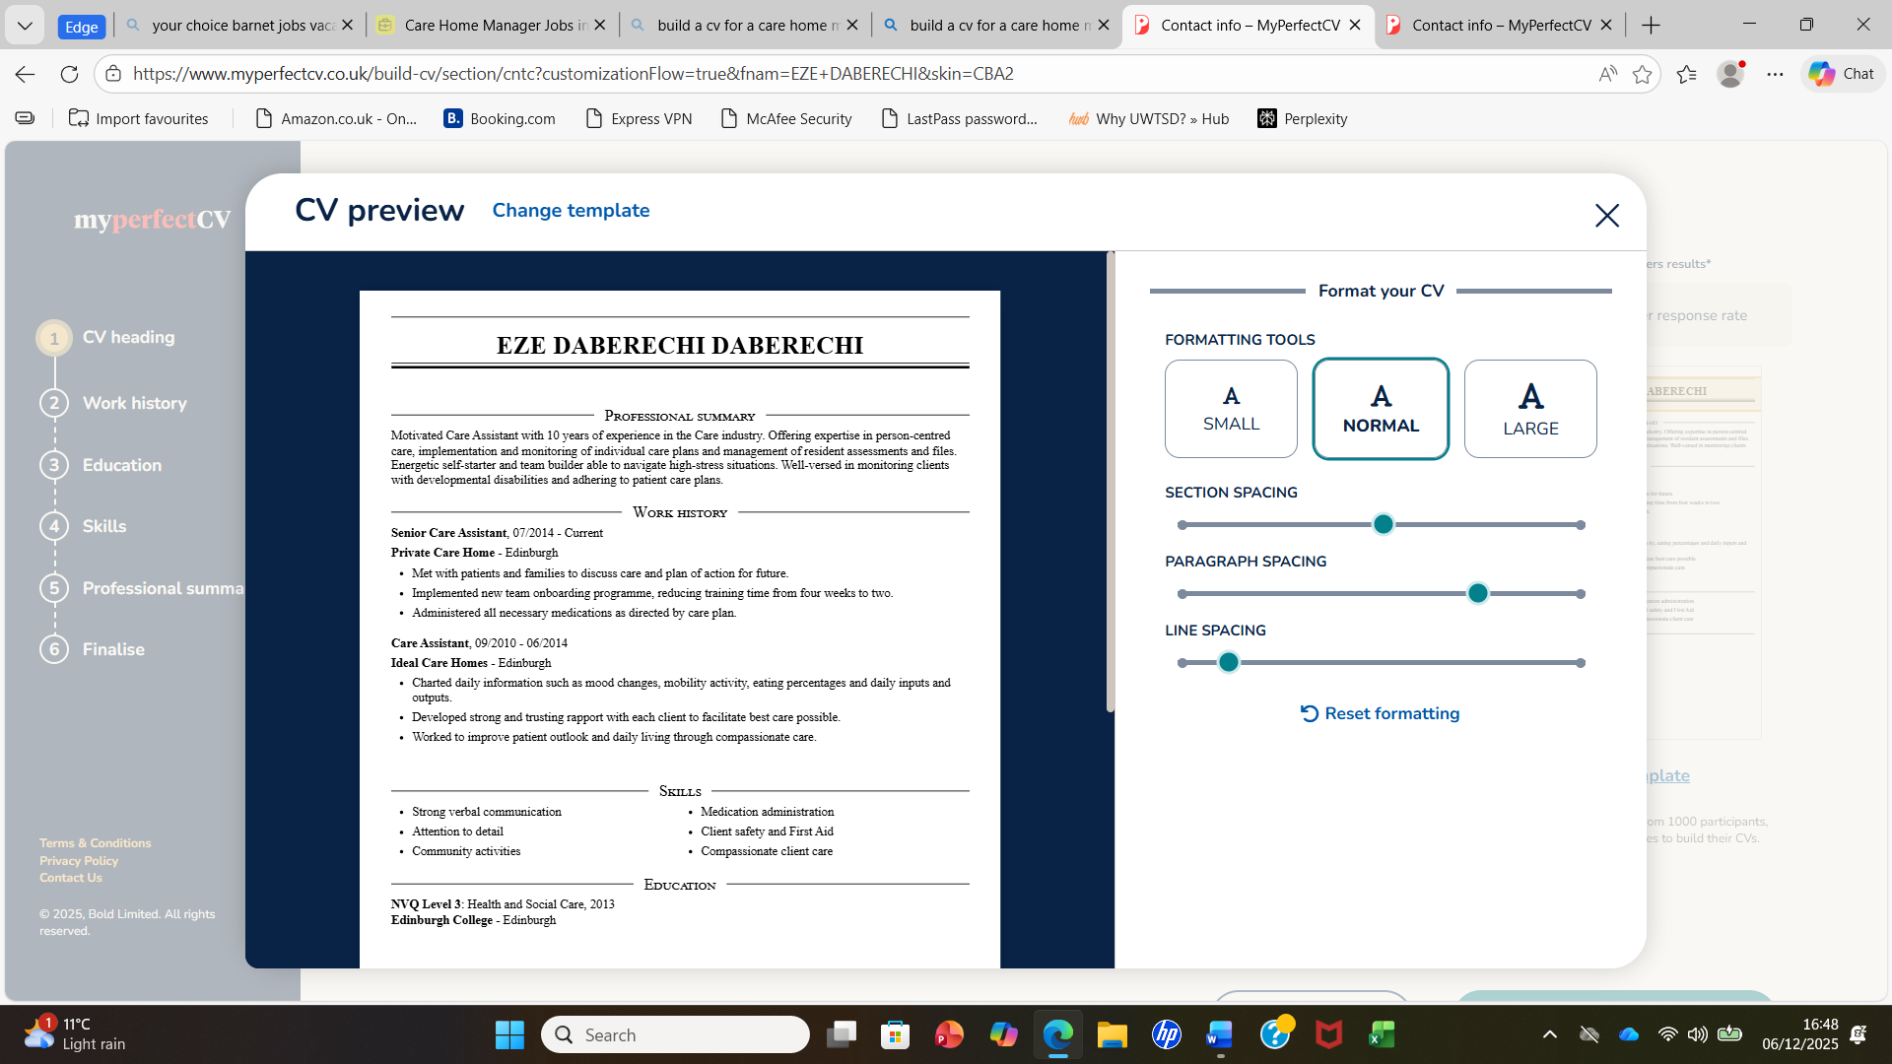

Applying as a registered manager.

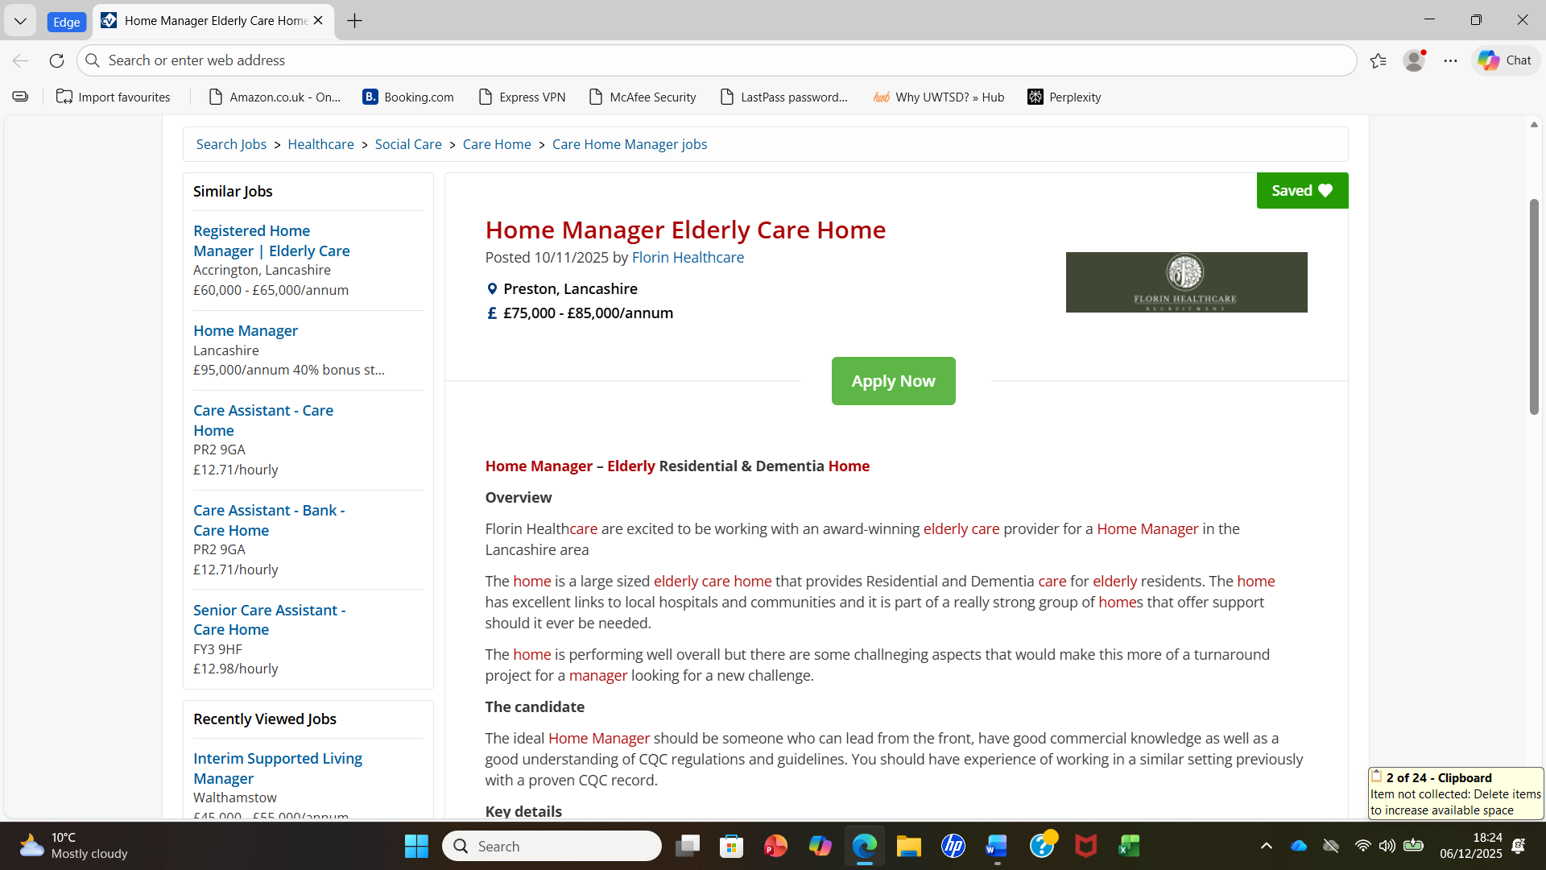
How you communicate your skills to a potential employer Interview
To communicate one’s skills to a potential employer, one can use a method that expresses leadership qualities. This leadership qualities comes in form of (STAR). Situation, Task, Action and Result to provide specific examples of leadership, delegation and problem-solving abilities (How well do you communicate? 2015).
Before the interview where you must communicate your skills to the potential employer, it is good to research the company or potential employer to demonstrate enthusiasm for the role being applied for and highlighting how your skills and ability will benefit the organisation. Show your ability by being an attentive listener throughout the interview.
Before the interview
Research the company to understand its values, goals and current challenges to show how your skills will be of benefit to them. Identify key skills in the job description and state the basic leadership and management skills they are looking for. Example on strategic planning, conflict resolution and communication. Reflect on your past experiences and state recent story that demonstrate your relevant skills and achievements. During the interview, demonstrate the star method when asked about your skill. Describe the situation, the task you must complete, the action you took and the result of the actions (How well do you communicate? 2015).
Conclusion
In conclusion, a manager’s effectiveness in a health and social care organisation directly reflects the quality of care provided and the overall performance of the organisation. My action plan focuses on professional growth and practical skill development. I intend to pursue management training, participate in leadership workshops, and engage in professional discussions with experienced managers to broaden my perspective. Reflective practice will remain central to my learning, allowing me to refine my approach and adapt to the evolving needs of the care sector. These activities directly support my career goal by building the managerial competence and confidence necessary for progression.
Throughout this process, I have developed a deeper awareness of the complexities of care home management and the importance of continuous professional development. Engaging in self-evaluation has helped me to identify my strengths and learning needs, fostering a proactive and reflective mindset that will support long-term success. This journey has deepened my passion for working with vulnerable adults and strengthened my motivation to lead services that promote compassion, dignity, and excellence in care.

References
Andino-González, P., Vega-Muñoz, A., Salazar-Sepúlveda, G., Contreras-Barraza, N., Lay, N. and Gil-Marín, M., 2025. Systematic review of studies using confirmatory factor analysis for measuring management skills in sustainable organizational development. Sustainability, 17(6), p.2373.
Anthony, M. 2022. A Theoretical Framework for Home Care Nursing. Home Healthcare Now, 40(3), pp.127–127. doi:https://doi.org/10.1097/nhh.0000000000001074.Assessed on the 9TH2025.
Benderly, B.L. 2013. Is it Time to Reconsider Your Career Goals? Science. doi:https://doi.org/10.1126/science.caredit.a1300192.
Birkhead, M., Sutherland, M. and Maxwell, T., 2000. Core competencies required of project managers. South African Journal of Business Management, 31(3), pp.99-105.
Cress, C. 2009. Care managers: working with the aging family. Sudbury, Mass.: Jones and Bartlett Publishers.
Devi, R., Martin, G., Banerjee, J., Butler, L., Pattison, T., Cruickshank, L., Maries-Tillott, C., Wilson, T., Damery, S., Meyer, J. and Poot, A. 2020 ‘Improving the quality of care in care homes using the quality improvement collaborative approach: lessons learnt from six projects conducted in the UK and the Netherlands’, International Journal of Environmental Research and Public Health, 17(20).
Gordon, A.L., Goodman, C., Davies, S.L., Dening, T., Gage, H., Meyer, J., Schneider, J., Bell, B., Jordan, J., Martin, F.C. and Iliffe, S., 2018. Optimal healthcare delivery to care homes in the UK: a realist evaluation of what supports effective working to improve healthcare outcomes. Age and Ageing, 47(4), pp.595-603.
Home and Career Skills, Grades 7 and 8. 1986.
How well do you communicate? 2015. Clinical pharmacist. Doi: https://doi.org/10.1211/cp.2015. 20068204.
Malik, E. and Shankar, S., 2025. Exploring the potential of self-managed organizational structure in enhancing home-based healthcare services in India. Discover Health Systems, 4(1), pp.1-16.
MS, L. 2014. Essence of Management. Archers & Elevators Publishing House.
Rattan, R., 2025. 2025: Time for change. BDJ In Practice, 38(2), pp.50-50.
Torgé, C.J., Nilsson, P. and Jegermalm, M., 2025. Support to ‘non-clients’: care managers’ role in direct and indirect carer support. European Journal of Social Work, 28(1), pp.143-154.
Woods, L. 2012. 4 Essential Skills for Leaders, Managers and High Potentials. Managingamericans.com.

